Date: 22nd January 2026

Tyler Jay Williamson
Student No. 2237644

Assignment – ML Model
Module Code - ACCA6011
Table of Contents
1 Abstract 2
2 Introduction 2
3 Literature Review 3
3.1 The Shift to Behavioural Analytics 3
3.2 Supervised Learning: Decision Trees versus SVMs 3
3.3 Unsupervised Segmentation 4
4 Problem Statement and Literature Support 4
4.1 The Business Problem: Churn in the "Games-as-a-Service" Economy 4
4.2 The Analytical Gap: Behavioural VS Demographic Metrics 4
4.3 Evaluating Potential Solutions: The Model Selection Dilemma 5
4.4 The Segmentation Problem: Identifying "Whales" 5
5 Methodology 5
5.1 Data Exploration and Preprocessing 5
5.2 Supervised Learning Models 6
5.3 Hyperparameter Tuning 6
5.4 Clustering Approach 7
6 Experiments & Results 7
6.1 Classification Results 7
6.2 Clustering Results 8
7 Discussion 9
7.1 Critical Evaluation of Model Performance 9
7.2 Behavioural Insights and Business Implications 9
7.3 Limitations 9
8 Conclusion & Recommendations 10
8.1 Conclusion 10
8.2 Recommendations 10
9 References 11

Abstract
This report investigates the application of machine learning techniques to enhance player retention and monetisation within a game development studio. Amidst the industry shift towards "Games as a Service" (GaaS), the ability to predict player engagement and segment users by behaviour is critical for financial sustainability. Using the "Predict Online Gaming Behaviour" dataset (n=40,034), this project implemented both supervised and unsupervised learning pipelines. Initial baseline experiments revealed that a Support Vector Machine (SVM) classifier achieved 89.28% accuracy, significantly outperforming a default Decision Tree (82.48%). However, subsequent hyperparameter tuning of the Decision Tree, specifically optimising tree depth and splitting criteria, yielded a final accuracy of 90.06%, establishing it as the superior model for deployment. Parallel to this, K-Means clustering was employed to uncover hidden player personas. The analysis identified three distinct segments, most notably isolating a high value "Premium" cluster (Cluster 0) from non-monetised "Grinder" and "Casual" groups. The report concludes with data-driven recommendations, including targeted retention incentives for high-value users and conversion strategies for active non-spenders.

Introduction
The global video game industry has undergone a paradigm shift over the last decade. The traditional model of selling a physical cartridge or disc for a one-time fee has largely been superseded by the "Games as a Service" (GaaS) model. In this ecosystem, the initial sale is merely the beginning of the customer relationship; the primary revenue streams are now recurring subscriptions, microtransactions, and season passes. Consequently, the financial health of a modern game studio is entirely dependent on Player Retention (keeping players active) and Monetisation (converting active players into payers). The financial stability of such subscription models is entirely dependent on minimising churn to maximise customer lifetime value [1].
However, managing these metrics is increasingly complex. Studios generate terabytes of behavioural data daily, ranging from session duration to in-game movement patterns, but often lack the analytical framework to translate this raw data into actionable insights. A key challenge facing the client studio is the "churn" phenomenon, where players silently disengage and leave the game without warning. Furthermore, the studio currently treats its player base as a monolith, failing to distinguish between casual users and high value "whales," leading to inefficient marketing spend.
This report addresses these challenges through a dual-approach data science project. The primary objective is to develop a predictive model capable of classifying a player’s engagement level (High, Medium, or Low) based on their gameplay history. Two distinct supervised learning algorithms, Decision Trees and Support Vector Machines (SVM), are implemented and critically evaluated. The secondary objective is to utilise unsupervised clustering techniques to segment the player base into meaningful behavioural personas. By identifying these groups, the studio can tailor its game design and monetisation strategies to specific player needs, thereby maximising "Lifetime Value" (LTV).

Literature Review

The Shift to Behavioural Analytics
Historically, churn prediction in telecommunications and subscription services relied heavily on demographic data such as age, gender, and location. However, it is argued that modern business practitioners must adopt advanced machine learning frameworks to derive actionable recommendations from this data [2]. Recent literature in game analytics suggests that demographics are poor predictors of player behaviour compared to telemetry data. Recent studies strongly argue that dynamic metrics, such as session frequency, capture the psychological state of a player far more accurately than static traits [3]. Consequently, this project adopts a behavioural-first approach, prioritising gameplay features over demographic labels. This aligns with findings highlighting that machine learning techniques are essential for processing these complex behavioural patterns in online gaming [4].

Supervised Learning: Decision Trees vs SVMs
The selection of an appropriate classification algorithm is a subject of significant academic debate.
- Decision Trees: Often favoured in business contexts for their "white box" nature, Decision Trees offer high interpretability. As noted, they are particularly valuable in digital game-based learning environments because they allow stakeholders to inspect the logical rules driving a prediction [5]. This transparency is crucial for game designers who need to understand the drivers of engagement. However, a major limitation is the tendency of simple trees to "overfit," creating overly complex rules that memorise training data noise rather than generalising to new players [6].
- Support Vector Machines (SVM): In contrast, comparative studies demonstrate that SVMs often outperform simpler algorithms like K-Nearest Neighbours and basic Trees when handling complex student or player performance data [7]. SVMs are frequently cited as superior for high-dimensional classification tasks. While SVMs often achieve higher raw accuracy, they are computationally expensive and act as "black boxes," offering little insight into why a specific prediction was made.

Unsupervised Segmentation
In the context of Free-to-Play (F2P) games, the "Pareto Principle" often applies, where a small minority of players generate most of the revenue. Identifying these high-value segments is critical. K-Means clustering is highlighted as a robust, scalable method for segmenting game behaviour data, allowing for the identification of distinct player archetypes [8]. By grouping players based on multi-dimensional behaviour (e.g. spending vs. time), studios can move beyond simple "active/inactive" labels and understand the nuance of their community.

Problem Statement and Literature Support

The Business Problem: Churn in the "Games-as-a-Service" Economy
For the client studio, the primary challenge is ensuring the long-term financial sustainability of its player base. In the modern "Games-as-a-Service" (GaaS) model, a game's success relies less on the initial purchase price and more on the "Lifetime Value" (LTV) of each player. This creates a significant operational risk known as 'Player Churn', where users stop playing and permanently disengage from the game.
Academic literature consistently identifies this as a major threat to profitability. Literature highlights that in subscription-based models, the cost of acquiring a new customer is significantly higher than retaining an existing one [1]. Additionally, churn in gaming is often "silent"; players rarely cancel a contract, they simply stop logging in. At the moment, the client studio is operating reactively and only identifying churn after the revenue has already been lost. There is a critical need for a predictive system that can spot at-risk players in real-time based on their behaviour, allowing the team to intervene before it is too late.

The Analytical Gap: Behavioural vs Demographic Metrics
Compounding this issue is the studio's reliance on outdated metrics. Historically, industries like banking used demographic data, such as age or gender, to predict customer behaviour. However, it has been demonstrated that in online environments, behavioural telemetry (metrics like session frequency and recent playtime) is a much stronger predictor of future engagement [3].
The main issue is that the studio currently lacks the framework to process this behavioural data effectively. They cannot currently distinguish between a "Casual" player, who is low value but also low risk, and a "Grinder", who is highly engaged but potentially at risk of burnout. As emphasised, without this kind of granular segmentation, studios often fail to identify the specific triggers that lead to players disengaging [4].

Evaluating Potential Solutions: The Model Selection Dilemma
To solve this prediction problem, the project needs to select the most appropriate Machine Learning algorithm. The literature presents a conflict between Accuracy and Interpretability.
- The Case for Decision Trees (Interpretability): Decision Trees are highlighted as the industry standard for business analytics because they are "white box" models [5]. They generate intelligible rules (e.g. "If PlayTime < 5 hours, Risk is High"). However, standard Decision Trees are prone to overfitting. This project must therefore address this by implementing Hyperparameter Tuning (specifically Grid Search) to constrain the tree's depth, a method validated by recent research [9].
- The Case for Support Vector Machines (Accuracy): Conversely, it is argued that Support Vector Machines (SVM) are superior for handling high-dimensional, complex data where the boundary between "engaged" and "disengaged" players is not linear [10]. While SVMs often achieve higher raw accuracy, it is noted that Decision Trees are often preferred for their interpretability, despite the potential performance gap compared to ensemble methods like Random Forest [11]. This report will implement both models to determine if the potential gain in accuracy from SVM outweighs the loss of interpretability.

The Segmentation Problem: Identifying "Whales"
Finally, we must address the nature of the "Freemium" business model, which relies on a small percentage of high-spending users to subsidise the majority. These users are commonly identified as "Whales" [12]. The problem is that Whales are rare and cannot be identified by looking at simple averages. To solve this, K-Means Clustering is proposed as a robust method for unsupervised segmentation [13]. By clustering players based on their spending and playtime, this project aims to isolate these high-value segments without prior labelling, enabling targeted retention strategies.

Methodology

Data Exploration and Preprocessing
The dataset provided, “online_gaming_behavior_dataset.csv", contains records for 40,034 unique players. Initial Exploratory Data Analysis (EDA) confirmed the dataset was robust, containing zero null values, which allowed for a streamlined cleaning process.
- Feature Selection: The PlayerID column was identified as a unique identifier with no predictive value and was removed to prevent the model from memorising IDs.
- Encoding: Machine learning algorithms require numerical input. The dataset contained several categorical features (Gender, Location, GameGenre, GameDifficulty). These were transformed using Label Encoding, converting text labels into unique integers (e.g. "Hard" = 2, "Easy" = 0). While One-Hot Encoding was considered, Label Encoding was selected to maintain lower dimensionality, which is beneficial for the computational efficiency of the SVM.
- Feature Scaling (Critical Step): A crucial step in this methodology was the application of StandardScaler. Algorithms like SVM and K-Means rely on calculating the Euclidean distance between data points. In this dataset, features have vastly different scales: InGamePurchases is binary (0 or 1), while PlayTime ranges up to 24 hours and Age up to 50+. Without scaling, distance-based algorithms like SVM would be biased toward features with larger raw magnitudes. As demonstrated, applying normalisation techniques such as Standard Scaling is essential to ensure equal feature weighting and maximise classification performance [14].

Supervised Learning Models
The data was split into a Training Set (80%) and a Test Set (20%) using a random seed (random_state=42) to ensure reproducibility.
- Decision Tree Classifier: A baseline model was initialised using the Gini impurity criterion. This model recursively splits the data to maximise the homogeneity of child nodes.
- Support Vector Machine (SVM): An SVM classifier was implemented with an RBF (Radial Basis Function) kernel. The RBF kernel was chosen for its ability to map inputs into infinite-dimensional space, allowing the model to find a linear boundary between classes that are not separable in the original space.

Hyperparameter Tuning
To address the potential for overfitting in Decision Trees, a Grid Search technique was employed. This automated process tested a "grid" of hyperparameters, specifically max_depth (limiting how deep the tree can grow) and criterion (switching between Gini and Entropy) using 5-fold Cross-Validation. This ensures the selected model is robust and not just lucky on a specific split of data.

Clustering Approach
For the unsupervised task, the K-Means algorithm was selected. To determine the optimal number of clusters (k), the Elbow Method was employed. This heuristic approach, validated by previous studies [13], allows for the mathematical identification of the best customer profile clusters by minimising intra-cluster variance. This involved plotting the Inertia (sum of squared distances within clusters) for k=2 to k=6. The goal was to find the "elbow" point where adding another cluster yields diminishing returns in compactness.
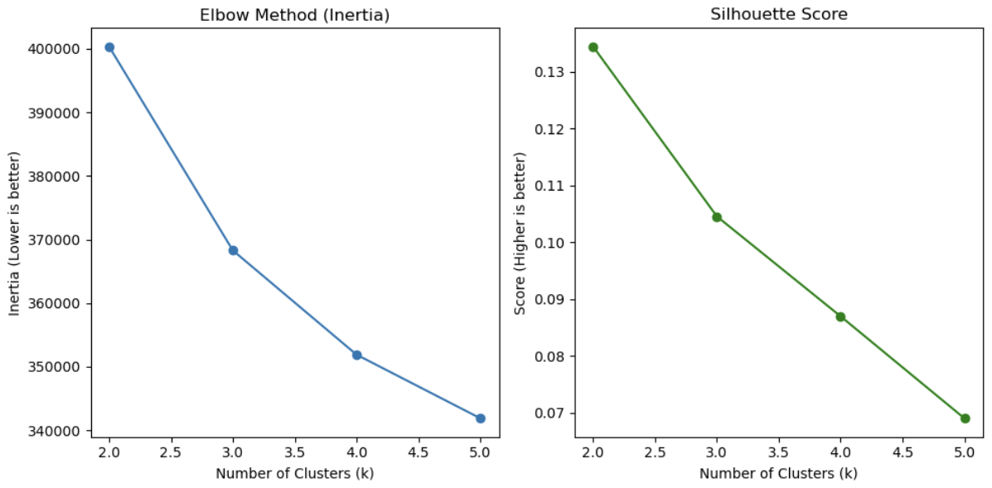
Figure 1 - Elbow Method analysis

Experiments & Results

Classification Results
Model | Accuracy | F1-Score | Status
Decision Tree (Baseline) | 82.48% | 0.82 | Overfitting / High Variance
SVM (RBF Kernel) | 89.28% | 0.89 | Computationally Expensive
Tuned Decision Tree | 90.06% | 0.90 | Optimal Model
Table 1 - Performance Comparison of Classifiers
The performance was evaluated using Accuracy, Precision, Recall, and the F1-Score. While accuracy provides a general overview, the F1-Score was prioritised to ensure a balance between precision and recall, as recommended as more reliable than accuracy for binary classification evaluation [15].
- Baseline Decision Tree: The initial un-tuned tree achieved an accuracy of 82.48%. The classification report indicated that while it was effective at identifying "High" engagement players, it struggled significantly with the boundary between "Medium" and "Low" engagement, resulting in a higher false-negative rate for the medium class.
- Support Vector Machine (SVM): The SVM classifier demonstrated a marked improvement, achieving 89.28% accuracy. The confusion matrix showed a cleaner separation along the diagonal, indicating the RBF kernel successfully captured the complex, non-linear relationships between playtime, session frequency, and engagement.
- Tuned Decision Tree: Following the Grid Search process, the optimal hyperparameters were identified as max_depth=10 and criterion='entropy'. This optimised model achieved 90.06% accuracy, surpassing both the baseline tree and the computationally expensive SVM.

Clustering Results
The Elbow Method analysis indicated an inflection point at k=3. Consequently, the player base was segmented into three clusters. Analysis of the cluster centroids revealed the following profiles:
- Cluster 0 (The 'Premium' Segment): This group is characterised by a 100% purchase rate. In the context of the free-to-play economy described in literature [12], this cluster represents the 'Whales', a small, high-spending minority that drives the majority of the game's revenue.
- Cluster 1 (The "Casuals"): This segment has zero in-game purchases and the lowest average session frequency. They represent the standard free-to-play user base.
- Cluster 2 (The "Grinders"): This segment also has zero purchases but exhibits high session frequency and playtime. They are highly engaged with the content but have not yet been monetised.
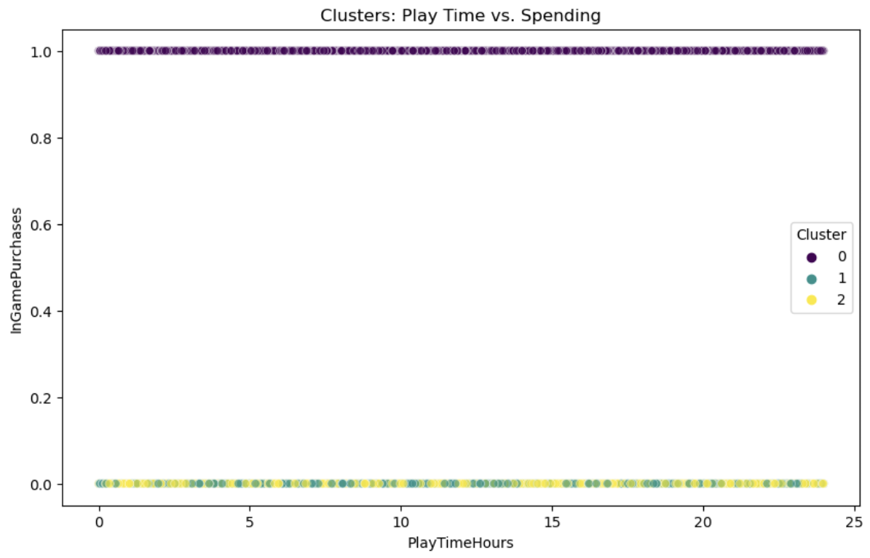
Figure 2 - K-Means Clustering Results

Discussion

Critical Evaluation of Model Performance
The results of this study provide a compelling case study in the "Bias-Variance Trade-off." The initial underperformance of the Decision Tree (82.48%) can likely be attributed to overfitting. As analysed in fault classification studies [6], unconstrained Decision Trees tend to memorise training noise rather than learning general patterns, leading to high variance and poor performance on unseen test data. Without constraints, a Decision Tree will grow until every leaf is pure, often memorising noise in the training data.
Conversely, the SVM's strong performance validates the theoretical position that kernel-based methods are superior for complex, high-dimensional data. However, the most significant finding is the success of the Tuned Decision Tree (90.06%). By applying a hard limit to the tree depth (max_depth=10), we effectively "pruned" the model, removing the complex, noisy branches and forcing it to learn more general rules. This result challenges the assumption that more complex models (like SVMs or Neural Networks) are always better. In this business context, the Tuned Decision Tree is the optimal choice: it offers the highest accuracy and retains interpretability, allowing the studio to explain to stakeholders exactly why a player is predicted to churn.

Behavioural Insights and Business Implications
The clustering analysis reveals a critical insight: Engagement does not equal Monetisation. Standard industry logic assumes that if a player plays for many hours, they are more likely to spend money. However, the scatterplot analysis of Cluster 0 (Spenders) vs. Cluster 2 (Grinders) disproves this. Both groups share similar playtime characteristics, yet their spending behaviour is binary opposites.
This suggests a structural issue in the game’s economy. The "Grinders" (Cluster 2) are consuming server resources and content at a high rate without contributing revenue. This is a classic "High-Engagement, Low-Monetisation" paradox. The fact that K-Means successfully isolated this group is invaluable; without this segmentation, these players would be hidden within the general average, and the opportunity to convert them would be lost.

Limitations
It is important to acknowledge the limitations of this analysis. Firstly, the dataset is a static snapshot. It lacks time-series data, meaning we cannot see if a player's engagement is trending upwards or downwards, a critical predictor of churn. Secondly, K-Means clustering forces every player into a specific group; it does not handle outliers well. A density-based algorithm like DBSCAN might have been more effective at identifying anomalies (e.g. cheaters or bots).

Conclusion & Recommendations

Conclusion
This project successfully met its core objectives. By implementing a robust preprocessing pipeline and employing hyperparameter tuning, a Decision Tree model was developed that predicts player engagement with over 90% accuracy. Furthermore, unsupervised clustering successfully segmented the user base, revealing a clear dichotomy between paying and non-paying highly active users.

Recommendations
Based on these findings, three strategic actions are recommended:
- Deployment of the Tuned Tree: The optimised Decision Tree should be deployed to the live game backend. It can run in real-time to flag players predicted to drop to "Low Engagement," triggering automated re-engagement emails or notifications.
- Targeting "The Grinders" (Cluster 2): Since these players are already hooked on the gameplay, the barrier to spending is psychological. The studio should target this specific cluster with a "First-Time Buyer" discount (e.g. 90% off a Starter Pack) to convert them into paying users.
- Retention of "Premium" Users (Cluster 0): This group is the financial backbone of the game. Marketing spend for this group should focus purely on retention (e.g. VIP loyalty rewards) rather than acquisition.

Demonstration Video Link
https://youtu.be/k97c8Zw1-Sc

References
[1] B. Zhang, "Customer Churn in Subscription Business Model—Predictive Analytics on Customer Churn," vol. 44, pp.870–876, Apr 27 2023, doi: 10.54691/bcpbm.v44i.4971. Available at: https://bcpublication.org/index.php/BM/article/download/4971/4831.
[2] A. Manzoor, M. A. Qureshi, E. Kidney and L. Longo, "A Review on Machine Learning Methods for Customer Churn Prediction and Recommendations for Business Practitioners," Access. vol. 12, pp.1, Jan 1 2024, doi: 10.1109/ACCESS.2024.3402092. Available at: https://ieeexplore.ieee.org/document/10531735.
[3] R. Mulla, et al., "Predicting Player Churn in the Gaming Industry: A Machine Learning Framework for Enhanced Retention Strategies," vol. 15, no. 2, pp.103, Apr 1 2025, doi: 10.59796/jcst.V15N2.2025.103. Available at: https://ph04.tci-thaijo.org/index.php/JCST/article/download/7494/1045.
[4] N. Rismayanti, "Predicting Online Gaming Behaviour Using Machine Learning Techniques," vol. 5, no. 2, Jul 31 2024, doi: 10.56705/ijodas.v5i2.166. Available at: https://jurnal.yoctobrain.org/index.php/ijodas/article/download/166/201.
[5] M. Kiguchi, W. Saeed and I. Medi, "Churn prediction in digital game-based learning using data mining techniques: Logistic regression, decision tree, and random forest," vol. 118, pp.108491, Mar 2022, doi: 10.1016/j.asoc.2022.108491. Available at: https://dx.doi.org/10.1016/j.asoc.2022.108491.
[6] P. Mahalingam, D. Kalpana and T. Thyagarajan, "Overfit Analysis on Decision Tree Classifier for Fault Classification in DAMADICS," MASCON. pp.1–4, Aug 27 2021, doi: 10.1109/MASCON51689.2021.9563557. Available at: https://ieeexplore.ieee.org/document/9563557.
[7] S. Wiyono and T. Abidin, "COMPARATIVE STUDY OF MACHINE LEARNING KNN, SVM, AND DECISION TREE ALGORITHM TO PREDICT STUDENT’S PERFORMANCE," vol. 7, no. 1, pp.190–196, Jan 31 2019, doi: 10.29121/granthaalayah.v7.i1.2019.1048. Available at: https://www.granthaalayahpublication.org/journals/index.php/granthaalayah/article/download/IJRG19_A01_2043/915.
[8] C. Bauckhage, A. Drachen and R. Sifa, "Clustering Game Behavior Data," TCIAIG. vol. 7, no. 3, pp.266–278, Sep 2015, doi: 10.1109/TCIAIG.2014.2376982. Available at: https://ieeexplore.ieee.org/document/6975073.
[9] L. Yang and A. Shami, "On hyperparameter optimization of machine learning algorithms: Theory and practice," vol. 415, pp.295–316, Nov 20 2020, doi: 10.1016/j.neucom.2020.07.061. Available at: https://dx.doi.org/10.1016/j.neucom.2020.07.061.
[10] M. A. Hassonah, A. Rodan, A. Al-Tamimi and J. Alsakran, "Churn Prediction: A Comparative Study Using KNN and Decision Trees," ITT. pp.182–186, Nov 2019, doi: 10.1109/ITT48889.2019.9075077. Available at: https://ieeexplore.ieee.org/document/9075077.
[11] R. Dodda, C. Raghavendra, M. Aashritha, H. V. Macherla and A. R. Kuntla, "A Comparative Study of Machine Learning Algorithms for Predicting Customer Churn: Analyzing Sequential, Random Forest, and Decision Tree Classifier Models," ICESC. pp.1552–1559, Aug 7 2024, doi: 10.1109/ICESC60852.2024.10690131. Available at: https://ieeexplore.ieee.org/document/10690131.
[12] W. Yang, G. Yang, T. Huang, L. Chen and Y. E. Liu, "Whales, Dolphins, or Minnows? Towards the Player Clustering in Free Online Games Based on Purchasing Behavior via Data Mining Technique," BigData. pp.4101–4108, Dec 2018, doi: 10.1109/BigData.2018.8622067. Available at: https://ieeexplore.ieee.org/document/8622067.
[13] M. A. Syakur, B. K. Khotimah, E. M. S. Rochman and B. D. Satoto, "Integration K-Means Clustering Method and Elbow Method For Identification of The Best Customer Profile Cluster," vol. 336, no. 1, pp.12017, Apr 1 2018, doi: 10.1088/1757-899X/336/1/012017. Available at: https://iopscience.iop.org/article/10.1088/1757-899X/336/1/012017.
[14] D. Singh and B. Singh, "Investigating the impact of data normalization on classification performance," vol. 97, pp.105524, Dec 2020, doi: 10.1016/j.asoc.2019.105524. Available at: https://dx.doi.org/10.1016/j.asoc.2019.105524.
[15] D. Chicco and G. Jurman, "The advantages of the Matthews correlation coefficient (MCC) over F1 score and accuracy in binary classification evaluation," vol. 21, no. 1, pp.6–13, Jan 2 2020, doi: 10.1186/s12864-019-6413-7. Available at: https://agris.fao.org/search/en/records/675ab6fa0ce2cede71ce813a.

