
BERGAMO PASQUALE
1816096
BUSINESS SKILLS
‘’THE LEGISLATIVE RISK IN THE HOTEL INDUSTRY’’
M4X01917



LECTURE: DALE CLARKE

1
PAGE CONTENTS

- INTRODUCTION………………………………………………………………. 3

- LIABILITY AND DATA PROTECTION………………………………………. 4

- HEALTH, SAFETY AND FOOD & HYGIENE……………………………….. 5

- HOTEL INDUSTRY AND ITS MANAGEMENT RISK……………………… 6

- LICENSING AND HOTEL PROPRIETORS ACT.1956 …………………… 7

- CONCLUSION…………………………………………………………………. 8

- REFERENCES…………………………………………………………………. 9

2
INTRODUCTION

In this task, we were asked to observe and analyze the legislative risk and to understand how these risks are managed by managers and employees. Every single company, which can vary from cocktail bars, hotels, restaurants, catering and so on, must follow the laws that regulate this industry to safeguard customers, its employees and itself to prevent penalties.

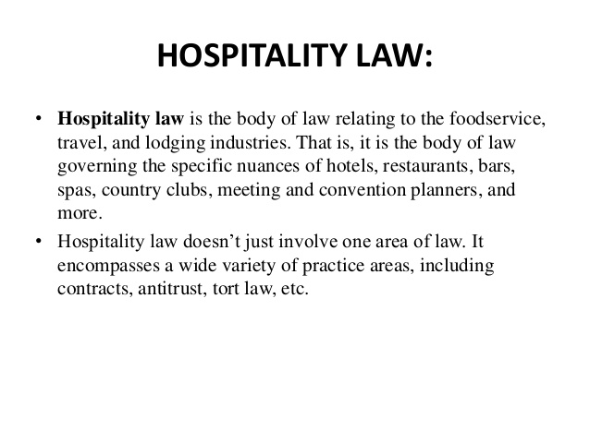
We will highlight the most significanrt laws to follow to exercise hospitality services, what are the things that employees must and must not do in order not to receive sanctions and these things must be to our knowledge to be good managers.
‘’Ethics refers to the behavior of an individual toward another individual or
group. Ethical behavior refers to behavior that is considered “right,” or the “right
thing to do.” (Barth, 2006)

3
LIABILITY AND DATA PROTECTION
‘’ To manage liability on the employee side, it is recommended that hotels frequently investigate updates on laws about minimum-wage increases, especially in urban markets.'' (Hotel management, 2019)
One of the most important responsibilities of the hotel is the security of customers' value. Any hotel, small or large capacity, needs employees for each department with different tasks and responsibilities.
The General Manager, for example, is responsible for most of the tasks and he must prepare annual budgets for the owners and have the final decision in all. One of his tasks is to manage and decide the company's assumptions.
The Front desk is the one that receives all the data to keep safe, phone numbers, credit card numbers, check-in, and checks out. Employees are responsible for a large amount of money, they also manage all the reviews working on complaints to solve room problems for example.
Housekeepers are responsible for cleaning the rooms and floors by checking them every morning and are also responsible for the laundry, providing clean pillows, sheets, and towels every day.
Breakfast hostess, waitress, and cooks are responsible for keeping their departments clean and tidy and for preparing and serving meals to customers, so they must be aware of any type of allergy or intolerance of customers.
A hotel maintenance person must ensure that each machine or other works perfectly, for example, must be available to the customers if he receives a call to change a non-working light bulb.
To make these things and many others work there is a need for the hotel to provide continuous training on service and safety to its employees on how they want things done. Each service is described above, but it changes in a subjective way from structure to structure.
‘’Developments in technology such as IoT, together with developments in the power of big data analytics mean that the traditional scenario in which people consciously provide their data is no longer the only or main way in which personal data is collected.’’ (Denham, 2019)

4
HEALTH, SAFETY AND FOOD HYGIENE
In recent years the standards and rules of hygiene and food safety have been created to make preparations and sales safe in the hospitality. Guidelines have been structured in the workplaces, tasks should be taken consciously by the employees not only to agree with the law and with the HACCP but above all to be sure of good health towards the customers.
One of the major causes of food poisoning is cross-contamination, which is the contact of bacteria from one food to another, dirty surfaces, unwashed hands or equipment. To manage risks every employee should maintain good personal hygiene to prevent and maintain a work uniform to prevent contamination. Each company has mandatory tests for its employees because they must be aware of every little detail regarding the subject, for example, food allergies and intolerances can cause real problems.
One way to manage food safety is to follow all the HACCP (Hazard Analysis Critical Control Points) principles, it allows us to control all the critical points and the problems that can be had with food, for example:
- Cook food at the right temperature,
- Store food at the right temperature,
- Serve cooked food at over 60 degrees Celsius or more and cold foods at 4 degrees Celsius or less.
‘’It is not necessary for the employer in control to designate an area as a
controlled area simply because people work under a general system that reflects
good practice in that sector.’’ (HSE, 2000).
The major causes of accidents at work are due to falls or slips. Employee protection is important and employers must ensure that safety regulations are respected and followed while tasks are being carried out and everyone must be aware of what they must do, so Hotel Management should, therefore, encourage employees to keep up-to-date with changes in regulations.
‘’When a relevant hazard has been determined in a certain food product or a
relevant contamination pathway has been determined, one should investigate
interventions to control this hazard for this route of contamination.’’ (Handbook of hygiene control in the food industry, 2005)

5
HOTEL INDUSTRY AND ITS RISK MANAGEMENT
Quality service is a service that "consistently meets and exceeds customer expectations." (Barrows, Powers, and Reynolds, 2006)
- Airbnb, Sharing economy, in the last few years we have been able to see the birth of sites like Airbnb, Housetrip, Homestay and more. What are the biggest threats to the economy of the hotel industry because so many students, young people prefer to choose to share an apartment for their trip rather than booking a hotel room.
- Shortage of experienced staff, in recent years, according to research by the Bureau of Labor, we have more than 15.000 people working in the hospitality industry, which in the coming years will become more than 17.000. The industry continues to grow and find people who have experienced could become very difficult indeed, especially for small companies. However, on the other side, companies should worry more about their employee's problems and their satisfaction in making them motivated to give a good customer experience.
- Perception risk from the customer, political incidents, terrorist attacks and more can have a strong impact on the locations chosen by people for their travels. These act as well as having a great social danger then become a great danger for the economy.
- Technology, companies today are looking for a new way to add technology to their venue, for example, Marriott's designed the Marriott's ‘'Internet of thing'' room with a digital key and the use of a smartphone to manage light, temperature, TV and more. Obviously, the technology exposes the owners to new risks such as, for example, the doors with digital keys can be unlocked more easily and the hotel has a higher risk that the customer's objects can be stolen.
- Data privacy, the hospitality sector was the more subjected to credit card data theft. Today everyone uses credit cards to make any kind of payment and is therefore exposed to very high risk.
‘’Maintaining the consistency and ‘reasonableness’ of a large risk assessment in a complex project, possibly incorporating the judgments from a diverse team of experts, requires special care.’’ (Cooper, Grey, and Raymond, 2005)

6
LICENSING AND HOTEL PROPRIETORS ACT.1956
The hospitality sector is one of the most regulated by law, in fact, to start this activity, numerous licenses are required that change according to the type of hotel and location. For example:
- The Fire Safety Certificate is required by the fire department and guarantees that the structure enjoys prevention and fire safety measures.
- The Health and Trade license is required by the Hotel Department for businesses that have direct contact with public health like restaurants.
- If the structure provides to serve alcohol the Bar license is requested by the authorities, in fact, the license is provided by the government and varies from state to state.
Then there are licenses for food, for employees, for taxes and for so much more than varies from state to state based on the laws of the country.
The Hotel Proprietors Act. 1956 was insert in place of the old legislation and limits the liability of the hotel owner for loss or damage to the property of the guest. This law reduces the responsibility of the owner but does not prevent him from loss or damage by customers against him.
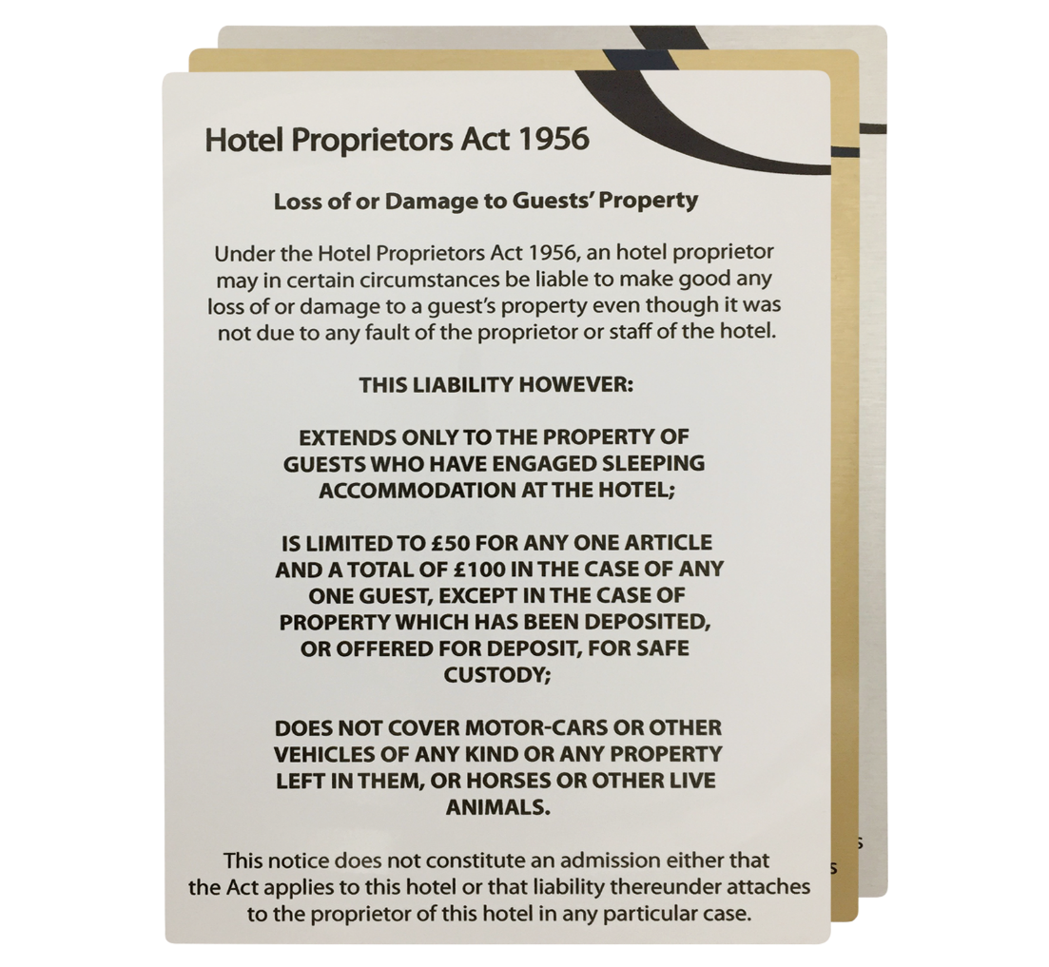

7
CONCLUSION
In this report, we have noticed that one of the most important elements of hospitality is the human factor, from the employee to the guest. The presence of the latter requires an important regulation to follow with its Pro's and Con's, as in everything.
All these regulations, on the one hand, reduce the risks, increase the professionalism of the employees and of the hotel itself and give a sense of common responsibility. On the other hand, it increases the costs and tasks to be performed. I am of the opinion, however, that without rules any activity cannot grow, and without hierarchy, no employee has the opportunity to grow, in this environment we need discipline and respect towards every act that is performed and towards every guest.

8
REFERENCES

- Barrows, C., Powers, T. and Reynolds, D. (2006). INTRODUCTION TO MANAGEMENT IN THE
- HOSPITALITY INDUSTRY. 1st ed. John Wiley & Sons LTD., p.296.
- Barth, S. (2006). Hospitality Law. 2nd ed. New Jersey: John Wiley & Sons Inc., p.9.
- Cooper, D., Grey, S. and Raymond, G. (2005). Managing risk in a large project and complex procurements. Chichester: John Wiley & Sons, LTD, p.94.
- Bibliografia: Denham, E. (2019). Big data, artificial intelligence, machine learning, and data protection. Information Commissioner’s office, p.12.
- Handbook of hygiene control in the food industry. (2005). 1st ed. North America: Woodhead’s published limited, p.37.
- Hotel Management. (2019). Liability concerns facing the hospitality industry today. [online] Available at: https://www.hotelmanagement.net/legal/liability-concerns-facing-hospitality-industry-today [Accessed 20 Aug. 2019].
- HSE. (2000). 1st ed. Health and safety executive, p.65.

9

