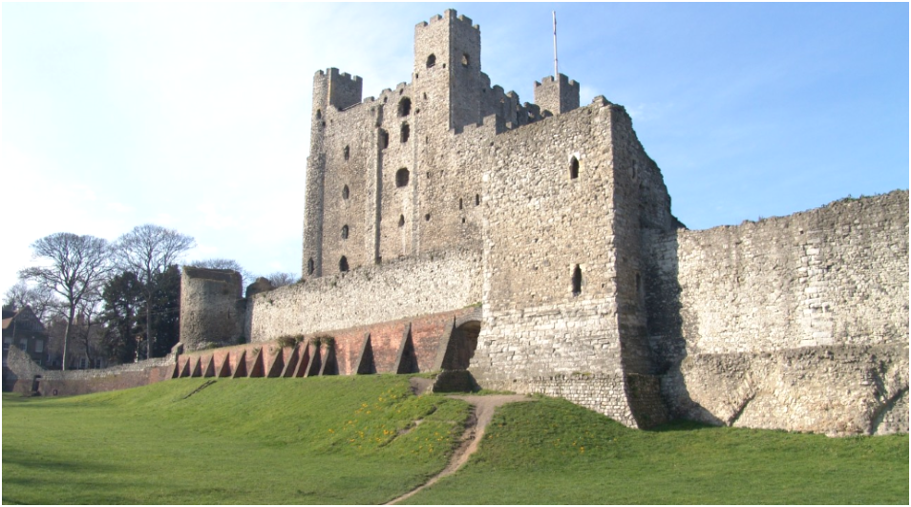
Portfolio Part 1: Rochester Castle image

The image chosen for the portfolio depicts Rochester Castle in Kent. The castle itself saw use from its construction in 1088AD as a Motte and Bailey castle though its reconstruction as a stone keep in 1127AD, through its abandonment and refortification in the 1300’s by Edward III in response to French raiding on the South East. The castles most noteworthy feature is its round tower on its south eastern corner in both its curtain wall and on the keep itself, this was reconstructed after a siege from 1215AD during the First Barons War.
Rochester was founded as a Roman Fort in 43AD to guard a temporary river crossing over the River Medway the roman army was using for their invasion. This fort was later expanded into a settlement called Durobrivae as is seen with most roman military settlements once the region has been occupied. The later settlement was also built on ‘Watling Street’ which was constructed by the Romans as they were building their road network in England and is one of the major road links into London still used today. This made Rochester a strategically important location in the South East of the country at the time due to its capability to defend two major transportation links into the capital.
After the Normans had occupied England, William had made Bishop Odo the Earl of Kent who began constructing the original Motte and bailey constructed at Rochester in 1067AD. The motte was constructed on Boley Hill, just to the south of the current sight, and it was sighted next to the ruin of the Roman city wall. In 1088AD Odo used Rochester Castle as a launching point for his rebellion against William II in preference of his brother Robert Curthose ruling over a joint Anglo-Norman Kingdom as the two brothers were in a bitter rivalry. The rebellion itself was short lived and saw the original castle ruined, the land was returned to the control of the crown and was reconstructed by Bishop Grundulf of Rochester on its current site, closer to the river. During the Reign of Henry I the Castle was given over to the control of William de Crobiel, the Archbishop of Canterbury, in 1127AD who had the stone keep in the centre of the stone curtain wall and tower built by Grundulf previously. The Castle remained in the churches possession until 1215AD when Stephen Langton gave the Castle over to the Magna Carta Rebels resulting in the aforementioned siege which destroyed one corner of the keep. The Castle was restored by Henry III in the 1220’s but was heavily damaged in another siege during the Second Barons War in 1264AD after which it remained unfixed until Edward III’s reign who renovated and refortified the castle to defend against French raids on the South East during the Hundred Years War.
The reuse of Roman fortifications is not entirely unheard of for the Normans in Britain, in fact the first castle they constructed in Britain after landing during 1066AD was at Pevensey. Pevensey castle was first constructed during the 3rd century AD as a part of a series of stone forts constructed along the English Channel. It is mentioned that Pevensey Castle had a strong rampart on one of its facings, this could be referring to the Normans reconstructing a wall that had been damaged by a land slip. Derek Renn argues that this was a relatively immediate construction with the Normans landing, occupying the damaged fort and reconstructing a stone rampart and converting the derelict Roman fort into a Castle. This is a fair argument as the fort itself which provided the foundation of the castle was in a relatively fine condition with only one damaged wall meaning that this would have been a relatively rapid repair job, however we know from both archaeological and textual evidence the Normans Constructed a ‘temporary fortification’ within or next to the original fort. The second argument here raised by Goodall can also be supported when looking at Rochester Castle since it was also constructed as a temporary fortification built near a Roman fortification which was later replaced by a stone keep built on the remains of the old Roman stone works.
However there are some examples of Norman castles and fortifications that were not built on top of old Roman Ruins, such as the castles at Northampton and Oxford. Archaeological evidence has found evidence of Saxon dwellings, ranging from huts to simple housing, in the form of foundations and basements underneath the castle grounds. This evidence goes to support the argument that the Normans constructed their castles out in a method to dominate the surrounding areas and subjugate the population and decimating their dwellings and building castles on them, the likes of which had not been seen in this country prior to the Normans. However the counter to this argument is that the castles were purely a defensive tool used by the Normans to protect their soldiers whilst they were on campaign, which again is a relatively accurate argument to make, when looking at castles like Pevensey castle. Rochester castle however, whilst built on Roman ruins, is not a structure created for a defensive purpose since it was constructed firstly during the invasion to garrison some soldiers in the region prior to the invasions completion, and latterly was reinforced in stone once any rebellious elements had been quelled, in order to intimidate any further rebellion.

Rochester Castle’s stone construction as previously mentioned was in 2 phases and both phases of construction also used different types of stone. The first stone construction in 1088AD, the curtain wall and a smaller central structure, was constructed using reused roman masonry and stone quarried from Normandy, this was a common trend with early Norman castle construction in England. This was done as the Normans were still establishing their rule in the country at the time and it is easier for them to get resources to build where they already had an established network and from ruins no one was contesting, by contrast the quarries at maidstone at the time were in a state of disuse from the Romans abandonment of Britain around 410AD meaning they would have to be reopened. The later Construction of the tower keep by William de Crobiel in the 1100’s was constructed using Kentish rag stone quarried from the Medway Valley quarries, which was treated with a Caen Dressing according to Renn which would have made the castle look whiter and more similar to the whiter Caen limestone used in the construction of the earlier castles in Britain. This does make more sense as by the time the keep was being constructed the Normans had established their reign in England and had the luxury of establishing networks to reopen quarries or develop their defences, and with the possibilities of dynastic quarrels between England and Normandy as seen in the Reign of William II.
Rochester castle itself both follows typical Norman castle building behaviour and goes against it. This is evident in how it was built on top of old roman town walls, which are still visible on the bottom right hand side of the image, however its role is not to defend a marching army, like the fortifications constructed and later expanded upon at Pevensey Castle. Rochester was constructed post conquest in an effort to consolidate power and defend a key transport link. Rochester Castle also follows the pattern on how the Normans source their building materials in how they first only used Roman Ruins and stone transported from Caen, but after 1076AD the construction stones are sourced from within Britain as it is easier and cheaper for them to source the construction materials within Britain.

Bibliography
- Cathcart King, D.J. The Castle in England and Wales: an Interpretative History, (Croom Helm, London, 1988)
- Goodall, J. Pevensey Castle, East Sussex, (English Heritage, Swindon, 1999)
- Laycock, S. Britania: the Failed State, (The History Press, Stroud, 2008)
- Myres, J.N.L. The English Settlements, The Oxford History of England, (clarendon Press, Oxford, 1986)
- Pettifer, A. English Castles, (Boydell Press, Woodbridge, 1995)
- Renn, D. Norman Castles in Britain, (Humanities Press, New York, 1968)
- Wilson, R.J.A. A Guide to the Roman Remains in Britain, (Constable, London, 2002)

Myres, J.N.L. The English Settlements, The Oxford History of England, (clarendon Press, Oxford, 1986) P.123
Pettifer, A. English Castles, (Boydell Press, Woodbridge, 1995) P.124
Pettifer, A. English Castles, (Boydell Press, Woodbridge, 1995) P.124
Renn. D, Norman Castles in Britain, (Humanities Press, New York, 1968) P.34
Pettifer, A. English Castles, (Boydell Press, Woodbridge, 1995) P.124
Pettifer, A. English Castles, (Boydell Press, Woodbridge, 1995) P.125
Wilson, Roger J.A. A Guide to the Roman Remains in Britain. (Constable, London, 2002) pp. 54–55.
Renn. D, Norman Castles in Britain, (Humanities Press, New York, 1968) P.27
Goodall. J, Pevensey Castle, East Sussex, (English Heritage, Swindon, 1999) P.20
Renn. D, Norman Castles in Britain, (Humanities Press, New York, 1968) P.12
Cathcart King, D.J, The Castle in England and Wales: an Interpretative History, (Croom Helm, London, 1988) P.26
Renn. D, Norman Castles in Britain, (Humanities Press, New York, 1968) P.14
Laycock. S, Britannia: the Failed State. (The History Press, Stroud, 2008) P.50
Renn. D, Norman Castles in Britain, (Humanities Press, New York, 1968) P.299

