

Industrial Measuring Systems
Module Number: PCEE 4003
Learner Name & Number: Luke O’Sullivan 176776

Lecturer Name: Tony Howles

Table of Contents
Task 1 – Pressure Sensor 3
Task 2 – Position Sensor 4
Task 3 – Temperature Sensor Characteristics 6
Task 4 – Recorders 8
Task 5 - Signal Transmission 11
Task 6 – Basic Control Systems 13
Appendix 15
Bibliography 18
References 19

Task 1 – Pressure Sensor
Pressure is found across many industries, S Yadav (2010) suggests that pressure is essentially required in all walks of human life including that of science, engineering, trade, commerce, efficiency, quality, and safety. Pressure The analogue bourdon tube pressure gauge would operate from a curved metal tube that would straighten and bend differently when there is pressure going through, whereas the digital pressure gauge works on the principle of strain gauges, this is where the resistance changes due to mechanical strain. The strain gauge will change with the pressure change and therefore changes the resistance, creating an electrical signal and producing a digital reading.
When an analogue gauge is operating at a normal pressure, it is common for the needle to be positioned at 12 o’clock or straight up. In most cases, the accuracy of the gauge is the best within the middle third of itself, due to this it is common to need a pressure gauge with a range double the normal operating pressure. Digital pressure gauges are more straight forward in terms of accuracy, the maximum pressure that is being measured gets matched to the pressure of the gauge. The digital gauge will automatically provide better accuracy due to not requiring double the normal operating pressure for accurate readings, unlike the analogue gauge.
When taking readings, the analogue gauge is often less reliable due to human eye errors and a commonly parallax issues, this is where the needle appears to be in a different position when viewed from different angles. Digital gauges do not have this issue and are easily readable to due to their digital display.
When it comes to maintenance and repairability, a digital gauge can usually withstand physical damage, whether it to be with the display or keypad, and damage will not usually affect the calibration. If damage were to occur, digital gauges can be repaired at a reasonable price. If the display of an analogue gauge were to be damaged, it may be more difficult to repair and recalibrate due to the precision of the needle.
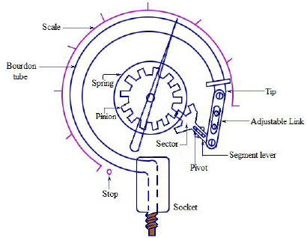
To conclude and compare, the analogue bourdon tube pressure gauge and the digital pressure gauge are two separate but similar devices for pressure management. Both devices offer the same principle and result despite operating differently. From the research obtained, the digital pressure gauge is the more useful option due to its greater reliability and maintenance. However, depending on the requirements of the application, the environment and budget, an analogue system could be preferred.

Figure 1 – Example and construction of an Analogue Bourdon Pressure Gauge.
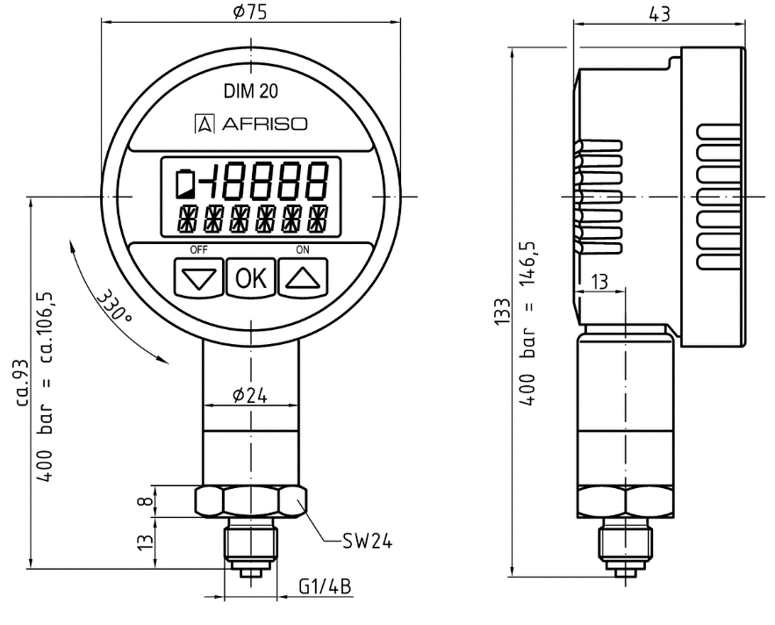

Figure 2 – Example of a Digital Pressure Gauge.

Task 2 – Position Sensor
- A sensor commonly used to measure the angular velocity of an electrical motor and has the capability of 0 to 3000 RPM is an optical encoder. W, Kester (2009) describes the construction of an optical encoder as ‘a disc that is divided into sectors that are alternately transparent and opaque. A light source is positioned one side of the disc, and a light sensor on the other side. As the disc rotates, the output from the detector switches alternately on and off. Depending on whether the sector appearing between the light source and the detector is transparent or opaque’. It’s operation of measuring the angular velocity is completed through light passing through the sections of the disk, this will generate pulses that can be counted to determine the speed and direction of the rotations. More specifically, the type of optical encoder to measure speeds as high as 3000 RPM would be an incremental optical encoder. An incremental optical encoder will produce pulses that relate to the changes in position, which allows precise measurements. Please see Appendix A for Datasheet example of an Incremental Optical Encoder.
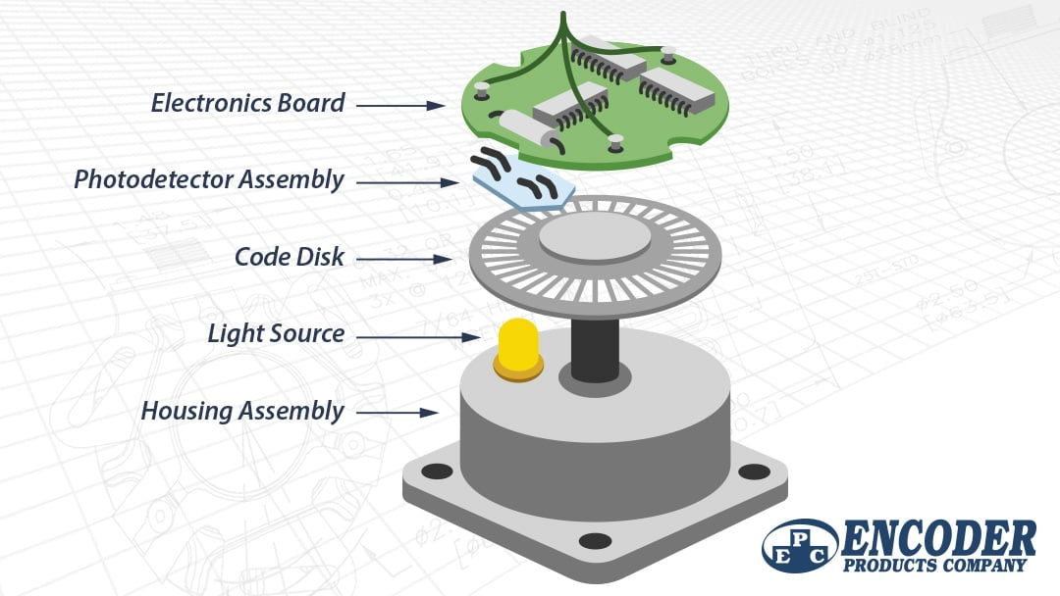
Figure 3 – Optical Encoder Construction

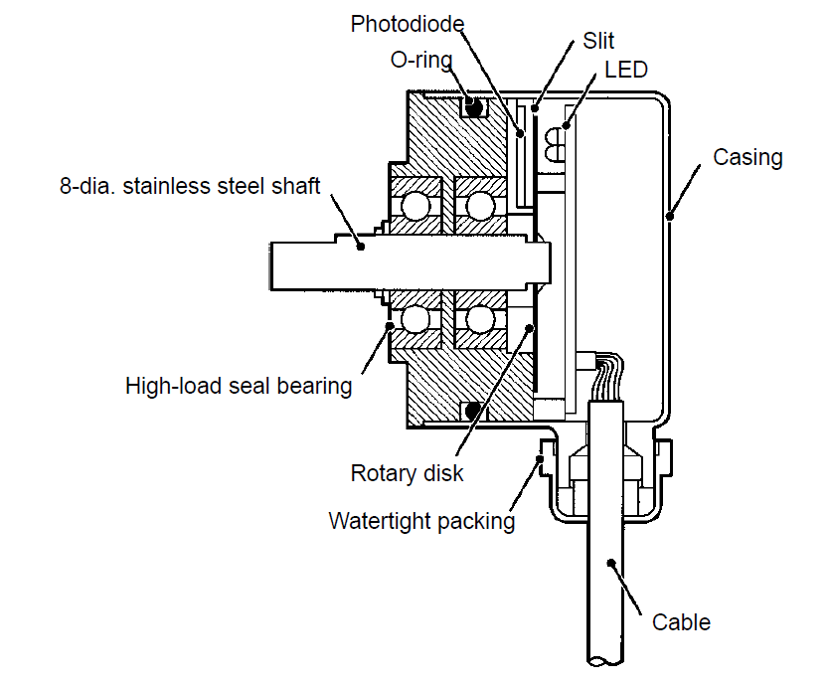
- An appropriate sensor to measure the rotation of a ball valve actuator through a 220-degree operation would be an absolute rotary encoder. This type of sensor provides accurate positioning for the valve’s rotation position. The encoder will provide a unique code for each position the valve is in within the 220-degree range, this gives an accurate reading of the valves position with no requirement of a reference point. An absolute rotary encoder is very useful due to its accuracy. Its working principle is that the sensors within the encoder will read the patterns of the internal discs as they rotate, this will then generate electrical signals which can be represented as binary code which will reflect the valves rotation position.

Figure 4 - Construction of a Absolute Rotary encoder

Please refer to Appendix’ A & B for Datasheet examples of the encoders chosen.

Task 3 – Temperature Sensor Characteristics
- To calculate the resistance of a sensor the formula R_{t} = R₀(1 + αt) = 100×(1 + 3.85×10⁻³ × (The Temperatureº) ) My results are shown below:

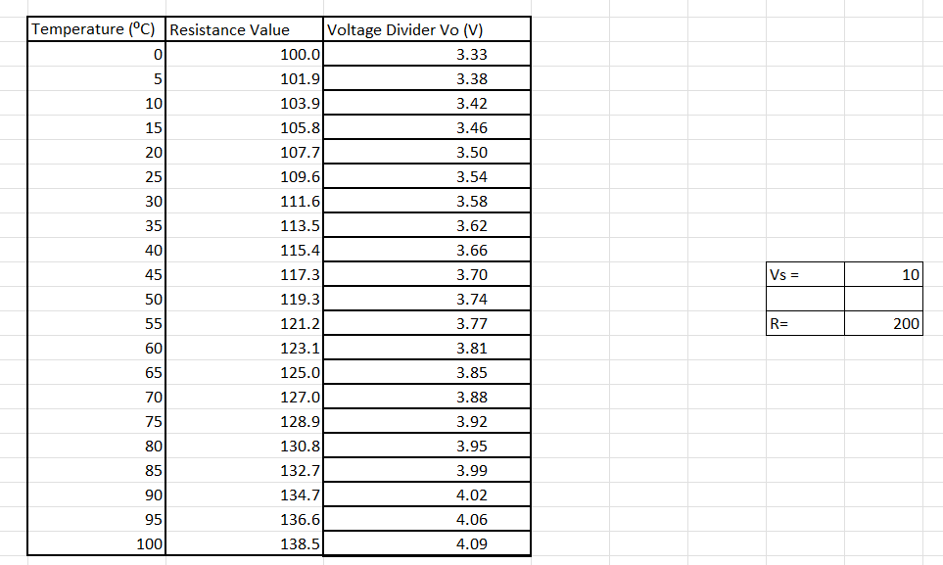

Figure 5 – Table of results.

- When converting output from an RTD that is going to a voltage, a voltage divider can be used. The formula to be used to determine the voltage divider value (Vo) is $\frac{Vs ×Resistance}{R+Resistance}$ the results for Vo can be seen in Figure 5.
- The table shown in Figure 5, can determine that my change in input is 100ºC based of the temperature values and change in output is based off the resistance values calculated, this means that the change in output is 38.5Ω. The formula used to determine sensitivity is Sensitivity = $\frac{change in output}{change in input}= \frac{∆Out}{∆In}$
Inputting results to the formula would equate to = $\frac{38.5}{100}$ = 0.385Ω

- To calculate the first order response, it is determined using this following formula,
Vo = Vs(1 – e^{-t/τ} ) τ represents time constant. For calculations, the time constant was 5m/s. The table below shows results and the graph plotted from results. `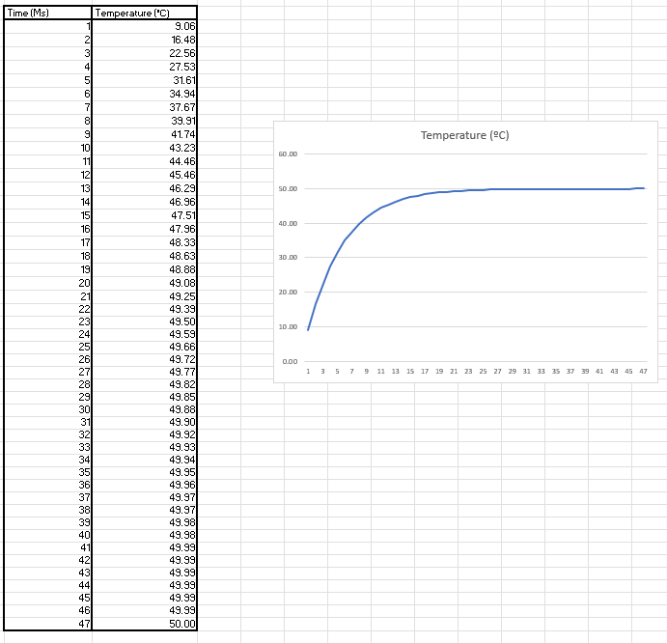
Figure 6 – First order response calculations and Graph
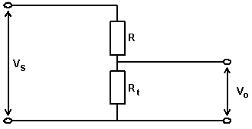 Figure 6.1 – Voltage Divider

Task 4 – Recorders
- Chart recorder’s purpose is to record trends and data from electrical/mechanical signals such as voltage, humidity, temperature, and pressure. The trends logged are usually recorded on a rolling piece of paper, on the paper many inputs can be recorded through different coloured pens. The chart recorder receives input signals, and this has the pens draw the relevant data from the inputs. There are a few types of chart recorders, these include mechanical chart recorders, electromechanical and electrical. The older types were mainly mechanical, these use motorized clockwork mechanisms to move the paper underneath the pens. Some chart recorders are electromechanical and use both mechanical and electronic systems to operate. The modern chart recorders are often and almost always electronically operated. Chart recorders offer many advantages and disadvantages, the benefits of using a chart recorder include the instant results, the ease of replacing paper/pens and that the data is physically recorded onto paper, meaning that there is no chance of corruption or lost data that can occur with digitally saved data. However, some may decide to avoid chart recorders. This may be due to the cost and chore of replacing the paper and pens, the restricted space from the various paper sizes and lengths
used and some of the chart recorders used are less portable due to their size.

Data loggers are now the most popular chart recorder used in industry, data loggers can be described as a recording device that has digital sensors and will detect conditions of any factors inputted to detect. Data loggers will often store the data it has tracked with internal memory, this data can then be uploaded to computer systems for viewing and storing. With these operations, data loggers require efficient and modern systems to operate. Data loggers hold many advantages, these include their compact design, advantages from using technology to view the data, the ability to import and study the data through several applications and there being no requirement for pens/paper replacements. The only real disadvantages with data loggers is the need for the data to be transferred from the data logger onto the computer system through memory drives or ethernet connections. Also, the competency to work well with computers is needed.

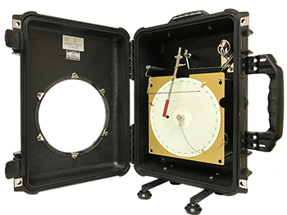
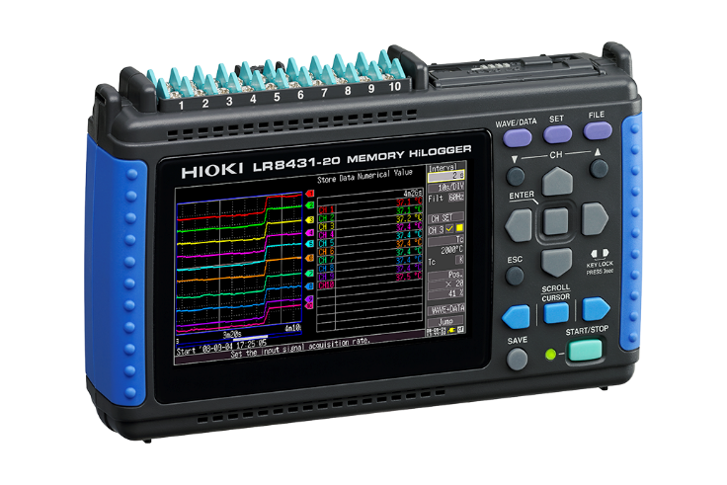

Figure 7 – Data Logger example Figure 8 – Chart Recorder Example

Task 5 - Signal Transmission
- Voltage and Current Transmission are two methods of transmission commonly used with electronic circuits and systems. Voltage signal transmission has various advantages, this includes the ease of measurement by using equipment such as a voltmeter. Voltage signals are also less affected by noises and disruptions compared to signal transmission. When measuring through voltage signal transmission, the equipment being used such as a voltmeter, often has an easy interface to use and navigate to see the signals. However, voltage signal transmission may be avoided when completing long distance transmission as the signals detected can sustain voltage drops which affects the reliability of the signals. When using voltage signal transmission, they can be impacted by load impedance, affecting accuracy. Load impedance can affect the signal transmission by influencing the current that is drawn from the source of the signal, causing a volt drop across the load impedance, when there is a low load impedance this can cause disruptions in the signal or a complete loss of the voltage signal, and can commonly occur in long distance transmission. When the load impedance is high, it will draw much less current from the signal source, resulting in the voltage drop being minimal and allows the signal transmission to be maintained.
Current signal transmission has the advantage over voltage signal transmission that it is less affected by resistance in transmission, this gives them the benefit of being useful for long distance transmission. The power distribution is simplified for current signal transmission, this is due to the same current having the ability for power and the signal transmission itself. Also, in situations where voltage drops or impedances are significant, current signals can provide a more accurate and efficient reading. However, current signal transmission can be considered more complex in terms of its measurement and interface, collecting data may involve using specialist equipment such as an ammeter which doesn’t provide the most user-friendly interface. In some scenarios, sensors and transducers wont naturally produce current signals, making the type of signal transmission unusable. Current signal transmission also requires high amounts of power compared to voltage signal transmission, this and the high current in the signal transmission can cause safety hazards among systems.
b.) When there is an output signal from a measurement system, there will be set processes to complete the operation and ensure that the signal is processed accurately for the next stage. One process involved is conversion, this is simply the change of signal from one type to another, for example converting a digital signal to an analogue signal. This process is used when the measurement signal requires change due to its compatibility with various equipment or when the data has a requirement to be stored and analysed on a computer system. Another process used is amplification, this is where the output signal has its magnitude increased however the signal will keep its characteristics and maintain accurate data. Amplification is applied as a process, as in some scenarios the output signal coming from the measurement system may read as weak and appear small, and in that case can not be effectively processed or analysed. Using the process of amplification enhances the strength of the signal which ensures that efficient analysis and other processes can be carried out. Another process involved is elimination, this is where certain components or noises are removed from the output signal. This is in place due to measurement systems often being interfered by external noises and the environment. Elimination allows the adjustment of signal to noise ratio and therefore enhances the accuracy and reliability of the output signals for analysis. Manipulation is another processed used for output signals and involves changing specific characteristics of the signal in a contained manner. The reason for this is to correct system errors, collect better data and allows for the process to be compatible with various requirements of further processes. Lastly, protection is a process involved with the output signals and consist of guarding the signal from any damage or corruption when being processed or stored. This is in place due to signals being vulnerable to interferences such as voltage spikes, electromagnetic interferences, and damage to equipment. For this, protection is put in place such as shielding, limiting, and filtering. Protection is important due to its ability to keep signals accurate and efficient.

Task 6 – Basic Control Systems
- An open loop control system can be described as a control system that does not have any feedback connected to it. Open loop control systems do not depend on their output, so for that reason, the output isn’t used as a control variable for the system and will not impact the input. Dilli-Babu (2015) states that ‘In open loop control systems, output is not fed-back to the input. So, the control action is independent of the desired output.’ They can also be described as one way signal flow systems as they do not contain any feedback. An example of where an open loop control system is used can be a washing machine, the washing machines process of washing, spinning, rinsing, and potentially drying the items in the washing machine are all time based and does not rely on how clean the clothes are or if the clothes are dry. An advantage of open loop control systems is that they are simple and easy to design, due to this they are much cheaper than other control systems available. A disadvantage to consider of an open loop control system is that due to it being a non-feedback system, they do not work if an automated process is required, meaning they are limited to certain pieces of equipment.
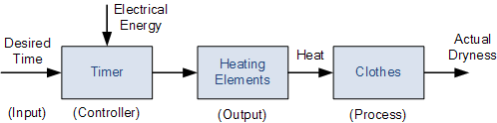

Figure 9 – Open Loop control system

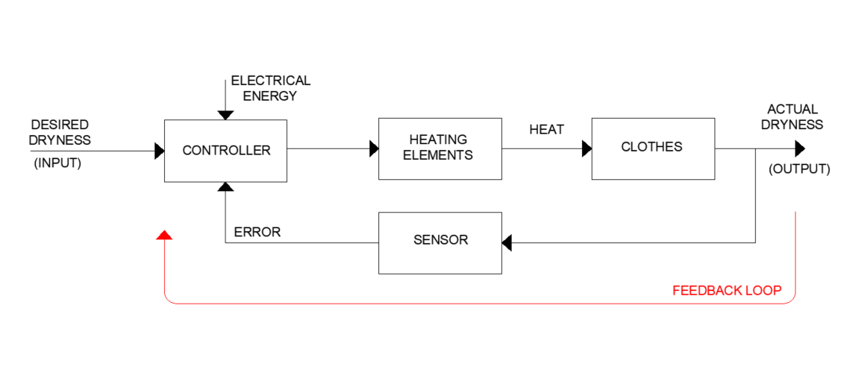

Figure 10 – Block Diagram drawn on AutoCAD of Closed Loop Control System – Showing Smart Tumble dryer.
As described by Dilli-Babu (2015) ‘In closed loop control systems, output is fed back to the input. So, the control action is dependent on the desired output. The control loop system shown (Smart Tumble Dryer), will start with an input which is for the clothes to become dry (Desired Dryness). This input is then sent through the controller which can be described as the brains of the system, the controller will determine the Temperature and duration of the drying cycle and this information will be sent to the Heating Elements, these elements produce the heat required to dry the clothes. The clothes or possibly items placed in the tumble dryer will then give an output of their actual dryness, this may be measured through the weight of the clothing, or the moisture detected. This will then (through the feedback loop) go through the sensor and back into the controller. The system will continuously monitor the weight/moisture/temperature of the clothes and feedback to the controller to adjust the temperature and duration of the cycle.

Appendix

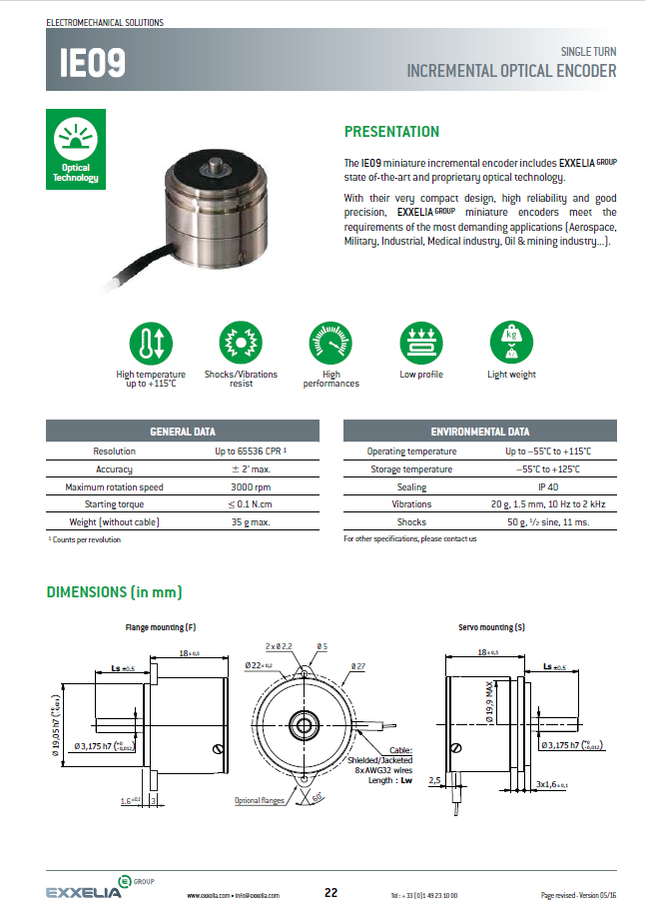
Appendix A – Incremental Optical Encoder Datasheet, Sourced from Electromechanical Solutions on 23/04/2024
Appendix B – Absolute Rotary Encoder Datasheet – Sourced from Omron Edata on 02/05/2024
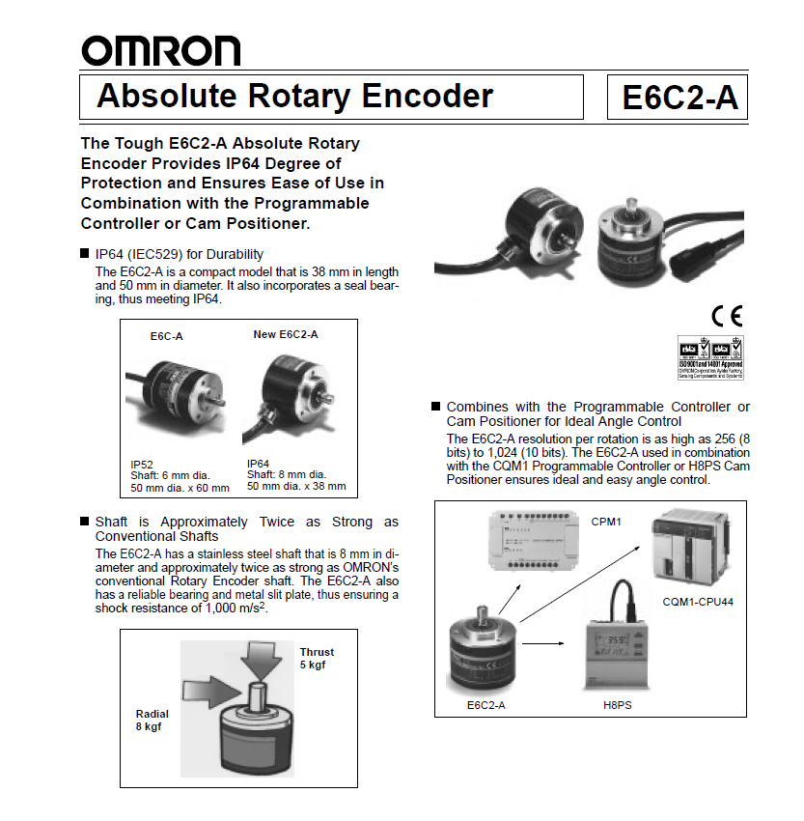
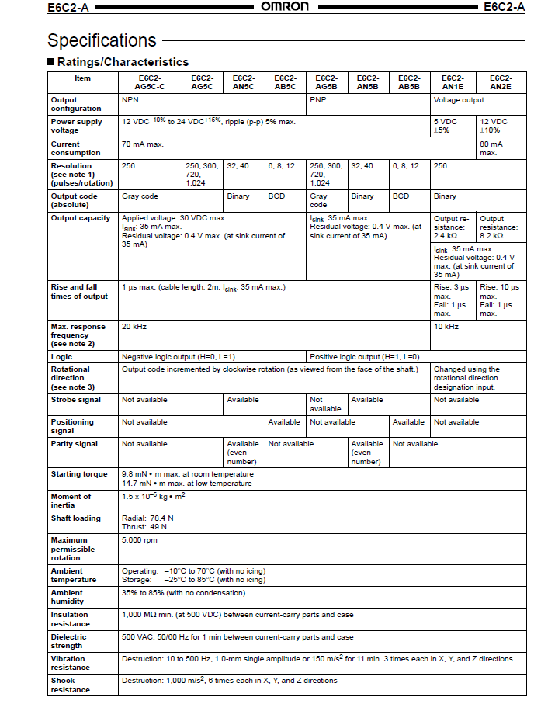

Bibliography
- Morris, A.S. (2003). Measurement and instrumentation principles, 3rd Edition. Butterworth Heinemann. (2003).

- Bolton W. (2015). Instrumentation and control systems, 2nd Edition. Newnes.

- Bolton W. (2015) Mechatronics: Electronic Control Systems in Mechanical and Electrical Engineering, 6th Edition. Pearson Education.

- Kamran Iqbal. (2024). Introduction To Control Systems. Arkansas: LibreTexts.

- Sharma, KLS. (2011). Automation Strategies. Overview of Industrial Process Automation. 1(6.2.2).

- M.A Laughton, D.J Warne, D.J Allan. (2003). Electrical Engineers Reference book. London: Newnes. pp.33.3-33.5.

- Robjohns.H. (2003). Understanding Impedance. Techniques. 1(1), pp.2-3.

- GES Inc. (2023). Ultimate Guide to Chart Recorders. [Online]. Global Electronic Services. Available at: https://gesrepair.com/guide-chart-recorders/ [Accessed 12 March 2024].

- S.Yadav, V.K. Gupta, A.K. Bandyopadhyay. (2010). Measurement Science Review. 10th ed. New Delhi: CSIR. pp.130-135.

- Kester,W. (2009). Optical Encoders. Massachusetts: Analog Devices. pp.1-2.

- Dilli Babu, K. (2015). Control System Engineering. BTECH. 2(2), pp.3-5

References
Figure 1 – Construction of an Analogue Bourdon tube pressure gauge. Sourced from https://www.researchgate.net/figure/Bourdon-tube-pressure-gauge_fig1_288020197 on 23/04/2024
Figure 2 – Example of a Digital Pressure Gauge Sourced from https://www.afriso.com/en/PM/Portable-measuring-instruments/Inspection-and-service/Universal-digital-pressure-gauge-DIM-20 On 23/04/2024
Figure 3 – Optical Encoder Construction Sourced from https://www.encoder.com/article-what-is-an-optical-encoder - On 26/04/2024
Figure 4 – Absolute rotary encoder construction – Sourced from https://files.pepperl-fuchs.com/webcat/navi/productInfo/doct/tdoct5126__eng.pdf?v=20200320035924 – On 26/04/2024
Figure 9 - Open Loop control system. Sourced from https://www.electronics-tutorials.ws/systems/open-loop-system.html On 27/02/2024.
Figure 7- Chart Recorder Example – Sourced from https://instrumentation.com/palmer-circular-chart-pressure-recorders.aspx On 18/03/2024
Figure 8- Data Logger Example – Sourced from https://gssb.com.my/what-data-logger-applications On 18/03/2024

Student FEEDBACK FORM

This section details the extent to which the assessment criteria are demonstrated by you, which in turn determines your mark. The marks available for each category of skill are shown. Lecturers will use the space provided to comment on the achievement of the task(s), including those areas in which you have performed well and areas that would benefit from development/improvement.

Generic Assessment Criteria | Marks available | Marks  awarded
1. Engagement with Literature Skills
.
Engagement with an extensive range of relevant and credible literature. Consistently accurate application of referencing. | 20 | 15
2. Knowledge and Understanding Skills

Excellent knowledge and understanding of the basic underlying concepts and principles of the subject. | 40 | 34
3. Cognitive and Intellectual Skills

Excellent ability to devise arguments using evidence and make appropriate and valid judgements. | 10 | 8
4. Practical Application Skills

An advanced application of a range of taught, basic methods, materials, tools and/or techniques.  The context of the application is well considered, and insightful. | 20 | 16
5. Transferable Skills for Life and Professional Practice

Work is accurate, exceptionally coherent, very fluent and presented well. | 10 | 8

Assessment Mark (Assessment marks are subject to ratification at the Exam Board. These comments and marks are to give feedback on module work and are for guidance only until they are confirmed. ) | Late Submission Penalties (tick if appropriate) |  | 81%
 | Up to 1 week late (40% Max) |  | 81%
 | Over 1 week late (0%) |  | 81%

GENERIC ASSESSMENT CRITERIA

Level 4
In accordance with the Framework for Higher Education Qualifications, at the end of Level 4 students will be expected to have demonstrated knowledge of the basic underlying concepts and principles of a subject, and an ability to evaluate and interpret these within the context of that area of study. They should be able to present, evaluate and interpret qualitative and quantitative data in order to develop lines of argument and make sound judgements in accordance with basic theories and concepts of their subject(s) of study. They will have learned how to evaluate different approaches to solving problems, and will be able to communicate the results of their study/work accurately and reliably, and with structured and coherent arguments. They will be able to undertake further training and develop new skills within a structured and managed environment and will have the qualities and transferable skills necessary for employment requiring the exercise of some personal responsibility.

Level 4 | FAIL | MARGINAL FAIL | SATISFACTORY  (3rd / Pass) | GOOD  (2.2 / Pass) | VERY GOOD  (2.1 / Merit) | EXCELLENT  (1st / Distinction) | EXCEPTIONAL  (1st / Distinction)
Category | 0-29% | 30-39% | 40-49% | 50-59% | 60-69% | 70-84% | 85-100%
Engagement with literature (including reading, referencing,  academic conventions and  academic honesty) | Little or no evidence of reading and/or reliance on inappropriate sources.  Views and findings mostly unsupported and non-authoritative.  Referencing conventions used incoherently or largely absent. | Poor engagement with essential reading. No evidence of wider reading. Reliance on inappropriate sources, and/or indiscriminate use of sources. Heavily reliant on information gained through class contact. Inconsistent and weak use of referencing. | Engagement with a limited range of mostly relevant and credible sources but with some reliance on information gained through class contact. Some omissions and minor errors.  Referencing conventions evident though not always applied accurately or consistently. | Engagement with an appropriate range of literature, including sources retrieved independently. Some over-reliance on texts rather than other sources. Referencing may show minor inaccuracies or inconsistencies. | Engagement with a wide range of literature, including sources retrieved independently.  Selection of relevant and credible sources. Generally sound referencing, with no/very few inaccuracies or inconsistencies. | Engagement with an extensive range of relevant and credible literature. Consistently accurate application of referencing. | Exceptional engagement with an extensive range of relevant and credible literature. High-level referencing skills consistently applied.
Knowledge and understanding (Knowledge of the basic underlying concepts and principles of a subject.) | Major gaps in knowledge and understanding of the basic underlying concepts and principles of the subject matter. Inclusion of irrelevant material. Substantial inaccuracies. | Gaps in knowledge of the basic underlying concepts and principles, with flawed or superficial understanding. Some significant inaccuracies and/or irrelevant material. | Limited knowledge and understanding of the basic underlying concepts and principles within the subject area. Some elements may be missing. | Knowledge of the basic underlying concepts and principles is accurate with a good understanding of the field of study but lacks depth and/or breadth. | Competent knowledge of the basic underlying concepts and principles. Exhibits very good understanding. | Excellent knowledge and understanding of the basic underlying concepts and principles of the subject. | Exceptional, detailed knowledge and understanding of the basic underlying concepts and principles
Cognitive and intellectual skills  (Evaluate underlying concepts and principles of a subject and interpret qualitative and quantitative data in order to develop lines of argument and make sound judgements.) | Wholly or almost wholly descriptive work. Little or no evaluation of the underlying concepts and principles.  Failure to develop arguments, leading to illogical or invalid judgements. Minimal or no use of  evidence to back up views. | Largely descriptive work, with superficial evaluation of the underlying concepts and principles. Weak interpretation of data, flawed development of arguments and judgements. Information accepted uncritically, uses generalised statements made with scant evidence and unsubstantiated opinions. Ideas sometimes illogical and contradictory. | Limited attempt at evaluation of the underlying concepts and principles, tending towards description.  Can interpret qualitative and quantitative data but with some errors. Some evidence to support emerging arguments and judgements but these may be underdeveloped or with a little inconsistency / mis-interpretation. | Good evaluation of the underlying concepts and principles. Can interpret qualitative and quantitative data, with minor errors.  An emerging ability to use evidence to support the argument.  Mostly valid arguments and logical judgements. | Sound evaluation of the underlying concepts and principles. Can interpret qualitative and quantitative data accurately. Ability to devise arguments using evidence to make mostly appropriate and valid judgements. | Excellent ability to devise arguments using evidence and make appropriate and valid judgements. | Exceptional evaluation of the underlying concepts and principles based evidence. Outstanding interpretation of qualitative and quantitative data.  Exceptional ability to devise arguments using evidence and make wholly appropriate and valid judgements.
Practical skills  (Different approaches to solving problems in particular contexts.) | Limited or no use of taught, basic methods, materials, tools and/or techniques.  Little or no appreciation of the context of the application.  Very weak evidence of different approaches to problem-solving in particular contexts. | Rudimentary application of taught, basic methods, materials, tools and/or techniques but without consideration and competence. Flawed appreciation of the context of the application.  Weak evidence of different approaches to problem-solving in particular contexts. | An adequate awareness and mostly appropriate application of basic methods, materials, tools and/or techniques.  Basic appreciation of the context of the application.  Can identify problems in particular contexts and propose basic alternative approaches or solutions though there may be errors. | A good and appropriate application of basic methods, materials, tools and/or techniques.  Clear appreciation of the context of the application.  Good evidence of different approaches to problem-solving in particular contexts and proposes mostly appropriate solutions. | A very good application of a range of basic methods, materials, tools and/or techniques.  Very good consideration of the context of the application. Very good evidence of different approaches to problem-solving in particular contexts and proposes appropriate solutions. | An advanced application of a range of taught, basic methods, materials, tools and/or techniques.  The context of the application is well considered, and insightful.  Excellent evidence of different approaches to problem-solving in particular contexts and proposes appropriate solutions. | Exceptional levels of application and deployment skills in particular practical contexts. Outstanding identification of problems in particular contexts and formulation of wholly appropriate, thoughtful solutions / different approaches.
Transferable skills for life and professional practice  (Communicate the results of their study/work accurately and reliably, and with structured and coherent arguments; the qualities needed for employment requiring the exercise of some personal responsibility within a structured and managed environment.) | Work is poorly structured, disorganised, inaccurate and/or confusingly expressed. Very weak use of language and/or very inappropriate style. Failure to work effectively individual or as part of a group. Little or no evidence of the skills for employment requiring the exercise of some personal responsibility. | Work is poorly presented in a disjointed manner. It is loosely, and at times incoherently, structured, with information and ideas often poorly expressed. Weak use of language and/or inappropriate style. Flawed approach to individual or group work, meeting only partial obligations to others. Limited evidence of the skills for employment requiring the exercise of some personal responsibility. | Mostly ordered presentation and structure in which relevant ideas / concepts are reasonably expressed. Work may lack coherence and/or accuracy in places. Can work as part of a group, meeting most obligations to others but perhaps with limited involvement in group activities.  Demonstrates the basic skills for employment requiring the exercise of some personal responsibility, with some areas of minor weakness. | Mostly coherent, organised and accurate work, in a suitable structure and is for the most part clearly expressed. Can work effectively independently and/or as part of a team, with clear contribution to group activities.  Demonstrates the skills for employment requiring the exercise of some personal responsibility, with some areas of strength and some of minor weakness. | Work is accurate, coherent, fluent, well-structured and organised.  Can work effectively independently and/or as part of a team, with very good contribution to group activities. Demonstrates very good skills for employment requiring the exercise of some personal responsibility, with just occasional minor weakness. | Work is coherent, very fluent and is presented professionally. Can work effectively independently and/or as part of a team, with an excellent contribution to group activities. Demonstrates excellent skills for employment requiring the exercise of some personal responsibility with an appetite for further development. | Work is accurate, exceptionally coherent, very fluent and presented well. Can work effectively independently and/or as part of a team, with an exceptional contribution to group activities. Demonstrates exceptional skills for employment requiring the exercise of some personal responsibility with an appetite for further development.

