Course: MBA
Module: Dissertation
Module Code: SBMA7123D
Supervisor:

Student: Barry Wilson
Student number: 1602075

Assessment 1
Dissertation Proposal

Title
Change Management. A case study in the diocese of St Asaph.

Key Question
What lessons can be learned from the process of structural change that occurred in the diocese of St Asaph from 2016-2018?

Objectives
To use qualitative research to analyse the strengths and weaknesses of the processes involved in defining and implementing the introduction of Mission Areas in the diocese of St Asaph in order to identify learning outcomes that can shape good practice in the future.

Background
Context
In September 2010 the Governing Body of the Church in Wales discussed the ongoing decline in church attendance which, at that time, was averaging approximately 3% per annum. Many of the contributors had a common message:

“The Church in Wales cannot go on doing the same things in the same way; some things need to change and we are open to – and indeed encourage - that possibility” (Church in Wales Review, 2012, p.1).

The Standing Committee and Bench of Bishops responded to the debate by appointing an external review of the Church, with particular reference to structures and use of resources. The findings and recommendations of the review group were published in July 2013. They covered a number of key areas, including: governance and decision making; leadership and training; mission areas and buildings; worship and outreach; and finance and administration (Ibid).

Not all of the recommendations were adopted by the Governing Body or Bench of Bishops, but there was general consensus that:

“the current parish system, as originally set up, with a single priest serving a small community is no longer sustainable” (The Church in Wales Review, 2012, p.12).

Instead, it was agreed that a revised structure in which mixed ministry teams of lay and ordained ministers, some of whom would be stipendiary but most of whom would not, would be established in wider geographical contexts known as a Mission Areas. The size and makeup of those Mission Areas, however, would be determined by the local context (Ibid).

To assist this process an implementation group was appointed. Their report was published in August 2013 and recommended that locally determined Mission Areas should be established in each diocese by 2020. However, each diocese was given the freedom to define both the nature and structure of the Mission Areas according to the needs and resources available (2020 Vision, 2013, p.3)

Focus
The proposed research will focus upon the process by which the diocese of
St Asaph defined and implemented the introduction of Mission Areas between 2016 and 2018.

Research Question
The research will explore the motivations, actions and feelings of people who were involved in the structural change, in order to better understand the strengths and weaknesses of what occurred and identify learning outcomes that can shape good practice in the future.

Boundaries
The research will involve eight interviews, comprised of the three people who will be asked to respond to the initial research question and five others who will join them in the second stage of data collection.

In the first instance the interviews will be unstructured so that the person is free to talk about the subject without interruption or intervention. In the second stage a semi-structured approach will be taken, with pre-determined questions that can be re-phrased or re-ordered to suit the characteristics of each interviewee (Saunders, Lewis & Thornhill, 2009, p.321). This should overcome the limitations of a more rigid approach which Armstrong (2009, p.182) suggests can inhibit spontaneous and revealing reactions.

Literature Review
According to Flick (2006) three types of literature are especially helpful in the development of qualitative research: theoretical literature; literature from empirical studies; and methodological literature on how the research should be conducted.

Theoretical Literature
Theoretical literature can be used to identify models that can shape and interpret the data that is collected.

At this stage three theoretical models have been identified:

- The Change Kaleidoscope, developed by Julia Balogun and Veronica Hope Hailey (2009).
- Forcefield Analysis, developed by Kurt Lewin (1951).
- The Eight Step Change Theory, developed by John Kotter (1996).

However, the final selection will be made once the research has been conducted. Other potential models include Johnson and Scholes ‘Cultural Web’ (1992) and Kotter and Schlesinger’s ‘Leadership Styles (1979).

The Change Kaleidoscope
The Change Kaleidoscope is a framework for exploring both the contextual features that might shape and impact a change programme and the design and implementation choices that are available.

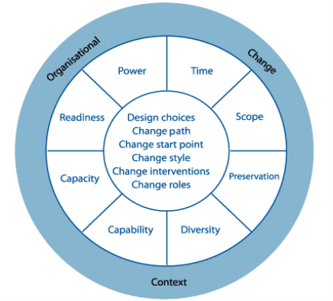

(MBA Knowledge Base, 2018)

The contextual features are represented in the outer ring of the diagram and include:

- Time – or how quickly the change is needed?
- Scope – or how much change is required?
- Preservation – or what organisational resources or characteristics need to be maintained?
- Diversity – or how homogeneous the groups and divisions within the organisation are?
- Capability – or the managerial or personal ability to implement change?
- Capacity – or the change resources that are available.
- Readiness – or the willingness of people to change.
- Power – or the extent to which the change leader has the authority to impose change (Johnson et al, 2016, p.472-473).

The design or implementations choices are presented in the inner ring and comprise:

- The ‘Design Choices’ or ‘Change Path’, which may be through evolution, adaptation, revolution or reconstruction.
- The ‘Change Start Point’, such as ‘Top-down Change’, where change is initiated from the top management; ‘Bottom-up Change’ where change is initiated from the bottom line; ‘Models of Good Practice’ where good practice in one part of the organisation is used as a model for other parts; and ‘Pilot Sites’ where change is initially implemented in only one part of the organisation, before rolling out to others.
- The ‘Change Style’ through education; collaborative decision making; direction or control; or coercion.
- The ‘Change Target’, such as behaviour or values.
- The ‘Change Levers’ or interventions that are needed to implement the change (Kaplan, 2018).

Forcefield Analysis
Lewin’s ‘Forcefield Analysis’ (1951) suggests that change results from the impact of driving forces upon restraining forces:

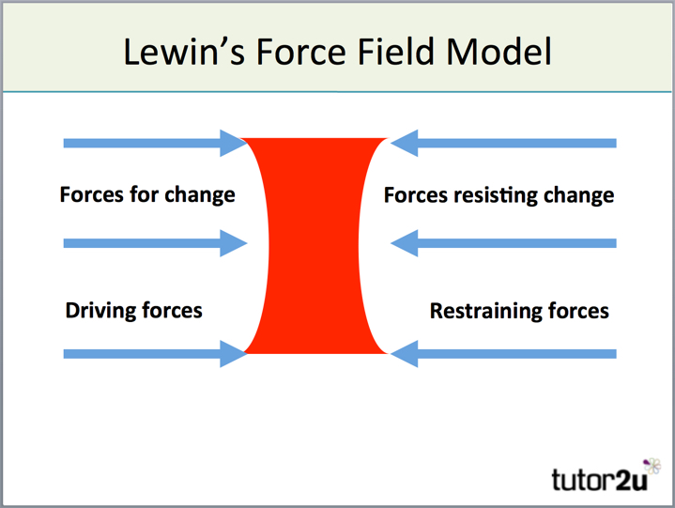
(Tutor2u, 2018)

According to Lewin, the driving forces are primarily concerned with improving organisational efficiency and effectiveness, whilst the restraining forces are more likely to reflect personal concerns. Or, as Thompson and Martin (2003, p.817) note, the driving forces are often based on logic whilst the restraining forces are typically based on emotion.

Effective change management, therefore, requires a degree of understanding about which features of the current situation might block change and how can these be overcome; what features of the current situation might aid change and how can they be reinforced; and what needs to be introduced or developed to support the change that is required? This information can be gained from frameworks such as the ‘Change Kaleidoscope’ (Ibid).

The Eight Step Change Theory
Kotter’s eight step change theory involves a series of overlapping steps, shown in the following diagram:

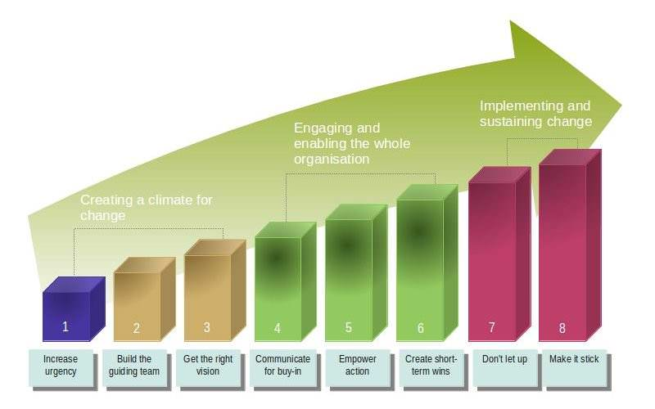
(Leadership Thoughts, 2018)

The first step recognises that in order for change to happen there needs to be a sense of urgency that persuades the majority of people that change is necessary. The second step involves the creation of a coalition of change leaders who will continue to build the momentum. In step three an overall vision is established that can help people to understand what you are trying to achieve and how that relates to the actions that are being taken. Step four involves communicating the vision and addressing peoples anxieties. Step five empowers action by employing change leaders, revising structures, recognising and rewarding those who help the change to happen, and identifying and addressing those who resist the change process. In step six, short-term targets are set to enable people to experience success early in the change process. Step seven recognises that real change takes time and requires ongoing attention and continuous improvement. Step eight seeks to anchor the changes into the culture of the organisation by ensuring that it is visible in every area, by celebrating successful initiatives, and by ensuring the continued support of existing and new leaders (Johnson, Whittington, Scholes, Angwin & Regner, 2016, p.491).

Empirical Literature
According to Gray (2009), empirical literature embraces other studies in the field that provide evidence in support of, or in opposition to, an argument. It also provides evidence of the methodological approaches or traditions that have been used in studying the field. A critical evaluation of those studies may lead the researcher to adopt similar methodological approaches, or to adopt alternatives.

Two types of literature currently fall into this category: faith-based literature that explores the phenomenon of change without recourse to research methodology or theoretical models; and non faith-based literature that uses both research and theory to interpret change in commercial or not for profit environments. Both can be used to shape or supplement the research process or conclusions offered in the dissertation.

Faith-based literature
There is only a limited supply of literature relating to the management of change in a church-based organisation, non of which employ qualitative research methodology or theoretical models. Most publications tend to focus on the management of change within a local church setting. More recent publications in this area include ‘Better Change in Church’ (Street, 2015); ‘Choosing Change’ (Coutts, 2013); ‘Creating the Future Church’ (Elford, 2013) and ‘Christian Reflections on Leadership Challenge’ (Kouzes, 2004).

There is also a small number of publications that explore the possibilities of change within the wider organisation. The most notable include ‘The Future of the Parish System’ (Croft, 2006) and ‘Hope for the Church’ (Jackson, 2003). However, a few books and articles also explore conflict and resolution within the church. These include ‘Promise and Peril: Understanding and Managing Change and Conflict in Congregations’ (Brubaker, 2005); ‘Managing Conflict in the Church’ (Kale, 2003) and ‘How to Manage Conflict in the Church’ (Shawchuck, 2003).

Non faith-based literature
There are a number of studies that explore change management in a commercial or not-for-profit setting. Turners study of the ‘Impact of Change Management on Employee Behaviour in a University Administrative Office’ is one example. This was a qualitative study using open-ended interviews with eleven employees working in a major research university in the Southern United States. Like the proposed study, it used a number of theoretical models, including those suggested by Lewin, and concluded that the voice of the employee is critical to the success of any change implementation or upgrade (2017, p.118).

Alice Khachian, Alireza Akbarzadeh and Houman Manoochehri’s exploration of the challenges of change management in nursing and midwifery schools (2012) is another example. This qualitative research used semi-structured interviews with ten participants to explore both the models of effective change management and the characteristics of the change manager. They concluded that in order to adopt an appropriate model and strategy for change in an organisation, a full understanding of the organisation and its components is necessary (Life Science Journal, 2012, p.2269).

A further example might also include Roy Smollan’s qualitative study of the ‘Personal Cost of Organisational Change’. This involved interviews with 31 employees of a New Zealand public sector health authority, and revealed that whilst stress was present to some degree before the implementation of change, for some the transition triggered negative reactions on “psychological, behavioural, affective and cognitive levels” largely because of perceptions of inadequate processes and the extent of uncertainty (2015, p.223-247).
Methodological Literature
This type of literature explores the methodological approaches that have been used to address change management studies in the past.

In this instance, the six-step approach to data collection, interpretation and analysis suggested by Bryman and Bell (2007) will be employed as a framework for the research:

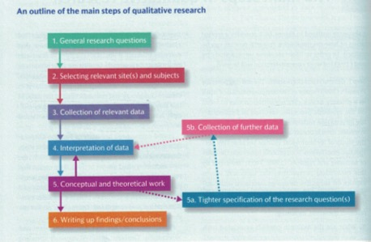
(Bryman & Bell, 2007, p.406)

The research will begin with an initial set of interviews, using an open research question (Step 1). Ideally, the candidates will include a mission area leader, a member of the clergy, and a lay member that was impacted by the change process, so that a range of perspectives can be gained.

The information from those interviews will be used to select other potential respondents (Step 2) and shape more focussed questions that will be used in the second stage of data collection (Step 3). Once the data has been collected the process of interpretation (Step 4) will begin, using the conceptual and theoretical frameworks identified in the Literature Review (Step 5). If necessary, further data will be collected during these stages to allow more specific exploration (5a & 5b). This information will then be used in the writing of the dissertation and the conclusions that are offered (Step 6).

In addition, the research will employ an unstructured and semi-structured interview strategy explored by Saunders, Lewis and Thornhill (2009, p.324). They note, for example, that unstructured research questions are particularly helpful in the initial stage of the research because they allow the researcher “to infer causal relationships between variables”, whilst semi-structured questions allow the researcher to explore areas in greater depth in order to understand the meanings that participants ascribe to various phenomena (2009, p.324).

During the interpretation stage, a template approach will be used to categorise and explain the data that has been collected. According to Robson (2002, p.458) this is a four step process that includes:

- Identifying key codes which can be determined either on an a priori basis, in which the codes are derived from theory or research questions, or from an initial reading of the data.
- Using the codes as a template for data analysis.
- Identifying text segments which can be used as empirical evidence for the template categories.
- Developing a matrix or flow chart which can be used to explore the relationship between the template categories.

Finally, in order to assure the reliability and validity of the qualitative research, the evaluation process suggested by Guba and Lincoln (1994) will be used. This assesses the research according to four criteria:

- Credibility
Which is established by ensuring that the research is conducted using established good practice and by submitting findings to those who were studied in order to confirm that the investigator has understood their perspectives correctly.
- Transferability
Or the extent to which the descriptions or information is helpful to other research areas.
- Confirmability
By evaluating if the researcher has acted in good faith and not overtly allowed personal values or theoretical inclinations to impact upon the conduct of the research or its findings.
- Authenticity
Or the extent to which the research has represented viewpoints fairly; helped people to arrive at a better understanding of their situation; and empowered people to take steps necessary to change their circumstances (Bryman & Bell, 2007, p.413-414).

Outcomes
There are a number of potential outcomes from this research. It may provide helpful insights for the senior leadership team in the diocese of St Asaph as they attempt to mitigate the problems caused by the introduction of Mission Areas. It may offer potential models or more nuanced processes that could be considered when undertaking future change management. It may assist other dioceses that are in the early stages of the design and implantation process. It may also contribute to the small but growing body of research into change management within churches and church-based organisations.

Timescale
The following timescale is anticipated:
- Submission of proposal: February 2019
- Literature review: March 2019.
- Research design and implementation: by April 2019
- Analysis: by May 2019.
- First draft of dissertation: June 2019.
- Second draft: August 2019.
- Submission: September/October 2019.

References

Armstrong, M., 2009. Armstrong’s Handbook of Human Resource Management Practice. London: Kogan Page.

Baluch, A., 2012. Human Resource Management in Nonprofit Organisations. London: Routledge.

Brubaker, D., 2-09. Promise and Peril: Understanding and Managing Change and Conflict in Congregations. Herndon: The Alban Institute.

Church in Wales., The Future of the Rural Church in the Next Ten Years. Available from: https://www.churchinwales.org.uk/structure/bishops/sermons-and-addresses-archbishop-Barry-Morgan/b16/ [Accessed 28 November 2018]

Cost, S., 2006. The Future of the Parish System. London: Church House Publishing.

Coutts, P., 2013. Choosing Change: How to Motivate Churches to Face the Future. Lanham: Roman and Littlefield.Elford, K., 2013. Creating the Future of the Church: A practical Guide to Addressing Whole-System Change. London: SPCK.

Elford, K., 2013. Creating the Future of the Church: A practical Guide to Addressing Whole-System Change. London: SPCK.

Fritz, R., 1984. The Path of Least Resistance. Oxford: Butterworth-Heinemann.

Gibson, L., 2010. Human Resource Management Practices in the Church. Pittsburgh: Dorrance Publishing.

Glowinkowski, S., 2010. It’s Behaviour Stupid! What Really Drives the Performance of your Organisation. Penryn: Ecademy Press.

Gold, J. Holden, R. Iles, P. Stewart, J. and Beardwell, J., 2010. Human Resource Development Theory and Practice. Basingstoke: Palgrave Macmillan.

Henderson, I., 2011. Human Resource Management for MBA Students. London: Chartered Institute of Personnel and Development.

Herrington, J. Bones, M. and Furr, J., 2000. Leading Congregational Change. San Francisco: Josey-Bass.

Johnson, G. Whittington, R. Scholes, K. Angwin, D. and Regner, P., 2016. Exploring Strategy Text and Cases. Noida: Pearson India Education Services.

Kale, D. and McCullough, M. 2003. Managing Conflict in the Church. Kansas: Beacon Hill Press.

King, R. And Glowinkowski, S., 2015. Strategy People Implementation: Taking Strategy to Action Through Effective Change Leadership. St Albans: Panama Press.

Kotter, J., 1996. Leading Change. Boston: Harvard Business School Press.

Kotter, J. and Cohen, D., 2002. The Heart of Change. Boston: Harvard Business School Press.

Kouzes, J. And Posner, B. 1995. The Leadership Challenge. San Francisco: Josey-Bass.

Kouzes, J. and Posner, B., 2006. Christian Reflections on the Leadership Challenge. San Francisco: Josey-Bass.

Leadership Thoughts., Successful Change Management – Kotter’s 8 Step Change Model. Available from: https://www.leadershipthoughts.com/kotters-8-step-change-model/ [Accessed 28 November 2018]

Marchington, M. and Wilkinson, A., 2008. Human Resource Management at Work. London: Chartered Institute of Personnel and Development.

MBA Knowledge Base., Change Kaleidoscope – Change Management Models. Available from: https://www.mbaknol.com/modern-management-concepts/change-kaleidoscope/ [Accessed 28 November 2018]

Newton, R., 2007. Managing Change Step by Step. Upper Saddle River: Prentice Hall.

Pilbeam, S. and Corbridge, M., 2002. People Resourcing HRM in Practice. Harlow: Pearson Education.

Potter, P., 2009. The Challenge of Change: A Guide to Shaping Change and Changing the Shape of the Church. Abingdon: The Bible Reading Fellowship.

Shawchuck, M., 1983. How to Manage Conflict in the Church. New York: Growth Resources.

Street, R. And Cuthbert, N., 2015. Better Change in Church. London: Hodder and Stoughton.

Tutor2u., Lewin’s Force Field Model. Available from: https://www.tutor2u.net/business/reference/models-of-change-management-lewins-force-field-model [Accessed 28 November 2018]

