Name – Julian Milligan
Student number – 1904804
Course – Bachelor of Science (Part-time): Computing (Software Engineering)
Module – L6 – Cloud-Based Web Services
Module code - ACCA6024
Assignment – Assignment 1

Contents
Introduction. 2
Site. 4
Comparing SOAP, REST and GraphQL web services. 9
SOAP 9
REST 12
GraphQL 14
Conclusion 14
Video link. 14
References. 14

Introduction.
The purpose of this report is to show how Representational State Transfer REST can be used by several Application Programming Interfaces API`s can be used to show dynamic data on a webpage. Some of the API`s are fired by code and some are fired at the request of the user. Non open other pages but display the data on the same page with out reloading the page. This is done using a technique called AJAX (Asynchronous JavaScript and XML.).
AJAX is not a programming language but more a way to exchange data between a web browser and server. The browser sends a request to the server, the server then sends data back in the form of JSON (JavaScript Object Notation) or XML (Extensible mark language). JavaScript can then be used to process the data and display it on webpage by targeting classes or ID in DOM (Document Object Model)

Below is an example of on the API used, in this example we look at the ‘Contact Us’ page. To give the illusion that an email has been sent and API is used to POST some JSON data to development URL.
Server
URL - https://jsonplaceholder.typicode.com/posts
Server processes the data from the JSON.
If all is ok, it sends the data back and STATUS code of 200 to say everything is ok.
If there is an error, then the status code of 400 is returned with a more detailed error message.
Browser
1.User fills in the details on the form.
2. User presses submit button.
3. Button click detected and postMessage function is called.
4. Function creates an Object using the data from the form. (Lines 104 – 110, Figure 1)
5. AJAX function is created, and data is converted into JSON and passed to API

Browser
- With the same code that sent the request the response is also handled (lines 119 and 120, Figure 1)
- On success another function is called
- On error a message is displayed to the user. (Figure 2)

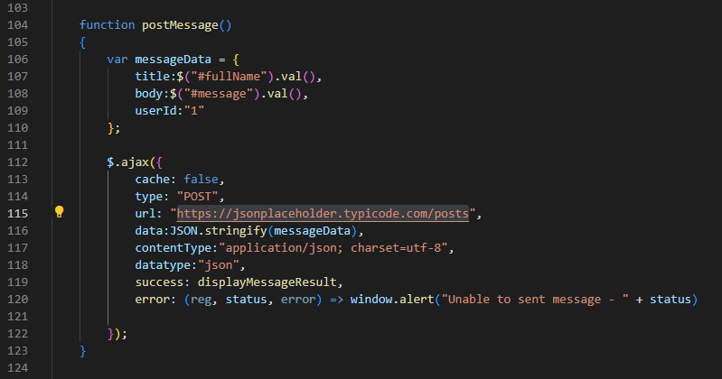
Figure 1 post Message Function
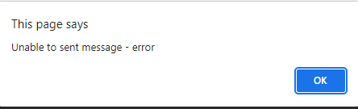
Figure 2 Error message on POST

The function displayMessageResults alters the text currently displayed on the Webpage via the DOM. The code for this site will be explained more in the following section and video presentation.

Site.

The method behind the design of the site is to demonstrate to use of REST and using AJAX to display some the results for a set of API`s. With in REST operations CRUD (Create, Read, Update and Delete) is used. However, when using an API, the HTTP Verb is used
GET - Read
POST - Create
PUT - Update
Patch - Update
Delete - Delete

Combining the above HTTP verbs allows a developer to create a new record in database, update it and delete it. The use of CRUD is also used in many over languages

The site created for this report is of a fictional company called EmkcaH, they are a company that will provide Hacking services. So far, the site consists of 5 webpages.
- Home page
- Abouts us
- Posts
- On-Line Store
- Contact Us
The Home page has two sections, the main information is on the right of the page and is called Find a target. The button allows a user to search for a hacking victim from a fake database of user information. This uses the GET method and a URL - https://randomuser.me/api/ . The API pulls back a large amount of fake data only a small part of the dataset is used for this site. Within the function displayUserDetails another function is called getLandWater. This has the longitude and latitude passed to it from the previous function. Based on the details passed it sends a GET request to https://api.onwater.io/api/v1/results/ which returns if the longitude and latitude are either on water or land. Once a response is received the function displayLandWater is called and a message displayed on the page. This API was used to show that other API`s can be called and used based on the data supplied by another API.
On the left-hand side of the page are a list of useful links. These also act as a reference to the sites used to help build the webpage and are included in the reference list of this report.[1][2][3]
This section is reproduced on all pages and uses Javascript to create the list and then display the text in a DIV Tag by altering the DOM.

The About Us page has no API`s running and just displays some basic information about the company.
The Post pages uses several API`s, the idea of this page was to demo GET, DELETE and PATCH methods.
On the right there is an input filed for a user to enter a username to see their posts. It does not matter what the username is, The API called displays a 10 post for 10 different users between 0 – 9. When the button is clicked a random userID is generated using Math.floor(Math.random()) function. This is then pasted to the function fetchPost as a variable.
The posts for the user are then displayed the Post Title and ID and non-writeable however the Post text is. On the right there are two options.
- Edit post
  - This allows the user to edit the post via PATCH, enter an id for the one they altered and submit the changes. To successful response of the API all post is hidden and the alter text along with a message is displayed to the user.
- Delete post
  - This allows the user to delete the post via DELETE, again the ID is entered and once the button is pressed the API is called and a message is displayed with a warning message that it cannot be undo.
All the API`s called on this page are for development only and no data is altered or deleted. The API`s used are from - https://jsonplaceholder.typicode.com/

On the Contact us page the final type is used POST, a simple form is used to simulate a contact us form. Once the button is pressed the information entered is converted into an object and is then converted into JSON and passed to the API. The API then returns the data which is displayed to the user along with a custom message.
Below are several images to show the process flow.
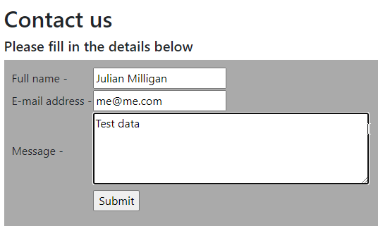
Figure 3 Contact Us - Enter text

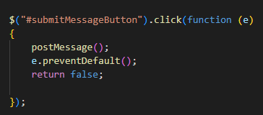
Figure 4 Contact us - Submit button JS

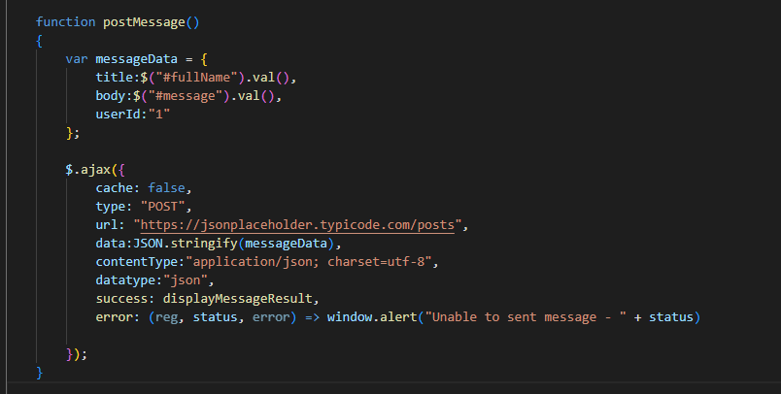
Figure 5 Contact Us - main POST Function

*mesageData is the object created and pulls data from the form the user filled in.

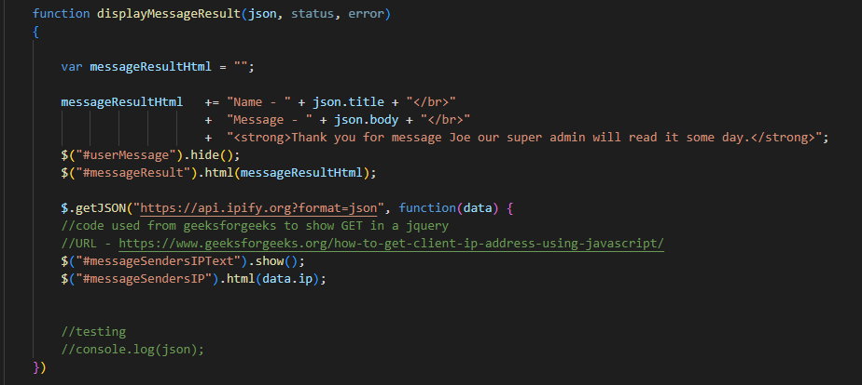
Figure 6 Contact Us - Display results

*A second API is also called to demonstrate an API being called in one using Jquery. This API captures the user IP.
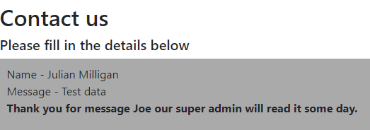
Figure 7 Contact Us - Message response

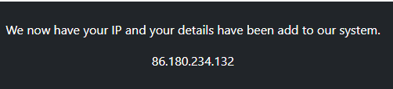
Figure 8 Contact us IP response in footer

The last page is On-Line Store, this page will be developed further for a future report / assignment.

The API used in the above site are
- https://randomuser.me/api/
  - Type - GET
  - Used to pull back data a random fake person.
- https://api.onwater.io/api/v1/results/
  - Type - GET
  - The longitude and latitude are passed to say if the location is on water or land.
- https://jsonplaceholder.typicode.com/posts?userId=
  - Type - GET
  - A user ID between 1 and 10 are passed and a selection of fake posts are returned.
- https://jsonplaceholder.typicode.com/posts
  - Type - POST
  - A JSON object is Posted to tis API.
- https://jsonplaceholder.typicode.com/posts/
  - Type – DELETE
  - A post ID is supplied, and the system responds as if the post has been deleted.
- https://jsonplaceholder.typicode.com/posts/
  - Type – PATCH
  - An ID and JSON Object are supplied, and the fake post is updated.

Comparing SOAP, REST and GraphQL web services.

The main part of this report is to investigate, compare and discuss SOAP, REST and GraphQL Web Services.

SOAP
Simple Object Access Protocol or SOAP was developed around the late 1990s to allow businesses to move data around and between corporate networks. SOAP uses XML to format the data and must use a SOAP endpoint the other end. One of the benefits of SOAP and as quoted by Maayan Gilad David [4]

“An important aspect of SOAP is that it has strong security measures built into the specification.”
An example of a soap request is shown below using POSTMAN. The example uses a simple API to convert a numeric number to text. The example is from Using SOAP requests from PostMan.
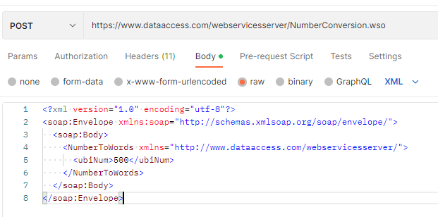
Figure 9 SOAP Example POST
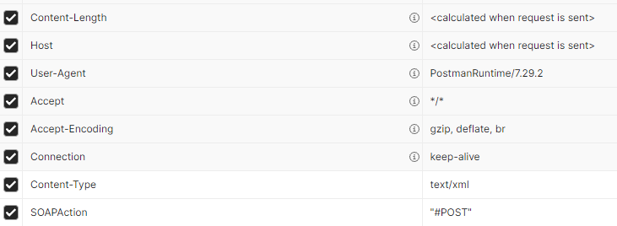
Figure 10 SOAP Example Headers

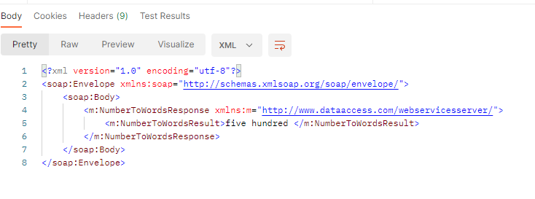
Figure 11 SOAP Example Response
Figure 9 shows how the body of request needs to be formatted. The SOAP Request architecture is formatted as so
- Envelope
- Header
- Body
- Fault
The above example only uses 3 parts and does not use the fault element. See below a Curl command that show the headers, envelope and body elements.

Unlike other web services that relay on mainly on HTTP Request SAOP can use other Protocols such as SMTP, TCP and UDP [5]. When we talk about SOAP, we must also discuss WSDL (Web Services Description Language) this is an XML format that can be used to aid developers in what input / output fields are expected. It is also able to generate a human readable document for SOAP API`s.
WSDL was most popular in the early 2000`s when Web services became the norm to connect internal systems in large companies, WDSL is main used to describe SOAP services and SOAP defines the format of the services.
SOAP does not relay on methods in the request but more on the webservice being called or a method with the service.
When should SOAP be used,
- When the webservice is SOAP based.
- Security is an issue.
- Documentation alongside the API is needed.
- Communication needs to be in a formal means
- Stateful operations.
Due to the size of the requests as they normally include the WDSL documentation then bandwidth within the network also becomes and issue. Unlike other webservices SOAP does have a standard as set out by W3C.

REST

REST or Representational State Transfer is an API that uses the HTTP Protocol, URI (Uniform Resource Identifier) and JSON data. REST is simpler to use and does not relay on the same data type in the response. So as along as it`s expected a developer can send JSON and receive a CSV file back as the request.
REST is also cross platform compatible and supports many programming languages. Security can be added to a REST request using BEARER tokens as an example. A token needs to be issued to the API and then that token is used in any further requests to the server that the webservices resides on.
REST API are also stateless meaning no data client information is stored from the requests and each request is not connected. So, an API can call API1 and then API2 and there is no connection between the two.
Data can be sent in several ways to a webservices, but this does depend on what the webservices is set to receive. Generally, with webservices there will be documentation with guidance on what format the request will need to be in and what the response will be.
According to Rapid API [6] there are four common types used.
Path Parameters
API/service/posts/{userID}
This value is passed as part of the URL, this type is open to misuse as it is in plain text and can be altered before being sent.

Query String
API/service/posts?userID=123
Again, the value is passed as part of the URL and as above can be altered to return posts by other users.

Header
These are normally used to sent authorization information and requests.
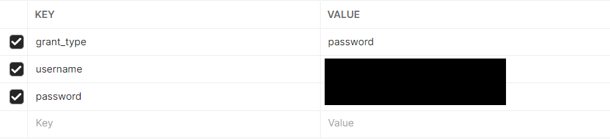
Figure 12 Bearer Token Request
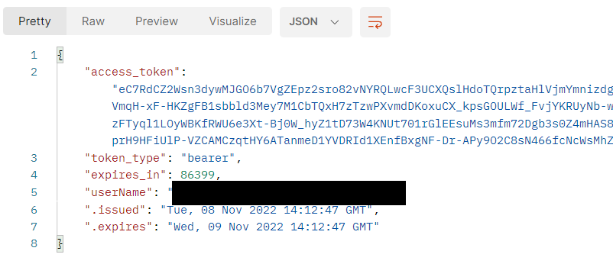
Figure 13 Bearer Token response
As figure 12 shows information is included in the header to receive a Bearer Token back in Figure 13. As this is included in the header it is a little more difficult to manipulate.

Request Body

When an object needs to be sent to the webservice the body of the API is used. Normally this is in the form of JSON, but others can be used like XML and CSV.
{
“title”: “Through the looking Glass”,
“isbn”: “978-1987785166”,
“author”: “Lewis Carol”,
“seller”: “Amazon”
}
As the URL is included in the code such as JavaScript then it is harder to change the information being sent to the webservice.

REST also support several methods for webservices the main ones are
POST – to create a new file / record
PATCH – to update a file / record (Put can also be used)
GET – to read a file / record
DELETE – to remove a file / record
As you can see these fall into the CRUD methodology.

GraphQL

GraphQL is a query language for API`s hence the QL in the name. Unlike REST and SOAP when a request is sent via POST all the data is returned from the API. As example in REST
We sent a request and need to supply the Product code.
{
“productCode”: “product123”
}
To http://somesite.com/products/api/getProduct
The returned data may look like
{
“productName”: “Super Power Supply”,
“price”: “34.99”,
“type”: “powerSupply”,
“stockLevel”: 27,
“colour”: “black”,
“stockLocation”: “C2Shelf5”,
“reStockLevel”: 15,
“supplier”: “CPC”
}
The reason all this data maybe returned is because the API could be used by several teams,
Finance - may only want to know the current stocklevel and price.
Web Team – may only want price, name, type and stock for the shop

This is where GraphQL can help. Instead of getting all the data the request can ask for certain fields of data.
The backend data would look like this
{
“product”: {
“productName”: “Super Power Supply”,
“price”: “34.99”,
“type”: “powerSupply”,
“stockLevel”: 27,
“colour”: “black”,
“stockLocation”: “C2Shelf5”,
“reStockLevel”: 15,
“supplier”: “CPC”
}
}

The request would then look for the Web Team
{
Product {
price
productName
type
stockLevel
}
}
This would only return the data they need access to. As quoted on the graphQl.org site [7]
“GraphQL APIs are organized in terms of types and fields, not endpoints.”
The process of creating a graphQL API differs from REST. In REST the endpoint is one address and in the code on the server the developer returns the data they believe is needed to be returned. In graphQL a schema is created to describe all the possible data that can be returned or queried by the user. The query is the received and graphQl checks and validates the request. Each field is then sent to a function called a Resolver which runs to get the value. This query would be the same as a READ in the CRUD model. The update, create and delete are controlled by Mutations.
A mutation is a way of creating a new record, updating one or deleting it.
GraphQl was developed by Facebook and is now an open-source project run by graphQl.org. It was first used in 2012 for Facebook`s mobile app. GraphQL is a framework and can be used with any language. [8]

Conclusion

In the report writers current work place they use a package to develop public facing forms and some of the time they need to interact with database to retrieve information, most of the endpoints run a store procedure which only pulls back the information that is needed from the database. Other times a more generic approach is taken so an API can be used in other forms and a developer may only need part of the dataset that is returned. REST API`s have always been used using the C# language and JSON.
After speaking to a developer about SOAP the question was asked if any SOAP API are used within the development team and yes one was used on a legacy system. Research many site the report author came to the same conclusion that SAOP is mainly used for legacy systems and large enterprise systems where security was a major concern. Speaking with the developer they said if there was time and resources, they would rewrite the API in REST, but the change would affect many systems, so the API is just maintained.
Rest API`s are used because of the easy of use and they have supplied the functionality that is needed. Normally when a new system is created several endpoints are written to view, update and delete data. If an existing API exists that will provide the data needed but it also supplies other non-relevant data, then it is used and only the required data is rendered on the front end. The rest is discarded.
After watching the tutorials on GraphQL at https://www.howtographql.com/ the author feels this could be an approach worth investigating further and will continue to research GraphQL to see if it can be used within the current development framework.
It maybe that it can not be implement with the current forms package and the other developers would need to understand how GraphQl works to enable them to support any integrations created using GraphQl.
The author feels that this approach maybe possible as the team are always looking for new ways to improve how they provide a service. Currently though REST is the framework that is used. Maybe if a Mobile Application is developed the GraphQl can be used as it removes the need to over fetch data and save on the amount of data that is downloaded or uploaded.

Video link.

YouTube link - https://youtu.be/fnzbJxGOsTE
Git Hub link - https://github.com/JulianMMilligan/ACCA6024-Assignment-1.git

References.

[1] W3 School, “jQuery Tutorial.” https://www.w3schools.com/jquery/default.asp (accessed Nov. 06, 2022).
[2] Geek for Geeks, “How to get client IP address using JavaScript ?” https://www.geeksforgeeks.org/how-to-get-client-ip-address-using-javascript/ (accessed Nov. 06, 2022).
[3] BootStrap, “Getting started with BootStrap.” https://getbootstrap.com/docs/3.3/getting-started/ (accessed Nov. 06, 2022).
[4] Gilad David Maayan, “What are APIs? A Complete Guide,” Oct. 21, 2021. https://www.computer.org/publications/tech-news/trends/what-are-apis (accessed Nov. 08, 2022).
[5] Kin Lane, “API 101: What Is a SOAP API?,” 2020. https://blog.postman.com/soap-api-definition/#:~:text=Simple%20Object%20Access%20Protocol%20%28SOAP%29%20is,Is%20a%20REST%20API%3F%20intro%20posts.%29&text=Simple%20Object%20Access%20Protocol,REST%20API%3F%20intro%20posts.%29&text=Access%20Protocol%20%28SOAP%29%20is,Is%20a%20REST%20API%3F (accessed Nov. 08, 2022).
[6] Ahmad Bilal, “Types of Rest API Parameters,” Dec. 16, 2021. https://rapidapi.com/guides/rest-parameter-types (accessed Nov. 08, 2022).
[7] “GraphQl.” https://graphql.org/ (accessed Nov. 11, 2022).
[8] “How to graphQL.” https://www.howtographql.com/ (accessed Nov. 11, 2022).

