Health, Wellbeing and Lifestyles in Early Childhood
Introduction
Health, wellbeing and lifestyles are important aspects of childhood and have an impact on a child’s development, their learning and relationships, as well as on their future opportunities. A child’s health is related to their development, their emotional wellbeing and their relationships, as well as family routines, the early years environment, the policies in place and social inequities (Welsh Government, 2020; Public Health Wales, 2023).
The World Health Organization’s definition of health includes physical, mental and social wellbeing, rather than the absence of illness. Although this definition was first established in 1948, Schramme (2023) explains that it remains useful as it encourages a holistic understanding of health. However, he also recognises that the idea of “complete” wellbeing has been questioned, as it can make health appear as an ideal state that may be difficult to achieve consistently in everyday life. The Curriculum for Wales Health and Well-being Area of Learning and Experience, recognises physical health and development, mental health, and emotional and social wellbeing as interconnected aspects of children’s learning and development (World Health Organization, 2025; Schramme, 2023).
This poster proposes that in early childhood, the interaction of individual, relational and structural factors influences health, wellbeing and lifestyles. Although lifestyle habits such as food and sleep, hygiene, physical activity, screen time and daily routines are important, they in turn are impacted by poverty, housing, parental stress, culture, as well as the availability of services and safe and accessible places for children to play (Marmot et al., 2020; Barnardo’s, 2024). Because of this, practitioners play an important role in health and wellbeing promotion, which should always be inclusive, rights-based and non-judgmental (Public Health Wales, 2023; UNICEF, n.d).
Health: A Holistic Concept
Childhood health extends beyond physical health or the absence of illness. While sleep, nutrition, safety, physical activity and oral health are important, emotional security, family situation and the availability of support services are also important. Musgrave (2017) promotes a holistic view of children’s health and wellbeing, arguing that practitioners should consider the whole child rather than focusing only on physical health.
Lynch (2024) takes this further by integrating physical education with emotional wellbeing and learning. From this viewpoint, movement promotes emotional wellbeing and self-confidence, as well as physical development. This is especially crucial during early childhood, as children learn through movement and through the relationships and environments around them.
Though health promotion efforts may focus on individual behaviors, they must also account for structural and contextual conditions. Otherwise, such an effort may widen health disparity. Marmot et al. (2020) contend that a person's health is a cumulative product of their social environment throughout their life course. Bambra (2019) contends that austerity measures and reductions in social resources have exacerbated health inequalities.
Taken together, these sources show that children’s health is both individual and social. While practitioners can promote healthy everyday routines, they must also recognise that families have different levels of access to resources, support and opportunities.

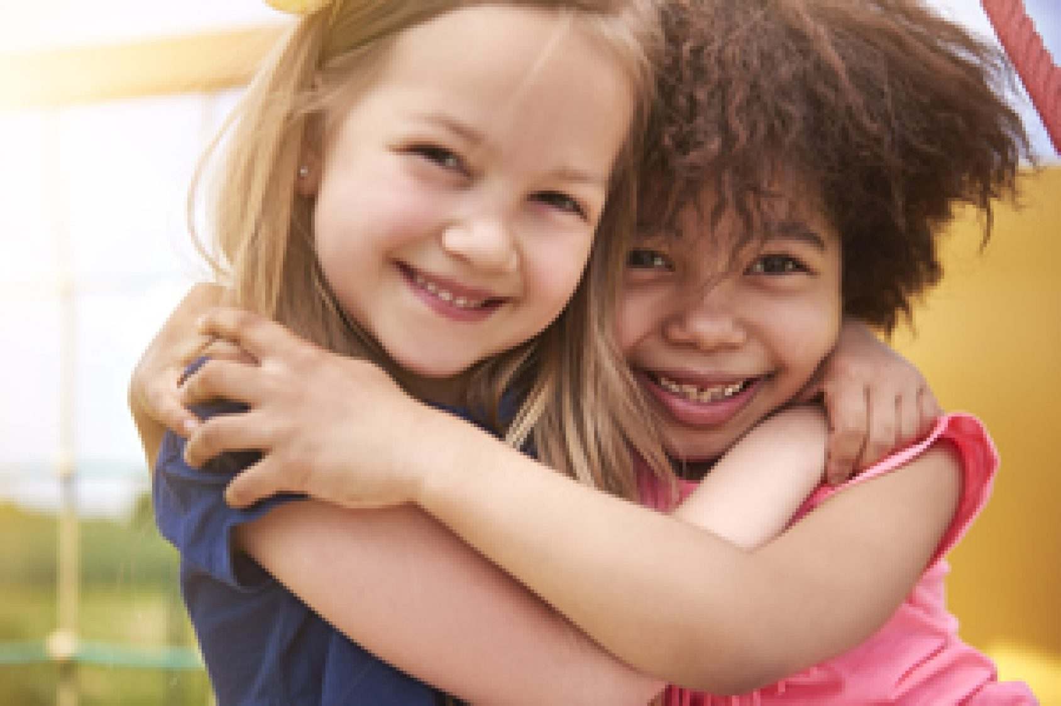
Wellbeing: Beyond Happiness
Wellbeing is often associated with happiness, confidence and positive behaviour, but this is too narrow. In early childhood, wellbeing also includes emotional security, belonging, relationships, participation, identity, resilience and feeling listened to. Fane et al. (2020) provide an important child-centred perspective by exploring preschool children’s own accounts of wellbeing. Their research challenges adult assumptions and highlights the need to include children’s voices when defining and supporting wellbeing.
The United Nations Convention on the Rights of the Child is directly related to this. While Article 31 safeguards children's rights to play, relaxation, and leisure, Article 12 grants children the freedom to voice their opinions and have them treated seriously (UNICEF, n.d). The Healthy and Sustainable Pre-School Scheme (HSPS) also reflects these rights by connecting health promotion to children's right to be heard, to play, and to have the greatest possible physical, mental, social, and emotional health (Public Health Wales, 2023).
Peill (2022) adds that supporting children’s health and wellbeing is not only the responsibility of individual practitioners, but also a leadership and whole-setting issue. This is significant because wellbeing should not be reduced to a single activity, display or intervention. Instead, wellbeing is created through the culture of the setting: how adults respond to children, how routines are organised, whether children feel included, and whether their views are taken seriously.
Source - https://letsgethealthy.ca.gov/early-childhood-well-being/
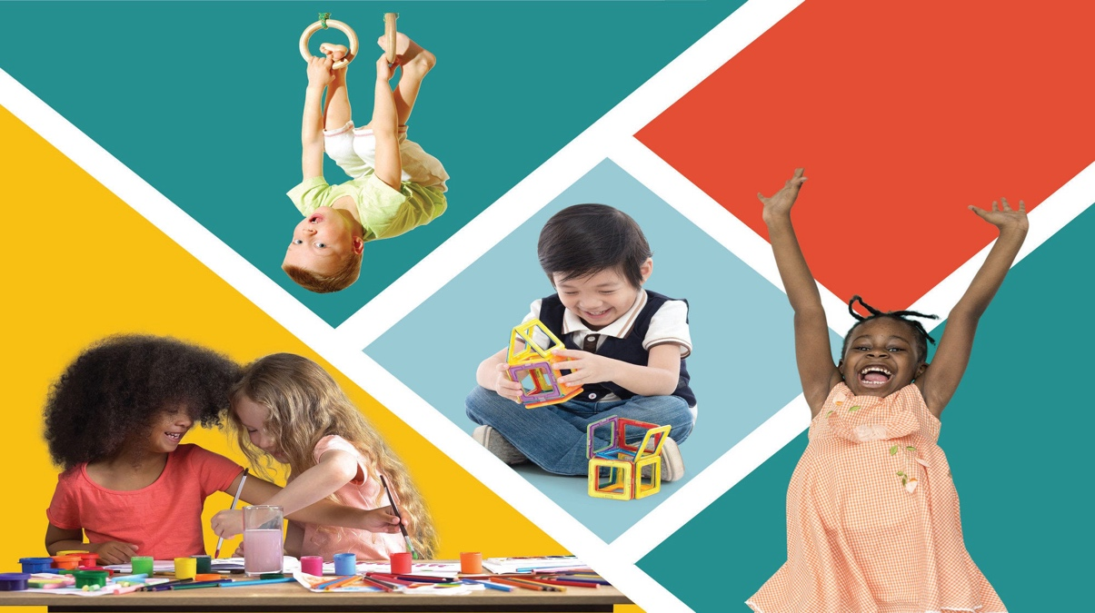
Source - https://www.oecd.org/en/publications/early-learning-and-child-well-being-in-england_c235abf9-en.html
Theoretical Perspectives: The Child in Context
Research has shown that health, wellbeing, and lifestyle cannot be considered separately. This is why Bronfenbrenner's ecological systems theory remains important, as it shows how children fit into interrelated systems. Tudge (2021) says that Bronfenbrenner's theory is relevant to early childhood education and care because it links children's development to families, educators, services, and social institutions.
In an early childhood context, the microsystem consists of the child’s family, peers/classmates, people who work with the child at the Education and Care setting and the environment. The mesosystem consists of the connections between children’s homes, the early childhood Education and Care setting and any other environment where the child may receive care or education. Exosystems are made up of parental employment, services available locally, and other community resources. The macrosystem consists of poverty, culture, legislation, and other social values. By recognising that children’s health and well-being are impacted by multiple systems; practitioners can help support children’s holistic development.

Dahlgren and Whitehead’s Rainbow Model also remain relevant because it shows that health is shaped by individual lifestyle factors, social and community networks, living conditions and wider socioeconomic, cultural and environmental influences. Dahlgren and Whitehead (2021) argue that the model continues to be used to explain the wider determinants of health. When compared with Bronfenbrenner, both models move away from individual blame. Bronfenbrenner focuses more on the systems surrounding the developing child, while Dahlgren and Whitehead focus more directly on the social determinants of health.
Together, these theories support a more critical question for practice: not simply “what lifestyle choices does this family make?”, but “what relationships, resources, systems and barriers shape this child’s health and wellbeing?”
Lifestyles: Choice, Routine or Inequality?
Lifestyle in early childhood includes food, sleep, hygiene, oral health, physical activity, screen use, rest and family routines. These habits matter because early routines can influence later health and wellbeing. However, lifestyle must be treated critically because it is not simply a matter of individual or parental choice.
The UK Chief Medical Officers (2019) link physical activity in the early years with health, sleep, movement skills, social development and brain development. Christakis and Hale (2025) also highlight the relationship between digital media, development and wellbeing. This is important as prolonged idle screen usage may limit possibilities for physical play, communication, and social connection. However, screen usage should not be considered as inherent risk in all contexts. The main question is if it replaces sleep, relationships, movement, and play.
The HSPS initiative takes a holistic view on health by looking at meal planning and dental care, physical activity and play, emotional stability, hygiene and safety, the environment, and engagement of the family members of children. This comprehensive approach is more effective than delivering singular health information because it integrates healthy lifestyles into the daily operation of the setting itself (Public Health Wales, 2023).

A key consideration when delivering lifestyle information is that it could be perceived as judgemental when it does not take account of the impact of inequalities. According to Barnardo's (2024), poverty impacts a family’s ability to purchase food and fuel; and the physical environments are the direct results of social economic conditions on a day-to-day basis that affect the daily lives of children. Similarly, Marmot et al. (2020), posited that poverty, housing, income and access to resource, have a profound impact on health opportunities. Consequently, service providers must affirm the development of positive habits, while being mindful that some families may have issues related to food insecurity, cooled homes, overcrowding, stress, limited transportation or dangerous outdoor environments.
Research, Policy and Guidance
Current research, legislation, and evidence-based practices in health and well-being reflect society's knowledge of an individual's health, well-being, and lifestyle. The Welsh Government's plan for a Universal Healthy Child Wales Initiative includes Universal Health and Development Services, including as health screening, immunisation and developmental monitoring, to assist early identification and intervention (Welsh Government, 2022). Families should be able to access universal support services that are evidence-based, supportive, relevant and accessible.
The Curriculum for Wales encourages a holistic approach to health and well-being. The Health & Well-being Area of the Welsh Curriculum encompasses overall physical health and development, mental health, and emotional and social well-being, supporting the notion that health and well-being should be integrated into the daily Early Years experience rather than seen as separate from learning (Welsh Government, 2020).
The All Wales Weight Management Framework reinforces the argument for a holistic approach to the health and well-being of a child and their families. Although the primary focus of the framework is on weight management, the principles can be applied to general health and well-being, with the key principle being that a body mass index (BMI) should not be used in isolation when making decisions about what is best for an individual. Rather, it should be considered together with the child and family’s overall physical, psychological, and social well-being (Welsh Government/Public Health Wales, 2021). The framework stresses the importance of having sensitive, non-judgemental conversations about weight with families, which extends to all lifestyle conversations with families.
The HSPS provides a practical Welsh framework for early years settings. It promotes a whole-setting approach, including children’s self-esteem, relationships, emotional wellbeing, play, home and community links, staff wellbeing, children’s rights and partnerships with outside agencies (Public Health Wales, 2023). This is valuable because it moves health promotion away from isolated activities and towards leadership, ethos, environment and daily practice.

Curriculum Links and Early Years Practice
The Curriculum for Wales supports holistic practice because health and wellbeing are positioned as central to children’s learning and development. Play, physical movement, connections, emotional literacy, outdoor experiences, dietary experiences, sleeping, hygiene routines, and child voice may all help to foster holistic approaches in early childhood education settings (Welsh Government, 2020).
By engaging in a variety of physically demanding outdoor play activities, such as play climbing, dancing, cooking, and movement games, practitioners can encourage physical fitness (Public Health Wales, 2023; UK Chief Medical Officers, 2019). Practitioners should be able to facilitate stable attachments, co-regulation, predictability, and inclusion in the setting to enhance emotional health. Giving children nutritious snacks, giving them access to water throughout the day, promoting good dental habits, helping kids practise good hygiene by washing their hands, and assisting kids in cutting down on their sedentary time by collaborating with families and the community are a few ways to support healthy lifestyles.
Wilson (2024) emphasises the value of respectful collaboration with parents, carers, and families. This is important since children's health and lifestyle habits are influenced by their household, location, and community. However, collaboration must resist passing judgement. Families might encounter poverty, stress, housing issues, shift work, language hurdles, or restricted access to resources. As a result, practitioners must collaborate with families to establish realistic and feasible assistance options.
Collaboration among agencies may be key to improving outcomes for children; for example, health visitors, school nurses, dietitians, speech and language therapists, dentists, Flying Start teams, and community services will all play a role in supporting children's health and well-being. However, multi-agency working should not create confusion about responsibility or become a way of passing concerns between professionals. The goal of multi-agency collaboration should be to combine the services of many agencies to provide a comprehensive package of care for the child and family (Welsh Government/Public Health Wales, 2021; Public Health Wales, 2023).
Critical Reflection: Risks and Tensions
While dealing with issues related to health, well-being and lifestyle practices, one of the main points of contention is how to promote positive behaviours while also acknowledging systemic injustices or barriers. Health promotion usually uses communications to encourage families to adopt healthy lifestyle choices, such as nutritious meals, exercising, reducing screen time, and creating sleep patterns (Marmot et al., 2020; Bambra, 2019; Barnardo’s, 2024). However, these messages are limited if they do not recognise poverty, housing pressures, parental stress and access to resources.
A second source of conflict is that if wellbeing is not precisely defined, it can become ambiguous. It might be simplified to happiness, behaviour control, or overall positivity. Fane et al. (2020), Musgrave (2017), and Peill (2022) contribute to the concept of wellbeing by connecting it to child voice, holistic development, relationships, and whole-setting culture.
A further risk is stigma. Discussions regarding diet, weight, hygiene, habits, and lifestyle can become critical if practitioners do not reflect. The All Wales Weight Management Pathway is effective because it emphasises person-centred, compassionate, and impartial approach (Welsh Government/Public Health Wales, 2021). This idea may be more broadly extended to early childhood health promotion.
As a result, health activities alone are insufficient for high-quality early childhood practice. It necessitates thoughtful practitioners, inclusive settings, supportive leadership, family partnerships, and an understanding of inequality. The goal is not to produce idealistic families or children, but rather to improve the settings that allow children to feel secure, included, active, fed, heard, and capable of flourishing (Peill, 2022; Wilson, 2024; Public Health Wales, 2023).
Conclusion
Health, wellbeing and lifestyles in early childhood are interconnected and shaped by routines, relationships, family circumstances, settings, policy and wider inequalities. The evidence shows that children’s health should be understood holistically, rather than as individual behaviour alone. Therefore, early years practitioners should promote wellbeing through everyday play, care, curriculum, environments and family partnerships in a rights-based, inclusive and non-judgemental way. This means effective practice should not only promote healthy routines but also challenge barriers that limit children’s opportunities to be healthy, included and heard.

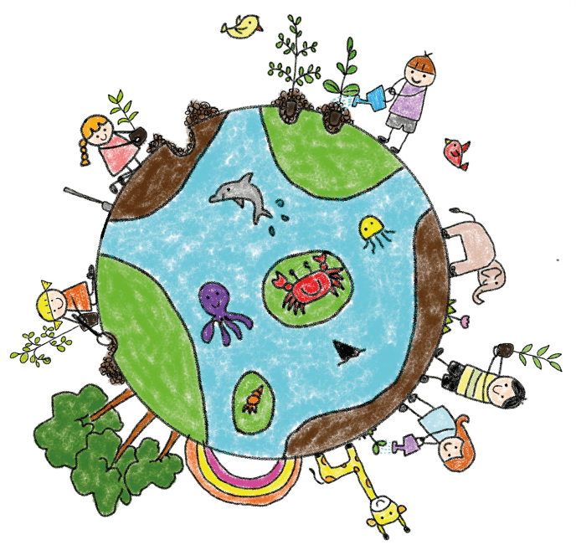
References
Source - www.teachearlyyears.com/learning-and-development/view/childrens-wellbeing-improve-mental-health-in-early-years-by-reconnecting-with-nature
Bambra, C. (2019). Health in Hard Times: Austerity and Health Inequalities (1st ed.). Bristol University Press. Available at: https://doi.org/10.2307/j.ctvndv4xh (Accessed: 13th June 2026)
Barnardo’s (2024) Empty Plates and Cold Homes: What it’s like to grow up in poverty in 2024. Available at: https://www.barnardos.org.uk/research/empty-plates-cold-homes (Accessed: 20 June 2026)
Christakis, D.A. and Hale, L. (eds.) (2025) Handbook of Children and Screens: Digital Media, Development, and Well-Being from Birth Through Adolescence. Cham: Springer. Available at: https://research-ebsco-com.uwtsd.idm.oclc.org/c/onvpsy/search/details/lktsoa7jxz?request-context=plink&db=e001mww (Accessed:17th June 2026)
Dahlgren, G. and Whitehead, M. (2021) ‘The Dahlgren-Whitehead model of health determinants: 30 years on and still chasing rainbows’, Public Health, 199, pp. 20–24. Available at: https://www-sciencedirect-com.uwtsd.idm.oclc.org/science/article/pii/S003335062100336X (Accessed:19th June 2026)
Fane, J., MacDougall, C., Jovanovic, J., Redmond, G. and Gibbs, L. (2020) ‘Preschool aged children’s accounts of their own wellbeing: are current wellbeing indicators applicable to young children?’, Child Indicators Research, 13(6), pp. 1893–1920. Available at: https://doi.org/10.1007/s12187-020-09735-7 (Accessed: 15th June 2026)
Lynch, T. (2024) Physical Education and Wellbeing: Global and Holistic Approaches to Child Health and Academic Learning. 2nd edn. Cham: Springer. Available at: https://research-ebsco-com.uwtsd.idm.oclc.org/c/onvpsy/search/details/nwcamczbmr?request-context=plink&db=nlebk&db=nlabk (Accessed:10th June 2026)
Marmot, M., Allen, J., Boyce, T., Goldblatt, P. and Morrison, J. (2020) Health Equity in England: The Marmot Review 10 Years On. London: Institute of Health Equity. Available at: 10.1136/bmj.m693 (Accessed:15th June 2026)
Musgrave, J. (2017) Supporting Children’s Health and Wellbeing. London: SAGE Publications Ltd. Available at: https://sk-sagepub-com.uwtsd.idm.oclc.org/book/mono/supporting-childrens-health-and-wellbeing/toc (Accessed: 27th May 2026)
Peill, F. (2022) ‘The pursuit of happiness: leadership challenges of recognising and supporting child health and wellbeing in the early years’, Education Sciences, 12(2), 113. Available at: https://www.proquest.com/docview/2632717799?accountid=130472&parentSessionId=zPDj0A18B6JpO0WZddPKs2ExNk0Sh0R%2FnwsPbk1uxtw%3D&pq-origsite=primo&sourcetype=Scholarly%20Journals (Accessed: 19th May 2026)
Public Health Wales (2023) Healthy and Sustainable Pre-School Scheme: National Awards Criteria. Cardiff: Public Health Wales.
Schramme, T. (2023) ‘Health as complete well-being: the WHO definition and beyond’, Public Health Ethics, 16(3), pp. 210–218. Available at: https://doi.org/10.1093/phe/phad017 (Accessed: 20th June 2026)
Tudge, J. R. H., Navarro, J. L., Merçon-Vargas, E. A., & Payir, A. (2021) ‘The promise and the practice of early childhood educare in the writings of Urie Bronfenbrenner’. Early Child Development and Care, 191(7–8), 1079–1088. Available at: https://doi.org/10.1080/03004430.2020.1844193 (Accessed: 2nd June 2026)
UK Chief Medical Officers (2019) Physical Activity Guidelines: Early Years, Birth to 5 Years. London: Department of Health and Social Care. Available at: https://assets.publishing.service.gov.uk/media/620a8add8fa8f549097b864a/physical-activity-for-early-years-birth-to-5.pdf (Accessed: 17 June 2026).
UNICEF (n.d) What is the UN Convention on Child Rights? Available at: https://www.unicef.org.uk/what-we-do/un-convention-child-rights/ (Accessed: 1st June 2026)
Welsh Government (2020) Curriculum for Wales: Health and Well-being Area of Learning and Experience. Cardiff: Welsh Government. Available at: https://hwb.gov.wales/curriculum-for-wales/health-and-well-being/ (Accessed: 20 June 2026).
Welsh Government (2022) An Overview of the Healthy Child Wales Programme. Cardiff: Welsh Government. Available at: https://www.gov.wales/sites/default/files/publications/2022-03/an-overview-of-the-healthy-child-wales-programme.pdf (Accessed: 1st June 2026).
Welsh Government/Public Health Wales (2021) All Wales Weight Management Pathway 2021: Children, Young People and Families. Cardiff: Welsh Government/Public Health Wales. Available at: https://www.gov.wales/sites/default/files/publications/2021-06/all-wales-weight-management-pathway-2021-children-young-people-and-families.pdf (Accessed: 16th June 2026).
Wilson, T. (2024) Working with Parents, Carers and Families in the Early Years: The Essential Guide. 2nd edn. London Available at: https://doi.org/10.4324/9781003429562 (Accessed: 11th June 2026)
World Health Organization (WHO) (2025) Obesity and Overweight. Geneva: WHO. Available at: https://www.who.int/news-room/fact-sheets/detail/obesity-and-overweight (Accessed: 11th June 2026).

