NICHE MARKETING AND SOCIAL MEDIA

NAME: TAO JONES
STUDENT ID:2302087

MODULE CODE: BMTP4014
LECTURER: CHRISTOPHER WILKIN

WORD COUNT: 1545
The purpose for this marketing plan, is to market the house party event that will take place in February 2024, which is in collaboration with tourism and event students and is being prepared for the arena managers.
This marketing plan will be structured using the PR Smith SOSTAC framework and will explore other key areas that includes marketing mix, Ansoff matrix as well as theorists like Kotler, McCarthy, along with others.

Situational Analysis:
COMPANY:
There are various strengths that the company provides. Davies, (2023) highlights the arena and coastal bridge, is a big part of the ongoing regeneration story, that worth over £1bn, creating jobs, giving local people opportunities, and boosting the economy. Suggesting that, being located in a busy city, it can limit unemployment and helps the infrastructure of the development of Swansea.

Next, a key opportunity Seabrook (2021) suggests is that the Cardiff Motorpoint is closing (temporarily) which will provide an opportunity for the arena itself as is often overshadowed by the Cardiff venue for key performances.

One threat that can be considered, Thomas (2023) states that Swansea nightlife venues are losing significant revenue and business due to no late transport services. Subsequently, it can be suggested that this factor has an impact on people experiences as they are unable to fully enjoy themselves due to the disparity, within this article it states that (Transport for Wales) has a “long-term ambition” to add late night services.

(See appendix A.1) for SWOT analysis table.
CUSTOMER: Analysing the Swansea arena utilizing Similar Web (2023), due to no recent data on customer profiles who attending the Swansea Arena, in comparison to a similar company Utilitia Cardiff the general customer profile includes followers who are aged 25-34, female. The interest of this demographic is very similar for example travel, social media, music.
COMPETITORS: Conducting primary research in an email, response from Morgan (2023) states that “In the city there are no direct competitors that are offering the same facilities as Swansea Arena, however relating to performances/events and conferences ICC, Utilitia Cardiff, Swansea.Com Stadium. Although smaller venues could be classified as competitors in regard to customer loyalty as the Swansea arena has only recently opened back in 2022”.
(See appendix (A.3) for propositional map)
COLLABORATORS: Referring, to the Swansea Arena (2023) website, the organization works with a several of partnerships stretching from suppliers, distributors, Council, charities, ATG tickets, institutions like UWTSD, bars and restaurants.

CLIMATE: (Pestle Macro analysis)- CIPD (2023) website says that pestle analysis reviews the factors (Political, economic, social, technological, legal, and environmental) that influences an company and can used for different scenarios.

Rail strikes, can have a political, social, economic impact and can likely impact on the event as it can initiate problems, disrupt people plans. Furthermore, the weather can be considered as environmental factor and is very likely to impact on the event as it can cause delays for example if there has been a storm before the event, rail lines been affected it going to affect logistics. E-tickets and social media are technological factors and likely to have a good impact on the event as e tickets are convenient and reduces queues, to elaborate further people are aware of the event due to it being promoted on variety of social media platforms on the other hand, if technology is down and e-tickets cannot be accessed, printing tickets/leaflets for back up is not too costly can be effective if discount code or something free offered.

(See appendix A.2. for Pestle analysis table)
Kotler et al. (2019, p.219) says that value proposition is an assortment of benefits, on which a product is differentiated and positioned, and it is the key to customers question ‘why should I use/buy your brand?’. There are different elements that this event people may value e.g., the line-up of the bands, location or how cheap the tickets are.

Objectives:
The main goal is to attract 2000 people. This goal is measurable by how many tickets are sold and how many people attend the event. This objective is both achievable and realistic since there is a full team of students and experienced mentors planning the event who can utilize a plethora of resources while promoting the event using social media. This plan will discover if this objective is fulfilled on the day of the event.

Strategy:
This plan will use, the marketing mix. Khan (2014) expresses that the marketing mix is a key concept of marketing and is a controllable marketing technique that companies to create a needed response for target audiences. Londe, (2014) states Marketing Mix was originated from the single element of P (price) Chong (2003). McCarthy (1964) offered to what is now called the four p’s product, place, price, promotion. To elaborate Lim (2021) supposes Boom and Bitner (1981) extended the marketing mix with further elements process, people, physical evidence.
Product – The house Party event
Place/Distribution –At the Swansea arena, tickets can be purchased through website and ATG tickets.
Price- £10 per ticket- non marketing pricing considered cheap, indicating mass marketing
Promotion- using communication mix, social media, PR, sales promotion etc. Todorova (2015) says that the communication mix is a combination of elements to promote that organisations utilizes to persuasively communicate customer value and build customer rapport. If there are offers or discounts the price will change.
Process- Giving out contact details, downloading e-tickets, before/after/during touchpoints, utilizing blueprint model
Physical evidence/environment- staff in the arena, website, emails
People—Both directly and indirectly who is involved.
Those who involved will need good customer service in order to create good customer experience- Bowie, et. Al (2017)

(see appendix A.5 for table on marketing analysis table)
Another market strategy that this plan for the event will utilize is the Ansoff Matrix. According to Loredana (2016) Ansoff Matrix is a marketing tool that helps companies to identify opportunities and growth. For this particular event, it would be classified market penetration as the event is an existing product as there was a house party event on back in 2022 which will have existing customers.

Tactics:
Using Internet marketing, in the communication mix it can be suggested that the Swansea Arena utilizes the race framework in order to prompt customers about the event. Chaffey (2010) states there are four phases that consist in race includes Reach, Act, Convert and engage.

Reach is first the stage and refers to building awareness to customers about this event, Swansea arena can reach customers by posting consistently at a suitable time e.g., lunch breaks, expressing the value of the event which it is charitable, to expand on this, Swansea Arena can reach customers by working with influencers to promote the event, or promotions.

(Similar web 2023) shows that the arena website performance has increased by 35.32% suggesting that this event will reach customers due to the increase of visits to the website.
Furthermore, analysing the Swansea Arena social media presence on their Instagram currently they have 6,739 followers and, on their post, promoting the event has 90 likes which is not considered a lot, and this can relate back to customer profile as not all customer segments are using Instagram.

Leading on to act, that generate online leads to make the next step for customers to reach website/social media Swansea arenas are lacking interactive posts for people one improvement could be example Instagram stories, involving people, to click, type or touch.
Convert that involves turning people into paying customers. Swansea arena can do this is by calls to action ‘contact us here’, creating quality content that interests the target market for this event, or showing customer reviews on their experience at the arena etc.
Engage in race, consist of long-term engagement from customers by companies building up customer loyalty, Swansea Arena could do this by ‘thank you emails’, exclusive promotions to attract customers to come back to the arena, or for example poor customer satisfaction occur, it can be dealt with survey feedback as customers would rate, their experience, showing that customers opinion are valued and what can be done to improve.
(see appendix A.6 for interactive post)

Action:
a Gannt chart has been created to show marketing activities leading up to the event. The marketing channels utilizes advertising, sales promotions, PR, and direct marking. Few examples, special offers will towards the last weeks to the actual day of the event and the reason for this is because offers are time-limited and push for last minute sales. Furthermore, for social media activities will be throughout the weeks as well as the week of the event, various social media platforms, due to promoting on social media is cost effective, and people engage with social media on daily basis, and this links back to customer market that this event is targeting for etc.

(see appendix A.7)

Control:
To measure success from using different marketing activities would be determined via (KPI) clicks, likes, shares, website traffic, increase in sales, new customers, customers satisfaction and feedback.

Conclusion:
To summarize this plan, it has used strategic marketing tools, as well as discovered target market that this event is aimed for. A recommendation that can suggested is for the Swansea Arena to enhance their social media presence e.g., using TikTok., or doing more interactive posts which potentially could increase engagement, leading to increase in sales.

Reference List
You will be expected to use credible reference sources (minimum of 15) for information used within your marketing plan. Your references are not part of the word count.
Akbari, D.A., Jastacia, B., Setiawan, E. and Ningsih, D.W., 2022. The Marketing Power of TikTok: A Content Analysis in Higher Education. Binus Business Review, 13(2), pp.159-170.
Bowie, D. Buttle, F. Brookes, M & Mariussen, A (2017), Hospitality Marketing. 3rd ed, Routledge, London

Chaffey, D. and Ellis-Chadwick, F., 2019. Digital marketing. Pearson UK
Davies, CRF. (2023). New figures show arena first year success. (Online). Swansea.gov.uk article (July2023). Available at: https://www.swansea.gov.uk/article/23426/New-figures-show-arena-first-year-success (Accessed: 10th November 2023)
CIPD (2023). What is pestle analysis (Online) Available at https://www.cipd.org/uk/knowledge/factsheets/pestle-analysis-factsheet/#what-is-a-pestle-analysis (Accessed 19th November)

GOV.WALES. (2023). Introducing default 20mph speed limits. [online] Available at: https://www.gov.wales/introducing-default-20mph-speed-limits. (Accessed 17th November)

Khan, M.T. (2014). The concept of ‘marketing mix’ and its elements. International journal of information, business, and management, 6(2), pp.95-107.
Kotler, PT, Armstrong, G, Harris, LC, & He, H 2019, Principles of Marketing, Pearson Education, Limited, Harlow, United Kingdom. Available from: https://ebookcentral.proquest.com/ (Accessed 15 November 2023)
Lim, W.M. (2021) ‘A marketing mix typology for integrated care: the 10 Ps’, Journal of strategic marketing, 29(5), pp. 453–469. Available at: https://doi.org/10.1080/0965254X.2020.1775683.
Londhe, B.R., (2014). Marketing mix for next generation marketing. Procedia Economics and Finance, 11, pp.335-340.
Loredana, E.M., 2016. The use of Ansoff matrix in the field of business. In MATEC Web of Conferences (Vol. 44, p. 01006).
Email from Morgan, J Swansea Arena Ambassador (2023) E-mail to (Tao Jones) 2302087student.uwtsd.ac.uk, (17th November)
Seabrook, A. (2021). Cardiff Motorpoint Arena could be demolished as part of plans for a ‘canal quarter’ in city centre. (Online). Wales Online (14th May 2021). Available at: https://www.walesonline.co.uk/news/wales-news/cardiff-motorpoint-arena-canal-quarter-20601881 (Accessed 7th November 2023)
SimilarWeb Identity. (2023). Swansea-arena.co.uk. Available at: https://pro.similarweb.com/#/digitalsuite/websiteanalysis/overview/website-performance/*/999/3m?webSource=Total&key=swansea-arena.co.uk (Accessed 9th November”)
SimilarWeb identity. 2023. Utilitaarena.co.uk. Available at https://pro.similarweb.com/#/digitalsuite/websiteanalysis/overview/website-performance/*/999/3m?webSource=Total&key=utilitaarena.co.uk (Accessed 9th November)
Swansea Arena (2023). About us / Partners. (Online) Available at: https://www.swansea-arena.co.uk/about-us/partners (Accessed 17 November 2023)

Shostack, G.L., (1977). Breaking free from product marketing. Journal of marketing, 41(2), pp.73-80.

Swansea Arena (2023). Arenaabertawe (Instagram) available at https://www.instagram.com/arenaabertawe/ (Accessed 22nd of November)

Thomas, A. (2023). City nightlife loses out due to no late trains. (Online). BBC.co.uk. (31 October 2023). Available at: https://www.bbc.co.uk/news/articles/c98d87r4x7jo (Accessed:14 November 2023)

Todorova, G., (2015). Marketing communication mix. Trakia Journal of sciences, 13(1), pp.368-374.

Appendices:
(A.1)-SWOT ANAYLSIS TABLE
Strengths  - Swansea Arena is a new, modern high-quality building that has the capacity of 3,500 making it one of the biggest venues in Swansea.  - The Swansea Arena is placed in a good location, as it very accessible for people to reach via train, bus, car.  - Swansea Arena is a multipurpose venue which is considered as a strength as the versatility/ diverse range of events and shows, attracting wide range of visitor types. E.g., conferences, concerts.  - Website of the Swansea Arena is very informative, accessed by variety of devices and people can easily use it.  - Swansea Arena is in partnerships with multiple of businesses and institutions, helping them increase their company.  - Boosts Swansea economy creates employment and opportunities for local people in Swansea area. (Davies, CRF. 2023)  - Reasonable ticket pricing for events and shows.  - Swansea Arena has a multistorey carpark for people who visits, they can park their car close by without the stress of finding a place to park.  - Swansea Arena are offering more facilities that other venues in Swansea aren’t. – (Morgan, 2023) | Weaknesses  - Parking at the multistorey carpark that Swansea Arena is convenient however it can be considered as costly. For 3+ to park can cost for a guest £10  Swansea Arena 2023 (website)  - For any event/ show tickets might sell out, but not all people show up, which can be considered as a weakness as the arena could lose customers and revenue from those people who don’t show up.

Opportunities  - Swansea Arena as a company are using social media to promote their events however, they need more social media presence and marketing e.g., using TIKTOK to promote their events, ‌ Akbari, et.al (2022) highlights that TikTok is an ideal platform for digital marketing due to the rapid increase of users, 41% of users aged between 16-24 years, links to customer profiles, and this platform would help Swansea arena as a company further.  - Motorpoint is closing (temporarily) and will provide an opportunity for the arena to make a name for itself as is often overshadowed by the Cardiff venue for key performances which can be considered. (Seabrook, A. 2021) | Threats  - There is other venues that situated in Swansea making them competitors, for example The Bunkhouse.  - Visitors leaving events/shows early due to catch the last trains as there is no late-night services. BBC article (2023)

(A.2) PESTLE analysis

Political  - Due to the cost-of-Living crisis, there has been minimum wage increase, meaning people have more disposable income which people can spend their money on events.  - The 20-mile hour speed limit rule that recently have put in place, for those people who will drive, GOV. WALES (2023) the traffic may impact on the event due to the influx of people coming into Swansea, on specifically 24th of February, the day of the event and during peak time lot of road rage may occur. | Economic  - Staffing cost increase  - No late-night services where people have to leave the event early to catch last train, impacting on revenue and business. BBC, article (2023)
Social  - Rail Strikes is very likely to have an impact on the event. Lots of people rely on public transport when there is an event/show for many different reasons such as cheaper, convenient, or if they want to drink, however, if there is a rail strike on the particular day of the event this can cause problems as it can disrupt people plans.  - The event will bring lots of people together, helping to boost the local area.  - Security is big factor and becoming a big concern lots of events been attacked. Swansea Arena take security measures very seriously, and it is a priority for the arena. E.g., bags searched, scan operations, LED CCTV Monitoring. Swansea Arena website (2023) | Technology  - Upon Arrival, the public will see a 93,000 LED display of the current event, which means utilizing the technology that already provided to promote the event.  - E-tickets will be distributed via email or website once tickets are bought, which will show a QR code, that will need to be scanned at the entrance to enter the event.  - Social media banners/content- if technology/WIFI is down going to need backups/ social media engagement.  - More people are aware of the event due to it being posted on social media.  - Print tickets/leaflets for back up that isn’t too costly can be effective if discount code or something free offered.
Legal  - At the event alcohol will be sold on the premises, Swansea Arena will have a alcohol license in able to provide alcohol.  - Swansea Arena will have their own risk Assessments as well as before the event risk assessments will be conducted to ensure the public safety. | Environmental  - Weather can have a huge impact on the event, can mess, delay people for instance if there has been a storm before the event, rail lines been affected it going to affect logistics.  - This particular event is indoors will have to consider people going outside during intermissions.

(A.3) Similar web (2023) updated.

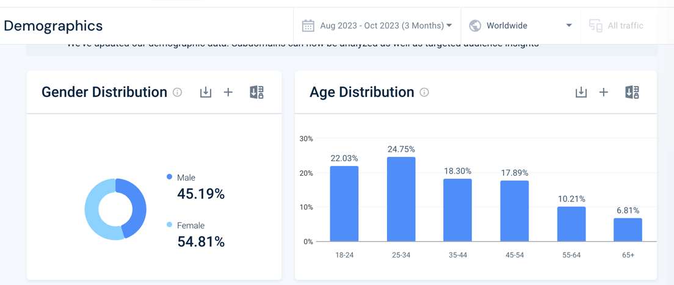
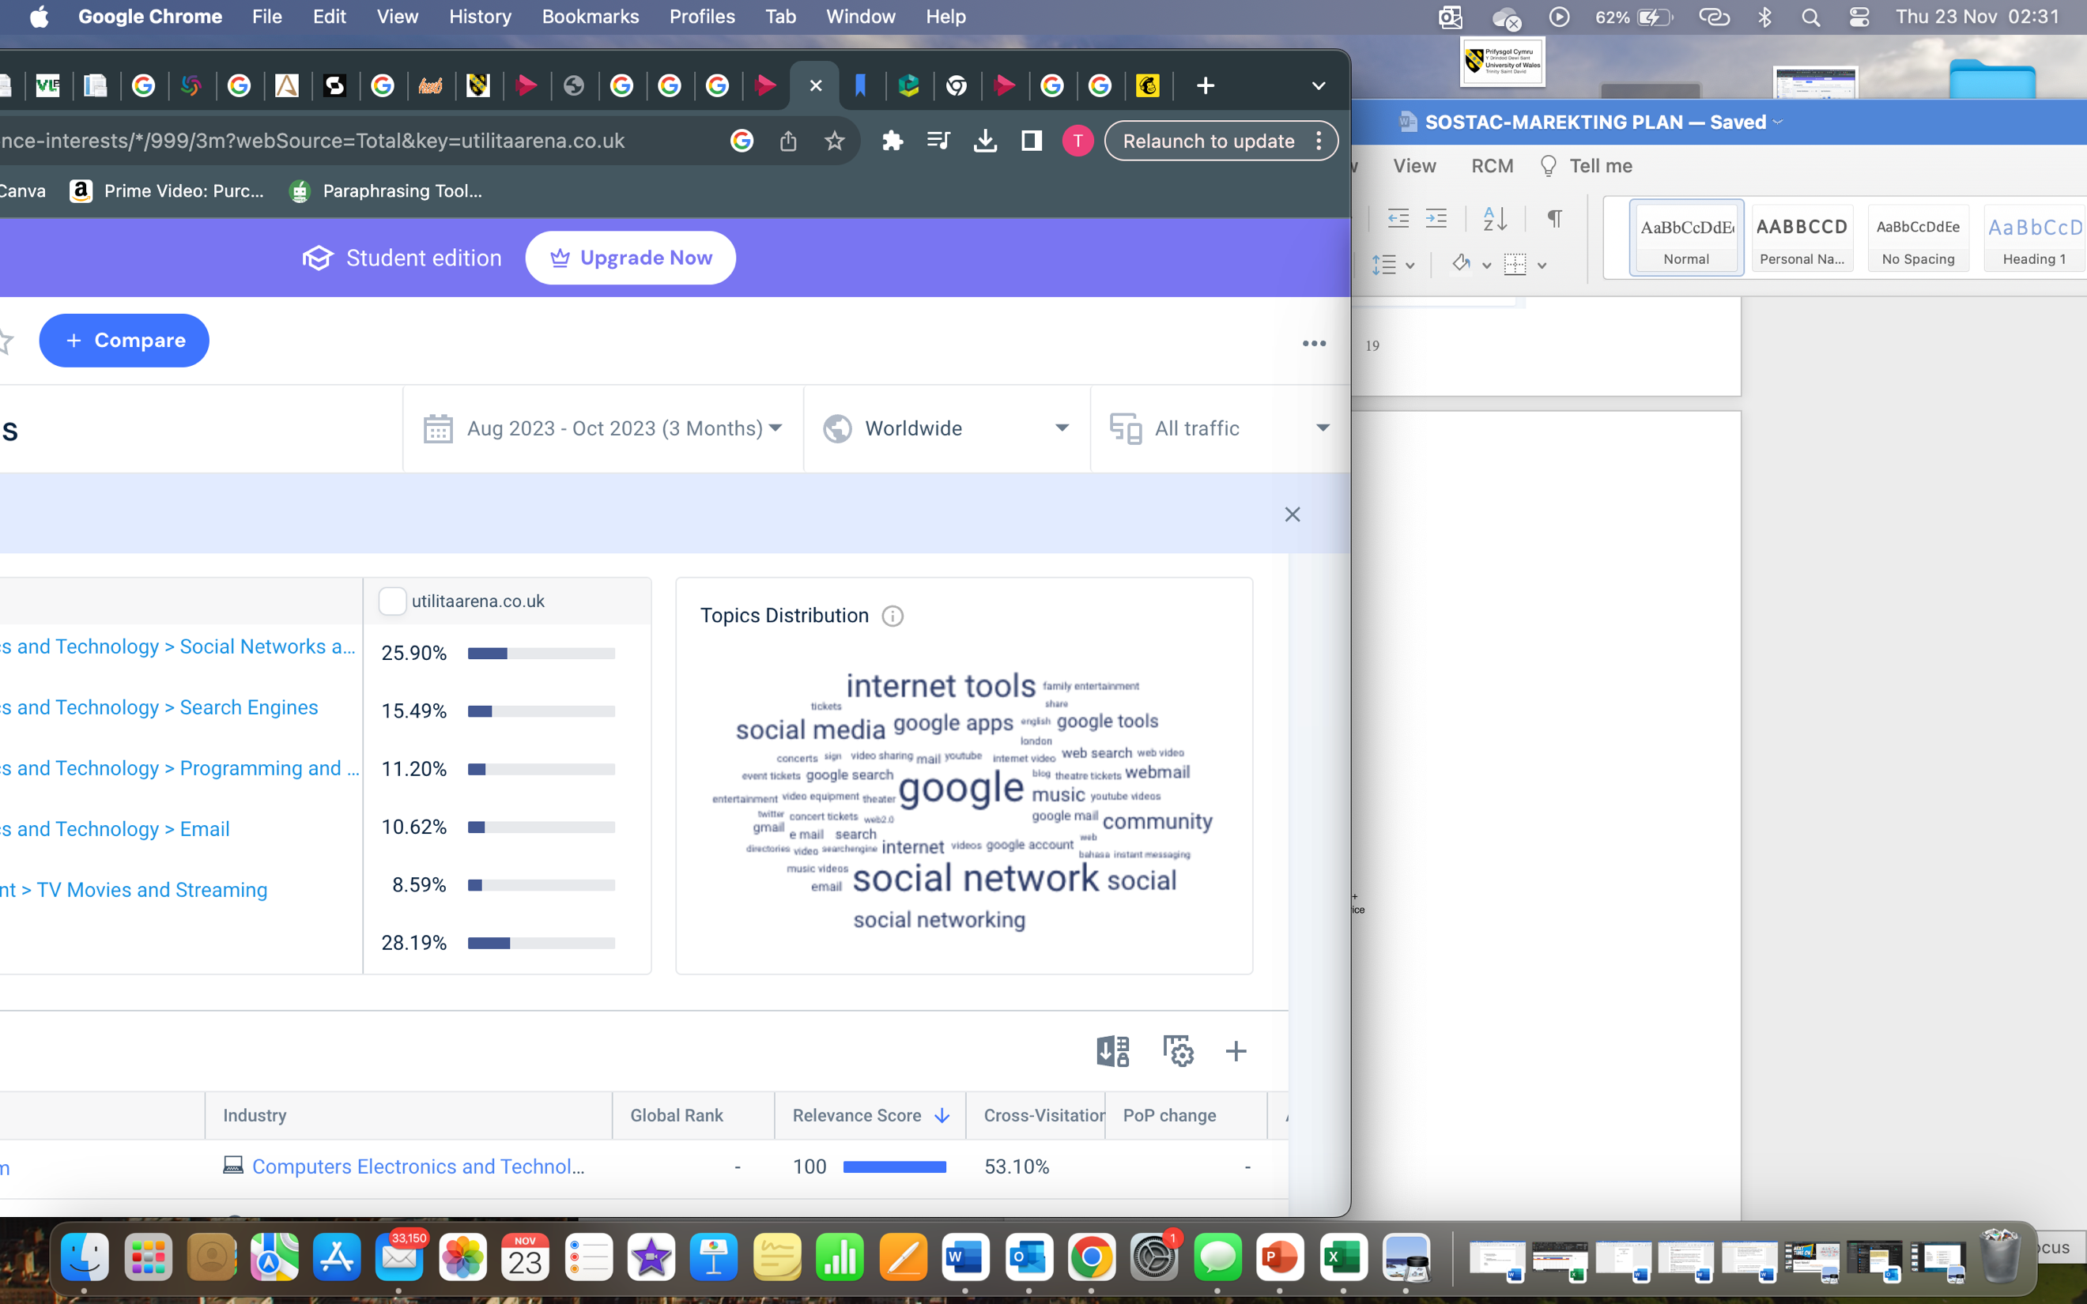

(A.4) PROPOSITONAL MAP

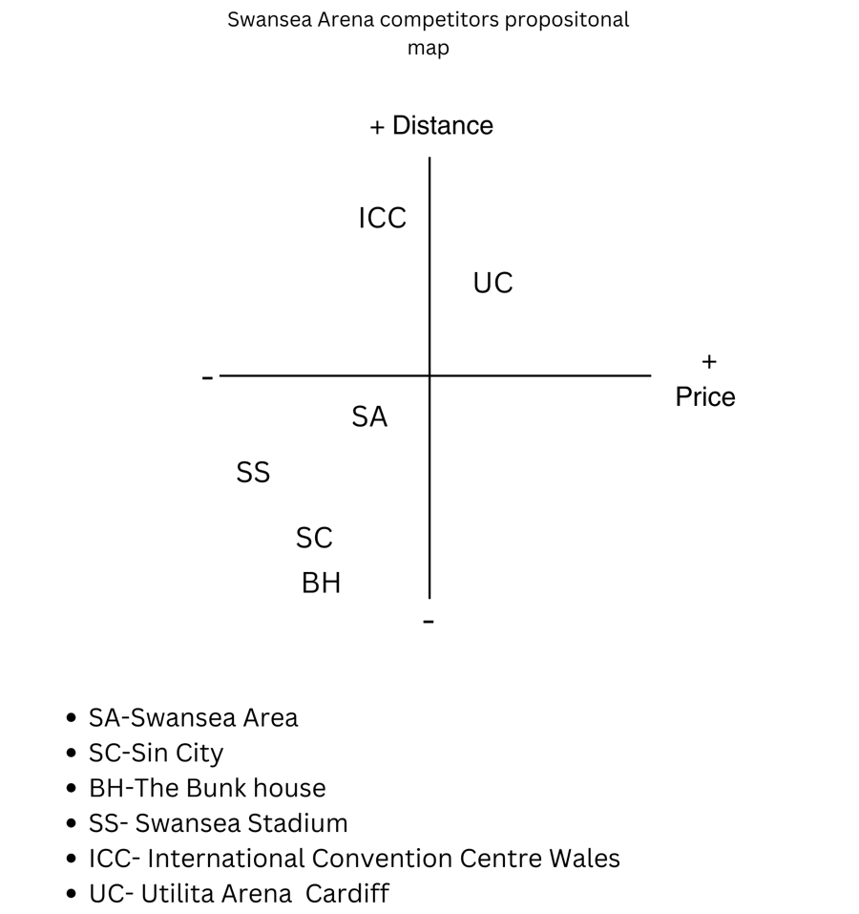

(created by learner)

(A.5) Marketing mix analysis

Marketing Mix Analysis on the House party Event.

Product | The product within this analysis is the house party event, which will bring lot of the community together into one place suggesting that it will be exclusive. Looking at the psychological aspect, people will attend this event for escapism.  Shostack (1997), states that the spectrum are a mix of goods and services that are tangible and intangible elements therefore the event fits in within this as there will be ancillary products.
Price | The cost of the ticket is £10. Relating back to target markets it would be geared to mass-marketing as it is a considered as cheap, indicating as non-market pricing.
Place/place of distribution | The place of the event will be at the Swansea Arena, which people can purchase a ticket is from the Swansea arena website and will also have the opportunity to buy tickets at the door.
Promotion | Promoting the event will utilize the communication mix. Todorova (2015) says that the communication mix is a combination of elements to promote that organisations utilizes to persuasively communicate customer value and build customer rapport.  All of the elements of the communication mix can be valuable to the event, but they all have weaknesses,  For this event, the arena could use sales promotions that includes offering discounts, offers like buy a ticket now and get a free drink which will persuade customers, although problem with promotions using it for this particular event, it is for charity. The start of a promotion campaign is generally towards the end before the event meaning it can be time sensitive.  Using digital marketing/direct marketing which will include using various social media, sending out direct emails although it would be to people who already been to the arena.  Personal selling could be another, where sending students around Swansea/ colleges to promote the event however the problem with this people could ignore it.  The arena have £500 budget for marketing, advertising could effective however the money side of it can add up.
Process | There are different processes that will involvement in event. One being before, during, after sales touchpoints, the marketing would come into by the is the communication mix.  During sales, customers will give out their details and after sales contacting for customer feedback, or engaging with arena social media page which suggests that customers will have medium involvement.  To streamline processes is by utilizing blueprint model which are tasks and processes that need to be conducted at various stages.
Physical evidence/environment | - Temperature of the arena  - Staff with uniform  - The colour scheme gold,  - Swansea arena website, Emails confirmations, news emails
People | At the event the people that involved it is essentiall that they have good customer service as it is essential for creating good customer experience. Bowie.et.al (2017)

(A.6)- social media act post
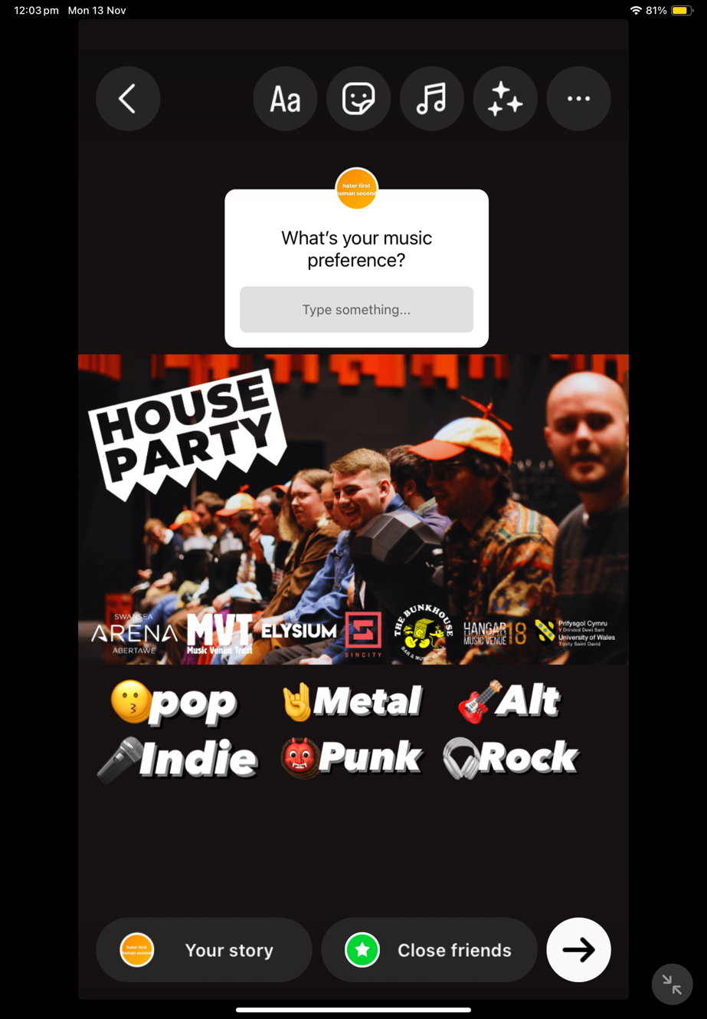
(Created by learner)

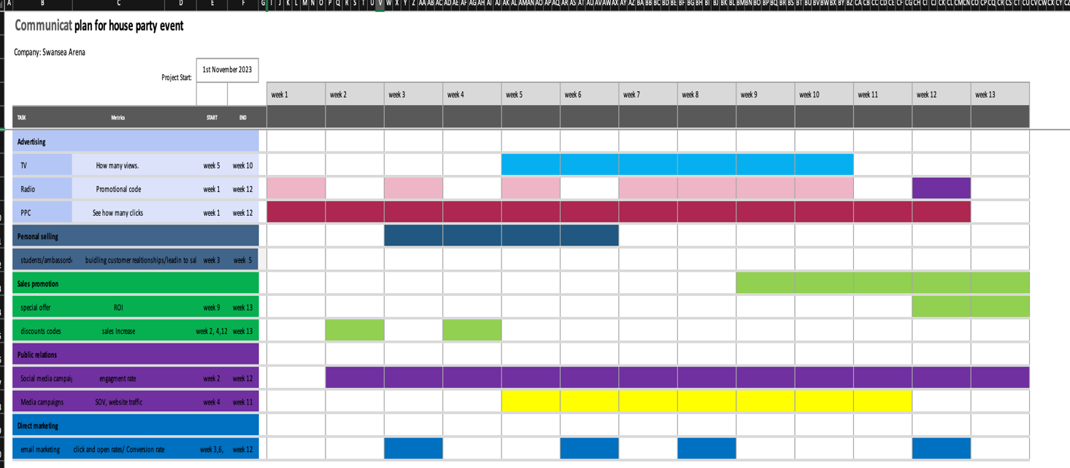
A.7- (Gannt Chart)

(Created by learner)

