
University of Wales Trinity Saint David
School of Engineering
Research on energy management strategy of hybrid power system for fuel cell vehicles

JIAN SONG
2300254
Automotive
18/11/24
ACFA7003 Master’s Project

Abstract
Countries all around the world have given hydrogen energy a lot of attention as a clean energy source in light of global carbon neutrality. Fuel cells are a significant source of hydrogen energy. The fuel cell hybrid electric vehicle is modeled using AVL Cruise M in order to confirm that the power system matching is feasible. This is done by analyzing the vehicle's fundamental configuration and potential usage scenarios.
Two energy management strategies—multi-point control and power following—are simulated and examined in Matlab/Simulink to investigate how they affect vehicle economy. The simulation results demonstrate that the power following strategy, as opposed to the multi-point control strategy, more equitably distributes the dual-energy source's output power while maintaining the power battery's state of charge. This enhances the power system's stability and lowers the vehicle's overall energy consumption.
An energy management method based on fuzzy control is proposed to further optimize the output power allocation mode of dual energy sources. The fuzzy control parameters are also optimized using the particle swarm approach. The results of the simulation demonstrate that the energy management strategy based on fuzzy control is optimized to further enhance vehicle economy, and the particle swarm algorithm is highly appropriate for optimizing the fuzzy control strategy due to its fast convergence speed and minimal iteration steps.
Key Words:
Fuel cell vehicles, Energy management strategies, Fuzzy control, Optimization algorithms

Content Page
Abstract 1
1. Introduction 1
2. Research Background 3
2.1 Current Research Status Of Fuel Cell Hybrid Power Systems 3
2.2 Current Research Status Of Energy Management Strategies For Fuel Cell Vehicles 4
3. Fuel Cell Vehicle Powertrain Matching And Vehicle Model Construction 7
3.1 Fuel Cell Vehicle Basic Configuration Selection 7
3.1.1 Fuel Cell-Power Cell Configuration 7
3.1.2 Fuel Cell-Supercapacitor Configuration 8
3.1.3 Fuel Cell-Power Battery-Supercapacitor Configuration 8
3.2 Research On Power System Selection And Parameter Matching Of Fuel Cell Vehicles 10
3.2.1 Drive Motor Selection And Parameter Matching 11
3.2.2 Fuel Cell Selection And Parameter Matching 14
3.2.3 Power Battery Selection Parameter Matching 17
3.3 Fuel Cell Vehicle Model Building Based On Avl Cruise M 19
3.3.1 Simulation Software Introduction 19
3.3.2 Vehicle Module Setup 20
3.3.3 Mechanical Components Section Module Setup 22
3.3.4 Module Settings For Electrical Component Parts 24
3.3.5 Cab And Calculation Task Module Setup 27
3.3.6 Vehicle Modelling 28
3.4 Simulation Verification Of Matching Results For Fuel Cell Vehicles 29
4. Research On Rule-Based Energy Management For Fuel Cell Vehicles 33
4.1 Analysis Of Energy Management System And Working Mode Of Fuel Cell Vehicles 33
4.1.1 Fuel Cell Vehicle Energy Management System Design Principles 33
4.1.2 Analysis Of Operating Modes Of Fuel Cell Hybrid Vehicles 34
4.2 Research On Energy Management Strategy Based On Multi-Point Control 36
4.2.1 Construction Of Energy Management Strategy Based On Multi-Point Control 36
4.2.2 Simulation Condition Selection 38
4.2.3 Co-Simulation Model Setup 40
4.2.4 Analysis Of Simulation Results 43
4.3 Research On Energy Management Strategy Based On Power Following Control 49
4.3.1 Construction Of Energy Management Strategy Based On Power Following Control 49
4.3.2 Analysis Of Simulation Results 51
4.4 Comparative Analysis Of Simulation Results Of Two Energy Management
Strategies 55
5. Research On Energy Management Strategy Based On Fuzzy Control And Its Optimization 58
5.1 Research On Energy Management Strategy Based On Fuzzy Control 58
5.1.1 Introduction To Fuzzy Control 58
5.1.2 Design Of Fuzzy Control Energy Management Strategy 59
5.1.3 Analysis Of Simulation Results 61
5.2 Design Of Fuzzy Strategy Optimization Algorithm Based On Particle Swarm Algorithm 66
5.2.1 Introduction To Particle Swarm Algorithms 66
5.2.2 Determination Of Initial Population And Fitness Function 67
5.2.3 Particle Swarm Algorithm Optimization Results Analysis 68
5.3 Comparative Analysis Of Results Of Fuzzy Control Strategies And Optimized Fuzzy Control Strategies With Particle Swarm Algorithm 70
6. Conclusions 73
7. Reference 75

Introduction
The global automobile industry has recently concentrated on developing renewable energy sources to lessen reliance on fossil fuels and lower pollutant emissions. Environmental pollution and the energy crisis are two of the biggest social issues facing the world in the twenty-first century. Vehicles' new energy is a crucial component of the automotive industry's modernization, and the automotive sector may make extensive use of hydrogen, a clean energy source(Teng et al., 2020). There are many different sources of hydrogen, and by using sophisticated and environmentally friendly production techniques and cutting-edge technologies for using hydrogen energy, it is possible to convert conventional fossil fuels into renewable green energy. This can help to modernize the global energy sector and hasten the emergence of a new energy sector. Major nations and areas around the world have created plans for the advancement and application of hydrogen energy. Currently, hydrogen energy application scenarios in the automotive industry are primarily separated into two categories: hydrogen internal combustion engines and hydrogen fuel cells. Because of its clean and effective properties, hydrogen fuel cells are currently the primary method of utilizing hydrogen energy(Yue et al., 2019; Tie et al. 2019).
With high energy conversion efficiency and clean operation, fuel cells are a new type of power generation device with great prospects for future development. At present, the research and development of fuel cells and their related technologies have become a hot spot in the new energy industry, and the research and development results have been demonstrated in some scenarios. In the future, fuel cells will be widely used in automotive, electric power and other fields (Barbir and Yazici, 2008; Chang, Ma and Wu, 2008). The complexity and variability of the usage scenarios and actual road conditions will lead to the response speed of reactive gases in automotive fuel cells lagging behind the load changes, and these transient operations lead to insufficient oxygen supply to the fuel cell, thus affecting the durability and reliability of the whole fuel cell system (Kim, Shimpalee and Van, 2004; Pischinger, Schonfelder and Ogrzewalla, 2006). Based on the characteristics of fuel cells operating under transient conditions, mainstream fuel cell vehicles adopt hybrid structures (Fathabadi, 2018). In fuel cell hybrid vehicles, the fuel cell provides most of the energy demand for the vehicle, while the on-board energy storage system can operate under high current demand conditions such as driving uphill or accelerating to make up for the shortfall of the fuel cell, and also store part of the energy recovered from the vehicle braking so that the fuel cell system operates stably and efficiently (Pollet, Staffell and Shang, 2012; Sulaiman et al,. 2015).
Aiming to optimize the matched vehicle structure and combine various energy management schemes to achieve the optimal economy under the premise of satisfying the power, lowering the cost of vehicle manufacturing and use, and accelerating the popularization of fuel cell vehicles, researchers have concentrated on the study of powertrain matching and energy management systems based on fuel cell hybrid vehicles in order for fuel cell vehicles to achieve the specified power and economy indexes.

Research Background

Current Research Status Of Fuel Cell Hybrid Power Systems
The design of fuel cell vehicles began in the 1980s, and major global automakers like Mercedes-Benz and Honda have been working on fuel cell vehicle development for over 40 years. The foundation of vehicle design that is connected to fuel cell vehicle performance is the powertrain matching design. The majority of fuel cell vehicles nowadays are hybrid constructions, and researchers and technicians from several nations have worked extensively on the pre-design and development of fuel cell hybrid vehicles.
Toyota Motor Corporation in Japan has always been committed to the development of fuel cell vehicles since the end of the last century. Figure 2.1 shows a sample drawing of Toyota's new generation fuel cell bus (Ogawa, Umayahara and Ikogi, 2019), which adopts an advanced hybrid powertrain matching concept to meet the dynamic performance and durability requirements of fuel cells. Compared with Toyota's 2002 fuel cell model, the new fuel cell bus has better performance, and while matching a higher power motor, it achieves to reduce the power fluctuation of the fuel cell output, which promotes the commercialization of fuel cell buses. The United States, South Korea and other developed countries are also in the leading position in matching design of fuel cell vehicles, which utilizes the advanced technology of NASA; Figure 2.2 shows the XCIENT fuel cell heavy duty truck of the South Korean Hyundai Group, which demonstrates that Hyundai attaches great importance to the technology of fuel cell hybrid commercial vehicles.

Figure 2.1 Toyota's New Generation Fuel Cell Buses

Figure 2.2 Hyundai XCIENT Fuel Cell Fuel Cell Heavy Duty Trucks
Nowadays, researchers are also in full swing on the research of fuel cell hybrid powertrain optimization and matching, Jean-Christophe et al (2017) proposed an optimal design method of hybrid powertrain system for fuel cell vehicles, and used a global optimization algorithm to find the optimality of each drive parameter, and got the optimal drive parameter, which guided the design of the fuel cell city concept car. Henning et al (2020) conducted a complete vehicle test based on the 2016 Toyota Mirai fuel cell vehicle, and analyzed the factors affecting the vehicle efficiency of fuel cell vehicles for the test results under different cycling conditions and different thermodynamic conditions, which provided an important reference for the fuel cell vehicle test and efficiency calculation method. Using a laboratory-developed fuel cell/super capacitor hybrid power system, J.S.P. Artridge et al. (2018) matched the system's components, particularly the DC/DC converter, to protect the fuel cell system in the event of a sudden change in the vehicle's overall power demand. They also optimized the hybrid power system's design in terms of cost and efficiency and identified the component dimensions and performance parameters under particular circumstances.

Current Research Status Of Energy Management Strategies For Fuel Cell Vehicles
To keep the overall system energy consumption as low as possible while meeting the dynamics needs of the entire vehicle, high standards must be set for the design of energy management strategies for fuel cell hybrid systems. This is due to the fact that the system's components need to function in a zone of better efficiency. The fuel cell vehicles that have been made available so far make extensive use of rule-based and optimization-based energy management strategies.
(1)Rule-based energy management strategy
The rule-based energy management strategy has the characteristics of good real-time and easy to implement, D. DIALLO et al (2011) adjusted the power output ratio of fuel cell and power cell under different working conditions according to the demand power information of fuel cell vehicle under EUDC working conditions, and set the minimum power of fuel cell under the working conditions of small speed change of the vehicle, and the energy management strategy meets the power economy design index of fuel cell vehicle after simulation test. After simulation test, the energy management strategy meets the power economy design index of the fuel cell vehicle.A.Tahri et al (2018a) based on the fuel cell-super capacitor hybrid power system designed energy management system successfully controls the charge state of the super capacitor in a certain interval, and at the same time reduces the power fluctuation of the fuel cell in the high load of the vehicle, avoids fuel starvation of the fuel cell, and ensures the stability of the power system. Bourouis et al (2020) proposed a new rule-based energy management algorithm, using the simulation model of a fuel cell hybrid vehicle, focusing on the control effect of the DC/DC converter on the output voltages and currents of the fuel cell and the power cell. The simulation results show that under the regulation of this energy management strategy and DC/DC converter, the SOC of the power cell can be maintained between 40% and 80%, and the fuel cell power system works stably, which is instructive for the design of DC/DC converter in the fuel cell system.
(2)Optimization-based energy management strategies
The design of vehicle energy management techniques is becoming increasingly crucial as fuel cell vehicle technology gradually matures and meets the present demands of automotive intelligent network connectivity, energy conservation, and emission reduction. The creation of a new generation of energy management techniques to enhance the vehicle's energy efficiency, prolong the fuel cell stack's lifespan, and maximize the fuel cell vehicle's performance has grown in popularity as a study area.
Researchers are also very interested in the development of optimization-based fuel cell energy management strategies. Kim.K et al (2015) applied the Pontryagin's principle of minima to a fuel cell vehicle model based on backward simulation, and the results obtained were very close to the optimal solution based on the dynamic planning strategy, and the energy management strategy using the principle of minima simplified the control architecture, which proved that the strategy has a very promising application. The results are very close to the optimal solution based on the dynamic planning strategy.Roberto et al (2018) used a genetic algorithm to globally optimize the energy management strategy of a fuel cell vehicle, and firstly determined the energy consumption optimization constraints. By comparing the simulation results of the optimized strategy using genetic algorithm with other strategies, it is proved that the energy control strategy using genetic algorithm improves the economy of the whole vehicle.Torreglosa et al (2011) designed an energy management strategy for the power system of a fuel cell rail train based on the equivalent hydrogen consumption minimization algorithm, which can meet the economic requirements of the rail traffic driving conditions, and the results of the hydrogen consumption on a specific line are close to the global optimum.Alexandre et al (2017) proposed an extreme value search algorithm, which can solve the nonlinear optimization problem effectively. The energy management strategy using the extreme value search method is found to allow the fuel cell system to operate efficiently and reduce the consumption of hydrogen after validation on a semi-physical simulation platform.

Fuel Cell Vehicle Powertrain Matching And Vehicle Model Construction

Fuel Cell Vehicle Basic Configuration Selection
Currently, there are three main configurations of fuel cell vehicles, i.e., fuel cell-power cell configuration, fuel cell-super capacitor configuration, and fuel cell-power cell/super capacitor configuration.
For the selection of fuel cell hybrid power system configuration, it should have good feasibility under the premise of meeting the requirements for the use of fuel cell vehicles. The basic principles are as follows:
(1) The service life of the fuel cell can be ensured, and the output power and dynamic characteristic requirements of the fuel cell system can be reduced within a reasonable range;
(2) It can provide large instantaneous power to meet the power demand under different working conditions of the vehicle.
(3) The system of hybrid power should not be too complex, and try to reduce the cost.
According to the above principles, combined with the development status of fuel cells, power batteries and super capacitors, the performance potential of the power system, so it is selected as the basic configuration of fuel cell hybrid bus. Fuel cell-power cell configuration, the power cell can provide energy alone, but also with the motor to complete the braking energy recovery function, reducing the overall energy consumption of the vehicle. In the hybrid structure type depicted in Figure 3.1, the fuel cell's unidirectional DC/DC converter and the power battery's bidirectional DC/DC converter currently handle the energy regulation requirements before supplying the motor with AC power via the inverter. The motor functions similarly to a generator when braking, producing energy in the opposite direction. This energy is then stored in the power battery via a bidirectional DC/DC converter, completing the recovery of braking energy. Although the fuel cell-power cell structure scheme is not the best in terms of performance when considering the operating cost and working conditions of city buses, this configuration has the highest feasibility due to the rapid development of power batteries in the automotive industry in recent years. At the same time, it is simple to bring out the performance potential of the hybrid system through a reasonable energy management strategy, which is why it is chosen as the basic configuration for fuel cell hybrid buses.

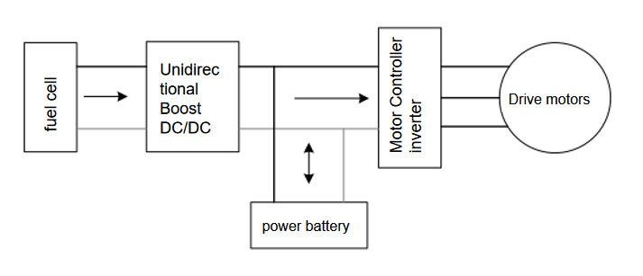
Figure 3.1 Fuel Cell-Power Cell Hybrid Vehicle Architecture

Research On Power System Selection And Parameter Matching Of Fuel Cell Vehicles
The dynamics index can serve as a foundation for figuring out the fuel cell car's drive system parameters once the fundamental configuration of the fuel cell hybrid vehicle has been established. This is based on the fundamental formula of the longitudinal dynamics of the entire vehicle. Based on the size of the vehicle's total power requirement and its pure electric range, the fundamental characteristics of the fuel cell and power cell must be established for fuel cell vehicles. The power system selection and matching work is done based on the fundamental parameters of a pure electric bus. Table 3.1 and 3.2 display the fundamental parameters and design goal values:
Table 3.1 Vehicle parameters of a pure electric bus
Vehicle parameters | Numerical value
Vehicle/external/dimensions Length*Width*Height[mm] | 12000*2550*3265
Overall vehicle weight [kg] | 12350
Maximum gross mass [kg] | 18000
Windward area [m2] | 7.5
atmospheric drag coefficient | 0.65
Rolling resistance coefficient | 0.008
Tyre rolling radius [m] | 0.464
Drivetrain efficiency | 0.95
Wheelbase [m] | 6100
Number of wheels | 6
Main Reducer Ratio | 6.14
drive method | 4×2，rear wheel drive
Table 3.2 Vehicle basic performance indexes
Performance indicators | Numerical value
Maximum speed [km/h] | 69
0-50 km/h Acceleration time [s] | ≤10
Maximum gradient at 15 km/h [%] | 18
Electricity-only driving range at constant speed (15 km/h) [km] | 100

Drive Motor Selection And Parameter Matching
Due to the operating characteristics of urban buses, which require frequent motor start-stop and speed regulation, motors need high response speed to cope with changing road conditions. For city buses, the motors are required to have a wide torque range and a large speed range, and considering the environmental differences in different regions, extreme weather and other natural factors, the vehicle motors need to be extremely high in reliability and durability.
Permanent magnet synchronous motors have higher efficiency, high-performance permanent magnet materials can provide excitation, so the motor design has more volume advantages, while permanent magnet synchronous motors in the low efficiency region can also ensure a high torque output. The permanent magnet synchronous motor is chosen as the fuel cell vehicle's drive device because it performs optimally in every dimension of the indicators and meets the demands of urban bus situations.
The longitudinal dynamics formula for the entire vehicle serves as the foundation for the parameter matching computation. The reasonable matching of the drive motor is essential in the power matching stage because if the chosen motor power is too high and not in line with the vehicle's current power need, the motor cannot operate in the acceptable power interval, which leads to a significant waste of power. the vehicle's overall force analysis graphic.As shown in Figure 3.2:
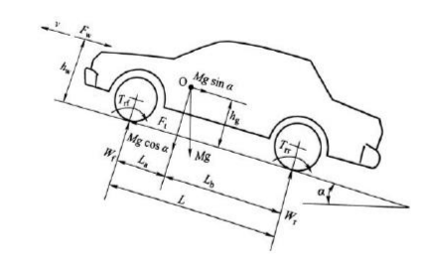
Fig. 3.2 Force analysis of the vehicle during travelling
From the force analysis diagram of the vehicle, the equations for the balance of resistance of the driving force of the vehicle can be derived:
$m\frac{dv}{dt}=F_{t}−F_{r}−F_{w}−F_{g}$ (Equation 3-1)
Where $F_{t}$ is the driving force in N, $F_{r}$ is the rolling resistance in N, and $F_{w}$ is the air resistance in N. $F_{g}$ is the ramp resistance in N, m is the vehicle mass in kg, and dv/dt is the vehicle acceleration in m/s2.
Equation 3-1 is the basis of the vehicle longitudinal dynamics model, from which the vehicle power balance equation can be derived.
$P=\frac{1}{η_{t}}(\frac{mgfcosα}{3600}v_{α}+\frac{mgfsinα}{3600}v_{α}+\frac{C_{D}A}{76140}v_{α}^{3}+\frac{δmv_{α}}{3600}⋅\frac{dv}{dt})$ (Equation 3-2)
Where $P$ is the power demanded by the motor in kW; $η_{t}$ is the mechanical transmission efficiency from the output shaft of the drive motor to the drive wheels; $g$ is the gravitational acceleration in N-m/kg; $f$ is the rolling resistance coefficient; and $α$ is the slope angle of the vehicle. $v_{α}$ is the vehicle speed in km/h; $C_{D}$ is the coefficient of air resistance, A is the windward area in m²; $δ$ is the rotating mass conversion factor of the vehicle. .From the definitions of maximum speed, acceleration time and maximum gradient, the power demand under the corresponding conditions can be calculated from Equation 3-2, and the power demand of the whole vehicle at maximum speed is:
$P_{1}=\frac{1}{η_{t}}(\frac{mgf}{3600}u_{max}+\frac{C_{D}A}{76140}u_{α}^{3})$ (Equation 3-3)
The overall vehicle power requirement at maximum gradient climb is:
$P_{2}=\frac{1}{η_{t}}(\frac{mgf}{3600}u_{α}cosα_{max}+\frac{mgf}{3600}u_{α}sinα_{max}+\frac{C_{D}A}{76140}v_{α}^{3})$ (Equation 3-4)
The power demand of the whole vehicle under the acceleration time requirement is:
$P_{3}=\frac{1}{{3600t_{m}η}_{t}}(δm\frac{u_{m}^{2}}{7.2}+mgf\frac{u_{m}}{1.5}t_{m}+\frac{C_{D}Au_{m}^{3}}{21.15×2.5}t_{m})$ (Equation 3-5)
In Eqs. 3.3-3.5 $P_{1}$, $P_{2}$, $P_{3}$, are the power requirements calculated under the above three performance indicators, $u_{max}$ is the maximum speed of the vehicle in km/h;${ α}_{max}$ is the maximum gradient of the vehicle, $u_{α}$ is the power requirement under the maximum gradient, unit is km/h; $u_{m}$ is the specified speed that the specified vehicle accelerates from 0 to in km/h,$t_{m}$ is the time required for the vehicle to accelerate from a standstill to the specified speed in s.
For a motor, the peak power $P_{m}$ should satisfy $P_{m}≥${$P_{1}{,P}_{2},P_{3}$},the rated power${ P_{e}≥P}_{1}$ should be satisfied. The speed/torque characteristic curve of the motor is shown in Fig. 3.3. The motor is in the constant torque region when the speed is lower than the rated speed $N_{e}$, the motor is in the constant power region when the speed is in the interval between the rated speed $N_{e}$ and the peak speed $N_{m}$. The ratio of $N_{e}$ to $N_{m}$ is the motor's expanded constant power region coefficient $β$, which affects the motor's torque performance in the constant power region.
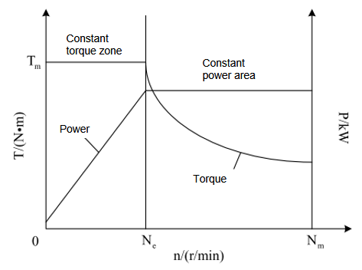
Figure 3.3 Typical motor speed/torque characteristic curve
Based on the formula between the motor speed and the vehicle speed, the formula for the peak motor speed can be derived:
$N_{m}=\frac{u_{max}i_{0}}{0.377r}$ (Equation 3-6)
Where $i_{0}$ is the vehicle main gear ratio, r for the wheel rolling radius, the unit is (m), by the peak speed of the motor and rated power relationship, easy to get the rated speed of the motor is:
$N_{e}=\frac{N_{m}}{β}$ (Equation 3-7)
The torque performance of the drive motor directly affects the dynamics of the vehicle, so the maximum torque of the motor should be reasonably selected according to the actual use of the vehicle scene. From the relationship between speed, power and torque, the rated torque of the motor $T_{e}$ can be calculated, and the peak torque of the motor $T_{m}$ is calculated using the demand torque of the motor at the maximum gradient climbed:
$T_{e}=9550\frac{p_{e}}{n_{e}}$ (Equation 3-8)
$T_{m}=\frac{r}{i_{0}η_{t}}(mgfcosα+mgfsinα+\frac{C_{D}Au_{α}^{2}}{21.15})$ (Equation 3-9)
According to Eqs. 3.1-3.9 and substituting the basic parameters of the whole vehicle, the final calculated motor parameters are shown in Table 3.3:
Table 3.3 Motor Parameter Matching Results
Parameter name | Numerical value
Rated power [kW] | 55
Rated speed [r/min] | 970
Rated torque [N-m] | 880
Peak power [kW] | 160
Peak speed [r/min] | 2197
Peak torque [N-m] | 2422

Fuel Cell Selection And Parameter Matching
Depending on the fuel type, the electrolyte type, and the temperature range in which the cell operates, fuel cells can be categorized in a number of ways. Proton exchange membrane fuel cells, alkaline fuel cells, phosphoric acid fuel cells, molten carbonate fuel cells, solid oxide fuel cells, and direct methanol fuel cells are the primary categories of fuel cells based on the kind of electrolyte. The primary attributes of the different fuel cells are displayed in Table 3.4:
Table 3.4 Classification of fuel cells and their characteristics(Bayat, et al. 2023)
Fuel Cell Type | Electrolyte (Ion) | Fuels | Oxidizing Agent | Working Temperature/°C
Proton Exchange Membrane Fuel Cell  Battery | Polymer Membrane (H+) | H₂ | O₂ | 40-90
Alkaline Fuel Cell | Potassium Hydroxide(Oh-) | H₂ | O₂ | 60-220
Phosphoric Acid Fuel Cell | Phosphoric Acid (H+) | H₂ | O₂ | 160-200
Molten Carbonate Fuel Cells  Battery | Potassium Carbonate/Lithium (${Co}_{3}^{2−}$) | H₂ Light HC | O₂ | 600-700
Solid Oxide Fuel Cells  Battery | Zirconium Oxide (O2-) | H₂ Light HC | O₂ | 600-1000
Direct Methanol Fuel Cells | Polymer Membrane (H+) | CH3OH | O₂ | 90-130
Among them, high-temperature fuel cells, including solid oxide, phosphoric acid, and molten carbonate fuel cells, offer a wide range of potential uses in large-scale power generation and are currently at the demonstration stage, with superwatt-level power.Low-temperature fuel cells such as direct methanol fuel cells affect their application in automotive applications due to the toxicity of the fuel (Kamarudin, Achmad and Daud, 2009), and proton exchange membrane fuel cells are suitable for automotive applications due to their fast startup, high efficiency, and absence of corrosive liquid electrolyte, with cathode, anode, and total reactions:
Anode: H₂ 2H⁺+2e⁻ (Equation 3-10)
Cathode: $\frac{1}{2}O_{2}+2H^{+}+2e^{−} H_{2}O$ (Equation 3-11)
Overall responses: $\frac{1}{2}O_{2}+H_{2} H_{2}O$ (Equation 3-12)
The working principle of the proton exchange membrane fuel cell and the basic structure of a single cell are shown in Figures 3.4 and 3.5. A potential difference is created and a low-voltage direct current (DC) output is formed to the load when hydrogen ions produced by the anode move from the anode to the cathode inside the fuel cell and electrons move from the external circuit to the cathode. The fuel cell stack is made up of multiple individual cells put together using a specific procedure. Each single cell's bipolar plates receive hydrogen and oxygen from the main inlet flow channel. Once the bipolar plates are evenly guided, they make contact with the catalyst inside the cell to initiate the electrochemical reaction, and they subsequently release the electrical energy externally.
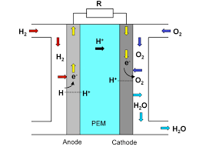
Figure 3.4 Proton Exchange Membrane Fuel Cell Working Principle
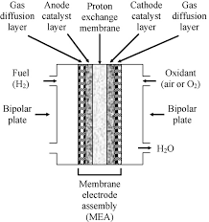
Figure 3.5 Proton Exchange Membrane Fuel Cell Structure
To guarantee that the fuel cell stack can supply enough power under typical operating conditions and satisfy the vehicle's drive power demand while operating at a steady speed under the current speed with minimal speed fluctuations, the fuel cell stack's output power should fulfill the following specifications:
$P_{fc}=\frac{1}{{η_{DC}η}_{t}}(\frac{mgf}{3600}u_{max}+\frac{C_{D}A}{76140}u_{α}^{3})+P_{ch}$ (Equation 3-13)
Where${ η}_{DC}$ is the efficiency of DC/DC converter; $P_{ch}$ is the power of other electric accessories of the car in kW; the vehicle speed u is taken as the designed maximum speed of 69km/h, and the output power of the fuel cell is calculated as$P_{fc}$=65kW according to the actual parameters.

Power Battery Selection Parameter Matching
In pure electric mode, the fuel cell hybrid vehicle's power battery serves as its only energy source. The battery must be able to meet the vehicle's power requirements in this situation under a variety of operating circumstances and within the bounds of fully electric driving. The energy and power characteristics of the battery must be considered when selecting a power battery since the overall quality of the vehicle must be considered during design. Table 3.5 lists the power batteries that are currently on the market along with performance comparisons.
Table 3.5 Classification of power battery and its main parameters(Zhang et al. 2022)
Battery Type | Specific Energy (Wh/Kg) | Specific Power (Wh/L) | Cycle Life (Times) | Cost ($/Kwh)
Lead-Acid Battery | 30-45 | 200-300 | 400-600 | 150
Nickel-Cadmium Battery | 40-60 | 150-350 | 600-1200 | 300
Nickel-Metal Hydride Battery | 60-80 | 550-1350 | 1000 | 500
Lithium Ion Battery | 90-130 | 250-450 | 800-1200 | 200
As can be seen from the data in the table, the indicators of lead-acid batteries are in a disadvantageous position, their cycle life is short, the specific energy and specific power are low, in addition to the application of the traditional automotive starter batteries, such batteries in the field of power batteries are being gradually phased out; nickel-cadmium batteries have a longer cycle life, a larger discharge current, the use of the temperature of the requirements of the low, the technology has been relatively mature, but due to the toxicity of heavy metal cadmium, a serious hazard to human health and the environment. The application prospects are general; nickel-metal hydride batteries have higher specific power and specific energy, and relatively long cycle life, but nickel-metal hydride batteries are not suitable for use at high temperatures, and have a certain memory effect, difficult to maintain; lithium-ion batteries have the advantage that the specific power and specific energy is very high, the number of cycles can be larger, stable performance, and the cost of the acceptance of the major automotive enterprises within the scope of the overall performance is better. Select the power cell type as lithium iron phosphate ion battery.
For matching the parameters of the on-board power battery, the capacity of the electric vehicle is matched using the isovelocity method, the matching results of parameters are shown in Table 3.6.
Table 3.6 Power Battery Parameter Matching Results
Parameter Name | Parameter Value
Monomer Voltage [V] | 2.5-5
Series And Parallel Numbers | 110s 2p
Total Battery Voltage [V] | 275-550
Battery Power Usage Range [%] | 0.2-0.8
Total Battery Capacity [Ah] | 68

Fuel Cell Vehicle Model Building Based On Avl Cruise M

Simulation Software Introduction
AVL Cruise M is a new system-level simulation platform software released by AVL Lister in October 2015 as a multidisciplinary system-level simulation tool that provides a new platform for vehicle system-level modelling.The main uses of AVL Cruise M include:
(1) Vehicle energy management system simulation;
(2) Vehicle control system development and calibration;
(3) Bench testing under various complex working conditions based on the model.
The simulation flow of AVL Cruise M is shown in Fig. 3.6. Firstly, the required modules are selected according to the basic configuration of the vehicle, the mechanical and electrical connections are made between the modules, the modules are modified by the basic parameters of the vehicle, and after modification, the parameter-signal connections are made after analyzing the parameter relations between the modules to complete the modelling, and the setup of the solver and the computation tasks can be carried out after the modelling is completed. Post-processing work to analyse the results.
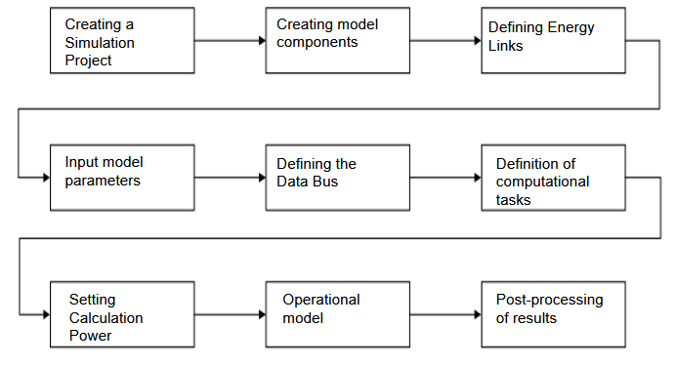
Fig. 3.6 CRUISE M vehicle modelling simulation process

Vehicle Module Setup
In a complete vehicle model, the vehicle module contains general data about the vehicle, including parameters such as the nominal size and weight of the vehicle, and only one vehicle module is required in each model. This component has no ports and is connected to the other modules through a data connection (databus). The parameters, including the vehicle's total mass, external dimensions, windward area, wind resistance coefficient, etc., are entered into the module in accordance with the vehicle's real data in Table 3.1. The vehicle module provides the other modules with the real-time parameters of the vehicle operation, such as the vehicle speed, resistance, and dynamic wheel load, in accordance with the principles of the longitudinal dynamics of the complete vehicle in the simulation process. The computational theory of the module is as follows.
(1)Calculation of vehicle transient mass
Under the condition that the load condition is a fixed load, the actual mass of the vehicle is determined by interpolating the mass of the whole vehicle in the three states:
$mv_{act}=mv(zv_{load})$ (Equation 3-14)
Where $mv_{act}$ is the actual mass of the vehicle and $zv_{load}$ is the load-dependent mass of the vehicle.
Unladen condition: $zv_{load}=0⟹ mv(0)=mv_{min}$ (Equation 3-15)
Half loaded: $zv_{load}=1⟹ mv(1)=\frac{mv_{min}+mv_{max}}{2}$ (Equation 3-16)
Under full load: $zv_{load}=2⟹ mv(2)=mv_{max}$ (Equation 3-17)
In Eqs. 3.15-3.17, $zv_{load}$ is the state variable, $mv_{min}$ is the unloaded mass of the vehicle, and $mv_{max}$ is the fully loaded mass of the vehicle. The instantaneous mass is evaluated as follows when the vehicle is loaded with additional loads:
$mv_{act}=mv(0)+mv_{max}$ (Equation 3-18)
The mass of the vehicle can be changed by the rate of change of the vehicle mass of the input signal on the bus. When the rate of change of the vehicle mass is specified, the instantaneous mass of the vehicle is calculated by the following equation:
$mv_{act}=mv(0)+\sum_{n=0}^{i}{\dot{m}v_{flow,n}}∙dt_{n}$ (Equation 3-19)
where $\dot{m}v_{flow,n}$ is the rate of change of vehicle mass and $dt_{n}$ is the time step of the simulation.
The selected model for calculating the vehicle mass is a fixed load, which can be modified according to the simulation requirements for no-load, half-load and full-load.
- Centre of gravity
For a moving vehicle, the centre of gravity position is calculated as:
$hv_{cog,act}=hv_{cog}(zv_{load})$ (Equation 3-20)
$lv_{cog,act}=lv_{cog}(zv_{load})$ (Equation 3-21)
Where $hv_{cog,act}$ is the true height of the centre of gravity, $lv_{cog,act}$ is the distance of the centre of gravity from the front axle of the car, and $zv_{load}$ is a state variable.
(3)Total centre of gravity position
For a moving vehicle, the centre of gravity position is calculated as:
$F_{w,x,f,ax}=mv_{act}[(1−\frac{lv_{cog,act}}{lv_{fr}})∙g∙coxα−\frac{hv_{cog,act}}{lv_{fr}}∙(αv+gsinα)]−Fv_{lift,f}$ (Equation 3-22)
The load on the front axle is distributed proportionally to the right and left front wheels. In this case, the dynamic load on the right front wheel is:
$F_{w,x,f,r}=\frac{F_{w,x,f,ax}}{2∙N_{w,f,r}}$ (Equation 3-23)
The dynamic load on the left front wheel is:
$F_{w,x,f,I}=\frac{F_{w,x,f,ax}}{2∙N_{w,f,I}}$ (Equation 3-24)
In Eqs. 3.22-3.24, $mv_{act}$ is the instantaneous mass of the vehicle, $lv_{cog,act}$ is the wheelbase, g is the acceleration due to gravity, $α$is the inclination, $αv$ is the current acceleration of the vehicle, $F_{w,x,f,ax}$ is the dynamic load on the front axle, $F_{w,x,f,r}$ is the load on the right front wheel, $N_{w,f,r}$ is the number of right front wheels, $F_{w,x,f,I}$ is the load on the left front wheel, $N_{w,f,I}$ is the number of left front wheels, and $Fv_{lift,f}$ is the force acting on the front axle upwards.
The dynamic loads on the rear axle are calculated in a similar way to the front axle with the equation:
$F_{w,x,f,ax}=mv_{act}[\frac{lv_{cog,act}∙g∙coxα}{lv_{fr}}+\frac{hv_{cog,act}}{lv_{fr}}∙(αv+gsinα)]−Fv_{lift,f}$ (Equation 3-25)
The dynamic load on the right rear wheel is:
$F_{w,x,r,r}=\frac{F_{w,x,r,ax}}{2∙N_{w,r,r}}$ (Equation 3-26)
The dynamic load on the left rear wheel is:
$F_{w,x,r,I}=\frac{F_{w,x,r,ax}}{2∙N_{w,r,I}}$ (Equation 3-27)
In Eqs. 3.25-3.27, $F_{w,x,r,ax}$ is the dynamic load on the rear axle, $F_{w,x,r,r}$ is the load on the right rear wheel, $N_{w,r,r}$ is the number of right rear wheels, $F_{w,x,r,I}$ is the load on the left rear wheel, and $N_{w,r,I}$ is the number of left rear wheels.
(4)Calculation of driving resistance of the whole vehicle
When the driving resistance calculation mode is chosen to be based on the physical model, the whole vehicle module is responsible for calculating the air resistance, ramp resistance and acceleration resistance, and the rolling resistance is partially calculated in the wheel module, where the air resistance is calculated by the formula:
$v_{Uv,rel}=v_{V}+v_{U,air}$ (Equation 3-28)
$F_{v,air}=−0.5∙c_{w}∙A_{v}∙{ρU}_{air∙}∙v_{U,V,rel}^{2}$ (Equation 3-29)
Where $v_{U,V,rel}^{2}$ is the relative wind speed in the direction of the vehicle speed,${ v}_{V}$ is the vehicle speed, $v_{U,air}$ is the wind speed, $F_{v,air}$ is the air resistance, $c_{w}$ is the wind resistance coefficient, $A_{v}$ is the windward area, and ${ρU}_{air∙}$ is the air density.
$F_{V,incl}=m_{V,act}∙g∙sinα$ (Equation 3-30)
Where $F_{V,incl}$ is the ramp resistance and $m_{V,act}$ is the instantaneous vehicle mass. Considering the effect of additional traction and thrust on the overall vehicle travelling resistance when the vehicle accelerates, the total resistance is calculated as:
${F_{V,res}=F}_{v,air}+F_{V,incl}+(k_{v,add,trac}+(k_{v,add,push})∙m_{V,act}∙g$ (Equation 3-31)

Mechanical Components Section Module Setup
The mechanical connection part of the whole vehicle mainly consists of main reducer module, differential module, brake module and wheel module. According to the actual structure of the whole vehicle, the modules can be mechanically connected according to the actual layout form, and the following describes the way to build each group:
- Main Reducer module setting
The main gearbox module is modelled as a single ratio with constant efficiency or speed-dependent torque losses. The input of the main gearbox usually comes from a rotating part, and in the vehicle model, the input of the main gearbox is connected to the motor module, and the output is connected to the differential. The ratio and efficiency of the main gearbox can be set in the model according to the actual parameters.
- Differential module setting
The mechanical input port of the differential module is from the main gearbox and the mechanical output port is connected to the brake and wheel modules. The module is set up by inputting its moment of inertia, output moment of inertia and torque distribution coefficient according to the actual data.
- Brake module setting
The AVL Cruise M brake module has two types of brakes, drum and disc, and the disc brake is selected according to the actual use scenario of fuel cell buses.The mechanical output port of the brake module is connected to the wheel module, and the values of braking surface area, friction coefficient, effective friction radius and brake moment of inertia are mainly set, and the calculation mode is set to the pressure calculation mode.
- Wheel module setting
According to the 4×2 rear-drive wheel arrangement of the vehicle, the wheel module is selected and then the wheel location is set. The front wheels are connected to the brakes only, and the rear wheels are connected to the brakes as well as mechanically connected to the drive end module. Depending on the actual parameters of the wheel, it is necessary to enter the rolling radius, rolling resistance coefficient, slip characteristics, and moment of inertia in the wheel module. wherein the road friction coefficient is transmitted from the environment module to the wheel module via the data bus, and the torque and power loss at the wheel end are calculated based on the data information from the vehicle module.

Module Settings For Electrical Component Parts
In the AVL Cruise M software, each electrical component contains positive and negative poles, with the positive pole representing a high potential and the negative pole representing a low potential, and the potential points between the different component modules are connected together through the Electric Node module, with equal potentials at the same Electric Node position and the negative pole can be grounded at the same time, while multiple Ground modules are allowed in one model. This facilitates the series-parallel connection of the electrical components.The following four main electrical component modules are set up.
- Motor module setting
In the Settings column, you need to select the motor type, motor loss calculation mode and working area, etc. In the Motor working area option, you need to select the first and fourth quadrant, i.e., the motor operates in the first quadrant when driving the vehicle, and the motor operates in the fourth quadrant when recovering energy from braking. The characteristic curves of the motor in quadrants one and four need to be entered in the Full Load tab, and its efficiency needs to be additionally entered in the Efficiency tab.
- Fuel cell module setup
Enter the fuel cell single reaction area, current density, optimum open circuit voltage, catalyst layer thickness, gas exchange layer thickness, and maximum permitted current based on the fuel cell monomer data. Additionally, adjust the air's oxygen content, the cathode inlet's gas pressure, and the current environment's relative humidity based on the real environmental conditions.A DC/DC converter in the vehicle model determines the fuel cell's power regulation, and a data bus connects the output power signal to the control model as a feedback signal. The electricity produced by the fuel cell module during the simulation can also be utilized to charge the battery module in addition to the motor module because the DC/DC converter that is attached to it is a unidirectional converter.
- Battery module setting
The number of series and parallel connections, the maximum and minimum voltage of a single cell, the contact internal resistance, the maximum capacity, the initial state of charge, and other information are entered into the battery module based on the matching result.
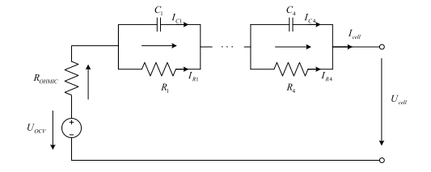
Figure 3.7 Equivalent circuit battery model
- DC/DC converter module setting
The AVL Cruise M software allows users to select the DC/DC converter model in either the voltage or current control mode. The DC/DC converter's internal model in voltage control mode is shown in Figure 3.8, and the calculation method is shown in Figure 3.9. The software calculates the current based on the output voltage and the output power requirement. When the voltage, current, and power are all within an appropriate range, the efficiency determines the power demand at the input.The battery's output voltage and input power demand are combined to determine the battery's expected output current.
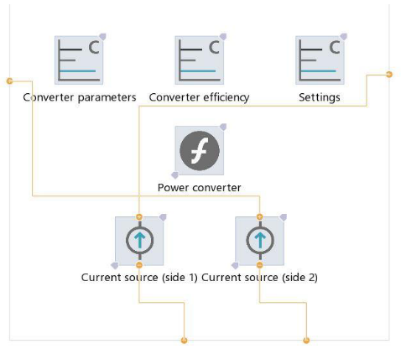
Figure 3.8 Internal Model of DC/DC Converter in Voltage Control Mode
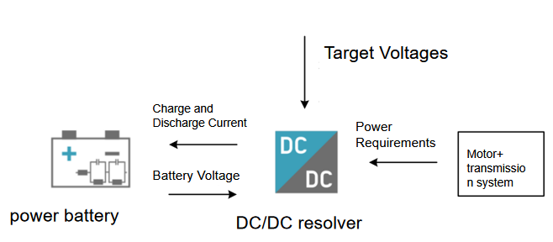
Figure 3.9 Calculation Principle of Voltage Control Mode
Fig. 3.10 shows a different calculation approach that uses the output voltage and current to determine the vehicle's current power consumption, even though the current control mode and the voltage control mode of the DC/DC converter have a similar structure. When the voltage, current, and power are all within a reasonable range, the inverter efficiency is used to calculate the power demand at the input. The battery's output voltage and input power define how much current the battery should generate.
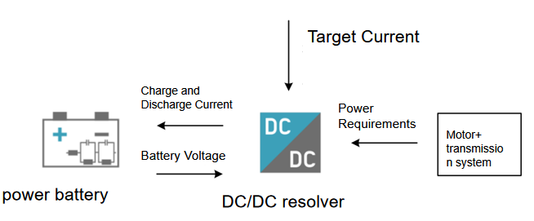
Figure 3.10 Current Control Mode Calculation Principle

Cab And Calculation Task Module Setup
The cab model connects the driver model to the vehicle model and, in the case of the driver model component, to the other components only via the data bus (databus). In the cab model it is possible to set the manual and automatic modes of the gearbox, define the throttle characteristics, etc., and provide driving information for the powertrain.
In the computational task module, it mainly consists of the driver module, the environment module and the road spectrum module. The driver module imitates the driver's behaviour as much as possible, and defines the driving behaviour through different input data, including acceleration behaviour, gear shifting behaviour and braking behaviour. The environment module characterises the environment and driving conditions according to the driving distance and time, and can define the instantaneous atmospheric pressure, air density and current ambient temperature according to the needs; the input data of the module is the driving distance, and the output is the friction coefficient of the road. The road spectrum module can import a fixed road spectrum configuration file, and select the road spectrum according to different models and simulation requirements. The model is simulated under full load acceleration conditions, and the dynamics simulation test of the model can be finished using the full load acceleration task module rather than the road spectrum module.
Figure 3.11 illustrates the signal link between the computing workload and the entire vehicle in the whole vehicle performance simulation model. The road spectrum module's driver module receives the signals from the accelerator and brake pedals. These signals are then passed from the driver module to the driver's cab module, which sends the load rate and brake pressure signals to the motor and brake modules to finish controlling the motor and brake.

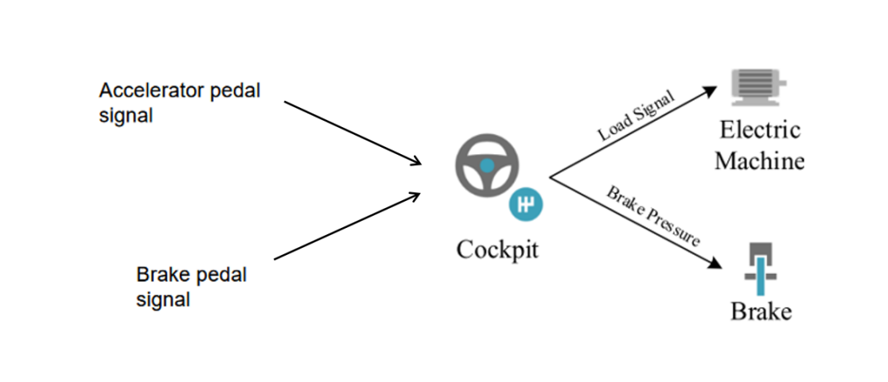
Figure 3.11 Signal relationship between computational tasks and the whole vehicle

Vehicle Modelling
The finished vehicle model is displayed in Fig. 3.12 based on the vehicle's layout and the connections between its essential parts. According to the rear-drive layout and the positioning and coupling of important mechanical parts in Section 3.3, the vehicle's mechanical portion is constructed.


Figure 3.12 AVL Cruise M Complete Vehicle Model
Due to the need to simulate and analyse the dynamics index and pure electric range of the whole vehicle after the whole vehicle model is built, all the energy is provided by the power battery, and the calculation task is set to the Full Load Acceleration condition, which can be set in the Full Load Acceleration module.

Simulation Verification Of Matching Results For Fuel Cell Vehicles
City buses travelling in the urban road, the whole vehicle mass is large and the actual situation of the road in different cities is very different, to ensure the dynamics of the city bus can greatly increase the applicability of the city bus vehicles. The simulation calculation of vehicle dynamics includes the calculation of maximum speed, 0-50km/h acceleration time and maximum gradient of fuel cell vehicle. Full load acceleration (Full Load Acceleration) task module is used to set up the full load acceleration condition, and the dynamics index of the fuel cell vehicle is calculated according to the simulation results of the whole vehicle model. The speed and acceleration curves of the whole vehicle are shown in Fig. 3.13.
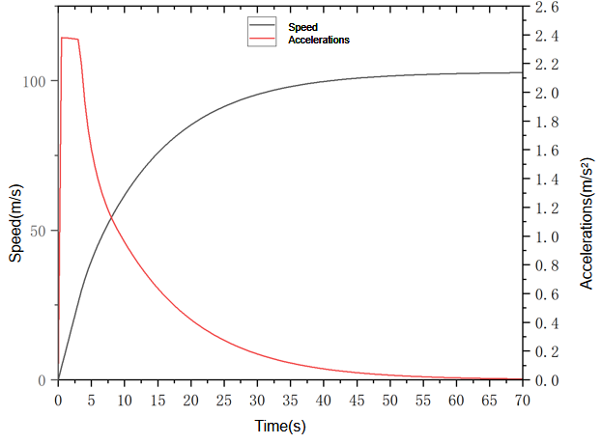
Figure 3.13 Vehicle Acceleration Curve
The vehicle acceleration simulation calculation process takes 71s.At 7s, the vehicle speed reaches 50km/h, that is, the vehicle acceleration time of 0-50km/h is 7s, and the maximum speed is 102.72km /h. The acceleration curve conforms to the acceleration law of the vehicle. In the front part of the simulation, according to the acceleration curve, it can be seen that the acceleration is very large, indicating that the motor has a large torque in the low speed stage and provides a large angular velocity during starting. After 20-50s, the entire vehicle exhibits good acceleration performance as its acceleration steadily drops and eventually achieves its maximum speed after 65 seconds.
Figure 3.14 shows the simulation of the whole vehicle gradient curve, in the simulation of 3.5s, the vehicle can reach the maximum gradient of 21.57%, at this time the vehicle speed data can be found in the vehicle speed of 19km/h.It shows that the vehicle has a good climbing degree in the time from starting to reaching the speed of 19km/h, and it also shows that the motor has a high power reserve in this period of time, which indicates that the fuel cell hybrid vehicle has a good dynamics for the actual operating conditions of urban buses.
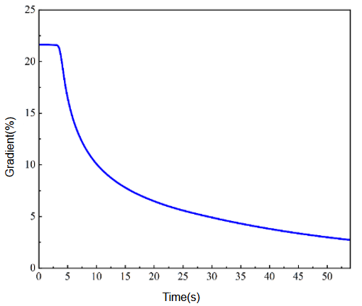
Fig. 3.14 Maximum gradient curve of the whole vehicle under full load condition
The simulation adopts isokinetic method to test the pure electric range of the fuel cell vehicle, defines isokinetic working conditions in the profile module, the simulation speed is 15km/h, the energy source is only the power battery, and the initial SOC of the power battery is set to 80%, and the curve of driving range and battery SOC is shown in Fig. 3.15.
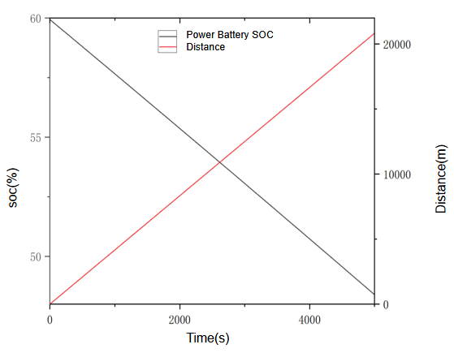
Figure 3.15 Vehicle mileage-battery SOC curve
The vehicle mileage-battery SOC curve simulation stops at 5000s, and the fuel cell vehicle mileage reaches 20 km at 4800s. When the vehicle starts, the speed is quickly stabilized at 15km/h, and the power battery needs to provide a large instantaneous power. Therefore, the SOC of the power battery decreases rapidly in a short period of vehicle start-up. The power battery's state of charge (SOC) drops linearly once the vehicle speed has been quickly stabilized. After 4800 seconds of simulation, the power battery's state of charge drops to 48.86%. A pure electric endurance of 107.62 kilometers can be attained when the power battery's state of charge (SOC) falls between 80% and 20%, based on the power battery's downward trend under these circumstances.Table 3.7 displays the comparison between the goal values and the simulation results produced for the entire vehicle.
Table 3.7 Comparison between simulation results and target values of the whole vehicle
Performance Indicator | target value | simulation value
Maximum speed [km/h] | 69 | 102.72
0-50 km/h Acceleration time [s] | 10 | 8
Maximum gradient (at 15 km/h) [%] | 18 | 21.57
Pure electric range [km] | 100 | 107.62
It is evident that all four indicators' simulation values satisfy the goal value specifications. The pure electric endurance mileage simulation value is higher than the 7.62 km target value. While the simulation value of the vehicle's maximum speed is 33.72 km/h higher than the target value, the simulation value of the vehicle's 0–50 km/h acceleration time is 2 seconds higher. Because the torque and power requirements of the motor that satisfies the acceleration condition are higher than the power requirements of the maximum speed during the motor matching calculation, the vehicle's maximum speed increases once the motor that satisfies the acceleration and climbing conditions is matched.

Research On Rule-Based Energy Management For Fuel Cell Vehicles

Analysis Of Energy Management System And Working Mode Of Fuel Cell Vehicles
As illustrated in Figure 4.1, the fuel cell hybrid vehicle's control system relies on the driver's shift, acceleration, and braking signals, which are sent to the controllers of each component over the CAN bus to accomplish component control. To fulfill the car's power needs, the overall fuel cell hybrid vehicle control system distributes the output power of the fuel cell and power battery based on the vehicle's current operating condition and the driver's operational data.
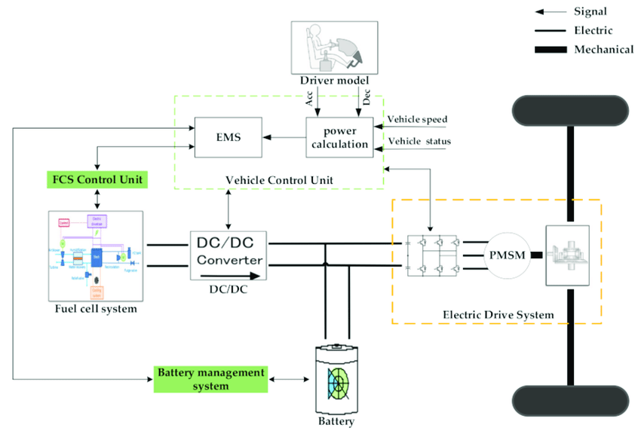
Fig. 4.1 Schematic diagram of the control system of a fuel cell hybrid vehicle
The goal of fuel cell hybrid vehicle energy management system design is to increase economy while maintaining overall vehicle dynamics. Generally speaking, energy management system design follows these principles:
- Minimize fuel cell power output fluctuations and switching times.
- Ensure that the power battery works within a reasonable SOC range.
- City buses require high braking frequency during driving due to the characteristics of urban road conditions.
Pure electric drive mode, hybrid drive mode, vehicle charging mode, and energy recovery mode are the four general categories into which the entire vehicle can be divided for the various operating conditions that occur during fuel cell vehicle driving: pure electric drive mode, hybrid drive mode, traveling charging mode, and energy recovery model.

Research On Energy Management Strategy Based On Multi-Point Control

Construction Of Energy Management Strategy Based On Multi-Point Control
Thermostat-based energy management is the most popular rule-based energy management strategy. The process of the thermostat-based energy management approach is shown in Figure 4.2. This approach uses a fixed power for the fuel cell and controls the running state of the fuel cell system according to the charge level of the power cell.
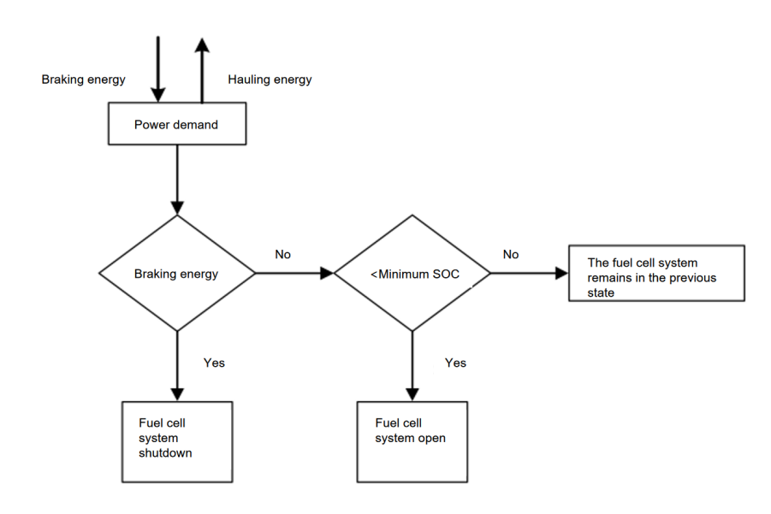
Figure 4.2 Thermostat Strategy Workflow Diagram
Different fuel cell operating points are designed based on the power cell's SOC interval; when the power cell is in the low SOC interval, the fuel cell should operate in the larger power zone to quickly charge the power cell to the moderate SOC region. The multi-point control energy management strategy is designed to optimize the thermostat strategy. To keep the power cell from overcharging, the fuel cell either runs in a lower power zone or shuts down when the power cell is in the high SOC zone. The design of energy management strategy based on multi-point control is shown in Fig. 4.3, and the input variables are vehicle demand power P_{d}, brake pedal formation β, and power battery SOC, where β<0 represents the driver stepping on the brake pedal, and the vehicle strategy determines whether to enter the braking energy recovery stage according to the current battery SOC value, and P_{mb} indicates the power of the motor to charge the power battery when braking energy recovery is in progress. In the driving mode (β=0), when the power cell SOC is 45% and below, in order to make the power cell SOC quickly recover to a higher level, the fuel cell output power is selected to be turned on to the maximum, and with the gradual increase of the power cell SOC, the fuel cell output power is gradually reduced, and when the power cell SOC is greater than the set maximum, the fuel cell stack is turned off.
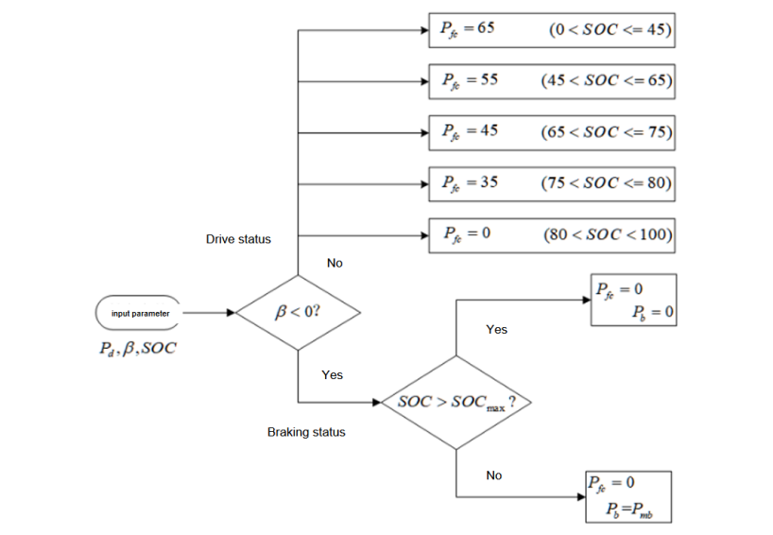
Figure 4.3 Workflow diagram of multi-point control strategy
When β<0, the system is in braking state, at this time, if the power battery SOC is less than the set maximum value, then the power battery will be charged according to the braking recovery power of the motor.

Simulation Condition Selection
According to the basic parameters of the selected fuel cell hybrid city bus, the simulation test of the whole vehicle should use the working conditions of heavy commercial vehicles. The‘Test Method for Energy Consumption of Heavy Duty Hybrid Electric Vehicles’ is applicable to hybrid electric vehicles with a maximum gross mass of more than 3500kg, which stipulates the test method for energy consumption of heavy duty hybrid electric vehicles. For city buses, according to the national standard, the simulation should be carried out using the typical city bus cycle (CCBC) conditions in China, the detailed information of the CCBC conditions is shown in Table 4.1, and the speed-time curve of the CCBC cycle is shown in Fig. 4.4.
Table 4.1 CCBC working condition details
travel time | 1314s
Travel distance | 5.8km
Average speed | 15.9km/h
top speed | 60km/h
maximum acceleration | 0.914m/s²
Maximum deceleration | 1.543m/s²
idle time | 762s
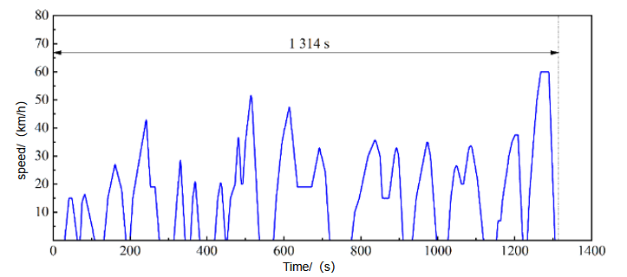
Figure 4.4 CCBC Condition Curve
The second working condition is ‘China's Vehicle Travelling Conditions Part 2: Heavy Commercial Vehicles’, in which the heavy commercial vehicle travelling conditions (CHTC), China's city bus travelling conditions (CHTC-B) are applicable to city buses with a maximum design gross mass of more than 3500kg, including two speed intervals for low speed (part 1) and high speed (part 2), with a total duration of 1310s, and the curve is shown in Fig. 4.5, and the characteristics of the curve are shown in Table 4.2.
Table 4.2 Statistical Characteristics of CHTC-B Condition Curve
Characteristics | Total | Part 1 | Part 2
Running Time [s] | 1310 | 399 | 911
Mileage [Km] | 5.49 | 0.74 | 4.75
Maximum Speed [Km/h] | 45.60 | 28.70 | 45.60
Average Speed [Km/h] | 15.08 | 6.71 | 18.75
Operating Average Speed [Km/h] | 19.43 | 10.06 | 22.78
Average Acceleration In The Acceleration Section [m/s²] | 0.48 | 0.45 | 0.49
Average Deceleration Speed In Deceleration Section [m/s²] | -0.54 | -0.47 | -0.57
Relative Positive Acceleration [m/s²] | 0.17 | 0.16 | 0.17
Percentage Of Acceleration [%] | 29.16 | 22.81 | 31.83
Reduction Ratio [%] | 25.88 | 22.06 | 27.55
Equalization Ratio [%] | 22.60 | 21.80 | 22.94
Idle Ratio [%] | 22.37 | 33.33 | 17.67
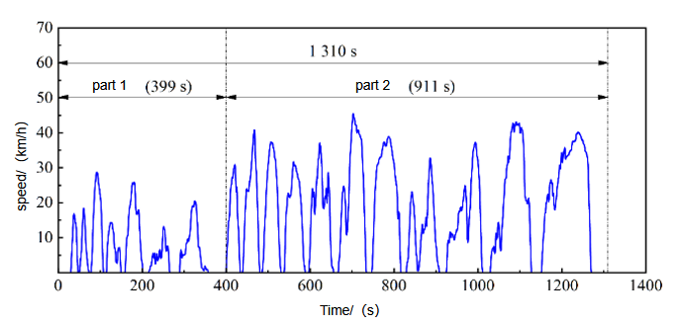
Figure 4.5 CHTC-B Condition Curve
The world transient vehicle cycle ( C-WTVC ) is a global driving cycle developed by the United Nations Economic Commission for Europe ( UNECE ). Its purpose is to provide a standardized test method for measuring emissions and fuel efficiency of heavy vehicles for cross-country comparison. While C-WTVC provides a global standard, localized cycles like CCBC and CHTC-B provide more accurate data for buses operating within China, particularly on emissions from urban areas where driving conditions are significantly different from those in Western countries.Table 4.3 is the basic situation of the three conditions.
Table 4.3 The basic situation of three working conditions
Drive Cycle | Purpose | Key Characteristics | Implications
CCBC | Tests city buses in urban China | Low speeds, frequent stops, high idling | Focused on emissions and energy efficiency under urban conditions
CHTC-B | Evaluates heavy-duty buses in mixed routes | Higher speeds than CCBC, less idling | Useful for broader heavy-duty vehicle applications across mixed urban/intercity routes
C-WTVC | Global standard for heavy-duty vehicles | Mixed urban, rural, and highway | International benchmarking, global standards compliance

Co-Simulation Model Setup
The fuel cell controller in the rule-based energy management strategy model is shown in Fig. 4.6. Brake pedal travel, current vehicle speed, vehicle demand power, and power cell state of charge are among the inputs that the controller receives. The vehicle's real-time speed corresponds to the road map speed, which is provided by the vehicle's road map. In order to complete scheduling and managing the fuel cell, the energy management strategy model then calculates the vehicle's real-time demand power based on the vehicle's real-time speed and assesses the fuel cell's operating condition and output power size based on the battery's condition, the vehicle's current demand power, and its braking demand.
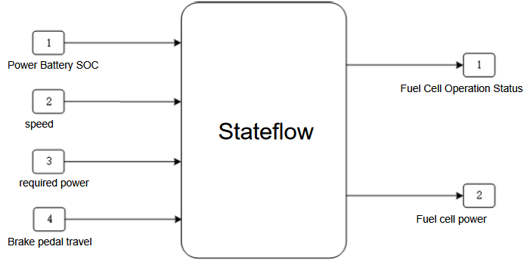
Figure 4.6 Fuel Cell Controller Model
Stateflow constructs the fuel cell output power state machine and on/off logic, and its graphical language makes it simple to create the state transfer diagram. The fuel cell operation state control and multiple operating point control must be completed by embedding the fuel cell operation state logic into the Simulink model of the energy management strategy in order to fulfill the control function.
Some of the functions in the energy management strategy are implemented in custom Function modules in AVL Cruise M. The motor drive mode and torque control modules are implemented by the written motor control and torque control modules, the motor drive control function is implemented by the eDrive Control wrapper module, the motor torque limiting module is implemented by the TM Control wrapper module, and the two The signal relationship between the two modules is shown in Figure 4.7.
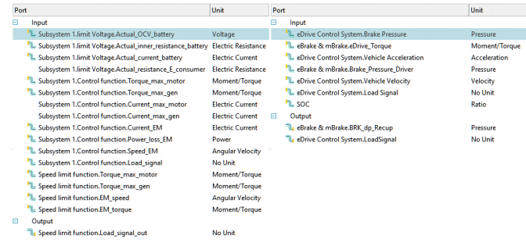
Figure 4.7 Signal connections for motor drive and torque control module
The energy management strategy model built in Simulink needs to be co-simulated with AVL Cruise M, which provides various co-simulation methods, including FMU, CMC Interface, etc., and the FMU module provides the import function of third-party software under the FMI standard.The Simulink model of the energy management strategy needs to be encapsulated according to the standard to generate a ‘.fmu’ file, which is imported into the FMU module to fill in the input/output data table of the module according to the input/output quantities of the original model, and automatically generate the input/output interfaces of the databus, and then carry out the signal connection between the corresponding components through the databus. Through the data bus, the signal connection between the corresponding components is carried out to complete the joint simulation function.
According to the simulation and analysis requirements of the rule-based energy management strategy, the FMU module, eDrive Control and TM Control modules are built as shown in Fig. 4.8. After all the signals are connected, the simulation can be started.
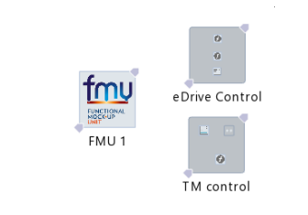
Figure 4.8 FMU, eDrive Control and TM Control Modules

Analysis Of Simulation Results
The power battery's initial state of charge (SOC) is set at 60%, and CCBC and CHTC-B are chosen as the two working conditions for the simulation based on the finished joint simulation model. The power battery's initial state of charge (SOC) is 60%, and the simulation step size is 0.01 seconds. Fig. 4.9 displays the speed following outcomes for the two simulated scenarios.
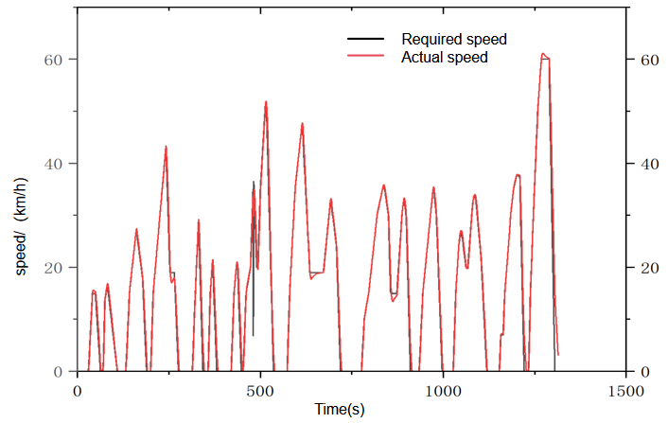
(a)CCBC condition
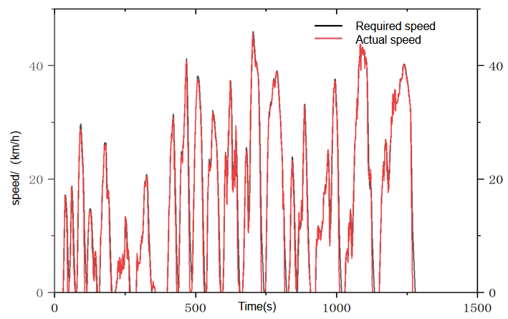
(b)CHTC-B condition
Fig. 4.9 Vehicle speed following plot based on multi-point control energy management strategy
While the CHTC-B condition's high-speed portion shows a slower speed fluctuation but a more frequent one, the CCBC condition shows a smaller speed fluctuation but a higher speed in the high-speed condition, in addition to testing the reasonableness of the vehicle power matching and the development of the energy management strategy. The simulation findings for the two conditions show that the vehicle speed follows well and that the actual speed and the target speed of the simulation conditions largely coincide. This implies that, under the multi-point control energy management technique, the vehicle can satisfy the dynamics assessment requirements and everyday use scenarios.
The power distribution outcomes under the multi-point control energy management technique are displayed in Figure 4.10. The figure shows that the power battery is currently primarily followed by the power change demand of the motor under the CCBC condition because the fuel cell's output power based on the multi-point energy management strategy is a step change, which is equivalent to the thermostat energy management strategy with multiple power points. When the motor demands a lot of power, the power battery's discharge power is mostly in charge of recharging the fuel cell, while its charging power is primarily made up of the motor's braking recovery power and the surplus fuel cell that is delivered to the motor. The efficiency of the energy management technique is demonstrated by the fact that the fuel cell, power cell, and motor all operate within its parameters.
The power distribution law between the fuel cell and the power cell is the same under the CHTC-B condition as it is under the CCBC condition. The power curve clearly shows the speed volatility under the CHTC-B condition, as well as the fuel cell's fixed-point power output and the power cell's power-following function under such a rule-based energy management strategy. The real performance of the multi-point control-based energy management strategy may be ascertained by contrasting the simulation results of the two situations. This makes it easy to compare and analyze with other energy management techniques.
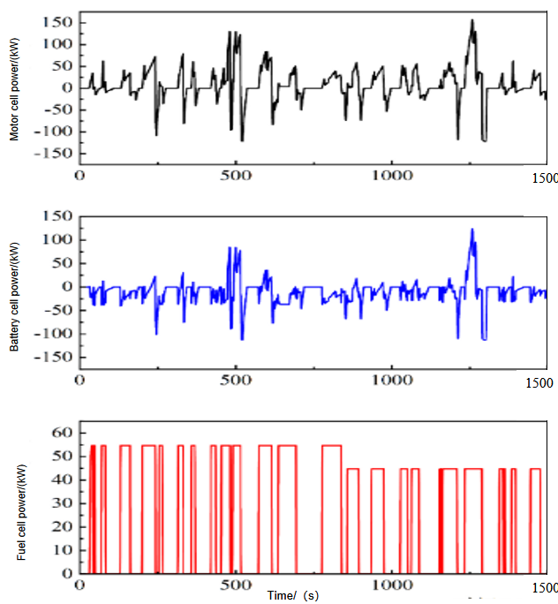
(a)CCBC condition

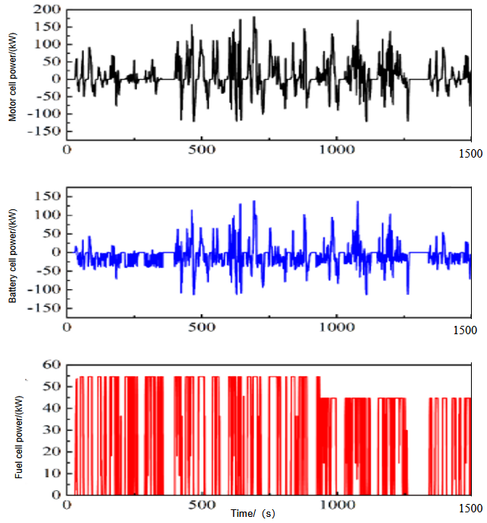
(b)CHTC-B condition
Fig. 4.10 Power allocation diagram based on multi-point control energy management strategy
It is essential to ensure that the power cell has sufficient power to handle the complex working conditions in the strategy design because the multi-point energy management strategy is primarily used by the power cell to deal with the power demand fluctuation of the vehicle during the course of travel. Figure 4.11 displays the simulation results of the power cell's state of charge (SOC) under two working conditions. Under these two working conditions, the power cell operates within the specified SOC range. The SOC rise value following the first working condition is smaller than the second one, as can be shown in the simulation process under two working circumstances. This is also consistent with the fuel cell power change rule under two working conditions. Nevertheless, the slowdown of SOC increase is not evident due to the limitations of the multi-point energy management technique, indicating that there is more opportunity for optimization in this energy management strategy.

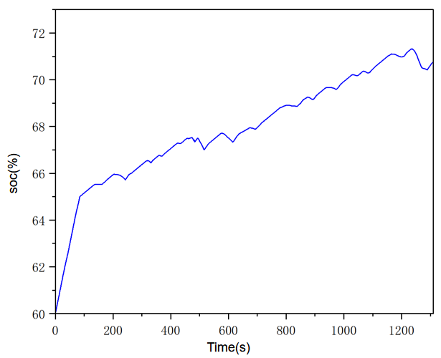
(a)CCBC condition
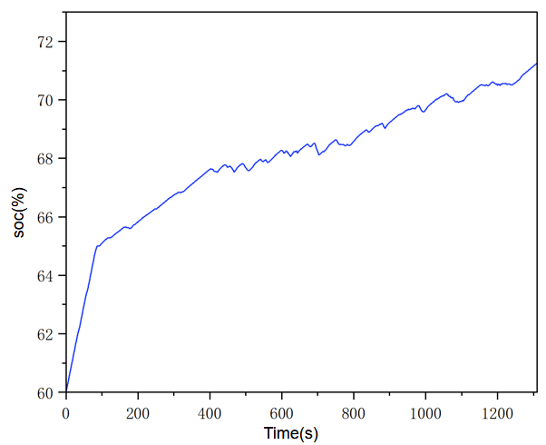
(b)CHTC-B condition
Fig. 4.11 Variation of SOC of power battery based on multi-point control energy management strategy
The cycle equivalent hydrogen consumption is calculated from the cycle hydrogen consumption calculated by the AVL Cruise M fuel cell module and from the NEC(Net Energy Change) of the power cell, which is calculated as shown in Equations 4.1-4.3
$NEC=k×[QSOC]×V$ (Equation 4-1)
$QSOC=k_{1}×\{η_{i}×\int{I_{i}dt}−\frac{\int{I_{0}}}{η_{0}}\}$ (Equation 4-2)
$V=\frac{\int{Udt}}{\int{dt}}$ (Equation 4-3)
In equations 4.1-4.3, NEC is the net energy change in kW-h; k is the unit conversion factor in kW/W. QSOC is the power battery power change at the beginning and end of the simulation in Ah; V is the average voltage of the power battery from the beginning of the simulation to the end of the simulation in V; $k_{1}$ is the unit conversion factor with the value of 3600⁻¹ in h/s; $η_{i}$ is the charging efficiency of the power battery; $I_{i}$ is the charging current of the power battery in A; t is the time in s. $I_{0}$ is the power battery discharge current in A; $η_{0}$ is the discharge efficiency of the power battery.
According to the conversion relationship between drive energy and fuel physicochemical characteristics, the power cell output energy can be partially converted to hydrogen consumption equation as follows：
$m_{H_{2}}^{2}=\frac{NEC}{k_{2}×NHV×η_{FC}}$ (Equation 4-4)
where $m_{H_{2}}^{2}$ is the equivalent fuel consumption in kg, $k_{2}$ is the unit conversion factor in kW-h/J, NHV is the low calorific value of hydrogen in J/kg, $η_{FC}$ is the average power generation efficiency of the fuel cell.
Then the equivalent fuel consumption is added to the hydrogen consumption of the fuel cell calculated by the model in the cycle to obtain the cycle equivalent hydrogen consumption of the whole vehicle Eq:
$M_{H_{2}}=m_{H_{2}}^{1}+m_{H_{2}}^{1}$ (Equation 4-5)
Under the CCBC cycle condition, the fuel cell module calculates a cycle hydrogen consumption of 1.001246kg for the electric stack and 0.984543kg for the CHTC-B cycle condition.
Substituting the simulation data into the equivalent hydrogen consumption formula, the cycle equivalent hydrogen consumption was calculated to be 0.592746kg for the CCBC case, and 0.595043kg for the CHTC-B case, which is slightly higher than that of the CCBC case. The equivalent hydrogen consumption in CHTC-B case is slightly higher than that in CCBC case. The economic indicators of the simulation are shown in Table 4.3. Based on the simulation results of the energy management strategy based on multi-point control, the power allocation and regulation of the dual energy system of the fuel cell hybrid vehicle can be further optimized during operation.

Table 4.3 Simulation economic results of energy management strategy based on multi-point control
Simulated working conditions | Circulating hydrogen consumption (kg) | Equivalent hydrogen consumption (kg)
CCBC | 1.001246 | 0.592746
CHTC-B | 0.984543 | 0.595043

Research On Energy Management Strategy Based On Power Following Control

Construction Of Energy Management Strategy Based On Power Following Control
The power following control energy management approach incorporates the design method of the thermostat rule-based energy management strategy in the formulation process to minimize fuel cell power fluctuation and keep the power cell's state of charge (SOC) from dropping too low. Under specific operational conditions, this causes the fuel cell stack's output power to remain constant. The power battery SOC is estimated to be 65% and has an operating range of 20% to 80%. This prolongs the battery's service life by causing the power battery SOC to vary around the predicted value during the course of the vehicle's drive.
According to the different SOC ranges of power batteries, the power following energy management strategies reasonably designed according to the power size of vehicle demand in different power battery SOC ranges are as follows, and its workflow is shown in Fig. 4.12:
- When SOC of power battery is more than 80%
To prevent overcharging, the power battery must be released as quickly as possible to the desired SOC. The power battery is now in charge of the vehicle's overall power. The braking energy recovery feature needs to be off concurrently. The brake energy recovery feature needs to be activated when the power battery's state of charge drops below 80%.
- When the SOC of power battery is more than 65% and less than 80%.
At this point, if the vehicle's overall energy demand is high, the fuel cell and power battery must work together to produce power; if the vehicle's overall energy demand is low, the power battery will supply all of the energy. This will cause SOC to gradually drop to the desired level, allowing the fuel cell's output power to follow the vehicle's overall energy demand and attempt to minimize power fluctuation.
- When the SOC of power battery is more than 20% and less than 65%.
In order to swiftly raise the power battery's state of charge (SOC) to the desired value and allow the fuel cell vehicle to operate in the charging mode, you can let the fuel cell generate power at a higher level while simultaneously meeting the vehicle's overall energy needs and the excess portion of the power battery's charging. This is because the SOC of the power battery is currently relatively low.
- When the SOC of power battery is less than 20%
The power battery is currently not operating within the designated SOC range. Similar to this, turning on the fuel cell power to its maximum is required to prevent harm to the power battery itself. This is done so that the power battery's SOC can be quickly restored to the designated SOC range, ensuring that the power system operates normally.
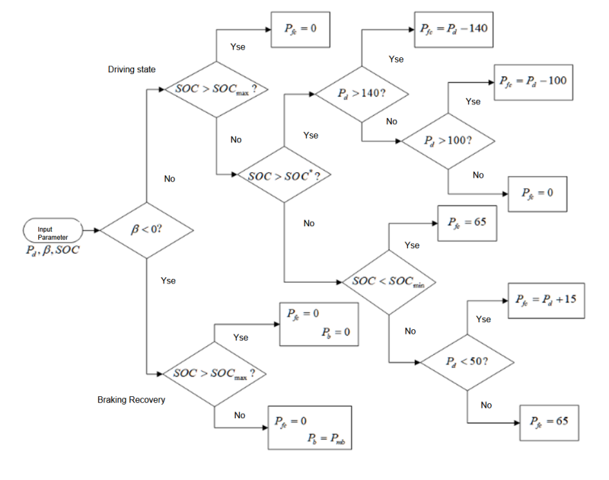
Fig. 4.12 Workflow diagram of power-following based energy management strategy

Analysis Of Simulation Results
The two operating conditions of CCBC and CHTC-B are chosen, the power-following-based energy management strategy is imported into the joint simulation platform, and the speed-following curves are displayed in Fig. 4.13. It has been demonstrated that the power-following-based energy management approach can adjust to high-speed operating conditions and power fluctuations while still meeting the needs of urban bus situations.
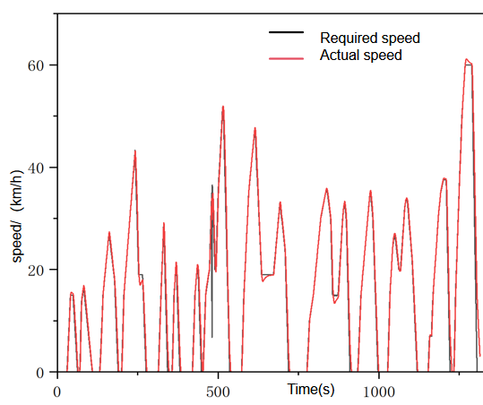
- CCBC condition
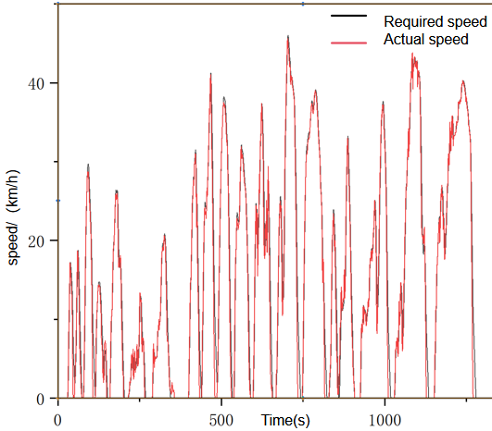
(b)CHTC-B condition
Fig. 4.13 Vehicle speed following diagram with power following based energy management strategy
The power distribution results under two simulation circumstances are displayed in Figure 4.14. As can be observed, the fuel cell primarily follows the motor's demand power when the motor's demand power is low; when the motor's demand power is high, the fuel cell produces a steady, high power output, and the power battery follows the motor's demand power. This allocation technique is consistent with the power-following energy management strategy design principle, which reduces battery output power fluctuations and assigns a portion of the power-following task to the fuel cell, making the hybrid power system's power output allocation technique more sensible.
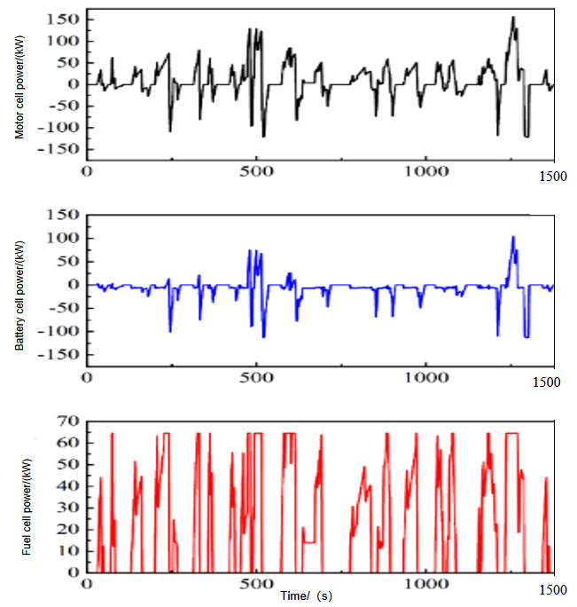
（a）CCBC condition

- CHTC-B condition
Figure 4.14 shows the results of power distribution under two simulation conditions.
The power battery's SOC curve under two simulation scenarios is displayed in figure 4.15. The design principle of the power following strategy is supported by the simulation results of the power battery SOC change under two scenarios. The power battery's SOC expectation, as set in the strategy, is 65%, but it is also evident that the original SOC was 60%. As the simulation runs, the SOC of the power battery gradually increases to the desired value under both simulation conditions, and then the SOC of the power battery fluctuates slightly around the desired value. Together with the fuel cell power and power cell power change rule that were obtained through the simulation of two working conditions, the fuel cell output power also follows the vehicle power once the power cell SOC reaches the desired value. This eliminates the need to supply the power cell with excessive power at this point, as the fuel cell's power output to the power cell is primarily utilized to stabilize the power cell SOC close to the desired value.
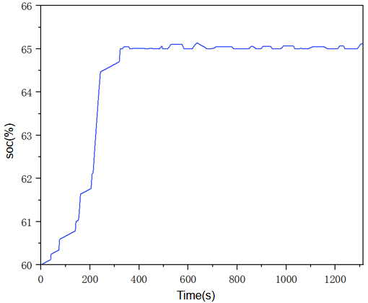
（a）CCBC condition
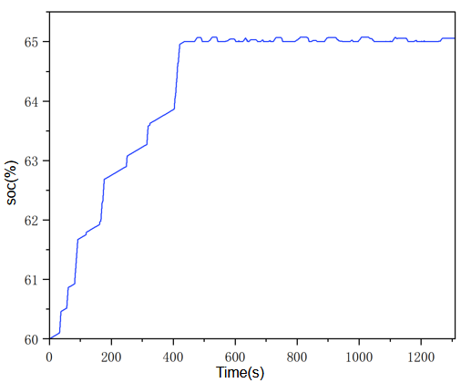
（b）CHTC-B condition
Fig. 4.15 Variation of SOC of power battery under power-following based energy management strategy
The circulating hydrogen consumption of the fuel cell under the CHTC-B condition is 0.748357 kg, which is marginally greater than the circulating hydrogen consumption of the fuel cell under the CCBC condition (0.716185 kg), per the simulation economic results of the power-following based energy management strategy in Table 4.4 below. The equivalent hydrogen consumption under the CHTC-B condition is higher than that under the CCBC condition, according to the equivalent hydrogen consumption data computed by the equivalent hydrogen consumption calculation method for the two conditions. This pattern is consistent with the simulation results under the multi-point control energy management strategy. As can be observed, the equivalent hydrogen consumption of the CCBC condition under the power following strategy is 7.99% lower than that of the multi-point control strategy, and the equivalent hydrogen consumption of the CHTC-B condition is 3.91% lower than that of the multi-point control strategy. Since the speed fluctuation is small in CCBC condition, the power fluctuation of the fuel cell is also relatively small, and the hydrogen saving effect of the power following strategy is more obvious at this time, which also shows that there is still more room for optimization of the rule-based energy management strategy.
Table 4.4 Comparison of economy under two operating conditions with power-following strategy
Simulation Conditions | Cyclic Hydrogen Consumption（kg） | Equivalent Hydrogen Consumption（kg）
CCBC | 0.716185 | 0.546285
CHTC-B | 0.748357 | 0.571757

Comparative Analysis Of Simulation Results Of Two Energy Management Strategies
The SOC change of the battery under two energy management schemes is compared in Fig. 4.16. It can be seen that in the first half of the simulation, the upward trend of the two strategies is very similar, which is due to the fact that the power-following strategy has been formulated as a result of combining the design ideas of the thermostat and the multi-point control strategy. But after attaining the target value, the power-following strategy's SOC increases more slowly and begins to oscillate within a narrow range. The power following strategy's SOC uplift value is lower than the multi-point strategy's. Because the power following strategy's power cell SOC change is more stable and can vary within a narrow range, the output power distribution between the fuel cell and the power cell is more reasonable. Additionally, the power cell provides less excess energy to the power cell, which improves the vehicle's overall economy.
It is more difficult to guarantee that the SOC change of is power battery reasonably stable in real-world working situations, and multi-point control strategies can only guarantee that the battery remains within the appropriate range. The power following strategy can modify the expected power battery SOC value for the operational settings. Once the SOC reaches the predicted value, it becomes more stable, which can, to some extent, extend the power battery's service life.

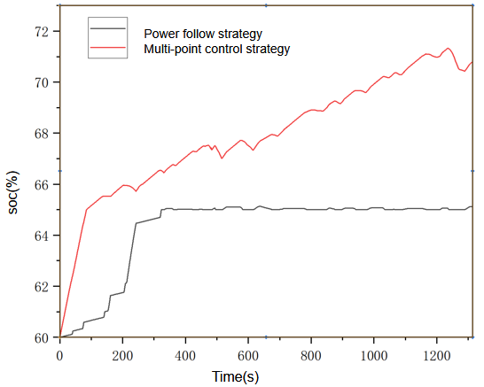
（a）CCBC condition
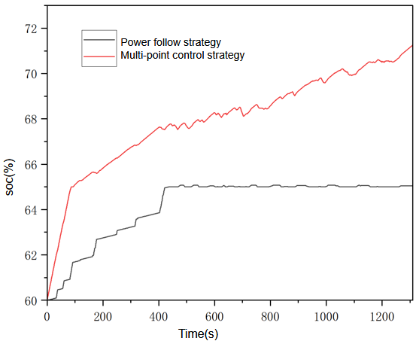
（b）CHTC-B condition
Fig. 4.16 Comparison of SOC change of power battery under two energy management strategies
Under two simulation conditions, the economic indexes are superior to the energy management strategy based on multi-point control because the power following energy management strategy can better adjust the power output mode based on the fuel cell's characteristics and ensure the reasonable use of the power battery. Table 4.5 compares the economic indexes.
Table 4.5 Comparison of equivalent hydrogen consumption between the two strategies
Simulation Conditions | Equivalent Hydrogen Consumption under Multi-point Control Strategy (kg) | Equivalent hydrogen consumption under power-following strategy (kg)
CCBC | 0.593746 | 0.546285
CHTC-B | 0.595043 | 0.571757
The CCBC case's equivalent hydrogen consumption is 7.99% lower than the multi-point control strategy's under the power following strategy, while the CHTC-B case's equivalent hydrogen consumption is 3.91% lower than the multi-point control strategy's. The rule-based energy management strategy still has more room for optimization because the speed fluctuation is minimal under CCBC conditions, which also means that the fuel cell's power fluctuation is minimal and the hydrogen-saving effect of the power-following strategy is more evident.

Research On Energy Management Strategy Based On Fuzzy Control And Its Optimization
It is challenging to guarantee economic optimization to a certain degree since the multi-point control and power following techniques are real-time and easy to implement, but they have low robustness and inflexible mode switching under specific driving situations. To further increase the fuel cell hybrid power system's energy usage efficiency, the energy management system is designed using fuzzy control theory and optimized using intelligent algorithms.

Research On Energy Management Strategy Based On Fuzzy Control

Introduction To Fuzzy Control
The process for fuzzy control is depicted in Figure 5.1. The design of the fuzzy controller is essential to achieving fuzzy control. In order to achieve the control function, the fuzzy controller must convert the input value and feedback value error input accurate quantity into fuzzy quantity. This process is known as fuzzification, and it involves using fuzzy reasoning to make decisions after processing has become clear.
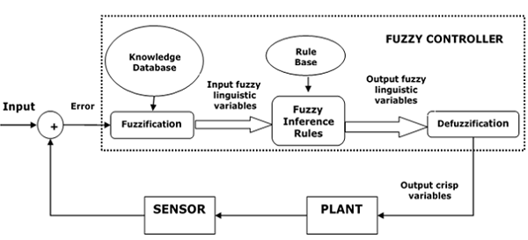
Figure 5.1 Fuzzy control workflow diagram
With a fuzzification interface that converts the input values into a fuzzy vector, a fuel cell controller is constructed based on the Mamdani type fuzzy controller (Cao, Rees, and Feng, 2001a). The fuzzy controller's knowledge base is made up of two parts: a rule base that contains the fuzzy rules that are established based on expert knowledge, and a database that has the affiliation vector values for each input and output variable. Based on the Zadeh approximation inference method, fuzzy inference produces a fuzzy quantity at the end of the inference process that must be explained and transformed into an actual control quantity in order to fulfill the control function.

Design Of Fuzzy Control Energy Management Strategy
An essential input parameter in the energy management strategy is the vehicle demand power, which is a reflection of the vehicle's present instantaneous energy demand. The fuzzy controller uses the power needed by the entire vehicle as one of its input values. The SOC of the power battery indicates the battery's operating condition, which is a crucial indicator of whether the car can recover braking energy and choose the energy source's power distribution method. Accordingly, the power battery's SOC serves as the fuzzy controller's second input value, and the fuel cell's output power serves as its output value. The vehicle model then completes the energy control of the power source based on the output power signal. In Figures 5.2 and 5.3, the fuzzy controller's input and output values as well as its structure are displayed.
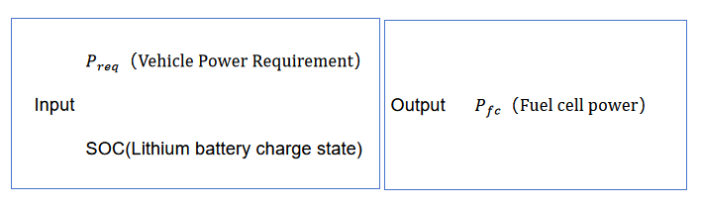
Figure 5.2 Definition of fuzzy controller inputs and outputs
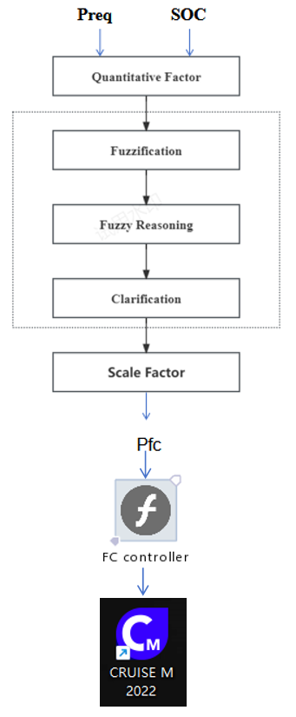
Fig. 5.3 Structure of fuzzy controller based on Mamdani inference
The fuzzy controller can be designed in the Matlab Fuzzy Control Toolbox and Figure 5.4 shows the input and output variables defined in the fuzzy inference editor.
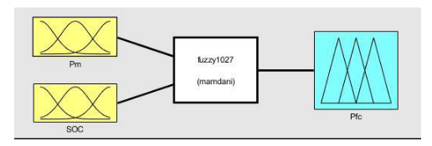
Figure 5.4 Input and output variables edited in the fuzzy inference editor
As shown in Figure 5.5 Trapezoidal and triangular affiliation functions are selected as the basic shapes of the affiliation function Adding fuzzy subsets to Pm is defined as four fuzzy linguistic variables: L, M, H, and mf, each with a different affiliation function. five fuzzy linguistic variables are also available for SOC: VLS, LS, MS, HS, and VHS. five fuzzy linguistic variables are added to IFC: VHP, HP, M, LP, and VLP, represented by different affiliation functions.
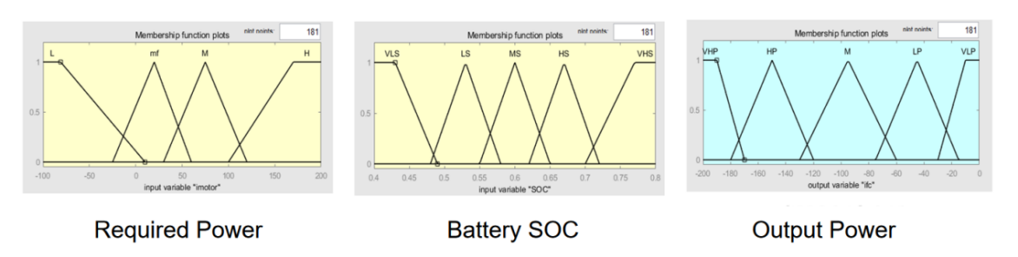
Figure 5.5 Distribution of the affiliation functions of the input and output variables are plotted
The fuzzy controller must be incorporated into the energy management strategy model by replacing the state machine, which creates the connection between the input and output values, in accordance with the rule-based energy management strategy Simulink model. There are four modes in the fuzzy control-based energy management strategy: driving, braking, idling, and halting.In drive mode, the fuzzy controller determines the fuel cell's output power based on the vehicle's input power demand and the power cell's SOC; in braking mode, the energy management strategy shifts the motor's operating mode to power generation mode in order to recover braking energy if the power cell's SOC is within a reasonable range. In order to prevent the fuel cell from starting and stopping frequently, the strategy is designed to keep the fuel cell in the low-power output idling mode and charge the fuel cell slowly. This prevents the power cell from being over-discharged, reduces the number of fuel cell starting and stopping times, and improves the stability of the power system if the power cell SOC is within the operating range and the fuzzy controller determines that the fuel cell demand is zero.

Analysis Of Simulation Results
The simulated speed following results are shown in Fig. 5.6, and it can be seen that the speed following results are good, which meets the demand of high-speed working conditions under CCBC working conditions, and also meets the requirement of speed fluctuation under CHTC-B working conditions, which illustrates that the dynamics of the whole vehicle can meet the usage requirements under the fuzzy control strategy.
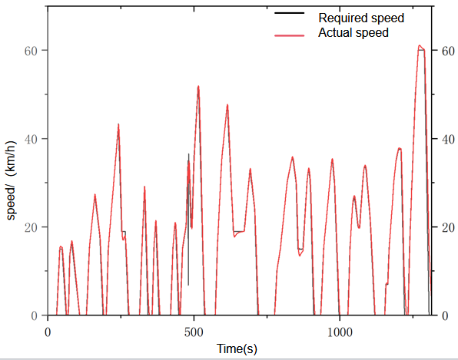
（a）CCBC condition
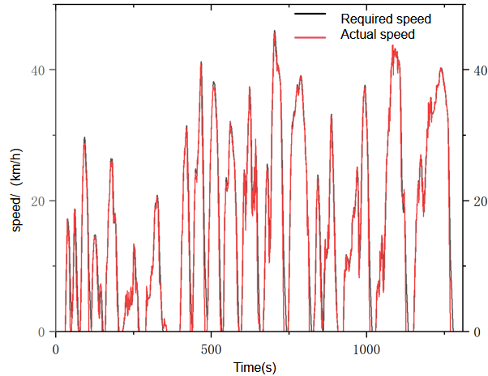
（b）CHTC-B condition
Fig. 5.6 Vehicle speed following diagram based on fuzzy control energy management strategy
Fig. 5.7 shows the power allocation results under the fuzzy control strategy. The fuel cell and power battery's power output is continuously determined by the fuzzy control technique based on fuzzy rules. Similar to the power following technique, the fuel cell and power battery share the power output to compensate for changes in the motor's demand power under different operating circumstances. The fuzzy control method The idling condition is incorporated into the design to enhance the power cell's state of charge stability and reduce the frequency of starts and stops for the fuel cell. The fuel cell output power change curve indicates that the idle power during the simulation process has the lowest fuel cell output power, which reduces the number of fuel cell start-stop times.
The average output power of the fuel cell is lower than the fuel cell power under the power following technique. The fuel cell's power output curve indicates that its output power is fixed in the low power region and fluctuates in the higher power region to accommodate changes in the motor's power demand. This power allocation makes the power cell's output power more average, allowing the energy management system to adjust the fuel cell's output power based on the vehicle's operating status when the motor's demand power varies.
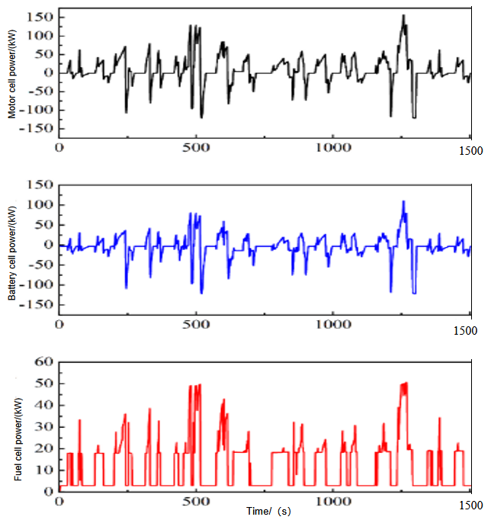
(a)CCBC condition
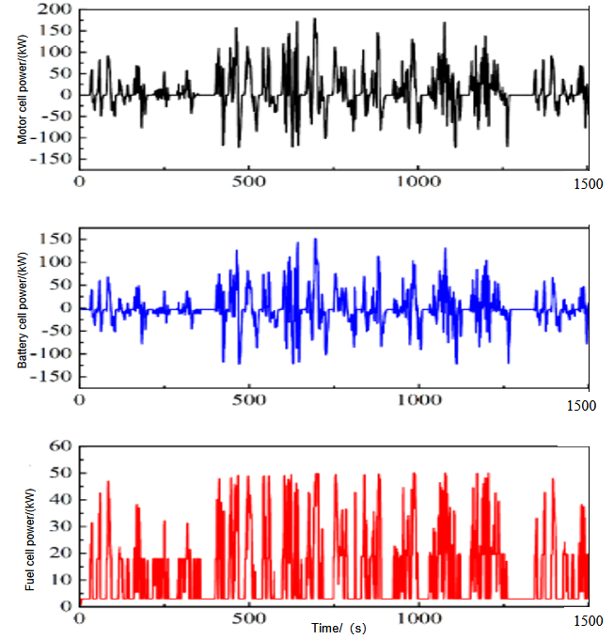
(b)CHTC-B condition
Fig. 5.7 Power allocation results based on fuzzy control energy management strategy
Fig. 5.8 shows the variation curve of power battery SOC based on fuzzy strategy. The stability of power battery SOC is improved with the fuzzy control approach. Even though the power-following-based approach can stabilize the power battery's SOC around the ideal SOC, it is impossible to predict when the vehicle will reach the ideal value from its initial value and to modify the energy management strategy in response to the actual circumstances during this time. Under the fuzzy control strategy, the vehicle controller tends to use more power when the power battery's SOC is high. Conversely, when the SOC of the power battery is low, it is also necessary to promptly replenish the battery's power in addition to meeting the vehicle's power demands. This promotes the stability of the power battery's operation, enhances the vehicle's economy, and simultaneously extends the power battery's service life.

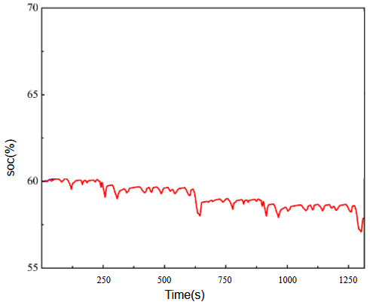
(a)CCBC condition
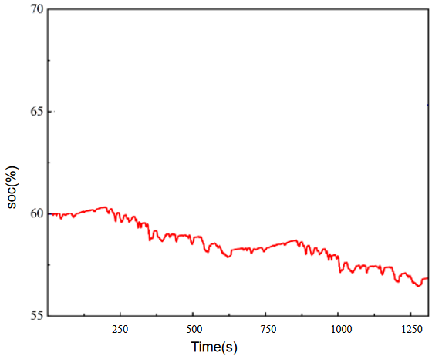
(b)CHTC-B condition
Fig. 5.8 Variation of SOC of power battery based on fuzzy control energy management strategy
The comparison of the power following strategy and the fuzzy control technique's equivalent hydrogen consumption is displayed in Table 5.1.Under the CCBC condition, the fuzzy control strategy's equivalent hydrogen consumption is 0.546285 kg, which is 25.6% less than that of the power-following strategy. Under the CHTC-B condition, the fuzzy control strategy's equivalent hydrogen consumption is 0.571757 kg, which is 20.6% less than that of the power-following strategy and slightly larger than that of the CCBC condition.
Table 5.1 Comparison of economic simulation results under different energy management strategies
Energy Management Strategy | Simulation Conditions | Equivalent Hydrogen Consumption（kg）
Power Follow | CCBC | 0.546285
Fuzzy Control | CCBC | 0.40621
Power Follow | CHTC-B | 0.571757
Fuzzy Control | CHTC-B | 0.45375

Design Of Fuzzy Strategy Optimization Algorithm Based On Particle Swarm Algorithm

Introduction To Particle Swarm Algorithms
Particle Swarm Optimization (PSO) is an iteration-based optimization technique. The particle swarm technique can quickly and effectively search for the global optimal solution since it is simple to build, has a flexible parameter change mechanism, and converges quickly. To improve optimization outcomes, particle swarm optimization will be applied to the fuzzy controller's affiliation function in this work. The particle swarm algorithm's computational flowchart is displayed in Figure 5.9.
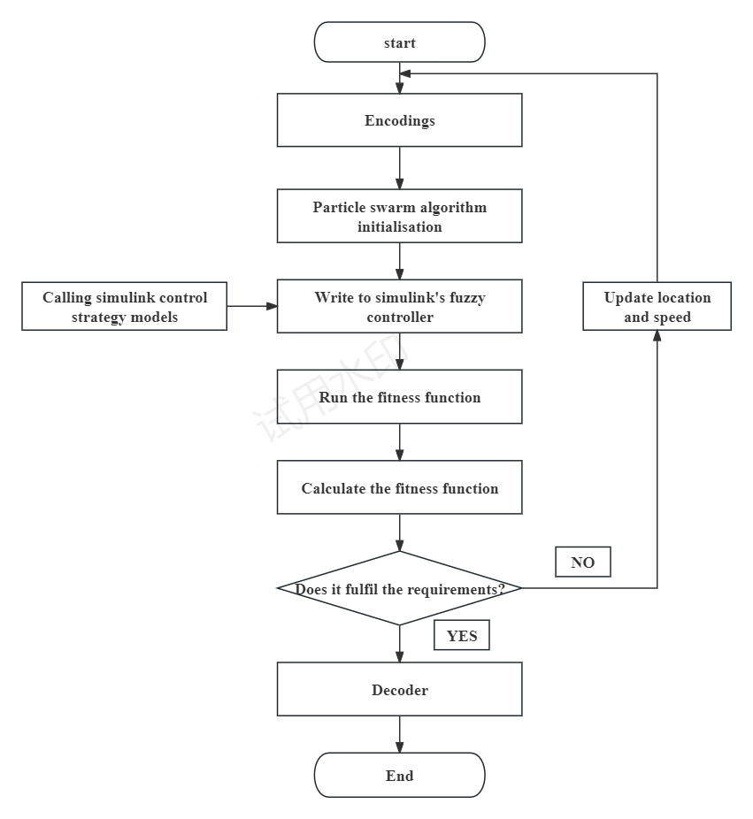
Figure 5.9 shows the particle swarm algorithm computational flowchart
In the particle swarm algorithm, the population is initialized with an arbitrary number of uncertain particles, and after searching for the optimal value, each update of the particles is based on tracking two ‘extremes’ to determine the latest position of the particles: $p_{pest}$ is the optimal value searched for each particle. $g_{pest}$ is the population optimum.Random particles get their velocity and position at the next moment by using Eq.
$v_{ij}(t+1)=w·v_{ij}(t)+c_{1}r_{1}(t)[p_{pest}−x_{ij}(t)]+c_{2}r_{2}(t)[g_{pest}−x_{ij}(t)]$ (Equation 5-1)
$v_{ij}(t+1)=v_{max}, v_{ij}(t+1)>v_{max}$ (Equation 5-2)
$v_{ij}(t+1)={−v}_{max}, v_{ij}(t+1)<v_{max}$ (Equation 5-3)
$x_{ij}(t+1)=x_{ij}(t)+v_{ij}(t+1)$ (Equation 5-4)
$x_{ij}(t+1)=x_{max}, x_{ij}(t+1)>x_{min}$ (Equation 5-5)
$x_{ij}(t+1)={−x}_{max}, x_{ij}(t+1)<x_{max}$ (Equation 5-6)
Where $v_{ij}(t+1)$ solve for the velocity of the ith particle in space in the jth dimension at generation t; $x_{ij}(t+1)$Solve for the position of the ith particle in the space in the jth dimension at generation t;$p_{pest}$ is current optimal particle position; $g_{pest}$ is the optimal position currently being explored by the population; $v_{max}$ is the maximum velocity of the particle; $x_{max}$、$x_{min}$ are the maximum and minimum values of the boundary of the current space respectively; $r_{1}$、$r_{2}$ are random number of random particles in the interval [0,1];$c_{1}$、$c_{2}$ are acceleration factors；$w$ is inertia weights.

Determination Of Initial Population And Fitness Function
- Initialization of the particle swarm algorithm
Initialize the particle swarm algorithm's parameters first, including the population size, learning factor, starting position range of each random particle in the swarm, and starting speed of each random particle between the maximum and minimum speeds. The initialization of each parameter is depicted in the following image.
（2）Constructing the fitness function
The fitness function is generally constructed from the objective function, usually the fitness function is used to evaluate the degree of merit of each individual's performance in solving the target problem. Here, the position of each particle is passed as an argument to the function to generate a fuzzy controller; the target() function is used to calculate the objective function value y(i) and store it in Y; xx and yy are used to store the current optimal position and optimal value of the individual.

Particle Swarm Algorithm Optimization Results Analysis
Figures 5.10 show the affiliation function plots of the vehicle demand power, power cell SOC and fuel cell output power for the two operating conditions after optimization.
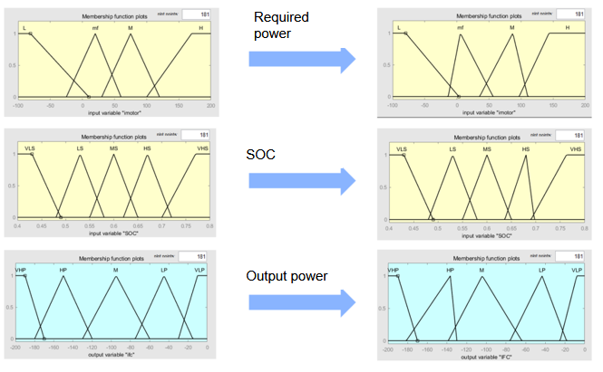
Figures 5.10 Comparison between before and after optimization of the affiliation function under CCBC conditions
Figure 5.11 shows the results of the power distribution after optimization by the particle swarm algorithm for the two operating conditions, and it can be seen that the power of the fuel cell in the low power output region is slightly less than that before optimization. When the motor needs additional power, the fuel cell may also provide energy at a greater power level.It is evident that the battery's output power is marginally higher following the particle swarm algorithm's optimization than it was prior to the optimization. This is because the affiliation function was optimized and the fuzzy control self-regulates.The power battery's output power drops as the fuel cell's output power rises, demonstrating the rationality of the optimized dual energy source's output power distribution. The power battery's state of charge curve must be examined in conjunction with the output power distribution change.
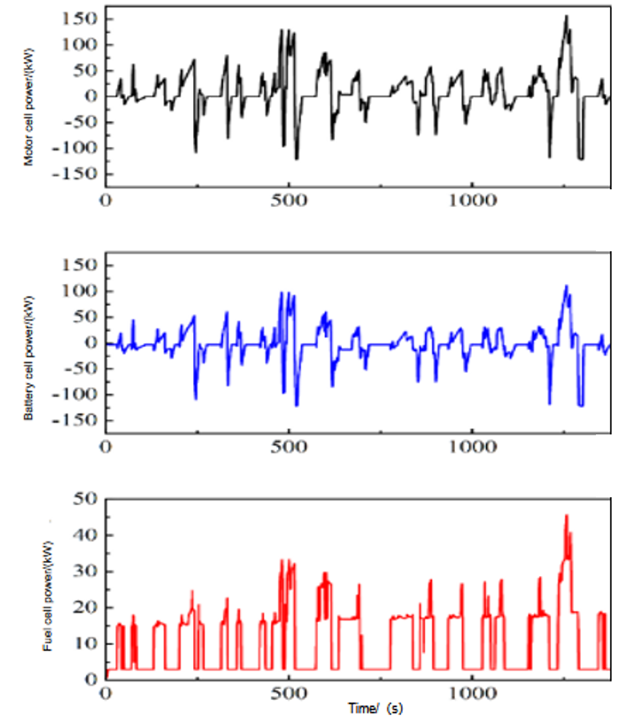
- CCBC conditions
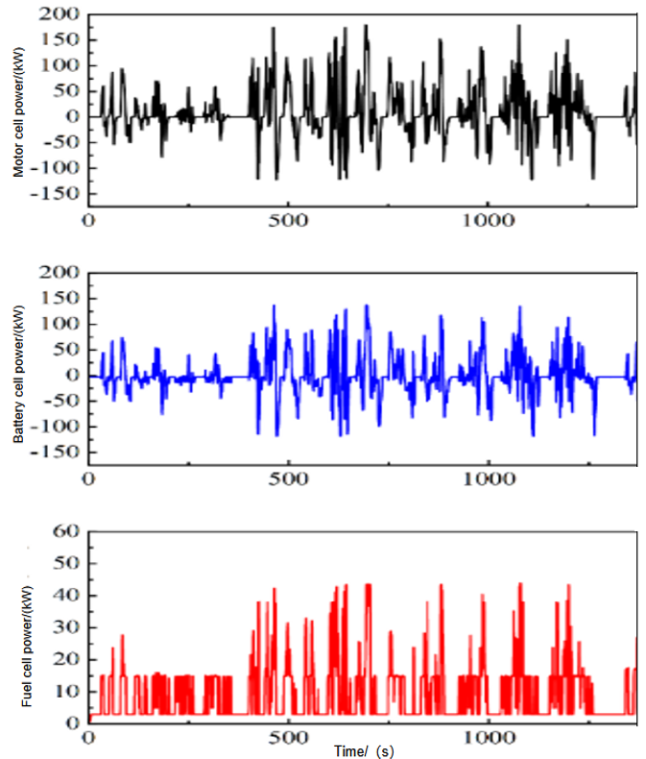
- CHTC-B conditions
Fig. 5.11 Optimized power distribution by Particle Swarm Algorithm

Comparative Analysis Of Results Of Fuzzy Control Strategies And Optimized Fuzzy Control Strategies With Particle Swarm Algorithm
Fig. 5.12 Comparison of SOC change of power battery under two working conditions. Comparison of power battery SOC changes under the above two working conditions, the amount of power battery SOC changes are reduced before optimization, but the overall trend of the SOC curve does not change much, and the overall direction is still inclined to be stable. The simulation findings demonstrate that following optimization, the dual-energy system's battery output power proportion rises, which helps to lower the percentage of fuel cells operating at high loads and low efficiency. Following optimization, the system increases the power battery's load, decreases the fuel cell's working area under high load and power fluctuation, and boosts the vehicle's overall economy. This is demonstrated by the slowing down of the power battery's SOC downward trend, which is consistent with the law that the fuel cell's output power increases in the second half of the simulation. The power battery's SOC continues to stabilize as a result of the fuzzy rules' regulation, and it is ensured that it operates within the designated range. Work. It demonstrates that the energy management method can more equitably distribute the fuel cell and power cell output power once the particle swarm algorithm has been optimized, provided that the power cell's SOC is maintained.
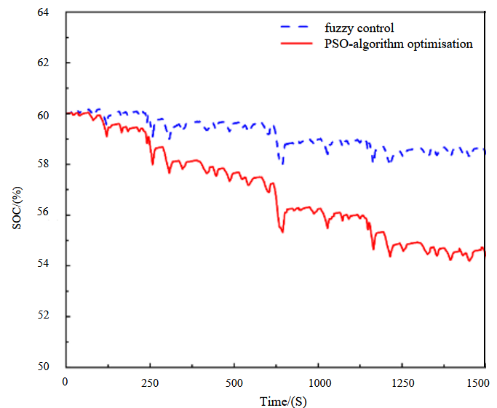
（a）CCBC operating conditions
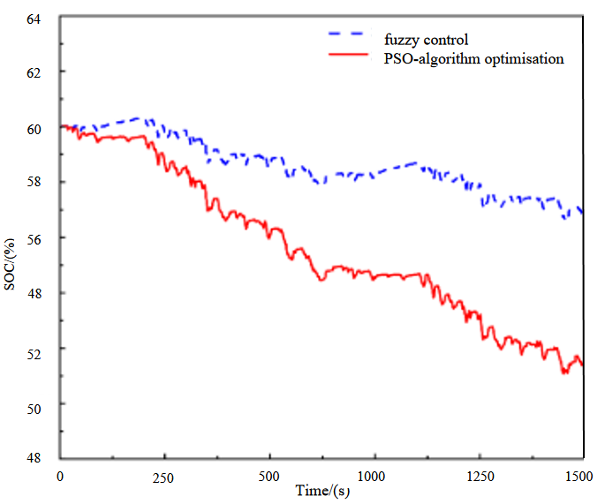
（b）CHTC-B operating conditions
Figure 5.12 Comparison of SOC change of power battery after optimization by particle swarm algorithm
The economic simulation results under the energy management approach before and after optimization using the particle swarm technique are compared in Table 5.2. It is evident that the fuel cell vehicle's cycle-equivalent hydrogen consumption decreases in both scenarios, and in the CCBC situation, the The fuel cell vehicle's overall cycle-equivalent hydrogen consumption under CCBC conditions is 0.394057 kg, whereas under CHTC-B conditions it is 0.43389 kg. These two conditions result in a 2.99% and 4.38% reduction in cycle-equivalent hydrogen consumption, respectively.
Table 5.2 Comparison of economic simulation results under different energy management strategies
Simulation Conditions | Energy Management Strategy | Equivalent Hydrogen Consumption（kg） | Hydrogen-saving Effect
CCBC | Particle swarm algorithm before optimization | 0.40621 | 2.99%
CCBC | Particle swarm algorithm after optimization | 0.394057 | 2.99%
CHTC | Particle swarm algorithm before optimization | 0.45375 | 4.38%
CHTC | Particle swarm algorithm after optimization | 0.43389 | 4.38%

Conclusions
While the main operating conditions and application scenarios of fuel cell vehicles are thoroughly studied, the basic structure of fuel cell hybrid vehicles is investigated, and the basic structure of fuel cell-power cell hybrid vehicles is finally determined based on the basic features of the three structures. Based on the fundamental parameters of a pure electric bus and the established basic structure of the fuel cell hybrid vehicle, we match and choose the fuel cell power system and identify the types and key characteristics of the electric motor, power cell, and fuel cell, respectively. The vehicle model is built in AVL Cruise M software based on the vehicle's basic configuration, basic parameters, and power system component parameters. The calculation task is set for the fuel cell vehicle's performance indexes, and the simulation results demonstrate that the power system selection and parameter matching can meet the fuel cell's design indexes, confirming the reasonableness of the matching of the entire vehicle power system.
The multi-point control and power following energy management methods are developed in Matlab/Simulink, and the two energy management strategies are simulated using a joint simulation platform that includes both the energy management strategy model and the entire vehicle model. According to the simulation results, the power-following strategy's equivalent hydrogen consumption is lower than that of the multi-point control approach by 7.99% and 3.91%, respectively, under the two simulated scenarios of CCBC and CHTC-B. Under the power-following strategy, the fuel cell can participate in the power-following task based on the vehicle's overall driving condition. This allows the power cell's state of charge (SOC) to fluctuate slightly around the desired value, improving the power system's operational stability and the vehicle's overall energy efficiency.When compared to the power following approach, the energy management method, which is based on fuzzy control theory, improves vehicle economy by 25.6% and 20.6%, respectively, under the two operating conditions of CCBC and CHTC-B, according to simulation data. The fuel cell's load is decreased, the power cell's state of charge is stabilized, and the vehicle economy is greatly increased under this energy management approach.
The fuzzy control's affiliation function is optimized using the particle swarm algorithm to further increase the energy management strategy's capacity to save hydrogen. The optimization of the particle swarm algorithm increases the overall vehicle economy by 2.99% and 4.38%, respectively, for the two operating conditions of CCBC and CHTC-B. For optimizing the fuzzy control strategy, the particle swarm method is a viable choice because of its high optimization efficiency and ability to guarantee good optimization outcomes.
Table 6.1 shows that different energy management strategies differ significantly in terms of cost, computational complexity, and difficulty of engineering realization, adapting to different application requirements. The strategy based on multi-point control is characterized by low hardware requirement and low development cost, and its logic is clear and easy to implement, but it is less adaptable to dynamic working conditions and suitable for simple and stable working condition scenarios. The strategy based on power-following control is based on real-time adjustment by dynamically tracking the load demand, with lower computational cost and engineering realization difficulty, and it can realize better energy distribution effect in the case of smooth load change, but its robustness to complex dynamic conditions is limited. In contrast, the fuzzy control strategy deals with multivariate inputs through fuzzy logic, which can better cope with the system complexity and nonlinear characteristics, and its adaptability and optimization ability are significantly enhanced. However, the strategy is highly dependent on engineers' experience, and the rule design and optimization process requires a large number of experiments and iterations. To further enhance the performance of fuzzy control, the particle swarm optimization (PSO)-based fuzzy control strategy is able to automatically adjust the fuzzy rules by introducing an intelligent optimization algorithm, which achieves efficient energy management for complex dynamic systems. However, this method requires higher computational power and development investment, and the difficulty of engineering applications is significantly increased. Overall, multi-point control and power following control are suitable for simple working conditions and low-end and mid-range applications, while fuzzy control and its optimization strategy are more suitable for complex systems and high-performance scenarios, especially in the field of high energy efficiency and economic requirements, which provides an important research direction for intelligent energy management.

Table 6.1 Comparison of four energy management strategies in terms of monetary cost, computational cost, and engineering difficulty in adapting/applying the solution
Types of Energy Management Strategies | Cost of money | Calculation of costs | Adjustment/application difficulty | Applicable Scenarios
Energy management strategy based on multi-point control | Low | Low | Middle | Simple and stable working conditions
Energy management strategy based on power following control | Middle | Middle | Low | Smooth dynamic conditions
Energy management strategy based on fuzzy control | Middle | Middle | Middle | Complex non-linear conditions
Energy management strategy based on particle swarm optimization algorithm with fuzzy | High | High | High | Demanding, dynamic and complex working conditions

Reference
Álvarez Fernández, R. et al. (2018) ‘Fuel optimization strategy for hydrogen fuel cell range extender vehicles applying genetic algorithms’, Renewable and Sustainable Energy Reviews, 81, pp. 655–668.
Available at: https://doi.org/10.1016/j.rser.2017.08.047
Barbir, F. and Yazici, S. (2008) ‘Status and development of PEM Fuel Cell Technology’, International Journal of Energy Research, 32(5), pp. 369–378.
Available at: https://doi.org/10.1002/er.1371
Bayat, M. et al. (2023) ‘Fuel cells basics and types’, Handbook of Thermal Management Systems, pp. 371–399.
Available at:https://doi.org/10.1016/b978-0-443-19017-9.00019-2.
Bourouis, B., Djeghloud, H. and Benalla, H. (2020) ‘An innovative algorithm for a hybrid FC/Battery System Energy Management’, Electrical Engineering &amp; Electromechanics, 0(6), pp. 35–44.
Available at: https://doi.org/10.20998/2074-272x.2020.6.06.
Cao, S.G., Rees, N.W. and Feng, G. (2001a) ‘Mamdani-type fuzzy controllers are universal fuzzy controllers’, Fuzzy Sets and Systems, 123(3), pp. 359–367. Available at: Available at:https://doi.org/10.1016/s0165-0114(01)00015-x.
Chang, X., Ma, T. and Wu, R. (2019) ‘Impact of urban development on residents’ public transportation travel energy consumption in China: An analysis of hydrogen fuel cell vehicles alternatives’, International Journal of Hydrogen Energy, 44(30), pp. 16015–16027.
Available at:https://doi.org/10.1016/j.ijhydene.2018.09.099
Fathabadi, H. (2018) ‘Novel fuel cell/battery/supercapacitor hybrid power source for fuel cell hybrid electric vehicles’, Energy, 143, pp. 467–477. doi:10.1016/j.energy.2017.10.107. Available at: https://doi.org/10.1016/j.energy.2017.10.107
Kamarudin, S.K., Achmad, F. and Daud, W.R.W. (2009) ‘Overview on the application of direct methanol fuel cell (DMFC) for portable electronic devices’, International Journal of Hydrogen Energy, 34(16), pp. 6902–6916.
Available at: https://doi.org/10.1016/j.ijhydene.2009.06.013
Kim, N. et al. (2015) ‘Sufficient conditions for optimal energy management strategies of fuel cell hybrid electric vehicles based on Pontryagin’s minimum principle’, Proceedings of the Institution of Mechanical Engineers, Part D: Journal of Automobile Engineering, 230(2), pp. 202–214.
Available at: https://doi.org/10.1177/0954407015583408.
Kim, S., Shimpalee, S. and Van Zee, J.W. (2004) ‘The effect of reservoirs and fuel dilution on the dynamic behavior of a Pemfc’, Journal of Power Sources, 137(1), pp. 43–52.
Available at: https://doi.org/10.1016/j.jpowsour.2004.05.035
Liu, X., Diallo, D. and Marchand, C. (2011) ‘Design methodology of hybrid electric vehicle energy sources: Application to Fuel Cell vehicles’, International Journal of Automotive Technology, 12(3), pp. 433–441.
Available at: https://doi.org/10.1007/s12239-011-0051-7
Lohse-Busch, H. et al. (2020) ‘Automotive fuel cell stack and system efficiency and fuel consumption based on vehicle testing on a chassis dynamometer at minus 18 °C to positive 35 °C temperatures’, International Journal of Hydrogen Energy, 45(1), pp. 861–872.
Available at: https://doi.org/10.1016/j.ijhydene.2019.10.150
Ogawa, T., Umayahara, K. and Ikogi, Y. (2019) ‘Development of Fuel Cell (FC) system for New Generation FC Bus’, SAE International Journal of Advances and Current Practices in Mobility, 1(2), pp. 782–786.
Available at: https://doi.org/10.4271/2019-01-0372
Olivier, J.-C. et al. (2017) ‘Multiphysics modeling and optimization of the driving strategy of a light duty fuel cell vehicle’, International Journal of Hydrogen Energy, 42(43), pp. 26943–26955.
Available at: https://doi.org/10.1016/j.ijhydene.2017.06.243
Pischinger, S., Schönfelder, C. and Ogrzewalla, J. (2006) ‘Analysis of dynamic requirements for fuel cell systems for vehicle applications’, Journal of Power Sources, 154(2), pp. 420–427.
Available at: https://doi.org/10.1016/j.jpowsour.2005.10.037
Pollet, B.G., Staffell, I. and Shang, J.L. (2012) ‘Current status of hybrid, battery and Fuel Cell Electric vehicles: From electrochemistry to market prospects’, Electrochimica Acta, 84, pp. 235–249.
Available at: https://doi.org/10.1016/j.electacta.2012.03.172
Sulaiman, N. et al. (2015) ‘A review on Energy Management System for fuel cell hybrid electric vehicle: Issues and challenges’, Renewable and Sustainable Energy Reviews, 52, pp. 802–814.
Available at: https://doi.org/10.1016/j.rser.2015.07.132
Tahri, A. et al. (2018a) ‘Management of fuel cell power and supercapacitor state-of-charge for electric vehicles’, Electric Power Systems Research, 160, pp. 89–98.
Available at: https://doi.org/10.1016/j.epsr.2018.02.003
Teng, T. et al. (2020) ‘A comprehensive review of energy management optimization strategies for Fuel Cell passenger vehicle’, International Journal of Hydrogen Energy, 45(39), pp. 20293–20303.
Available at: https://doi.org/10.1016/j.ijhydene.2019.12.202
Tie, D. et al. (2019) ‘Hybrid Energy Storage Devices: Advanced Electrode Materials and matching principles’, Energy Storage Materials, 21, pp. 22–40.
Available at:https://doi.org/10.1016/j.ensm.2018.12.018
Torreglosa, J.P. et al. (2011) ‘Hybrid fuel cell and battery tramway control based on an equivalent consumption minimization strategy’, Control Engineering Practice, 19(10), pp. 1182–1194.
|Available at: https://doi.org/10.1016/j.conengprac.2011.06.008
Wu, W., Partridge, J.S. and Bucknall, R.W.G. (2018) ‘Stabilised control strategy for PEM fuel cell and supercapacitor propulsion system for a city bus’, International Journal of Hydrogen Energy, 43(27), pp. 12302–12313.
Available at: https://doi.org/10.1016/j.ijhydene.2018.04.114
Yue, M. et al. (2019) ‘Review on health-conscious energy management strategies for fuel cell hybrid electric vehicles: Degradation models and strategies’, International Journal of Hydrogen Energy, 44(13), pp. 6844–6861.
Available at: https://doi.org/10.1016/j.ijhydene.2019.01.190
Zhang, Y. et al. (2022) ‘Parameter matching methods for Li Battery–supercapacitor hybrid energy storage systems in electric buses’, Machines, 10(2), p. 85.
Available at:https://doi.org/10.3390/machines10020085.
Zhou, D. et al. (2017) ‘A comparative study of extremum seeking methods applied to online energy management strategy of Fuel Cell Hybrid Electric Vehicles’, Energy Conversion and Management, 151, pp. 778–790.
Available at: https://doi.org/10.1016/j.enconman.2017.08.079

