FUSION 4: Amlabye Seetaram – 1715718 Francisco Pirogue -1715712 Nishad Potyram -1715713 Ravisen Ramma- 1715880
TWWIST BAR
How do we generate more revenue and enhance guest experience by the establishment of a new outlet “TWWIST BAR” within the Green Shack at Tamassa Resort? Assessing the feasibility of the implementation of the TWWIST BAR.
BMPF 4010: Work Based Project
Word Count: 1000
Date of Submission: 05/11/2019
Table of Contents
1.0 Introduction 2
1.2 Justification of the study 3
1.3 The intended impact 4
1.4 The outlined intention 4
1.5 Ethics and insider research 5
1.6 Expected group learning outcomes 5
1.7 References 5

Introduction

Tamassa Bel Ombre is an all-inclusive resort situated in the south of Mauritius, surrounded by a lush nature, a destination well designed to create experiences for all generations of guests’ being a family resort with a capacity of over 420 guests.
Tamassa resort is constructed on 23 hectares of land, where only 20% of the area currently has buildings which include guest rooms, spa, kids club, activity center, reception area, boat house, restaurants, offices and bars. Part of the landscaping includes a garden named as “green shack”, situated at the back of the spa.
The “green shack” is presently planted with herbs and some vegetables and was initially designed as a guest experience. Despite this, the meaningful location is not often frequented by guests. To add value to this area and to enhance guests’ experience, the project of Tamassa TWWIST bar will create a meaningful link between this area and the spa.
What does TWWIST indicate?

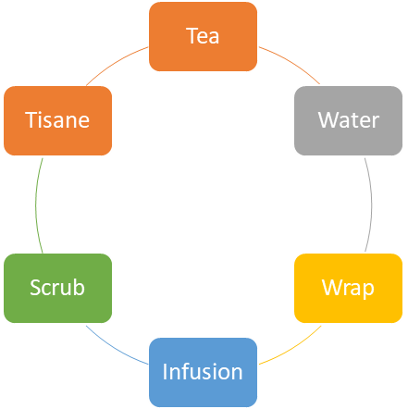
Figure 1.0
Tamassa TWWIST bar! A new approach to promote Tea, Water, Wrap, Infusion, Scrub and Tisane while using the existing plants to blend in with Tea and Water.
In order to excel in the hospitality industry nowadays, creativity and innovation are of paramount importance in the field of Spa, Wellness, Food and Beverage among other so as to exceed sophisticated customers’ expectation in the years to come.

1.2 Justification of the study
The project will encourage guests to explore and experience more varieties of beverages, spa products and wellbeing local fusion through the blending of water and tea. The project will help to transform the 'green shack’ into a revenue generating experience through tea, water, wrap, infusions and tisane. The wrap and scrub will be further purchased through recommendations to further personalised spa treatments with natural and raw ingredients. This project will also help to create new job opportunities as a new job position, specialised on tea and water.
A water and tea sommelier would need to be created for Tamassa resort and THE LUX COLLECTIVE, to create the link to the healthiest beverages which will change the view on water consumption on a global level. ( Martine Riese MR, [2015])

Furthermore, it will help to boost our local tea entrepreneurs; helping towards the promotion and development of local businesses in Mauritius.
The study and statistics for the market forecast demand for 2019 has been found using the figures of satistita.com (Statista provides statistics and data within 600 industries and 50 + countries). The report indicates that water and teas are the most consumed beverages in the world. Revenue in tea segment amounted to USD 214,761.7m between 2011 and 2016, the market is expected to grow annually by 6.9%. Bottled water shows a forecast of USD 286,238 m in 2019, the market is expected to grow annually by 6.4 % as indicated below in figure 1 (CB, [2019])

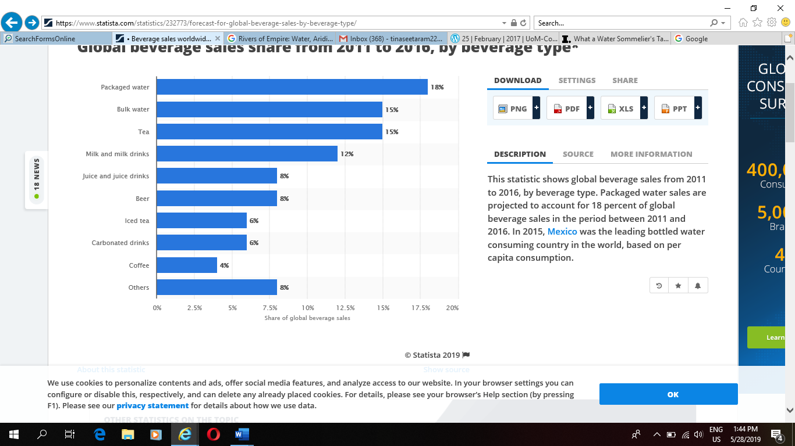
Figure 1.2

The cultivation of tea forms an integral part of Mauritian culture, as from 2000, the tea industry moved into a new phase and now covers an area of 760 hectares of tea plantation (Ministry of Agro industry and food security:( Crops tea- date of RSC 28/05/19).
The TWWIST bar will use our local tea while blending it with the remedial ingredients found in the ‘green shack’ to create awareness of the healing benefits for guest experience, and the same will be sold to generate further revenue.
Water is the most consumed liquid which helps for digestion, circulation, control of temperature of the human body and excretion of waste products. Research shows that there are many minerals in natural water, which influences the taste.

1.3 The intended impact
Nowadays, many people prefer gentler yet effective approaches for their health which carries healing benefits such as natural remedial plants, holistic medicines, raw food, organic products, aromatherapy, Ayurveda, traditional recipes amongst others to adopt for their health prevention and cures which work with the body’s own immune system, yet it is another reason why holistic medicine is growing increasingly and becoming more popular. (DW, 2016)
Tamassa TWWIST Bar will provide the guests’ a wider choice of beverages, spa treatments and products through a menu, to complete the sense of taste into a holistic and healing approach.

1.4 The outlined intention
The paper will consist of qualitative and quantitative research methods as shown below:

Guest survey
A one to one interview will be done with in house guests to obtain qualitative information while sharing had voluntarily share personal opinions.

Benchmarking
A tea sales analysis will be done within the group to determine the demand of the product for retail in the shops and online research to compare what other companies have done to promote water and teas.

Focus group
A tasting panel for local grandmother’s and inhouse elderly guest who would voluntarily like to participate in sharing their knowledge of healing ‘recipes’ and ideas.
The project proposed will be presented to the concerned departments as it requires capital and operation expenses for implementation. Same will be worked along with financial department to forecast the cost and profit.

1.5 Ethics and insider research
The questionnaire will include a cover note where guests will participate voluntarily. Collected data will be handled in a confidential manner. Quantitative and qualitative data will be collected through the surveys. A group session will be performed to review the data and the process strategy will be reviewed to ensure that the researchers remain neutral in the analysis of the results.

1.6 Expected group learning outcomes
The Tamassa TWWIST Bar will increase the researcher’s knowledge of types of remedial plants, herbs and their healing benefits as well as uses in beverages and body treatments. It will also provide an opportunity to write the process of project implementation of a new outlet.
Moreover, it will also give new insight about studying the types of water and tea quality, varieties, locally and internationally. Furthermore, the group study will bring more confidence on research and monitoring new group project through a better understanding, communication and teamwork.

1.7 References

Martine Riese MR, [2015]. what is means to be a water sommelier, America: s.n.
CB, C. B., [2019]. Global beverage sales share from 2011 to 2016, by beverage type, s.l.: s.n.
DW, D. W., 2016. Why More People Than Ever Are Embracing Holistic Medicine. Spirit of change, 18 June.
Security, M. o. A. I. a. F., [2019]. Crops - TEA CT, s.l.: s.n.

