Chapter 4 – Data Analysis

Chapter three discussed the methods for the primary research. This chapter will present the findings collected by the researcher alongside an analysis of how these findings relate to the literature discussed in chapter two.
This chapter meets the requirements to fulfil objective three:
- To analyse data collected to understand the behaviour of fast fashion consumers and whether they believe there is a need for sustainability within the fashion industry alongside steps on how this could be achieved.

The data collected was received through E-interviews via email which were conducted with ten participants who were knowledgeable and passionate about the topic area. The participants were majority female and 100% fell within the 18-25 age category. All participants who were emailed an interview sheet responded, meaning there was a successful completion rate, allowing for results to become more generalised to fast fashion consumers.

Methods
To analyse the data different software packages were used. Firstly, Microsoft Excel was used to create graphs for less in depth analysis such as gender and age. For open ended answers to qualitative questions NVivo software package was used. NVivo allows for the grouping of key words and themes and the organisation on such themes to enable the researcher to gain a better context for data collected (Dollah, Abduh & Rosmaladewi, 2017). The interview response sheets can be found in the appendix with the exception of interviewees signatures to keep confidentiality. However, understanding of the study and consent was gained prior to the sheets being sent via email.

Demographics
Within the interview questions there were two basic demographic questions; gender and age to help link respondent answers to previous research discussed in chapter two. To be eligible to take part in the interview, respondents had to be at least eighteen years old. Therefore, three age categories were provided as options; 18-25, 26-35 and 36-45. 100% of respondents were aged 18-25 which was beneficial for the study as the 18-24 age category are responsible for the majority of fast fashion sales, allowing the results found to be applied to the general fast fashion consumer market (Cavender & Lee, 2018). Participants were also asked, if they felt comfortable, to disclose their gender, for which every participant did. 90% of respondents identified as ‘female’ while 10% identified as male. As discussed in chapter three, it was expected that the sample would be predominately female due to the nature of the topic. Horton (2019) discusses how fast fashion retailers aim their products at ‘young women’ and therefore, having a majority female interview base can again allow the results to be generalised to the market.

Themes
Theme 1- Fast Fashion
For the research a purposive sample was chosen to ensure knowledge on the topic area to create meaningful results. Therefore, participants were asked to describe the term fast fashion based on their knowledge. Previous research on fast fashion as supported by Bhardwaj & Fairhurst (2010) showed that fast fashion is popular among its younger target audience due to its cheap nature, fast production and imitation of trends.
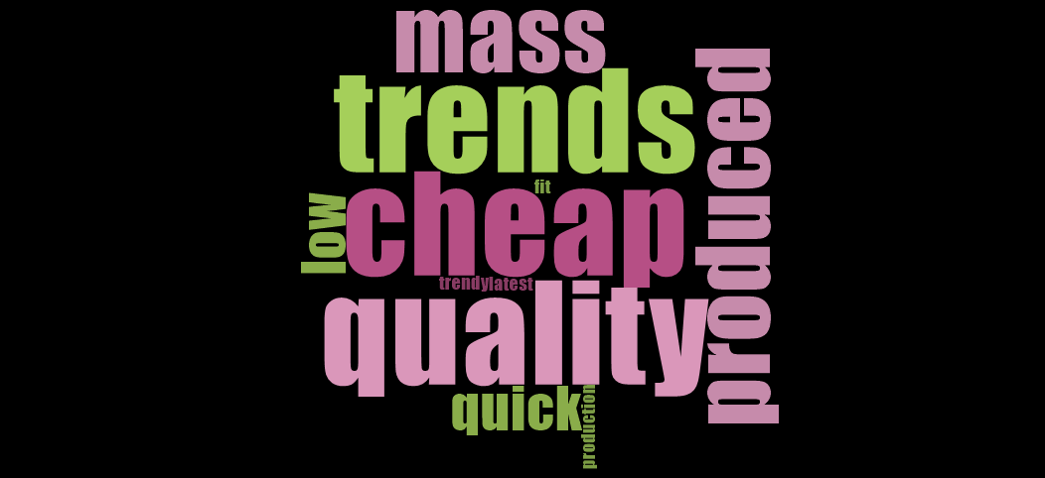
Figure 4.1 Description of fast fashion

Figure 4.1 displays a word cloud generated on NVivo showing the key terms used by interviewees when asked to describe the term ‘fast fashion’. Responses correlated with previous literature on the topic, showing that interviewees had a good knowledge and understanding of one of the main research themes. Much of these descriptions for fast fashion also doubled as reasons as to why the interviewees purchase fast fashion as a consumer which can be shown in the figure below.

Figure 4.2 Reasons for purchasing fast fashion.
Figure 2.1 shows the main reasons given to the researcher for fast fashion consumption. Half of the interviewees gave influencer marketing and the availability of discounts as the main reasons for purchasing fast fashion. Based on previous research these results are expected as Pacheco (2018) explained how fast fashion companies rely on influencers for promotion and Tapping (2014) who discusses the cheap nature of the fast fashion clothing. Khan & Malik’s (2014) previous research stated that the reason fast fashion companies are able to create pieces for low prices is due to poor fabrics and dyes being used that often end up polluting the surrounding environment. This knowledge however, is not unknown to the fast fashion consumer with 100% of respondents stating negative connotations when asked about how they feel fast fashion affects the environment which participant 9 stating:
“I think it has a horrible effect on the environment not in just the waste caused by the physical items themselves but through its factories, its methods, etc”.
This shows that respondent attitudes are aware of the dangerous effects of fast fashion. However, despite this, each respondent still purchases fast fashion on a monthly basis, ranging from once a month up to potentially eight times a month as shown in figure 4.3.

Figure 4.3: Interviewees purchasing frequency per month.
Therefore, this links to the attitude behaviour gap discussed in chapter two. Research conducted by Joergens (2006) found that despite concerns people have regarding the environmental impacts of fast fashion that often their actions do not correlate. Therefore, this study supports this finding as regular purchasing still occurs despite the level of awareness and strong emotions towards the environment. However, it is important to note that every respondent was aged 18-25 and therefore disposable income could be a barrier to the ability to purchase more expensive slow fashion products.

Theme 2 – Influencer Marketing
As displayed in figure 4.2, influencer marketing is a key tool used by fast fashion companies to promote their items. Ki & Kim (2019) stated that influencer marketing is successful as consumers can relate to them making them mimic their purchases and style. This theory proves to be the case for the interviewees within this study as 100% of respondents follow influencers on social media. Additionally, 90% of respondents stated that they followed influencers for fashion related reasons including inspiration or predictions for latest trends. Therefore, influencer marketing proves successful for the target audience. However, as influencers are heavily used by fast fashion brands and many target consumers follow them, a question was raised regarding how these influencers affect buying behaviour. 100% of respondents claimed that an influencer had made them purchase an item before with participant 6 stating the reason that
“An influencer encourages you as they produce better content than the fast fashion retailer”.
While increased sales are to be expected with marketing tactics, the concern regarding fast fashion influencer marketing is that many people often impulse buy items they did not previously want due to seeing it worn by an influencer. Figure 4.4 displays this showing that 70% of interviewees had bought items they did not previously desire due to influencer marketing. Participant 9 explained how the influencer styled a pair of shoes that they wanted which encouraged the purchase and so while the item was previously desired, the influencer created the deciding factor, encouraging the purchase.

Figure 4.4: Impulse buying behaviour
Gunawan & Iskander (2020) support this finding as they discovered a link between influencers and impulse buying behaviour. However, Green (2020) states that the promotion of fast fashion items and impulse buying feeds the fast fashion problem, leading to a throw away culture which has detrimental environmental impacts with the UK Parliament (2020) finding one million tonnes of textiles being wasted annually in the UK. However, participant 5 generated an interesting point that could contribute to the percentage of impulse buying being high, stating that
“I may have not seen the piece before seeing it on the influencer as I don’t check online shops often”
Therefore, people may use influencers for inspiration rather than scrolling through websites meaning it is not a matter of not wanting the items prior to the influencer but rather the items had not been seen before. This enables online stores to promote products to people who may never have otherwise seen their pieces. However, by targeting people who may never have bought the items prior it should be considered whether influencers are fuelling the fast fashion problem. When asked, 100% of respondents believed that influencers do increase fast fashion consumption. Figure 4.5 shows the reasons why interviewees believe this to be the case with the main beliefs being through increased inspiration and brand deals. 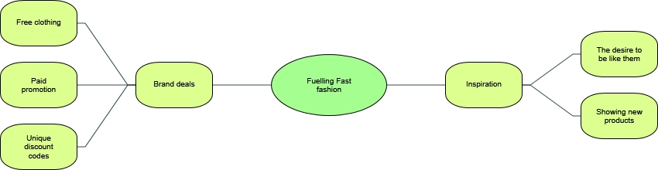
Figure 4.5: Fuelling Fast Fashion Consumption
As it has been found that influencers have a strong impact on consumer buying behaviour and fast fashion consumers believing that influencers are fuelling the industry, it should be considered if whether influencers should hold greater responsibility for promoting fashion that is bought at alarming rates and has negative impacts.
- Will discuss findings showing whether the interviewees believe influencers should be held accountable

Theme 3 – Sustainability
- Following sustainable influencers – is this as popular as standard fast fashion ones
- Have they bought sustainable fashion, why? How is it different to buying fast fashion
- Would fast fashion consumers transition to fast fashion
- What would encourage them
Conclusion
References:
Dollah, S., Abduh, A. & Rosmaladewi, M. (2017) ‘Benefits and drawbacks of NVivo QSR application’, 2nd International Conference on Education, Science, and Technology, 149, pp. 61-63.
Cavender, R. C. & Lee, M. Y. (2018) ‘Exploring the Influence of Sustainability Knowledge and Orientation to Slow Consumption on Fashion Leaders’ Drivers of Fast Fashion Avoidance’, American Journal of Theoretical and Applied Business, 4(3), pp. 90-101.
Horton, K. (2019) ‘Just Use What You Have: Ethical Fashion Discourse and the Feminisation of Responsibility’, Australian Feminist Studies, 33(98), pp. 515-529.

