Unit name: Strategic Managemnet and Sustainability

Module code: BMBM6015

Huawei Strategic Analysis and Sustainable Business Report
Prepared for: Robyn Griffiths
Written by: YI LI
Student ID: 2400195
Date submitted: 21 March 2025
Word count: 2183 words

Executive Summary
This report conducts a strategic analysis and sustainable development study on Huawei Technologies Co., Ltd（Huawei）. By PESTEL analysis and Porter's Five Forces model to analyze Huawei's external environment. And identifies challenges，such as political restrictions, economic instability, and fierce market competition. It also highlights opportunities presented by technological innovation and green development. Through the Resource-Based View (RBV) and Value Chain Analysis, the report further elaborates on Huawei's strengths in terms of research and development teams and investment, while also pointing out the disadvantage of reliance on external suppliers. SWOT analysis is used to clarify strategic positioning .The report suggests that Huawei should adopt differentiation and cost leadership strategies, and explore potential growth strategies using the Ansoff Matrix. The report proposes that Huawei should promote a green supply chain, enhance research and development, expand international cooperation and comply with local regulations to achieve sustainable development. This report provides strategic reference for Huawei and related enterprises, aiding the development of the global communication technology industry.

Contents Pages
Executive Summary
Contents Pages
1.0 Introduction 1
2.0 External Analysis 3
2.1 PESTEL Analysis 3
2.2 Porter’s Five Forces 7
2.3 Key Economic Trends Influencing Business Strategy 10
3.0 Internal Analysis 11
3.1 Resource-Based View (RBV). 11
3.2 SWOT Analysis 12
4.0 Strategy Formulation & Competitive Positioning 14
4.1 Porter’s Generic Strategies 14
4.2 Ansoff’s Matrix 15
4.3 Evaluation of M&A Activities 16
5.0 Sustainability and Strategic Recommendations 17
6.0 Conclusion 18
References 19

1.0 Introduction
Huawei is a leading enterprise in the ICT field, offering comprehensive ICT infrastructure, intelligent terminal products and services.Chen, Zhu and Tong（2023） have both shown its business includes communication technology, smartphones and cloud computing. Huawei leads in communication equipment and 5G technology.It is researching 6G technology (Figure 1). Huawei's products and services have covered 3 billion users in over 170 countries and regions. Huawei is committed to driving sustainable development through technological innovation (Huawei, 2024).
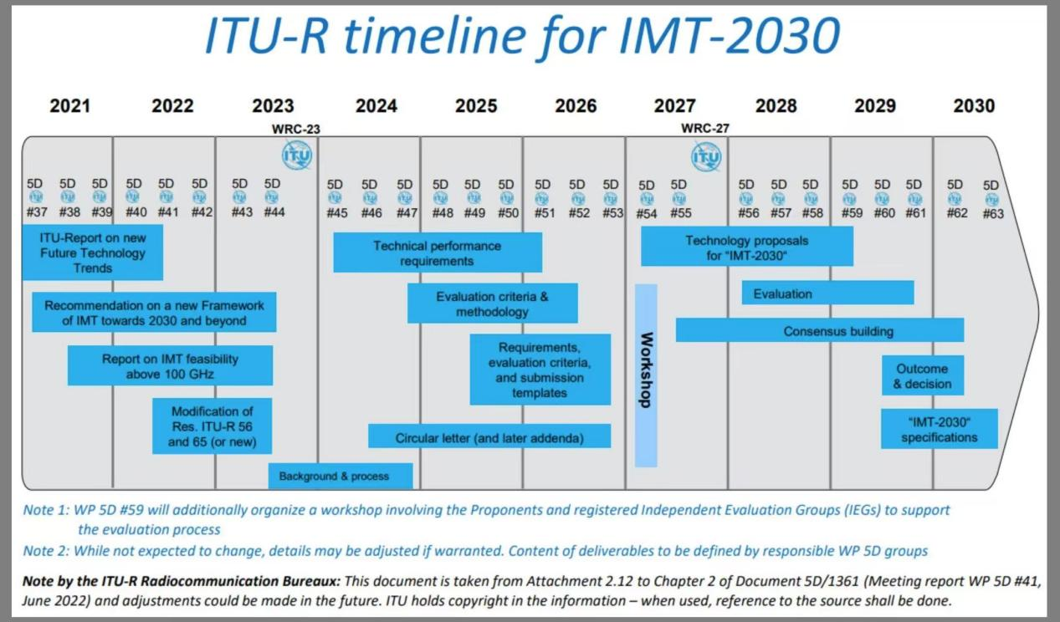
Figure 1:ITU-R timetable for IMT-2030 (6G).
Sources:https://www.huawei.com/en/huaweitech/future-technologies/itu-r-wp5d-completed-recommendation-framework-imt-2030.
The telecommunications industry is highly competitive and influenced by global political and economic factors. As a key player, Huawei has a global impact on the telecommunications sector with its decisions. Huawei has introduced the S.H.A.R.E concept to promote sustainable development (Huawei, 2022). However,De Andrade et al (2025) found that it faces economic strategic challenges, such as the global chip shortage and supply chain disruptions affecting production and development. Huawei competes with Apple and Samsung in the fields of AI and communication technology.
This report aims to comprehensively analyze Huawei's strategy by studying its operational system.It assist Huawei in formulating scientific and sustainable development strategies and provide a reference for global communication technology enterprises.It also promote industry development and to build an advanced, efficient and sustainable global digital ecosystem.

2.0 External Analysis

2.1 PESTEL Analysis

2.1.1 Political
Rahman and Mishra（2023）states that it has government policies, taxation and political stability. In the complex international political environment, Huawei faces numerous challenges. Anderson (2024) indicated that restrictions and export controls resulting from the China-US trade war have made it difficult for Huawei to obtain critical chips. However, according to Calcara (2023) that the Chinese government has provided strong policy support for Huawei, including tax incentives and government subsidies，which have provided a strong support for Huawei to maintain its global competitiveness.

In different regions, the difference in political attitudes has a significant impact on Huawei's market. For instance, some countries influenced by the US taht adopt a cautious stance.Others maintain an open and cooperative towards Huawei to their economic and technological development. This reflects the complexity of political factors (Christie,Jakobsen&Jakobsen,2024; Ryan&Burman,2024）.

2.1.2 Economic
It has economic growth rate, inflation rate, exchange rate and interest rate, which significantly affect Huawei's cost structure and revenue levels. (Buye, 2021). Zhu (2020) has shown the COVID-19 pandemic has exacerbated ，leading to a decrease in consumer and enterprise spending on communication devices and smartphones. This has directly impacted Huawei's operating revenue. In the fiercely competitive smartphone market, competitors such as Apple, Samsung and Xiaomi also affect Huawei's sales performance (Susskind and Vines, 2020).

2.1.3 Social
It involves stakeholders' values, lifestyles and educational levels, which influence consumer demand and behavior. Political factors have negatively impacted Huawei's brand image, leading some international consumers to question the reliability of its products, which could affect sales performance. Public concern on personal privacy protection has increased. Huawei to strengthen research and development in related technological fields (Wylde et al, 2022).

2.1.4 Technological
Technological innovation, R&D activities, automation and information technology play a key role in corporate competitiveness (Cox, 2021).According to the research by Zhang and Yan (2024), Huawei leads globally in the field of communication technology and its efforts to drive the development from 5G to 6G . Huawei has invested heavily in artificial intelligence, cloud computing and chip design，reducing potential risks associated with the chip supply chain. Despite the progress Huawei has made in 6G technology research and development, facing the rapid development of the industry , Huawei must continue to innovate and accelerate its R&D efforts to ensure it maintains an advantage in future market competition.

2.1.5 Environmental
Environmental protection and sustainable development have become a global focus. According to Chen's research (2023), Huawei actively promotes sustainable development and collaborates with suppliers to build a green and low-carbon supply chain system, aiming to achieve carbon neutrality by 2030. Compared with the same industry, Huawei stands out in the construction of green supply chains, especially implements strict environmental protection standards for suppliers in the procurement of raw materials. However, in the face of industry development trends and the strengthening of environmental regulations, Huawei still needs to seek more efficient green technologies to meet the growing consumer demand for green products. (Zhang, Miao&Shang, 2025), which not only enhances the company's brand image but also reflects its proactive commitment to environmental protection.

2.1.6 Legal
For a company to achieve sustainable development, it is crucial to strictly comply with relevant laws and regulations. As a global player in the field of communication technology, Huawei must adhere to the legal requirements of various countries when expanding into international markets to avoid potential legal risks. It also needs to ensure that its product import and export activities meet regulatory requirements and strengthen the protection and management of intellectual property rights to ensure the stable operation of the business (Schilling - Vacaflor &Gustafsson, 2024).

PESTEL analysis indicates that although international political and economic instability poses a threat to Huawei's market position, technological advancements and increasing attention to environmental protection also bring new opportunities for its development.

2.2 Porter’s Five Forces

2.2.1 Bargaining Power of Suppliers
Sun (2021) indicates that Huawei relies on the global supply chain to obtain critical components, and the China-US trade war has enhanced the bargaining power of suppliers. However, the Chinese government's policies supporting the development of domestic semiconductors have provided Huawei with opportunities to alleviate supply pressures. Huawei has increased investment in the research and development of Kirin chips and domestic semiconductors and implemented a diversified supply chain strategy to reduce dependence on a single supplier (Pangarkar and Prabhudesai, 2024). According to Tse etal (2024), Huawei has collaborated with multiple domestic semiconductor companies to develop chip technology, reducing dependence on foreign suppliers, diversifying procurement analysis, and weakening the bargaining power of suppliers.

2.2.2 Bargaining Power of Buyers
In the electronics market, consumers have a wide range of choices and strong bargaining power. Butarbutar, Purnamasari and Safitri (2023) state that different consumer groups have varying bargaining power over products. High-end consumer groups focus on product quality and have low bargaining power. Mid-to-low-end consumer groups are more price-sensitive and have strong bargaining power. Zhang et al (2024) found that Huawei can enhance its brand competitiveness and reduce the impact of buyers' bargaining power through satellite communication technology. In addition, Huawei should develop different strategies for consumers to meet personalized needs.

2.2.3 Threat of Substitute Products or Services
Apple, Samsung and Xiaomi products are the main substitutes for Huawei's offerings. Consumers' demand for high-end smartphones is increasingly diversified, and the threat of substitutes is relatively high. Xiaomi attracts customers with high cost-performance, Apple has a clear advantage in operating systems. Zhang and Gao (2024) believe that Huawei can strengthen its product differentiation advantages through the HarmonyOS and Mate series products to reduce this threat.

2.2.4 Threat of New Entrants

Huawei has built a strong brand and sales network globally. Kornelakis and Petrakaki (2024) found that technological barriers and supply chain issues make it difficult for new entrants to compete with Huawei in the short term. However, industry development has prompted some tech giants to enter the communication field, such as Microsoft potentially entering the communication field, posing a threat to Huawei (Chen, Huang & Tseng, 2024). Therefore, Huawei needs to pay attention to industry trends and strengthen technological innovation to consolidate its market position.

2.2.5 Rivalry among Existing Competitours
The higher the intensity of competition from existing competitors that a company faces, the greater the impact it will suffer. Huawei is facing fierce competition with Nokia in the telecommunications equipment market and has to compete with Samsung, Xiaomi and Apple in the smartphone market (Tang, 2024). The intense competition within the industry poses a serious threat to Huawei's market position.

The Porter's Five Forces analysis indicates that Huawei is facing a challenging competitive landscape, with competition intensity, threat of substitutes, and supplier bargaining power posing significant threats to it.

2.3 Key Economic Trends Influencing Business Strategy
The analysis indicates that Huawei's key economic trends involve global economic uncertainty, technology investment, product innovation, and the sustainability of the supply chain. Huawei should strengthen research and development and innovation to maintain technological leadership and reduce dependence on the supply chain. At the same time, it should seize opportunities in emerging markets, promote the development of artificial intelligence and cloud computing, and facilitate digital transformation. Huawei's flexible response to these trends will help the company achieve sustainable development.

3.0 Internal Analysis

3.1 Resource-Based View (RBV).
Lubis (2022) found that the Resource-Based View Theory posits that firms gain competitive advantage through unique resources and capabilities. According to Dmitrienko et al (2023), Huawei possesses strong brand value, a robust R&D team, substantial R&D investment and an extensive sales and service network, which enable it to respond swiftly to market demands and enhance operational efficiency. For instance, Huawei employs 114,000 R&D personnel, accounting for 55% of its total workforce.It has made significant investments in areas such as 5G, artificial intelligence and cloud computing, holding over 140,000 valid patents (Figure 2). This has elevated Huawei's industry discourse power and these resources have allowed it to maintain a competitive edge in the global communications technology market.
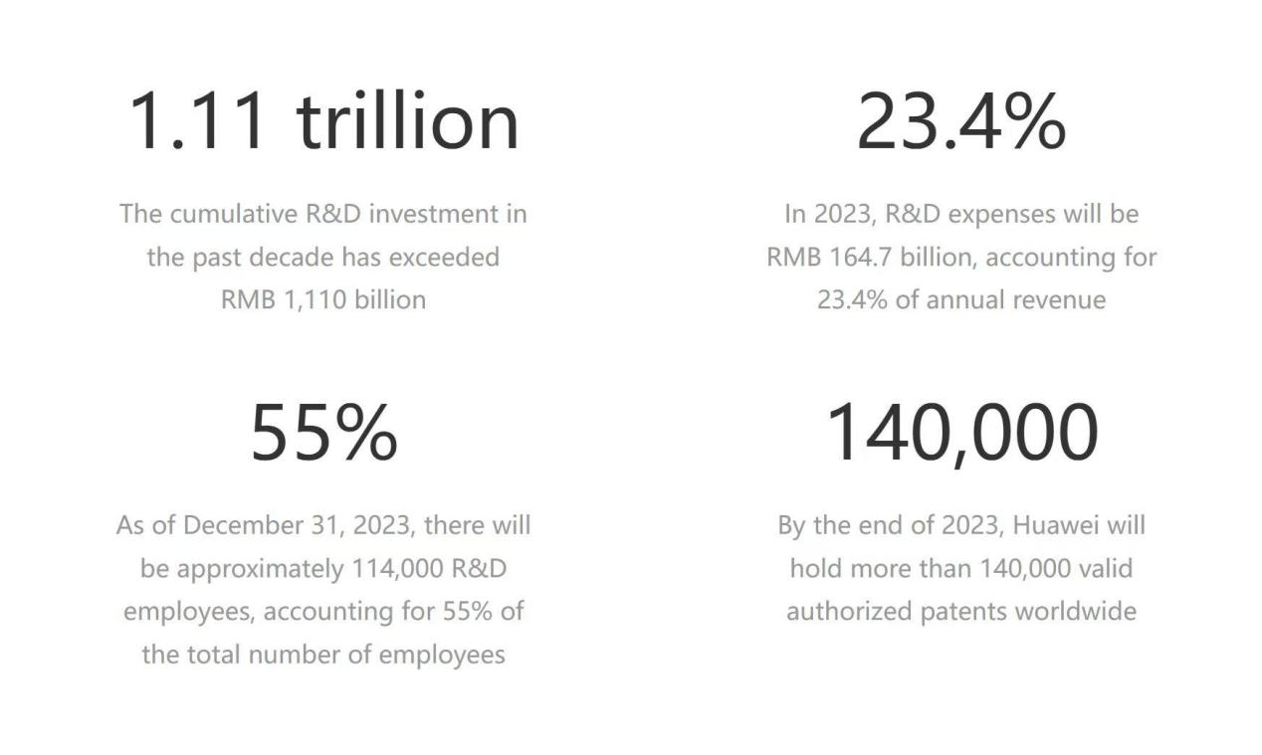
Figure 2：Huawei's unique advantages
Sources：https://www.huawei.com/cn/corporate-information.

3.2 SWOT Analysis
As can be seen from Figure 2, Huawei's strength depends its R&D capabilities, with leading 5G and AI technologies.Furthermore, according to the research by Wu, Fan and Su (2021), Huawei cooperates with multiple countries, such as Russia, Kenya and the UK. The brand has recognition and influence in the international market, laying the foundation for product promotion and business expansion.

The disadvantages are also evident, the policy regulations, consumer habits and market competition landscapes vary greatly among different countries and regions.In addition, under the influence of political factors in some countries, Huawei's brand image has been damaged, and market expansion has been restricted.

In terms of opportunities, digital transformation offers market opportunities for Huawei's cloud computing and AI technologies, enabling the company to provide solutions for enterprise digital upgrades and smart city construction (Ramesohl,Gunnemann&Berg,2021). Despite fierce market competition, Huawei must enhance technology and services to meet customer needs, and strengthen market promotion and brand building.

In terms of threats , Zheng (2024) found that Huawei is facing complex international political and trade restrictions, such as the China-US trade war and 5G construction restrictions. These risks affect its market expansion, product supply and international image, increasing operational risks. Political uncertainty makes market predictions difficult and could lead to more countries imposing restrictions on Huawei, severely impacting its global business.

The SWOT analysis comprehensively demonstrates Huawei's internal capabilities and external environment, providing a reference for its future strategic formulation (Weihrich, 1982). Huawei needs to maintain its technological leadership and global layout while actively responding to external uncertainties and competitive pressures.

4.0 Strategy Formulation & Competitive Positioning

4.1 Porter’s Generic Strategies
According to report by Ali and Anwar（2021)，the model includes three strategies.Cost leadership attracts price-sensitive customers by reducing production and operational costs.Differentiation establishes brand loyalty and competitive advantage through unique products or services.Focus strategy targets specific markets or groups, offering customized products and services to meet specific needs.

Huawei adopts the differentiation strategy. Through continuous R&D investment, it has formed unique advantages in 5G technology, artificial intelligence and cloud computing, especially leading the world in 5G technology. In addition, Huawei also focuses on the cost leadership strategy. While ensuring product quality, it reduces costs by optimizing the supply chain to attract more customers.

4.2 Ansoff’s Matrix
It mainly helps enterprises identify and evaluate potential growth strategies and divides them into four categories: market penetration, market development, product development and diversification (Zugay & Zakaria, 2023).

4.2.1 Market Penetration
It mainly refers to achieving growth by increasing the market share of existing products or services in the existing market. For instances, Huawei launched a trade-in program or extended warranty service to increase customer loyalty and satisfaction (Huawei, 2025).

4.2.2 Market Development
It mainly involves introducing existing products or services into new markets. Huawei can increase the global promotion of cloud computing and 5G technology, especially in emerging markets in Africa and South America .

4.2.3 Product Development
It means launching new products or services in the existing market. Huawei can increase its investment in 6G technology development and strive to promote 6G technology in advance to enhance its competitiveness.

4.2.4 Diversification
It is to launch new products in new markets. Negassi and Wu (2023) suggested that Huawei can continue to promote the development of the automotive industry. By combining existing 5G and AI technologies, it can launch new intelligent vehicles .

4.3 Evaluation of M&A Activities
Huawei relies on independent research and development and internal innovation for growth, rarely engaging in large-scale mergers and acquisitions. In the future, Huawei may consider acquiring small technology companies to enhance its technological capabilities and market share. Especially AI and cloud computing.It can help Huawei absorb innovative culture and talent and enhance competitiveness in emerging markets.

5.0 Sustainability and Strategic Recommendations
Firstly, Huawei needs to continuously advance the construction and improvement of a green supply chain, strengthen the supervision of raw material suppliers to ensure legality, compliance and environmental protection, and enhance supply chain transparency.

Secondly, Huawei should increase investment in research and development, break through technological bottlenecks, reduce dependence on external suppliers, focus on the development of low-carbon and environmentally friendly products and enhance brand image.

Thirdly, Huawei can establish a special research and development fund to encourage the tackling of key technologies and strengthen cooperation with universities and research institutions.

Lastly,Huawei must comply with local laws and regulations, respect local culture, develop products that meet demands in import and export trade, increasing market acceptance and promoting local economic development.

6.0 Conclusion
Huawei operates in a complex global environment, facing internal and external challenges and opportunities. For instance, pressures from politics, economy and society, issues with suppliers providing high-end technology, as well as opportunities from technological innovation, green development and government support, all impact Huawei's sustainable development.

Overall, Huawei should maintain technological leadership and global deployment, enhance internal capabilities and actively implement a sustainable development strategy. In this way, it can maintain a competitive edge in the global communications industry, promote technological advancement and sustainable industry development and contribute to the global digital future.

References：
Ali, B.J. and Anwar, G., （2021）. Porter’s Generic Competitive Strategies and its influence on the Competitive Advantage. International Journal of Advanced Engineering, Management and Science, 7(6), pp.42-51.
Anderson, S.J., （2024）. Comparing Section 889’s Huawei Ban and the Cybersecurity Maturity Model Certificate: The Challenge of Pursuing Cybersecurity Through Friend-Shoring. The George Washington University.
Buye, R., （2021）. Critical examination of the PESTEL Analysis Model. Project: Action Research for Development.
Butarbutar, I.P., Purnamasari, N. and Safitri, K., （2023）. AN ANALYSIS ON FIVE FORCES DAN BCG MATRIX FOR APPLE INC. COMPANY. Maker: Jurnal Manajemen, 9(2), pp.229-240.
Calcara, A., （2023）. From quiet to noisy politics: Varieties of European reactions to 5G and Huawei. Governance, 36(2), pp.439-457.
Chen, Y., Zhu,P.Y., and Tong,W.,(2023). ITU-R WP5D Completed the Recommendation Framework for IMT-2030 (Global 6G Vision). [online] June. Available at: https://www.huawei.com/en/huaweitech/future-technologies/itu-r-wp5d-completed-recommendation-framework-imt-2030.[Accessed 27 February 2025]
Chen, X., (2023). Cooperation and mutually beneficial development.pp.161-163
Chen, T.K., Huang, P.C. and Tseng, Y., （2024）. CEO Extraversion, Management Team Characteristics, and Firm Operating Performance. NTU Management Review, 34(2), pp.91-138.
Christie, Ø.S., Jakobsen, J. and Jakobsen, T.G., （2024）. The US way or Huawei? An analysis of the positioning of secondary States in the US-China rivalry. Journal of Chinese Political Science, 29(1), pp.77-108.
Cox, J., （2021）. The higher education environment driving academic library strategy: A political, economic, social and technological (PEST) analysis. The Journal of Academic Librarianship, 47(1), p.102219.
De Andrade, T.N., et al,（2025）.The Trade War Between China And The USA And The Geopolitical Impacts Of The 5G.IOSR Journal Of Humanities And Social Science .30(1），pp.21-29
Dmitrienko, A., et al（2023）. Development strategies of high-tech companies in China: Huawei and Tencent. Nexo Revista Científica, 36(02), pp.176-187.
Huawei (2022). Sustainability. Available at: https://www.huawei.com/en/sustainability. [Accessed 22 February 2025]
Huawei (2023). MWC2023: Huawei Enterprise BG holds the first Global Partner Night, kicking off a new journey of partnership cooperation.[Online]28 February.Available at:
https://e.huawei.com/cn/news/2023/branding/mwc2023-global-partner-night.[Accessed 7 March 2025]
https://e.huawei.com/cn/news/2023/branding/mwc2023-global-partner-night
Huawei (2024). Our Company. Available at:https://www.huawei.com/en/corporate-information. [Accessed 22 February 2025]
Huawei (2025). Huawei Service Store Trade-in Service Guide. Available at:https://consumer.huawei.com/cn/support/content/zh-cn15888493/.[Accessed 22 February 2025]
Kornelakis, A. and Petrakaki, D., (2024). Technological innovation, industry platforms or financialization? A comparative institutional perspective on Nokia, Apple, and Samsung. Business History, pp.1-26.
Lubis, N.W., （2022）. Resource based view (RBV) in improving company strategic capacity. Research Horizon, 2(6), pp.587-596.
Negassi, S.,and Wu, B.,(2023). Symbiotic evolution mechanism of the digital innovation ecosystem for the smart car industry. Sustainability, 15(20), p.14939.
Nofrizal, N. and Aznuriyandi, A., （2024）. SURVIVE AFTER THE COVID-19 PANDEMIC ON UMRAH AND HAJJ TRAVEL INDUSTRY, WHAT IS THE BEST MARKETING STRATEGY?. Jurnal Ilmiah Ekonomi Dan Bisnis, 21(1), pp.100-109.
Pangarkar, N. and Prabhudesai, R., （2024）. Using Porter's Five Forces analysis to drive strategy. Global Business and Organizational Excellence, 43(5), pp.24-34.
Rahman, S. and Mishra, A., (2023). PESTEL Theory. SAGE Publications.
Ramesohl, S., Gunnemann, A. and Berg, H., (2021). Shaping digital transformation-digital solution systems for the transition to sustainability: a study commissioned by Huawei Technologies Deutschland GmbH.
Ryan, M. and Burman, S., (2024). The United States–China ‘tech war’: Decoupling and the case of Huawei. Global Policy, 15(2), pp.355-367.
Schilling-Vacaflor, A. and Gustafsson, M.T., （2024）. Towards more sustainable global supply chains? Company compliance with new human rights and environmental due diligence laws. Environmental Politics, 33(3), pp.422-443.
Susskind, D. and Vines, D., (2020). The economics of the COVID-19 pandemic: an assessment. Oxford Review of Economic Policy, 36(Supplement_1), pp.S1-S13.
Sun，X.,F.,(2021). Digital technology competition and East Asian security order. International Organization , 75 (2), pp.65-90.
Tang,F.,(2024）. Research on the impact of foreign capital repatriation on the economy. Sustainable Development , 14(12) , pp.2980-2988.
Tse, Y.K., et al,（2024）. Recovering from geopolitical risk: An event study of Huawei's semiconductor supply chain. International Journal of Production Economics, 275, p.109347.
Weihrich, H., （1982）. The TOWS matrix—A tool for situational analysis. Long range planning, 15(2), pp.54-66.
Wylde, V., et al（2022）. Cybersecurity, data privacy and blockchain: A review. SN computer science, 3(2), p.127.
Wu, S., Fan, D. and Su, Y., （2021）. The co-evolution of global legitimation and technology upgrading: The case of Huawei. American Business Review, 24(2), p.8.
Xi, W.,D., (2021), March. Analysis of Huawei's International Marketing Strategy Based on the SWOT Analysis. In 2021 2nd International Conference on E-Commerce and Internet Technology (ECIT) ,pp. 151-154.
Yac,C.,W.,(2019).State Support Helped Fuel Huawei’s Global Rise.[Online]25 December.Available at: https://www.wsj.com/articles/state-support-helped-fuel-huaweis-global-rise-11577280736?mod=Searchresults_pos1&page=1.[Accessed 6 March 2025]
Zhang，Y.,and Yan,Q.,(2024). Catch-up and Dynamic Mechanism of Enterprise Complex Core Technologies: A Longitudinal Case Study on Huawei Wireless Network Technology. Science & Technology Progress and Policy, 41(5), pp.150-160.
Zhu,Kun.,Fu.,(2020). The COVID-19 shock on global production chains and risk of accelerated China's industrial chains outflow. Bulletin of Chinese Academy of Sciences (Chinese Version), 35(3), pp.283-288.
Zhang, K., et al, (2024), October. The Key Technology of PIM in Mobile Satellite Communication. In 2024 14th International Symposium on Antennas, Propagation and EM Theory (ISAPE) .pp. 1-4.
Zhang，S.,D.,and Gao，C.,X., (2024). New Milestone Achievements in China's Industrial Transformation and Upgrading. China Economist, 19(2), pp.2-30.
Zhang, J., Miao, X. and Shang, T., （2025）. Impact Mechanism of Digital Transformation on Supply Chain Resilience. Finance Research Letters, 76，p.106993.
Zheng, H., (2024). Analyzing Huawei’s Development Based on SWOT. In SHS Web of Conferences .(181), p. 01039.
Zugay, B. and Zakaria, R., （2023）. Ansoff matrix. SAGE Publications, Inc..

