

LEVEL 5

SEMESTER 1 & 2

MODULE CODE: SHSS5084
Expedition Skills

aSSESSMENT TYPE: Project
Assessment/Component: 2
COMPONENT WEIGHTING: 70%
WORD COUNT: 5,000 WORDS
MODULE TUTOR: DENISE LEONARD

Expedition Portfolio

Produce a detailed log of the planning for your expedition. This will include comprehensive risk assessments, route plans, emergency procedures, transport arrangements, medical forms, pre-expedition training/ preparation and any other relevant details. Further information related to this assessment can be found on Moodle under Expedition Portfolio Resources as well as on-going tutorial support.

SUBMISSION DETAILS:

Deadline:
Date: 7th February 2020
Time: 3.00pm
Portal: Turnitin

School of Sport, Health & Outdoor Education

Assessment Feedback Sheet

Student No./Name:
Module: SHSS5084
Module Code: Expedition Skills

Personal Evaluation – to support your academic progress please complete the section below BEFORE submitting your work.
What do you consider to be the best aspects of this work?
Which aspects do you consider could have been improved in this piece of work?
What have you found most satisfying whilst undertaking this submission?
ASSESSMENT CRITERIA | Learning  Outcomes |  | GRADE
ASSESSMENT CRITERIA |  |  | Poor  0 – 25% | Unsatisfactory  26-39% |  | Satisfactory  40 – 49% | Good  50 – 59% | Very Good  60 – 69% | Excellent  70 – 85% |  | Exceptional  86– 100% | %
Produce a well presented and comprehensive expedition planning log with logical format and clarity of purpose | 1,2,4,6 |  |  |  |  |  |  |  |  |  |  | 80%
Use of appropriate reference material | 6 |  |  |  |  |  |  |  |  |  |  | 20%
It is expected that students will present work that is proof read, correctly referenced and adheres to the Assessment Checklist. Therefore a range of 0 – 10 marks will be deducted for non-completion of any of the points on the checklist below.
TUTOR COMMENTS:

Submission date:  via Turnitin |  | Return date:  (at least within 4 weeks) |  |  | Tutor: Denise Leonard |  |  |  |  | Mark:

Assignment Checklist

- Please complete the Personal Evaluation section of the Assessment Feedback sheet, add your name and details, and paste the whole of this assignment document into the front of your assignment

- Submission is a single word file, clearly labelled with your name and module code
- Font style - Times New Roman, size -12 for text and 14 for headings
- Ink colour – black only
- Line spacing – 1.5 line spacing and 2cm- 2.5cm page margins
- Quotations more than three lines to be indented 1 line spacing
- One line space between paragraphs, paragraphs must be left aligned
- Pagination (your assignment should have page numbers)
- All tables and figures are internally referenced and have a title
- Word count checked and written at end of text (before references and any appendix)
- Assignment is within 10% of the word limit (excluding references and any appendices)
- All references in the text are included in the reference list
- Correct referencing following the Harvard style, as described in the Palgrave study skills book ‘Cite them Right’.
- Correct spelling using UK English
- Correct use of punctuation
- Grammar and syntax correct- double check anything that has a green line under it
- I have read my assignment out loud to myself and it makes sense and is easy to read
- Somebody else has read my work and it makes sense to him or her!
- I have checked and I have not plagiarised
Failure to follow these guidelines will cost you marks!
Expedition Contract

I will run my expedition between the dates of
I will at all times, conduct myself as professionally as possible, adhering to the University’s Code of Conduct, and only operate within the agreed parameters of my signed-off expedition, as outlined below.

I will be running an expedition by foot / bike

The aims and objectives of my expedition are:
To learn about the erosion of the Pembrokeshire Coastal Path.
To clean the part of the path in which my expedition will be taking place.
To help my team experience the coastal path for themselves.
The venues I have chosen to use are:
Day 1: Amroth Beach Carpark (SN162070) to The Esplanade, Tenby (SN134001)
Day 2: The Esplanade, Tenby (SN134001) to Manorbier Beach (SS 057976)
Day 3: Manorbier Beach (SS 057976) to Broad Haven South Beach, Bosherston (SR 976937)

My appointed assistant leader is:

The members of my expedition group are:

I have checked the abilities of all expedition group members and deem them able to partake in the expedition.

I have collected relevant and up-to-date medical details from each expedition group member and am aware of any condition that may affect their ability during the expedition.

TITLE
Expedition Overview
Aim & Objectives
How will you meet these objectives
Expedition Leader Profile
Eroding Coastal Paths
First Aid Provisions
First Aid Kit List
Medical Declaration Forms
Assumption of Risk Forms
Behavioural Expectations
Individual Kit List
Group Kit List
Equipment Request Form
Preparatory Training Undertaken
Campsites
Route Cards
Escape Routes
Contingency Planning
Environmental Impact
Weather Forecast Sources
Generic Risk Assessments
Site Specific Risk Assessment
Important Contact Details
References

Expedition Overview

As part of this module, I will be carrying out a walking expedition which will take place on a part of the Pembrokeshire coastal path based in south west Wales. My first day will consist of walking from Amroth beach car park (SH162070) toward our finishing point for that day which will be The Esplanade in Tenby (SN134001). The distance for the first day is roughly 12km which will give us around 4 hours walking time. This is not including regular breaks and stops along the way. At the end of day one we will be setting up tents and staying the night at Haven Kiln Park.
Day 2 is the shortest day of the expedition where, unlike the first day, we will only be covering about 11.30km giving us the walking time of 3 hours and 45 minutes. We will be leaving The Esplanade (SN134001) around late morning and ending the day at Manorbier beach. (SS057976) from the beach we will then be walking up towards Middle Hill Farm caravan site where we will be setting camp and staying for the night.
Day 3 is the longest day where we will be covering 15km from Manorbier (SS057976) to Broad Haven south beach in Bosherston (SR976937). As we will be covering 15km on the last day, we will be walking for about 5 hours, again, this is not including any breaks and stops along the way. My main purpose of this expedition is to gain experience on erosion of coastal paths and also erosion to this particular stretch of coastal path. It will also be a good experience to learn about how many people use the coastal path and why this particular part of the path is being affected by erosion.

Aims and Objectives

My primary aim for this expedition is for outdoor education students can learn and experience the erosion damage to the Pembrokeshire coastal path and also experience the path for themselves.

How will you meet these objectives?

To fulfil my aims and objectives for my chosen expedition I will research and collect information about the current wealth of the Pembrokeshire coastal path, what damage there is to the path and what we, as outdoor facilitators, can do to help preserve the path so it can last longer. Whilst walking the route of the path, I will be giving this information to those who I have chosen to join me on this expedition. This will enable me to teach them the erosion difficulties of the west coast and encourage them to help protect the Pembrokeshire coastal path. Before carrying out the main expedition, I plan on doing a complete run through of the expedition including staying at each of the campsites that I will be staying at during the main expedition. This will also help me to determine whether the route is safe enough and simple enough to walk across. Another thing this will help me with is that I will learn what shops will be open in the local area just incise we need supplies of some sort.

Expedition Leader Profile

At this moment in time, I do not currently hold any coastal qualifications. However, I am determined to start my Lowland Leader training (LL) as soon as possible. I have gathered experience from adventuring and navigating through different terrain and weather conditions over the last year as part of my course Outdoor Adventure Education.
I have been to Pembrokeshire coast on many occasions and experienced certain obstacles when venturing around the area. For example, I like to visit Pendine a lot because I enjoy the peacefulness of being by the sea. What I find a lot when being next to the coast is that, any stone steps or paths can be very slippery due to the moist sea air. Another thing I noticed was undercut cliffs, especially near the edge alongside more rocky terrain. This can be where erosion can start because there is nothing to support the cliff from underneath.

Eroding Coastal Paths

My reason for picking the Pembrokeshire coast is because the erosion of the coastal path is becoming more dangerous and more noticeable. The way the coast falls off is quite astonishing but also sad as each year the path is being moved back further and further due to erosion. The reason we have this issue with erosion is due to rising sea levels from global warming which then takes a tole on the cliff faces, resulting in them to eventually break apart and fall off. However, rising sea levels is not the only problem with eroding coastal paths. Each year, thousands and thousands of people walk the coastal path which can age the cliffs quite a lot too. Routes are then diverted inland but it is not always that easy to due to farmers lands and other obstacles.

First Aid Provisions

First Aid treatment can save lives, so it is imperative that first aid equipment is carried during an expedition. The leader of the expedition must make first aid equipment available to you if you do not have a first aid kit on yourself. First aid provisions are put in place from taking a risk assessment. This will help you find out what extra first aid equipment you will need to take on the expedition. (UNISON, 2020)

In Regard to first aid provisions during my expedition, everyone will be carrying their own first aid kit. This will mean that we have a enough medical supplies to help the group as much as we can. If the injury is a lot worse and we cant help the individual, then we would call 999 or mountain rescue.

First aid kit list

Personal First Aid Kit

- Plasters
- Bandages and dressings
- Vinyl examination gloves
- Tweezer
- Microporous tape
- Hygienic cleansing wipes
- Adhesive plasters
- Medical scissors
- Adventure Knife
- Safety pins
- Eumovate ointment
These are some of the things that I carry in my personal first aid kit. In regard to everyone else’s first aid kit. I will be expecting them to be bringing some of the things that I have listed above as well as any medical equipment that is personal to the for example: inhaler, epi pen, allergy tablets etc.

In relation to my medical qualifications, I have completed my level 3 first aid course with the university and it valid for 3 years. However, this will be the last year it is valid for. I have also completed some defibrillation training with the army.

Medical Declaration Form

Having a medical declaration form is very important when leading an expedition so it helps me, as the leader, to know the medical history of my team. It is so I know who to keep an eye on in my team and whether I need to alter my expedition to so that everyone in my team can complete the expedition safely.

I have included the teams Declaration forms in my appendices. I will be handing out these forms prior to the expedition.

Assumption of Risk Forms

I have considered the risks involved in my expedition, for instance I understand that there might be unanticipated risks during my expedition which could involve damage to my property or physical injury. I also am aware that I have a personal duty of care over the team I will be taking with me on my expedition.
I believe that I am physically and mentally capable of carrying out this expedition and you will find the assumption of risk form attached below in my appendices.

Behavioural Expectations

The group I will be taking on my expedition are all individuals aged between 20 – 22 years of age so my expectations will be that the group are mature and well behaved. However, I will be reminding them of the rules of the country code, before the expedition and during the expedition so that we don’t leave any rubbish behind or leave and gates open along the way.

Individual Kit list

In this kit list, I will be including that warm clothing is paramount because we will be spending most of our journey by the coast, this because it lowers the risk of hypothermia and helps keep the moral high.
Another important item I will be adding to the kit list is walking boots. Along the path, the terrain will vary from gravel paths to muddy, grassy areas. We might also encounter some rocky areas along the way so wearing appropriate footwear will help to decrease the chances of foot or ankle injury.
As well as warm clothing, I will be suggesting everyone brings waterproof clothing as the weather might not be the best on the day and we will be by the coast so the air will be damp. Warm and waterproof clothing will also help toward wind chill and again decrease the chances of one of us catching hypothermia.
Another important Item I will be adding to the list is a personal first aid kit. It is important that everyone has their own first aid kit so that we know that person has the right medication personal to them.

Clothing

- 1 pair of walking boots (broken in)
- 2 Pairs of walking socks
- 2-3 T-shirts
- Thermal T-shirt (optional)
- 2 fleece tops or similar
- 2 pairs of walking trousers (not jeans)
- Underwear
- Nightwear
- Flip flops or trainers (for campsite)
- Wool hat or sun hat
- 1 pair of gloves
- Waterproof trousers and jacket

Personal Kit

- Sleeping bag
- Waterproof compression stuff sack
- Whistle
- Headtorch and spare batteries
- Personal First aid kit
- Expedition food (including emergency rations)
- Water bottle
- Knife, fork, spoon or spork
- Plate/bowl
- Mug
- Matches or lighter
- Wash kit
- Sun cream
- Spare laces

I will be sending a copy of this to every team member prior to the expedition. My reason for adding a comment of boots to be broken in prior to the expedition is to lower the risk of anyone getting any blisters which could possibly lead to infections if not treated. As a bonus to lower this risk I have recommended everyone brings blister plasters in their personal first aid kit.
Another thing I have added into my kit list is that no one is to bring jeans on the expedition. This is because jeans can get very heavy when wet and start to rub. Most of the expedition will be right by the sea so the chances of rain are quite high.
The BCA claims that skinny jeans reduce mobility “even if it is just walking that you’re doing”. “Restrictive clothing can lead to loss of ‘bounce’ in your stride and natural shock-absorbing qualities in your walk, causing pressure in your joints” (BCA, 14 March 2017).

Group kit list

- Group shelter
- Tent
- Tin opener
- Bin liners
- Toilet roll
- Maps
- Camping stove
- Camping stove fuel
- Washing up liquid
- Scouring pads

Equipment request form

I have a included a copy of the request form in my appendices.

The request form is used when borrowing kit for example. On my expedition, I will need to borrow things like:

Tent
Group shelter
Maps
Camping stove etc

Once taken from my university stores, I will then need to put these items on the form and then sign it so that myself and my lecturers know what kit has been removed from the stores and what kit they will be expecting back after my expedition is completed.

Preparatory Training Undertaken

Prior to my expedition. I will be doing a full run through of my expedition. I will be using this time to look out for items I can add to my risk assessment and route card ready for the main expedition. I will also be testing whether the campsites I have chosen are appropriate enough for my expedition in regard to price and facilities. Another thing I will be looking out for is to support my main reason for choosing this particular route. For example, I will be looking at the erosion evidence along the route so I know what to point out to my team on the day of the expedition.

In relation to training, I have not done a lot of coastal walks but I do go to the coast quite a lot, specifically the beach. However, I have done a lot of walking to places like Snowdonia, Scafell Pike and the Brecon Beacons. I have also completed my bronze, silver and gold Duke of Edinburgh awards, so expedition planning is not entirely new to me.

Campsites

So, for the first day of my expedition, we will be finishing in Tenby. I have had a look around and there aren’t too many campsites available if anything, there are more B and Bs than campsites. After looking around, I found a campsite close to our route. The campsite itself is called ‘Meadow Farm’. My reason for choosing this particular campsite is because, to get to the campsite, we don’t have to walk too far out of the way. The other reason is that the campsite is nice and cheap for one night.

Meadow Farm Tenby
Tel. 01834 818500
SA70 8AU
Grid reference: SN 133 013

For my second and final night, we will be stopping in Manorbier where the campsite I have chosen to stay at will be Middle Hill farm. My reasons for choosing this campsite is that it is also really close to the route that I will be taking. It is also again nice and cheap to set up camp for one night.

Middle Hill Farm Manorbier
Tel. 01834 871329
SA70 7SL
Grid Reference: SN 406 067

Route Cards

Having a route card for planning your route can have a lot of benefits, for example:

- It helps to structure and plan your route for a day out.
- It shows details of who’s in the group and their emergency contact details.
- It can help to record what kit is carried including maps.
- It can help you to keep track of progress/schedule throughout the day.
- It can help to keep track of alternative and escape routes available.
‘Planning your route in detail will allow you to know whether your idea is possible, given group and other factors’ (MountainSafety, 2020)

Escape routes

It is good to have escape routes because they provide a clear and safe way to escape from the area. The escape routes that I have put in place are dotted throughout the path. Thankfully, throughout my route, there are villages close by where in an emergency we could get transport from. Although we are on the coast for most of the way, we will not be completely isolated and because it is a well looked after path, if there is a danger on the path, there will be a diversion route put in place with escape routes alongside.

Contingency planning

If for some reason, anyone was to seriously injure themselves then we would ring 999 where the nearest hospital would be Glangwili hospital in Carmarthen. The good thing about my chosen route is that at all times, we will not be too far from the nearest village where an ambulance or a paramedic can get to us. We also are not far from, or at least right next to, a public road for the majority of the way so that getting transport to us will be easy and relatively straightforward.

My contingency plan for my expedition, if the wind becomes too heavy, is to walk alongside the nearest road instead. That way, we will be sheltered from the wind by the high sided bushes separating the road from the farmer’s fields.

Environmental impact

In regard to Environmental impact, by walking, we are being environmentally friendly as it is the Cleanest approach to tourism providing, we clean up after ourselves when walking along the coastal path.
It is important that we clean up after ourselves as simple things such as crisp packets and plastic bottles can hurt or kill the local wildlife and can stay there for a long time without decomposing. As a countermeasure of this, I will be carrying a roll of degradable plastic bags in order to carry our rubbish with us until we locate a public bin to dispose of it.

Weather forecast sources

The Met Office

One of the main websites that will be using for my weather forecasts will be the Met Office. The Met Office is the national meteorological service for the UK. The state on their official website that they provide critical weather services helping the public to make better decisions before going outside. (Met Office) My reasons for choosing this forecast provider is that they are one of the top operational providers in the world for accuracy with weather forecasts. The met office is also highly recommended by a number of different sources including the BBC.

Magic seaweed

Magic Seaweed is the second source I have chosen to use for my expedition because most of my route is alongside the sea. Magic Seaweed is a surf website but can still be very useful when spending time by the sea. The reason I’ve chosen Magic Seaweed is because I have used the website a number of times when going to the beach or in the sea. Magic seaweed is used for mostly when going surfing or body boarding but I’m using it for my expedition because it will be useful to know when the tide is in or out at what times and mainly what the forecast would be on the coast on what day. (MSW, 2020)

Generic Risk Assessment

Whilst I will be leading my expedition, I will be forming a generic risk assessment which will consist of certain hazards depending on where I am and what is around at the time that can potentially cause risk to both myself and those who are taking part in my expedition. Those certain risks will consist of:

- Heavy sea wind – I will be making sure that, along the way there are places where we can take shelter if I feel like we are getting too cold or too tired from fighting the wind.

- Lack of hydration – whilst walking along the route, I will be making sure that we take regular stops where we can rehydrate. I will also be making sure that everyone has enough water to hydrate whilst walking along the path. I also planned my route so that we will be walking through small villages where we can have access to food and water if need be.

- Heal blisters from boots – I will be carrying blister pads and a ‘Compeed’ stick in my first aid kit ready to use if anyone has any blisters. However I have recommended that all walking boots that everyone is using for the expedition are to be broken in prior to the expedition. I have also recommended that everyone carries some sort of blister protection and prevention of some sort in their personal first aid kits.

Site Specific Risk Assessment

I have included two site specific risk assessments in my appendices both specific to both the campsites that we will be staying at, the first and second nights of my expedition.

Having a risk assessment is very important as they form an important part of an occupational health and safety management plan (CCOHS, 2020)
Having a risk assessment helps us plan ways around risks and dangers so that it can help us to prevent injury to myself and those on my expedition team.

According to the Britsafe organisation, these are the differences between a hazard, a risk and an accident:

- An Accident is an ‘unplanned event that results in loss’
- A Hazard is ‘Something that has the potential to cause harm’
- A Risk is ‘the likelihood and the severity of a negative occurrence resulting from a hazard’
The main purpose of a risk assessments is:

- To identify Health and Safety Hazards and evaluate the Risks presented in the area.
- To evaluate the effectiveness and suitability of existing control measures.
- To prioritise further resources if needed to ensure the above. Carrying out a suitable and efficient Risk Assessment is the primary management tool in effective risk management (BSC, 2020)

Below is a simple Site-specific Risk Assessment I have created specifically to Meadow Farm, Tenby. It consists of some basic risks that can cause quite serious harm is not made aware of or treated immediately.
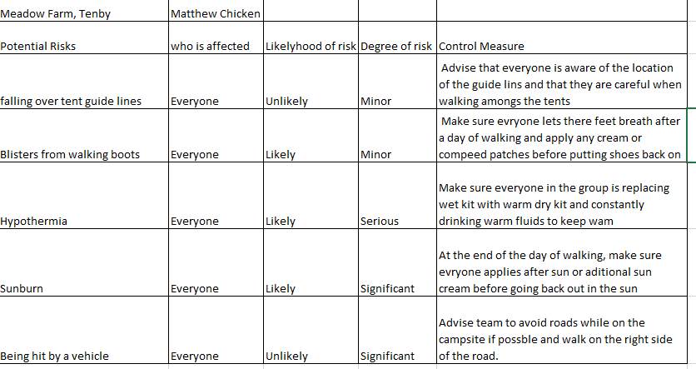
Below is the same risk assessment as Tenby but instead it is for Middle Hill Farm, Manorbier. It has the same contents because there is no significant difference between the two campsites, and they share the same specific Risks which could cause potential harm
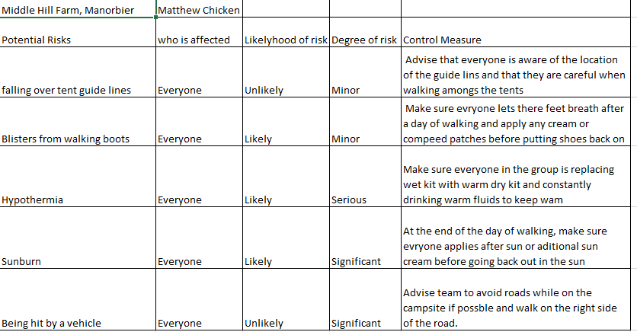

Important contact details

Emergency services – I would call 999 and ask for the appropriate service
University

Thomas Moore –
- Tel. 07794 445535
- Email: T.Moore@uwtsd.ac.uk
Denise Leonard
- Tel. 07979 695733
- Email: Denise.Leonard@uwtsd.ac.uk
Graham Harvey
- Tel. 07896 431200
- Email: G.harvey@uwtsd.ac.uk
Expedition Contact Details

Student A
Student B
Student C

Appendices
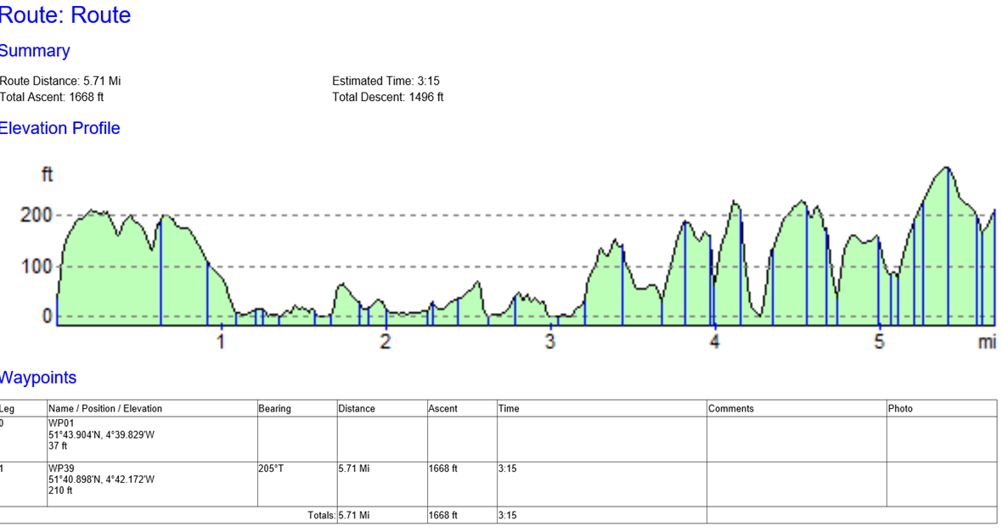
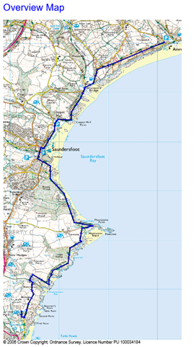
Day 1 Route Card

Day 2 Route card
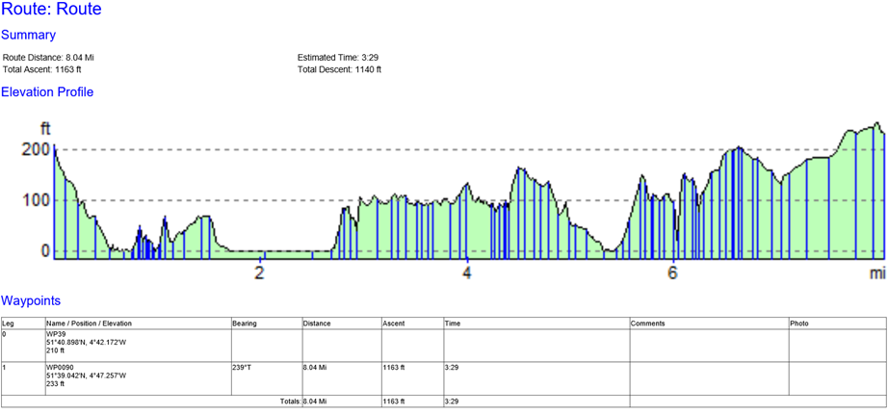
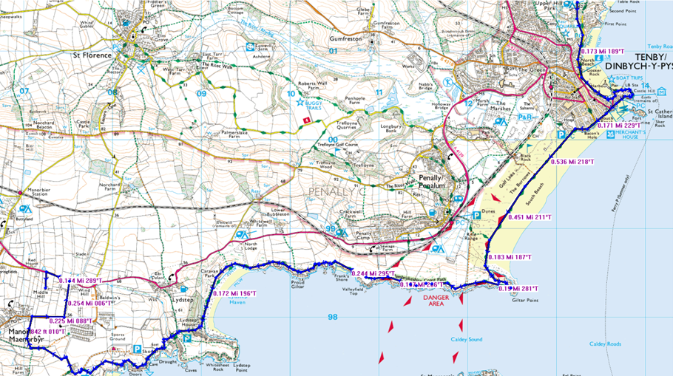
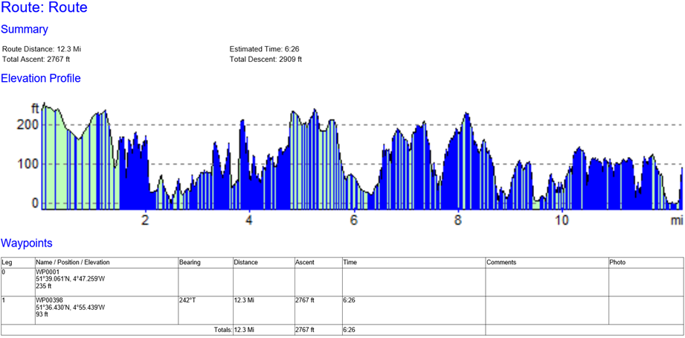
Day 3 Route Card
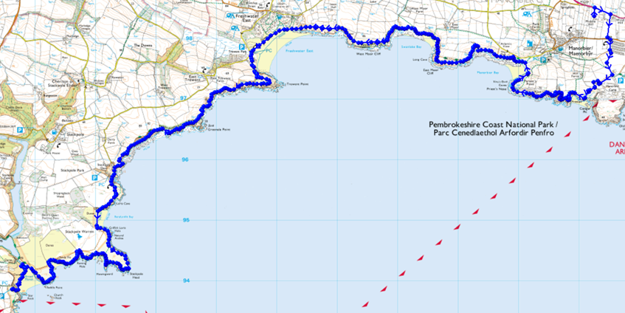

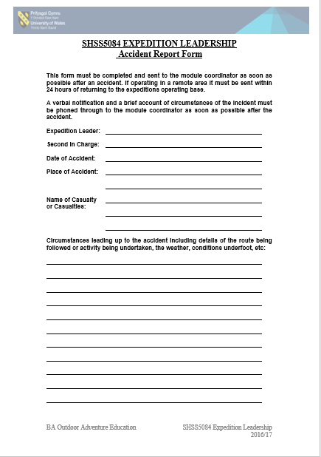
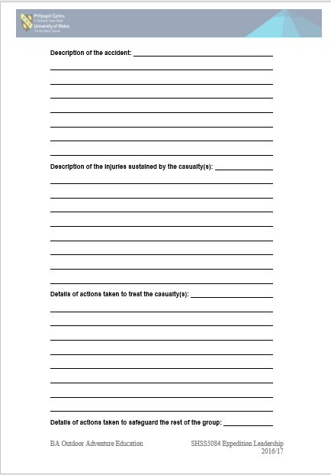

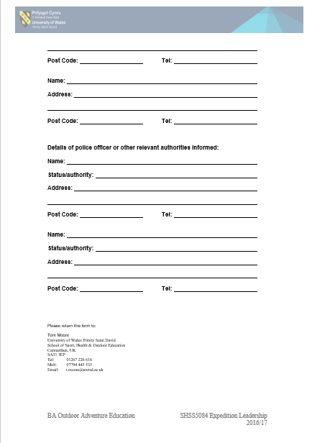

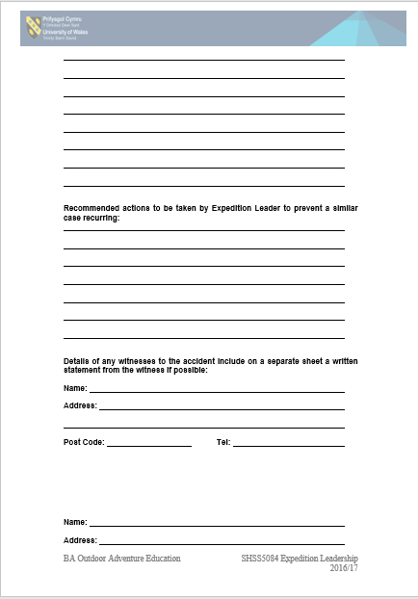

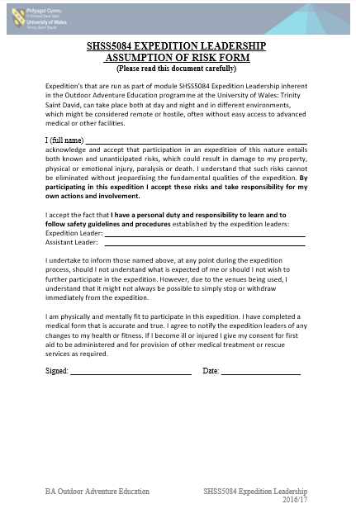

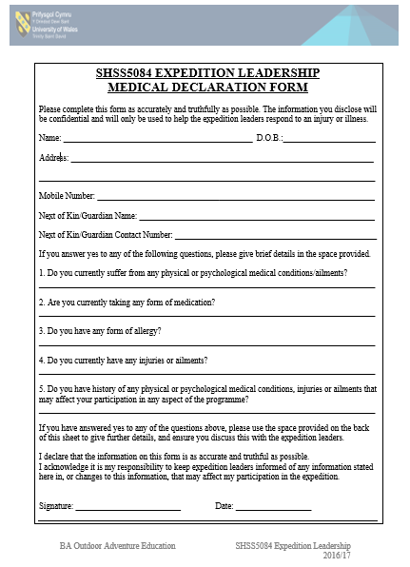

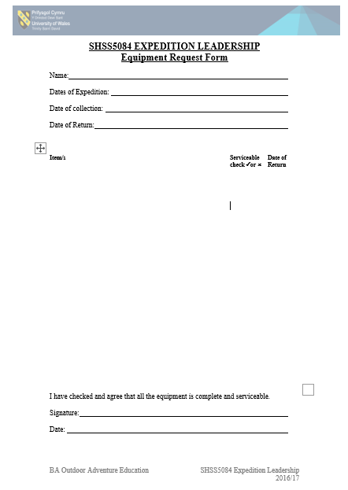

References

Route Cards
Mountain Safety
Located at: http://www.mountainsafety.co.uk/Route-Route-Cards.aspx
Accessed:13/02.2020

are skinny jeans really harmful?
British Chiropractic Association
BBC
Located at: https://www.bbc.co.uk/news/health-39266383
Accessed: 03/02/2020

Accuracy and trust
The Met Office
Located at: https://www.metoffice.gov.uk/about-us/who
Accessed: 12/02/2020

Online mapping
OS Maps
Located at: https://www.osmaps.ordnancesurvey.co.uk
Accessed: 12/01/2020

Tenby Surf Forecast
MSW – Magic Seaweed
Located at: https://magicseaweed.com/Tenby-South-Beach-Surf-Report/33/
Accessed: 12/02/2020

Risk assessment
CCOHS - Canadian centre for occupational health and safety
Located at: https://magicseaweed.com/Tenby-South-Beach-Surf-Report/33/
Accessed: 12/02/2020

Risk Assessments
BSC – British Safety Council
Located at: https://www.britsafe.org/training-and-learning/find-the-right-course-for-you/informational-resources/risk-assessment/
Accessed: 12/02/2020

First Aid Provision
UNISON
Located at: https://www.unison.org.uk/get-help/knowledge/health-and-safety/first-aid/
Accessed: 14/02/2020

