
Marketing Fundamentals(LCbb4004)


University of Wales trinity saint David

Blog Report: Samsung Company

Made by: Stanislav Danailov(2112418)

Module Lecturer: Tushara Balendran
Table of Contents
Introduction: 1
History of the company: 1
Samsung’s mission statement 2
Products 3
Television 3
Refrigerator: 4
Telephone: 4
Price: 5
Place: 6
Promotion: 8
Communication with their customers 8
Advertising 9
Sales promotion 9
Personal Selling 10
Conclusion: 11
References: 12

Introduction:

This report aims to identify and clarify Samsung corporation from its very beginning until its current position globally. First part is about company’s background and their mission statement. Second part outlines a range of products, their features, and statistics. The final part provides Samsung’s manufactories around the world, and its marketing communication strategy.

History of the company:

Far in the past, Lee Byung-chul commenced Samsung association based in a city called Taegu in 1938 with the modest amount of US$27. Moreover, he only had 40 employees and ‘a grocery store, trading and exporting goods which were produced in and across the town’(Burris,2020). Twenty-two years later, Samsung penetrated the electronics market with the establishment of ‘numerous electronics-targeted divisions as follows: Samsung Electronics Devices, Samsung Electro-Mechanics, Samsung Corning, Samsung Semiconductor & Telecommunications’(Burris,2020). Additionally, a partnership between Samsung and Sanyo commenced, paving the manner to manufacture televisions, microwaves, and other products.
Picture.1 Samsung logo
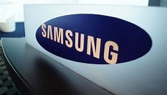
Accordingly to Burris, (2020) the alliance between the two companies manufactured its first black and white fridges, electric desk calculators, and air conditioners. Furthermore, in 1978 the company reached the landmark of generating five million televisions, entered the telecommunications hardware enterprise with the purchase of Hanguk Jeonja Tongsin (Burris,2020). Initially, building smartphone switchboards, Samsung developed into cell phone and fax structures, which led to mobile phone production (Burris,2020).

In 1987, founder Lee Byung-chul died, and his son, Lee Kun-hee, inherited his position in Samsung. Soon after that, Samsung Semiconductor and Telecommunications merged with Samsung Electronics. The combined agency focused on domestic appliances, telecommunications, and semiconductors have become an international chief in cheap production, shaped Samsung Motors, and began producing digital televisions. It’s been sought to become a world's leader in manufacturing electronics.
In the early 2010s, Samsung received businesses that evolved technologies for electronic gadgets. One year later, Samsung released the Galaxy S II, accompanied in 2012 by Galaxy S III, which is globally recognised smartphone. Samsung has also introduced its Gear VR, a virtual tool which operates with Galaxy Note 4. By the year 2015, Samsung enlarged its American patents with more than 7,500.

Samsung’s mission statement

Samsung's mission statement is ‘to be innovative, make best items and administrations, and adding to a superior worldwide society.’ This corporate mission was adopted during the 1990s, when the organization was going through quick worldwide extension in different semiconductors, digitals, and related innovation markets. In view of its business activities and current worldwide industry situating, Samsung centre around the accompanying parts in its corporate mission: innovative assets, Prevalence of items and administrations, Improvement of the worldwide society. (Martin, 2019)

Products
Picture.2 Samsung TV
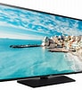
Television:

Samsung has good quality televisions that fascinates and enhances the viewing experience, and most of the customers prefer buying their televisions, which is the major reason that the company has growth as a market leader for such a long time (Fig.1). Samsung company employs the recent technologies as in QLED Televisions with many improved features and an excellent sound quality. In accordance with Giovanni (2021) the best smart television for 2021 is Samsung QN90A QLED with 4K resolution. Moreover, its design distinguishes it from all previous models, as it has comparatively high contrast ratio, providing dimming feature (Giovanni,2021). In fact, Samsung 'Ultra Viewing Angle' technology has wide viewing angles and creates a wide seating arrangement, and if it i (Giovanni, 2021)s to be used in a well-lit room, it has great reflection and gets bright enough to fight glare, together with its range of colours and high peak brightness in HDR, for prime quality. (MALLA, 2020)
Figure.1 Samsung Global Televisions
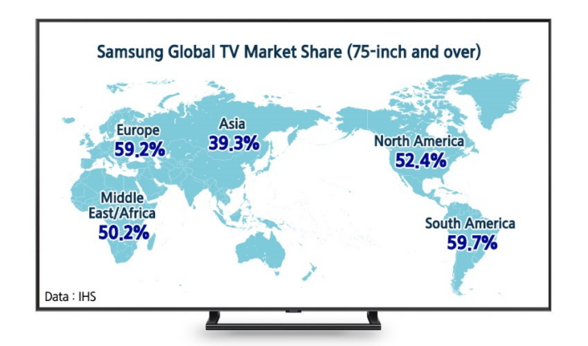

Source: Samsung Newsroom, 2018
Picture.3 Samsung Fridge and Refrigerator

Refrigerator:

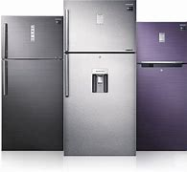
The Company is also well-known for producing home appliances as they make high quality products. (Granger,2011) Indeed, Samsung is amongst other major refrigerator entrepreneurs, whereby it manufactures variety of refrigerators with quality materials they put into their products. Besides, they have the adjoining types featuring the fridge and the freezer neighbouring to each other and it could observe that this category fridge is often utilised in developed and modernized kitchens (Granger,2011). The company has manufactured outstanding features that are not found in most ordinary units sold in the market. In fact, one extraordinary attribute of Samsung fridge is that it possesses the ‘Energy Star feature’, hence it operates with less energy, or so-called energy efficient model, and decreases electrical bills, together with an alarm that ignites when the refrigerator is open for a longer period (Granger, 2011). In addition, further optimistic asset is the ‘Twin Cooling System’ where the air flow for the refrigerator is divided from the freezer, and it helps to sustain dryness in the freezer section and creates small amount of moisture in the refrigerated part for the products fresher and crisper. (Granger, 2011)

Telephone:

Samsung is recognised to be highly innovative phone hardware amongst other companies across the world, as it manufactures first class phone processors, high quality front and back cameras, and displays (ProVsCons.com, 2021). Moreover, Samsung’s phones provide cutting edge features technology, curved and folding screens, and in every leading phone, the company is crossing limits, as they sell greatest hardware in terms of memory, ram, processor, and others (ProVsCons.com, 2021).

Picture.4 Samsung Galaxy Z Fold3 5g
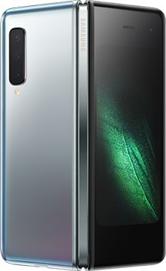
For instance, Samsung Galaxy Z Fold3 5G is the thinnest, pocket-size phone, which has Flex mode, allowing the device to open and stands upright, and when the 7.6-inch display brightens up, the under-display camera has no wholes, hence becomes invisible and there is only screen(Samsung.com,2021). Moreover, the phone has two-sided screen and an exclusive S Pen, so while using it, the customer might take a call through the top half of the device, while writing its work on the second one (Samsung.com,2021).

Price:

There are different prices for Samsung products depending on the economy of the country, their promotions throughout shops, regions, and cultures. Moreover, a comparison of prices is shown below within several countries on the phone Samsung Galaxy S21 Ultra.

Picture.5 SAMSUNG GALAXY S21 ULTRA
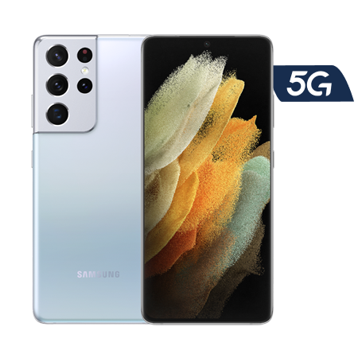

First check is made In Bulgaria, where the same model with the same parameters can be outright purchased for only 810 pounds. (Telenor, 2021)
Second check is made In United Kingdom, where the same model with the same parameters can be outright purchased for 1,149 pounds. (Mobile, 2021)
Third comparison is made In United States, where the same model with the same parameters may be outright purchased for 1,091 pounds. (Amazon, 2021)
Forth check is made In France, where the same model with the same parameters can be outright purchased for 1,257 pounds. (Samsung, 2021)
Fifth check is made in Sweden, where the same model with the same parameters can be outright purchased for 1,351 pounds. (Mobile57, 2021)

Place:

It ought to be outlined that Samsung Group makes a huge range of products spanning from consumer electronics such as televisions, tablets, smartwatches, virtual reality headsets, to home theatre and audio, desktop computers, laptops, monitors, printers. (EXPOSE, 2017). Furthermore, the largest subsidiary of Samsung manufactures all the mentioned above plus memory devices, home appliances and security/monitoring systems, semiconductor, and memory parts. (EXPOSE,2017).

Picture.6 Indian mobile factory of Samsung
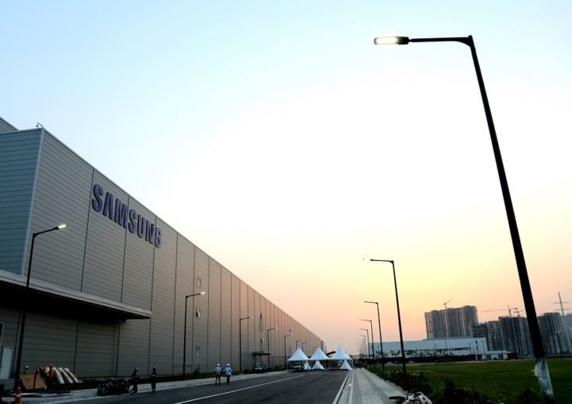

Correspondingly to Adnan, (2021) India holds Samsung’s enormous mobile factory, which in addition is the largest mobile phone manufacturing unit in the world based on production capacity with total production of $120 million units per year. Big part of the goods is directed towards Indian market, which is one of the most profitable markets for the corporation. Hence, Samsung ought to produce locally in order to oppose its rivals and avoid import taxes (Adnan, 2021).
Samsung possesses a mobile factory in Brazil too, with more than 6,000 workers at the facility from where Samsung supplies its devices to all Latin Americans, as import taxes applies. (Adnan, 2021).
Indonesia is another country where Samsung phones are being produced. In fact, the factory was opened in 2015 with production performance of nearly 800,000 units annually (Adnan,2021).
Furthermore, these manufactories are merely assembling the parts of the smartphones, as they all are consisting of the same elements, but respect and follow the same producing and quality operations(Fig.2). (F., 2021)

Figure.2 Samsung global smartphone shipment (in million units)

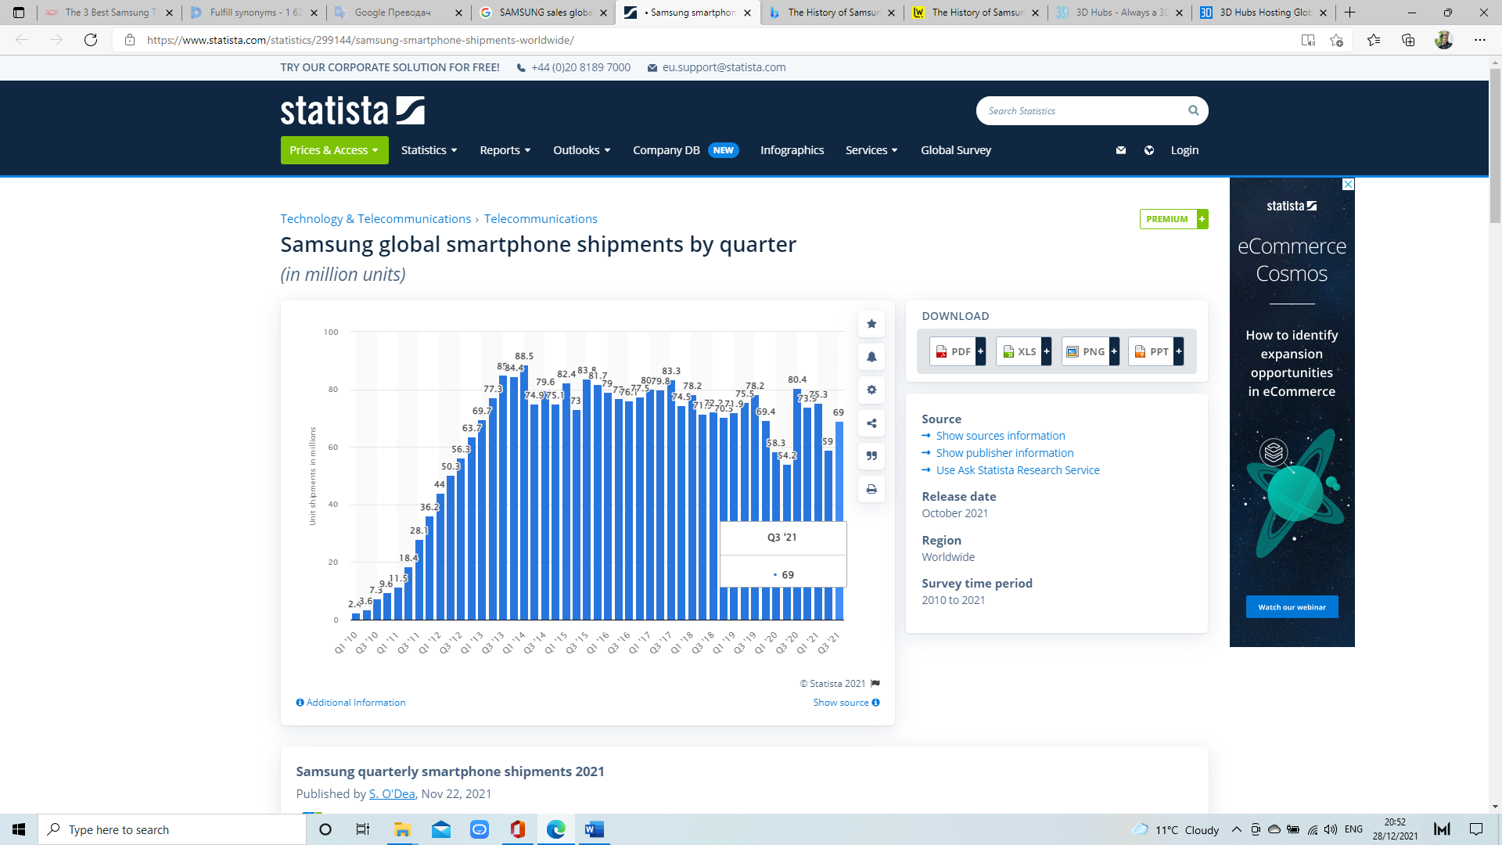

Source: Statista, 2021

Promotion:

Communication with their customers

Samsung company adopted plethora of strategies to create efficient communication with its customers in the market, and frequently delivers facts and details according to their new features, products, and technologies. Therefore, it assists the organisation to create an interest within new consumers and build sustainable marketing interaction between sellers and buyers. Thus, to enrich the corporate image, and reinforce stable communication with accurate information, the company applies marketing communication mix to satisfy customers’ wants and needs with new products and services. In fact, the company utilises effective marketing channels as print and media advertising, search engines, sales promotion, events, public relations, knowledge, banner ads and many others (Dudovskiy,2018).

Advertising

Print and media advertising is one of the major components of the marketing mix adopted by Samsung Electronics. Currently, the company prints advertising in public newspapers, magazines, and journals. Moreover, Samsung partnerships with Fox channel in the United States, which performs four advertising videos with duration of 30 seconds during the National Football League, college football and World Series games in 2012 (Dudovskiy, 2018).Accordingly to Kotler, et al (2019) the new marketing is ‘customer-engagement marketing, which gives the priority to consumers to inform themselves before buying a product and push managers to use rich marketing mix online, therefore more people will be engaged on a personal level. In fact, Samsung cooperates with social media sites such as Facebook, Twitter, and YouTube, so its online profile is maintained and updated regularly, which allows the company to build, retain and maintain a relationship with its loyal customers. Undoubtedly, these types of initiatives are included in pull advertising strategy. (Sattar, 2021)

Sales promotion

Certainly, to enhance the promotion of their products and services, Samsung has affiliated with public figures and celebrities. Hence, through this association, groups of famous people are capable to advertise their devices and other businesses throughout all social media platforms and may assure an increase within the brand and product exposure due to their considerable fanbase. From one point of view, Samsung works with a diverse marketing approach throughout the year, both during the festive season and outside of it, whereby from the other point, it offers countless incentives and discounts to its business associates to stimulate them to market Samsung above the rivals. (Shastri, 2021)(Fig.3)

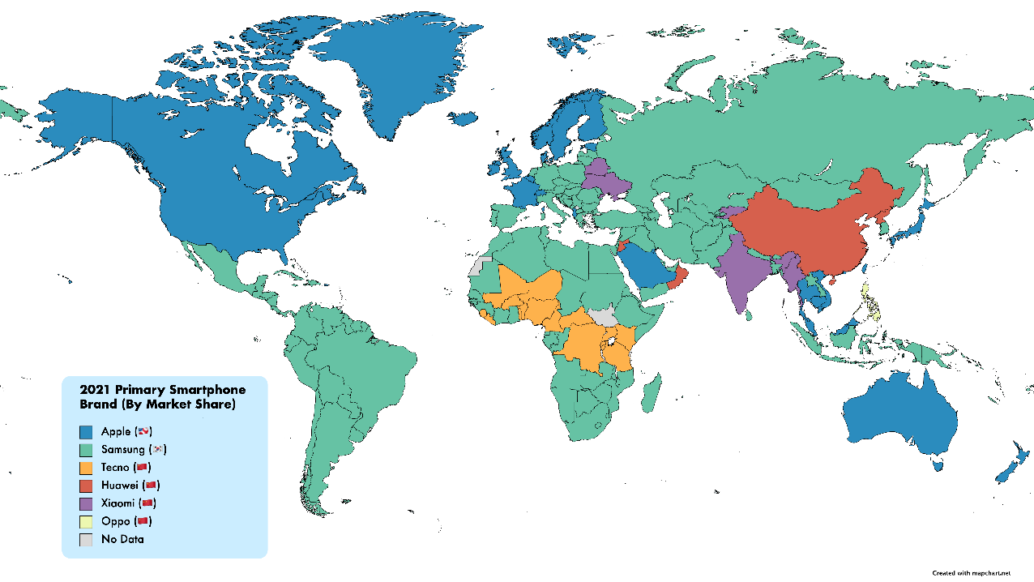
Figure.3 Primary Smartphone Brand (By Market Share)

Source: Reddit Inc, 202

Personal Selling

Samsung prioritises relationship selling, manufactures products of high value with good quality, that appeals to consumers across the world for a long period of time. Furthermore, examples of this are identified in most of Samsung products, as they appear wrapped and bundled with questionnaires and surveys that customers can complete. Often these investigations aim to gain reviews obtained from its consumers, asking various questions ranging from customer satisfaction to the performance of the product. Hence, this provides the buyer the feeling that Samsung is truly involved in customer opinion, and the company itself benefits from it with useful information on how to improve what their products and services. These surveys can also be fulfilled online using personal email or the company's official website, forming this type of relationship as faster in terms of responses and a cost and time efficient way to collect information. In addition, regular customers who choose to complete this process normally receive special offers, and discounts towards their next order for being loyal customers. (S., 2013)

Conclusion:

Samsung is one of the largest companies in the world of electrical engineering, offering products from telephones to televisions, kitchen appliances, as well as many engineering parts. From its inception to the present day, it remains one of the leaders in sales, this is because the company is skilled enough to provide what the customer is interested in. The innovations it has made over the years and the quality it has strived for have led to this successful path the company is taking. With this communication with customers and the quality offered by the company Samsung will be one of the leaders in the future too.

References:

Amazon, 2021. Samsung Galaxy S21 Ultra 5G Smartphone. [Online]
Available at: https://www.amazon.de/-/en/Samsung-Galaxy-Smartphone-Phantom-Android/dp/B08QXW7GY3
Burris, M., 2020, The History of Samsung (1938-Present), [Online] Available at: https://www.lifewire.com/history-of-samsung-818809
Dudovskiy, J., 2018. Samsung Marketing Communication Mix. [Online]
Available at: https://research-methodology.net/samsung-marketing-communication-mix/
F., A., 2021. Where are Samsung phones made? It’s not where you think. [Online]
Available at: https://www.sammobile.com/where-are-samsung-phones-made
Granger, J., 2011. Samsung Refrigerator Benefits For The Homeowner. [Online]
Available at: https://ezinearticles.com/?Samsung-Refrigerator-Benefits-For-The-Homeowner&id=5812198
KOREA EXPOSE, K., 2017. What Does Samsung Make?. [Online]
Available at: https://www.koreaexpose.com/samsung-products-basic-information/
Kotler, PT, Armstrong, G, Harris, LC, & He, H 2019, Principles of Marketing, Pearson Education Limited, Harlow, United Kingdom. Available from: ProQuest Ebook Central. [29 December 2021].
MALLA, S., 2020. 12 Pros and Cons of Samsung Television. [Online]
Available at: https://honestproscons.com/pros-and-cons-of-samsung-television/
Martin, V., 2019. Samsung’s Mission Statement & Vision Statement (An Analysis). [Online]
Available at: http://panmore.com/samsung-corporate-vision-statement-corporate-mission-statement-analysis#:~:text=Samsung%20is%20a%20technology%20conglomerate%20whose%20corporate%20mission,leadership%20in%20the%20semiconductors%2C%20electronics%2C%20and%20other%20market
Mobile57, 2021. Samsung Galaxy S21 Ultra 5G Price in Sweden. [Online]
Available at: https://www.mobile57.com/se/phones/samsung-galaxy-s21-ultra-5g-10743
Mobile, C., 2021. Samsung Galaxy S21 Ultra 5G. [Online]
Available at: https://www.currys.co.uk/mobile/phones/p/samsung-galaxy-s21-ultra-5g-black-128gb-10220024/
ProVsCons.com, (2021), Samsung Phones Pros and Cons.. [Online]
Available at: https://provscons.com/samsung-phones-pros-and-cons/
Reddit Inc, 2021. The Primary Smartphone Brand By Market Share In Each Country, [Online]Available at: https://www.reddit.com/r/MapPorn/comments/oplkgw/the_primary_smartphone_brand_by_market_share_in/
S., B., 2013. Chap. 17: Personal Selling and Sales Management. [Online]
Available at: https://bspence2.blogspot.com/2013/10/chap-17-personal-selling-and-sales.html
Samsung, 2021. Samsung Galaxy S21 Ultra 512GB. [Online]
Available at: https://shop.samsung.com/ie/samsung-galaxy-s21-ultra-512gb-phantom-black
Samsung,2021, Samsung Galaxy Z Fold3 5G, [Online] Available at: https://www.samsung.com/global/galaxy/galaxy-z-fold3-5g/
Samsung Newsroom, 2018, Samsung Dominates the Large Screen TV Market, [Online] Available at: https://news.samsung.com/global/next-for-qled-part-1-samsung-dominates-the-large-screen-tv-market
Sattar, S. B., 2021. Advertising Strategy of Samsung. [Online]
Available at: https://www.thestrategywatch.com/advertising-strategy-of-samsung/
Shastri, A., 2021. Detailed Marketing Strategy of Samsung. [Online]
Available at: https://iide.co/case-studies/marketing-strategy-of-samsung/
Statista, 2021. Samsung global smartphone shipments by quarter, [Online] Available at: https://www.statista.com/statistics/299144/samsung-smartphone-shipments-worldwide/
Telenor, 2021. SAMSUNG G998B Galaxy S21 Ultra 256GB. [Online]
Available at: https://www.telenor.bg/private/device/view/samsung-g998b-galaxy-s21-ultra-256gb
Vailshery, L. S., 2021. Samsung Electronics - statistics & facts. [Online]
Available at: https://www.statista.com/topics/985/samsung-electronics/#dossierKeyfigures

