

Module Name: Managing Enterprise
Module Code: (BMSW4011_SWAN)
Assignment Name: Business Plan
Student Name: Ahmed Mehmed Ahmed
Number:2436755
Lecturer: Jaliya de Silva

AI Acknowledgement
I confirm that I have not presented any AI generated materials as my own work.
I confirm that I have copies of my drafts, notes, and other resources I used, which I may be asked to provide in evidence.

- Business Plan for Trusted Wheels:
Business Name:
Trusted Wheels
Business Type:
Sole Trader
Location:
Swansea and Online
Introduction:
This is a business plan for Trusted Wheels, a used car lot in Swansea. The company will focus on selling used cars that are safe and don't cost a lot. They want to attract first-time buyers, kids, and families. The car business is crucial to the UK economy. Over 7 million used cars are sold every year in the UK, according to the Society of Motor Manufacturers and Traders (SMMT, 2024). This statistic shows how important the used car market is. Recent changes in the economy and higher car prices have made more people want to buy used cars (Statista, 2024; Bank of England, 2023). Mintel (2024) also says that research indicates that people are choosing used cars more because they are cheaper and better value for money. In the UK automobile retail market, this means that starting a used car shop like Trusted Wheels is a real business chance.
Business Concept and Product Offer:
Trusted Wheels will only sell used cars that have been carefully chosen and checked for safety and reliability. The company will start out with 10 cars, mostly famous types that are known for being reliable and economical on gas in the UK market.
Each vehicle will include:
- Full mechanical inspection
- Service history check
- Minimum 12-month MOT
- Optional warranty packages
Deloitte (2023) says that giving clear information about a car's past and state builds trust with customers and boosts their confidence in buying. The McKinsey (2023) study also shows that stability and price are the two most important factors that people consider when they decide to buy a used car.
Background and Motivation for the Business Idea:
Trusted Wheels was created because I saw the problems that many people have when they try to buy used cars. Buyers often have doubts about how reliable a car is and how honest the seller is. Because I am interested in cars and outstanding customer service, I decided to open a store that puts trust and openness first. Trusted Wheels wants to make getting a car more reliable by providing thorough vehicle checks and fair prices. In the car shopping business, trust is a crucial factor in how customers make decisions (Kotler and Keller, 2016). Small, independent businesses also tend to do well by providing personalised services and having strong ties with local customers (Burns, 2016).
Business ownership:
Trusted Wheels will operate as a sole trader business. According to HM Revenue & Customs (2024), this format is popular among new small businesses because it is easy to set up and doesn't require a lot of paperwork. A sole trader also has the advantage of making all business choices and keeping all the money the business makes. There are, however, some problems with this business arrangement. For instance, the owner is responsible for everything that happens in the business, even if it fails (Scarborough, 2014). Even with these risks, the sole dealer plan is good for starting out because it is easy to use and flexible.
Mission, Aim and SMART Objectives:

Mission Statement
"To offer reliable, low-cost cars while earning the trust of loyal customers over time by being honest and open."

Business Aim
Trusted Wheels' main goal is to open a trustworthy used car lot in Swansea within three years.

SMART Objectives
- In the first year of business, sell 120 autos.
- Earn £250,000 in revenue in the first 12 months.
- Achieve customer satisfaction rates greater than 90%.
- Increase car inventory from 10 to 25 vehicles in two years.

Unique Selling Proposition (USP)
Trusted Wheels stands out by offering clear car background records, low prices, and individual customer service. These are all things that have a big effect on customer trust in retail markets (Kotler and Keller, 2016).

Location:
Trusted Wheels will be based in Swansea Enterprise Park, a well-known business area close to the M4 road in Swansea. Retail stores need to be careful about where they put their stores because exposure and ease of entry can affect how many customers come in and how well they sell (Porter, 2008). Swansea Enterprise Park gets a lot of traffic and is easy for people coming from nearby places to get to.

Human Resources:
Trusted Wheels will initially employ three staff members. Burns (2016) says that keeping the team small helps keep costs down in the early stages of a business. The business may hire more workers as it grows.

Owner/Manager
- Sales assistant
- Mechanic(part-time)
Marketing strategy:
Digital marketing
Online car classifieds sites like AutoTrader and social media sites like Facebook and Instagram will both push vehicle ads.
AutoTrader (2024) research shows that most people who buy a car start their process online, where they look at different vehicles and compare prices.
Promotional activities
- Flyers distributed in local areas
- Branded businesses cards
- Google business profile
Market research:
Primary research
Primary research was conducted through a questionnaire completed by 11 potential car buyers.
Key findings included:
Question | Result
Preferred vehicle type | 80% used cars
Budget range | £3,000 – £7,000
Key purchase factor | Good condition

Secondary research
Secondary research indicates that people in the UK want to buy used cars. The market for used cars is still much bigger than the market for new cars. According to industry studies, hatchbacks like the Ford Fiesta and Volkswagen Golf are still some of the most-bought used cars in the UK (IBISWorld, 2024).
Financial resources:

Startup Costs
Expense | Cost
Vehicle stock | £50,000
Premises rent | £1,000
Insurance | £220
Marketing | £300
Office equipment | £50
Total | £51,570
A small business needs sound financial planning to stay alive and grow (Scarborough, 2014; Barringer and Ireland, 2019).
SWOT analysis:
Strengths
• More people want to buy used cars (SMMT, 2024)
• Reasonable prices
• Clear information about vehicles
Weaknesses
• Not enough money to start
• At first, a small collection
Opportunities
• More people want to buy cheap cars (Mintel, 2024)
• More hybrid cars being sold
Threats
• Uncertainty in the economy
• Tough competition from bigger auto shops
Conclusion:
This business plan has examined the possibility of opening Trusted Wheels as a used-car shop in Swansea. The UK used-car market is still strong and growing, according to industry data (SMMT, 2024; Statista, 2024). This is because people want to buy cheap cars. Trusted Wheels has a great chance to grow and stay in business in the area if they use smart marketing strategies, plan their finances carefully, and put an emphasis on trust and openness, especially by targeting budget-conscious consumers who are looking for affordable used cars.

2. Individual Reflection:

Making my business plan for Trusted Wheels has changed me and shown me how much I could be an entrepreneur in the future. I was able to use everything I've learned about spending, planning, researching, and selling in this project. That experience gave me the chance to discuss a business idea I had, and it taught me how much work it takes to build something from scratch. Learning more about the ins and outs of being a business is making me understand how important it is to be strong and flexible along the way. Every task I face not only makes me better at what I do, but it also feeds my desire to make a real difference in the car business.
Real customer needs helped me make a full business plan, which was one of the most important things I learned. To learn more about the business, I did a questionnaire. Based on the answers to my questions, I was able to shape my business ideas, improve my price, and choose where to sell my cars. I had no idea how useful study could be for making business choices. I also liked learning how to take a simple idea and turn it into an organisational plan, complete with growth plans, financial forecasts, and marketing strategies. This experience has made me more confident in my decision-making and sparked my interest in starting my own business.
Managing my time better was another thing I worked on. To stay on track, I had to carefully plan each part of the business plan. Some jobs, like the financial outlook (which guesses what will happen with money in the future) and the SWOT analysis (which looks at strengths, weaknesses, opportunities, and threats), were harder than I thought they would be. By following a plan and working one step at a time, I finished the job on time and achieved a level of quality that I am proud of. This experience helped me become a better project manager and taught me how important it is to work with others and ask for help. In the end, the process made me feel more confident in my ability to handle difficult jobs and change my approach to problems as they come up.
I've always loved cars, but I never thought about turning that into a business. It was always my dream to turn my hobby into a job, but I was afraid of the risks. It makes me feel a lot better to have learned this new thing. If someone makes their interest their job, there's nothing they can't do. With my increased confidence, I want to try different things in the car business. I am excited to bring my love of cars and my desire to be a business together. To be successful, you must try. Making mistakes helps us learn from them and become better at what we do.

References:
- AutoTrader (2024) Retailer Market Insights Report. London: AutoTrader.
- Bank of England (2023) UK Economic Outlook. London: Bank of England. Available at: https://www.bankofengland.co.uk (Accessed: 5 March 2026).
- Barringer, B. and Ireland, D. (2019) Entrepreneurship: Successfully Launching New Ventures. 6th edn. Harlow: Pearson Education.
- BBC News (2024) UK Automotive Market Trends. Available at: https://www.bbc.co.uk/news/business (Accessed: 5 March 2026).
- Burns, P. (2016) Entrepreneurship and Small Business: Start-up, Growth and Maturity. 4th edn. London: Palgrave Macmillan.
- Deloitte (2023) Global Automotive Consumer Study. London: Deloitte Insights. Available at: https://www2.deloitte.com (Accessed: 5 March 2026).
- European Automobile Manufacturers Association (2024) European Automobile Industry Pocket Guide. Brussels: ACEA. Available at: https://www.acea.auto (Accessed: 5 March 2026).
- Financial Times (2024) Automotive Industry Analysis. Available at: https://www.ft.com (Accessed: 5 March 2026).
- HM Revenue & Customs (2024) Setting Up as a Sole Trader. London: HMRC. Available at: https://www.gov.uk/set-up-sole-trader (Accessed: 5 March 2026).
- IBISWorld (2024) Used Car Dealers Industry Report UK. London: IBISWorld.
- KPMG (2023) Global Automotive Executive Survey. London: KPMG. Available at: https://home.kpmg (Accessed: 5 March 2026).
- Kotler, P. and Keller, K. (2016) Marketing Management. 15th edn. Harlow: Pearson Education.
- McKinsey (2023) Automotive Industry Trends. New York: McKinsey & Company. Available at: https://www.mckinsey.com (Accessed: 5 March 2026).
- Mintel (2024) UK Automotive Retail Market Report. London: Mintel Group Ltd.
- Office for National Statistics (2024) UK Retail Market Data. Newport: ONS. Available at: https://www.ons.gov.uk (Accessed: 5 March 2026).
- Porter, M. (2008) Competitive Strategy: Techniques for Analyzing Industries and Competitors. New York: Free Press.
- Scarborough, N. (2014) Essentials of Entrepreneurship. 7th edn. Harlow: Pearson Education.
- Statista (2024) Used Car Sales in the United Kingdom. Available at: https://www.statista.com (Accessed: 5 March 2026).
- Society of Motor Manufacturers and Traders (SMMT) (2024) Used Car Market Report. London: SMMT. Available at: https://www.smmt.co.uk (Accessed: 5 March 2026).
- UK Government (2024) Automotive Sector Overview. London: Department for Business and Trade. Available at: https://www.gov.uk (Accessed: 5 March 2026).
- McKinsey & Company (2023) Automotive Consumer Survey. New York: McKinsey & Company. Available at: https://www.mckinsey.com (Accessed: 5 March 2026).
- Deloitte Insights (2023) Global Mobility Trends. London: Deloitte Insights. Available at: https://www2.deloitte.com (Accessed: 5 March 2026).

Appendix 1: Location
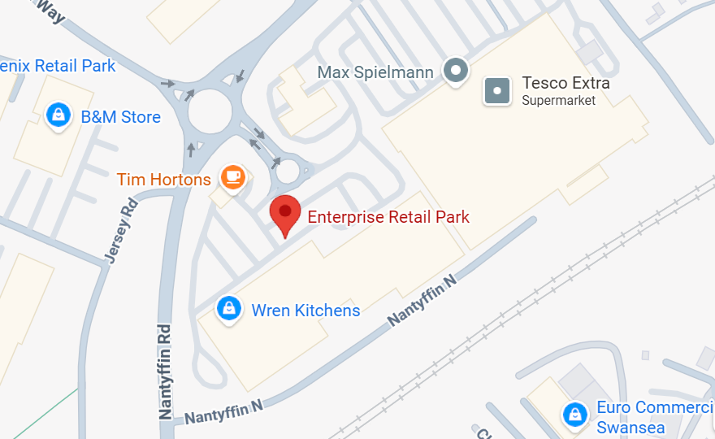
Appendix 2: Flyer
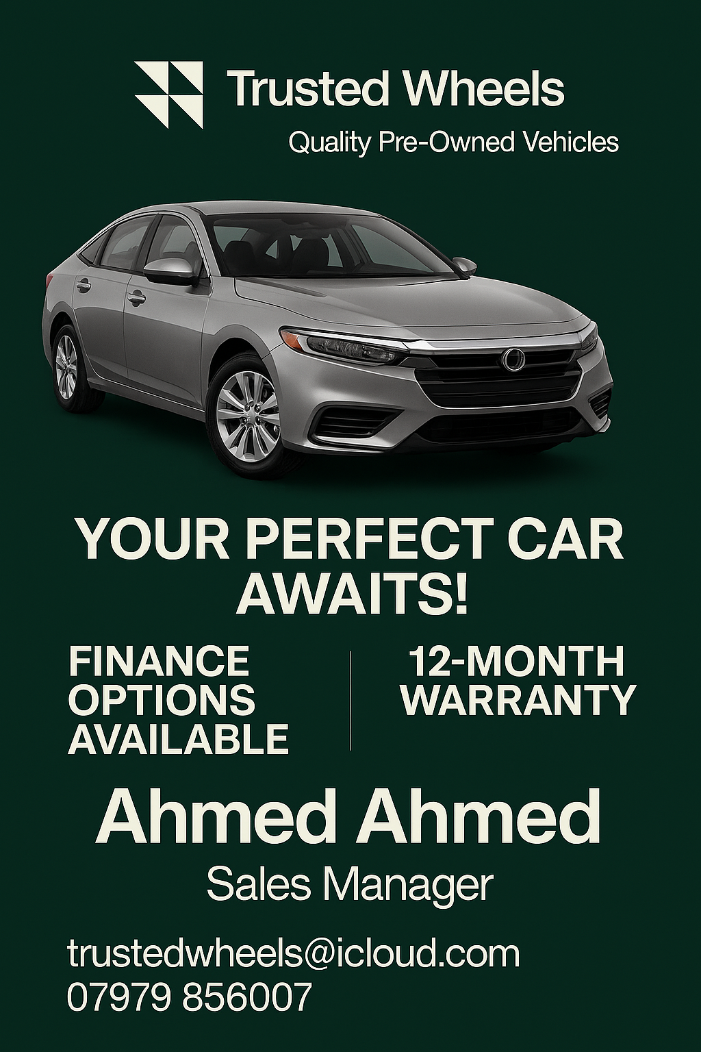
(Canva,2026)
Appendix 3: Business card
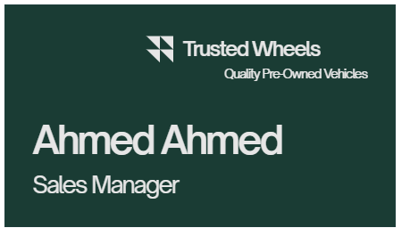
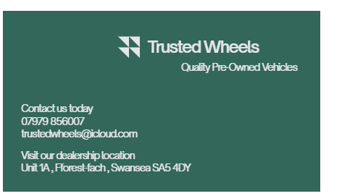
(Canva,2026)
Appendix 4:
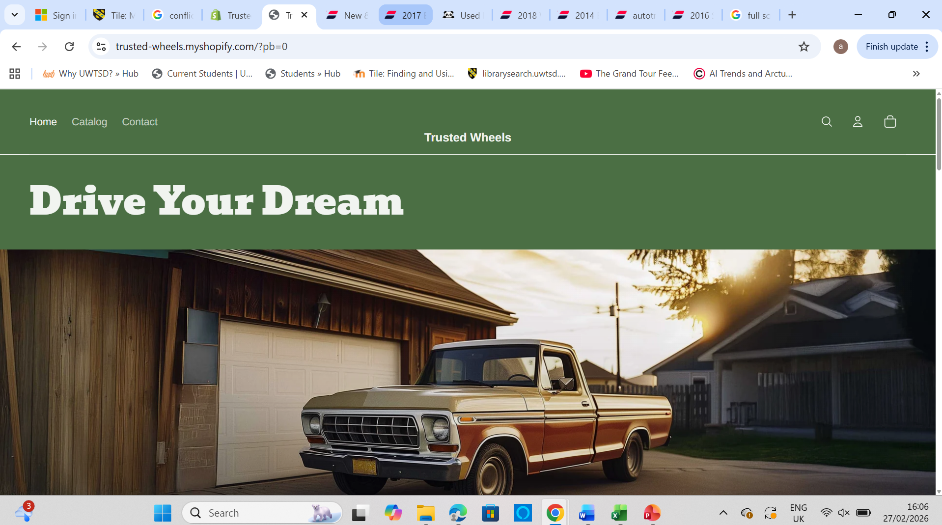
(Shopify,2026)
Appendix 5:
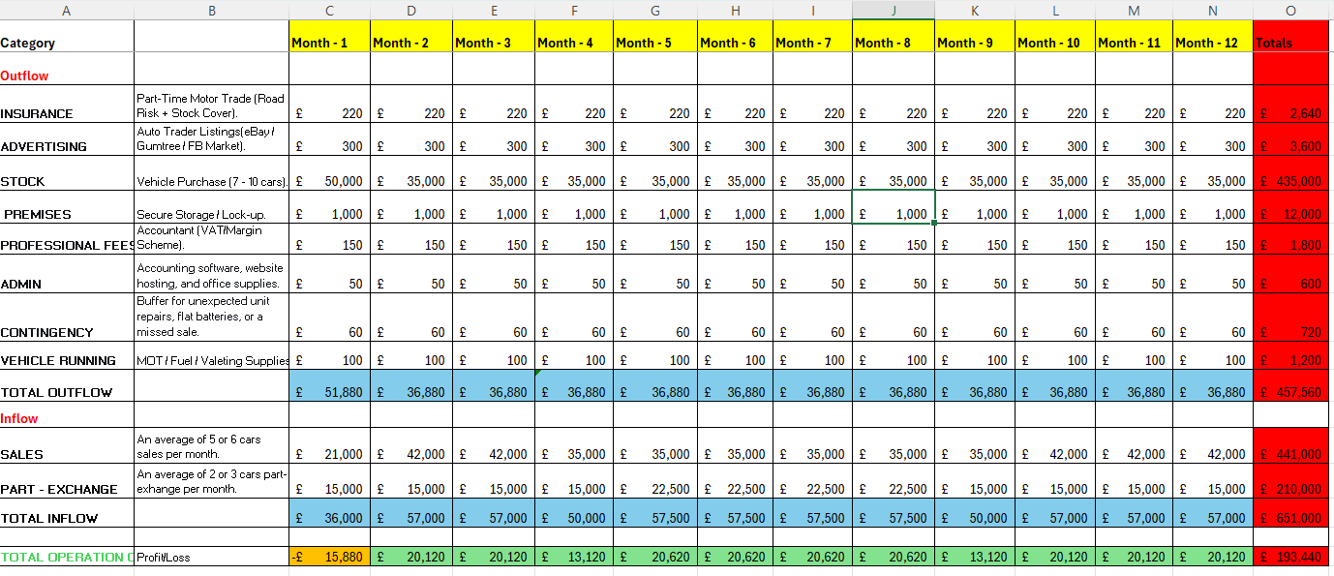
Appendix 6:
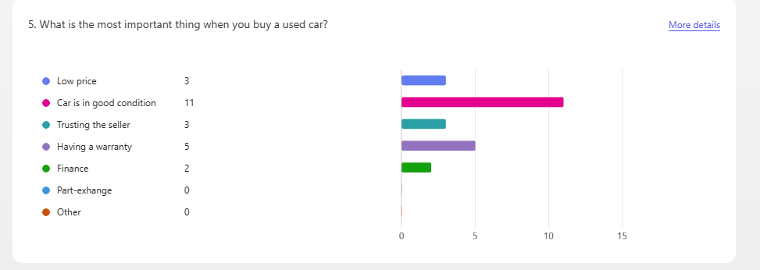
Appendix 7:
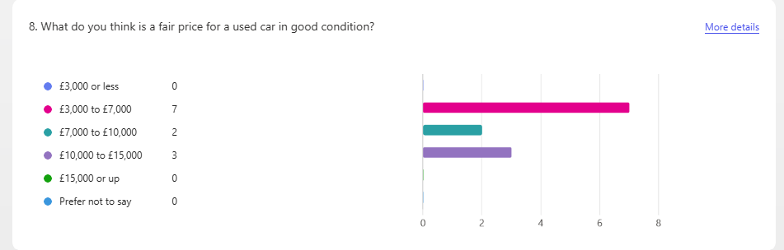
Appendix 8:


