0
Module Name: Academic Skills in the Digital Era
Module Code: BMSW4013
Assessment 1:
Student Name: Alina Stefania Cirstea
Student Number: 2519335
Lecturer: CHRIS WILKIN
Deadline: 17.08.2026

Contents
Component 1 – Development of Academic Skills (500 words) 3
Component 2 – Application of Academic Skills (1,000 words) 6
Component 3 – Academic Poster 10

Component 1 – Development of Academic Skills (500 words)
Source 1
Cottrell, S. (2019) The Study Skills Handbook. 5th edn. London: Macmillan Education UK.
This source was accessed through the university reading list and library resources. Using the CRAAP Test, it can be considered a reliable source for this assignment. In terms of Currency, the book was published in 2019 and remains relevant because the academic skills discussed, such as time management, organisation and independent learning, continue to be important in higher education. The source is highly Relevant as it focuses on the development of skills that help students succeed in academic study. The Authority of the source is strong because Stella Cottrell is a recognised author in the field of academic skills and her books are widely used by universities. The information is Accurate because it is based on educational research and practical guidance for students. The Purpose of the book is educational, aiming to support students in developing effective study habits and improving academic performance. Therefore, this source provides reliable information for understanding student success in the digital era.

Source 2
Cottrell, S. (2023) Critical Thinking Skills: Effective Analysis, Argument and Reflection. 4th edn. London: Bloomsbury Academic.
This source was also accessed through the university reading list. According to the CRAAP Test, it is a credible academic source. The Currency of the source is a strength because it was published in 2023 and reflects current approaches to academic learning and critical thinking. It is highly Relevant because critical thinking is an essential skill when students are working with large amounts of digital information. The Authority of the source is demonstrated through the author's expertise in academic skills and the book’s use within higher education. In terms of Accuracy, the content is supported by academic concepts, practical examples and established approaches to analysis and evaluation. The Purpose of the text is educational, helping students develop stronger analytical, evaluative and reflective skills. As a result, the source is highly suitable for understanding how students can succeed in a digital learning environment.

2. Synthesis of Academic Sources
Both sources emphasise the importance of academic skills in supporting success in higher education. A common theme is the need for students to become independent learners. Cottrell (2019) focuses on practical skills such as organisation, planning and managing study time effectively. In contrast, Cottrell (2023) concentrates on analysing information, evaluating evidence and developing reasoned arguments. Although the two sources focus on different aspects of learning, they complement one another by showing that academic success requires both effective study habits and critical thinking skills. Together, the sources suggest that students must be able to manage their learning while also making informed judgements about the information they use. Synthesising these sources provides a broader understanding of the skills needed for success in the digital era (Cottrell, 2019; Cottrell, 2023).

3. Identifying a Key Challenge and Opportunity
A key challenge for students in the digital era is evaluating the large amount of information available online. Students need to identify credible sources and avoid unreliable information, making critical thinking an important academic skill (Cottrell, 2023). A significant opportunity is increased access to learning resources. Digital platforms, online libraries and academic databases provide students with quick and flexible access to information, supporting independent learning and academic development (Cottrell, 2019).

4. Academic Planning
Component 2 will begin with an analysis of the main challenges and opportunities faced by students in the digital era, as these areas are central to answering the assessment question. Further discussion will focus on critical thinking, digital literacy and time management because these skills were explored throughout the module. The report will be structured into five sections: introduction, challenges, opportunities, strategies for success and conclusion. This structure provides a clear and logical approach to addressing the topic and supporting academic discussion with evidence.

Timeline
Task | Date/ Deadline
Finish research | 01.08.2026
Draft first section | 09.08.2026
Complete first draft | 14.08.2026
Final editing | 17.08.2026

Reference List – Component 1
Cottrell, S. (2019) The Study Skills Handbook. 5th edn. London: Macmillan Education UK.
Cottrell, S. (2023) Critical Thinking Skills: Effective Analysis, Argument and Reflection. 4th edn. London: Bloomsbury Academic.

Component 2 – Application of Academic Skills (1,000 Word Report)
Introduction
Digital learning has become an important part of higher education. Students regularly use virtual learning environments, online libraries, academic databases and communication platforms to support their studies. These technologies have changed how students access information and complete academic work. While digital learning offers many benefits, it also presents challenges that can affect academic performance. Understanding both the challenges and opportunities of digital learning is important because students need a range of academic skills to succeed in higher education. Skills such as critical thinking, time management, digital literacy and academic integrity are becoming increasingly important. This report will discuss key challenges faced by students in the digital era, examine opportunities created by digital technologies and explore strategies that can help students achieve academic success.
Challenges for Students in the Digital Era
One major challenge for students in the digital era is dealing with the huge amount of information available online. Although information can be accessed quickly and easily, not all sources are reliable or suitable for academic work. Students need to evaluate sources carefully before using them in assignments. According to Cottrell (2023), critical thinking helps students analyse information, identify bias and decide whether evidence is trustworthy. Without these skills, students may use poor-quality information, which can weaken academic work and reduce its credibility.
Another challenge is managing time effectively. While digital technology supports learning, it can also create distractions. Social media, streaming services and online entertainment can take students’ attention away from their studies. Cottrell (2019) explains that organisation and planning are important for academic success because students need to balance deadlines, study time and other responsibilities. If students struggle with time management, they may find it difficult to complete work to a high standard or submit assignments on time.
These challenges can affect academic performance because students may use unreliable information or struggle to manage their workload effectively. As a result, developing strong academic skills is essential for success in higher education.
Opportunities in the Digital Era
Despite these challenges, digital technology also offers important opportunities for students. One significant advantage is easier access to learning resources. Students can use online libraries, e-books and academic databases to find information quickly and conveniently. This supports independent learning and allows students to explore topics in greater detail. McMillan (2021) highlights that access to a wide range of academic resources can help students build knowledge and improve the quality of their work.
Another opportunity is the flexibility that digital learning provides. Students can access learning materials from different locations and often at times that suit their individual study schedules. This flexibility can help students take greater responsibility for their learning and develop independent study habits.
However, the effectiveness of digital tools depends on how they are used. Simply having access to technology does not guarantee academic success. Students still need the skills to identify useful information, evaluate evidence and use resources responsibly. As Cottrell (2023) suggests, technology is most effective when combined with strong critical thinking and academic skills. Therefore, digital learning can create valuable opportunities, but students must be able to make effective use of the tools available to them.
How Students Can Adapt to Succeed
Students can adapt successfully to the digital era by developing important academic skills that help them overcome challenges and take advantage of opportunities.
Strategy 1: Develop Critical Evaluation Skills
Critical evaluation is essential when using information found online. Throughout this module, the CRAAP Test was introduced as a useful tool for assessing sources by considering their Currency, Relevance, Authority, Accuracy and Purpose. Cottrell (2023) explains that critical thinking allows students to judge the quality of information and make informed academic decisions. By developing these skills, students can avoid unreliable sources and improve the quality of their academic work.
Strategy 2: Improve Time Management and Organisation
Good time management helps students stay focused and meet deadlines. Two techniques covered during the module were the Pomodoro Technique and the Eisenhower Matrix. The Pomodoro Technique encourages students to work in focused study sessions with short breaks, helping to maintain concentration. The Eisenhower Matrix helps students prioritise tasks by identifying what is important and urgent. Cottrell (2019) argues that organised study habits contribute to academic success because they reduce procrastination and improve productivity. Bedford and Wilson (2020) also suggest that effective planning and structured study routines support independent learning and help students manage academic demands more successfully. These strategies can help students manage digital distractions and use their time more effectively.
Strategy 3: Strengthen Digital Literacy and Academic Integrity
Digital literacy is the ability to find, understand and use information effectively in digital environments. This skill is particularly important because students regularly work with online information and digital learning platforms. Alongside digital literacy, academic integrity is essential. Students must reference sources correctly and acknowledge the ideas of others. Cite Them Right (n.d.) highlights the importance of accurate referencing in maintaining academic standards and avoiding plagiarism. Strong digital literacy and academic integrity allow students to use technology responsibly while producing credible academic work.
When students develop critical thinking, time management and digital literacy skills, they are better prepared to study successfully in digital learning environments. These skills help students deal with challenges while making the most of the opportunities technology provides.
Conclusion
Students in the digital era face challenges such as information overload and difficulties managing time effectively. At the same time, digital technologies provide opportunities through greater access to learning resources and more flexible ways of studying. To be successful in higher education, students need to use digital tools effectively while developing strong academic skills. Critical evaluation, effective time management and digital literacy are important strategies that can help students adapt to digital learning environments. Overall, students who combine these skills with the opportunities offered by technology are more likely to achieve academic success and become independent learners.

Reference List – Component 2
Bedford, D. and Wilson, E. (2020). Study Skills for Foundation Degrees. 3rd edn. Routledge
Cite Them Right (n.d.) Cite Them Right: The Essential Referencing Guide. Available through UWTSD Library.
Cottrell, S. (2019). The Study Skills Handbook. 5th edn. Macmillan Education UK.
Cottrell, S. (2023). Critical Thinking Skills: Effective Analysis, Argument and Reflection. 4th edn. Bloomsbury Academic.
McMillan, K. (2021). The Study Skills Book: Your Essential Guide to University Success. 4th edn. Pearson.

Component 3 – Academic Poster

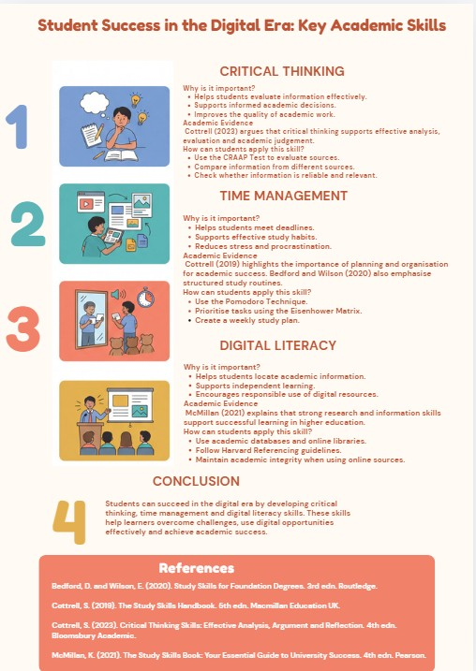

Reference List – Component 3
Bedford, D. and Wilson, E. (2020). Study Skills for Foundation Degrees. 3rd edn. Routledge.
Cottrell, S. (2019). The Study Skills Handbook. 5th edn. Macmillan Education UK.
Cottrell, S. (2023). Critical Thinking Skills: Effective Analysis, Argument and Reflection. 4th edn. Bloomsbury Academic.
McMillan, K. (2021). The Study Skills Book: Your Essential Guide to University Success. 4th edn. Pearson.

