BMSW4003 DIGITAL SKILLS AND RESEARCH METHODS

Lizel Johan Cedeno Canas
2111894
Executive Summary
The study has elaborated on the applicability and impact of VLE in educational institutions that help in enhancing employability and efficiency in individuals. The study also highlighted the implications of VLE usage in workplaces. Both primary and secondary data have been used in the study to evaluate the use of Virtual Learning environment tools and their growing usability in the global market.

Table of Contents
Introduction 4
Aim 4
Concept of Virtual Learning Environment (VLE) 4
Impact of Virtual Learning environment in Universities 6
Appropriate use of contemporary techniques (VLE) to improve workplace efficiency and employability 7
Secondary data analysis 8
Primary Data Analysis 9
Conclusion 15
References 16

Introduction
The Virtual Learning Environment is an online educational platform which skyrocketed during the Covid 19 pandemic period with Covid 19 restrictions locking down public places. It comprises a web-based platform for the digital aspects of the study, simplifying and streamlining education and learning experiences while enhancing the overall efficiency by integrating additional tools into it. The study will thus elaborate on the applicability and impact of VLE in educational institutions that help in enhancing employability and efficiency in individuals. The study will be using both Primary and secondary data in order to provide a deeper insight into the concept of VLE and its functionality.

Aim
The aim of the study is to assist in the improvement of digital skills in students within the workplace and develop awareness of effective analysis of information and transforming it into knowledge through the assistance of web-based or VLE tools.

Concept of Virtual Learning Environment (VLE)
Virtual Learning Environment or VLE as has been introduced is a web-based platform for digital aspects of learning. In VLE the learning experience within students is enhanced through the use of digital tools like computers, mobile phones and a steady internet connection which is a cloud-based solution online. This platform lets both instructors and participants engage with each other while replicating a learning environment similar to school or college. As per the scholarly perspective of Henritius et al. (2019), it has been stated that just as in a physical learning set-up, in virtual learning set up too, students' emotion is influenced by the type of interaction made through the virtual platforms.

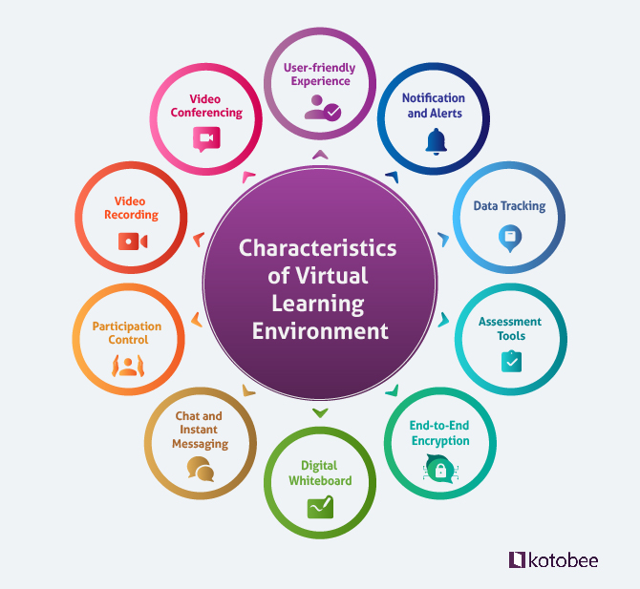
Figure 1: Characteristics of VLE
(Source: Influenced by Chaim et al. 2018)
As opined by Chaim et al. (2018), despite the profound Technology revolution there have been limited changes in educational and training practices which calls for more holistic and self-sufficient means of education that can be incorporated by integrating technology used in virtual learning in the learning and development programs. Based on two scholarly perspectives it can be claimed that VLE helps in making the educational process more flexible with increased user accessibility and user affordability while enabling simple learning management and increased learner motivation. Thus, it can be concluded that VLE is increasingly conquering physical education globally. The size of the global e-learning market in 2020 was estimated to be $250 billion (Statista, 2022).
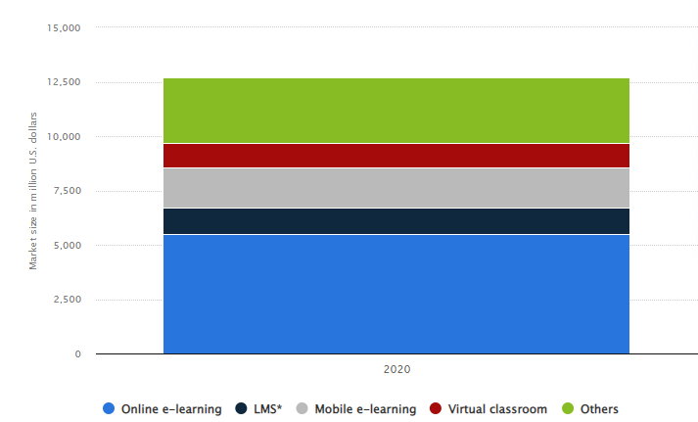
Figure 2: Global Virtual e-learning market 2020
(Source: Statista, 2022)

Impact of Virtual Learning environment in universities
As per the data gathered during the pandemic it has been observed that more than 150 countries witnessed disruption in their education system forcing them to shift to remote education and learning procedures. As per the article published by (World bank, 2022), it has been found that universities and other educational institutions including workplaces have been embracing virtual learning environments or remote learning. Further, the article suggested that though the technology is a necessary factor for effective remote learning it is not a sufficient condition and regardless of the learning morality the instructors play a critical role in VLE. Further, it has been found that 1.2 billion children in 186 countries had been affected by the Pandemic restrictions and a major percentage of the population shifted to remote education which is expected to increase global education technology investments to $350 billion by 2025 (Weforum, 2020).
UWTSD Moodle is a virtual ed-tech platform which is run by the University of Wales Trinity Saint David Moodle Course (Moodlehelp, 2022). Universities including the University of Wales have integrated the Moodle LMS into their educational environment in order to create flexibility and make online learning accessible for students helping them to save time with better support throughout their academics. Many universities have also created custom Moodle plugins to serve as a useful evidence source for study materials (Liu et al. 2019). As per the perspective of Dumford and Miller (2018), with the increase in popularity of online education many colleges in universities globally have adopted virtual learning platforms exploring the online mediums of studying which has usually impacted student engagement. Students who are engaged in a greater number of online courses are more likely to be indulgent and engaged in quantitative reasoning however they are not much likely to be engaged in collaborative learning or student interactions compared to their traditional classroom counterparts. However taking into account the University of Wales, the Moodle platform with integrity collaboration tools for reuse and remixing support of open badges have helped in creating a collaborative and highly educative environment helping to engage more students.

Appropriate use of contemporary techniques (VLE) to improve workplace efficiency and employability
As per Bramley (2018), students becoming more comfortable with technological advancement in education especially business-critical Technologies, they are subconsciously elevating their employability skills as well. In order to employ virtual learning tools like Moodle, and Google classroom, students need to have basic technological skills. Using the tools also helps in working on their soft skills like time management and critical thinking skills which pushes them off the edge into developing skills that ease job finding post-graduation. It has also been noticed that with the onset of the pandemic postponing and cancelling in-person meetings many the reputed businesses have opted for VLE platforms and tools to impart training and employee developmental skills for reskilling and bringing workplace transformation which wouldn't have been possible by simply pushing the pause button on critical workplace learning. In order to make a comprehensive learning offering in the workplace, several companies-built a cross-functional response teams composed of members from different stakeholder groups helping to establish regular operating cadence and coordination at the workplace (Mckinsey, 2020). Thus, the incorporation of VLE tools has effectively accelerated inclusivity, accessibility, community and relationship building, cost savings, and improved technical skills among employees.
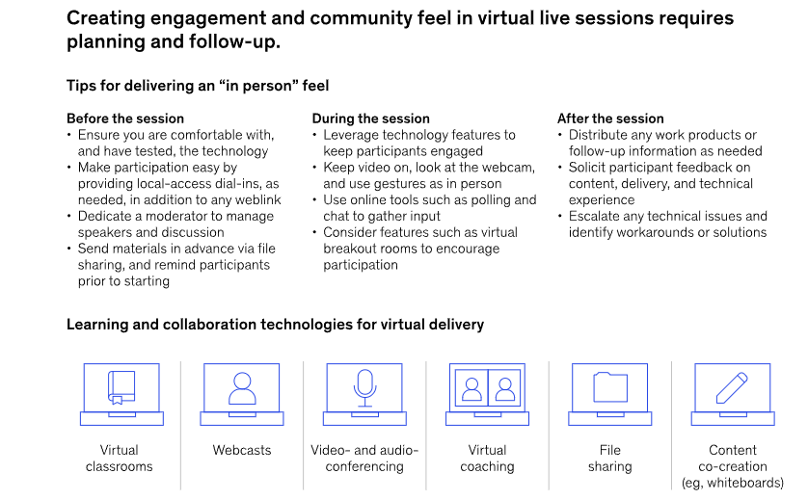
Figure 3: Implementation of VLE in organisations
(Source: Mckinsey, 2020)

Secondary data analysis
Article 1: “Augmented reality: A systematic review of its benefits and challenges in e-learning contexts”
According to Alzahrani (2020), Augmented Reality (AR) has received substantial attention as a “fundamental pedagogical tool” in enhancing learning procedures at most educational levels. AR along with cloud computing have served as the two most imperative tools that have helped in enhancing virtual learning environments supporting kinaesthetic, collaborative, remote, creative and learner-centred learning.
Article 2: “Online learning: Adoption, continuance, and learning outcome—A review of the literature” As per Panigrahi et al. (2018), technology has facilitated better learning procedures and training programmes in organisations which is increasingly gaining momentum worldwide in both educational areas as well as in workplaces while reducing the temporal and spatial issues related to traditional learning. However, the study also suggests that despite the increasing benefits the procedure has its own challenges in retaining learners.
Article 3: “Using technology‐oriented, problem‐based learning to support global workplace learning” As amplified by O'Brien et al. (2019), it has been observed that after emerging from recessionary periods and significant Technological challenges companies are increasingly integrating virtual learning environments in order to allow employees to adapt to the constant changes while helping them to invite in the new skills that enable the workforce in becoming flexible. The UK Government stresses the need for digital skills within employees in order to ensure empowering workers embracing the continuous changes and it is the Virtual learning tools that have helped the UK based organisations in effectively impacting the required skills to their employees with greater flexibility and accessibility. Workplace competency is a set of specific skills and abilities which are required in completing a job efficiently and it is through this VLE platform that organisations ensure reskilling of their employees.
Article 4: “Enhancing graduates’ employability skills through authentic learning approaches” As per Ornellas et al. (2018), VLE helps in developing a competence centred approach of study which enhances employability skills within employees and sets out a "taxonomy of skills required to enhance new graduates' employability". This article emphasises the need to improve connectivity between the online curriculum and the demands of the real world.

Primary Data Analysis
15 students from all age groups have been randomly surveyed to deduce first-hand information on VLE usage and their perspective on it.
First question: What is your Age?
The first question was related to the age of the respondents which reflects that most of the respondents are between the age range of 18-25 which means they are in their late teenage years or are adults followed by students below the age range of 18. Only 6.7% of the 15 surveyed respondents have been within the age range of 26-30, meaning the survey included students or learners from almost all the age ranges.
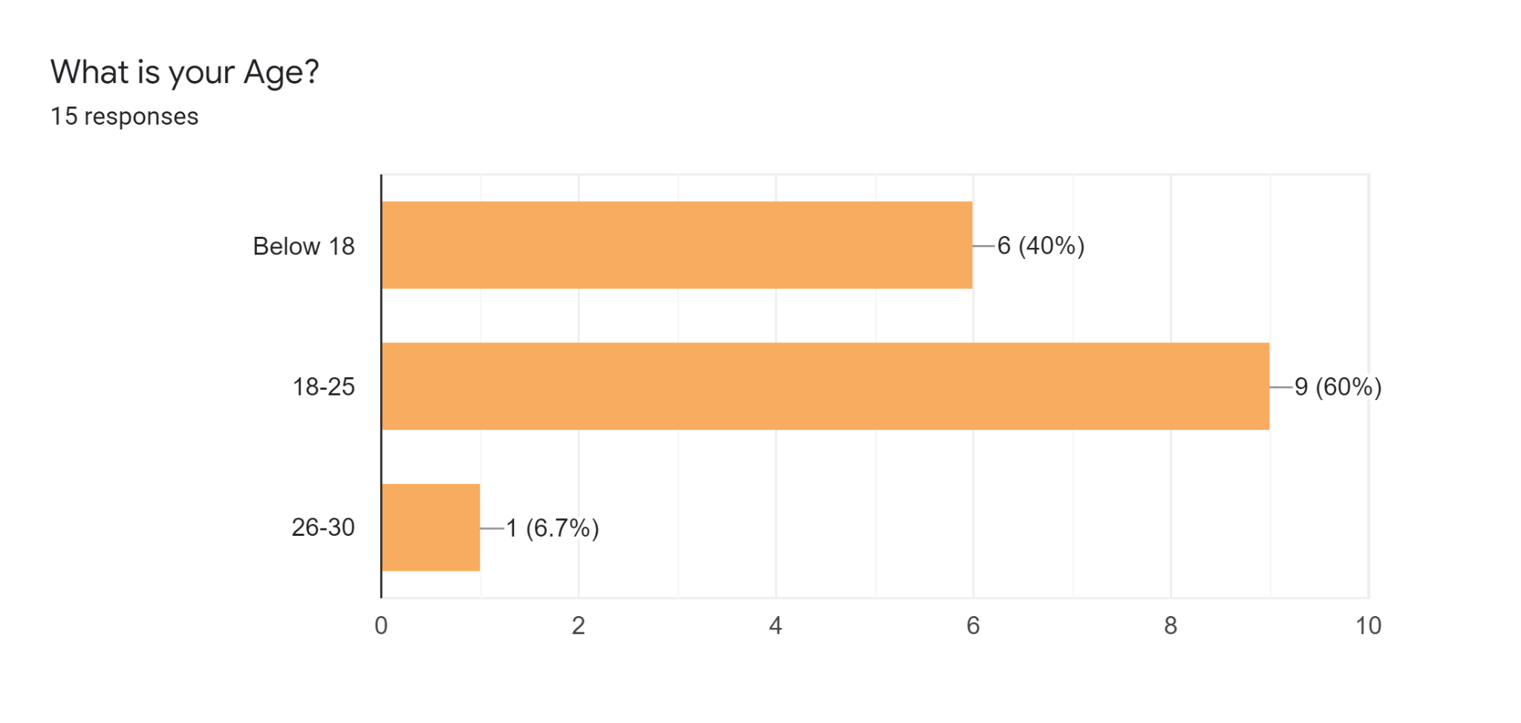

Figure 4: Age of respondents
(Source: Self Developed)
Second Question: What is your gender?
The response to gender reflects that there had been males. Female and other genders as well, meaning the study has not been biassed and has been inclusive which means it is likely to reveal authentic information relative to Virtual learning.
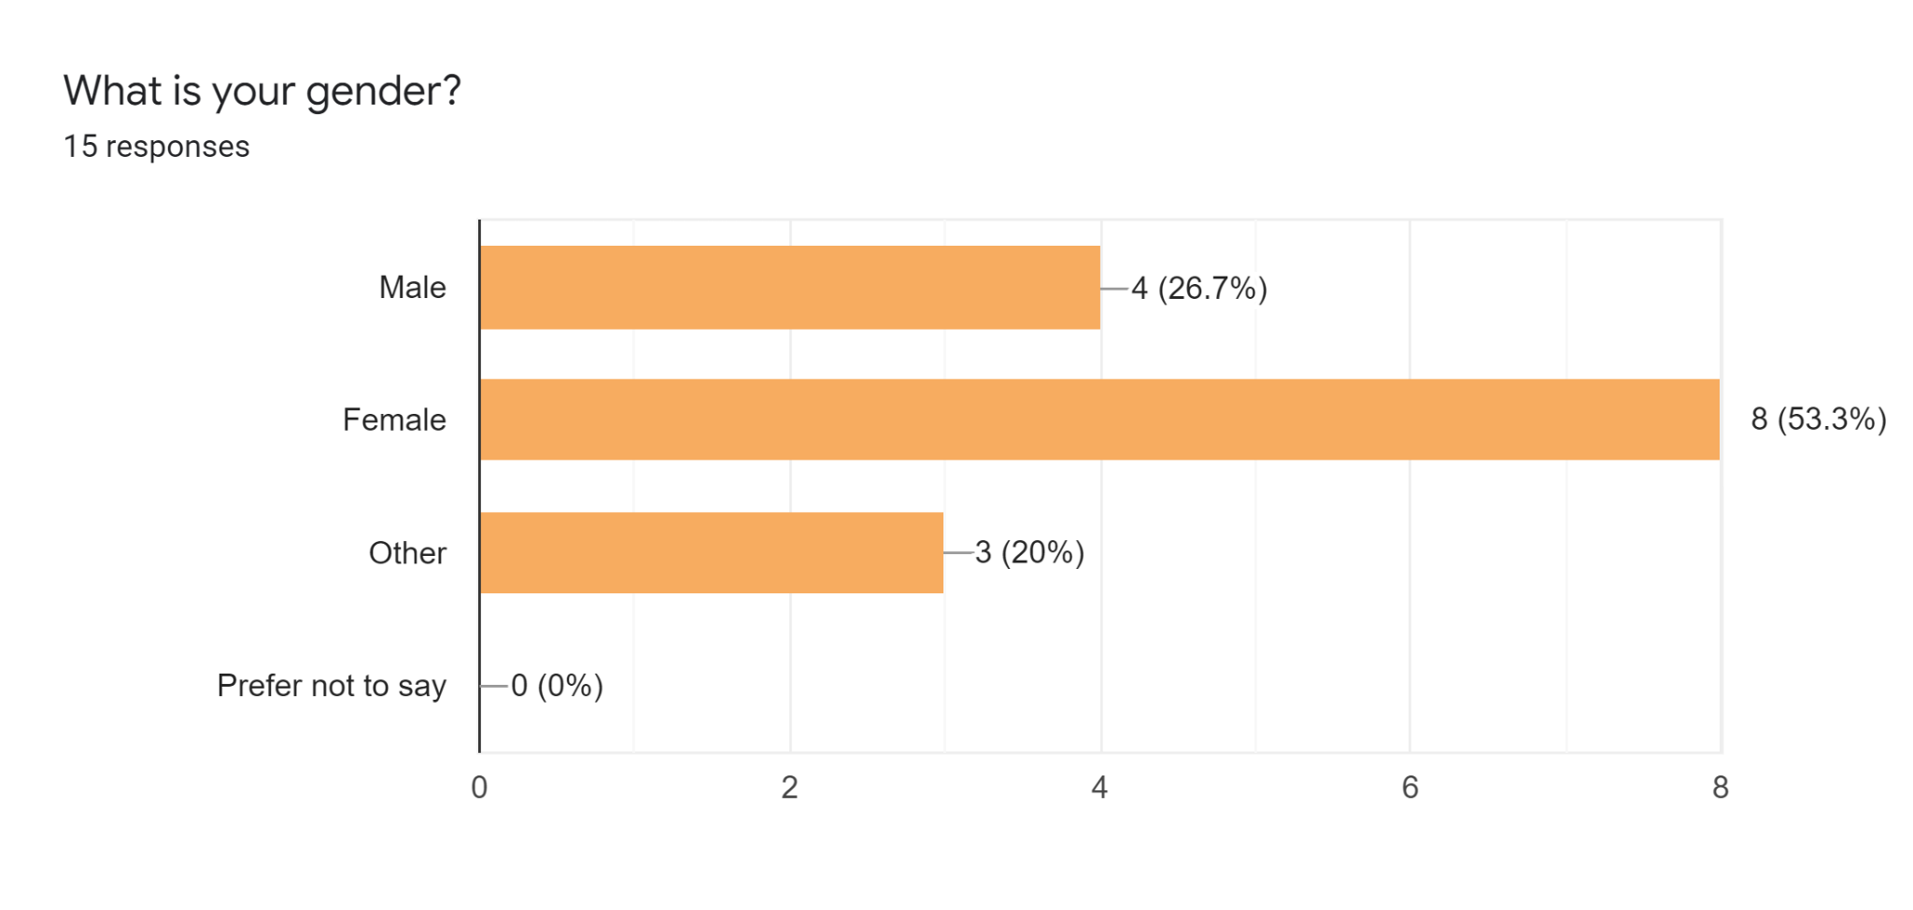
Figure 5: Gender of respondents
(Source: Self Developed)
Third Question: What device do you use for Virtual learning?
Figure 6 regarding the theory question reflects the response to the third question highlighting that 66.7% of the respondents use laptops, 26.7% use PCs and only 13.3% uses smartphones, meaning that in order to have accessibility to online learning modules there must be a proper tool or medium and rigid internet connection.
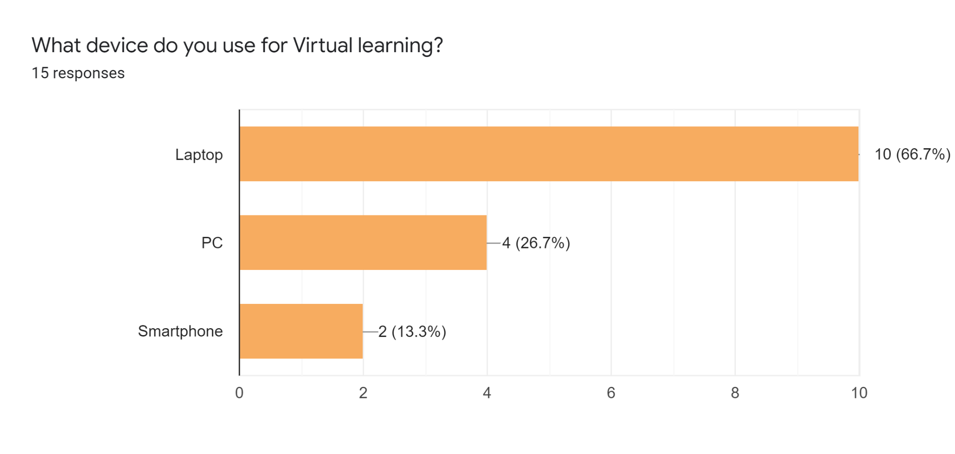
Figure 6: Device used for virtual learning
(Source: Self Developed)
Fourth Question: How difficult or easy is it for you to connect to the internet to access your assignments and learning modules?
Figure 7 reflects the response to the 4th question, highlighting that 53.3% of the respondents found it easy to connect to the internet in order to access the assignments while 20% remained neutral and the response to very easy and difficult have been 13.3% signified that there have been quite some difficulties with access to proper internet connectivity, which can be connected to the portion of the study which discussed that it is necessary to have a robust internet connection and proper gadgets in order to gain access to online learning platforms.
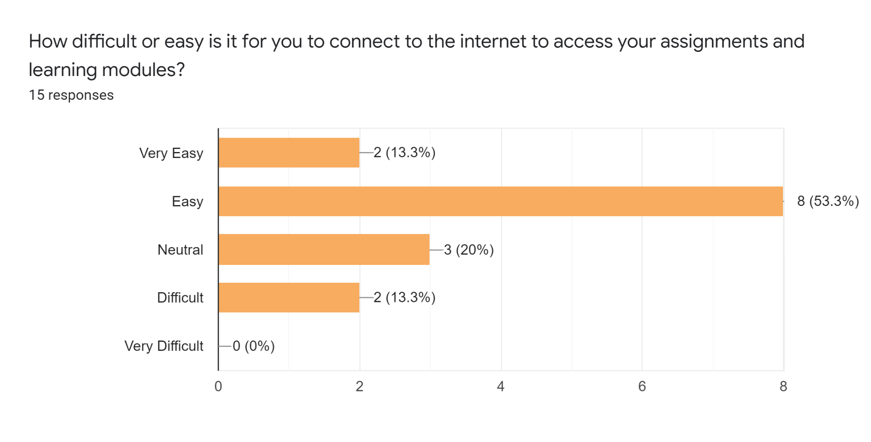
Figure 7: Available Internet access for online learning modules
(Source: Self Developed)
Fifth Question: How much average time do you spend each day on Virtual Learning Platforms?
Figure eight reflects the response to the fifth question which highlights that about 60% of the learners spend two to five hours on the virtual learning platforms signifying an increased learner population has started depending on the contemporary learning tools.
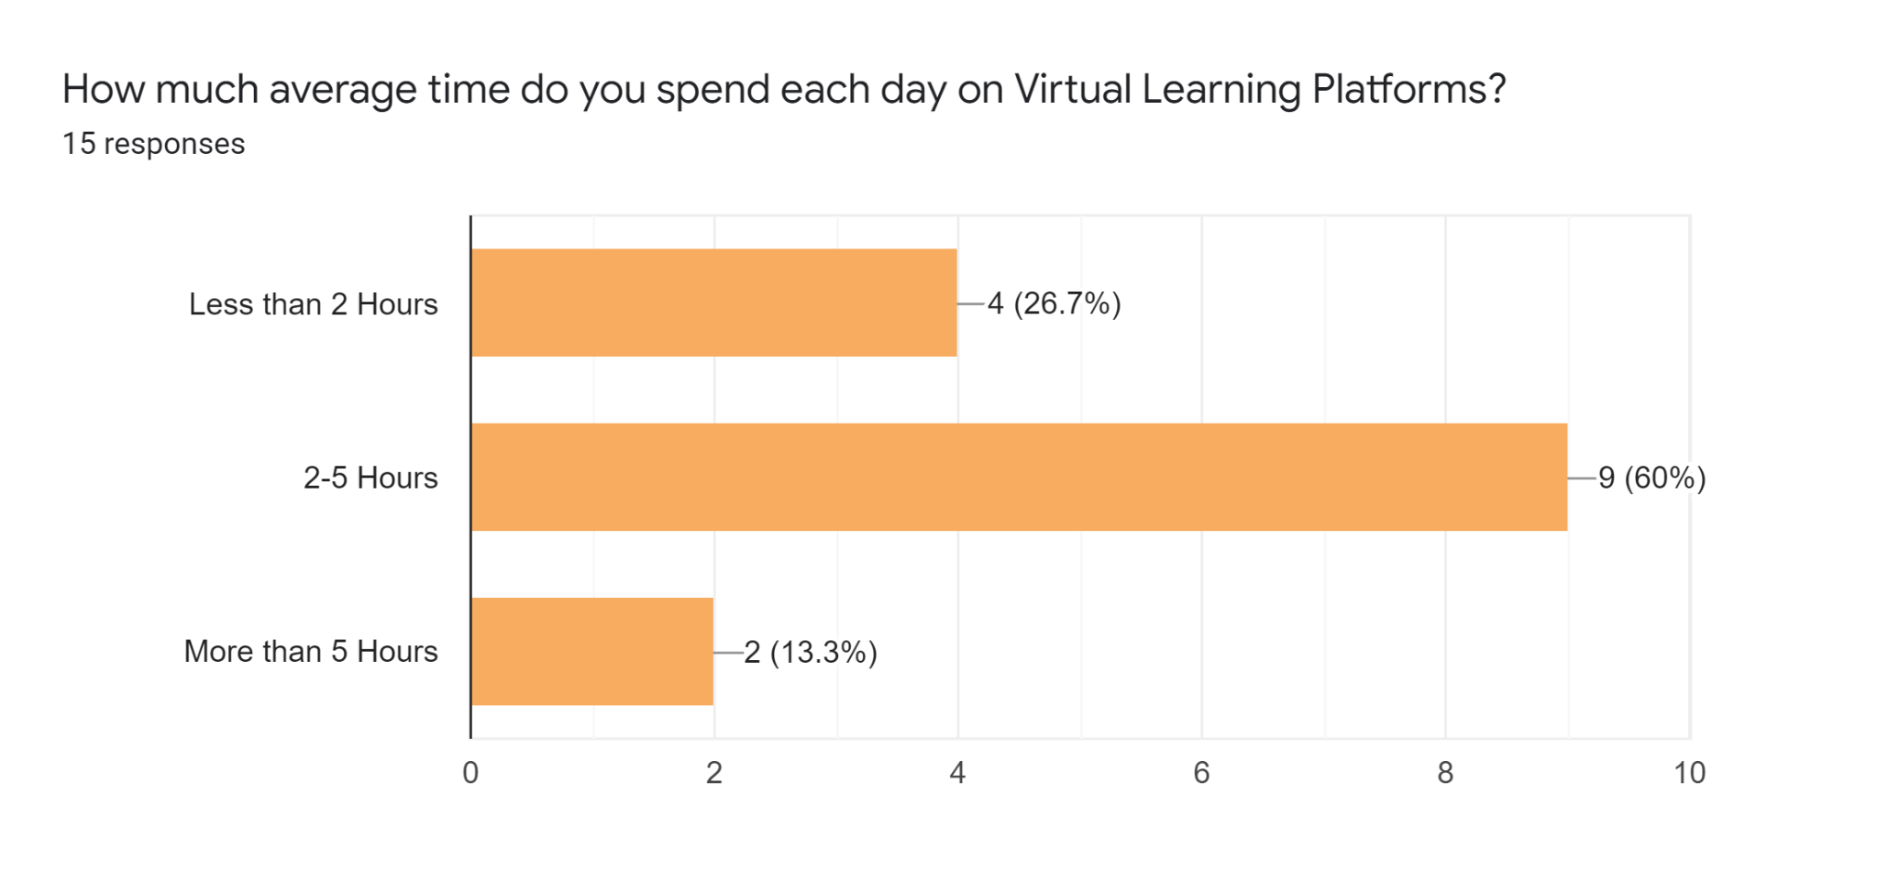
Figure 8: Average time spent on virtual Learning platforms
(Source: Self Developed)
Sixth Question: Do you think Virtual Learning Platforms are better compared to physical learning setups?
Figure 9 reflects the response to the sixth question highlighting that more of the respondents believe virtual learning platforms to be better compared to physical learning setup or traditional education procedures which justifies the future growth of the e-Learning market size that has been demonstrated previously in the study.
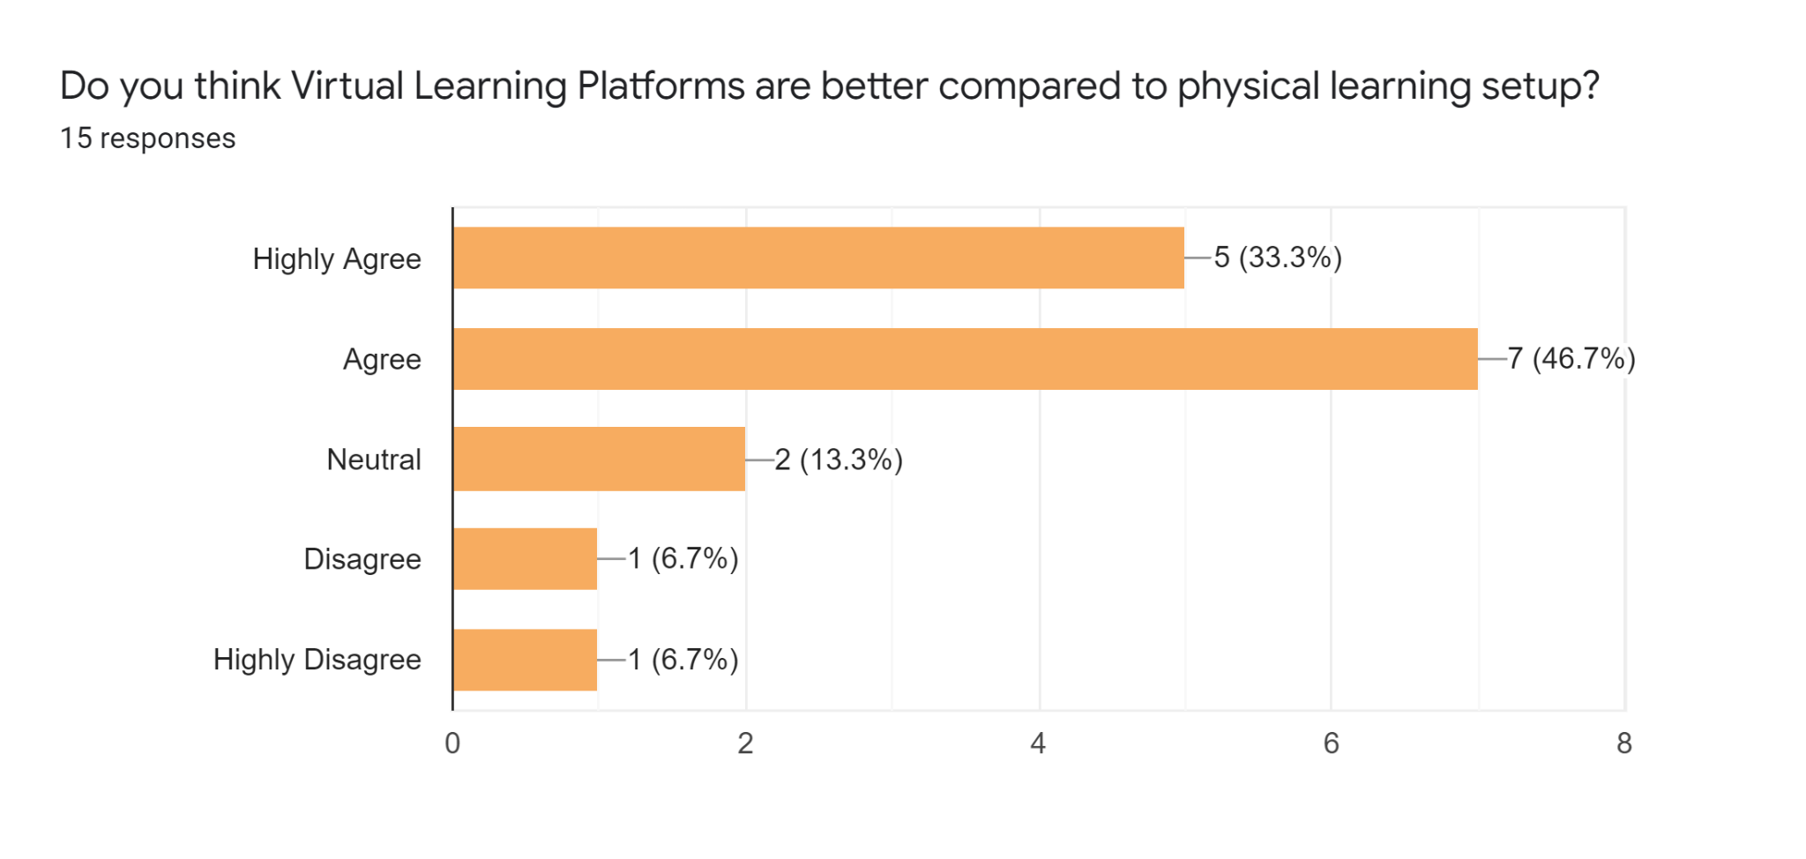
Figure 9: Virtual learning platforms vs. traditional learning procedures
(Source: Self Developed)

Seventh Question: How effective has VLE been for you, especially during Covid?
Figure 10 demonstrates the response to the 7th question which highlights that majority of the respondents believe that VLE had been a highly effective and impactful medium during Covid 19 which again justifies the sudden surge in the use of e-learning tools globally during Covid 19 Pandemic.
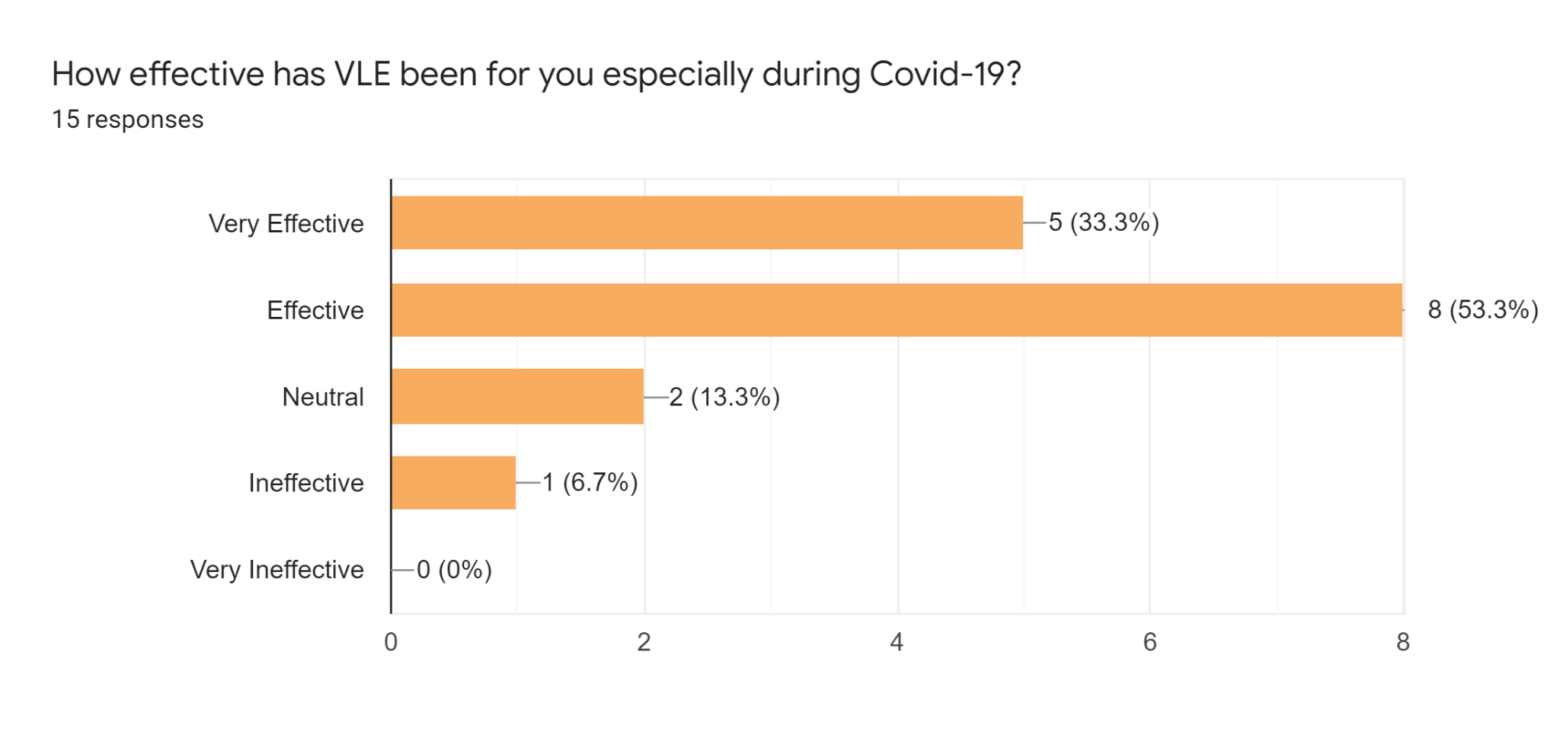
Figure 10: Effectiveness of VLE during Covid 19
(Source: Self Developed)

Eighth Question: Which learning Platform do you prefer the most?
Figure 11 demonstrates the response to question 8 which highlights that moodle had been the top choice of online learning platform among students followed by Google classroom. Previously the study discussed the surge in the rate of Moodle users with the rise in the use of e-learning platforms and tools. The primary data hens justify the increasing user base of the Moodle app in both educational institutions and workplaces.
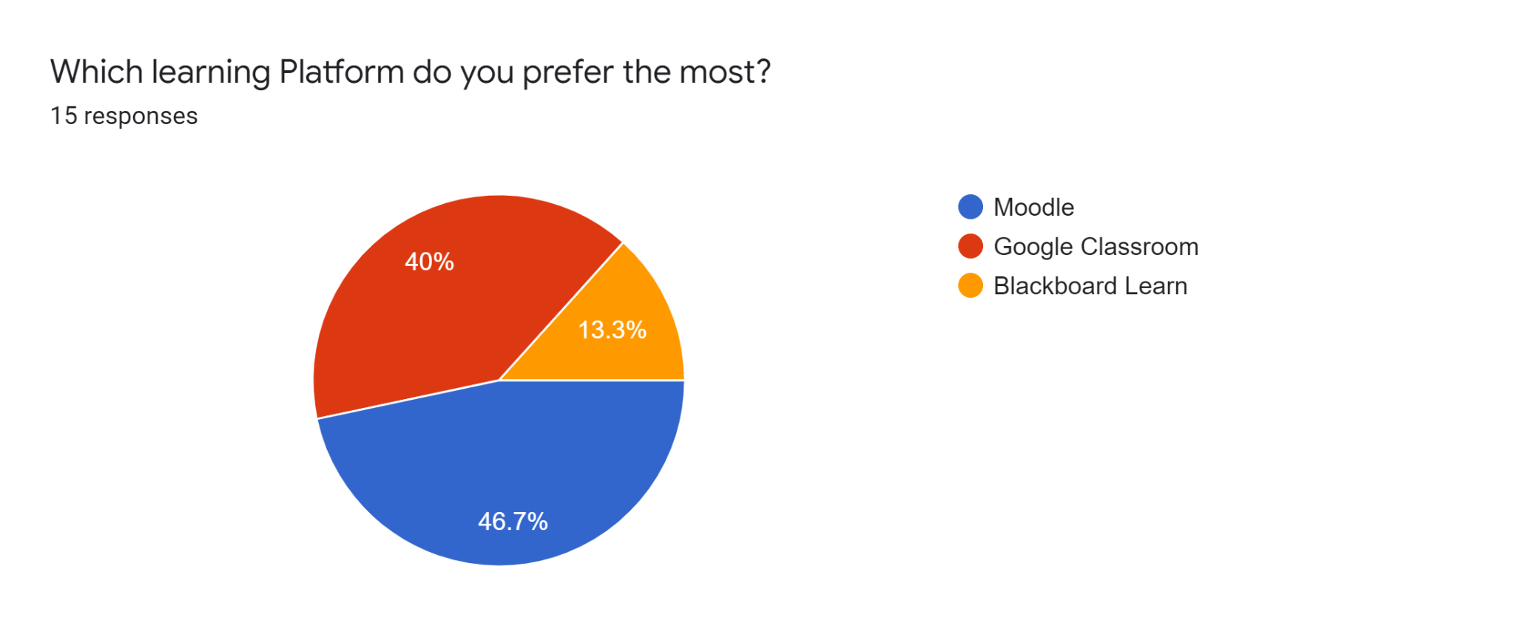
Figure 11: Most preferred learning platform
(Source: Self Developed)

Ninth Question: How do you think VLE can be employed in workplaces?
Figure 12 demonstrates the response to the 9th question which highlights that 60% of the respondents believe that VLE can be employed in organisations in order to enhance employee training and development programmes. While 26.7% of the respondents believed that VLE can be employed in workplaces for offering online learning options to employees, designing online employee training programs, and managing administrative work as well which may be the reason why more the companies are integrating VLE tools into their operational framework.
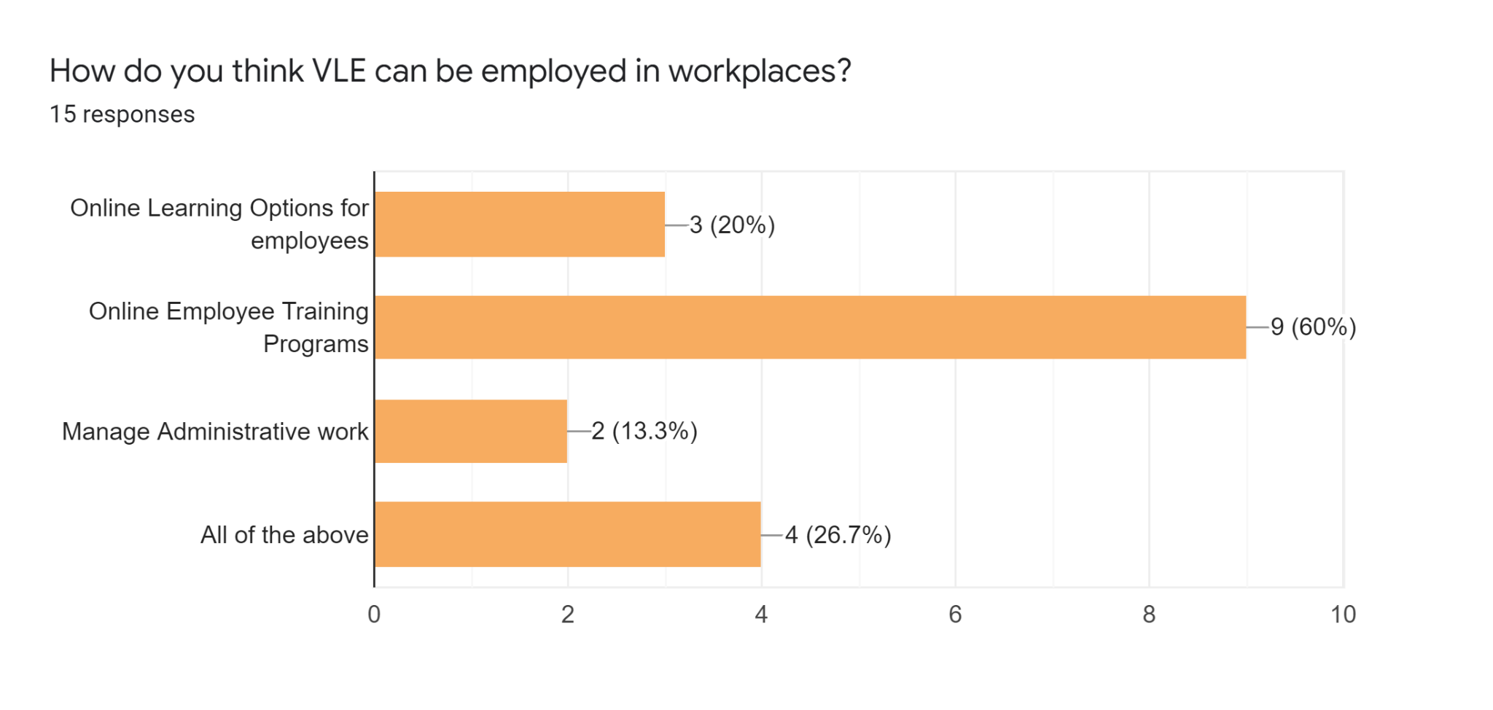
Figure 12: Integrating VLE in workplaces
(Source: Self Developed)

Conclusion
Conclusively, it can be stated that the virtual learning environment is gaining pace, especially with the advent of the pandemic. More educational institutions and workplaces are embracing the e-learning tools in order to enhance employability skills in workers. Through studies, it has been predicted that the global market for e-learning is going to witness substantial expansion in the upcoming future. Since integrating AR, AI, ML, and IoT have made the learning procedure flexible and simple with high accessibility therefore more of individuals and institutions have started relying on the VLE infrastructure. The primary study conducted with 15 students also demonstrates a similar fate in the VLE market.

References
Alzahrani, N.M., 2020. Augmented reality: A systematic review of its benefits and challenges in e-learning contexts. Applied Sciences, 10(16), p.5660.
Bramley, G., 2018. How to help engage students in flipped learning: a flipping eventful journey. Student Engagement in Higher Education Journal, 2(1), pp.78-85.
Chaim, O., Muschard, B., Cazarini, E. and Rozenfeld, H., 2018. Insertion of sustainability performance indicators in an industry 4.0 virtual learning environment. Procedia Manufacturing, 21, pp.446-453.
Dumford, A.D. and Miller, A.L., 2018. Online learning in higher education: exploring advantages and disadvantages for engagement. Journal of Computing in Higher Education, 30(3), pp.452-465.
Henritius, E., Löfström, E. and Hannula, M.S., 2019. University students’ emotions in virtual learning: A review of empirical research in the 21st century. British Journal of Educational Technology, 50(1), pp.80-100.
Liu, D.Y.T., Atif, A., Froissard, J.C. and Richards, D., 2019, January. An enhanced learning analytics plugin for Moodle: student engagement and personalised intervention. In ASCILITE 2015-Australasian Society for Computers in Learning and Tertiary Education, Conference Proceedings.
Mckinsey, 2020, Adapting workplace learning in the time of coronavirus, [Online]. Available at: https://www.mckinsey.com/business-functions/people-and-organizational-performance/our-insights/adapting-workplace-learning-in-the-time-of-coronavirus [Accessed on 23rd April 2022]
Moodlehelp, 2022, About us, [Online]. Available at: http://www.au-moodlehelp.com/moodle-uwtsd-login/#:~:text=UWTSD%20Moodle%20is%20a%20virtual,in%20the%20first%20instance%20service. [Accessed on 23rd April 2022]
O'Brien, E., Hamburg, I. and Southern, M., 2019. Using technology‐oriented, problem‐based learning to support global workplace learning. The Wiley handbook of global workplace learning, pp.591-609.
Ornellas, A., Falkner, K. and Stålbrandt, E.E., 2018. Enhancing graduates’ employability skills through authentic learning approaches. Higher education, skills and work-based learning, 5, pp. 65-78
Panigrahi, R., Srivastava, P.R. and Sharma, D., 2018. Online learning: Adoption, continuance, and learning outcome—A review of literature. International Journal of Information Management, 43, pp.1-14.
Statista, 2022, Size of the global e-learning market in 2020, by segment [Online]. Available at: https://www.statista.com/statistics/1130331/e-learning-market-size-segment-worldwide/ [Accessed on 23rd April 2022]
Weforum, 2020, The COVID-19 pandemic has changed education forever. [Online]. Available at: https://www.weforum.org/agenda/2020/04/coronavirus-education-global-covid19-online-digital-learning/ [Accessed on 23rd April 2022]
Worldbank, 2022, Remote Learning During COVID-19: Lessons from Today, Principles for Tomorrow, [Online]. Available at: https://www.worldbank.org/en/topic/edutech/brief/how-countries-are-using-edtech-to-support-remote-learning-during-the-covid-19-pandemic [Accessed on 23rd April 2022]

