Paraphrasing Worksheet
Activity 1
In-text citations are one way to refer to material from sources when writing. The two types of citation are below:
Direct citation: when you copy a part of a book or article exactly as it is written and give credit to the person who wrote it. This requires a page number as well as the author’s name and the date it was published.
e.g. Smith (2020, p. 25) states that “nursing students must study and understand the human anatomy within their first term of school”.
Paraphrased citation: when you restate the ideas or information from a source in your own words, while still giving credit to the original author. This type of citation also includes the author's name and publication year, but the wording is not identical to the original text.
e.g. It has been argued that, in their first term of school, nursing students need to learn and grasp the structure of the human body (Smith, 2020).
There are 4 possible ways to change a piece of text when paraphrasing. With your group, what three things can you change in order to paraphrase well? (if stuck, consider ‘key words’ when thinking about the first tip)
Example Extract: Adults in an undergraduate education often struggle with time management due to busier lives than 18 year olds and the need to balance the demands of school with family, jobs, and other such pressures (Barton, 2017)
- Using synonyms
Mature students in a university learning setting frequently encounter challenges in organizing their schedules because of more hectic lifestyles than those of 18-year-olds, and the necessity to juggle academic responsibilities alongside familial, occupational, and comparable stresses.
- Changing word class
Adults undergoing undergraduate education often grapple with managing their time due to the busier nature of their lives compared to 18-year-olds, and the necessity to juggle school demands alongside familial, occupational, and other similar pressures
- Changing word order

Due to their busier lives compared to 18-year-olds, adults in undergraduate education often struggle with time management and the need to balance school demands with family, jobs, and other pressures.

- Changing the subject of the original/changing from active to passive voice or vice versa
Time management is often struggled with by adults in undergraduate education due to busier lives than 18-year-olds and the need to balance the demands of school with family, jobs, and other such pressures.

What is the most ideal way to paraphrase? Use an appropriate mix of ALL of these techniques to paraphrase!

Try to do this for the example extract!
e.g. Balancing the demands of school, family, and work often poses a challenge for adults pursuing undergraduate education, leading to difficulties in managing their time, especially considering their busier schedules compared to 18-year-olds (Barton, 2017)
Activity 2
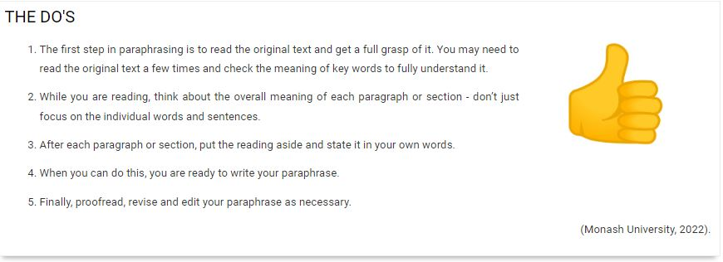
Here are some guidelines about paraphrasing. Are any of these new for you? If so, which ones? Which tips do you struggle with the most when you are paraphrasing? Discuss with a partner.

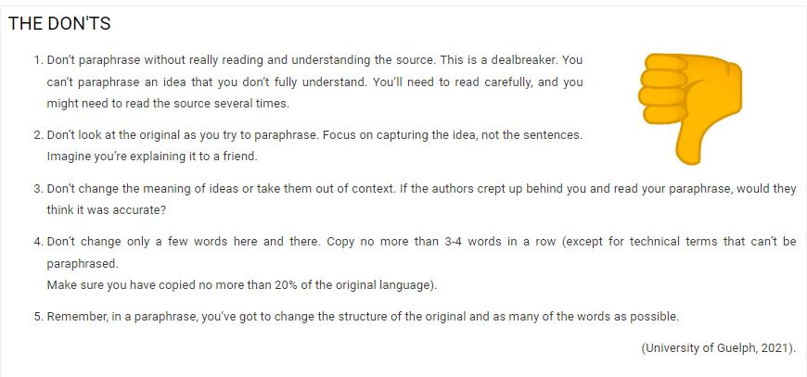
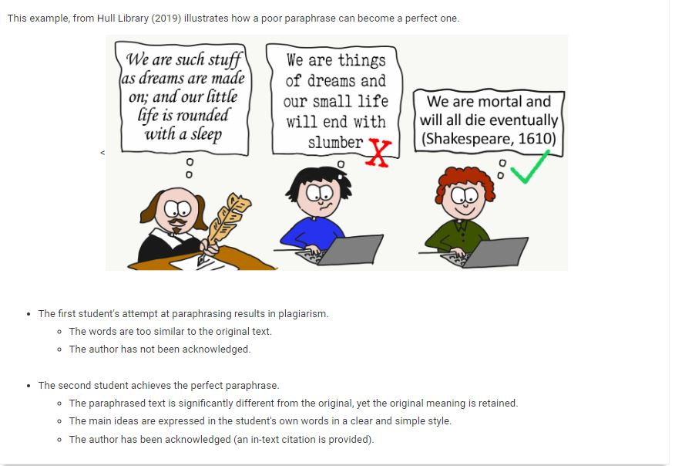
All above images taken from Tus Library, 2024
Activity 3:
Which of the below extracts is the better paraphrase? Why? Discuss with a partner and take notes on your thoughts
Text 1
Ancient Egypt collapsed in about 2180 BC. Studies conducted of the mud from the River Nile showed that at that time the mountainous regions which fed the Nile had suffered from a prolonged drought. This would have had a devastating effect on the ability of Egyptian society to feed itself.

Paraphrase A
The sudden ending of Egyptian civilisation over 4,000 years ago was probably caused by changes in the weather in the region to the south. Without the regular river flooding there would not have been enough food.
Paraphrase B
Research into silt from the Egyptian Nile indicate that a long dry period in the mountains at the river's source may have led to a lack of water for irrigation around 2180 BC, which was when the collapse of Egyptian society began.
Answer/Notes:
TEXT 1: Paraphrase B is better for the text on ancient Egypt because:
- Paraphrase A is vague as to the nature of the changes in weather
- Paraphrase A does not maintain the specificity of time
- Paraphrase A does not mention any research findings.
Text 2
Economists (Baylis et al, 2008, p.352) claim that globalisation’s opening up of markets can increase efficiency and reduce pollution, provided that the environmental and social damage associated with the production of a good is properly factored into its market price.
Paraphrase A
Economists argue that globalisation’s development of markets may enhance efficiency and lessen pollution, on condition that the environmental and social harm caused by production of a good is correctly reflected in its real costs (Baylis et al, 2008, p.352)
Paraphrase B
Positive effects of globalisation identified by economists can include efficiency gains and pollution reduction, although the price of a good should reflect the full costs of producing it, including its environmental and social costs (Baylis et al, 2008, p. 352).

Answer/Notes:
TEXT 2: Paraphrase B is better for the text on globalisation as it:
- Reorders the sentence structure
- Uses synonyms
- Changes word class while also keeping the key source material
- Paraphrase A’s sentence structure mimics the original text too closely

