

Assignment Title: Individual written report on
”How do broader external environmental factors along with COVID-19 affect organisational culture and its performance?”

Student name- Miss Irina Merlan
Student No- 1818268
Module Name- Workplace Culture and its impact on Organisational Efficiency
Module Tutor- Mr. Syed Jaffery
Module Code- BMSW5105_LON

Table of Contents:
- Introduction:
- Executive Summary
- Brief introduction of TkMaxx and its background (200-300 words)
- Theoretical review of organizational culture (300 words)
- Internal emphasis and eternal. Difficult areas which could be improved in TkMaxx(400-five00 words)
- Critical evaluation of the broader environment in which TkMaxx operates-Sustainability - The impact on TkMaxx culture and performance SWOT PESTLE ANALYZE PORTER’S Five Forces Hofstede
- How do broader external environmental factors along with COVID-19 affect TkMaxx culture and its performance
- Conclusion
- References
- Appendix

Abstract
“It’s our associates who bring our business to life, and we aim to support them by making TJX Europe a terrific place to work”

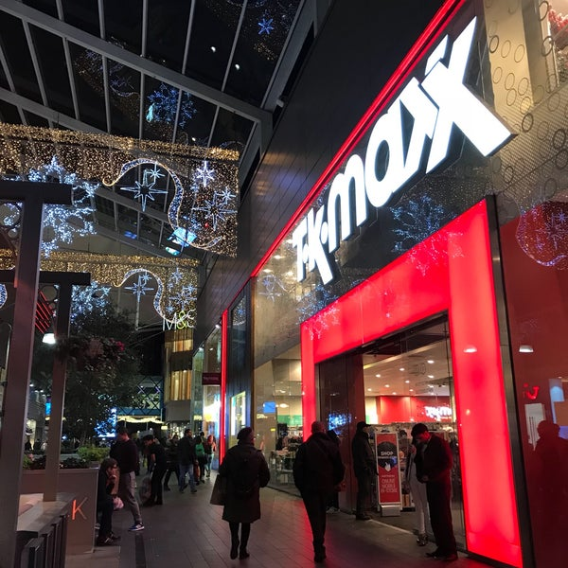
Image 1: Originally taken by me
TkMaxx Store located in Westfield-Stratford City

- Introduction:
“We take great pride in our culture at TJX Europe. As our business has grown, maintaining our culture has been key to our success. In fact, you’ll find we talk about it quite a lot!We strive for a workplace where our Associates feel welcomed when they walk in the door, valued for their contributions, skills, and experience, and engaged with our mission to provide value to our customers.”
2.0 Executive Summary:
The individual report content is specifically written here in the executive summary briefly. First thing that I have included is a brief introduction of the chosen organization which is TkMaxx in my report. After that I have a sub-section about a theoretical review of organizational culture of TkMaxx. In addition I made the next sub-section about the key management theories and models and which methods are scanning tools for underpin my report. In the following section I provided a critical evaluation of the broader environment in which TkMaxx operates and its impact on the culture and performance of TkMaxx. Also I have made a SWOT and PESTLE analyse of TkMaxx to contribute at the evaluation of performance and the culture. The next part that I have done forthe report is to critically evaluate the extent to which I think TkMaxx’s present cultural and ethical standards and the values and the beliefs of most employees are sustainable and to assure how this can help TkMaxx to achiece its corporate objectives and social responsibilities especially due to COVID-19 situation and along with the pandemic situation of the year. At the end I have answered at the question of how do broader external environmental factors along with COVID-19 affect TkMaxx culture and its performance.
3.0 Brief introduction of TkMaxx and its background (200-300 words)
TK Maxx is the name of the organization that I choose to critically evaluate. TK Maxx store is quite possibly the most mainstream off-value retailer from Europe. The store is essential for the Massachusetts based TJK inc. Gathering of organizations. The principal store its opened in Bristol in 1994. In the present there are more than 260 TK Maxx stores across the UK generally yet additionally in Poland, Germany and Ireland. TK Maxx is as yet a relative new idea on the grounds that each thing from TK Maxx is extraordinary. Additionally this idea is special and hasno direct contenders along these lines.
The plan of action achievement of TK Maxx lies in contribution more prominent architect marks for upto 60% less. TK Maxx capable purchasers arrange awesome dealsfrom a colossal number of providers entirely through the season, scouring the design and style markets across the world toseize purchasing openings at whatever point they discover them. The relationship with those names and planner is basic. 3
The"off-value" retailing strategy was acquainted with the UK from the United States in 1994. TK Maxx is as yet the lone style off-value retailer in Europe since it collabs with planners ina current yet straightforward way, our stores convey aSMART shopping experience for our clients. TK Maxx is the 10th greatest plan store in the UK. (Source: TNS Fashion Tracker)
T. K. Maxx is the fourth most revered retailer in the UK, the third most appreciated apparel retailer and shoe store in the UK for 2009. (Source: Verdit Retail Group). TK Maxx has in excess of 500 specialists in its home office with more than 10,000 people who are used all through the UK and Ireland. European expansion continued in 2015 with TK Maxx stores opening in both Austria and the Netherlands. In 2017 Home Sense cleared its paths for Ireland and we would like to fill in much more countries from Europe.
4.0 Theoretical review of organizational culture (300 words)
Our cultural factor is that value that make us what our personality is. TJX is an engaging working atmosphere and we depend upon our accomplices to restore our affiliation. Keeping up our appraisals of trustworthiness, fairness, respectability and treating others with fulfillment and regard is our need - through all that we do.
To help TJX's future turn of events, we are endlessly looking for vivacious and submitted individuals from a wide extent of establishments and experiences to join our gathering. We acceptthat the assortment of our Associates makes us love grounded Company and better prepared to serve our customers around the world. We also acknowledge that setting up a thorough atmosphere wherein Associates are bolted inand empowered strengthens our business and develops a culture where Associates are stirred to lock in, challenge themselves, andbe inventive in their thinking. At TJX, thought and assortment are both basic to us. We enable associations among pioneers, bosses, and Associates so all Associates feel welcome in the Company, regarded for their responsibilities, and drewin with our business mission.Our organizational culture have contributions from different factors such as the cultural factors which are mentioned in the beginning of this sub-section. Another factor is inclusion&diversity because TkMaxx foster a culture where all the employees need to feel inspire to work hard and challenge themselves. The organization create an environment where the associates can think freely and innovately. In this way, they help drive the TkMaxx success.
The main factor is their open-door philosophy. Explained in a simple way: everybody have a voice!Having a comprehensive workplace supports their proceeded with progress. At the point when every associate is happy with bringing their one of a kind viewpoints, conclusions, and abilities to work, the company get new and imaginative thoughts that they can use for critical thinking and finding new chances and also for developing the TkMaxx`s culture.
Source-http://www.earlycareers.tjxeurope.com/culture-benefits/our-culture/#:~:text=OUR%20CULTURAL%20FACTORS&text=TJX%20is%20an%20exciting%20place,us%20–%20across%20everything%20we%20do(Accessed: 09.12.2020)
- Internal emphasis and external. Difficult areas which could be improved in TkMaxx (400- 500words)
External vs Internal: What's the Difference? “External focus of attention is described as “where the performer's attention is directed to the effect of the action” while an internal focus of attention is described as “where attention is directed to the action itself.” (Wulf 2007)
The association that centers just around business necessities without contemplating how they will convey will wind up making guarantees that can't be kept. The association that centers just around inward frameworks without contemplating whatadministrations they backing will wind up with costly administrations that convey little worth.
The potential for job struggle between the outside and inner perspectives is the consequence of numerous factors, including the development of the association, its administration culture, its set of experiences, and so on This makes an equilibrium hard to accomplish, and most associations tend more towards one part than th other. Obviously, no association willbe absolutely inside or emotely centered, yet will end up in a situation along a ange between the two. This is shown in the figure bellow.
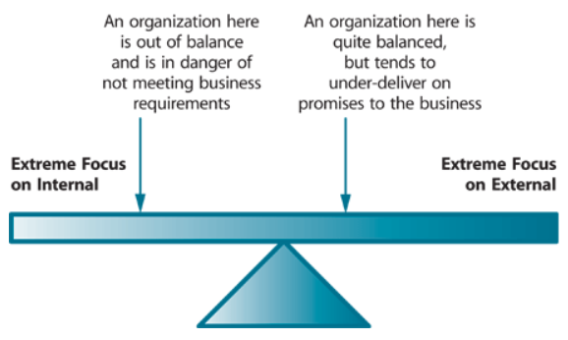
Image 2. The balance between external and internal focus
From my experience as an associate at TkMaxx(internal)and with a deeply investigation of the organization(eternal) I might want to make afew recommendations to improve the organization TkMaxx.
A proper model for changing the association changed its administrative ethos, using the workforce in a baffling way and saving the costs of numerous district heads. With the new declaring structure, an association savesthe organization time similarly as the rate and net working period of agents of an association. An association changes the solicitation for availability of a thing toan open thing inline with a head and moreover changes the solicitation for added substances. The outcomes of this change are cost-reasonability and feasible correspondence of the chiefs to their laborers.
To improve the quality control measure, a business needs to use incredible, experienced and capable staff, as there is a market design these days that things are continually soldfor the sakeof esteem, features, benefits and fabulous presentation. There is no necessity for adifferent lead coach. An association should giv this commitment to a HRM office, by getting a change, a business can save a spending plan.An organization needs to dispatch a few motivators for representatives on the grounds that propelled in assorted types consistently persuades workers and these representatives are the foundation ofa business.
Articles of clothing and product ought to be totally researched before the items are sent off TkMaxx stores, as they may be hurt or worn. That would be an immense improvement in light of the fact that as long as I fillin as a clerk I have seen such countless returned or changed items since they are harmed regardless of whether it's simply a little piece of it or even worn, primarily for garments and shoes things, additionally for adornments, for example, purses and caps.
TkMaxx stores arejust arranged in European countries and the United States. To construct its business and give extraordinary customer uphold, it is proposed that T. K Maxx stores moreover be pened in non-modern countries and to fundamental concentration in Europe on the grounds that there is where the association have the most achievement and variety in executing their social factors and advance the business and TkMaxx items.
To diminish the believing that customers straight will pay for shares TkMaxx needs to assemble the amount of delegates which should be opened in non-modern countries and in all the nations where there isn't a store open yet.
6.0 Critical evaluation of the broader environment in which TkMaxx operates-Sustainability(1300-1500 words)
As discussed in the Brundtland Commission report, sustainability ‘can be understood as an overarching worldview recognizing the interconnectedness of ecological, social, and economic factors in human activity’ (Docherty et al., 2009: 6). The sustainability is represented below in the following image.
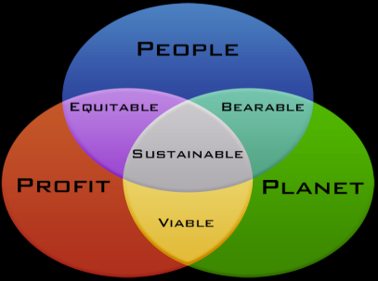
Image 3. Sustainability
The 3 main factors are people-planet-profit which interacts and results another 3 components which are: between people-profit the component equitable, between people-planet resultant the component bearable and between profit-planet results the component viable. All these have equally contributions to the sustainability of TkMaxx organisation.
How is TkMaxx Sustainable ?
By signing the Vendor Code of Conduct which commit to:
- No child or forced labour
- Protect employee rights on wages, working hours and freedom of association
- No harassment, abuse or discrimination
- Adhering to health and safety regulations in the workplace
- Complying with all applicable environmental laws and regulations
Environment
We are enthusiastic about attempting to make a positive, maintainable effect on the world wherein we live and direct our business. We've for some time been focused on seeking after activities that are useful for the climate and savvy for our business. We persistently search for approaches to limit our effect on the planet.
CarbonFootprint
As holders of the Carbon Trust standard, a year ago TK MAXX decreased their impression by over 15% and are on target to lessen it by 30%* by 2020. Around the world, accomplishing a main rating from worldwide carbon benchmark, the CDP.
ReducingWaste
TK MAXX has a zero waste to landfill target. All waste from stores and operations is sent to be recycled. 91% of this is diverted from landfill and They’re working on the rest.
RecyclingClothes
Since 2004, UK customers and associates have recycled over 1.3 million bags of clothing through in-store Give Up Clothes for Good campaign. This equates to 6,830 tonnes of clothing or 150,000 tonnes of saved carbon emissions.
Reducing Plastic Waste -TK MAXX is investing in three innovative projects to reduce single-use plastic waste.
We've presented LED lighting in all new and redesigned stores and our handling habitats. This conveys 65% more proficiency and lessens our energy utilization in each store by 42% and our preparing focuses by 45%.
Coordinations
With our coordinations accomplices we hope to amplify the usage of our vehicles and to help oversee conveyance courses all the more productively, offering driver schooling and putting resources into advances like vehicle following.
Decreasing Plastic Use and Waste We're putting resources into ventures to help diminish plastic use and waste.
The Ocean Cleanup
We're supporting The Ocean Cleanup, a non-benefit association with a mission to clean the world's expanses of plastic. They hope to tidy up to half of plastic at regular intervals, prompting in excess of a 90% decrease of contamination levels by 2040 (since 2018).
The Plastic Collective
The Plastic Collective transforms plastic waste into pay for Pacific Island people group, making work via preparing them to work the hardware. We've subsidizedtwo shruder machines in Bali to help reuse plastic waste and help make important pay. Neighbourly
Through our partnership, we’re supporting environmental and clean-up initiatives in our UK local communities. Fundsdonated have enabled 2000 environmental and clean-up schemes, involving 43,000 people and resulting in 103 tons of litter and waste removed
We’ve joined forces with environmental behaviour change charity, Hubbub, to fund their Plastic Pioneers Project. Thissupports 12 schools inthe UK to develop a range of interventions to educate children on plastic and help reduce their usage.
Our Approach to 'Single-use' Plastic
We distinguished elite of the greatest supporters of sea squander plastic and eliminated them from the entirety of our storesand workplaces, including plastic beverage bottles, single-use transporter sacks, straws, plastic cups and non-biodegradable wipes.
To assist our clients with decreasing their transporter sack use, we offer an assortment of packs forever. Thecost of these incorporates a gif to Cancer Research UK Children and Young People.
Since the single-use transporter sack charge becameeffective in England, Scotland and Wales, we've given all returns to great aims.
Saving Native Woodland
Through our association with the Woodland Trust we're assisting them with defending the forested areas and trees of Wales. Since our rganization started in 2004 we have given £1million, empowering more than 70,000 trees to be planted across 112 sections of land, counterbalancing 18,210 tons of CO2.
Getting these trees in the ground is helping the Trust run after its vision of a UK wealthyin local woods andtrees, for individuals and untamed life.
The impact on TkMaxx’s culture and performance
There are many indicators that have a contribution to the culture and performance of TKMaxx organisation. They are both internal and external and some of them are (sales targets, profitability, value of sale per customer, number of customers, percentage of market share, customer complaints, new product/service launch, acquisition of qualifications/training targets for employees, attendance, absence, employee turnover, external feedback and so on – need to be relevant to your chosen organization, with clear links.
SWOT ANALYSIS OF THE BUSINESS
Strengths - A moderate expense and a quality thing are the premium of the greatest number of customers and the TK Maxx has the constructive outcome of customers. TK Maxx covers a wide extent of adventures and people have relatively few options yet buy new articles of clothing and various additional items they choose for TK Maxx. The lessening in the cost of things over the span of the latest decade has driven buyers to buy things more habitually than previously. Retail exhibiting in the UK has a strong custom in style and plan. T. K Maxx was similarly included.
Weaknesses- Sales are periodic, exorbitant things like coats, party pieces of clothing and various presents are essentially needed during the Christmas season. Various tremendous retailers pass on set up clothing and it is difficult to fight in new TK Maxx stores. The plunge moreover set off a worth war that further broken down net incomes.
Opportunities-The T. K Maxx chain, which offers generally modest merchandise, should perform well during the downturn. UK inhabitants keep on saving on dress than Europeans on the grounds that there is proceeded with development potential in the general market. Men save on garments than ladies. also, there is occasion to urge men to be more intrigued by style.
Threats- Growth in the retail market gives little sign of a stoppage in the business as a result of extended contention. So the customer's options may lessen.
The fall in the assessment of the pound can provoke the cost of the TK Maxx retail market moreover because imported dress and various embellishments will fabricate, which may achieve lower bargains volumes. A deferred and significant decline can change shopping inclinations as time goes on with another highlight on saving. Clients can downsize to spend more money on clothing and various zones of usage. The advancement in unassuming creation and extended competition can impact the overall business.
PESTLE Analysis
External components impact the corporate area. Outside elements that impact movement are managed in the PESTLE examination. PESTLE represents political, monetary, social, mechanical, legitimate and natural elements.
1. Political elements: Politics is the craftsmanship and study of government. Government arrangements directly affect business. Similarly, T. K Maxx is influenced by monetary arrangement, exchange limitations, political strength, customs limitations, and so on
2. Financial elements: The overall slump and financial dive have lessened arrangements of retail things and other home enhancements. By far most are as of now jobless. The joblessness rate was unaltered for the quarter from October to December 2009 at 7. 8%. The amount of jobless fell 3,000 in the quarter to 2. 46 million. The amount of jobless for longer than a year rose 37,000 for the quarter to 663,000, the main level in the three months completed September 1997.
The amount of people ensuring joblessness benefits (the amount of occupation searchers) extended by 23,500 to 1. 64 million between December 2009 and January 2010, the most important since April 1997. This extension in month to month demand was gone before by two nonstop month to month decreases . (Source: Office for National Statistics) Rising joblessness is influencing the economy. This in like manner applies to the association T. K Maxx. T. K Maxx ruled in contribution to everyone and in this way offers an extent of things and organizations going from a motivation to the best expenses, thus pulling in all parts of the market.
3. Social components: Society and culture are significant elements that all organizations should underline. Today, the vast majority go refined and wild about chic garments and shoes. T. K Maxx offers these in vogue garments and shoes at reasonable costs. Clients additionally positivelyaffect the item nature of T. K Maxx Company.
4. Innovative elements: Technology offers organizations another approach to speak with buyers. Innovation can decrease costs and improve item quality, web based shopping, online gift voucher rivalry, facebook T. K Maxx fan, CCTV recording for security reasons, and so forth are instances of innovation utilized in T. K Maxx. Clients can choose and arrang items from the closest T. K Maxx store of their decision utilizing a specialized instrument.
5. Ecological Factors: To keep the climate perfect and clean in each T. K Maxx store, the cleaners are provided by the UK Initial Company. The new business offers cleaners preparing in waste cleaning and reusing
6. Legal Factors: as faras possible, the expansion in the lowest pay permitted by law, the different work laws for representatives (understudy 20/10 hours, full-time worker 40 hours) are instances of late laws influencing organizations. Changes in business strategy, wellbeing and security, item security are legitimate variables.

PORTER’S Five Forces
Porter Five Forces Analysis is a strategic management tool to analyze industry and understand underlying levers of profitability ina given industry. The TJX Companies, Inc. managers can use Porter Five Forces to understand how the five competitive forces influence profitability and develop astrategy for enhancing The TJX Companies, Inc. competitive advantage and long term profitability in Department Stores industry. Inhis revolutionary article - "Five Forces that Shape Strategy", Michael Porter observed five forces that have significant impacton a firm's profitability inits industry. These five forces analysis today in business world is also known as -Porter Five Forces Analysis. In his revolutionary article - "Five Forces that Shape Strategy", Michael Porter observed five forces that have significant impact on a firm's profitability in its industry. These five forces analysis today in business world is also known as -Porter Five Forces Analysis. The Porter Five (5) Forces are:
- Threat of New Entrants
- Bargaining Power of Suppliers
- Bargaining Power of Buyers
- Threat from Substitute Products
- Rivalry among the existing players.

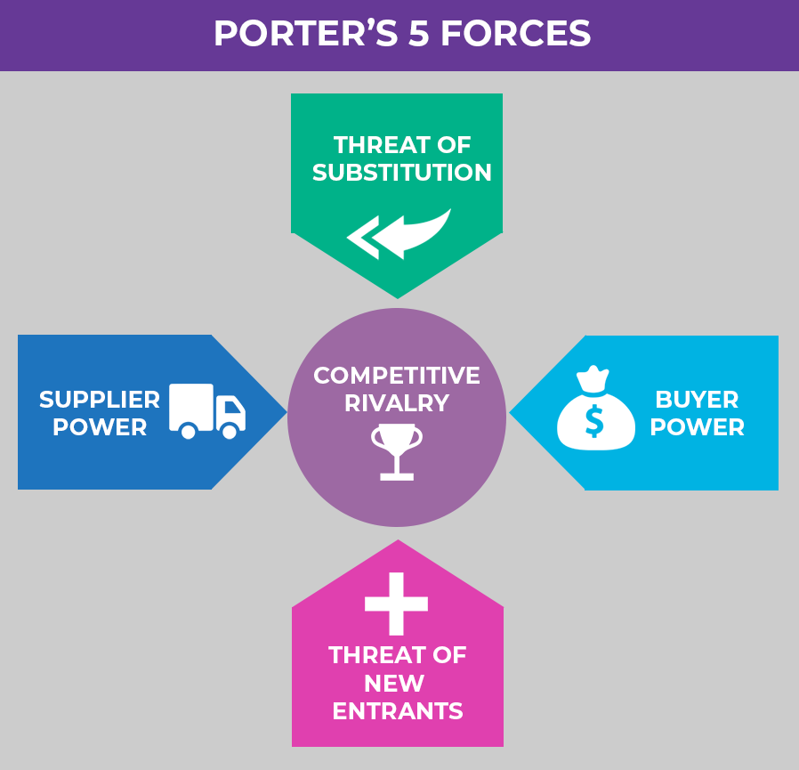
Porter Five Forces is a holistic strategy framework that took strategic decision away from just analyzing the present competition. Porter Five Forces focuse on - how The TJX Companies, Inc. can build a sustainable competitive advantage in Department Stores industry. Managers at The TJX Companies, Inc. can not only use Porter Five Forces to develop a strategic position with in Department Stores industry but also can explore profitable opportunities in whole Services sector.
The TJX Companies, Inc. Porter Five (5) Forces Analysis for Services Industry
Threats of New Entrants New entrants in Department Stores brings innovation, new ways of doing things and put pressure on The TJX Companies, Inc. through lower pricing strategy, reducing costs, andproviding new value propositions tthe customers. The TJX Companies, Inc. manage all these challenges and build effective barriers to safeguard its competitive edge.
How The TJX Companies, Inc. can tackle the Threats of New Entrants
By innovating new products and services. New products not only brings new customers tothe fold but also give old customer a reason to uy The TJX Companies, Inc. ‘s products.
- By building economies of scale so that it can lower the fixed cost per unit. Building capacities and spendingmoney on researchand development. New entrants are less likely to enter a dynamic industry where the established players such as The TJX Companies, Inc. keepdefining the standards regularly. It significantly reduces the window of extraordinary profits for the new firms thus discourage new players in the industry.
Bargaining Power of Suppliers
All most all the companies in the Department Stores industry buy their raw material from numerous suppliers. Suppliers indominant position can decrease the margins The TJX Companies, Inc. can earn in the market.
Powerful suppliers in Services sector use their negotiating power to extract higher prices from the firms inDepartment Stores field. The overall impact of higher supplier bargaining power is that it lowers the overall profitability of Department Stores.
How The TJX Companies, Inc. can tackle Bargaining Power of the Suppliers
- By building efficient supply chain withmultiple suppliers. By experimenting with product designs using different materials so that if the prices go up of one raw material then company can shift to another.
Developing dedicated suppliers whose business depends upon the firm. One of the lessons The TJX Companies, Inc. can learn from Wal-Mart and Nike is how these companies developed third party manufacturers whose business solely depends on them thus creating a scenario where these third party manufacturers have significantly less bargaining power compare to Wal-Mart and Nike.
Bargaining Power of Buyers
Buyers are often a demanding lot. They want to buy the best offerings available by paying the minimum price as possible. This put pressure on The TJX Companies, Inc. profitability in the long run. The smaller and morepowerful the customer base is of The TJX Companies, Inc. the higher the bargaining power of the customers and higher their ability to seek increasing discounts and offers.
How The TJX Companies, Inc. can tackle the Bargaining Power of Buyers
- By building a large base of customers. This will behelpful in two ways. It will reduce the bargaining power of the buyers plus it will provide an opportunity to the firm to streamline its sales and production process.
- By rapidly innovating new products. Customers often seek discounts and offerings on established products soif The TJX Companies, Inc. keep on coming up with new products then it can limit the bargaining power of buyers.
New products will also reduce te defection of existing customers of The TJX Companies, Inc. to its competitors.
Threats of Substitute Products or Services
When a new product or service meets a similar customer needs in different ways, industry profitability suffers. For services like Dropbox and Google Drive are substitute to storage hardware drives. The threat of a substitute product or service is high if it offers a value proposition that is uniquely different from present offerings of the industry.
How The TJX Companies, Inc. can tackle the Treat of Substitute Products / Services
- By being service oriented rather than just product oriented.
- By understanding the core need of the customer rather than what the customer is buying.
- By increasing the switching cost for the customers.
- Rivalry among the Existing Competitors
If the rivalry among the existing players in an industry i intense then itwill drive down prices and decrease the overall profitability of theindustry. The TJX Companies, Inc. operates ina very ompetitive Department Stores industry. This competition does take toll on the overall long term profitability of the organization.
How The TJX Companies, Inc. can tackle Intense Rivalry among the Existing Competitors in Department Stores industry
- By building a sustainable differentiation
- By building scale so that it can compete better Collaborating with competitors to increase the market size rather than just competing for small market. Implications of Porter Five Forces on The TJX Companies, Inc.
- By analyzing all the five competitive forces The TJX Companies, Inc. strategists can gain a complete picture of what impacts the profitability of the organization in Department Stores industry. They can identify game changing trends early on and can swiftly respond to exploit the emerging opportunity.
- By understanding the Porter Five Forces in great detail The TJX Companies, Inc. 's managers can shape those forces in their favor.
Hofstede`s Cultural Dimensions
There are 5 cultural dimensions which are named by Gert Jan Hosftede as Power Distance Index (high versus low). Individualism Versus Collectivism. Masculinity Versus Femininity. Uncertainty Avoidance Index (high versus low).
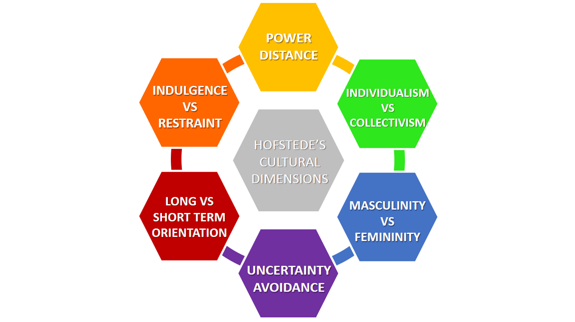

A quick example applied for TkMaxx is one of the cultural dimensions named masculinity versus femininity.
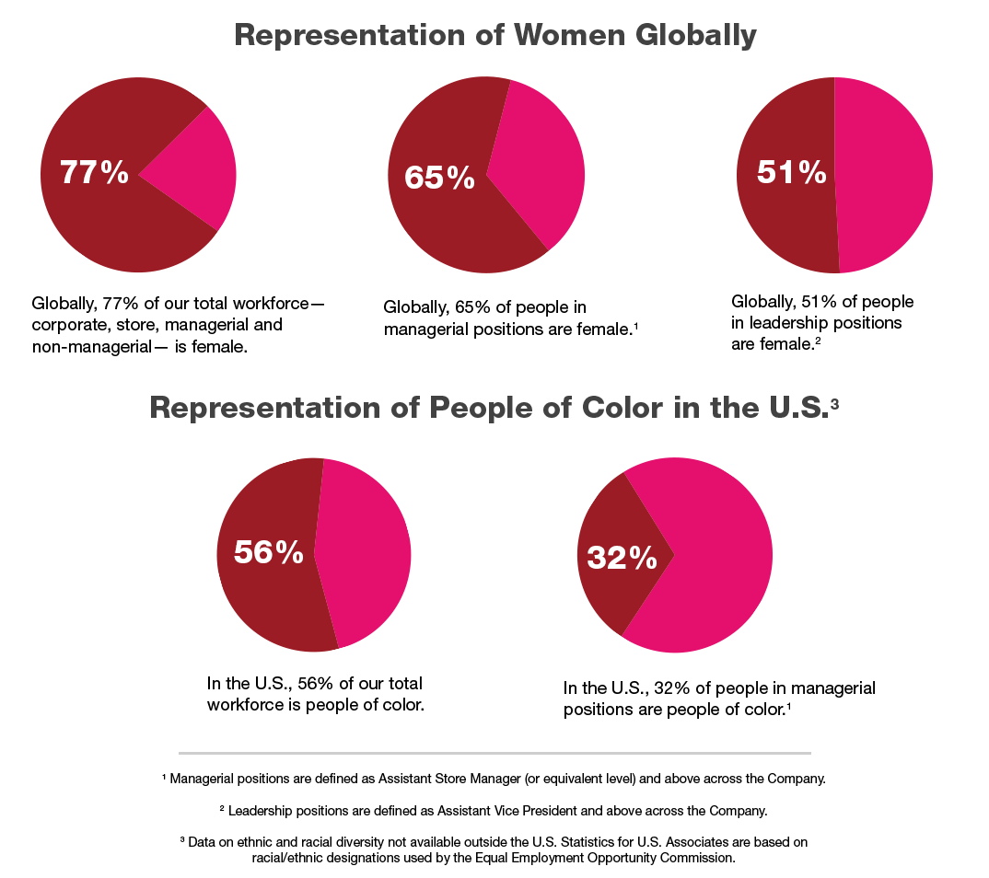
As we can see this company is predominated by women all over the world.77 percent of the total TkMaxx workforce corporate,store, managerial and non-managerial is female.

How do broader external environmental factors along with COVID-19 affect TkMaxx culture and its performance
The pandemic situation and the impact of Covid-19 is abvious along TkMaxx business in addition to the fact that many other organizations had a difficult time to adapt to this new change in 2020 and to face the challenges and to survive with brio. Not many of them could to that. BBC News announced that the businesses which were small or medium at the beginning of 2020 were voluntary closed or gone bankrupt because of the pandemic situation which lead to not enterning liability among those small or medium businesses. In TkMaxx company which is a big company which continuously developed even in the pandemic situation of the last year (2020) were implemented safety measurements and from time to time during lockdowns all the stores were close. The good thing is that TkMaxx has the option of online shopping and made available exchanges or returns if so. All the brainstorming activities and face to face meetings were changed with online meetings via skype or zoom and all the next steps which needed to be followed by employes were sent-received online.

Conclusion
The organization`a culture defines the most appropriate mood and the way to behave for and withing the organization. It’s emperious necessary for the organization to share ideas, beliefs and values which are established by leaders, a thing which TkMaxx showed it’s done in the proper way for it`s organization.

References:
- Docherty, P., Kira, M. and Shani, A.B. (2009) Creating Sustainable Work Systems, Routledge
- UKEssays. November 2018. T.K.Maxx Strategic Analysis. (online). Available from: https://www.ukessays.com/essays/retail/tk-maxx-strategic-analysis.php?vref=1 (Accessed 14 December 2020)
- Culture at TJX.(online) Available from: http://www.earlycareers.tjxeurope.com/culture-benefits/ourculture/#:~:text=OUR%20CULTURAL%20FACTORS&text=TJX%20is%20an%20exciting%20place,us%20–%20across%20everything%20we%20do(Accessed:09.12.2020)
- Cartwright, R. (2002) Mastering Marketing Management, Palgrave
- http://www.tkmaxx.com14 Feb 2010 at 00:35 (Accessed 12.12.2020)
- Ennis, R., 1996. Critical Thinking Dispositions: Their Nature and Assessability. Informal Logic, [online] 18(2), pp.165 -182.
- Facione, P., 2000. The Disposition Toward Critical Thinking: Its Character, Measurement, and Relationship to Critical Thinking Ski. Informal Logic, [online] 20(1), pp.61-84.
- Frey, L.R. (2002). New directions in group communication. Sage
- http://www.tjx.com 17 Feb 2010 at 15:37(Accessed 12.12.2020)
- “About T.K Maxx”. T.K Maxx Retrieved 26 Feb 2010 20:26
- Frain, J. (1999) Introduction to Marketing 4th edition, London: Thomson Business Press

Appendix

