Targed/Target 1 | “Further develop your critical evaluation.” This target is developed within this essay through the analysis of Assessment for Learning as well as different research tools in the methodology.

Design and conduct a small-scale research study, and critically evaluate the impact of chosen research tools and data/findings on the learner and on your professional practice.
"To what extent is written feedback used by pupils to support progression?"

“Assessment is one of the most powerful tools for promoting effective learning” (Assessment Reform Group (ARG), 1999, p.2). Within this essay, Assessment for Learning (AfL) and more specifically feedback was analysed and researched in an attempt to answer the research question. "To what extent is written feedback used by pupils to support progression?" Using this question, the study aimed to determine the impact and extent to which written feedback was used by pupils to progress their learning. Furthermore, it aimed to determine if there was a correlation between pupils’ engagement with written feedback and the benefits and barriers of written feedback.
There has been a considerable amount of research conducted regarding feedback from individuals such as, Black and Wiliam (1998). Their views, alongside a research study being conducted, were analysed to develop a greater understanding of written feedback and determine if there was a connection between this study and previously conducted research. The study was conducted in a Year 5/6 class within school X on the outskirts of Swansea. This enabled primary research to be collected from both pupils and educational professionals using tools such as, questionnaires, interviews and observations. Finally, the research hypothesised that if continuously implemented across teaching and learning, the benefits of written feedback on pupil progression would be extensive as it would enable pupils to reflect and understand what was necessary to progress.
Assessment for Learning was defined as any assessment in which the main priority was to promote learning for instance, through questioning, feedback and peer and self-assessment (Wiliam, 2009). Following AfL, formative assessment should be used within a short cycle for example, minute to minute to adapt teaching to meet the pupils’ needs. Donaldson’s (2015) 37th recommendation further highlighted this as a need for prioritisation within teaching and learning. However, it was important to distinguish this from summative assessment which used tests and procedures, following the learning, to gain pupils’ levels and grades (ARG, 1999). Furthermore, formative assessment was identified as an “essential component” providing the opportunity to gain an additional eight months of learning annually at a relatively low cost of two thousand pounds per year (Black and Wiliam, 1998.p.139; Wiliam, 2009). Yet, the Education Endowment Foundation (EEF) (2018) suggested a more modest estimate of three to four months as a result of formative assessment with eight additional months of development available for certain areas of the Curriculum.
A benefit of AfL was that pupils could become active participants and understand how to develop within their learning. Thus, reducing the gap between what was currently known and deeper understanding as conveyed within Vygotsky’s Zone of Proximal Development (ARG, 1999; Pound, 2006). Moreover, the purpose of “ambitious, capable learners” was developed to create lifelong learners who understood how to develop across their lives (ARG, 1999; Donaldson, 2015, p.31). Furthermore, AfL enabled pupils, especially currently lower attaining pupils, to understand how to progress within the learning period which raised the overall achievement of the class (Wiliam and Black, 1998; Cambridge Assessment International Education (CAIE), ND). Confidence and self-efficacy were also beneficial as they provided opportunities for pupils to fail and consequently develop in preparation for summative assessments (CAIE, n.d.). However, additional training and time were limitations of AfL as they needed to be introduced and executed effectively to be successful causing possible time constraints (CAIE, n.d.).
“Feedback is one of the most powerful influences on learning and achievement” (Hattie and Timperley, 2007, p.81). Within the research study, the AfL strategy of feedback was examined to understand how written feedback was used to progress learning and the benefits and barriers to this. Hattie and Timperley (2007) defined feedback as information given by representatives such as, peers and educational professionals on an individuals’ understanding and performance.
A powerful impact of feedback and specifically comments was that it allowed pupils to understand the areas of success and improvement within their practice and ways to develop these further through specific feedback and actions (Black et al. 2002; Donaldson, 2015; Black and Wiliam, 1998; EEF, 2018). Feedback was also beneficial to educational professionals to inform how learning could be extended through bridging teaching and learning as an “essential and natural part of the teaching process” (Donaldson, 2015, p.76; ARG, 1999; CAIE, n.d.). Furthermore, pupil involvement as “active agents” was necessary as feedback could not benefit “passive participants” in their progression (Brooks et al., 2019, p.15). Brooks et al., (2019, p.14) suggested a “conceptual matrix of feedback” which aimed to develop feedback as the vehicle of improvement regarding pupils’ learning outcomes through linking practice and research. Typically, within research, feedback had been viewed as a transformative practice due to the consequential learning that occurs (Hattie, Gan and Brooks in Brooks, 2017). However, Sadler (2010;1989) challenged this stating there was a small amount of improvement from feedback which was not always guaranteed as pupils had limited interactions or benefits from feedback despite being provided regularly. To remedy this, task specific feedback was required to provide detail on how to improve rather than “ego-focused” comments as pupils can become fearful of failure or complacent as they believed they could not improve (CAIE, n.d.). Formative assessment, however, supported this through providing an environment in which pupils could fail and consequently develop (CAIE, n.d.).
Despite feedback being provided there were still limitations to the support it offered pupils in progressing their learning thus, conveying that quality rather than quantity was required for effective feedback (CAIE, n.d.; ARG, 1999). Hattie (2012) stated that comments were often too late to be effective and were ignored. Nevertheless, Hattie, Gan and Brooks in Brooks et al. (2019) made the case that there was a need to rethink how feedback was received by pupils as opposed to how it was given by educational practitioners. In an Australian study by Brooks et al. (2019, p.14-15) they referred to the 2006 work by Carless which identified that feedback “given by teachers is rarely used and implemented by students”. Another disadvantage of feedback was the provision of marks as it created a competitive environment in which comments were disregarded and currently lower attaining pupils believed they could not improve due to continuous low marks (Black et al. 2002). However, through clear feedback conveying what was required to improve, and the opportunity to develop these, pupils were encouraged to believe that they could develop (ARG, 1999; Black and Wiliam, 1998). The final limitation recognised by Black and Wiliam (1998, p.4) was that “feedback to pupils seems to serve social and managerial functions” instead of supporting the pupil as the user of the feedback thereby, creating a barrier to its effectiveness.
Within this research a mixed methodology was implemented in which quantitative, factorial and numerical data, and qualitative data, perceptions, beliefs and attitudes, were combined using questionnaires, interviews and an observation (Hope, 2016; National Foundation for Educational Research (NFER), 2013; Punch, 2014). This method was selected as it merged the strengths of both qualitative and quantitative data while decreasing their weaknesses in the “fundamental principle of mixed methods research” (Punch, 2014, p.303). For instance, tracking trends using quantitative data and expanding upon these using qualitative data to gain a deeper understanding (Punch, 2014). Furthermore, the Mosaic approach was used to enable pupils to become active participants rather than “passive objects” of the research (Clark, 2011, p.12). Thereby, supporting The Rights of the Child 12.1 Article, which stated if a child can form their own views, they have the right to freely express their views on all areas affecting them (UNICEF UK, 1989).
Furthermore, as the research was based on AfL, a common classroom practice, parental consent was unnecessary. However, as gatekeepers, informed consent was gained from school X (Appendix 1) following an explanation of the research and its aims. Moreover, pupil assent; agreeing to participate in the study, was also used in an “ongoing process of assent” in which pupils were able to withdraw without repercussion at any point using colour cards (Appendix 2) (Cohen, Manion and Morrison, 2011; Blackburn, 2015; Hope, 2016; UWTSD, 2017; British Educational Research Association (BERA), 2018, p.10). Ethically however, it was difficult to know when a child could provide informed consent due different pupils and their extents of understanding (Blackburn, 2015). Finally, confidentiality was used to anonymise participants and their data as conveyed within the ethics form (Appendix 3) (Hope, 2016).
The first tool to be utilised in the research was anonymous online questionnaires (Appendix 4). These were beneficial as they removed the necessity of manually imputing data or creating graphs which could be a barrier of paper-based questionnaires. Moreover, their anonymous and independent nature enabled the research to arguably be more objective due to the participants’ detachment from the researcher however, this limited the possibility of acquiring additional information (NFER, 2013; Cobb, 2016).
Questionnaires were also valuable as they offered the opportunity to acquire and compare a large range of data quickly. However, this posed the potential barrier of excessive data which may not always be easily summarised (Cohen, Manion and Morrison, 2018; NFER, 2013; Cobb, 2016). Consequently, the questionnaires were limited to a representative sample of five mixed ability Year 5/6 pupils and their class teachers whose data on written feedback could be analysed effectively. This sample was beneficial as it ensured the population was equally represented and that the samples’ views could be related back to the larger population of the Year 5/6 class (Punch, 2014; Cohen, Manion and Morris, 2018). The sample was selected from the researcher’s previous professional teaching experience. Within the research, it was important to account for any sampling obstacles such as, low response times among online questions to ensure the desired sample was achieved. Nevertheless, this was rectified through the questionnaires being completed on the research day (Cohen, Manion and Morris, 2018; NFER, 2013). However, it would have been beneficial to increase the sample size to provide further validity to the quantitative data (NFER, 2013). As the data was reliant on the participants, the questionnaires were created to be linguistically accessible and comprehensible. But, it would have been beneficial to reduce the amount of questions to ensure the participants did not become tired, withdraw, provide “satisficing” answers or miss questions (Cohen, Manion and Morrison, 2018, p.474; Cobb, 2016; NFER, 2013).
The next research tool to be examined were interviews as “the most widely used data collection technique in qualitative research” (Punch, 2014, p.163). Semi-structured interviews (Appendix 5) were used with prepared questions that offered the flexibility to adapt to the participants’ answers (NFER, 2013). Using a quiet room and the supervision of an additional adult, the interviews were conducted face-to-face with a Year 5/6 focus group and the class teachers individually (Cobb, 2016, NFER, 2013). Within the interviews, written notes were collected however, in future practice, audio recording would have been beneficial in enabling transcripts to be created and an understanding of any participant effects on the data (Punch, 2014).
A benefit of interviews was the extent and depth of data provided on written feedback which may not have occurred naturally within observation or conversation (Danby, Ewing and Thorpe, 2011; NFER, 2013). Moreover, the interviews enabled participants to express their “lived experiences” and feelings of feedback as experts within their learning (NFER, 2013; Cobb, 2016; Danby, Ewing and Thorpe, 2011; Clark, 2011, p.17). Focus groups were also an effective and efficient way of gathering opinions using “multiple listening” to highlight the groups’ opposing and consistent views on written feedback (NFER, 2013; Punch, 2014; Clark, 2011, p.19). Furthermore, due to the time constraints of conducting and transcribing interviews a purposeful sample was selected (Punch, 2014; NFER, 2013). A barrier however, of focus groups was the possible power struggle between participants but, this was limited through the interviewer ensuring all participants had the opportunity to share their views (Cobb, 2016; NFER, 2013; Punch, 2014). The final barrier of interviews was bias as participants may have felt unable to provide honest answers or felt compelled to provide answers they believed the researcher wanted which could have affected the data gathered (Punch, 2014; Cobb, 2016).
Observations was the final research tool implemented in which the researcher was an overt non-participant observer. Thus, the observer did not manipulate any of the lesson but observed the natural actions, routines and behaviour of the classroom with the informed consent of the teacher (Appendix 6) (Punch, 2014; NFER, 2013). Moreover, an observation schedule (Appendix 7) was used to gain data of how written feedback was provided and the effects these had on pupil progression (Punch, 2014). To ensure the observation was manageable the sample was reduced to four participants (Punch, 2014).
A strength of observation was its ability to provide non-verbal data on pupils for instance, recording first-hand how written feedback was used within the classroom and how this affected pupil progression (NFER, 2013). Furthermore, this was beneficial in observing what occurred within the classroom rather than what was reported, as with other research tools which enabled more reliable data (Cobb 2016; Cohen, Manion and Morris, 2018). However, the observations were limited by the observer’s interpretations which made the data potentially subjective and biased. Furthermore, it could have been argued that the observer’s presence within the classroom could have caused an “observer effect” in which behaviour altered because of the observation (Cobb, 2016, p.85; NFER, 2013). Nevertheless, the observation was beneficial in the limited time it required to be conducted as opposed to that of questionnaires which may have taken additional time (Cohen, Manion and Morris, 2018). The final barrier of observations was that they could be overly simplistic and restricted thus, reducing the usefulness of the observations (Early Childhood Australia, 2012).
Finally, the possible threats to reliability and validity such as, biases, which can never be completely removed, were acknowledged throughout the essay (Cohen, Manion and Morrison, 2018). However, within this section the reliability and validity of the “classroom-based action research” were analysed (Mertler, 2014, p.149). For instance, validity was demonstrated with the research tools’ questions, which were critically analysed to ensure they met the research themes of the effectiveness and engagement of written feedback. Moreover, reliability was secured through ensuring consistency was present in the data collected (Mertler, 2014). This consistency and thus, reliability were indicated using triangulation which collected and analysed the data from numerous sources, such as the research tools, to understand if they were consistent (NFER, 2013).
Within the research, questionnaires, interviews and an observation were used to explore the question “To what extent is written feedback used by pupils to support progression?" Within this section, the most relevant findings were evaluated using themes.
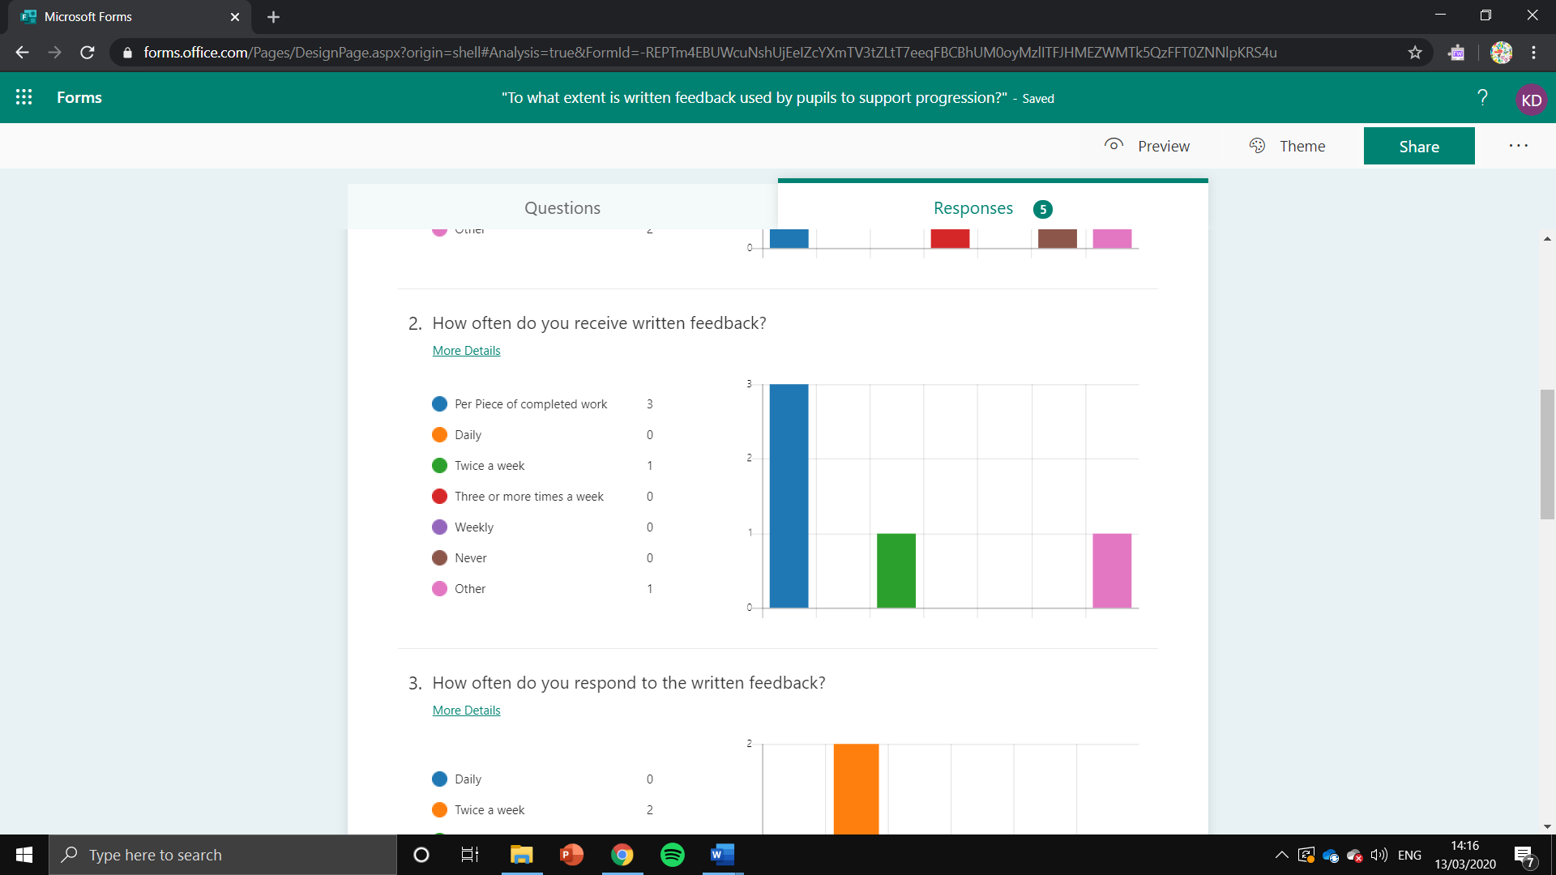

Figure 1- How often do you receive written feedback? (Pupil questionnaire)
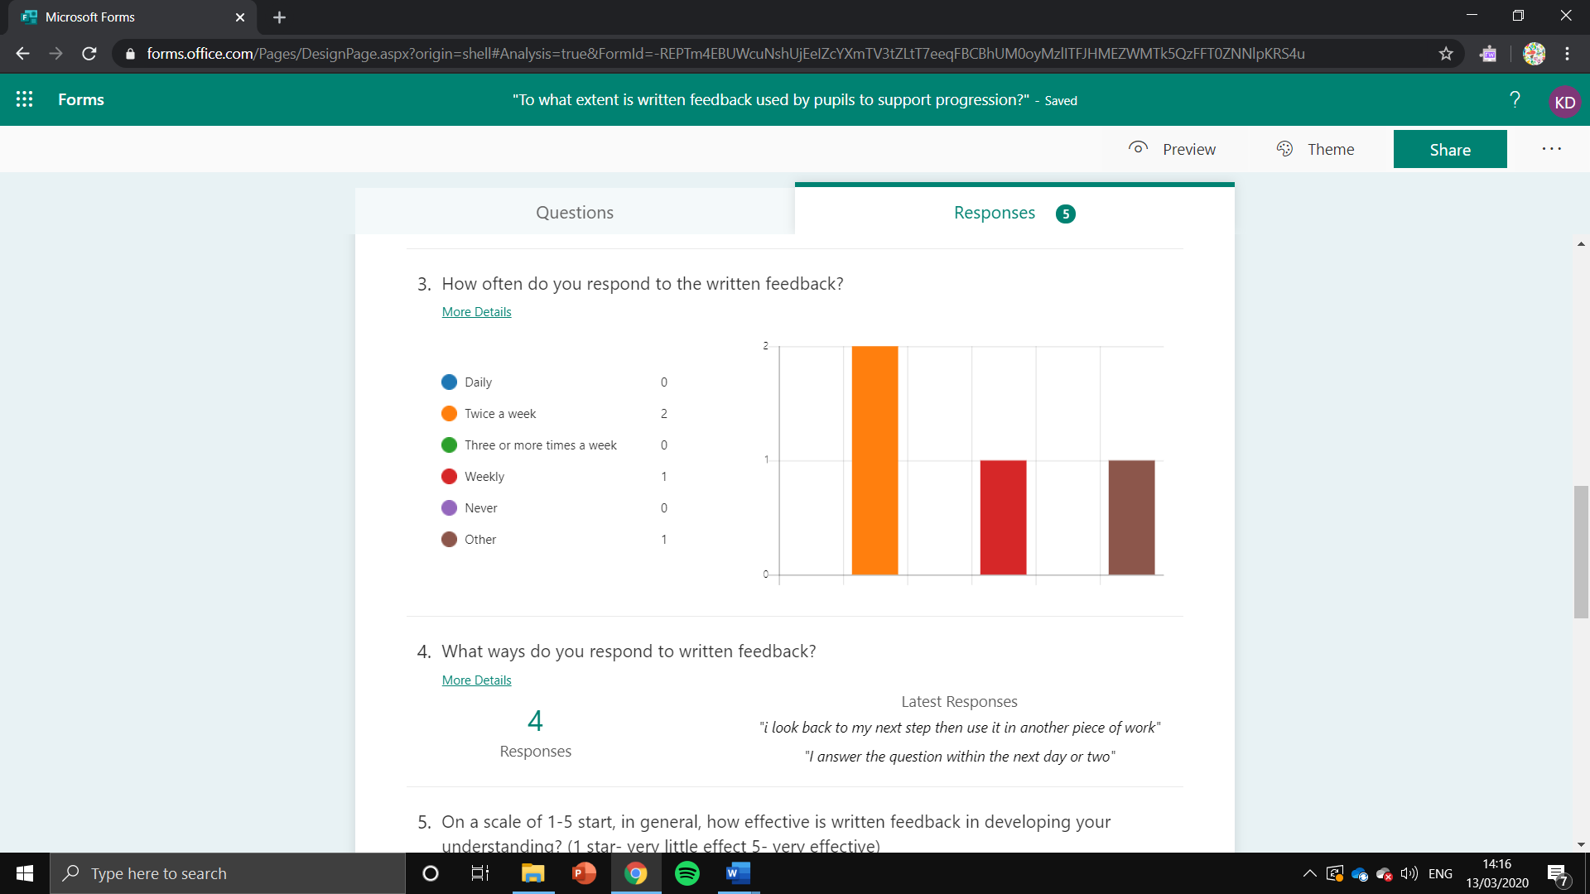

Figure 2- How often do you respond to the written feedback? (Pupil questionnaire)
When analysing the findings, a theme that emerged was the disparity between written feedback being provided and engaged with. For instance, as demonstrated in Figure 1, (Appendix 8) three out of five pupil participants and both teacher participants (Appendix 9) stated that written feedback was received “per piece of completed work”. Despite this, the majority of pupil participants stated they responded to written feedback “twice a week” as shown in Figure 2 (Appendix 8). This posed the question as to why there was a disparity between written feedback being provided and implemented. Carless in Brooks et al. (2019) further emphasised this within the literature review stating that pupils rarely implement feedback provided by teachers. Hattie, Gan and Brooks in Brooks et al. (2019) suggested that it was not how feedback was provided by teachers but, how feedback was received by pupils which required further consideration.
Furthermore, the teacher participants stated within their independent interviews (Appendix 10) that time was a possible barrier to engagement as opportunities needed to be scheduled for pupils to have quality time to reflect on their feedback thus, reducing teaching time. However, pupils benefitted from feedback as it enabled them to believe they could improve and work towards improvement as conveyed by ARG (1999) and Black and Wiliam (1998). This was further emphasised within the focus group (Appendix 11) which stated that their engagement with written feedback was usually a consequence of scheduled target time and teacher direction. Additionally, they stated the development of these would further encourage pupils to interact with written feedback. Moreover, within the teacher interviews (Appendix 10) they argued a possible cause of this disparity was the challenges faced by poor readers and additional learning needs pupils from written feedback compared to verbal feedback because it enabled feedback to be clearly articulated and pupils’ understanding to be gauged. In line with Black et al. (2002) this was further exemplified as currently lower attaining pupils can become disengaged with the feedback as they believed they cannot improve if marks are provided rather than comments.
Finally, when questioned “what action would you put in pace to combat the barrier?” Teacher A stated they would provide teacher explanations and teaching assistant support of next steps. Alternatively, Teacher B stated they would reduce written feedback to what was necessary and use conversations instead. However, both teachers agreed they would “build quality feedback time” into the timetable (Appendix 10). They noted however, that interactive feedback was the most effective type of written feedback. For instance, using questions as pupils were “more likely to answer” rather than “proactive” statements. For example, the participants stated that lengthy or complex feedback could cause pupils to have limited interaction or require further verbal reassurance to interact with the feedback (Appendix 10 and 11).
A further theme identified within the findings was the effectiveness of written feedback compared to verbal feedback in progressing pupils’ understanding. On analysis of the effectiveness of written feedback, the questionnaires (Appendix 8 and 9) highlighted that four out of seven participants either agreed or strongly agreed that written feedback was an effective way of developing pupils’ learning. This was further displayed within the star ranking question in which pupils gave 3.60 stars and two-stars out of five from the teachers on the effectiveness of written feedback. A pupil’s reasoning was exemplified as “when I look back at my work, I look how I did it before and the feedback they gave me”. Yet, pupils were inconclusive in their reasoning of the most helpful feedback with data (Appendix 8) suggesting they agreed with the teacher’s unanimous opinion. The opinion that verbal feedback was “the most effective way to provide feedback” to develop pupils understanding because dialogue can occur immediately within the learning. Unlike, written feedback which can be ineffective due to being too late and having to look back as Hattie (2012) indicated previously.
However, one teacher stated in the questionnaire (Appendix 9) that “given the right timings, environment and setting” written feedback could challenge and improve pupils effectively. The pupils also recognised that the next step, a written feedback method, was also beneficial in providing details about areas of concern and how to improve upon these as conveyed within the literature review as a powerful impact on learning (Donaldson, 2015; EEF, 2018). For instance, the next step was used within an angle lesson to practice for future lessons or to extend pupils using models of the work. Furthermore, the pupils recognised that positive comments were also a benefit of written feedback as it made them feel happy and confident to complete the work independently next time if supported. The observation (Appendix 12) also recognised this occurring within practice and impacting the pupils through encouragement as indicated by CAIE (n.d.) which stated that AfL benefited self-efficacy and confidence through providing opportunities for pupils to fail and consequently improve.
Conversely, the participants did identify some compromises to the effectiveness of written feedbacks. For instance, a teacher participant stated that written feedback did not develop pupils as “complete, competent learners” with written feedback only effective for some pupils with others continuing their mistakes despite written feedback being provided. Sadler (2010;1989) stated that learning was not always guaranteed as pupils had limited interactions and benefits of feedback despite regular feedback being given (Appendix 8, 9 and 11). This emerged in the observation in which a star and a step were used following the lesson for three quarters of the participants. However, verbal feedback had the greatest observed impact with immediate support evident in the pupils’ work which was also conveyed in the teacher interviews (Appendix 10 and 12).
Finally, the effectiveness of written compared to verbal feedback was highlighted by Teacher B who suggested “verbal feedback is for the pupils. Written feedback is for book scrutiny and other people” (Appendix 10), which concurred with Black and Wiliam (1998, p.4) who stated “feedback to pupils seems to serve social and managerial functions” instead of supporting the learning thereby, creating a barrier to its effectiveness.
In conclusion, the research question “to what extent is written feedback used by pupils to support progression?" and intended aims of the study were successful in investigating the extent to which pupils engaged with written feedback and the impact that this had on their progression. Moreover, it developed an understanding of the links between engagement and the benefits and barriers of written feedback. Most notably, written feedback was beneficial in enabling pupils to reflect on their feedback, simultaneously, this was also a barrier in the immediacy of written feedback when compared to verbal feedback. As conveyed by Hattie (2012) who recognised that often written feedback was ineffective due to being provided too late and therefore, ignored. Furthermore, the research also indicated a disparity between received and engaged written feedback for instance, written feedback was beneficial but, limited in the pupils it benefitted due to aspects such as, length and understanding.
As a consequence of the study, the researcher was able to develop both personally and professionally. For instance, personally, the researcher was able to develop as a skilled researcher through understanding the ethics and critically analysing primary and secondary data which can support the researcher in their future practice. Yet, in future practice, the researcher could strive to develop the research using a larger sample size thereby, extending the depth of the research and account for any obstacles such as, withdrawals to ensure the data was not affected. Professionally, however, the researcher was able to develop aspects such as, observation. This could benefit future practice through understanding the complexities of the pupils’ play, friendships and behaviour as an essential aspect of an inquiring profession (Early Childhood Australia, 2012). Finally, the hypothesis was challenged to a certain extent with the research indicating that although written feedback progressed a limited number of pupils, the results indicated that verbal feedback was perhaps a more beneficial approach due to its greater interaction and immediacy.

Reference list used

Assessment Reform Group. (1999) Assessment for Learning: Beyond the Black Box. Cambridge: The Assessment Reform Group.
Black, P. et al. (2002) Working Inside the Black Box. London: Department of Education and Professional Studies, Kings College, London.
Black, P. and Wiliam, D. (1998) Inside the Black Box: Raising Standards Through Classroom Assessment. Available at: https://www.rdc.udel.edu/wp-content/uploads/2015/04/InsideBlackBox.pdf (Accessed: 17th February 2020).
Blackburn, C. (2015) Researching with young and developmentally young children – ethical considerations, dilemmas and compromises. Available at: https://www.bera.ac.uk/blog/researching-with-young-and-developmentally-young-children-ethical-considerations-dilemmas-and-compromises (Accessed: 17th February 2020).
British Educational Research Association (2018). Ethical Guidelines for Educational Research. Available at: https://www.bera.ac.uk/researchers-resources/publications/ethical-guidelines-foreducational-research-2018 (Accessed: 17th February 2020).
Brooks, C. et al. (2019) ‘A Matrix of Feedback for Learning’, Australian Journal of Teacher Education, 44(4), pp. 14-32. Available at: https://ro.ecu.edu.au/cgi/viewcontent.cgi?article=4007&context=ajte (Accessed: 24th February 2020).
Cambridge Assessment International Education. (n.d.) Getting started with Assessment for Learning. Available at: https://cambridge-community.org.uk/professional-development/gswafl/index.html (Accessed: 26th February 2020).
Clark, A. (2011) Ways of seeing: using the Mosaic approach to listen to young children’s perspectives. Available at: https://learningaway.org.uk/wp-content/uploads/RL56-Extract-the-Mosaic-Approach-EARLY-YEARS.pdf (Accessed: 9th March 2020).
Cobb, W. (2016) ‘Research methods: how will I collect the data?’, in Austin, R. (ed.) Researching Primary Education. London: SAGE Publications Ltd.
Cohen, L., Manion, L. and Morrison, K. (2011) Research Methods in Education. 7th edn. Abingdon: Routledge.
Cohen, L., Manion, L. and Morrison, K. (2018) Research Methods in Education. 8th edn. Abingdon: Routledge.
Danby, S., Ewing, L. & Thorpe, K. (2011) ‘The Novice Researcher: Interviewing Young Children.’ Qualitative Enquiry, 17(1), pp.77-84.
Donaldson, G. (2015) Successful Futures. Available at: http://www.ewc.wales/site/index.php/en/documents/ite-accreditation/802-donaldson-report-successful-futures.html (Accessed: 4th March 2020).
Early Childhood Australia. (2012) ‘Observing Children’, National Quality Standard Professional Learning Program, 39, pp. 1-4. Available at: https://moodle.uwtsd.ac.uk/pluginfile.php/347213/mod_resource/content/1/Dewey-quote_nqs-plp-e-newsletter-no-39-2012-observing-children.pdf (Accessed: 7th March 2020).
Education Endowment Foundation. (2018) Feedback. Available at: https://educationendowmentfoundation.org.uk/pdf/generate/?u=https://educationendowmentfoundation.org.uk/pdf/toolkit/?id=131&t=Teaching%20and%20Learning%20Toolkit&e=131&s= (Accessed: 20th February 2020).
Hattie, J. (2012) Visible learning for teachers maximizing impact on learning. London: Routledge.
Hattie, J. and Timperley, H. (2007) ‘The Power of Feedback’, Review of Educational Research, 77(1), pp.81-112. DOI: 10.3102/003465430298487
Hope, G. (2016) ‘Methodology: what approach should I take?’, in Austin, R. (ed.) Researching Primary Education. London: SAGE Publications Ltd.
Mertler, C. A. (2014) Action Research: Improving Schools and Empowering Educators. 4th edn. London: Sage Publications Ltd.
National Foundation for Educational Research. (2013) How to... Run qualitative and quantitative research: From definitions through to analysis. Slough: NFER.
Pound, L. (2006) How Children Learn. London: Practical Pre-school Books.
Punch, K. F. (2014) Social Research: Quantitative and Qualitative Approaches. 3rd edn. London: Sage Publications Ltd.
Sadler, D. R. (1989) ‘Formative Assessment and the design of instructional systems', Instructional Science, 18, pp. 119-144. Available at: http://pdf.truni.sk/e-ucebnice/iktv/data/media/iktvv/Symposium_LTML_Royce%20Sadler_BFormative_Assessment_and_the_design_of_instructional_systems.pdf (Accessed: 25th February 2020).

Sadler, D. R. (2010) ‘Beyond feedback: developing student capability in complex appraisal’, Assessment & Evaluation in Higher Education, 35(5), pp. 535–550. DOI: 10.1080/02602930903541015

UNICEF UK. (1989) The United Nations Convention on the Rights of the Child. Available at: https://www.unicef.org.uk/rights-respecting-schools/wp-content/uploads/sites/4/2017/01/UNCRC-in-full.pdf (Accessed: 17th February 2020).

University of Wales Trinity Saint David (2017) Research Ethics & Integrity Code of Practice. Available at: https://www.uwtsd.ac.uk/media/uwtsd-website/content-assets/documents/research/research-ethics-integrity-code-practice.pdf (Accessed: 3rd March 2020).
Wiliam, D. (2009) Assessment for learning: why, what and how? London: The Institute of Education, University of London.

Total word count: 3813

