
Module name: Software Solutions for Business
Module Code: ACCA 4026
Lecturer: Kwame Assa-Agyei
Trinty Saint David University of Wales
London Campus

Student Name: Susan Henry
Student ID: 2517524



Table of Contents
1
Introduction 1
Task 1. e-Commerce Website builders or software solutions 2
1.1 Wix 2
1.2 Woo Commerce 3
Task 2. Mind-map of contemporary software applications 4
Mind mapping and explain the benefits of using mind mapping in business operations 5
b Create a mind map of contemporary software applications 5
Task 3. Office Applications 6
a. Four office software solutions for business operations 6
MS Word 7
MS PowerPoint 9
MS Excel 10
MS Access 11
b Practical demonstration of Two Office Features 12
Mail Merge 12
If Statement 16
Task 4. Communication and Collaboration applications 17
One contemporary Communication and one Online Collaboration applications/tools 17
MS Outlook 17
MS Teams 19
a. One feature of a freely available Communication (1) and one feature of a Collaboration (1) application 20
MS Outlook 20
Ms Teams 22
Conclusion 24
References 25



Introduction

The ability to use software and applications effectively has become fundamental to organisational success and professional development. This module provides a balance of practical skills and theoretical knowledge, enabling new users to work confidently with the tools that fortify business operations in today’s modern world. Using essential Office applications such as Microsoft Word, PowerPoint, Excel, alongside collaboration platforms like Teams, SharePoint, Skype for Business allow students to gain the competence to manage information and communicate in a professional manner.
Working with these applications covering other topics such as mail merge, spreadsheets, email communication reinforce my knowledge and technical skills by creating, sharing and presenting information clearly and effectively. Preparing me for use of a wide range of range of software packages that will support daily business operations and solutions.

Task 1. e-Commerce Website builders or software solutions

1.1 Wix

Founded in 2006 Wix.com is an Israeli company commanding the market of cloud-based website builders today. It was initially designed for users to create websites with no coding experience but has now developed into a much more complex software that incorporates some key features. Over 2,000 templates to customise for different industries, enter and describe your ideas and Wix will generate a site that is ready to use and tailored for your needs. The drag and drop tool make text easy to arrange, add sections and images. Advanced design tools allow animations and interactive element from the editor view. A website can be built in minutes decreasing the time required to produce a professional document that grabs the audience’s interest, making it perfect for beginners [1], [2]
Key Features
- Flexibility: Suitable for small businesses, creatives and freelancers.
- Scalability: Offers advanced features for businesses scaling up.
- Drag and drop editor
- Library templates: hundred pre-picked designs.
- AI website builder genetates personalise sites based on the user input.
Benefits | Limitations
Ease of use for beginners | You cannot switch templates once site is live
Free version available | Storage limits
Suitable for portfolios, blogs, online stores and small businessess | Less advanced than WordPress or custom coded sites
Secure and reliable | Advanced users may find it restrictive in comparison to other open source platforms
Websites created in hours with no prior expertise required | Better for small to medium projects

Wix.com is a one-stop platform all in one website builder that empowers its users to create professional websites rapidly and cost effectively. Its greatest benefits ease of use, integrated tools and design flexibility. Customising, and running websites, combining design freedom with powerful business tools.

1.2 Woo Commerce

WooCommerce is free to use, an open e-commerce resource for WordPress that converts a website into an online store, making it one of the most popular online store solutions globally. Powering millions of businesses WooCommerce has many key features that contribute to its global success [1] , [2]. Launched in 2011 WooCommerce was released officially on September 27th, by Woothemes.It quickly became the most popular powering thousands of online stores. In 2015 the company Automattic [3] took over WooCommerce and Woothemes and that resulted in an even larger impact globally and an even stronger integration of WordPress. The next 4 years updates such as WooCommerce 3.0, Admin and payments were introduced and it celebrated its 10th Anniversary in 2021, with millions of online stores it became the lead E-commerce solution. 2023 to 2025 it continued to grow and develop integrations for social media and marketplace, improved apps on mobile devices and AI powered recommendations on products [3]
Key features
- Product management
- Installs directly into WordPress
- Built in tools for tax and shipping that configure rates and tax calculations and configure shipping zones
- Supports multiple payment types such as PayPal, Woo Payments and Stripe
- Works with WordPress
- Integrated with social media platforms, marketplaces and Points of Sales (POS) systems
- Free extensions for marketing analytics and integrations, there also aid extensions.
- Track customers, customers sales, product sales using dashboards

Benefits | Limitations
Flexibility: Customisable | Requires knowledge of WordPress, set up may be to difficult for beginners
Scalability: Small or large business suitability | The user is responsible for updating. Security measures and hosting their store
Integration: Seamlessly works with WordPress and CMS features | Cost may increase due to hosting expenses. Extensions and premium themes

If you are already familiar with and use WordPress, then WooCommerce is ideal. It’s flexibility, cost-effective and scalable but needs much more management that platforms like Shopify. Shopify will provide you with simplicity and speed and is perfect for those who prefer less technical work.
Websites generally fall into one of several categories, information sharing sites, social networking and community platforms, portals, entertainment and corporate sites. Whichever the domain, effective design should prioritise the end use. Software designers should consider content and presentation factors of a website, such as page layout, search functionality, navigation structure and multimedia integration and URL design. All these factors will maximise clarity and usability when organising and presenting information. When structured and organised effectively, these components lead to seamless navigation tools and efficient information retrieval [3]

Task 2. Mind-map of contemporary software applications

Mind mapping and explain the benefits of using mind mapping in business operations
Mind mapping is a technique used to organise ideas from one central concept, adding branches with each new idea [4], [5], [6]. This technique mimics the brains natural processing of information. It was popularised by Tony Buzan in the 70s and is widely used in business, personal development and education. The professional benefits of a mind map are:
- Connects visual concepts which enhances learning and understanding [4], [5], [6]
- Improves memory, as this format aids the brain by storing and recalling information effectively. [4], [5]
- Free thinking, allowing ideas to flow easier [4], [5].
- boosts creativity and productivity by prioritising clearly and organising project tasks and linking visual ideas [4], [5].
- Problem solving enhanced, overcoming challenges by exploring several points.
- records how the ideas connect. [4], [5]
- Connects with Google Drive, Microsoft Teams and much more providing a seamless workflow.
Key Features
- Mixed map layouts
- Create and assign tasks
- Themes and styles that are pre-picked
- customise fonts, styles and colours
- Focus and presentation modes
- Share thoughts by leaving comments, tagging colleagues and keep others updated and in sync.
- Sharing and exports via link with others who require access
- Collaborate securely with edit or view permissions set for individuals or groups to control safety
- Real-time synchronisation which means you can switch for device to device, to work continuously whilst on the move
Useful for students when note-taking, examination revision and planning projects [4], [5], [6]

b Create a mind map of contemporary software applications

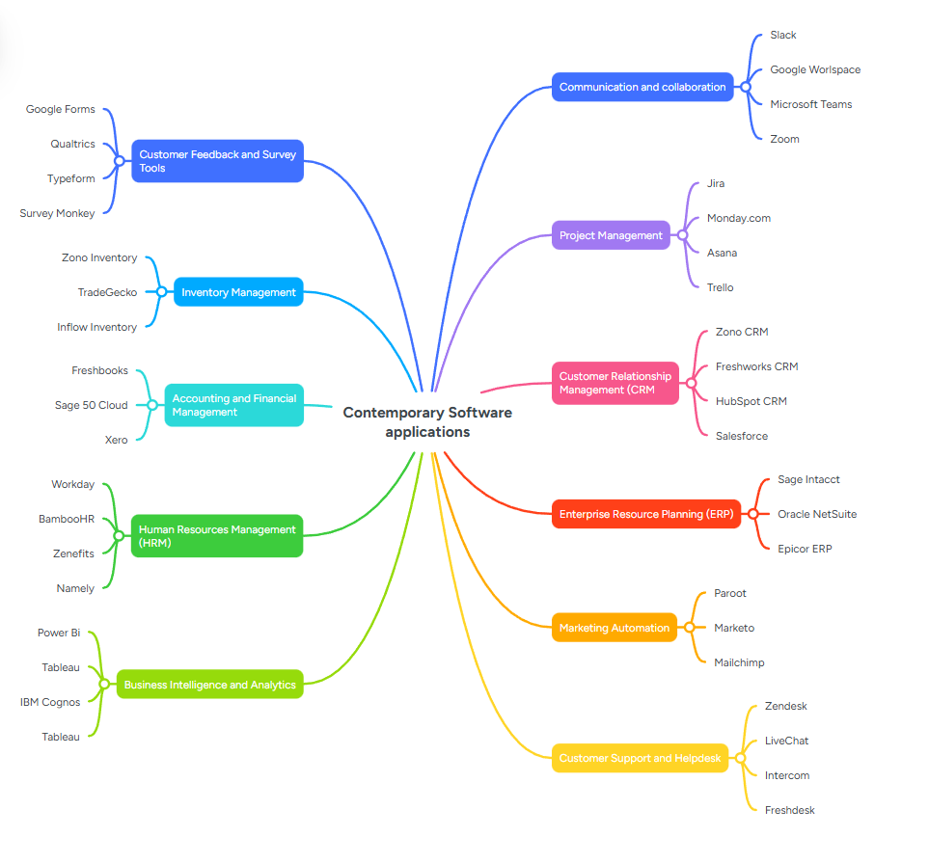

Task 3. Office Applications

Four office software solutions for business operations

MS Word
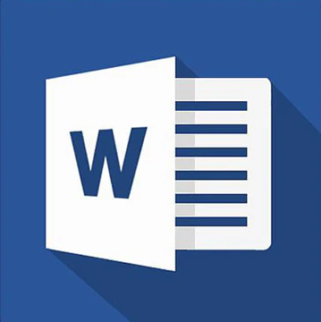
Microsoft Word was first released in 1983 as Word for MS DOS, developed by Richard Brodie and Charles Simonyi. During the period between 1990s – 2000s additional features such grammar and spell check and advanced formatting were added, resulting in MS Word gaining dominance in the word processor market. In 2007 the Ribbon interface was introduced. In the last 10 years this software has excelled exceptionally integrating advanced new features. 2013 saw the introduction of Microsoft 365, a subscription-based service offering access to apps and software like word, excel, PowerPoint. A year later Microsoft noticed a gap in the market for collaboration and launched real-time collaboration across devices [7], allowing multiple editors to work simultaneously on one document. Each year Microsoft continued to build and integrate additional tools [7], [8]2017 saw accessibility features included such as Read Aloud which allowed documents to be read aloud on a device. Also added to the list of benefits, Immersive Reader and these tools provide sight impaired users audio-based reading. Covid-19 Saw the integration of Microsoft Teams, after the discovery of thee growing trend of remote working, co-authoring, online communication and collaboration. This helped education, business and different households continue to work collaboratively, remain focused and complete tasks, while working remotely. Built on AI powered writing tools and added text prediction in 2021. The importance of data security and privacy influenced the development and implementation of vigorous security features as encryption enhancement, 2-factor authentication. The upgraded features provided protection in real-time, protecting against malware, phishing attacks and cyber security threat, safeguarding your personal data [7]. This significant progression for Microsoft Word stems from their understanding of the importance of collaboration, AI and accessibility and visuals to continue to meet the needs of its users [7], [8]. Today, Microsoft Word is available on Android, IOS and Mac devices.

Key features
- Formatting text: fonts and font size, styles, colours, Bold, italics, underline and alignment
- Tables and graphics: Insert tables and charts, images, Shapes
- Collaboration: Share, view and co-edit documents via OneDrive or SharePoint
- Templates: Brochures, Invitations, flyers, reports and much more
- Layout: Margins, columns, Paper size, Indentation, Wrap text
Benefits | Limitations
User friendly | Subscription costs
Integration of Microsoft apps PowerPoint, Teams & Excel | Advanced features often overwhelm new users
Built in referencing tools | Instability with complex and or large documents

The dynamic and vast number of features in Word, and the dedication Microsoft has to continuous improvement within the application, will innovate further as needs evolve. Creating documents will become increasingly seamless and proficient. All these features’ aids anything from basic letters to complex report writing, collaboration, proofing and automatic referencing tools compel its essential use academically and professionally. (C)

MS PowerPoint
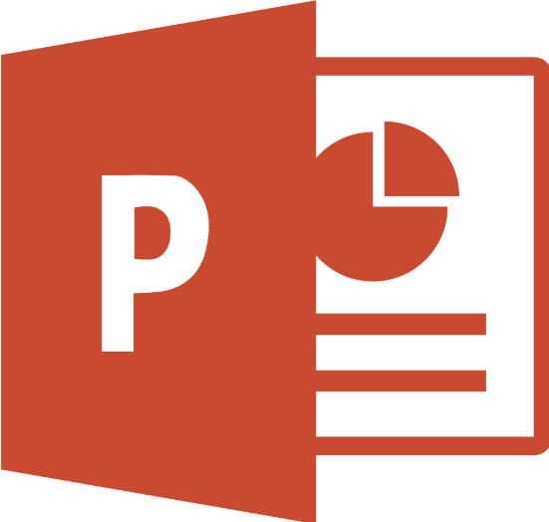
In 1987 PowerPoint 1.0 was develop by Forethought. During the 3-year period of development was initially called Presenter, but that name had been used. The name PowerPoint originated from a imaginary thought he had from a sign he had seen on a runway in an airport. He felt that users would construct ideas and points, then share them via a presentation. He stuck with this name and rolled out his first production which sold out. PowerPoint has always been part of Microsoft package from Office launched in 1989 and at this stage most group presentations were executed using overhead projectors. They required a large white wall to present; equipment was bulky and laminated sheets used were blurry at times. [9], [10]
Key Features
- Create slides and design by adding text, charts, tables, images
- Professional design templates and themes
- Animations and transitional tools offer visual effects to improve engagement
- Presentation tools and multimedia integration depict notes, timings of rehearsals, a Presenter view making delivery smooth [10]
- Collaboration tools offer real-time co-editing, feedback and comments, sharing files for others to access (providing permissions) via OneDrive or SharePoint.
- Accessibility features include alt test for images, screen reader support and is compatible with several devices.

Benefits | Limitations
Easy to use making a suitable for beginners | Large presentations can slow down devices that are less powerful
It is versatile and used for training purposes, interviews, business pitches, education [10] | Advanced features may be overwhelming
Helps structure your ideas clearly using slides | Cost as it requires Microsoft 365 subscription or purchase
Collaboration: Teams can edit and review presentation using cloud integration | Slides contain too much information resulting in the Presenter reading more content, than free flow presentation delivery.

MS Excel
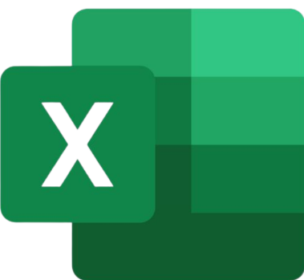
Microsoft Excel is a software program used worldwide for data entry, visualisation, analysis and automation. A powerful tool in Microsoft 365 suite is a spreadsheet program that helps to fulfil everyday tasks like budgeting, advance applications and scientific analysis [14]. Excel was first released in 1985 for Mac and Windows was later in 1987. Over the next 3 years it became the dominant spreadsheet software, outshining Lotus 1-2-3, which was leading the market at the time. [11], [15].
Key features
- Formulas and functions, built in mathematical functions, finance, statistics and text manipulation
- Organised data in rows and columns for grid-based data entry.
- Charts and graphs: pie charts, bar charts, scatter diagrams and much more tools which help visualise data.
- Collaboration via OneDrive or SharePoint which enables co-editing and shared access.
- Data analysis tools: Solver, Scenario manager.
Benefits | Limitations
Ease of use: beginners can use it | Subscription costs
Versatility: Used for accounting, project management, scientific research & budgeting | Advanced features are more difficult to learn
Integration: Seamless working with Word, Teams & PowerPoint | Issues with performance when dealing with large datasets.
Visualisation: Dashboards that make data easy to interpret | Not designed for database management

Excel is used in business for tracking expenses and revenue, creating dashboards showcasing sales. Run scenarios through the “what IF” tool to predict profits and report automation using macros to generate charts. A survey study carried out by Carl M. Rebman et al to established if Microsoft Excel should be made obsolete now due to the use of Google Sheets. The results were overwhelming and indicated that Excel is top choice, most required spreadsheet application by employers [15].

MS Access
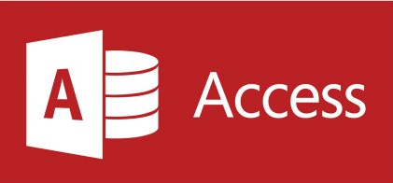
Microsoft Access first version was released in 1990 Developed by Microsoft as a relational database management system, it boasts graphical user interface amalgamated with database tools that allow its users to design, manage and analyse data [12], [13]
Key features
- User-friendly, supporting drag and drop tools for reports and forms.
- Databases can be built from scratch.
- Tables, forms, queries and reports can be stored, retrieved and present data.
- Links to data source like Excel, Share point, SQL server
- Queries can be created without SQL [12] [13]
- Data is stored locally for larger and more secure applications

Benefits | Limitations
Build apps for business without extensive coding required | It is not available on Mac OS only windows
Cost effective, cheaper than enterprise databases | Does not cope with the enterprise-level demands unlike SQL Server
Suitable for small and medium-sized business, or personal projects | Performance issues when dealing with complex issues or when there are multi-users

Microsoft access bridges the gap between working with simple spreadsheets and business databases, keeping it valuable for their operations as well as personal learning. Holding a small percentage of the market, Access is embedded in many organisations operational procedures and therefore have long standing databases making migration difficult and costly. This leaves Access in the position of cost effectiveness and reliable for small businesses and this comes from its ease of use and integration with Microsoft Office. However, a study showed that students possessed low level skills of significance. The recommendations were that institutions and offices of Technical Management should offer suitable training of Microsoft Access to enhance their capabilities. [13], [14]
Alternatives are needed to Microsoft Access today are MySQL, Google sheets and Airtable.

b Practical demonstration of Two Office Features

Mail Merge

My Recipient List

From the mailings tab click on Start Mail Merge and select letters
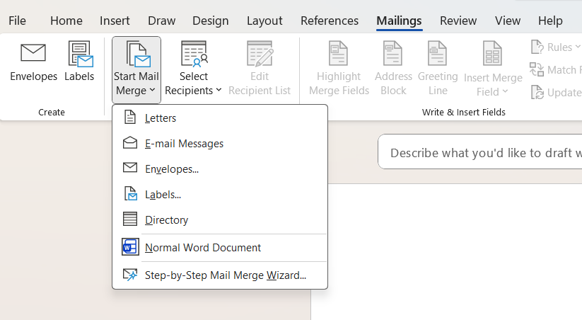
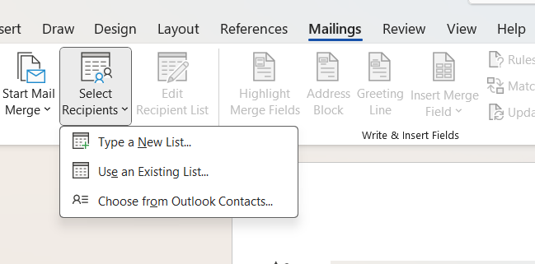
Click on Select Recipients and choose ‘Use existing List’

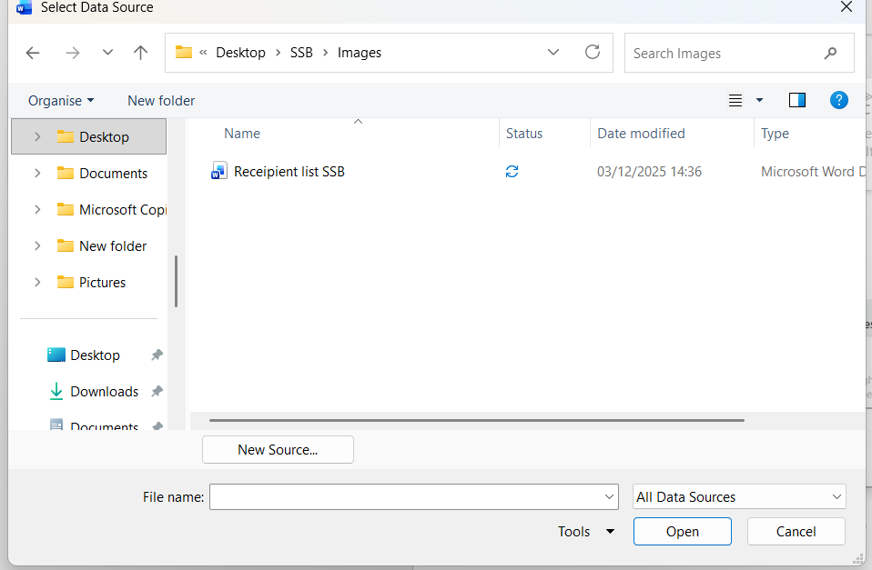
Locate your saved recipient list and select it to open

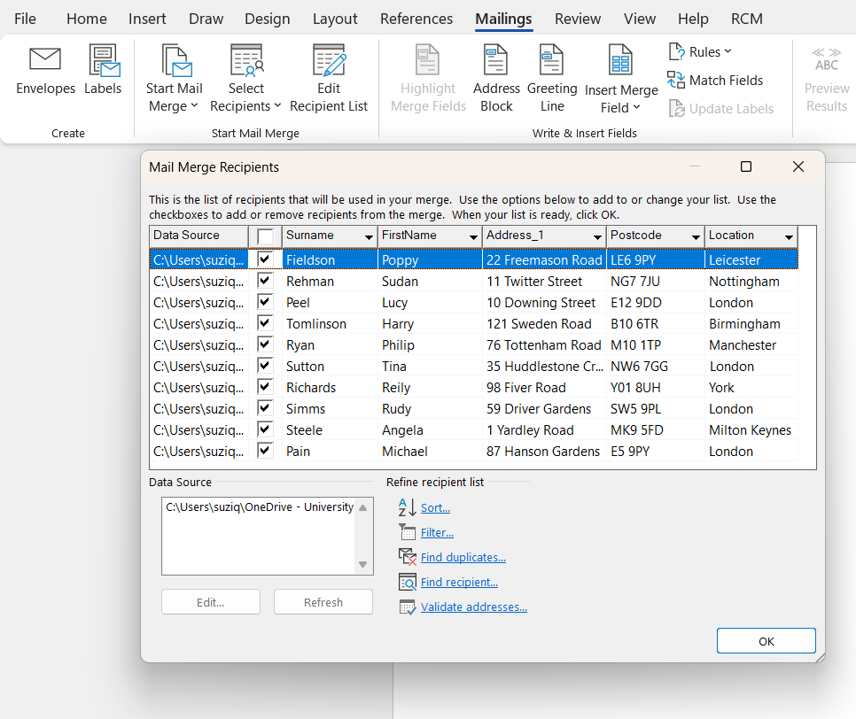
recipient list is now available for mail merge

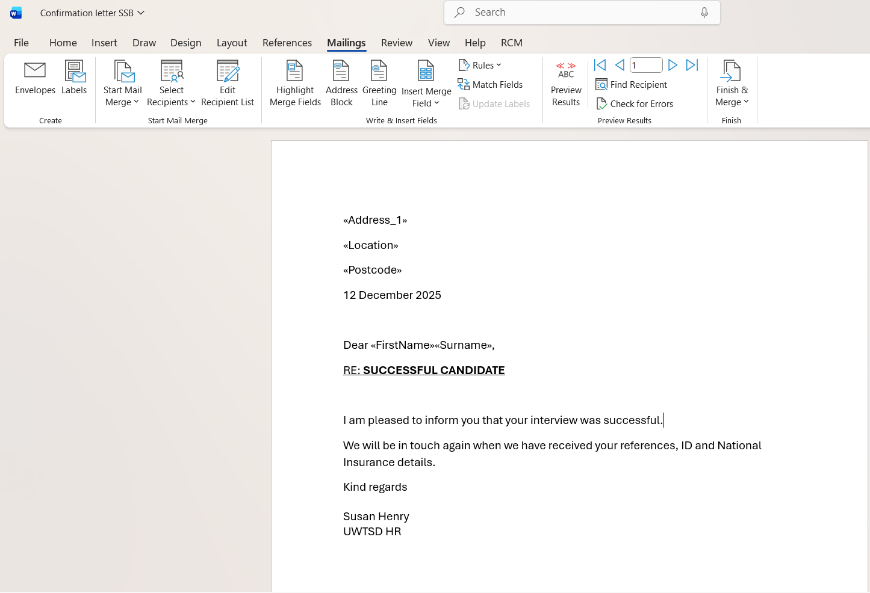
Click on Insert Merge field to select your relevant fields.

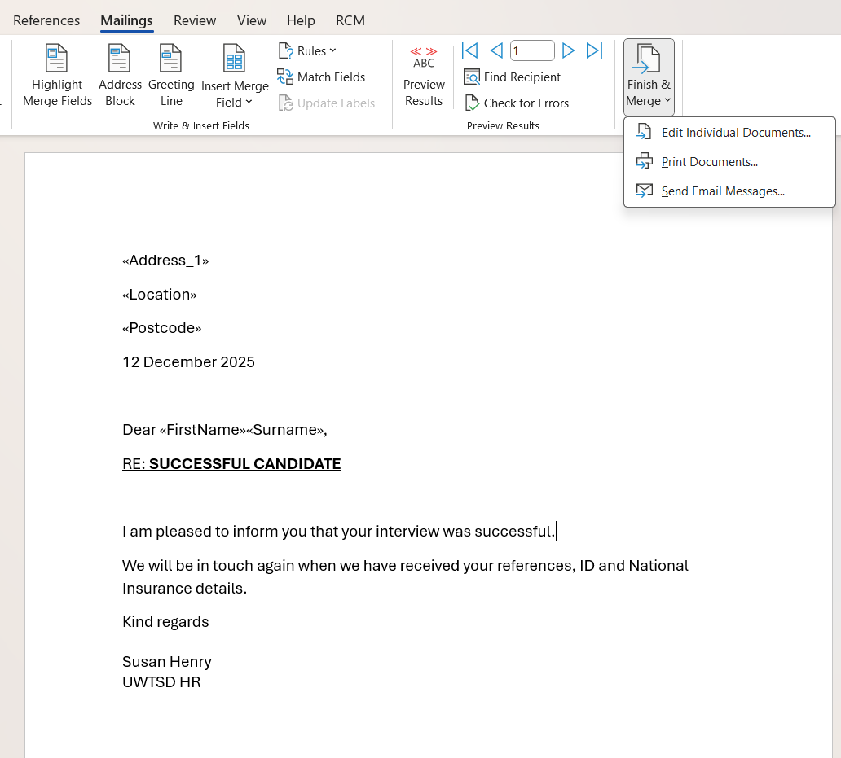
Select Edit Individual Documents
Click on finish & merge and select

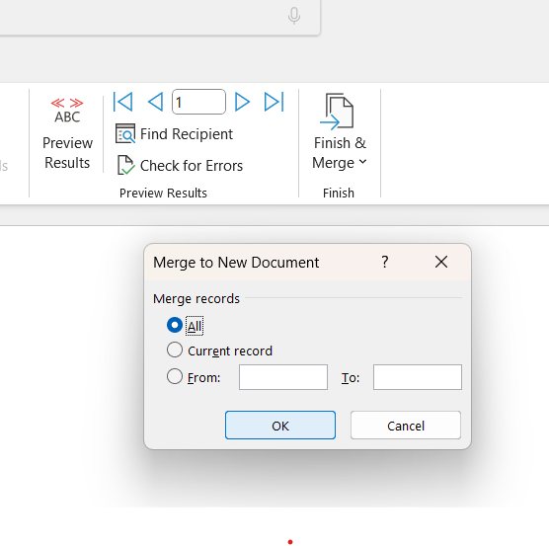
This pop up will appear select all and then click OK

Your mail merge is now ready to go. As you can see in screenshot below 10 fields were created for 10 recipients.



If Statement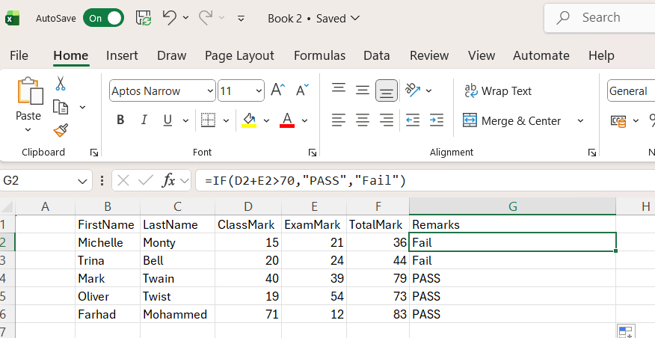

Task 4. Communication and Collaboration applications

One contemporary Communication and one Online Collaboration

MS Outlook

Information Communication Technology (ICT) is the collection of systems and tools that allow individuals and organisations to connect, share and work in today’s digital world. Outlook is an asynchronous type of communication which is not received immediately or responded to instantly. Emails, messages, WhatsApp allow individuals to communicate at times that suit their schedule. Microsoft Outlook is used in many businesses and organisations globally, making it a popular application. As part of Office 365 it is available as a cloud tool or a desktop tool.
Key features
- Send and receive emails
- Blind copy (Bcc) and Carbon Copy (CC)
- Calendar for checking availability and scheduling meetings
- To Do Lists
- Automatic responses (for out of office replies)
- Signatures
Developed by Microsoft for emails communication to send and receive emails, it is much more than just an email client. Like every Microsoft application it is suite of productivity tools to use for creating contact groups, so you can email them simultaneously. Email security offers 24/7 scanning of messages and attachments for malicious software. Microsoft data centres help protect our data and must meet several industry-standard security certifications. Phishing is the simplest form of cyberattack yet is the most effective and dangerous, preying on the vulnerability of the human mind. Malspan is any kind of malicious malware that invites you to click on a link to download or opening an attachment. Trojan is a malware designed to steal financial or sensitive information from your computer, some Trojans come disguised as a delivery mechanism for other malware such as spyware.

Benefits | Limitations
Outlook allows you to manage several different accounts in one domain | Less user-friendly with non-Microsoft tools
Connects seamlessly with Excel, Word, PowerPoint and OneNote | New design relies on cloud, limiting its offline functions unlike the older versions
Outlook 2025 provides cross platform consistency across Windows, web and mobile | New design offers fewer options for layout and rules

MS Teams

Microsoft Team is a synchronous communication and collaboration platform built in the office 365 package. Used for personal or business use, enabling people to connect via video conferencing, instant messaging, voice calls, organise group meetings and upload and share files all in the one domain. Share screens via video conferencing for short training purposes. Microsoft Teams saw a dramatic rise in its use during Covid-19, promoting working remotely and communicating and collaborating online. It is widely used by organisations to streamline teamwork in the office or remotely.
Key features
- Instant messaging and chat
- Video Conferencing
- Channels and collaboration domain
- Sharing Files and storage
- Meetings and events
- Immersive reader
- Productivity tools
Benefits | Limitations
Reduces the need to switch between apps | Interface can be daunting for first time users
Works for small teams and extremely large organisations with thousands of employees | Overuse could lead to buried conversations and files, making it difficult and time consuming to cipher through
Real time communication | Less flexible with non-Microsoft tools
In-built Compliance and data protection

One feature of a freely available Communication (1) and one feature of a Collaboration (1) application

MS Outlook

Open you outlook app and sign in using your email and password. This home screen will appear.
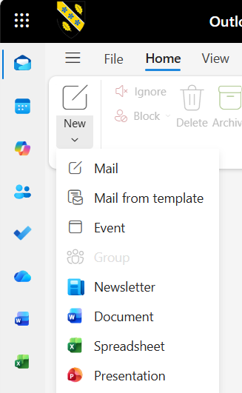
Click on New and select email from the drop-down menu.

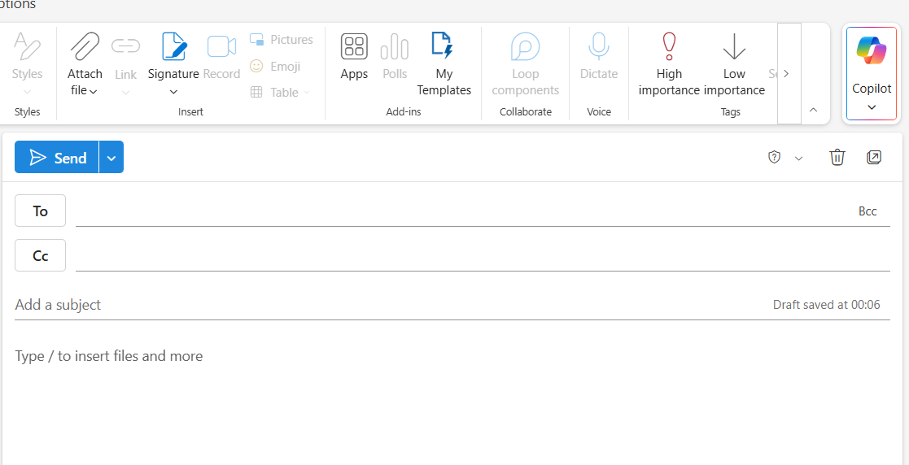
To: type your email address here. If you click on ‘To’ and it will bring up a list of contact options
A new window opens
CC is used to copy other persons in but not addressed specifically to them

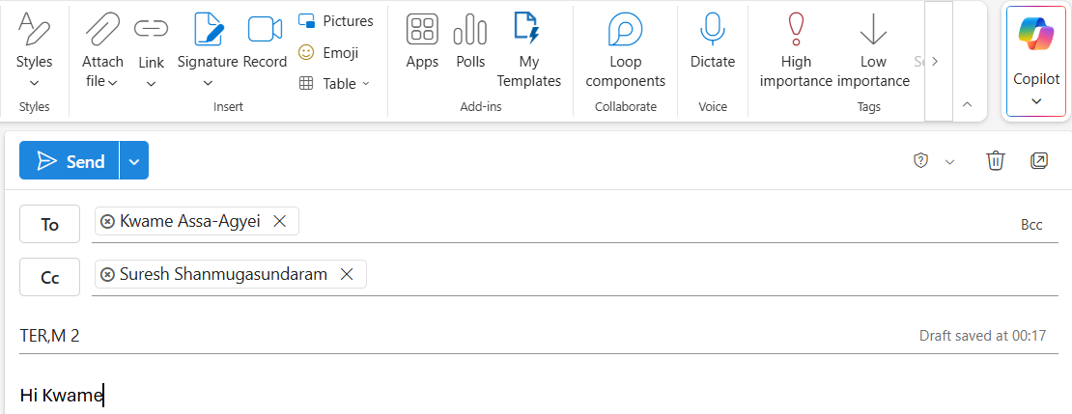
Enter a subject heading and type your email
Click Send
BCC stands for Blind Carbon Copy and this is often used when the sender does not wish the receiver to know that someone else is copied in

Ms Teams
Login into Ms Team using your username and password.

When you log in you will see the screen below

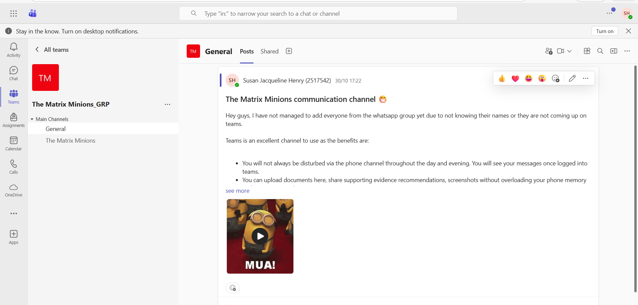

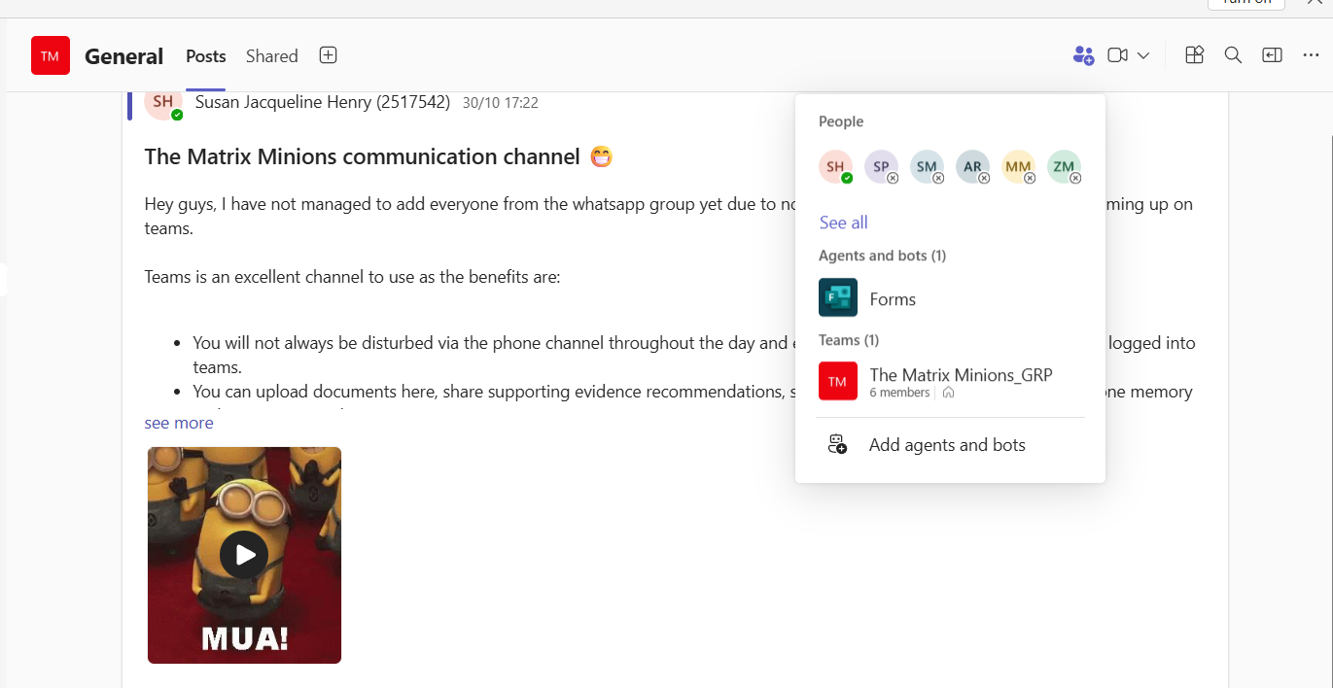

Click on the blue people icon and a drop-down menu will appear. At the top it will show you all the members in the group and their availability.
Here is a message sent in the chat channel.


To schedule a meeting click on the arrow next to the video icon

Select Schedule meeting


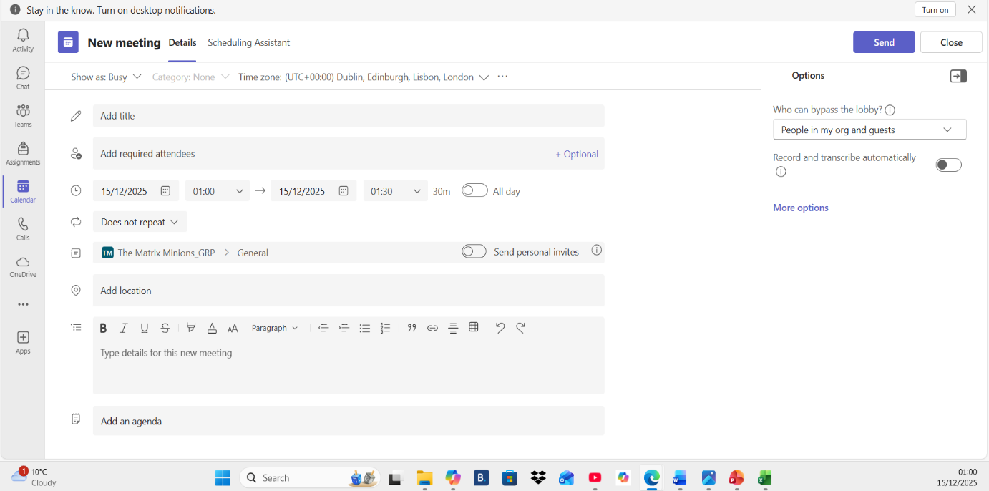

Enter the date and time of the meeting, you can add more attendees that are not in your group here. Set the reminder, you can add a location and enter information about the meeting and attach the agenda. More options offer meeting access permissions, production tools, roles and recording & transcription selections. Click send and all group members will receive the invite as well as anyone else you added outside the group.

Conclusion
The software solutions explored in this assignment show how technology supports modern day businesses by continuously improving communication, collaboration, data management and online store operations. Each tool has it benefits and limitations which highlight the importance of choosing the correct application to meet the organisations requirements. Developing digital skills in these areas not only supports day to day tasks but also builds a strong foundation for future career opportunities in digital transformation.

References
[1] Flavian C, Gurrea R, Orús C (2009), "Web design: a key factor for the website success". Journal of Systems and Information Technology, Vol. 11 No. 2 pp. 168–184, doi: https://doi.org/10.1108/13287260910955129
[2] K. Aboalganam, A. S. Alnaser, M. M. AL-ma'aitah, K. AlshakeTheep and H. Awad, "Measuring the impact of website design on student trust: An empirical study on software applications," vol. 13, no. 2, pp.201–210, 2023,
[3] About WooCommerce - WooCommerce.com
[4] M. Davies, "Concept mapping, mind mapping and argument mapping: what are the differences and do they matter?" vol. 62, no. 3, pp.279–301, 2011,
[5] M. Crowe and L. Sheppard, "Mind mapping research methods," vol. 46, no. 5, pp.1493–1504, 2012,
[6] A. Buran and A. Filyukov, "Mind Mapping Technique in Language Learning," vol. 206, pp.215–218, 2015, doi: 10.1016/j.sbspro.2015.10.010. Available at: https://www.sciencedirect.com/science/article/pii/S1877042815051435.
[7] A. Jalil, F. Rosa, R. Affandi, A. Aziz, W. N. H. Saputra and A. A. Ridho, "Literature Review: Exploration of Features Microsoft Word," vol. 3, no. 1, pp.28–32, 2024,
[8] A. Mamishev and M. Sargent,Creating Research and Scientific Documents Using Microsoft Word, Microsoft Press, 2014.
The history and timeline of Microsoft Word – Microsoft 365 online
[9] A. A. Z. Rosyiddin, A. Fiqih, H. Nugraha, A. Hadiapurwa and D. A. Komara, "The effect of interactive PowerPoint media design on student learning interests," vol. 8, no. 1, pp.12–24, 2023,
[10] I. M. T. A. Wirawan and I. K. Gading, "Interactive powerpoint learning media on science content for fifth grade elementary school," vol. 5, no. 2, pp.190–198, 2022,
Presenting: PowerPoint, a retrospective – Microsoft 365 online
[11] M. Omar, "New insights into database security: An effective and integrated approach for applying access control mechanisms and cryptographic concepts in Microsoft Access environments," 2021,
[12] A. F. Tony-Okeme, "Microsoft Access Application Competencies Possessed by Office Technology and Management Students for Employability and Self-reliance,"
[13] P. Beynon-Davies, "Microsoft Access," in Database systems, Springer, 2004, pp. 446–456.

[14] C. M. Rebman Jr, Q. E. Booker, H. Wimmer, S. Levkoff, M. McMurtrey and L. M. Powell, "An Industry Survey of Analytics Spreadsheet Tools Adoption: Microsoft Excel vs Google Sheets." vol. 21, no. 5, pp.29–42, 2023,
[16] A. P. Aires, J. Escola and N. Lopes, "Microsoft 365: A teaching and learning resource during the pandemic", INTED2021 Proceedings, pp. 3647–3652.
[17] E. Karpova, A. Correia and E. Baran, "Learn to use and use to learn: Technology in virtual collaboration experience," vol. 12, no. 1, pp.45–52, 2009,
[18] P. R. Srivastava, "Communication, collaboration & trust: Interpersonal challenges in virtual collaboration team," vol. 5, no. 4, pp.1273–1278, 2020,

