
BMSW4001

Academic and Employability Skills AS2

Student Name: Bogdan Dumitru Mesch
Student ID: 2030724

Module Leader: Silvia Hoffmann

Contents
Introduction 2
Kolb’s model of reflection 2
Discussion on learning in this module 3
Time management skill 3
Academic writing skill 4
Paraphrasing skill 5
CV Writing skill 5
Conclusion 7
References 8

Introduction
As a student I need to acquire potential academic and employability skills which can help us to secure good academic result as well as securing good profession in the future. This report will discuss about my learning of academic and employability skills in this module. Skills development carries great significant for us as this can help us to secure potential skills which can be effective in our future professional life. In this report, I will discuss about four academic and employability skills which I have learnt in this module. I will also provide effective reflection on each skill I have acquired from this module. For the reflection, I will use the Kolb’s reflective model.

Kolb’s model of reflection
This reflective model is also regarded as the experimental learning model which is developed on the basis of experience. This model underscores on reviewing, analysing and evaluating any experience gathered by a person. There are four stages of this reflective model which discuss on learning from the experience gathered from the module.
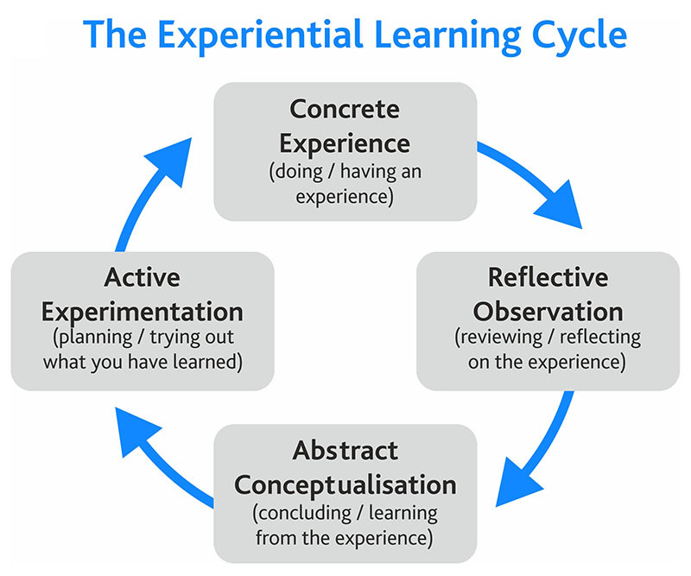
Figure: Kolb’s reflective model (Source: Reflective model according to Kolb - Dr Nicole Brown, 2021)
Concrete experience: This is the first’s step of this reflective model which will underscore on describing any particular situation on which this reflection will be given. At this stage, I will describe about the learning experience from the module.
Reflective observation: After describing the event or experience, this part of the model will underscore on describing the event more deeply. In this regard, some questions will be answered like what went well, what went bad, how you and others behaved on that particular situation etc.
Abstract conceptualisation: This third part of the model focuses on describing how you will handle the situation differently. This part will also discuss how I will face this same type situation in the future (Miniano and Rui, 2020).
Active experimentation: This is the last stage of the model which will describe about the learning from this experience. This last part of the model will tell about what I have learnt from this particular experience.

Discussion on learning in this module
This module has covered different academic and employability skills. Learning of academic skills will help us to perform well in the next classes as well as gaining good academic result. On the contrary, employability skill gathering will make us fit for having excellent profession in the future. Getting a good job is getting very tough. In this regard, there is alternative to securing employability skills. This part of the report will discuss about four different employability and academic I have gathered from this module. For each skill, I will underscore on writing reflective description. Pertaining this, I will use the Kolb’s reflective model.

Time management skill
Time management skill is one of the key skills which should be present in every person of the world. Time management can be defined as managing our time perfectly to carry our daily activities effectively and efficiently. For the student like me, this crucial skill is very crucial. Student life is the best period of time when we can build ourselves. At this stage proper management of time can help us to carry out our all the activities perfectly (The Complete List of Time Management Skills | Spica International, 2021). Proper time management skill can also help to make the best use of time as this is very crucial at this stage of life. Success cannot be achieved without proper utilisation of time. Learning of this skill carries great value to me.
Reflection: This module has taught us effective time management including both theoretical and practical knowledge about this potential skill. This particular experience has taught us about how to make best use of time. At this step, I have learnt different ways of securing good time management skills which can help us in the future regarding both academic and professional life. All the issues of the learning session went very well. Particularly the learning about some particular tactics about managing the time effective went very well. Our teachers helped me greatly in this regard greatly for securing this skill perfectly. All the participants of the class response significantly for learning this skill perfectly. In my future life, I will implement my learning from this module. I will practice on using daily routine or checklist which can help us to divide my daily time perfectly according to work. This particular experience has helped me greatly to acquire effective time management which will help me in the future regarding both my academic and professional life.

Academic writing skill
Academic writing skill is regarded as potential academic skills which can help to achieve good academic result. Securing good academic result is essential to have good job in the future. In this regard acquired good academic writing skills can help greatly. It is not only essential for the students, this potential skill is also essential for the teachers, professionals and the business man. The academic writing skills mainly underscore on learning about how to write essay, research papers, reports, presentation, articles etc. (Academic Writing Skills, 2021). As a student, having good potential knowledge about these issues is very crucial. Academic writing skills acquired on this module has underscored on learning relevant issues on learning all these issues.
Reflection: Learning experience of academic writing skills on this module mainly focused on inculcating us about how to write best academic writing like essay, presentation, research paper etc. In this situation, I have learnt about appropriate format about different academic writing as well as how to approach in different academic writing. From this situation, I have learnt about how set up formal tone of academic writing, good writing praxis, adhering to the topic of writing etc. All the experiences related to this learning went very well. As I have problem regarding this skill, I have paid good attention to this skill. Our teachers helped me greatly in this regard to have good understanding about effective academic writing skills. From this experience, I learnt relevant concept and ways of showing good capability regarding effective academic skills. Especially, learning of structure of each writing style has helped me in this regard. Besides, I learnt about the how write formally in academic writing which will also help tremendously in my future success. Now I will focus on implementing all these learning about academic writing in the future. Proper implementation of this learning in the future will help me to have good academic result which will increase my chance to getting good profession in the future.

Paraphrasing skill
Paraphrasing is regarded as the expression of information and ideas from the sources of others and this potential skill was also learnt in this module. Paraphrasing skill is an effective academic writing skill which is mostly used in our writing. Writing of other authors directly is illegal. In this regard, effective paraphrasing skills can help how to include writing of other authors legally in my writing. Paraphrasing doesn’t copy the writing of other writers directly but it takes the overall meaning of the writing of other writer (LibGuides: Writing Resources: Paraphrasing, 2021). In out academic writing, we have to write literature review which is based on the writing of others writer. In this regard, securing potential paraphrasing skills will help greatly.
Reflection: My experience of learning about paraphrasing was very good. In this session, I have learnt about how to make perfect paraphrasing in a legal way. In this learning session, I have learnt about different techniques which can help me regarding perfect paraphrasing. For example, I was learnt about reading a topic perfectly understanding the meaning of the topic. Then I will focus rewriting the topic in my own avoiding the direct writing of the writer. I have also learnt how to maintain exact meaning of the writing of other writers. Our teacher made a good effort of inculcating us this essential skill. At first it seemed very tough to me to understand but good caring of my teacher and class mates enabled me to learn this potential skill. For learning this skill perfectly, I took notes from the class and practiced at home which helped me greatly for learning this potential skill perfectly. Learning of this skill will help me greatly in the future for securing good academic result. I have been able to implement this potential skill regarding effective writing like research papers and articles. This potential skill will also help me to avoid plagiarism in my academic writing.

CV Writing skill
Creating an excellent CV is seen as a valuable skill that may aid a student's career success. Having the skill to create a decent CV is critical for a student to have a successful career in the future since companies pick applicants based on the CVs they send. This section of the essay will go over CV writing abilities. This learning will also underscore on learning effective CV writing skill which will help me greatly to develop attractive CV (Resume Writing Skills | Key Skills for CV - Careerisma, 2021). Securing this professional skill will help me to have good careen in the future. This learning session underscored on teaching different crucial steps of developing attractive CV.
Reflection: This learning event was based on informing us about how to create professional CV which is regarded as effective employability skills. In this learning session, I learnt about all the crucial steps of developing good CV for my future career. In this session, my teacher taught us about different parts of the CV as well as the structure of a formal CV. All the issues relating to learn CV development went very well. I along with my class mates paid high concentration on this learning session. In the learning session, I tool all the relevant notes which is helping me to greatly to remember what were learnt in the session. From this session I have learnt how adorn my CV according to the requirement of a particular organisation. Fox example, when I will include my skills in the CV those will be in accordance with the requirement of the task. For the further development of this skill, now I researching different websites and articles which are especially for CV development. This further attempts of developing putting great impact on developing this potential skill.

Conclusion
The session about developing academic and employability skills went very well as this underscored on developing some crucial skills. From this learning session, I have gathered crucial knowledge and understanding about development of these potential skills. Perfect learning of these skills will help me effectively in the future regarding both my academic result and professional life. Now I will focus on bringing further development on these skills by practicing perfectly what I have learnt in the learning session. After complete learning of these skills, I will implement these skills in my academic life. Besides, this skill development will also help me to find a good profession in the future successfully.

References
Careerisma. 2021. Resume Writing Skills | Key Skills for CV - Careerisma. [online] Available at: <https://www.careerisma.com/skills/resume-skills/> [Accessed 15 August 2021].
Dr Nicole Brown. 2021. Reflective model according to Kolb - Dr Nicole Brown. [online] Available at: <https://www.nicole-brown.co.uk/reflective-model-according-to-kolb/#:~:text=Kolb's%20reflective%20model%20is%20referred,starting%20point%20for%20another%20cycle.> [Accessed 15 August 2021].
Grammar.yourdictionary.com. 2021. Academic Writing Skills. [online] Available at: <https://grammar.yourdictionary.com/style-and-usage/academic-writing-skills.html> [Accessed 15 August 2021].
Miniano, C.M. and Rui, Y., 2020. Kolb’s learning styles and managerial concern for people and task: A reflective measurement model. European Journal of Business and Management, 12(9), pp.12-21.
Ncu.libguides.com. 2021. LibGuides: Writing Resources: Paraphrasing. [online] Available at: <https://ncu.libguides.com/writingresources/paraphrase> [Accessed 15 August 2021].
Spica.com. 2021. The Complete List of Time Management Skills | Spica International. [online] Available at: <https://www.spica.com/blog/time-management-skills> [Accessed 15 August 2021].

