
Cintia Azahara Leiva Cantador (2617404) 07/11/2026

Assignment component 1
Learning in the Digital Era-ACCA4025 CertHE Computing Skills for Workplace

Table of Contents
Task 1 2
Task 1A 2
Task 1B 3
Claude (Anthropic) 4
Shannon AI (Open Source) 4
Microsoft Security Copilot 5
Task 1C 6
Reference list Task1 6
Task 2 7
Task 3 7
Task 4 7

E-Portfolio

To visit the e-portfolio created for this assignment, click the link below.


Component 1: E-Portfolio
Go to this Sway

Task 1

Task 1A

The goal after favourably concluding the learning journey is working in Cyber Security, specialising in ethical Hacking.
Cyber Security is a promising career opportunity [1] nowadays smart technologies are affecting our lives virtually every aspect, consequently the current risks of exposure to a cyber-attack have notably increased. In the healthcare sector the has been a considerable growth in cyber threats with nearly 90% of organizations raising alarm [3].
Additionally Artificial Intelligence (AI) has become undeniably appealing for cyber security stakeholders when the recent developments in this technological domain have indicated to impact cyber security. Cyber security will probably be affected in the short term by AI supporting equally cyber defence and offense [5].
Employability in this field and the standards of competencies of the job’s applicants are considerably elevated; on this endeavour it is not sufficient for the academics to increase the chances of employment, it’s important to participate in competitions outside of the classroom that can increase relevant experiences [1].
Essential skills for Cyber Security are a merge of technical expertise, mental agility and interpersonal qualities [2]. GAI output from [4] states that the most important skills to focus improvement are:

- Networking fundamentals to understand how computers communicate between each other.
- Operating systems Linux and Windows, learn how these operating systems work and how to manage them, investigate suspicious activities and identify potential security issues.
- Security fundamentals, the core concepts behind protecting systems and information to recognise threats.
- Programming and scripting, Python language for automation and security tools, Bash for Linux, PowerShell for Windows and Basic SQL and web technologies to improve efficiency.
- Security tools and practical investigation, learn how to detect and investigate security problems such as Wireshark, Nmap, vulnerability scanners, security logs, virtual machines and isolated practice labs to monitor networks, analyse security alerts and respond to incidents.
- Problem-solving and communication skills for analytical and critical thinking and attention to detail, will assist with investigate complex security incidents, work effectively with colleagues and explain technical issues clearly.

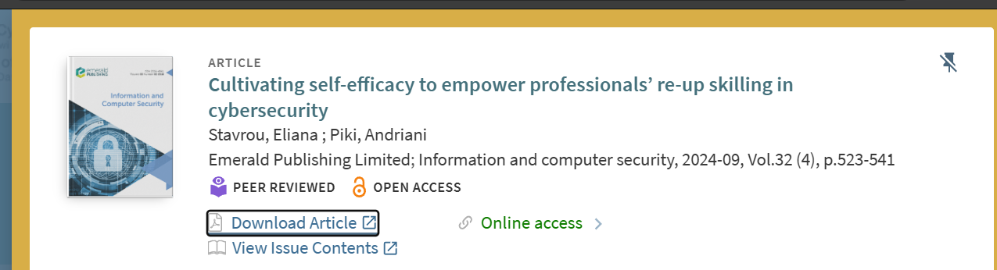
Figure 1: Cultivating self-efficacy to empower professionals’ re-up skilling in cybersecurity published in 09/2024 by Emerald Publishing Limited.

Task 1B

Claude (Anthropic)

Claude AI is a generative AI system used in cybersecurity for threat detection, phishing prevention, vulnerability analysis, and secure code generation. Like other large language models, it supports automated defence but can also be misused for cyberattacks. Its responsible use requires safeguards, including watermarking, adversarial defence mechanisms, and industry while introducing risks that require careful management and ethical deployment.[6]

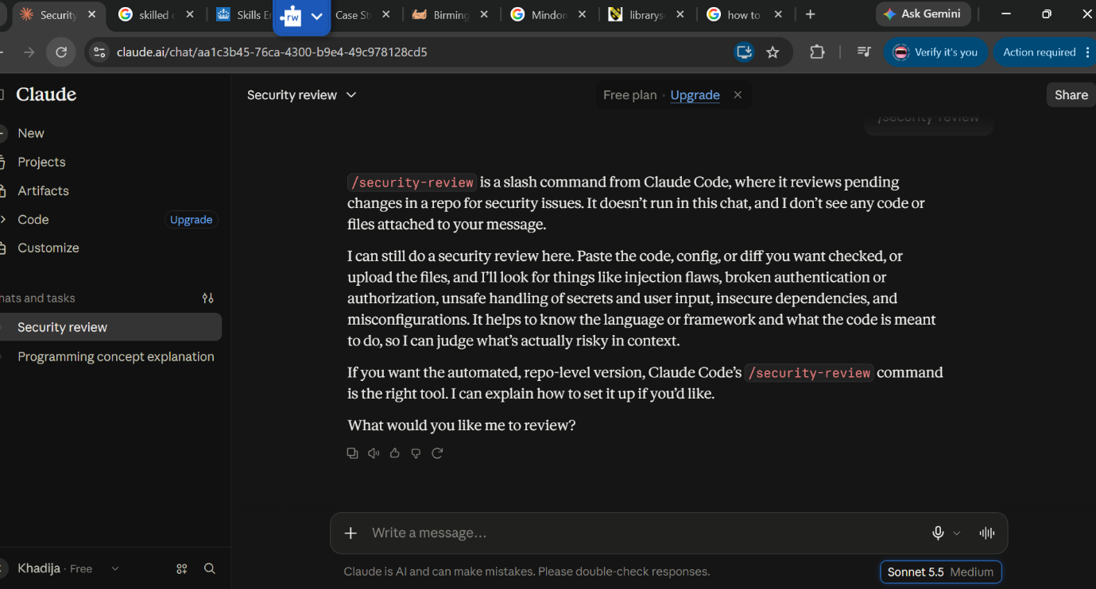
Figure 2 testing Claude AI analysing vulnerabilities is a paid service.

Shannon AI (Open Source)
Shannon entropy is used in network intrusion detection systems (NIDS) to measure uncertainty and assess the reliability of AI predictions. Neurosymbolic AI combines entropy-based scoring with symbolic reasoning and clustering to improve system robustness and interpretability. These methods help quantify prediction confidence, improve model generalisation and support transfer learning across different datasets, enhancing the reliability of AI-driven cybersecurity systems.[7]

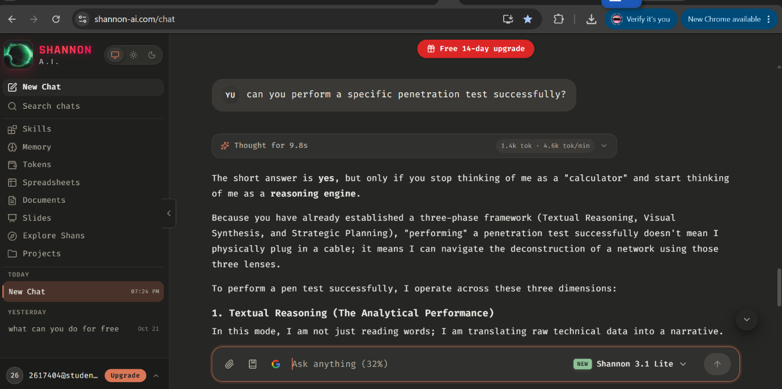
Figure 3 testing the open-source application.

Microsoft Security Copilot
Microsoft Security Copilot is an AI-powered cybersecurity tool that helps professionals detect and manage complex cyber threats through automation and advanced analytics. It supports creating and managing customised promptbooks and integrating plugins to extend its capabilities. Designed for cybersecurity professionals and IT specialists of different skill levels, it provides practical examples and actionable insights to strengthen security strategies and improve cyber defence efficiency across organisations.[8]

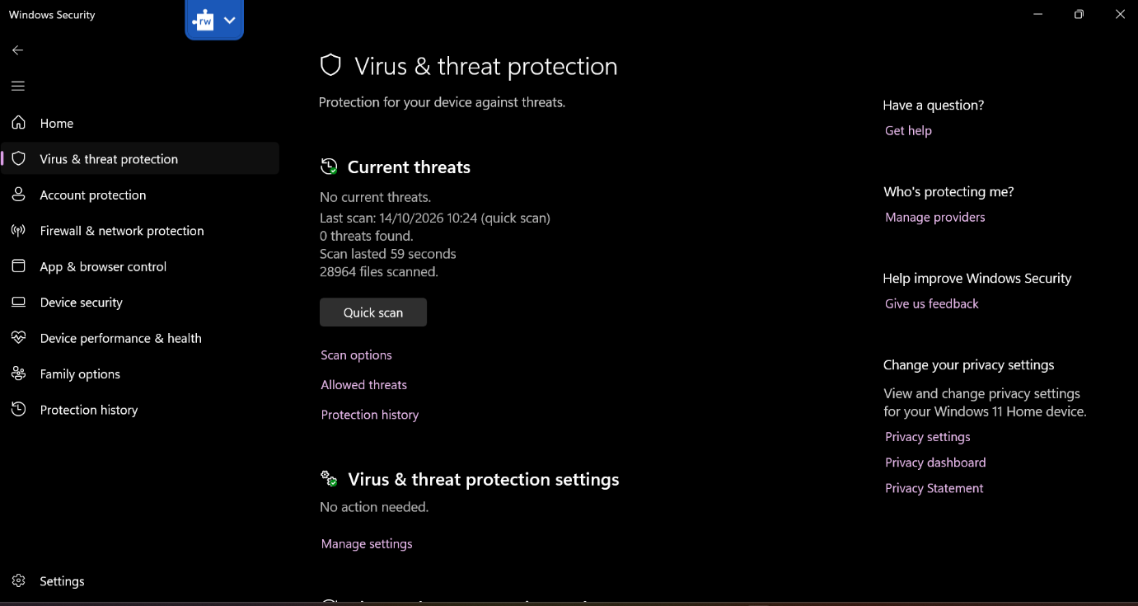
Figure 4 Windows Security app.
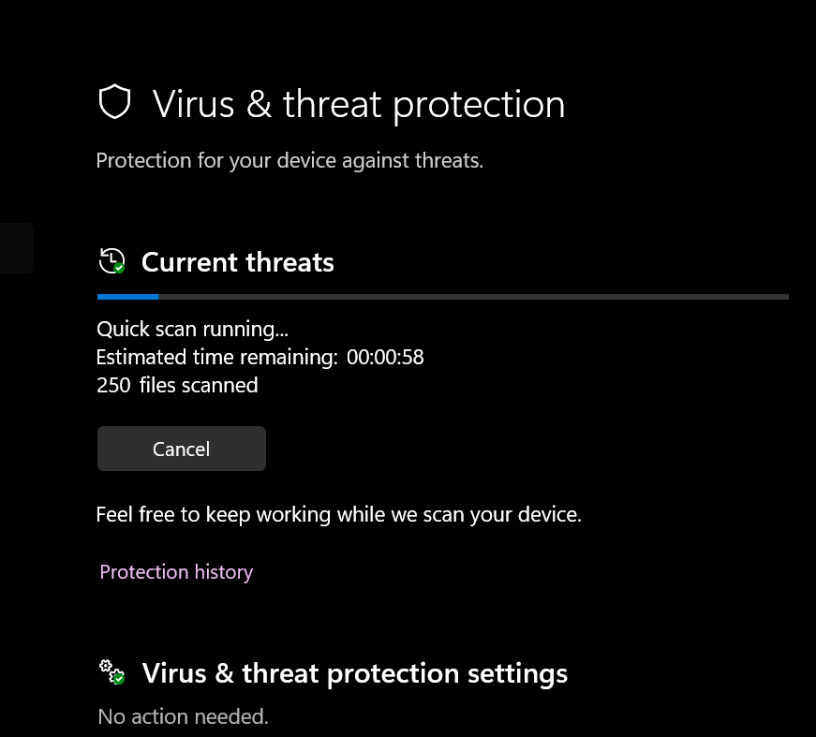
Figure 5 Testing threats scan.
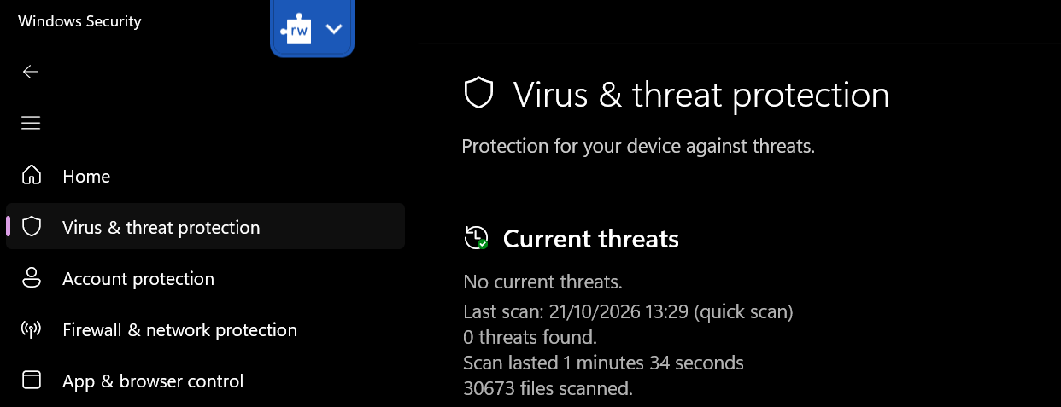
Figure 6 Report of the threat scan.

Task 1C

Reference list Task1

[1] D. Manson, M. A. Zantua, and Z. L. Fowler, “Beyond the Classroom: Competition Competency Creates Cybersecurity Careers (5Cs),” Communications of the IIMA, vol. 23, no. 1, p. COV7, Jan. 2025, doi: 10.58729/1941-6687.1463.
[2] E. Stavrou and A. Piki, “Cultivating self-efficacy to empower professionals’ re-up skilling in cybersecurity,” Information and computer security, vol. 32, no. 4, pp. 523–541, Sept. 2024, doi: 10.1108/ICS-02-2024-0038.
[3] V. S. Viswanathan, P. Harri, J. Volin, J. Kadakia, N. Safdar, and E. Kikano, “Safeguarding Radiology: Best Practices in Cybersecurity Governance,” Journal of the American College of Radiology, June 2025, doi: 10.1016/j.jacr.2025.06.001.
[4] OpenAI’s ChatGPT, private communication, Feb. 2023
[5] M. Dunn Cavelty and A. Wenger, Eds., Cyber Security Politics: Socio-Technological Transformations and Political Fragmentation, 1 ed. s.l: Routledge, 2022.
[6] K. Ahi and S. Valizadeh, “Large Language Models (LLMs) and Generative AI in Cybersecurity and Privacy: A Survey of Dual-Use Risks, AI-Generated Malware, Explainability, and Defensive Strategies,” July 2026, doi: 10.48550/arxiv.2607.06963.
[7] H. T. T. Tran, J. Sander, A. Cohen, B. Jalaian, and N. D. Bastian, “Neurosymbolic Artificial Intelligence for Robust Network Intrusion Detection: From Scratch to Transfer Learning,” arXiv.org, June 2025.
[8] Bi Yue Xu and Rod Trent, Microsoft Security Copilot. Packt Publishing, 2025.

Task 2

- To access the poster, click in the link below:

PosterPresentations.com-36x48-Template-Aragon.pptx

- To access the mind map, click in the link below:
https://canva.link/zix4aqf15lis3e6

Task 3

Task 4

