

Name: Maryam Hassan
Student ID: 2311534
Programme: BSc Health and Social Care
Module: Introduction to Independent Research Skills
Module code: BMPH5019
Assignment Title: Component 2: Written Assignment (Research Report)
Word count: 3609

Research Topic: Barriers and Facilitators to Early Diagnosis and Support for Children with ADHD in the United Kingdom
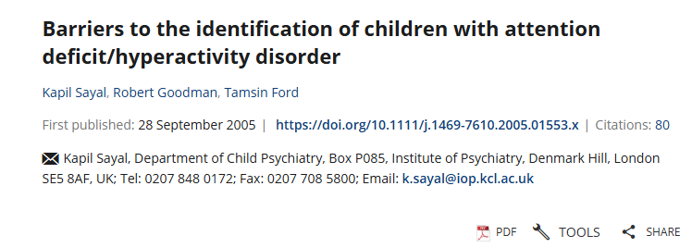
Peer review articles
1)

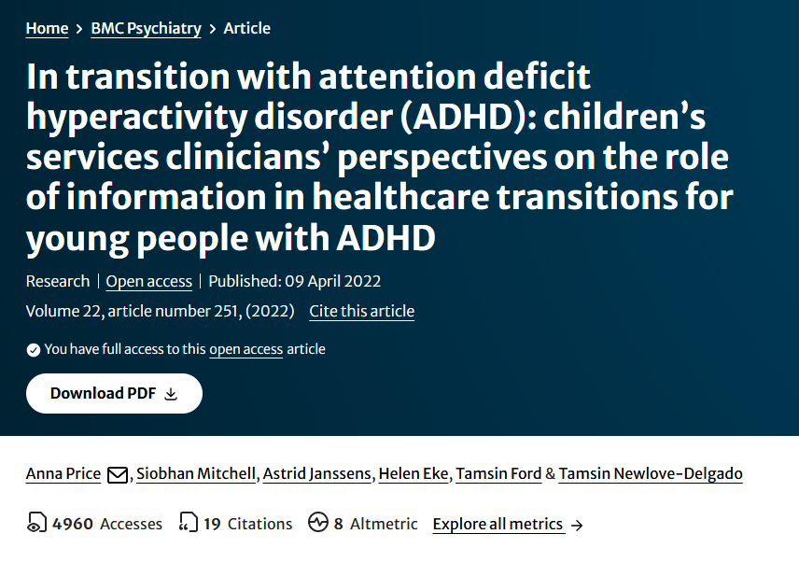
2)

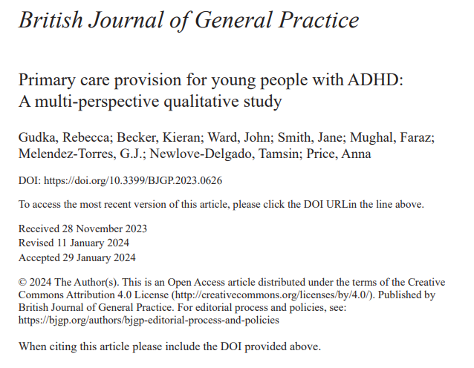
3)

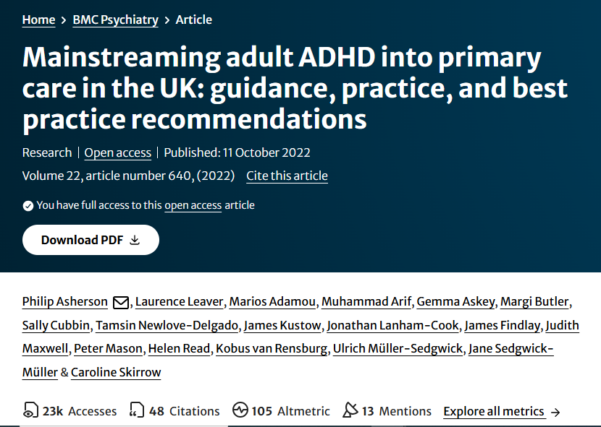
4)

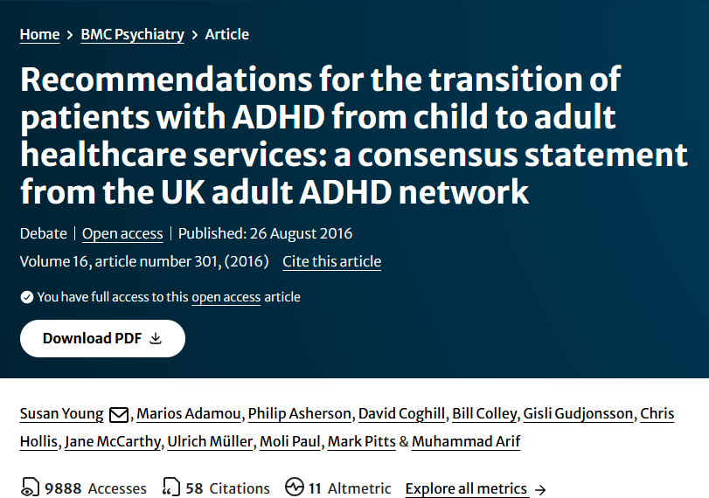
5)

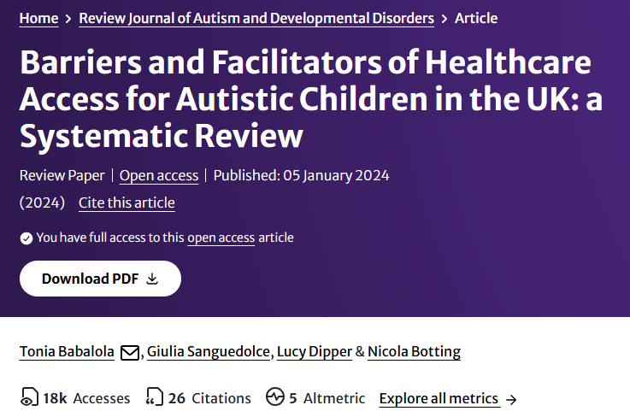

6) 7)
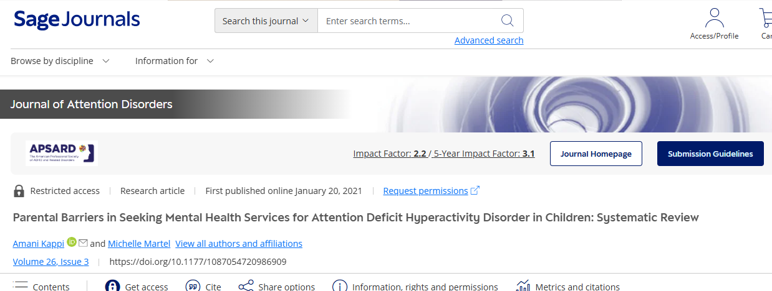

Contents
1. Introduction 3
2. Background 3
2.1 The Context of ADHD Services in the UK 3
2.2 Policy and Legislation 4
2.3 Social and Systemic Barriers 4
3. Methods 5
3.1 Scoping Review Framework 5
3.2 Search Strategy and Databases 5
3.3 Inclusion and Exclusion Criteria 5
3.4 Study Selection 6
3.5 Data Extraction and Analysis 6
3.6 Ethical Considerations 6
4. Results 7
4.1 Overview of Included Studies 7
4.2 Thematic Findings 8
5. Discussion and Implications 9
5.1 Inconsistency and Inequality in Service Provision 9
5.2 Stigma, Awareness, and Family Engagement 9
5.3 Transition Gaps and Continuity of Care 10
5.4 Emerging Facilitators: Integrated and Digital Care Models 10
5.5 Policy and Practice Implications 11
6. Conclusion and Recommendations 11
6.1 Key Research Gaps 12
6.2 Implications for Future Research 12
6.3 Conclusion 13
References 14

1. Introduction
Attention-Deficit/Hyperactivity Disorder (ADHD) is a common neurodevelopment disorder, which is defined as recurring patterns of inattention, hyperactivity, and impulsivity, disrupting functioning and development. ADHD is estimated to occur in 5-7% of children of school-going age, and this percentage is found in the United Kingdom as well (NICE, 2018). Although there are established diagnostic guidelines, early ADHD diagnosis and effective support to children has not been consistent across the regions in the UK (Partridge et al., 2021). ADHD must be diagnosed at an early age as untreated childhood ADHD comes with poor academic performance, low self-esteem, family stress, and psychosocial problems later in life (Sayal et al., 2018).
The review question guiding this scoping review is:
What are the barriers and facilitators to early diagnosis and effective support for children with ADHD in the United Kingdom?
This question aligns with the objectives to:
- Identify major challenges hindering early ADHD diagnosis in children.
- Explore factors that facilitate timely assessment and access to appropriate support.
- Summarise current evidence on best practices and service models that improve outcomes for children with ADHD and their families.

2. Background
ADHD has been formally recognised as a chronic neurodevelopmental condition that often persists into adolescence and adulthood. The National Institute of Health and Care Excellence (NICE) in the UK sets more detailed recommendations on diagnosis and treatment (NICE, 2018), paying attention to the early diagnosis by means of multi-disciplinary assessment and evidence-based treatment. Nevertheless, it has been noted that these instructions have not been delivered effectively because of systemic, cultural, and structural obstacles within the National Health Service (NHS) (Asherson et al., 2021).

2.1 The Context of ADHD Services in the UK
The UK healthcare system operates under a tiered model, with primary care (usually GPs) acting as gatekeepers to specialist child and adolescent mental health services (CAMHS). Sayal et al. (2005) found that that a majority of the parents, at the onset, contact education-based professionals, instead of healthcare professionals and postpone medical visits or referrals. This trend shows that they rely on schools to detect and refer possible cases, yet teachers might not be formally trained to detect ADHD symptoms. A 2021 consensus statement by Asherson et al. affirmed a great variety of misconceptions in many clinicians and educators related to ADHD and stigma and misdiagnosis. Service delays and the disparity in diagnoses were further increased in the impact of the COVID-19 pandemic. According to Asherson et al. (2021), the subsequent complications in service provision were observed when the wait time increased and the referral system was overloaded. The backlogs had the effect of exerting more stress on parents and further educational and behavioural issues among children who were waiting to be assessed.

2.2 Policy and Legislation
UK policy frameworks emphasise equality in access to mental health care for children. Children and Families Act 2014 and SEND Code of Practice (2015) is the law that expects schools to designate and assist pupils who have special educational needs and who have ADHD. In the meantime, the NHS Long Term Plan (2019) pledges to create CAMHS and decrease the assessment waiting push. Though such promises have been made, there is inconsistency in the implementation of ADHD care in practice. Gudka et al. (2024) note that general practice environments are poor and inadequately staffed, crippled by the lack of resources needed to treat ADHD. Absence of well-defined procedures of shared care between CAMHS and GPs leads to discontinuous service provision and inter-regional disparities.

2.3 Social and Systemic Barriers
Socioeconomic status, ethnicity, and regional disparities also influence diagnosis rates. According to Sayal et al. (2005), the parents were found to depend more on the influence of the behaviour of the child on adults, than on the severity of the symptoms in determining the ADHD symptoms. Families in disadvantaged backgrounds might have an added disadvantage of lack of health literacy, reduced trust to services, or may have a hard time navigating the referral process. In addition, the cost of a private assessment is high and many cannot access it, further increasing the problem of social inequities (Asherson et al., 2021). Price et al. (2022) cited the lack of good information exchange between paediatric and adult services as one of the difficulty areas in terms of systemic barriers. The lack of explicit transition guidelines consequently results to resignation process of care during transition as youths bequeath to adulthood. A 2016 consensus statement of the UK Adult ADHD Network (UKAAN) also highlighted the importance of having a jointly planned transition, which also includes patients, families, and originating and receiving services (Young et al., 2016). Failure to attain this may lead the youth to experience a lack of continuity in treatment and this will lead to poor long term outcomes.

3. Methods

3.1 Scoping Review Framework
This study followed the Arksey and O’Malley (2005) five-stage framework for scoping reviews, which includes:
- Identifying the research question
- Identifying relevant studies
- Study selection
- Charting the data
- Collating, summarising, and reporting results
The PRISMA-ScR (Preferred Reporting Items extension of Preferred Reporting Items Version 2) checklist was used to supervise this process to achieve methodological transparency and uniformity (Tricco et al., 2018). The methodology allowed a wide coverage of the existing knowledge about barriers and facilitators of early ADHD diagnosis and assistance to children in the UK.

3.2 Search Strategy and Databases
PubMed, PsycINFO, Google Scholars and CINAHL were searched in database, but only peer-reviewed articles published since 2015 were included, with an exception of seminal older studies conducted by Sayal et al. (2005), as such are also foundational in the UK:
(“ADHD” OR “Attention Deficit Hyperactivity Disorder”) AND (“diagnosis” OR “identification” OR “support”) AND (“children” OR “young people”) AND (“United Kingdom” OR “UK”).
Reference lists of included papers were also screened to identify additional relevant studies.

3.3 Inclusion and Exclusion Criteria
Inclusion criteria
(a) Peer-reviewed primary or secondary studies conducted in the UK, (b) focus on children, adolescents, or families affected by ADHD, and (c) discussion of diagnostic or support processes, barriers, or facilitators.
Exclusion criteria
(a) Non-UK studies, (b) articles focusing solely on adult ADHD without transition data, and (c) Non-peer-reviewed commentaries, policy papers, or editorials.

3.4 Study Selection
From the initial pool, six articles met the inclusion criteria and were selected for analysis:
- Asherson et al. (2021) – Failure of Healthcare Provision for ADHD in the United Kingdom: A Consensus Statement
- Sayal et al. (2005) – Barriers to the Identification of Children with ADHD
- Price et al. (2022) – Children’s Services Clinicians’ Perspectives on Transitions
- Gudka et al. (2024) – Primary Care Provision for Young People with ADHD
- Asherson et al. (2022) – Mainstreaming Adult ADHD into Primary Care in the UK
- Young et al. (2016) – Recommendations for the Transition of Patients with ADHD from Child to Adult Healthcare Services.
These studies collectively represent multidisciplinary perspectives—clinical, educational, and patient-centred—reflecting diverse UK service contexts.

3.5 Data Extraction and Analysis
Data were charted in Microsoft Excel using a template including:
- Author(s) and year
- Study aim
- Population and setting
- Methods
- Key findings (barriers and facilitators)
- Implications for practice
The thematic analysis approach was used to determine common themes of studies (Braun and Clarke, 2006). The themes were inductively created and were classified into major categories, including systemic barriers, knowledge and training of the professionals, information sharing, and service innovation.

3.6 Ethical Considerations
Since this review involved secondary data, which included published literature, there was no need to seek any ethical approval. Nonetheless, the review followed principles of research integrity, such as the credibility of citing all the sources correctly, the presentation of data without biases, and the transparency of the analytical process (Arksey and O'Malley, 2005).

4. Results

4.1 Overview of Included Studies

Author(s) & Year | Aim / Focus | Design & Participants | Main Barriers Identified | Facilitators / Recommendations | Key Implications for UK Practice
Asherson et al. (2021) | Examine failures in UK ADHD healthcare provision | Consensus statement (multi-stakeholder) | Cultural stigma; lack of training; underfunded and fragmented services | Increased funding, professional training, and improved coordination | Urgent national action required to address structural inequalities
Sayal et al. (2005) | Identify help-seeking barriers for children with ADHD | Quantitative analysis (n = 232) | Low GP recognition; reliance on schools; parental misunderstanding | Parental education and health service collaboration with schools | Need for early identification pathways through education–health partnerships
Price et al. (2022) | Explore clinician perspectives on ADHD transition | Qualitative interviews with paediatricians and psychiatrists (n = 22) | Poor information exchange between child and adult services; unclear transition protocols | Clear information, joint meetings, and accessible resources for families | Better communication and planning essential for care continuity
Gudka et al. (2024) | Investigate experiences of ADHD care in primary care | Qualitative interviews with GPs, staff, and young people (n = 20) | GPs feel unsupported; inconsistent protocols; time pressures | Standardised care models; support for HPs; reasonable adjustments for patients | Strengthen GP training and clarify shared-care responsibilities
Asherson et al. (2022) | Develop recommendations for mainstreaming ADHD into primary care | Consensus discussion among clinicians | Resource shortages; lack of ADHD expertise in primary care | Development of ADHD specialism within primary care; integrated care networks | Shift routine management from tertiary to primary care to reduce delays
Young et al. (2016) | Formulate transition recommendations | Consensus statement (UKAAN experts) | Poorly planned transitions; inadequate collaboration | Structured transition protocols; family involvement | Implement transition as a process not an event, ensuring flexible timelines

4.2 Thematic Findings
Theme 1: Systemic and Structural Barriers
All six studies highlighted chronic underfunding and fragmentation across UK ADHD services. Asherson et al. (2021) woutlined the concept of the de-prioritisation of ADHD in the NHS, in which most areas do not provide specialists. Gudka et al. (2024) further included the idea that primary-care practitioners do not feel supported, which is a system that is under stress. These institutional infirmities slow down diagnosis and restrict fair access.
Theme 2: Professional Knowledge and Diagnostic Awareness
Sayal et al. (2005) found that the most serious impediment was a lack of GP recognition and only 35 percent of parents describe their child problem as hyperactivity. Teachers are likely to diagnose behaviour problems at the initial stage although they get very little training. Asherson et al. (2021) and Gudka et al. (2024) also repeated that even health professionals need specific education on ADHD in order to improve the early diagnosis.
Theme 3: Communication and Transition Gaps
One of the significant problems occurred to be continuity of care. According to Price et al. (2022), exposing information between child and adult services was inconsistent, and Young et al. (2016) emphasized that the services, families, and a young person should be involved in the process of transition planning. Absence of joint meetings and roles is likely to lead to disruption in treatment.
Theme 4: Parental and Social Factors
The help-seeking behaviour is influenced by the socio-cultural factors. According to Sayal et al. (2005), the parental recognition is related to burden and not conditions. Families in disadvantaged settings encounter even higher barriers with the stigma, financial constraints, as well as, health literacy (Asherson et al., 2021).
Theme 5: Emerging Facilitators and Service Innovations
Facilitators included multi-agency collaboration, standardized protocols, and integration of ADHD care into primary care. Asherson et al. (2022) suggested the creation of ADHD specialisms in the general practice to improve monitoring and treatment processes. Price et al. (2022) and Young et al. (2016) identified information accessibility and joint service planning as the key enablers.

5. Discussion and Implications
The evidence of the six studies reviewed points to a situation where despite the good awareness of ADHD as a neuro-developed disorder, systemic, cultural and resource related barriers still contribute to late diagnosis of the condition among children and impede the provision of effective support in the United Kingdom. This discussion critically interprets such findings concerning current policy frameworks in the UK and points out what it implies to the healthcare practice, healthcare education, and family support systems.

5.1 Inconsistency and Inequality in Service Provision
The similarity among the literature is that there has been unevenness in the accessibility of ADHD services across regions in the UK that has led to the existence of long waiting lists and the unfair access to these services. As Asherson et al. (2021, p. 5) remarked, that ADHD is still under-identified, under-diagnosed and under-treated throughout UK, and is due to the lack of specialist resources and inconsistent commissioning of services. Though the NICE guidelines (2018) exist, the interpretation of recommendations into the local practice is uneven. Mental health access is a priority of the NHS Long Term Plan (2019), but, due to capacity issues in CAMHS, capacity limits opportunities to conduct early assessment. A systemic gap between the primary and specialist care is a factor that many GPs complain about when providing medical services to young people with ADHD (Gudka et al., 2024, p. 2). This is in line with the previous results of Sayal et al. (2005) that showed that a small percentage of children with the signs of ADHD were referred to the secondary services indicating a continued bottleneck in the primary-care referral channels. Socioeconomic disparities also contribute to the increase of regional variability. Families who possess more financial resources are able to get their assessments privately, whereas others spend years in the waiting list of the NHS services (Asherson et al., 2021). In turn, inequality in access hinders the concepts of Children and Families Act (2014), which requires providing equal opportunities to children with special educational needs and disabilities (SEND).

5.2 Stigma, Awareness, and Family Engagement
The reviewed studies reveal that stigma and misunderstanding about ADHD persist within both educational and healthcare settings. Sayal et al. (2005, p. 101) observe that determination of parental recognition of ADHD is more dependent on the impact the behaviour has on adults rather than the severity of the symptoms. This implies that the needs of children are not usually met until they become disruptive in either school or family situations. Under-diagnosis is also caused by cultural stigma, especially in the case of minority communities. Asherson et al. (2021) pointed out that numerous families are unwilling to seek assistance because of the existence of negative stereotypes regarding ADHD, medication, and thus, interventions are not provided promptly. Misconceptions held by the teachers and GPs like seeing ADHD as a behavioural and not a neurodevelopmental problem further complicate early diagnosis. On the bright side, Price et al. (2022) proved that family-centred and co-produced care models could help to remove these obstacles because they provide an opportunity to share the understanding and actively engage in the treatment planning. They concluded that continuity of care becomes a significant topic when families receive correct information about ADHD. These results indicate that psychoeducation of parents and education of educators should be structured to enhance early referral and eliminate stigma.

5.3 Transition Gaps and Continuity of Care
Transition from child to adult ADHD services remains one of the most challenging aspects of care continuity. Non-delivery of services results in having disengagement and untreated symptoms (Young et al., 2016), which were defined by the authors as a significant cause of service breakdowns. Price et al. (2022), on the same note, observed that gaps in services provided by children and their adult services are caused by poor communication as well as incompatible information systems. These transition gaps do not comply with the NICE guidelines, which propose the planned, collaborative transitions of all young people with ADHD. These problems indicate that there are no standardised procedures among NHS trusts. As the reviewed literature demonstrates, service fragmentation at this stage does not only disturb the treatment, but also exacerbates long-term educational failure, social exclusion, and mental health worsening risks. Policy action is therefore needed to create unified transition frameworks that ensure continuity across life stages.

5.4 Emerging Facilitators: Integrated and Digital Care Models
Encouragingly, several studies identified integrated and digitally enhanced service models as promising facilitators. Asherson et al. (2022, p. 4) emphasized successful pilot programmes in which GPs trained in structured ADHD care provided simple cases in primary care and thus it minimized waiting times and enhanced access. These integrated care models are aligned with the very community-based solution focused on the NHS, and can be considered as a solution to the existing capacity issues because they are scalable. Besides this, digital screening and online psychoeducation programmes have demonstrated the possibility to engage more. Price et al. (2022) also noted that digital programs offer available and flexible platforms to parents and adolescents, especially in situations that recover the services after the pandemic. With providing an opportunity to conduct prior triage and dissemination of information, digital tools contribute to recognizing the cases that need immediate attention of specialists and providing support to the individuals under further evaluation.

5.5 Policy and Practice Implications
The findings of this review have clear implications for policy and professional practice:
- Training and Workforce Development:
Teachers, GPs, and community health workers need systemic training to identify the ADHD symptoms at an early stage and to use the diagnostic criteria as recommended by the NICE (2018). Education in teacher schools Mandatory ADHD awareness modules would empower school-based identification pathways.
- Integrated Pathways:
Collaborative models (Shared-care) between school-based, primary care, and CAMHS needs to be embraced within the national context. They must resemble pilot schemes narrated by Asherson et al. (2022), in which GPs will serve as initial caretakers when it comes to mild-to-moderate ADHD cases.
- Transition Protocols:
In line with Young et al. (2016), well-coordinated system of transition should be established that will guarantee continuity between paediatric services and adult services, in terms of shared digital databases and frequently-held joint meetings across teams.
- Family Engagement and Psychoeducation:
According to Price et al. (2022), the co-production of care and family psychoeducation should become standard practice because it enables parents to feel confident navigating services.
- Equity of Access:
The policymakers have to curse the postcode lottery in the management of ADHD by making sure that there is a balanced resource distribution among the NHS trusts. Ending dependence on focusing on the personal evaluation is extremely important in ensuring fairness.

6. Conclusion and Recommendations
This scoping review reviewed six peer-reviewed studies in a systematic way to determine the barriers and facilitators that affect early diagnosis of ADHD and support of children in the United Kingdom. These conclusions indicate that, although reliable guidelines have been established in the diagnosis process, early detection of ADHD is crippled by structural burdens, uneven training of professionals, and stigma.
Across the reviewed literature, three interrelated themes emerged:
- Systemic and service-level barriers (e.g., long waiting times, fragmented services, and under-resourced CAMHS);
- Socio-cultural and family factors (e.g., stigma, limited awareness, and inequitable access); and
- Facilitators such as integrated care pathways, digital innovations, and co-produced family engagement models.

6.1 Key Research Gaps
Although the evidence base has substantially increased in the last ten years, this review has identified a number of critical research gaps that should be investigated. Empirical research on the early identification pathways is limited since the majority of UK-based research is on delivery services or the transition stage instead of the preliminary phases of recognition and referral (Asherson et al., 2021). Moreover, limited research analyses the influence of ethnicity, socioeconomic background, or geographic location on timelines of diagnosis, which results in an insufficient representation of different groups of people. A body of emerging evidence indicates that integrated primary-care and digital triage models are capable of reducing delays (Asherson et al., 2022), although they need strict, longitudinal cost-effectiveness and sustainability analyses. Even though the consequences of transition to adult services have been discussed (Young et al., 2016; Price et al., 2022), there is little empirical evidence on transition readiness and post-transition outcomes. Lastly, although it has consensus statements the scanty evidence on the operationalisation of the recommendations exists which requires implementation science frameworks to assess the policy translation into practice across the NHS Trusts.

6.2 Implications for Future Research
Moving forward, research must adopt a systems-level perspective, integrating healthcare, education, and family contexts. The research product that is co-produced, incorporating parents, the children, and the practitioners as active participants will create more viable solutions, which are locally responsive. Also, it is urgently required that data be shared between NHS digital platforms and educational databases and between educational and population health systems to facilitate large-scale, population-based research studies on the ADHD identification patterns. Lastly, studies must also explore any barriers but equally, ways forward, such as digital measurements, telehealth follow-ups, and interprofessional training models that can be scaled to bolster the infrastructure of early intervention across the country.

6.3 Conclusion
In conclusion, this scoping review highlights that the early-onset diagnosis and support of children with ADHD in the United Kingdom are influenced by multifaceted interrelations between the systemic, social, and educational factors. In spite of general adoption of the ADHD as a valid neurodevelopment disorder, imbalances in service provision exist because of fragmented services, inadequacy of resources, and stigmatisation. Although consensus frameworks (Asherson et al., 2021; Young et al., 2016) have improved professional knowledge, more studies are needed to assess and implement integrated care and digital innovation frameworks. Empirical, longitudinal evidence and research that informs policy, as well as practice, must form a part of future research, to ensure that all children with ADHD, whatever their background or postcode, obtain access to assessment and support in a timely and equitable fashion. The UK can only transition out of its current state of fragmentation in diagnosis and positively transform to a system of evidence-based care of early ADHD through the sustained efforts of interdisciplinary efforts.

References
- Arksey, H. and O'Malley, L. (2005) Scoping studies: towards a methodological framework. International Journal of Social Research Methodology, 8(1), pp.19-32.
- Asherson, P. et al. (2022) Mainstreaming adult ADHD into primary care in the UK: guidance, practice, and best practice recommendations. BMC Psychiatry, 22, 640. Available from: https://link.springer.com/article/10.1186/s12888-022-04290-7 [Accessed 25 October 2025].
- Asherson, P., Buitelaar, J., Coghill, D., DeSoysa, R., Hollis, C., Lloyd, T., ... & Wong, I. C. (2021). Attention deficit hyperactivity disorder in adults: A consensus statement from the UK Adult ADHD Network (UKAAN). Frontiers in Psychiatry, 12, 720254.
- Asherson, P., Wong, I. C. K., DeSoysa, R., Lloyd, T., McCarthy, S., & Buitelaar, J. K. (2022). Integrating ADHD care into primary care: Challenges and opportunities for the UK health system. Frontiers in Psychiatry, 13, 857349.
- Department for Education and Department of Health. (2015). Special educational needs and disability code of practice: 0–25 years. London: DfE/DH.
- Gudka, R., Owens, C., Jones, D., Price, A., & Asherson, P. (2024). “We feel unsupported”: General practitioners’ experiences of managing young people with ADHD in primary care. BMC Primary Care, 25(1), 101–109.
- Gudka, R. et al. (2024) Primary care provision for young people with ADHD: A multi-perspective qualitative study. British Journal of General Practice. Available from: https://bjgp.org/content/bjgp/early/2024/02/05/BJGP.2023.0626.full.pdf [Accessed 25 October 2025].
- National Institute for Health and Care Excellence (NICE). (2018). Attention deficit hyperactivity disorder: Diagnosis and management (NICE Guideline NG87). London: NICE.
- NHS England. (2019). The NHS Long Term Plan. London: NHS.
Children and Families Act (2014). UK Public General Acts. London: The Stationery Office.
- National Institute for Health and Care Excellence (NICE) (2018) Attention deficit hyperactivity disorder: diagnosis and management. NICE Guideline [NG87]. Available from: https://www.nice.org.uk/guidance/ng87 [Accessed 24 October 2025].
- Price, A., Young, S., Gudka, R., Jones, D., & Asherson, P. (2022). Transitioning from child to adult ADHD services in the UK: A mixed-methods analysis of experiences and solutions. Frontiers in Psychiatry, 13, 856472.
- Price, A. et al. (2022) In transition with attention deficit hyperactivity disorder (ADHD): children’s services clinicians’ perspectives on the role of information in healthcare transitions for young people with ADHD. BMC Psychiatry, 22, 251. Available from: https://link.springer.com/article/10.1186/s12888-022-03813-6 [Accessed 24 October 2025].
- Partridge, B. et al. (2021) Failure of Healthcare Provision for Attention-Deficit/Hyperactivity Disorder in the United Kingdom: A Consensus Statement. Frontiers in Psychiatry, 12, 649399. Available from: https://www.frontiersin.org/journals/psychiatry/articles/10.3389/fpsyt.2021.649399/full [Accessed 23 October 2025].
- Sayal, K., Taylor, E., & Beecham, J. (2005). Pathways to care for children at risk of attention-deficit/hyperactivity disorder. British Journal of Psychiatry, 187(1), 101–107.
- Sayal, K., Goodman, R. and Ford, T. (2005) Barriers to the identification of children with attention deficit/hyperactivity disorder. Journal of Child Psychology and Psychiatry, 47(7), pp.744-750. Available from: https://acamh.onlinelibrary.wiley.com/doi/abs/10.1111/j.1469-7610.2005.01553.x [Accessed 23 October 2025].
- Tricco, A.C. et al. (2018) PRISMA Extension for Scoping Reviews (PRISMA-ScR): Checklist and Explanation. Annals of Internal Medicine, 169(7), pp.467-473.
- Young, S. et al. (2016) Recommendations for the transition of patients with ADHD from child to adult healthcare services: a consensus statement from the UK adult ADHD network. BMC Psychiatry, 16, 301. Available from: https://link.springer.com/article/10.1186/s12888-016-1013-4 [Accessed 15 May 2024].
- Young, S., Murphy, C. M., Coghill, D., & Asherson, P. (2016). Transition from child to adult mental health services for young people with ADHD: Consensus recommendations from the UKAAN. BMC Psychiatry, 16, 301–310.

