3/24/2026
University of Wales Trinity Saint David
London campus
E-Portfolio Link: Portfolio Projects | Wix.com
Module Name: Learning In the Digital Era
Module Code: ACCA 4025

Student Name: Saidas Stankevicius
Student ID:2533410
Group: 2

Lecturer’s Name: Koushik Modak

LDE Assignment 1
E-Portfolio

Introduction
Essential skills for studying and employment in computing
Communication in computing extends beyond general conversation – it includes the ability to explain technical concepts to non -technical stakeholders, document code clearly, and present project findings effective for computing graduates, strong communication skills bridge the gap between technical teams and business users. After graduation, this skill supports career progression into roles such as technical lead, business analyst, or IT consultant, where translating complex technical information into accessible language is essential.
What digital skills I need for my career path
As education beyond high school becomes more important for getting good jobs, more programs are using ‘’career pathways’’ approach. This method helps both young people and adults prepare for education and better employment.
MDRC has studied different career pathways programs and their key parts. This brief explains what career pathways are, lists their main features and highlights MDRC’s research on how well they work and how they can help people succeed in school and careers.
Key topics:
- Career education and guidance
- Job skills and readiness
- Program effectiveness
- Models and definitions
- Low-income groups
- Evidence from high schools
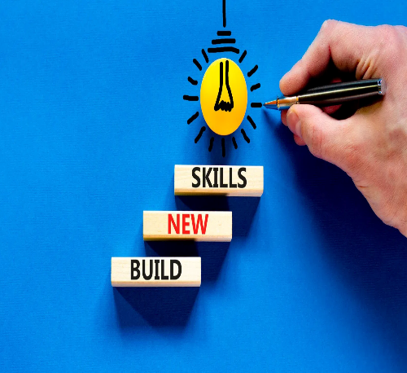

Academic and Employment Skills
Developing the core academic skills needed for university including finding sources, reading, writing, listening, speaking and conducting research. It offers detailed instruction on avoiding plagiarism and effectively using sources through paraphrasing, quoting, summarizing, in text citations and reference lists. The book also covers key assessment tasks such as essays, reports, case studies, reflective writing, presentations, group work and primary research. Academic language support is integrated throughout, with relevant examples and both in-book and online activities to reinforce learning.
Essential academic skills is designed to help students become more effective learners by breaking down the essential skills for university success into manageable steps and offering practical activities that encourage deeper understanding. (turner, kathy, ireland, lynette,krenus, brenda, and pointon, 2011)

 Essential skills Images - Free Download on Freepik

What academic skills I need for my future employment
Academic skills matter because there is a growing gap between what schools teach and what jobs require. Technology now touches every profession and skills quickly become outdated. Academic training develops essential abilities such as critical thinking, adaptability, and digital literacy- qualities employers increasingly value over narrow expertise.
Ultimately education must involve beyond traditional methods. By focusing on innovative technology driven learning, academic institutions can prepare individuals not just for their first job but for lifelong career resilience in rapidly changing world (Laura Garcia perez Marina Garcia Eva Maria, 2021). 7 Essential Good Key Skills For CV Success In 2026 | John Logan Business Mentoring Consultancy

