LCBB4013 Stakeholder Engagement
Component 1: Coursework-Portfolio
Portfolio on East London Waterworks Park

Student Name: Ionut Marin
Student ID: 2512904

Table of Contents
Element 1: Introduction 3
Description of the selected project 3
Relevance 3
Six key stakeholders and their benefit from the project 4
Element 2: Application to include Stakeholder Engagement Strategies 5
Power-influence-interest matrix 5
Stakeholder map with justification 5
Communication plan and consultation strategy with justification 7
Element 3: Ethical Consideration in Stakeholders Consultation, Participation and Feedback 9
Method of consultation 9
Ethical considerations 10
Process to collect and review stakeholders’ feedback 11
Element 4: Conclusion and Reflection 12
Conclusion 12
Reflective account (Kolb’s reflective model) 13
Reference List 15
Appendices 17
Appendix 1: The transformation of the land after East London Waterworks Park project 17

Element 1: Introduction

Description of the selected project
East London Waterworks Park is a community-led project that is governed by London Real Estate Forum (LREF), playing a significant role in urban development. The proposal is set to acquire a 14-acre concrete slab in Waltham Forest and transform it into a biodiversity and vibrant community park (East London Waterworks Park, 2026). The park will include wild swimming pools and community spaces that aim to create a harmonious relationship between the East London community and nature (East London Waterworks Park, 2026a). The aim of this project is to develop a healthy and sustainable future for the community as a part of the urban development programmes.
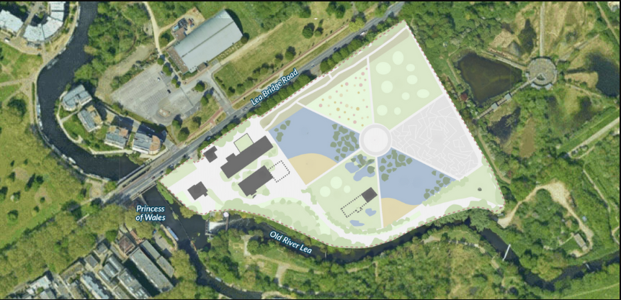
Figure 1: Area selected for the park
(Source: East London Waterworks Park, 2026a)

Relevance
The park project is considerably important in the East London urban development initiative with its contribution to the sustainable future. The community-first and community-led approach behind this park is focused on revolutionising the concept of blue and green spaces without compromising existing biodiversity. The objective for the East London Waterworks Park is to promote preservation, conservation, and improvement of both physical and natural environment for the public (East London Waterworks Park, 2023). It effectively contributes to the perception of a circular economy through repurposed infrastructure, biodiversity boost, and urban well-being by introducing green spaces.

Six key stakeholders and their benefit from the project
The park is subject to some significant stakeholders, mainly governing bodies, such as “Waltham Forest Council,” “the Greater London Authority,” and “the Lea Valley Regional Park Authority”, Themes21, London Waterkeeper and others (East London Waterworks Park, 2023). Apart from that, the local community, developers, suppliers, landscape architects, and general contractors are also considered as major stakeholders who are involved with the project. It benefits the stakeholders by offering free wild swimming opportunities, a place for social inclusion, and active participation towards climate resilience.
The development of East London Waterworks Park demonstrates an effective balance between community well-being and green urban initiatives. Involved stakeholders in this project may benefit a long-term sustainable community and natural environment, supporting their overall well-being. The project as an entirety emphasises physical, biological, and cultural preferences. Reuse of the plane also contributes to flood resistance, which is advantageous for the associated stakeholders to accomplish environmental resilience (East London Waterworks Park, 2023a). Therefore, development of this park is considered highly valuable to both LREF and the East London community likewise to ensure strategic development of urban sites, while sustaining environmental contexts.
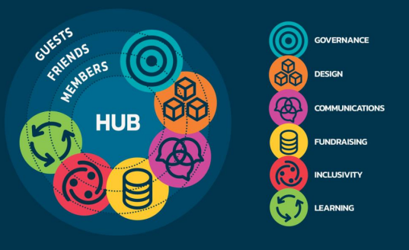
Figure 2: Governance plan of the project
(Source: East London Waterworks Park, 2023)

Element 2: Application to include Stakeholder Engagement Strategies

Power-influence-interest matrix
Effective stakeholder management is dependent on the understanding of their power, influence, and salience towards a project. According to the opinion of Zhu et al. (2024), power refers to stakeholders’ ability to exert influence, whereas interest indicates their interest in the problem the project aims to address through operations. The following table presents the key stakeholders involved with the project and their position in terms of power, influence, and interest.
Key internal and external stakeholders | Power | Influence | Interest
Governing bodies (national and local) | High | High | High
Landscape architects | Medium | High | Low
Developers | High | Medium | Medium
Suppliers | Medium | Medium | Low
General contractors | Medium | High | Medium
Local community | Medium | Medium | High
Table 1: Power-inter-influence matrix
(Source: Developed by learner)

Stakeholder map with justification
Stakeholder mapping is critical in a project due to its ability to identify the key players and helps in developing communication strategy according to them in order to minimise any potential project risk. In light of the stakeholder theory, large construction projects effectively recognise the interests of stakeholders and constantly aim to build the best possible approaches to create more value for them (Ebekozien, Aigbavboa, and Ramotshela, 2024). The following stakeholder map presents a clear outlook of the interest and power of stakeholders in the East London Waterworks Park project.
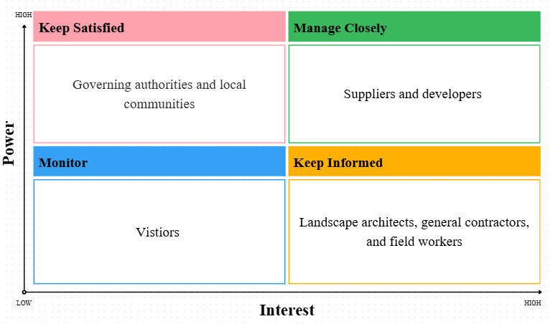
Figure 3: Stakeholder map regarding stakeholders involved with the project
(Source: Developed by learner)
Governing authorities and local communities: Keep satisfied
The East London Waterworks Park involves high-stake governing authorities, spanning across national and local levels. It includes agencies such as Themes21, The Greater London Authority, The Lea Valley Regional Park Authority, Clementina Estate Residents Group, and others. These stakeholders are the key factors in addressing activities such as planning approval, fund granting, regulatory access, and others that determine potential for successful project completion. On the other hand, the contribution of local communities in the project has made it one of the critical stakeholders to consider. As of 2022, it has been reported that 2,194 donors have pledged £250,000 to the project, since the business plan itself is expected to deliver £16.24 million in social value (East London Waterworks Park, 2022). Given the fact about these stakeholders’ high power and interest in the project, they need to be kept satisfied in order to address the associated corporate social responsibility of the project.

Suppliers and developers: Manage closely
Both suppliers and developers are considered for close management in the project as they play a critical role in handling activities such as designing, execution, material sourcing, and others. According to the views of Hedborg and Rosander (2024), developers play a critical role in procuring consultants, contractors, and suppliers to plan, design, and construct according to the specifications for urban development programmes. The East London Waterworks Park project is a high-value urban development initiative, which increases the need for minimal disruption in the operation. Inability to manage suppliers and stakeholders can affect successful completion of the project, for which these stakeholders need to manage closely.
Landscape architects, general contractors, and field workers: Keep informed
The monetary benefits and philanthropic interests available for the landscape architects, general contractors, and field workers increase their interest in the project. These stakeholders are required to be kept informed as they also play a critical role in determining the project process and effective execution within the intended timeline. According to the reports, volunteer architects and ecologists have contributed to the project, including activities such as co-designing the park to make it accessible and welcoming for the community (Environment Job, 2026). These actions effectively align with the corporate social responsibilities of the involved stakeholders, without compromising the financial aspect of the project. For this reason, these stakeholders have been considered for this quadrant of the stakeholder map.
Visitors: Monitor
The East London Waterworks Park is a community-led, community-first urban development programme, making it significant for local communities and outside visitors. However, these visitors have seemingly low interest in the project as well as low power to influence it other than contribution to community engagement. Due to monitoring this stakeholder would be sufficient for the project, as its influence on the activity is minimal.

Communication plan and consultation strategy with justification
A clear communication plan and consultancy strategy in stakeholder engagement addresses successful alignment of project goals and objectives with stakeholder expectations, ensuring transparency and trust. As explained by Ziegele and Zerfass (2024), strategic communication helps in demonstrating service quality to the client, especially in a dynamic environment. The following communication plan and consultancy strategy presents the process of communication that will help in connecting and discussing with the stakeholders.

Audience | Deliverables | Frequency | Priority | Delivery methods | Owner
Governing authorities | Updates on project progress | Quarterly or as required | High | One-on-one meetings or official Google meet conferences | Project manager
Suppliers | Material requirements | As required | Medium to high | Emails and phone calls | Supervisor
Developers and contractors | Project designing and development updates | Quarterly | Medium | Direct meetings, emails, and Zoom conferences | Project leaders
Local community | Updates on the progress | As required | Low to medium | Social media posts, community emails | Project leader
Table 2: Basic communication plan
(Source: Developed by leaner)
The table represents a basic communication plan that can be used to connect with stakeholders regarding the project development and progress. It indicates the specification of stakeholders who are to be consulted with for the operations to ensure successful execution of the East London Waterworks Park. For example, project managers will communicate with the governing authorities through one-on-one meetings or official Google meet conferences to discuss and update regarding the project. It will include topics, such as ethical compliances, regulatory supports, government approvals, and other initiatives. The frequency of the communication is set to be quarterly or as required, since government approvals take a significantly longer time compared to other project activities. The project got its official approval in 2022, under the Policy G3 of London as a part of the quality and range of uses enhancement of Metropolitan Open Land (London Assembly, 2022). Therefore, transparent consultation with the government authorities will be prioritised by the project managers involved in the park development initiative.
A range of mediums is selected to communicate with key stakeholders that include emails, one-on-one meetings, online conferences, and others. The selection of communication medium requires being able to deliver clear, concise, and timely information to the target audiences so that they can cater to project goals, task expectation and require constructive reviews (Akintelu et al., 2023). Moreover, an opportunity for open consultation with the stakeholders, such as designing concerns with the developers and resourcing with suppliers can be achieved through a strategic communication plan. Apart from that, the communication plan also signifies that each interaction with stakeholders will take place based on their requirements, power, and interest in the East London Waterworks Park project. The chosen communication channel in this project is, therefore, expected to meet these requirements, establishing transparency and trust among the stakeholders.

Element 3: Ethical Consideration in Stakeholders Consultation, Participation and Feedback
The development of the public park in the UK must be performed based on all the different standards of the construction industry set by the government of the UK. The implementation of the government standards is crucial to manage the ethical aspects of the project. Some ethical standards that are required to be followed to develop East London Waterworks Park have been discussed further.

Method of consultation
In addition to these direct face-to-face consultations with the local governing authorities regarding the plan and the collected information through the survey is also required to maintain ethical standards of the project. All the information that will be collected to complete the project the data protection act of the UK must be followed. In this regard, Data Use and Access Act 2025 have to be followed to collect, store and use public information for a project purpose (GOV, 2025). The responsible project team will need to address the aforementioned act in order to avoid ethical challenges regarding the use of data.
Several approaches can be considered in this regard that will allow maintaining appropriateness and transparency in the entire consultation process. For example, town hall meetings can be conducted to connect with community representatives and some of the population. This gathering can be used for discussing the progress or any potential project scopes that requires community involvement. Similarly, information notices can be delivered to the community or contractors to inform them about the process. These methods are valuable for community consultations to ensure all information is conveyed or discussed effectively.
The responsibility of the consultancy process in a project reflects on its ability to avoid any potential negative results. Amarasinghe, Hong, and Stewart (2024) pointed out that consultants often consider ecological factors unlike the contractors, where financial benefits are highly valued. Due to this reason, initiatives such as establishing a safety committee and setting up coordination meetings can be considered for this project, which will ensure in the field workers’ safety and maintain through coordination among the involved stakeholders.

Ethical considerations
National Planning Policy Framework (NPPF) is required to be followed when developing any plan of public construction projects. This standard states that the government has proactively been funding initiatives to ensure the development of leisure-public areas and country parks (GOV, 2026). NPPF is required to be followed to complete the public construction process to ethically contribute to the green infrastructure plan of the UK government.
The project managers are required to follow the National Model Design Code in order to specify the type and infrastructure of the park when consulting with the stakeholders. Under the National Model Design Code, there can be three different structures for a park such as Local Areas of Play (LAP), Local Equipped Areas of Play (LEAP), and Neighbourhood Equipped Area of Play (NEAP) (GOV, 2021). It indicates that the project managers have to specify the project structure based on the design code in order to convey them ethically to the key stakeholders like governing authorities and the local communities.

Process to collect and review stakeholders’ feedback
In order to develop the park and its infrastructure, collection of information regarding the demand of the local communities are crucial. Project managers can collect information from the perceived frequent visitors of East London Waterworks Park to predict the crowd level that the park will require to manage or the type of facilities that the end users will expect. The information will be collected from the neighbourhood of the park through surveys in order to design the park as per the expectation of community people. For instance, to conduct a survey for the construction project purpose, the project managers are required to follow the criteria of Equality Act 2010 and Inclusivity and Accessibility (GOV, 2026a). The survey must ensure that participation is allowed for people based on the nine protected characteristics such as age, disability, gender reassignment, marriage/civil partnership, pregnancy/maternity, race, religion/belief, sex, and sexual orientation to address the CRI standards.
The survey must be conducted in accessible formats and inclusive language, along with a transparent data collection process. This will help to collect information from a diversified group of people to collect different perspectives for developing an inclusive plan for the East London Waterworks Park. A dedicated committee established for this purpose to maintain accuracy of the information in order to deliver a successful project will review the collected data. Dai et al. (2022) mentioned that stakeholder intervention ensures continued viability of a project and further exchanges that helps in accomplishing a long-term continuity. A clear action plan about implications on stakeholder feedback will be presented that may contribute to strengthening stakeholder trust in this project.
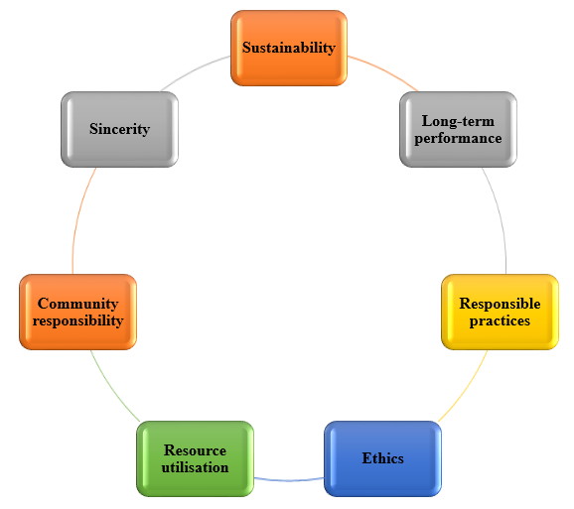
Figure 4: Key aspect of corporate social responsibility adhered to in the project
(Source: Developed by learner)

Element 4: Conclusion and Reflection

Conclusion
Stakeholder management and their engagement to the East London Waterworks Park have contributed to successful funding, integration of inclusive design, and implications of the circular economy in urban development programmes. The strategy has been a critical step by the governing bodies towards sustainability aims, without compromising the opportunity for development of the local community. It addresses corporate social responsibility, while increasing the overall project value for the stakeholders.
It can be concluded from this discussion that engaging multiple stakeholders broadened the development prospect for East London Waterworks Park as it involved major stakeholders including governing bodies such as the LREF and The Greater London Authority. The communication plan and consultancy approach not only aims to contribute to maintain effective communication between the stakeholders but also secures trust and transparency for future project success. Ethical considerations and attention towards diversity and inclusivity promotes social and regulatory obligation of stakeholder management that can be concluded from this report. Adherence to ethics and active involvement in incorporating stakeholder feedback into operations promotes trust within the relationship between stakeholders. Therefore, the report concludes that an effective stakeholder management plan is required to have elements such as strategic communication, in-depth understanding of power-interest dynamics, and ethical awareness. These factors are highly relevant to East London Waterworks Park’s successful completion as well.

Reflective account (Kolb’s reflective model)
I think the importance for effective stakeholder engagement for project success and sustainability is highly valued in operational practices. Kolb’s reflective model has been used further to convey my thoughts regarding this concept.
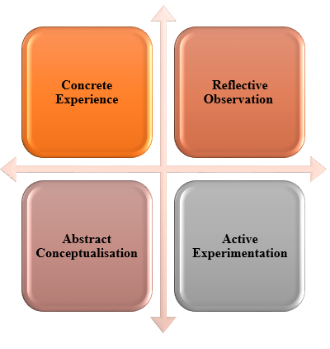
Figure 5: Four stages of Kolb’s reflective model
(Source: Developed by learner)
Concrete experience
I selected the East London Waterworks Park as the example project for exploring the significance of stakeholder engagement in a development activity. I explored key stakeholders involved with the project, who influenced the overall progress and development of this park. It made me realise that stakeholders are the major drivers of project success, supporting long-term continuity through guidance to effective decisions. I feel like it was a necessary step to incorporate ideas of stakeholders, turning a space like the chosen one into a community-led green space. In my opinion, the approach has been highly significant to promote active stakeholder participation in sustainable urban development.

Reflective observation
The involvement of a multi-stakeholder perception in projects minimises potential project risks in a real-work context that helps in strategizing and designing operations as a part of sustainable community development initiatives. For instance, I noticed that providing sufficient resources and human capital for the East London Waterworks Park to initiate the development process. The clearance from the London government in 2022 put the project officially on roll, while the local community started crowd funding to support the operations. Although it helped in retaining CSR considerations, I believe the complexity of the execution process increased greatly as well. In my opinion, multi-stakeholder engagement enhances the necessity of strategic communication and interaction in the project, which may leave a negative impact otherwise.
Abstract conceptualisation
The improvement of stakeholder engagement and management in high-stake projects like the East London Waterworks Park requires a clear strategy that aligns project objectives with stakeholders’ expectation. I think my perception of this stakeholder management has changed noticeably as I now have a better comprehension of the process. From the lessons that I have learned, I can infer that strategic stakeholder management contributes to community advocacy after completion of a project as well as reduces the possible resistance during execution. The process ensures effective decision-making that I have noted in recent lessons.
Active experimentation
I understand that effective and strategic stakeholder engagement contributes to successful project delivery and assurance of sustainability. It is a major supportive factor to maintain alignment between operations and project goals that I intend to apply in my future roles as a project manager. Moreover, active participation of stakeholders in a project secures the notion of trust and transparency that enhances overall CSR and ethical obligation in a project for long-term sustainability. It will help me to maintain a strong stakeholder relationship in future.

Reference List
Akintelu, S.O., Oyebola, A.I., Tiamiyu, S. and Olateju, O., (2023) The impact of project communication management on successful project delivery in the construction industry: A case study. International Journal of Development and Sustainability, 12(8), pp.376-386. Available at: https://isdsnet.com/ijds-v12n8-04.pdf. (Accessed: 6 August 2026).
Amarasinghe, I., Hong, Y. and Stewart, R.A., (2024) Development of a material circularity evaluation framework for building construction projects. Journal of Cleaner Production, 436, p.140562. Available at: https://www.sciencedirect.com/science/article/pii/S095965262400009X. (Accessed: 3 August 2026).
Dai, Y., Day, S., Masi, D. and Gölgeci, I., (2022) A synthesised framework of eco‐industrial park transformation and stakeholder interaction. Business Strategy and the Environment, 31(7), pp.3122-3151. Available at: https://publications.aston.ac.uk/id/eprint/43744/1/Dai_Day_Masi_and_Golgeci_Synthesised_framework_of_eco_industrial_park_transformation_and_stakeholders_Accepted_Manuscript.pdf. (Accessed: 8 August 2026).
East London Waterworks Park (2022) Crowdfunding Campaign to Build new Swimming Ponds in East London Hits Halfway Mark. Available at: https://elwp.org.uk/Press/4. (Accessed: 6 August 2026).
East London Waterworks Park (2023) BUSINESS PLAN. Available at: https://www.elwp.org.uk/Committee/Display.php?File=607&Code=Iwyy8oiIuaHGFgEqzYggz097ZVZgRtnu. (Accessed: 3 August 2026).
East London Waterworks Park (2023a) East London Water Works Park: Renaturalizing a Brownfield into a Wild Swimming Sanctuary in East London. Available at: https://elwp.org.uk/Design/MLA_Thesis_McKenna%20Montgomery_05122023.pdf. (Accessed: 8 August 2026).
East London Waterworks Park (2026) East London Waterworks Park wins People’s Choice Award in Reimagine London competition. Available at: https://elwp.org.uk/Press/22. (Accessed: 8 August 2026).
East London Waterworks Park (2026a) Home. Available at: https://elwp.org.uk/Home.htm. (Accessed: 6 August 2026).
Ebekozien, A., Aigbavboa, C.O. and Ramotshela, M., (2024) A qualitative approach to investigate stakeholders' engagement in construction projects. Benchmarking: An International Journal, 31(3), pp.866-883. Available at: https://www.emerald.com/bij/article-pdf/31/3/866/9564639/bij-11-2021-0663.pdf. (Accessed: 5 August 2026).
Environment Job (2026) Volunteer Landscape Architects and Ecologists. Available at: https://environmentjob.co.uk/volunteering/109405-volunteer-landscape-architects-and-ecologists. (Accessed: 8 August 2026).
GOV (2021) National Model Design Code Part 2 Guidance Notes. Available at: https://assets.publishing.service.gov.uk/media/6111531fd3bf7f043c4badd1/NMDC_Part_2_Guidance_Notes.pdf [Accessed: 3 August 2026].
GOV (2025) Data (Use and Access) Act 2025. Available at: https://www.legislation.gov.uk/ukpga/2025/18/contents [Accessed: 3 August 2026].
GOV (2026) Open space, sports and recreation facilities, public rights of way and local green space. Available at: https://www.gov.uk/guidance/open-space-sports-and-recreation-facilities-public-rights-of-way-and-local-green-space [Accessed: 3 August 2026].
GOV (2026a) Equality Act 2010: guidance. Available at: https://www.gov.uk/guidance/equality-act-2010-guidance [Accessed: 4 August 2026].
Hedborg, S. and Rosander, L., (2024) Self-organizing in urban development: developers coordinating between construction projects. Construction management and economics, 42(2), pp.114-128. Available at: https://www.tandfonline.com/doi/pdf/10.1080/01446193.2023.2181367. (Accessed: 4 August 2026).
London Assembly (2022) East London Waterworks Park. Available at: https://www.london.gov.uk/who-we-are/what-london-assembly-does/questions-mayor/find-an-answer/east-london-waterworks-park. (Accessed: 8 August 2026).
Zhu, Q., Xi, J., Hu, X., Chong, H.Y., Zhou, Y. and Lyu, S., (2024) Stakeholder mapping and analysis of off-site construction projects: Utilizing a power–interest matrix and the fuzzy logic theory. Buildings, 14(9), p.2865. Available at: https://www.mdpi.com/2075-5309/14/9/2865. (Accessed: 7 August 2026).
Ziegele, D. and Zerfass, A., (2024) The evolution of communication consulting: A long-term comparison of service quality in strategic communication. International Journal of Strategic Communication, 18(5), pp.445-468. Available at: https://www.tandfonline.com/doi/pdf/10.1080/1553118X.2024.2365692. (Accessed: 7 August 2026).

Appendices

Appendix 1: The transformation of the land after East London Waterworks Park project
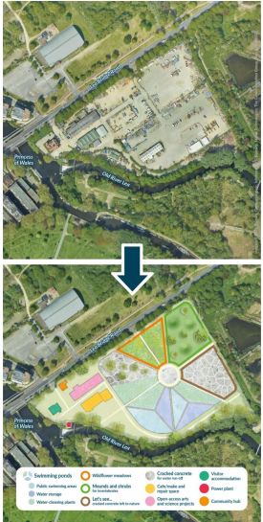
(Source: East London Waterworks Park, 2023)

