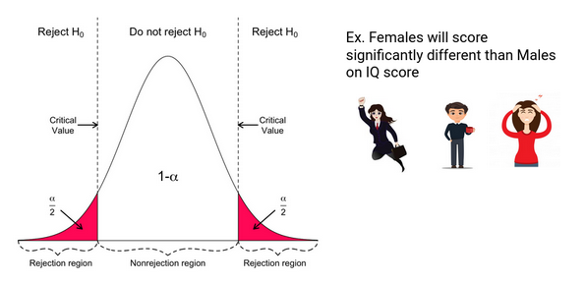

Data Analysis & Visualization (ACCB4002_LON)
Teacher name: Suneth Fernando

Student: Daniel Popescu | 25.08.2021

Contents
Introduction 2
Dataset description 2
What is a t-test in data analysis? 2
What is hypothesis? 2
T-Test selection: 2 samples as variances are not equal. 4
Testing hypothesis to various significance level p 5
Identified outliers in data and impact on outcome 6
Other factors found in dataset 7
Results 7
Conclusion 7
References 7

Introduction
Here we have a report which has been presented at BBC News UK. They did a research and concluded that there is a different infection rate with Covid-19 between the BAME and White population in UK. Data from 50 patients has been collected to be able to identify the ratio and truthfulness.

Dataset description
We must analyze the data to find the truthfulness. We have a varied infection rate of Covid-19 between the White patients and BAME patients. Dataset has 50 patients of each category. The age is between 20 and 50. Hypotheses is done in both types as the infections rate of the two categories is different.

What is a t-test in data analysis?

A t-Test can tell you how important or less important is the difference between groups. With other words it tells you if there the difference has happened by measuring the means. [1]
A good example, we can say that we want to measure the body weight gain. Going to gym, working with weights, I gained 3kg in 2 weeks. Then want to see if supplements helps and measure 6kg weight gain in 2 weeks. I do a research with friends and they tell me that without supplements gained half body mass in 2 weeks. Comparing the means we can have an answer if these results are happening indeed. [1]

What is hypothesis?

Hypothesis is an idea which can be evaluated. This is not the definition, but it is a better understanding.
For example if someone tells that blueberries in London are expensive, this is an idea, or a statement, but is not testable, until I have something to compare it with.
For instance, if I define expensive as: any price greater than £1.75 pounds per kg, then it immediately becomes a hypothesis.
Here’s a simple topic that can be tested.
According to Glassdoor (the popular salary information website), the mean data scientist salary in the US is 113,000 dollars.
I can test and check if their estimation is acurate. There are two hypotheses that are made: the null hypothesis, denoted H0, and the alternative hypothesis, denoted H1 or H A.
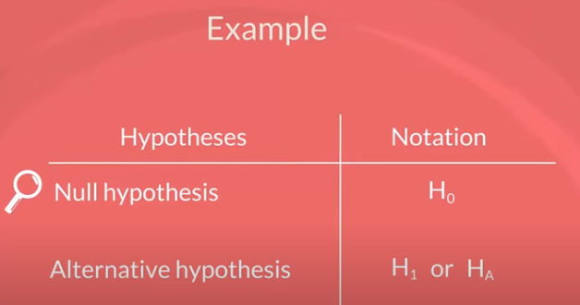

The null hypothesis is the one to be tested and the alternative is everything else.
In our example, the null hypothesis would be: The mean data scientist salary is 113,000 dollars, While the alternative: The mean data scientist salary is not 113,000 dollars.


Now, I want to see if 113,000 is close enough to the true mean, predicted by our sample. In case it is, you would accept the null hypothesis. Otherwise, I would reject the null hypothesis. The concept of the null hypothesis is similar to: innocent until proven guilty. We assume that the mean salary is 113,000 dollars and we try to prove otherwise.
This was an example of a two-sided or а two-tailed test. You can also form one sided or one-tailed tests.
Say your friend, Paul, told you that he thinks data scientists earn more than 125,000 dollars per year. You doubt him so you design a test to see who’s right. The null hypothesis of this test would be: The mean data scientist salary is more than 125,000 dollars. The alternative will cover everything else, thus: The mean data scientist salary is less than or equal to 125,000 dollars.

It is important to note that outcomes of tests refer to the population parameter rather than the sample statistic.
As such, the result that we get is for the population.
Another crucial consideration is that, generally, the researcher is trying to reject the null hypothesis. Think about the null hypothesis as the status quo and the alternative as the change or innovation that challenges that status quo.

In our example, Paul was representing the status quo, which we were challenging.

T-Test selection: 2 samples as variances are not equal.
White and BAME patients has different variance. Will need age comparation and find the infection ratio and truthfulness of finding.

Testing hypothesis to various significance level p
- Where p=0.10
 |  |  |  | White Patient | BAME Patient
 | Mean |  |  | 36.18 | 36.74
 | Variance |  |  | 88.72204082 | 86.80857143
 | n |  |  | 50 | 50
 | Difference |  |  | 0
 | df |  |  | 98
 | t Stat |  |  | -0.298879822
 | P{T<=t} two-tail |  |  | 0.76566461
 | t Critical two-tail |  |  | 1.660551217

When t Stat is lower then critical two tail and true -0298 is lower then 1.6605, the null hypothesis can not be rejected. Data can support it. Infection ratio for the two categories can be taken as equal. When p value of two tail is higher then alpha, the null hypothesis can not be rejected. Alpha is 0.10 where 0.765 is higher, hypothesis can not pe rejected.

- Where p=0.01
 |  |  | White Patient | BAME Patient
Mean |  |  | 36.18 | 36.74
Variance |  |  | 88.72204082 | 86.80857143
n |  |  | 50 | 50
Diference |  |  | 0
df |  |  | 98
t Stat |  |  | -0.298879822
P{T<=t} two-tail |  |  | 0.76566461
t Critical two-tail |  |  | 2.626931096

Similar technique used. The null hypothesis can not be rejected when t Stat is lower then two-tile value. T Stat value is the same -0.298879822, being lower then 2.626, so the null hypothesis is accepted or fail to be rejected.
The p value is higher then significance value so the null value can not be rejected.
P two tail is 0.765 higher then 0.10, alpha value.

- Where p=0.02
 |  |  | White Patient | BAME Patient
Mean |  |  | 36.18 | 36.74
Variance |  |  | 88.72204082 | 86.80857143
n |  |  | 50 | 50
Diference |  |  | 0
df |  |  | 98
t Stat |  |  | -0.298879822
P{T<=t} two-tail |  |  | 0.76566461
t Critical two-tail |  |  | 2.36500241

When age of the two categories are compared two-sample unequal variances are done.
We notice that t Stat -0.298879822 is lower then the value of t critical two tail 2.365, the null hypothesis fail to be rejected. If the probability of two tail 0.765 is higher then the significance 0.02, the null hypothesis fail to be rejected.

Identified outliers in data and impact on outcome
Data value has a high level or a low level, they are a large or a small observation. They can affect the mean an statistics research. Outliers are not always a bad thing. These are observations not following the same layout as the other. Some can help in science, for example a vaccinated patient has been positive tested where other in the same group not.
One outlier can reject the normal hypothesis. [2]
In our data, outliers has not been found. Values are less then 20-50 so no unusual value. Standard deviation and mean has no high difference.

Other factors found in dataset
- Size of the sample – the bigger the sample the accurate test results. On small samples we can not get an accurate trend line. Our case has 50 samples which is relative small.
- True value parameter – shows difference between value in the null and true value.
- The level of significance – the lower significance value is, the low power it has. When lower values, the acceptance get higher and probability of rejection is low.

Results

The hypothesis fail to be rejected, infection ratio of the two categories is not equal.
The truthfulness is there in every significance level and more often for the level p=0.10

Conclusion

The research of the two categories of patients between White people and BAME people, analyzing the BBC data has been done in order to find out the infection rate if is different or not. As the null hypothesis failed to be rejected results are that there are differences on infection rate.
A better result more efficient and true can be achieved if data can be done on a higher number of patients.

References

[1] | T. T. (. T.-T. D. a. Examples, "T Test (Student’s T-Test): Definition and Examples," [Online]. Available: https://www.statisticshowto.com/probability-and-statistics/t-test/. [Accessed 03 09 2021].
[2] | S. S. Mangiafico, "What are the consequences of outliers in data analysis?," [Online]. Available: https://www.researchgate.net/post/What_are_the_consequences_of_outliers_in_data_analysis. [Accessed 03 09 2021].

