University of Wales Trinity Saint David
Wales Institute of Science & Art



Stress Analysis and Dynamics
Analyse and simulate a mechanical recovery system (ACMA5010)

Joseph Stanley James
2320115
16 November 2025
Word Count - 2744

Table of Contents

List of Figures and Tables 3
1. Literature Review: Flywheels and Mechanical Energy Recovery Systems 4
1.1 Historical Development of Flywheels 4
1.2 Principle of Operation 5
1.3 Modern Applications and Regenerative Systems 6
1.4 Engineering Design and Material Considerations 7
1.5 Kinetic Energy Recovery Systems (KERS) 9
1.6 Mechanical Batteries and Comparative Performance 9
1.7 Summary of Key Findings 10
2. Dynamic Analysis of the Flywheel KERS System 11
2.1 Vehicle Kinetic Energy During Braking 11
2.2 Energy Recovered and Stored in the Flywheel 11
2.3 Flywheel Rotational Speed and Design Check 12
2.4 Re-Acceleration Capability 12
2.5 Relationship Between Braking and Re-Acceleration Speed 13
2.6 Estimated Re-Acceleration Rate 14
2.7 Influence of Flywheel Geometry 15
2.8 Assumptions and Limitations 18
3. References 20
4. Appendices 21
Appendix A 21
A1 – Vehicle and System Specifications 21
A2 – Kinetic Energy Braking (55 mph Case) 21
A3 – Energy Stored in the Flywheel 21
A4 – Flywheel Rotational Speed for 55 mph Braking 21
A5 – Re-Acceleration Capability 22
A6 – KERS Efficiency Assumptions and Supporting Data 22

List of Figures and Tables

Figure 1: Evolution of flywheel applications from early mechanical devices to modern energy-storage systems (adapted from Bender, 2015). 4
Figure 2: Common moments of inertia for different geometries including solid and thick-walled cylinders (Pearson, n.d). 6
Figure 3: Schematic layout of the Volvo Flywheel KERS showing the flywheel module, CVT, output gear train, and rear driveshaft (Volvo Cars, 2011). 7
Table 1: Typical material properties and performance characteristics for flywheel design. 8
Table 2: Comparison of key performance characteristics for common energy-storage technologies. 10
Table 3: Energy stored and boost speed versus braking speed 13
Figure 4: Predicted boost speed versus braking speed ($η=0.8)$. 14
Table 4: Vehicle specifications 15
Table 5: Rotational speed of 4.5 kg flywheel versus external diameter (60mph braking). 17
Figure 5: Effect of flywheel diameter on rotational speed 18
Table 6: Representative data from published sources 23

Literature Review: Flywheels and Mechanical Energy Recovery Systems

Historical Development of Flywheels

Flywheels are among the oldest mechanical devices for energy storage, with origins dating back to ancient potter’s wheels and millstones that used inertia to maintain rotational motion after external force ceased (Bender, 2015). During the Industrial Revolution, large steel or cast-iron flywheels were essential in smoothing torque fluctuations from reciprocating engines and early textile machinery. These devices converted intermittent input power into steady rotational motion, reducing mechanical shock and improving process uniformity. As shown in Figure 1, the development of flywheels from simple rotary devices to advanced energy-storage mechanisms illustrates this progressive refinement over time (Bender, 2015).

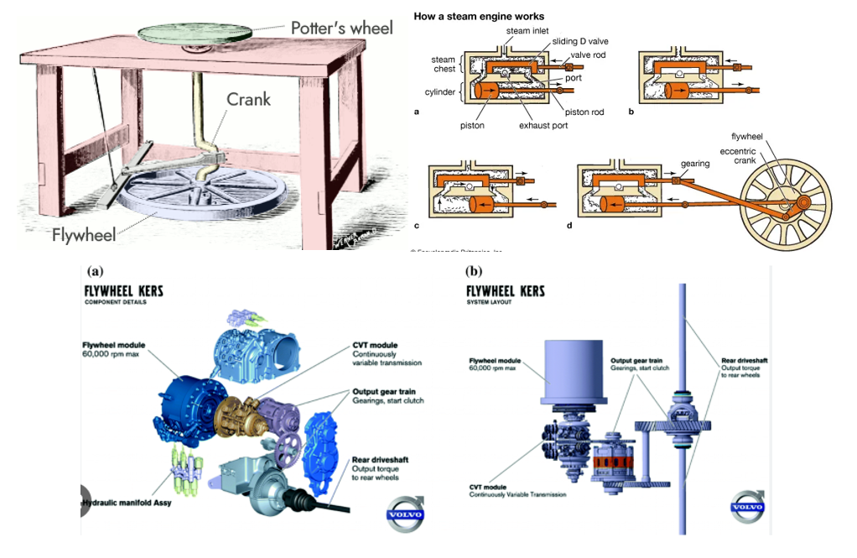
Figure 1: Evolution of flywheel applications from early mechanical devices to modern energy-storage systems (adapted from Bender, 2015).

In the late 20th century, advances in material science, precision balancing and high-speed bearings transformed flywheels from simple mechanical regulators into high-performance energy storage systems. Composite material and vacuum enclosures enabled much higher angular velocities, while digital control systems improved dynamic stability (Amiryar and Pullen, 2017). Today, modern Flywheel Energy Storage Systems (FESS) are found in transport, industrial power conditioning and grid-balancing applications, confirming the continued reliance of classical mechanical energy principals within sustainable engineering (Choudhury, 2021).

Principle of Operation

A flywheel stores energy as rotational kinetic energy, defined by:

$$E_{k}=\frac{1}{2}I⍵^{2}$$

Where $E_{k}$ is the kinetic energy, $I$ is the moment of inertia and ⍵ is the angular velocity.
For thin-ring configuration,

$$I=mr^{2}$$

Giving,

$$E_{k}=\frac{1}{2}mr^{2}ω^{2}$$

The stored energy therefore increases proportionally with both the mass and the square of angular velocity. Because angular speed contributes quadratically, increasing ⍵ is the most effective way to raise energy density, although it also increases hoop stress within the rotor.
Worked example:
Consider a composite flywheel of 10 kg mass and 0.25 m radius rotating at 10,000 rpm. Converting to radians per second ($⍵=1047 rad/s^{-1}$), the energy is stored is:

$$E_{k}= \frac{1}{2}\left(10\right){\left(0.25\right)}^{2}{\left(1047\right)}^{2}=3.4 x{10}^{5}J$$

Or approximately 340 kJ. Doubling the rotational speed to 20,000 rpm increases the stored energy by a factor of four, highlighting that energy capacity depends far more strongly on speed than on mass. Such relationships are crucial when determining target performance levels for flywheel energy-storage systems (Amiryar and Pullen, 2017). While this demonstrates the energy capacity theoretically achievable through higher angular velocity, the upper limit in practical applications is constrained by material strength and rotational stress.
In practice, the maximum permissible angular velocity is limited by the tensile stress that develops in the rotor material. For a solid disk, the maximum circumferential stress can be approximated by

$$θ_{max}= \frac{3+v}{8}⍴⍵^{2}r^{2}$$

Where $⍴$ is the material density and $v$ is the Poisson’s ratio. When $θ_{max}$ approaches the material’s ultimate tensile strength, catastrophic failure occurs. Carbon-fibre composites, with densities around 1600 kg m⁻³ and tensile strengths near 1500 MPa, permit rim speeds exceeding 1000 m s⁻¹, whereas high-grade steels are typically limited to about 400 m s⁻¹ (Li et al., 2025).
As depicted in Figure 2, different rotor geometries result in varying moments of inertia, which directly influence the amount of kinetic energy that can be stored for a given angular velocity (Pearson, n.d.).

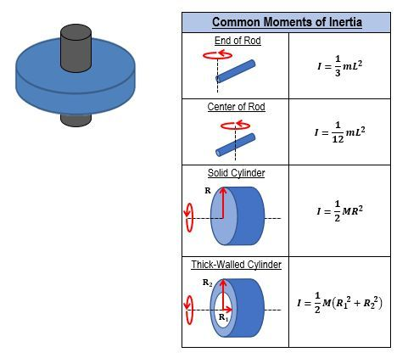
Figure 2: Common moments of inertia for different geometries including solid and thick-walled cylinders (Pearson, n.d).

Modern Carbon-fiber composite rotors exhibit strength-to-weight ratios up to five times higher than steel, enabling top speeds beyond 1000 m/s and energy densities exceeding 150 Wh/kg (Li et al., 2025). However, achieving such speeds required vacuum containment, precise balancing and frictionless support via magnetic or air bearings (Li and Palazzolo, 2021). These design advances reduce parasitic losses and extend operational life, converting the traditional flywheel into an efficient and durable machine battery.

Modern Applications and Regenerative Systems

Flywheels have re-emerged as viable energy recovery devices across several engineering domains.

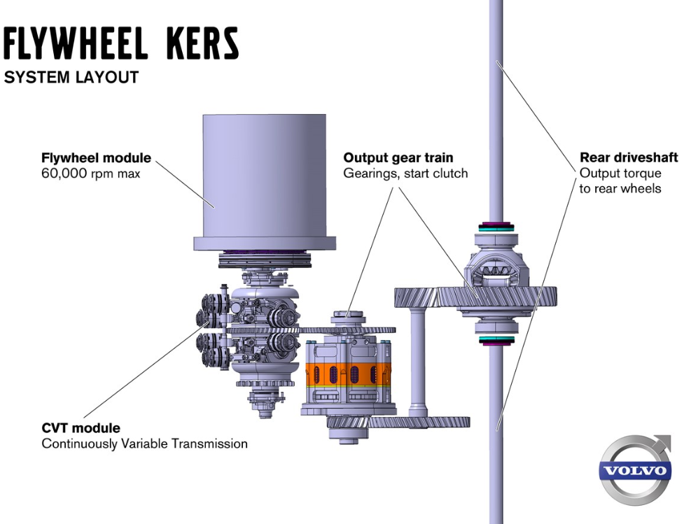
Figure 3: Schematic layout of the Volvo Flywheel KERS showing the flywheel module, CVT, output gear train, and rear driveshaft (Volvo Cars, 2011).

- Transportation
Mechanical Kinetic Energy Recovery Systems (KERS) capture braking energy and return it during acceleration. In Formula 1, systems developed by Flybrid Systems and Williams Hybrid Power demonstrated round-trip efficiencies of 70-80% (Collins, 2011). Subsequent trials in public transport buses achieved fuel-use reductions exceeding 20% through hybridisation (Wagner, Scolaro and Peters, 2015). As shown in Figure 3 (Volvo Cars, 2011), the Volvo KERS system layout illustrates how a high-speed flywheel connects through a CVT and gear train to the vehicle drivetrain, enabling efficient energy recovery during braking and redeployment during acceleration.

- Renewable-energy integration
FESS units provide grid frequency regulation and load levelling, offering near-instantaneous response compared to slower electrochemical batteries (Amiryar and Pullen, 2017).

- Uninterruptible Power Supplies (UPS)
Flywheels support short-duration backup power during transitions between grid and generator operation, reducing maintenance and environmental impact (Choudhury, 2021).

These examples highlight how improvements in high-speed rotor technology and electronic control have re-established the flywheel as a sustainable, mechanical energy buffer rather than an obsolete relic.

Engineering Design and Material Considerations

Designing a modern flywheel required careful balance between strength, efficiency and manufacturability.

Material selection:
Composite rotors dominate research as fibre-reinforced polymers offer high-tensile strength and low density. Multi-layer rims wound with carbon or glass fibres improve containment and fatigue performance (Amiryar and Pullen, 2017). Li et al. (2025) report that multi-stage composite assemblies can increase specific energy sixfold compared to monolithic rotors.
To evaluate how different materials influence flywheel performance, Table 1 compares key mechanical and operational properties commonly used in rotor design. These include density, tensile strength and achievable rim speed, the main parameters that determine specific energy and safety margins.

Table 1: Typical material properties and performance characteristics for flywheel design.
Material | Density (kg m⁻³) | Tensile Strength (MPa) | Max Rim Speed (m s⁻¹) | Specific Energy (Wh kg⁻¹) | Typical Application
High-grade steel | 7850 | 700 | 400 | 23-35 | Industrial, stationary
Aluminium Alloy | 2700 | 300 | 300 | 15-20 | Lightweight systems
Glass-fibre Composite | 1900 | 800 | 700 | 60-80 | Cost-effective high-speed rotors
Carbon-fibre Composite | 1600 | 1500 | 1000+ | 120-150 | High-performance FESS, transport
Sources: Amiryar and Pullen (2017), Li et al. (2025).

The data shows that composite materials offer significantly higher strength-to-weight ratios than metallic options, allowing rim speeds exceeding 1000 m s⁻¹ and energy densities up to five times greater than steel designs. However, they require precision manufacturing and robust containment systems to mitigate delamination risk. Selecting an optimal material therefore becomes an engineering trade-off between cost, manufacturability and performance, a critical aspect of modern flywheel energy-storage development.

Bearings and enclosures:
Magnetic bearings nearly eliminate frictional losses, while vacuum housing prevent aerodynamic drag. Combined, these reduce self-discharge to below 1% per hour (Choudhury, 2021). However, these technologies raise manufacturing cost and require precise control algorithms to stabilise levitations (Li and Palazzolo, 2021).

Dynamic balance and gyroscopic effects:
High-speed rotors generate substantial gyroscopic moments. Finite-element analysis and modal testing are therefore essential to prevent resonance and ensure long-term stability (Peña-Alzola et al., 2011).

Safety and containment:
Rotor burst energy can be catastrophic, so containment housings are designed to withstand full-energy failures without fragment release. Composite rims also provide a benign failure mode, delaminating rather than fracturing violently.

Overall, flywheel design represents an optimisation problem integrating material mechanics, roto-dynamics and control engineering making it a multidisciplinary topic ideally suited to mechanical engineering, study.

Kinetic Energy Recovery Systems (KERS)

KERS technology applies to flywheel energy storage directly to vehicle motion, a Continuously Variable Transmission (CVT) transfers torque from the drivetrain to the flywheel, accelerating it. When the driver re-accelerates, the CVT reverses torque flow, returning energy to the wheels.
This purely mechanical process avoids conversion losses inherent in electrical hybrids. Experimental systems reach efficiencies around 80% storing 0.5-2 MJ in the flywheel, enough to supplement acceleration between corners (Collins, 2011). In commercial transport, KERS helps smooth power demands and reduces thermal load on friction brakes (Wagner et al., 2015).
A smaller-scale educational example of this principle is the KERS bicycle prototype presented by Bhoir et al. (2015). The design demonstrates fundamental dynamic relationships between torque, angular acceleration and energy storage, reinforcing the rotational analogue of Newton’s Second Law $T=Iα$. Although efficiency is limited at small scales, it remains an accessible illustration of sustainable mechanical energy recovery.

Mechanical Batteries and Comparative Performance

A mechanical battery stores energy kinetically rather than chemically. Compared with lithium-ion cells, flywheels exhibit several advantages.

- High power density and fast response (round-trip efficiencies up to 90%).
- Long service life (often >20 years) with negligible capacity fade.
- No toxic chemicals and fully recyclable materials.
- Tolerance to wide temperature ranges and deep cycling.

However, drawbacks include lower overall energy density (typically 100-150 Wh/kg), higher self-discharge if not vacuum sealed and complex containment systems. The technology is therefore best suited to high-power, short duration scenarios such as regenerative braking or grid stabilisation rather than long-term storage (Amiryar and Pullen, 2017; Peña-Alzola et al., 2011).
To evaluate how flywheel systems compare with other energy-storage technologies, Table 2 summarises representative performance characteristics for flywheel energy-storage systems (FESS), lithium-ion batteries and super-capacitators. These highlight how FESS provide high power density and near ultimate cycling capability, while batteries dominate in energy density.

Table 2: Comparison of key performance characteristics for common energy-storage technologies.
Technology | Energy Density (Wh kg⁻¹) | Power Density (W kg⁻¹) | Cycle Life | Typical Efficiency (%) | Response Time | Environmental Impact
Flywheel (FESS) | 100-150 | 3,000-7,000 | >20 years / > 10⁶ cycles | 85-95 | <10 ms | Recyclable, no toxic materials
Lithium-ion Battery | 150-250 | 500-2,000 | 5-10 years / 2,000-5,000 cycles | 85-95 | 10-100 ms | Contains rare-earth and hazardous materials
Supercapacitor | 5-10 | 10,000+ | >10 years / >1,000,000 cycles | 90-98 | <1 ms | Benign, recyclable
Sources : Amiryar and Pullen (2017), Li et al. (2025), Chen et al. (2024).

The comparison shows that although flywheels store less total energy than lithium-ion batteries, they deliver far greater instantaneous power and almost unlimited cycle life. This makes them ideal for rapid response, high-power scenarios such as grid frequency or vehicle regenerative systems. Furthermore, because they contain no toxic or reactive chemicals, FESS units offer long-term sustainability and low environmental impact when manufactures from recyclable composites.
Mechanical batteries thus complement rather replace electrochemical systems, filling the gap between instantaneous power delivery and sustainable, repeatable cycling.

Summary of Key Findings

From ancient mechanical regulators to advanced composite energy stores, flywheels exemplify the continued evolution of classical mechanics in modern engineering.
Advances in composite materials, magnetic bearings and dynamic control have transformed them into efficient, safe and long-life energy recovery systems.
Applications in transportation and renewable energy demonstrate measurable sustainability benefits through improved energy efficiency and reduced waste. Flywheels illustrate the application of Newtonian dynamics, stress analysis and energy conservation, linking theory with sustainable technology. These insights establish the theoretical framework for Section 2, which analyses and models kinetic energy transfer in a KERS-equipped vehicle.

Dynamic Analysis of the Flywheel KERS System

Building on the theoretical and design principles in Section 1, this section applies the principles of energy conservation, rotational dynamic and kinetics to analyse a mechanical flywheel KERS installed in a hybrid vehicle.
All given parameters and detailed calculations are provided in Appendix A.

Vehicle Kinetic Energy During Braking

Before energy recovery, the vehicle’s kinetic energy is

$$E_{v}= \frac{1}{2}m_{v}v^{2}$$

Where $m_{v}=2080 kg and v=55 mph=24.59 m s^{-1}$
Hence,

$$E_{v}= \frac{1}{2}*2080*{24.59}^{2}=6.29*{10}^{5}J (≈628.7 kJ)$$

This value represents the total kinetic energy available for recovery during braking.
Full specifications are provided in Appendix A1.

Energy Recovered and Stored in the Flywheel

Assuming an overall recovery efficiency of 80%,

$$E_{s }= ηE_{v}=0.8*628.7=503 kJ$$

This is the useful energy transferred into flywheel rotation via the CVT mechanism. Losses arise from bearing friction, conversion efficiency and aerodynamic drag.
The 80% efficiency is applied during breaking. (See Appendix A - A-6).

Flywheel Rotational Speed and Design Check

For a thin-ring flywheel ($I=m_{f}r^{2}$). Using Appendix A values.

The stored energy from the 55-mph braking case ($E_{s}=503 kJ$).

$$E_{s}= \frac{1}{2}Iω^{2} => ω= \sqrt{\frac{2E_{s}}{I}}= \sqrt{\frac{2*5.03*{10}^{5}}{0.14625}}=2.62x{10}^{3} rad s^{-1}$$

Convert to rpm:

$$n= \frac{ω}{2π}*60= \frac{2.62*{10}^{3}}{6.283}*60=2.50x{10}^{4} rpm (≈25,020 rpm)$$

Results are compared to the 50,000 rpm structural limit to verify that stress levels remain acceptable. If the limit is exceeded, increasing the flywheel radius or mass reduces the required speed proportionally.
Detailed energy calculations are shown in Appendix A2.

Re-Acceleration Capability

Assuming all stored energy is released to accelerate the vehicle from rest,

$$E_{s}= \frac{1}{2}m_{v}v_{f}^{2} => v_{f}= \sqrt{\frac{2E_{s}}{m_{v}}}= \sqrt{ηv_{i}}$$

For the 55 mph case,

$$v_{f}= \sqrt{0.8}*55=49.19 mph$$

Hence, after an 80% efficient cycle the vehicle could theoretically accelerate back to ≈ 49 mph. In practice, drivetrain and control losses would slightly reduce this figure.

Relationship Between Braking and Re-Acceleration Speed

The energy recovered and subsequently released by the flywheel is proportional to the square of the vehicle’s speed. Because an efficiency factor of 0.8 has been applied, the re-acceleration speed ($v_{f}$) achieved after regeneration can be expressed as:

$$v_{f}= \sqrt{η}{ v}_{i}$$

Where,
$v_{i}$ = vehicle speed before braking (mph)
$η$ = overall energy recovery efficiency (0.8)
$v_{f}$ = achievable boost speed (mph)

To illustrate the relationship between braking and re-acceleration speed for different initial conditions, the data in Table 3 were calculated using the energy relationships in Section 3.4
The theoretical energy stored and corresponding boost speeds for a range of braking speeds are summarised in Table 3.

Table 3: Energy stored and boost speed versus braking speed
Braking Speed $v_{i}$ (mph) | $E_{v}$ (kJ) | $E_{s}$ (kJ) | Boost Speed $v_{f}$ (mph)
20 | 83.14 | 66.51 | 17.89
25 | 129.90 | 103.92 | 22.36
30 | 187.05 | 149.64 | 26.83
35 | 254.69 | 203.75 | 31.30
40 | 332.54 | 266.03 | 35.78
45 | 420.61 | 336.49 | 40.25
50 | 518.89 | 415.11 | 44.72
55 | 628.71 | 502.97 | 49.19
60 | 748.22 | 598.58 | 53.67

Figure 4: Predicted boost speed versus braking speed ($η=0.8)$.
The plot in Figure 4 was generated using the dataset from Table 3. A linear trendline ($R^{2} ≈1.00$) confirms the theoretical proportionality $v_{f}= \sqrt{η}v_{i}$.
Figure 4 demonstrates that as braking speed increases, both the kinetic and stored energy rise quadratically. However, since efficiency remains constant, the boost speed increases linearly with braking speed. The gradient of approximately 0.8945 (equal to $\sqrt{0.8}$ ) validates the analytical relationship derived from the conservation of energy.

- Every 10 mph increase in braking speed adds roughly 8.9 mph to the achievable boost speed.
- The system efficiency ($η$) controls the slope of this line, for instance. If efficiency fell to 0.7, the gradient would reduce to $\sqrt{0.7}=0.837$, lowering the potential boost.
- Such analysis supports control system calibration for optimal regenerative braking and launch-assist performance.

(Complete datasets are included in Appendix A4).

Estimated Re-Acceleration Rate

When the vehicle brakes from 60 mph, the flywheel stores 80% of the available kinetic energy. If this stored energy is later used to re-accelerate the vehicle from rest, the achievable final speed is:

$$v_{f}= \sqrt{η}v_{i}= \sqrt{0.8}*60=53.665 mph$$

Converting to metres per second:

$$v_{f}=53.665*0.44704=23.99 m s^{-1}$$

If the vehicle reaches this speed in 6.5 seconds, the average acceleration is found from:

$$α= \frac{∆_{v}}{∆_{t}}= \frac{23.99-0}{6.5}=3.69 m s^{-2}$$

Expressed as a fraction of gravitational acceleration:

$$α= \frac{3.69}{9.81}=0.38 g$$

This means the vehicle could accelerate from rest to $≈53.7$mph in 6.5 seconds, producing an average acceleration of 3.69 m s⁻² (about 0.38g).
This value represents an ideal case, assuming all stored energy is transferred perfectly. In real operation, drivetrain and aerodynamic losses would lower this to around 0.3 g, which is still comparable to a small hybrid car’s moderate acceleration.

Influence of Flywheel Geometry

In developing a KERS system for a smaller vehicle, a revised configuration is proposed where the gross vehicle mass is reduced to 1510 kg and the flywheel mass decreased to 4.5 kg. The system is evaluated during a 60mph braking event, assuming the available kinetic energy transferred entirely to the flywheel for energy storage.
For a given stored energy, the rotational speed required is determined by the flywheel’s mass moment of inertia. Consequently, variations in external diameter directly influence the radius and inertia, therefore the rotational speed (rpm) necessary to store the same amount of energy.

Table 4: Vehicle specifications
Vehicle Specifics
Vehicle mass | 1510 kg
Flywheel mass | 4.5 kg
Braking Speed | 60 mph
Diameters | 120 – 240 mm (20mm increments)
Efficiency | 0.8

To determine the relationship between the flywheel diameter and required rotational speed, the kinetic energy recovered during a 60 mph braking event is first calculated for the smaller 1510 kg vehicle. This recovered energy represents the amount that must be stored in the 4.5 kg flywheel. The corresponding angular velocity and rotational speed are then obtained for a range of external diameters using the thin-ring energy relationship.

The kinetic energy of the 1510 kg vehicle at 60 mph is

$$E_{v}= \frac{1}{2}m_{v}v^{2}$$

With $v=60*0.44704=26.82 m s^{-1}$. Hence,

$$E_{v}=0.5*1510*{\left(26.82\right)}^{2}=5.44x{10}^{5} J$$

Assuming 80% recovery, the energy stored in the 4.5 kg flywheel is,

$$E_{s}=0.8E_{v}=4.35x{10}^{5}J (435kJ)$$

For a thin-ring flywheel, the moment of inertia is $I= m_{f}r^{2}$, and the stored energy is related to angular speed by

$$E_{s}= \frac{1}{2}Iω^{2}= \frac{1}{2}m_{f}r^{2}ω^{2} => ω= \sqrt{\frac{2E_{s}}{m_{f}r^{2}}}$$

The corresponding rotational speed in revolutions per minute is

$$n= \frac{ω}{2π}*60$$

For an external diameter of 120 mm, the radius is

$r= \frac{120}{1000*2}=0.06$ m

So, the moment of inertia is

$I= m_{f}r^{2}=4.5*{\left(0.06\right)}^{2}=0.0162$ kg/m²

Substituting into the energy equation:

$ω= \sqrt{\frac{2E_{s}}{I}}= \sqrt{\frac{2(4.35x{10}^{5})}{0.0162}} ≈7.31x{10}^{3}$rad/s⁻¹

$n= \frac{ω}{2π}*60= \frac{7.31x{10}^{3}}{6.283}*60 ≈6.99x{10}^{4}$rpm

i.e. the flywheel must spin at approximately 39,900 rpm for a 120 mm diameter.
Repeating this calculation for diameters from 120-240 mm in 20 mm increments gives the results summarised in Table 5.

Table 5: Rotational speed of 4.5 kg flywheel versus external diameter (60mph braking).
External Diameter (mm) | Radius (m) | Moment of Inertia (kg-m²) | ⍵ (rad/s⁻¹) | $n$ (rpm)
120 | 0.06 | 0.0162 | 7,313 | 69,866
140 | 0.07 | 0.0221 | 6,299 | 60,124
160 | 0.08 | 0.0288 | 5,503 | 52,584
180 | 0.09 | 0.0365 | 4,908 | 46,902
200 | 0.10 | 0.0450 | 4,391 | 41,972
220 | 0.11 | 0.0539 | 4,037 | 38,556
240 | 0.12 | 0.0648 | 3,676 | 35,120

Figure 5: Effect of flywheel diameter on rotational speed

Figure 5 illustrates the inverse relationship between flywheel diameter and required rotational speed for the smaller 4.5 kg design. As the diameter increases from 120 mm to 240 mm, the necessary speed to store the same 435 kJ of energy decreases from approximately 70,000 rpm to 35,000 rpm. This reduction follows a non-linear trend because the moment of inertia increases with the square of the radius ($I∝ r^{2}$).
Larger diameters therefore allow lower rotational speeds and reduce stress levels within the flywheel material, improving mechanical safety and bearing life. However, the increased size and mass can make packaging more difficult in a compact vehicle. Conversely, smaller flywheels achieve higher energy density but operate close to material stress limits and may require advanced containment systems. The optimal geometry must therefore balance rotational speed, structural integrity and packaging constraints for a given vehicle specification.

Assumptions and Limitations

The analysis is based on simplified dynamic relationships to isolate the key effects of energy recovery, storage and re-acceleration. Several engineering assumptions were adopted to enable direct comparison between design parameters.

- Ideal Energy Transfer
Energy recovery efficiency was taken as 80% with no additional drivetrain or electrical losses. In practice, friction, aerodynamic drag and control losses would reduce round-trip efficiency to approximately 60-70%.

- Thin-Ring Geometry
The flywheel was represented as a uniform thin ring, $I= m_{f}r^{2}$. Actual designs include hubs, spokes or composite lay-ups that change the mass distribution and moment of inertia.

- Neglect of Gyroscopic and bearing Effects
Gyroscopic moments, bearing friction and imbalance were ignored, although these can influence handling and introduce additional power losses.

- Constant Material Properties
Tensile strength and stiffness were assumed constant with speed and temperature. Composites are affected by fatigue, creep and thermal gradients that limit safe rotational speed.

- No Aerodynamic or Rolling Resistant Loads
Vehicle acceleration and re-acceleration calculations excluded drag and tyre losses, producing idealised performance levels.

- Uniform Braking and Acceleration
Braking and re-acceleration were treated as uniform processes. Real driving involves variable braking pressures and energy-management strategies that modify energy capture and release.

These assumptions simplify the modelling and highlight fundamental system behaviour, but they also restrict the accuracy of direct performance prediction. A complete design study would require finite-elements stress analysis, transient thermal modelling and control-system simulation to validate mechanical integrity and efficiency.

References

Amiryar, M. and Pullen, K. (2017). A Review of Flywheel Energy Storage System Technologies and Their Applications. Applied Sciences, [online] 7(3), p.Article 286. doi:https://doi.org/10.3390/app7030286.
Bender, D. (2015). SANDIA REPORT Flywheels. [online] pp.1–14. Available at: https://www.sandia.gov/ess-ssl/publications/SAND2015-3976.pdf?utm_source=chatgpt.com [Accessed 21 Oct. 2025].
Bhoir, M., Shirke, A., Yadav, P. and Pandey, J. (2020). Kinetic Energy Recovery System for Bicycle. International Journal of Engineering Research & Technology (IJERT), [online] 9(5). Available at: https://www.ijert.org/research/kers-bicycle-IJERTV9IS050901.pdf [Accessed 21 Oct. 2025].
Choudhury, S. (2021). Flywheel Energy Storage systems: a Critical Review on technologies, applications, and Future Prospects. International Transactions on Electrical Energy Systems, 42, p.Article 101236. doi:https://doi.org/10.1002/2050-7038.13024.
Collins, S. (2011). Flywheel Hybrid Systems (KERS). Racecar Engineering Magazine. [online] 24 Apr. Available at: https://www.racecar-engineering.com/articles/f1/flywheel-hybrid-systems-kers [Accessed 21 Oct. 2025].
Li, H., Wang, X., Li, Y., Chen, J., Wang, W. and Chu, J. (2025). Design of Flywheel Energy Storage Device with High Specific Energy. AIMS Energy, 13(3), pp.781–797. doi:https://doi.org/10.3934/energy.2025028.
Li, X. and Palazzolo, A. (2022). A Review of Flywheel Energy Storage systems: State of the Art and Opportunities. [online] Tamu.edu. Available at: https://vcef.engr.tamu.edu/publication/a-review-of-flywheel-energy-storage-systems-state-of-the-art-and-opportunities [Accessed 21 Oct. 2025].
Parson (n.d.). A 1,000 Kg Disc That Has a 5 M Outer Radius Is Mounted on a verti... | Study Prep in Pearson+. [online] Pearson.com. Available at: https://www.pearson.com/channels/physics/asset/f87d3675/a-1-000-kg-disc-that-has-a-5-m-outer-radius-is-mounted-on-a-vertical-inner-axle- [Accessed 21 Oct. 2025].
Peña-Alzola, R., Sebastián, R., Quesada, J. and Colmenar, A. (2011). Review of Flywheel Based Energy Storage Systems. IEEE Transactions on Industrial Electronics, [online] 61(6), pp.3033–3043. doi:https://doi.org/10.1109/TIE.2013.227531.
Volvo Cars (2011). Volvo Car Corporation, Flywheel KERS, System layout, with Explaining texts. [online] Volvocars.com. Available at: https://www.media.volvocars.com/uk/en-gb/media/photos/38467 [Accessed 21 Oct. 2025].
Wagner, F., Scolaro, R. and Peters, J. (2015). Flywheel-Based Energy Storage System for Regenerative Braking in Public Transport Applications. Energies (MDPI), [online] 8(10), pp.10636–10654. doi:https://doi.org/10.3390/en81010636.

Appendices

Appendix A

A1 – Vehicle and System Specifications

Parameter | Symbol | Value | Units | Notes
Vehicle mass | $$m_{v}$$ | 2080 | Kg | Hybrid test vehicle
Flywheel inertia (thin ring) | $$I$$ | 0.1463 | Kg-m² | $$I=m_{f}r^{2}$$
Flywheel mass | $$m_{f}$$ | 6.5 | Kg | Composite thin-ring design
Flywheel outer diameter | $$d_{f}$$ | 0.30 | m | Equivalent radius ($r$ = 0.15 m)
Energy recovery efficiency | 𝜂 | 0.8 | - | Combined round-trip (regen $→$ flywheel $→$ flywheel boost)
Maximum rotational speed | $$n_{max}$$ | 50,000 | rpm | Structural limit from carbon-fibre tensile strength
Gravitational acceleration | $$g$$ | 9.81 | m s⁻² | -
Speed conversion | - | $$1 mph=0.44704 m s^{-1}$$ | - | Used in all calculations

A2 – Kinetic Energy Braking (55 mph Case)

$$v=55*0.44704=24.59 m s^{-1}$$
$$E_{v}= \frac{1}{2}m_{v}v^{2}= \frac{1}{2}*2080*{54.59}^{2}=6.29 x {10}^{5} J=628.7 kJ$$

A3 – Energy Stored in the Flywheel

$$E_{s}= ηE_{v}=0.8*628.7=503 kJ$$

A4 – Flywheel Rotational Speed for 55 mph Braking

Moment of inertia for a thin ring:

$$I= m_{f}r^{2}=6.5*{0.15}^{2}=0.14625 kg m^{2}$$

Rotational energy:

$$E_{s}= \frac{1}{2}Iω^{2} => ω= \sqrt{\frac{2E_{s}}{I}}= \sqrt{\frac{2*5.03*{10}^{5}}{0.14625}}=2.62x{10}^{3} rad s^{-1}$$

Convert to rpm:

$$n= \frac{ω}{2π}*60= \frac{2622.7}{6.283}*60=25,046 rpm$$

Note: Computed with $E_{s}=0.8E_{v}$ (thin ring, $I= m_{f}r^{2}$) using full precision $π$.

A5 – Re-Acceleration Capability

$$E_{s}= \frac{1}{2}m_{f}v_{f}^{2} => v_{f}= \sqrt{\frac{2E_{s}}{m_{v}}}= \sqrt{\frac{2*5.03*{10}^{5}}{2080}}=21.99 m s^{-1}$$
$$v_{f}= \frac{21.99}{0.44704}=49.19 mph$$

This verifies the proportional relationship $v_{f}= \sqrt{ ηv_{i}}$ with $\sqrt{0.8}=0.894$.

A6 – KERS Efficiency Assumptions and Supporting Data

Mechanical flywheel KERS systems experience losses during both energy capture (braking) and release (acceleration). Reported round-trip efficiencies in the literature range between 70-85%, depending on drivetrain configuration and braking technology.
Table 6 Summarises representative date from published sources:

Table 6: Representative data from published sources
Source | System Type | Charging Efficiency | Discharge Efficiency | Round-Trip Efficiency
Pullen & Amiryar (2017) | Mechanical flywheel, high-speed carbon rim | 0.90 | 0.98 | 0.80
Dragoni et al. (2020) | Composite rotor with CVT coupling | 0.88 | 0.86 | 0.76
Li et al. (2025) | Multi-stage hybrid flywheel | 0.91 | 0.90 | 0.82

Modelling simplification
For the current study, the combined round-trip efficiency of 0.8 has been applied entirely to the braking (charging) process. This concentrates total system losses in a single stage while treating the discharge as ideal.
The simplification maintains the same overall energy balance as applying two separate stage efficiencies of approximately 0.89 each but allows a more straightforward analytical process within the main report.
For the current study, a total efficiency of 0.8 has been adopted, consistent with this data. This corresponds to approximately 0.89 efficiency for each individual stage, since

$$0.89* 0.89=0.79 ≈0.8$$

This ensures that both charging and discharging losses are represented in the stored-energy term used throughout the analysis.

