Intercultural Competency

Student name: Md Taslim Olid
Student ID: 2027984
Teacher name: Rodrigo Fernandes Aguilera
Module name: Foreign Languages & Cultural Awareness

Contents
Executive Summary 3
Introduction 4
Country A 4
Country B 6
Critical Analysis 7
Handbook of Dos and Don’ts 8
Conclusion 8
Reference list 10

Executive Summary
Intercultural competency is a most important thing for the tourism and hospitality industry. This paper assessed UK and Bangladeshi culture using Hofstede’s cultural dimensions. From the assessment it is identified that there have significant differences between Bangladeshi and British culture. So, different approach is required for managing people of Bangladesh and the UK.

Introduction
Intercultural competence is often explained as "the capacity to acquire focused understanding, skill sets, and perspectives that direct to observable behavior and relationships that are both successful and acceptable in intercultural relationships (Neil Remington Abramson and Moran, 2018). It is useful in adapting to a culture other than the native culture. Intercultural competency entails good engagement and communication with individuals from diverse different cultures and may minimize cultural ambiguities, therefore the hospitality and tourist business has increased its relevance (Jandt, 2020). This report aims to demonstrate the cultural differences between Bangladesh and the UK using Hofstede’s cultural dimension for a better understanding of these cultures. It also examines how hotel workers in the UK can adapt to the Bangladeshi culture. Moreover, summary sheets related to Do’s and Don’ts in these cultures are illustrated.

Country A
United Kingdom has been chosen as country A. The chosen hotel is Britannia International Hotel in Canary Wharf and Docklands, London.
Analysis of UK culture
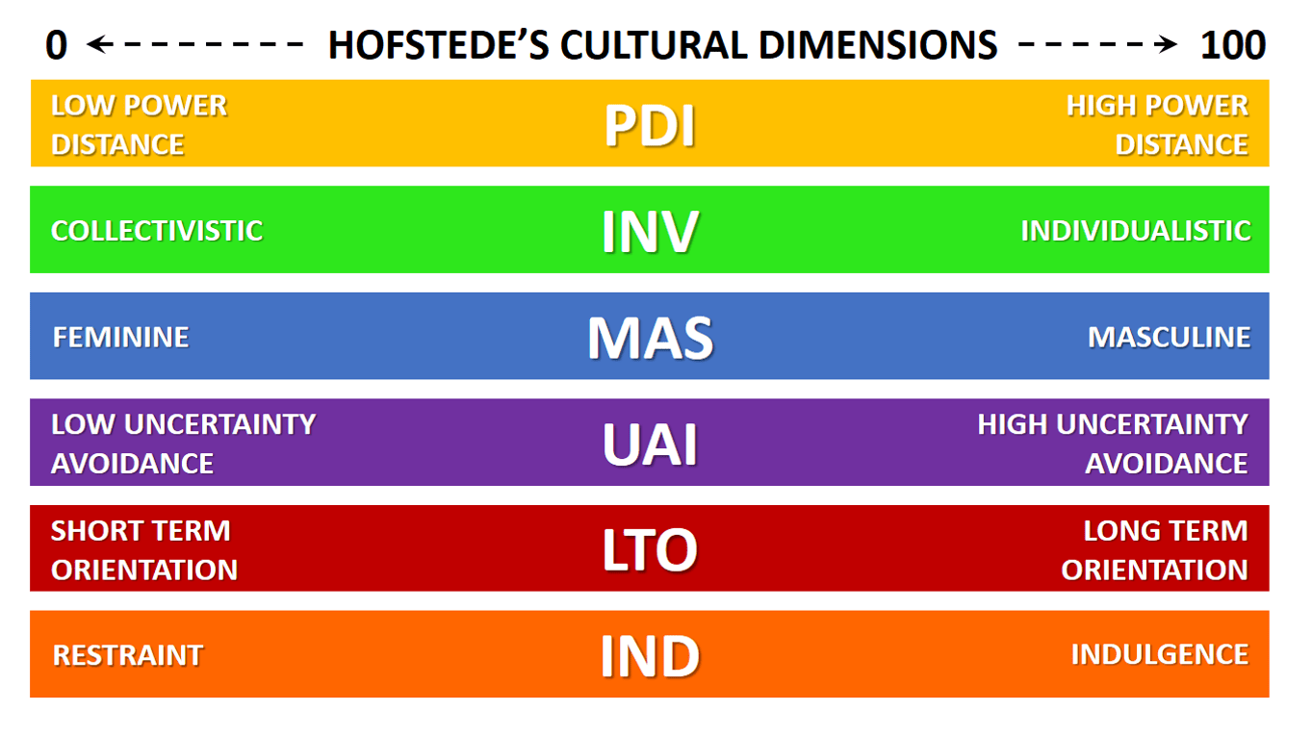Source: (Hofstede, 2011)
Figure 1 Hofstede's Cultural Dimensions

Power Distance: The UK ranks low for power distance, which measures how much less powerful citizens of culture anticipate and tolerate uneven power allocation (Hofstede and McCrae, 2004). This suggests that the British want to reduce inequality and deal with everybody with equal importance. So, everybody will be treated fairly in the UK.
Individualism: The UK ranks high for individuality, which represents a person's self-image in either 'I' or 'we' (Minkov, Blagoev and Hofstede, 2012). As an individualistic culture, the British prefer to care for themselves and their family members and spend less in societal structure or their communities. This indicates that the hotel will respect and value individual privacy.
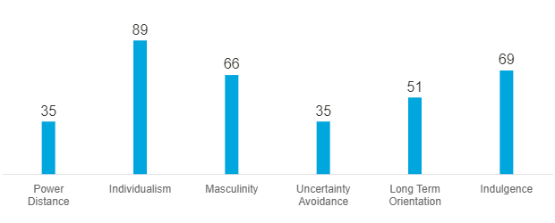Source: Hofstede Insights, 2022
Figure 2 UK Scores
Masculinity: The UK is a masculine nation, according to the Cultural dimensions of Hofstede. The UK scored 66 in this contextual factor, UK culture values competitiveness, ambition, and achievements above getting along with others, modesty, and living standards. So, it is expected that the guest will get quality and modest service from the hotel.
Uncertainty Avoidance: The United Kingdom has low participation in avoidance of uncertainty, indicating that its citizens are tolerant of ambiguity and can bear a lack of knowledge about the future. This indicates that the hotel might have flexibility.
Long/short-term Orientation: The United Kingdom is rated as having a neutral sense of time orientation. This explains how a culture deals with the problems of the present while maintaining ties to the past. So, there has a chance of serving the customer by developing a long-term relationship with the customer or a short-term gratification in the hotel.
Indulgence: The UK has poor impulse control & tries to fulfil its aspirations. Workplace flexibility, as well as work-life balancing, could be a good method to attract employees from indulgent cultures like the UK (Gert Jan Hofstede, Hofstede and Pedersen, 2012). It's okay to be casual at work, and it's generally best not to be too focused in the hotel.

Country B
Bangladesh is chosen as country B in this report.
Analysis of Bangladeshi culture using Hofstede’s Dimension
Power Distance: Bangladesh is a high-power distance country with a score of 80, which means that people support a hierarchical framework where each person has a position. Hierarchy considers underlying inequities, centralization is appealing, employees appreciate being told what to do, as well as the excellent leader is a kind of authoritarian. Senior holds the most power in Bangladesh. Guests of the higher socioeconomic background might expect better services than the guests of lower socioeconomic backgrounds.
Collectivism: Bangladesh has scored 20 in this dimension which indicates collectivism. This elaborates on a close, long-term attachment to the members 'cluster,' whether families, close family, or expanded connections. In a collectivist society, loyalty trumps most social laws (Tehrani et al., 2021). Everyone in society shares responsibility for participants. So, every guest in a group must be treated fairly.
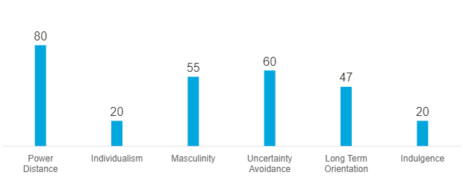
Source: Hofstede Insights, 2022
Figure 3 Bangladesh's Scores
Masculinity: Bangladesh scored 55 therefore it is a Masculine society. Masculine cultures "live to work," management is intended to be assertive and forceful, and problems are addressed by countering (Hafeez et al., 2021). The guests might be less polite.
Uncertainty Avoidance: Bangladesh has a high score on this aspect (60). High Uncertainty avoidance cultures like Bangladesh have rigorous beliefs and behavioral rules and are unaccepting of the unusual.
Short-term orientation: Bangladesh's score of 47 indicates no particular fondness. So, there might have both short and long-term tendencies.
Restraint: Bangladesh is a restraint country with a score of 20 on Indulgence. A low score on indulgence is pessimistic and cynical. Spare time is not valued in a restrained culture (Lutsiv, 2021). They control their need, which is different from indulgent cultures.

Critical Analysis
From the analysis of the cultures of the UK and Bangladesh, it is perceived that there have significant differences between the culture of Bangladesh and the UK. In the power distance dimension, the culture of Bangladesh is opposite of the culture of the UK i.e. Bangladesh high power distance and the UK low power distance. So, Bangladeshi guests do not prefer equal facilities. So, Britannia International Hotel must serve the guests according to their preferences or requirements.
The difference is also found in the individualism and collectivism dimension. British are individualist and Bangladeshis are collectivist. So, Bangladeshis are more likely to travel with family members or groups. So, the hotel must treat everybody fairly. Mistreatment of anybody might dissatisfy others. Besides, Bangladeshi guests might be less polite than the British. So, the guests from Bangladeshi culture must be dealt with cautiously.
Finally, Bangladeshi guests are restrained and British guests are indulgent. So, opposite cultural traits are also present here. So, these guests might be a pessimist and regulate their wants. So, understanding their wants is important before serving them.

Handbook of Dos and Don’ts
A handbook for the hotel employees for understanding the etiquettes differences and do’s and don’ts are as follows:
Etiquettes |  | Do’s and Don’ts
Greetings | UK | - Handshake
Greetings | UK | - Address using the last name (Johnson, 2010)
Greetings | UK | - Don't make long eye contact (Johnson, 2010)
Greetings | Bangladesh | - Handshake with men
Greetings | Bangladesh | - Avoid handshake with women if she does not extend her hand (Rahman, 2014)
Greetings | Bangladesh | - Address the men as sir and women as madam (Rahman, 2014)
Nonverbal communications | UK | - Privacy must be maintained (Johnson, 2010)
Nonverbal communications | UK | - Don’t speak loudly (Johnson, 2010)
Nonverbal communications | Bangladesh | - Maintain eye contact
Nonverbal communications | Bangladesh | - Don't use the left hand only for serving the guests
Time & Punctuality | UK | - Always be punctual
Time & Punctuality | Bangladesh | - Don’t be too late
Women etiquettes | UK | - Offer the same respect as men
Women etiquettes | Bangladesh | - Make gentle complements. (Rahman, 2014)
Taboos | UK | - Don't stare (Johnson, 2010)
Taboos | UK | - Don't ask personal questions (Johnson, 2010)
Taboos | Bangladesh | - Don't talk much with women
Taboos | Bangladesh | - Don't stare at women

Conclusion
Intercultural competence is vital in the hospitality industry as they need to serve customers from a different culture. Based on the analysis, it is identified that cultural differences are significant between British and Bangladeshi cultures. Britannia International Hotel should consider these before dealing with customers and employees from Bangladeshi and British cultures. The employees must consider the handbook of Dos and don’ts before serving guests from each culture.

Reference list
Gert Jan Hofstede, Hofstede, G. and Pedersen, P.B. (2012). Exploring culture : exercises, stories and synthetic cultures. Boston: Intercultural Press.
Hafeez, I., Maitlo, Q., Lashari, I.A. and Rehman, K.U. (2021). Nexus among the Hofstede Cultural Dimensions and Consumer Brand Loyalty: Empirical Evidence from Pakistan. Journal of Business and Social Review in Emerging Economies, 7(4), pp.985–996. doi:10.26710/jbsee.v7i4.2066.
Hofstede Insights (2022). Country Comparison. [online] Hofstede Insights. Available at: https://www.hofstede-insights.com/country-comparison/bangladesh.
Hofstede, G. (2011). Dimensionalizing Cultures: The Hofstede Model in Context. Online Readings in Psychology and Culture, [online] 2(1), pp.1–26. doi:10.9707/2307-0919.1014.
Hofstede, G. and McCrae, R.R. (2004). Personality and Culture Revisited: Linking Traits and Dimensions of Culture. Cross-Cultural Research, 38(1), pp.52–88. doi:10.1177/1069397103259443.
Jandt, F.E. (2020). INTRODUCTION TO INTERCULTURAL COMMUNICATION : identities in a global community. S.L.: Sage Publications.
Johnson, D. (2010). The little book of etiquette. Philadelphia ; London: Running Press.
Lutsiv, S. (2021). Wymiary kulturowe w negocjacjach według teorii G. Hofstede (Cultural Dimensions in Negotiations According to the Theory of G. Hofstede). SSRN Electronic Journal. doi:10.2139/ssrn.3875728.
Minkov, M., Blagoev, V. and Hofstede, G. (2012). The Boundaries of Culture. Journal of Cross-Cultural Psychology, 44(7), pp.1094–1106. doi:10.1177/0022022112466942.
Neil Remington Abramson and Moran, R.T. (2018). Managing cultural differences global leadership for the 21st century. London Routledge.
Rahman, U. (2014). Bangladesh-Culture Smart!: The Essential Guide to Customs & Culture. 1st ed. Great Britain: Bravo Ltd.
Tehrani, M., Rathgeber, A., Fulton, L. and Schmutz, B. (2021). Sustainability & CSR: The Relationship with Hofstede Cultural Dimensions. Sustainability, 13(21), p.12052. doi:10.3390/su132112052.

