

Operating Systems
ACCA4022: Computer Architecture and
Operating Systems
Zoe Clark 97011450 | University of Wales Trinity Saint David|
School of Engineering| BSc Degree Apprenticeship Computing
(Computer Networks & Cybersecurity)|April 2024


Table of Contents

Introduction 4
1 General Operating Systems: Key Functions 5
1.1 An Operating System (OS) Overview 5
1.2 Importance of User Interface 5
1.2.1 Graphical User Interface 5
1.3 Operating System Types 6
1.3.1 Microsoft and Apple OS 7
1.3.2 Linux and its Distributions 7
1.3.3 Mobile Operating Systems 8
1.4 Core Functionality 8
1.4.1 Process Management 8
1.4.2 Memory Management 11
1.4.3 File System Management 12
1.4.4 Device Management 13
1.4.5 Security and Access Control: 13
1.4.6 Network management: 15
2 Use of Windows OS CLI commands 16
2.1 Basic Windows CLI Commands 16
2.2 System Information: ‘ver’, ‘systeminfo’, and ‘time’ 16
2.3 Performance and Resource Monitoring: ‘Taskmgr’, ‘Tasklist’, ‘resmon’, ‘perfmon/rel’, ‘Eventvwr’ 17
2.3.1 Monitoring and analysis with diagnostic data: ‘Powercfg /batteryreport’ 18
2.4 File navigation and management: ‘cd’, ‘tree’, ‘dir | find’, ‘sort’, ‘>’ 18
2.4.1 Network management: ‘route print’, ‘netstat’, ‘ping -t’, ‘ipconfg’ 20
2.4.2 Additional Administration Commands: ‘chkdsk’, ‘sfc’ 21
3 Use of Linux OS CLI commands 22
3.1 Linux and the CLI 23
3.2 System Information in Linux: ‘lscpu -p’, ‘lscpu -J’ 23
3.3 Performance & Resource Monitoring: ‘ps aux’, ‘top’ 23
3.4 File Navigation and Management: ‘pwd’, ‘cd /’, ‘ls’ 24
3.4.1 Using ‘mkdir’, ‘rm- R’, ‘history’, ‘cp’, ‘chmod’ and ‘cat’ 25
3.5 Network Management: ‘netstat’, ‘ping – c’ 26
3.5.1 User and Permission Management: ‘useradd’, ‘chmod’ (octal), ‘sudo’ 27
4 Use of Windows OS scripts 28
4.1 Basic Syntax and Commands: ‘@Echo off’, ‘exit’, ‘exit /b’ 28
4.1.1 Comments 29
4.1.2 Variables: ‘set’, ‘%’, ‘~’ 29
4.1.3 Set local environment 30
4.2 Input and Outputs 31
4.2.1 User Input: ‘/p’ 31
4.2.2 Output Formatting and Effects: ASCII, colour & ‘cls’ 33
4.2.3 Using Outputs for File, Performance, and Network Management 34
4.3 Control Structures 34
4.3.1 ‘Pause’ 35
4.3.2 Array 35
4.4 Decision-Making 36
4.4.1 If Statement: ‘if’, ‘else’ 36
4.5 Automation and Repeatable Code 37
4.5.1 Functions 37
4.5.2 ‘Goto’ 37
4.5.3 ‘For’ Loop 38
4.6 Error Handling and Debugging - 39
5 Use of Linux OS scripts 40
5.1 Basic Syntax and Commands 40
5.1.1 Shebang: ‘#!/bin/bash’ 41
5.1.2 ‘Echo’ and ‘$’ 41
5.1.3 Comments: ‘#’ 42
5.2 Variables 42
5.3 Input and Output Handling: ‘read’, ‘-e’ 42
5.3.1 User input: ‘-p’ 43
5.3.2 Outputs: ‘printf’, ‘-s’ and colour 43
5.4 Control Structures and Decision-Making: Array, ‘if’ statements, operators, ‘case’ 44
5.5 Automation and Repeatable Code 45
5.5.1 Functions and reusable code 45
5.5.2 Loops: ‘while’, ‘for’ and using ‘break’ 46
5.6 Error Handling and Debugging 47
5.7 File, Performance, and Network Management 48
5.7.1 Text processing in Linux: ‘grep’ 48
5.7.2 ‘Nano’ 49
6 Conclusion 50
References 51
Further Reading 55
Image Citations 55
Appendix 60
Appendix 1: Tutorial Research/ draft Notes 60
Q 1 & 2 – tutorial research 60
Appendix 2: Online Course Engagement – Learning PowerShell 63
Screenshots 63
Appendix 3: Batch Scripts 64
Appendix 4: Bash Scripts 74
Appendix 5: Further research and reading 79

Introduction

This report provides an overview of general Operating Systems (OS), demonstrating Windows and Linux OS CLI commands and scripts (using Batch for Windows and Bash for Linux) through screenshots and narration. Commands and script filenames have been highlighted in captions in bold for ease of reference.

Supplementary materials from classroom activities, personal research and scripts are included in the References and Appendices.

General Operating Systems: Key Functions

An Operating System (OS) Overview

An OS “manages a computer’s resources, especially the allocation of those resources among other programs. Typical resources include the central processing unit (CPU), computer memory, file storage, input/output (I/O) devices, and network connections.” [1]

Central is the kernel which “performs a variety of tasks, including process management, memory management, device management, and file system management. In process management, the kernel is responsible for creating, scheduling, and terminating processes. It also manages inter-process communication and synchronisation.” [2]

Enabling execution of multithreaded processes simultaneously, while managing memory (RAM/ VRAM) effectively including virtual memory, pages, and swapping techniques to optimize memory usage, and handling interrupts e.g. a mouse click. Different kernel types offer differing rings of protection between user interaction and core operations.

Importance of User Interface

Common user interfaces provide a standardised platforms for software and user interactions, enhancing software development and navigation. [3]

Device drivers handle input and output operations, Streamlining interactions internally or externally communicating with hardware. Hardware component switching (inbuilt graphics cards, external printers etc) simplified via the interface which makes an OS itself “quite complex.” [3]

Graphical User Interface

A Graphical User Interface (GUI) provides visual outputs, aiding users when launching applications and managing tasks.

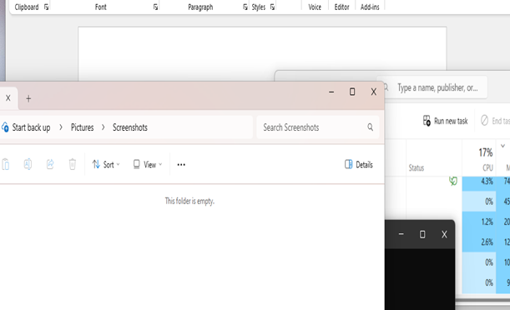

Figure 1: Windows Interface shows - Task manager, File Explorer and Word Software in GUI view. Also shown (in black) is the text-based Command Line Prompt (CLI).

Operating System Types

Various OS are available developed for diverse needs “There are many different types of OS, reflecting different purposes and goals, and many different methods of organizing operating systems. These differences are indicated by the way in which the user interacts with the system.” [4]

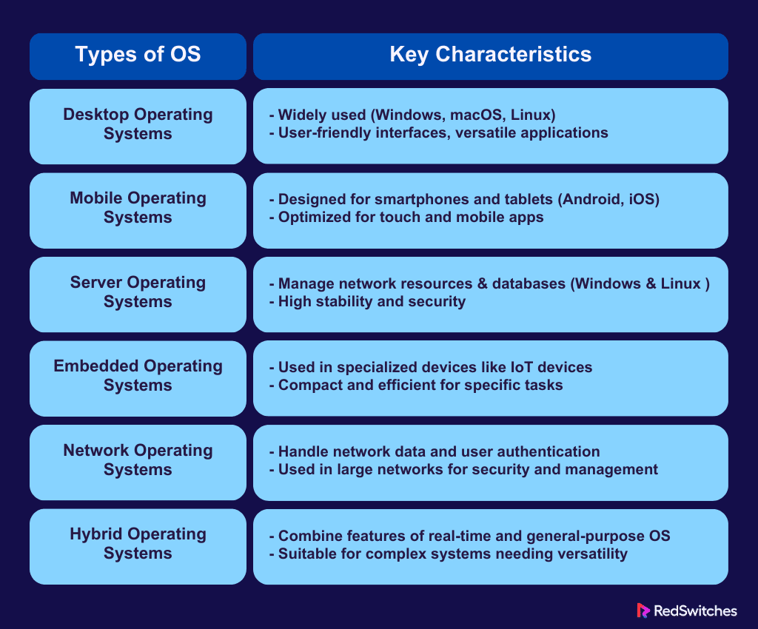
Figure 2: OS Types ranging from small scale Embedded OS, as used in individual devices to large scale Network OS linking LAN’s (local area networks) and internet etc. [5]

Notable developments include GUI, cloud computing services (Amazon’s cost-effective and scalable AWS).

Advancements in machine learning and artificial intelligence have developers keenly exploring integrations, with Quantum computing also offering radical possibilities in communication and task processing. [6]


Figure 3: Microsoft increasing market value over Apple, observed around a period of development in generative A.I. [7]

OS development can be profit centric. A strong cultural focus on development and availability can also be seen through open-source development.

Microsoft and Apple OS

Microsoft Windows, features GUI, and is widely compatible with Hardware and Software.
[8] It “controls the way you work with your computer.” [9]

Apple’s macOS offering has a similar GUI. Apple achieves compatibility through its own brand software. Both have changed appearance over time, but core functionality remains.

Linux and its Distributions

Linus Torvalds’, Linux (based on Unix style), is known for a Command Line Interface, stability, and multiple distributions (Mint, Debian, and Ubuntu also offer GUI). Being open source removes license purchase requirements for the basic OS.

“Linux’s popularity also stems from its flexibility and cost-effectiveness. Many companies now use Linux servers as part of their IT infrastructure in a variety of environments, such as embedded systems, private clouds, and endpoint devices.” [10]

Mobile Operating Systems

Android and iOS dominate mobile OS markets. Despite cosmetic differences, they share essential features. It could be argued Android has wider reach due to broader compatibility.


Figure 4: Linked functionality through wireless connections, provides the ability to work across mobile and other types of OS e.g. Apple Mobile iOS, linkable to macOS. [11]

Core Functionality

Process Management

OS manage the creation, scheduling, and termination of processes. including context switching (CPU switches between tasks). A process scheduler allocates CPU time, managing process communication prioritising to avoid resource conflicts ensuring efficient multitasking.

Tools like Windows Task Manager provide performance insights.

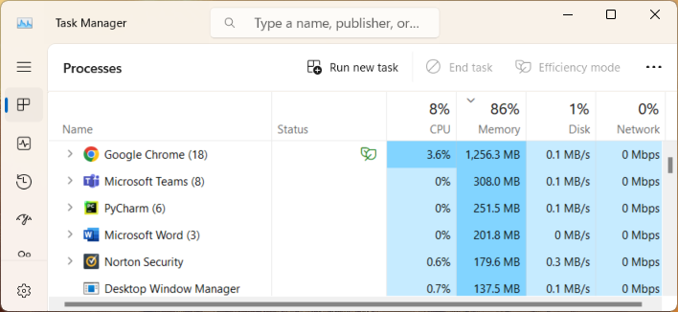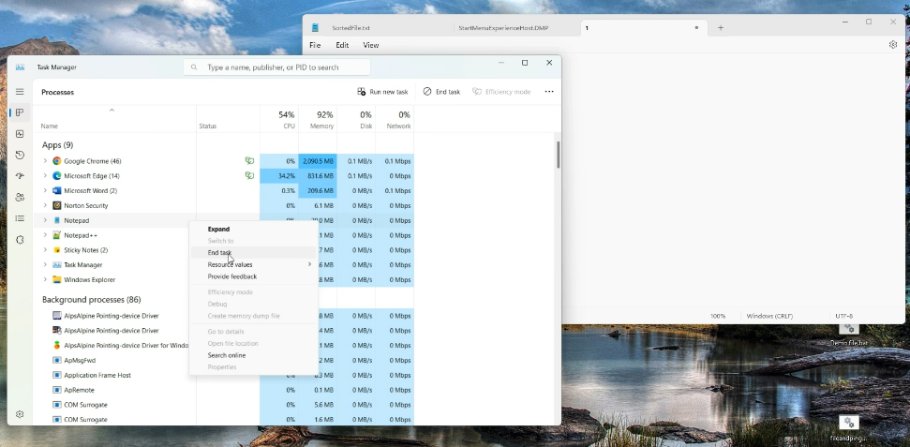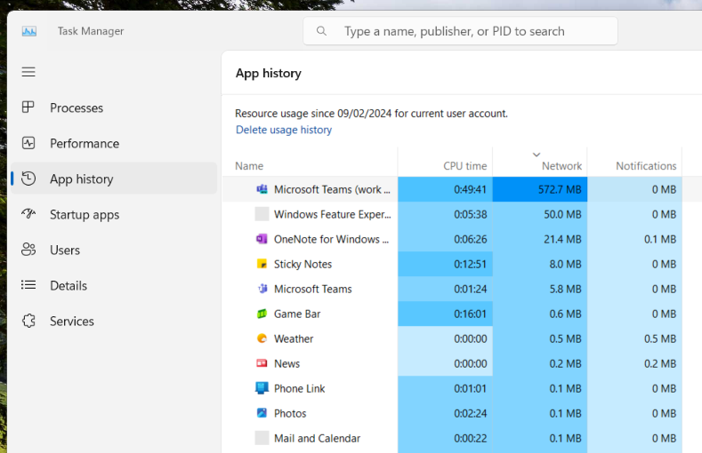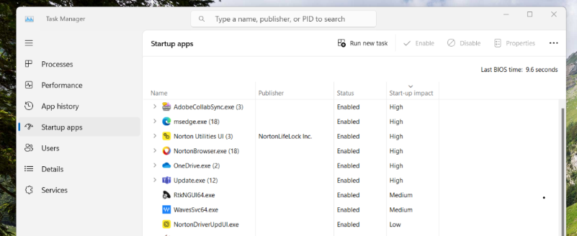
Figure 5: Windows Task Manager, easily filtered. Shown is CPU, Memory (RAM), disc (storage) and Network activity. Options include current, historical and startup activity.

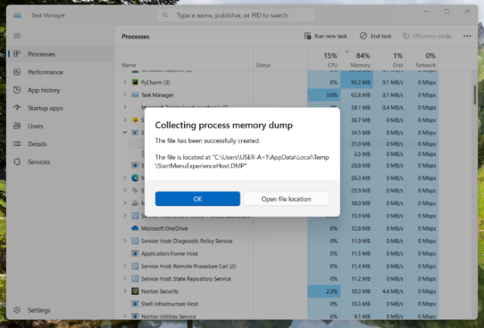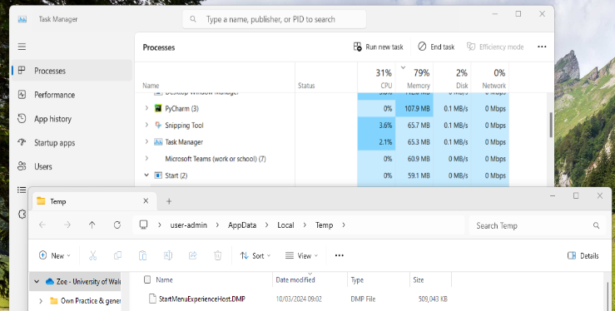
Figure 6: Creating a Dump File from Task Manager via menu selection. This gives a snapshot of memory including high utilisation for analysis of performance or errors.

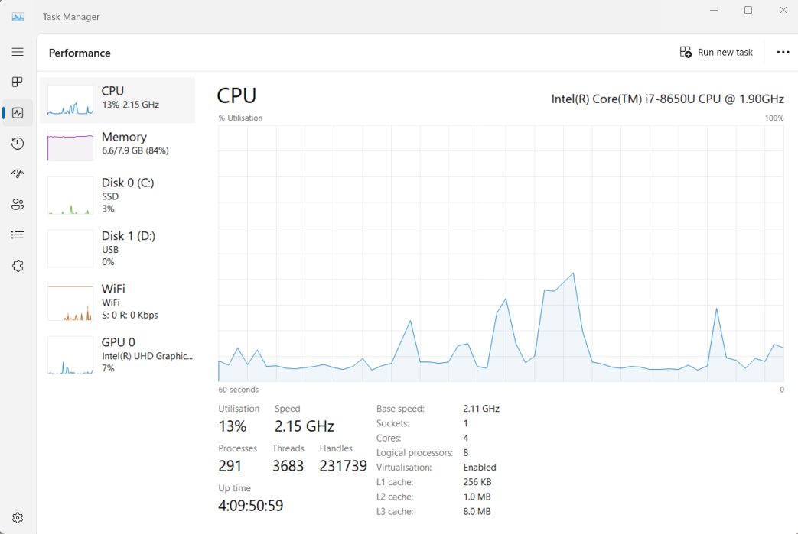
Figure 7: Performance Management in Windows Task Manager, visualising real time performance. The OS manages performance to prevent deadlock, this tool allows user interaction to enhance performance management.

In addition to a job scheduler, (kernel software level), a Task Scheduler is available (user software level).

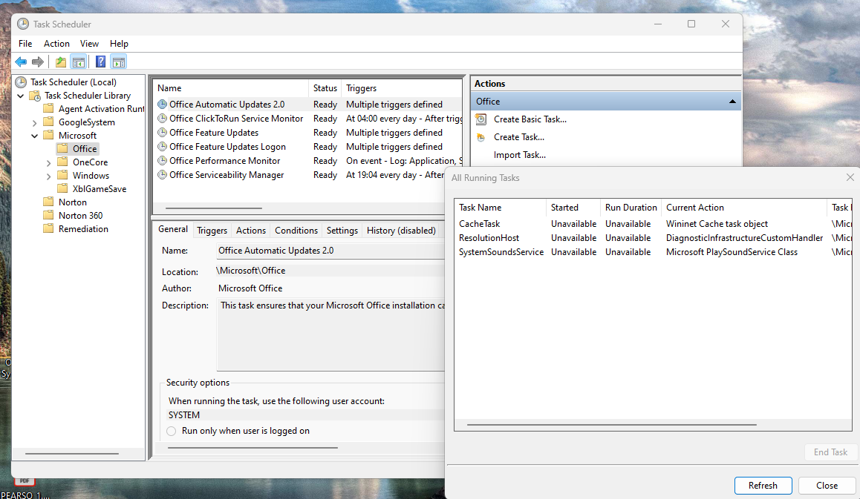
Figure 8: Task Scheduler – Users can set tasks to automatically run processes.

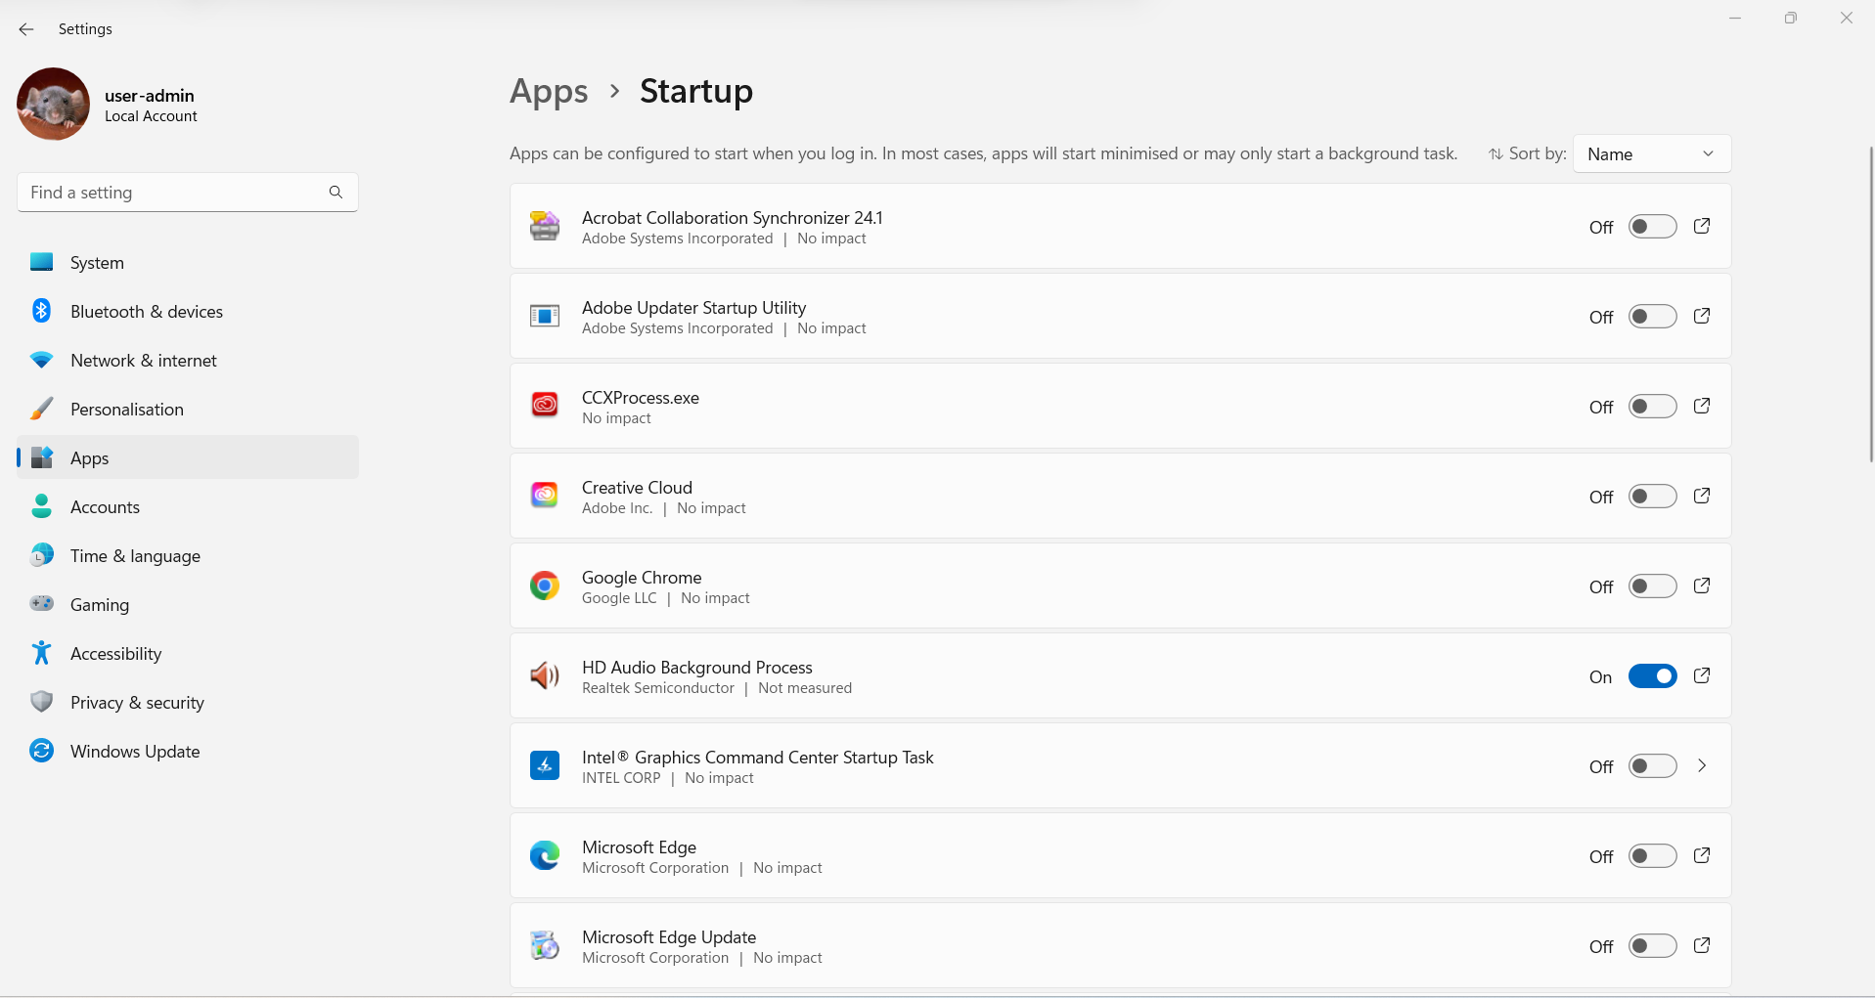
Figure 9: Startup Tab - Improving startup time through managing what can run automatically when device is booted up.

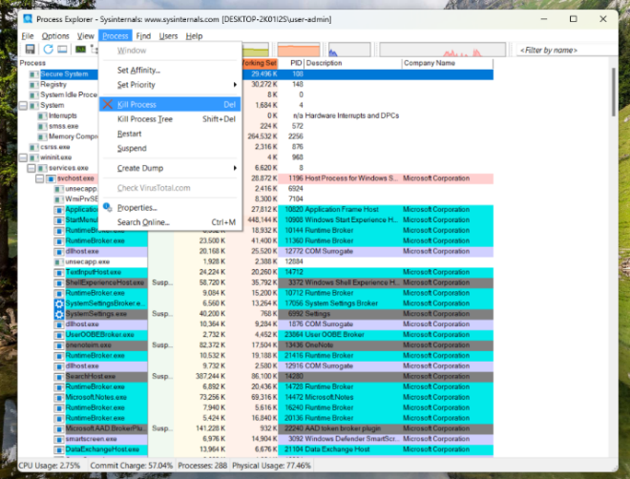
Figure 10: Process Explorer showing linked processes and threads. Useful for narrowing down root causes of issues and spotting suspicious processes or behavior of processes.

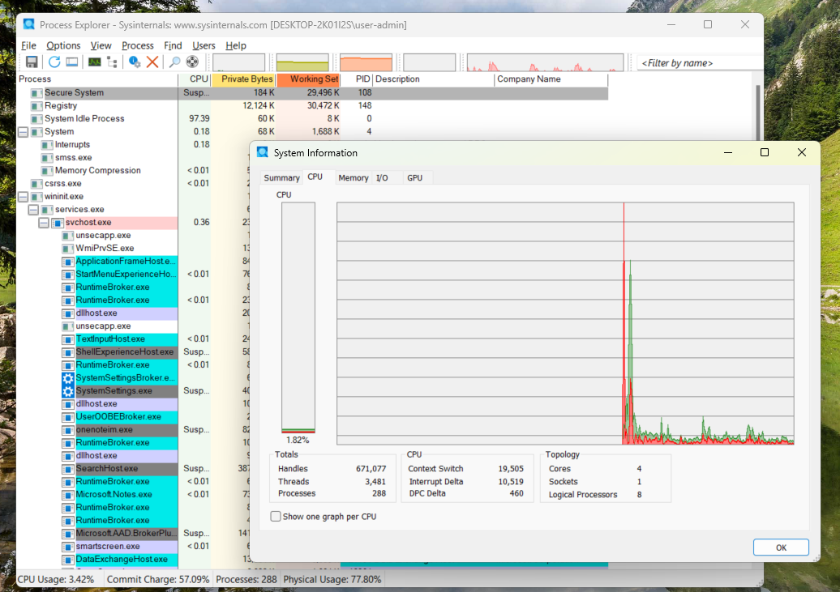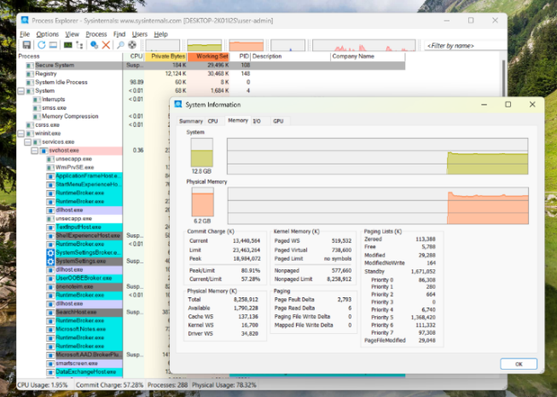
Figure 11: Details live monitoring activity via Resource Manager. Live monitoring activity gives dynamic insights also important in cloud-based OS.

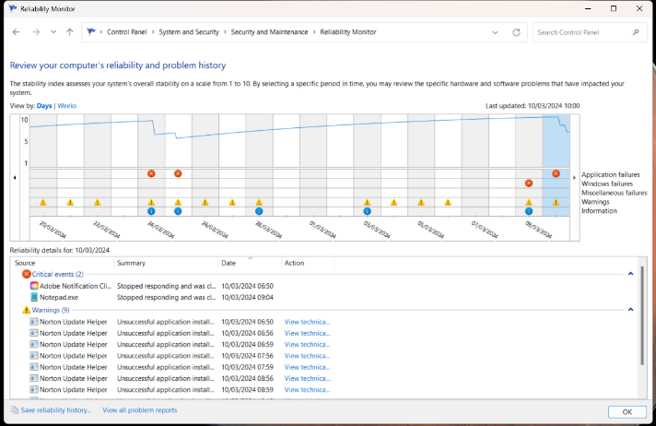
Figure 12: An OS manages error handling and system errors. The reliability monitor displays events including these that impact system reliability.

Windows has advanced debugging and troubleshooting tools. Providing detail (kernel/ user interface levels) on critical system errors (Blue Screen). WinDbg identifies issues and automatically creates dump files, for analysis.

Memory Management

Manages the system's memory hierarchy, allocating and deallocating as needed.

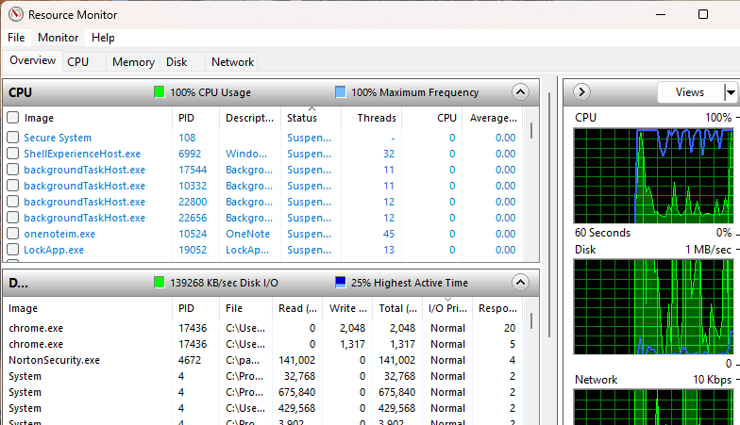
Figure 13: Windows Resource Monitor. Insights and monitoring of system memory resources.

Memory is key to how modern computers operate. “To take the first step towards the computers of today, which are capable of carry out multiple tasks on command, researchers had to develop a computer with a memory.” [12]

Processes, threads, and jobs rely on efficient memory management to execute tasks effectively.

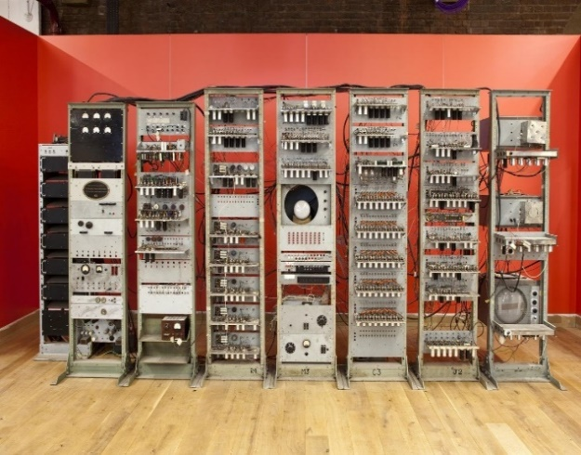
Figure 14: Figure 14: Ferranti’s ‘Baby.’ Key development in memory storage and software execution.[12]. Modern memory includes RAM, VRAM or fast access, and SSDs for long-term storage.

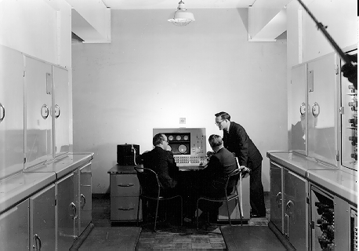
Figure 15: Designers and Turing overlooking Ferranti ‘Mark 1’ Console - First commercially available, general-purpose computer, with program storage (delivered Feb 1951). [13] Essential for running systems and software in an OS.

File System Management

Assists managing physically stored files (creation/ access/ deletion). Ensuring data integrity and security. Example File Explorer in Windows or Finder in macOS. [14]

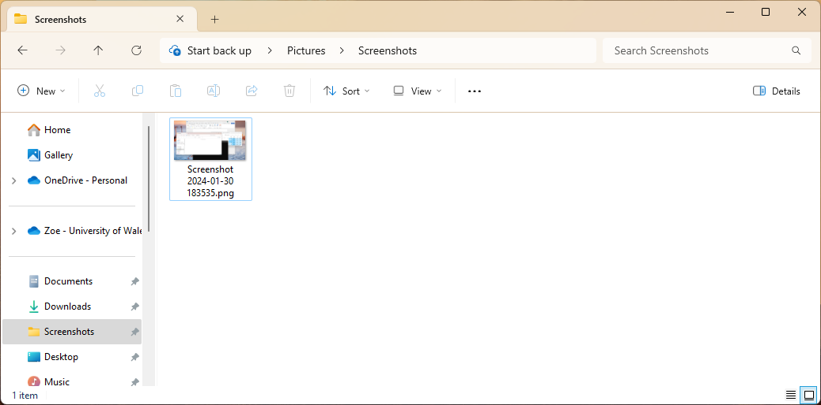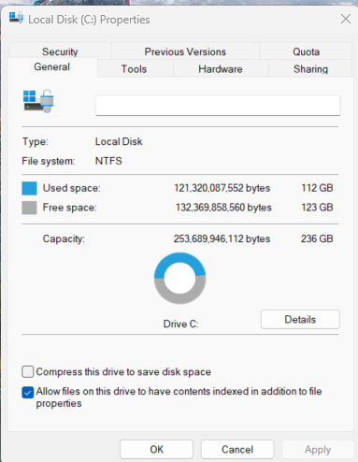
Figure 16: Windows File Explorer showing Quick Access navigation feature and a saved file within a folder and C disc Properties showing file system type and disc storage.

Device Management

Interacting with hardware, it facilitates communication between software and peripherals. Including I/O traffic control and I/O scheduler, for managing data transmission. Device stripers efficiently transfer data between the CPU and devices. [15]

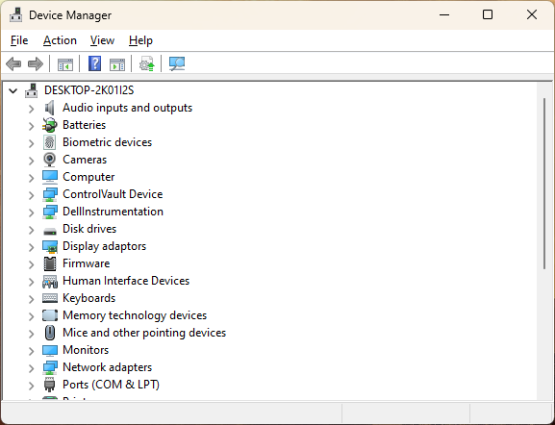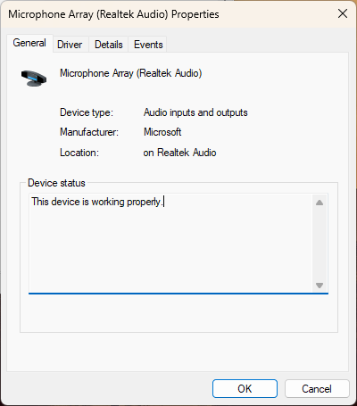
Figure 17: Windows Device Manager and pop-up screen opened by double clicking on one of the devices listed. Shows device details and the peripherals e.g. keyboards and mice.

Security and Access Control:

To protect data and system integrity. the OS includes tools to manage user authentication, access control, encryption, and firewall management.

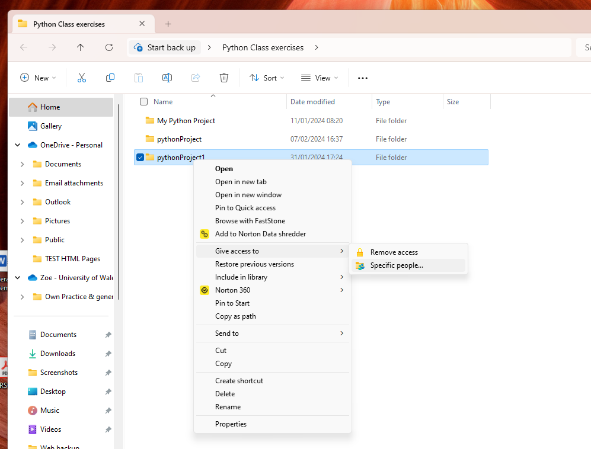
Figure 18: Managing Security through User Management, via Windows control panel.

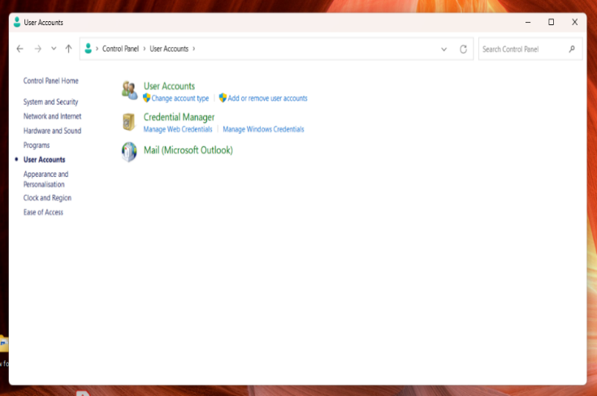
Figure 19: User Management provides insights into user authentication processes, including password management and user account settings used to protect systems and data.

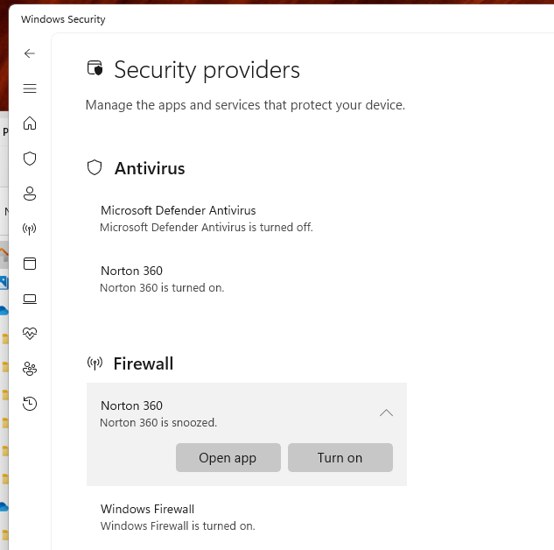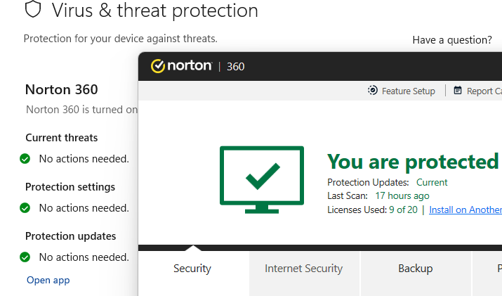
Figure 20: Managing Security Features such as Firewalls, preventing unauthorized access via the network. It can also link to 3rd Party software such as Norton to confirm protection status.

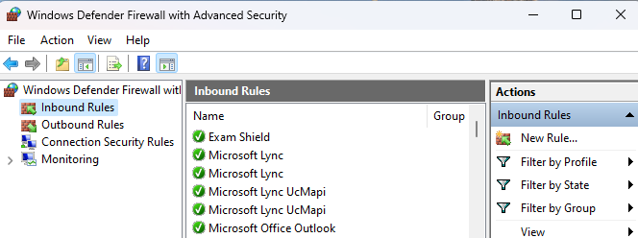
Figure 21: Windows Defender advanced options such as managing firewall rules (Windows 10).

Encryption plays a crucial role in safeguarding sensitive data.

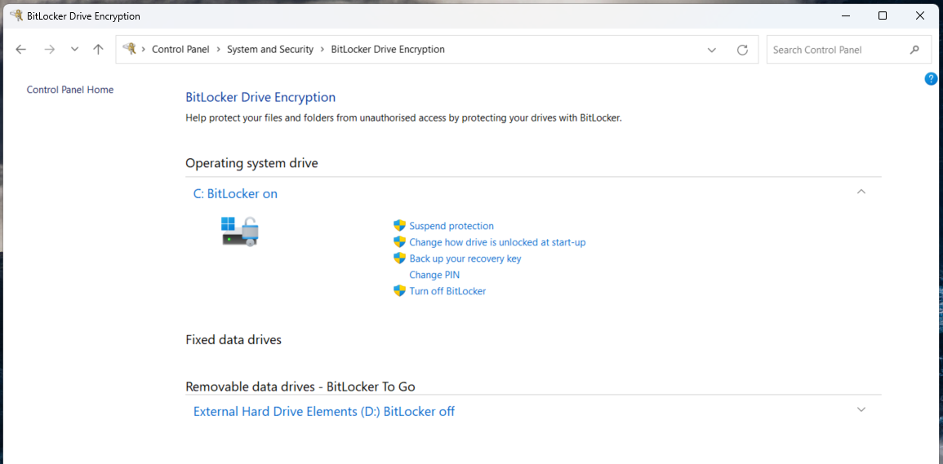
Figure 22: Managing BitLocker encryption settings to protect OS and user data. Encryption is used to protect storage including directories and files stored.

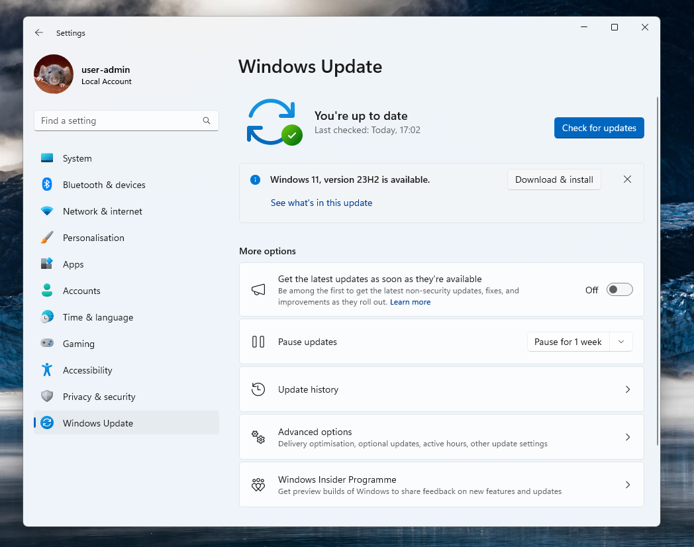
Figure 23: Managing Security by checking and installing updates which include improvements, bug fixes and security patches.

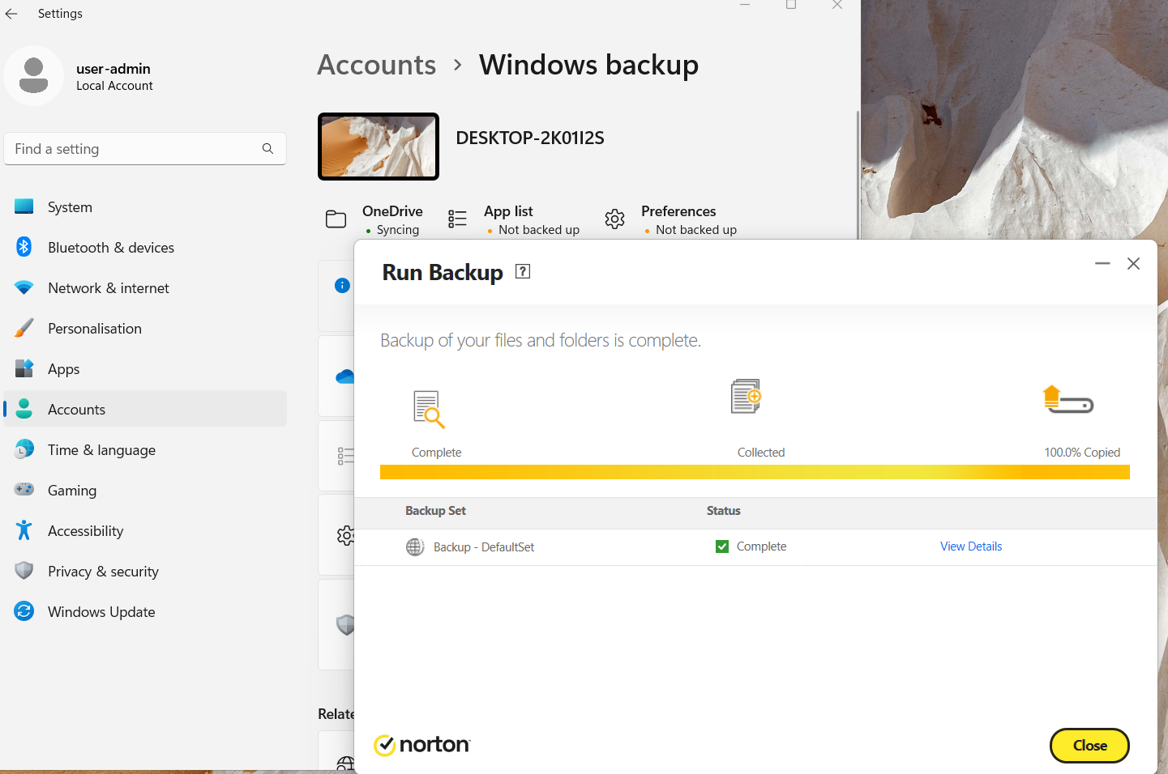
Figure 24: Protecting data by saving to external drives or the cloud. Allows restoration or recovery.

Network management:

Network management facilitates communication between components, within devices and across networks, establishing connections and data transmission. Excessively securing may hinder genuine access. Unsecured or unmonitored risks disruption, reduced performance, or compromise.

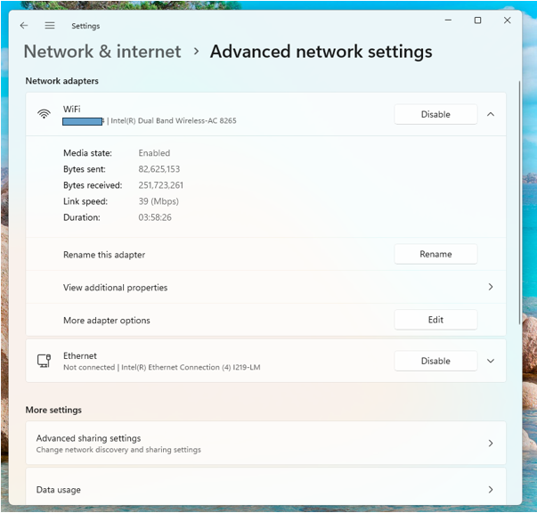
Figure 25: Network Management on Windows. An OS manages network protocols e.g. HTTP, TCP, and IP addressing to identify networked devices. Both at the Local (LAN) and wider (WAN) access levels.

Networks are “applications at the network application layer that connect users working in offices, branches, or remote locations to applications and data in a network. These services typically run on servers.” [16]

Modern computing relies heavily on networked environments and internet connectivity. The Internet of Things (IoT) has diversified threat entry points. [17]

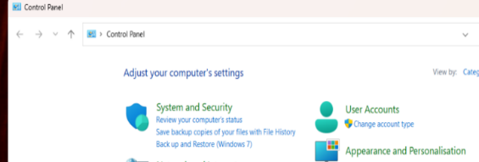
Figure 26: Accessing System and Security or Network and Internet settings via the Windows Control Panel. Control of user accounts can protect file.

The command line (CLI) can also be used for analysis and management.

Use of Windows OS CLI commands

In resource heavy or constrained environments (cloud, network , data centre, edge devices), a CLI streamlines. “..you can use a CLI to see system logs and quickly find comprehensive error messages and debugging information. The text-based commands can also be documented easily. This helps ensure tasks can be reproduced and makes it easier to troubleshoot steps in the future.” [18]

Basic Windows CLI Commands

CLI offers wide ranging functionality, buildable control and is more efficient than running GUI. Learning without GUI visual prompts could be a disadvantage, but resources are plentiful e.g. learn.microsoft.com[19], tutorialspoint.com[20] or W3Schools.com[21] (researched for below demonstrations).

Verifying prevents errors or malicious damage. ‘Stop-Process’ stops everything. [22] ‘Taskkill /f /im notepad.exe’ specifically stops notepad ensuring correct deletion of content, file or directories. Typing ‘help’ (or help plus command) is built-in and virtual machines provide safer learning environments.

System Information: ‘ver’, ‘systeminfo’, and ‘time’

Commands verify OS versions and provide information helpful for compatibility/ configuration checks with hardware and software.

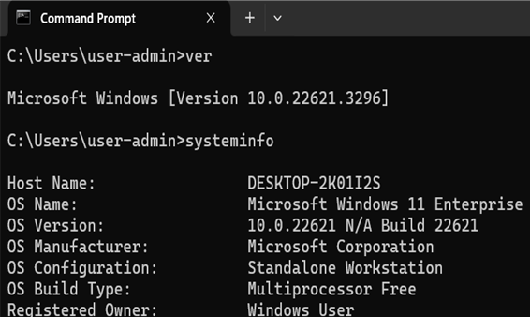
Figure 27: Displays OS version and key system information using 'ver' and 'systeminfo' commands in the Command Line Shell interface.

Figure 28: Use of ‘time’ to display (can also set) OS time. [23]

Performance and Resource Monitoring: ‘Taskmgr’, ‘Tasklist’, ‘resmon’, ‘perfmon/rel’, ‘Eventvwr’

CLI can also be combined with GUI when using tools described previously.

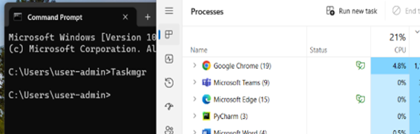
Figure 29: ‘Taskmgr’ used to open Windows Task Manager directly from the command interface. One instruction with no navigation involved.

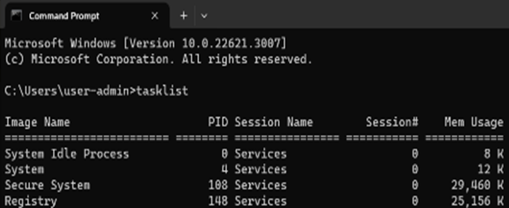
Figure 30: ‘Tasklist’ - Lists current running processes including memory usage.

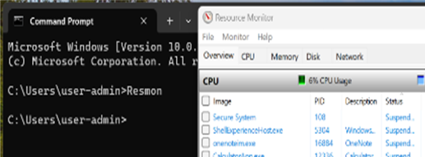
Figure 31: ‘resmon’ - Opening the resource monitor from the CLI.

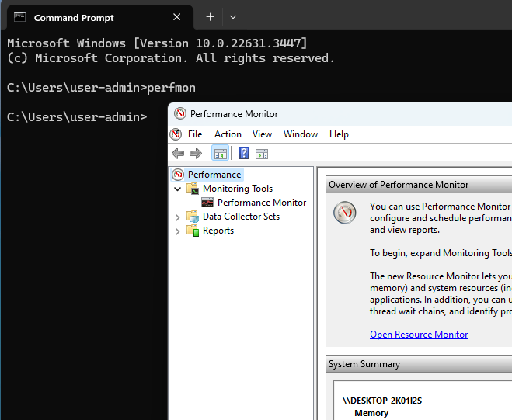
Figure 32: ‘perfmon’. Viewing Information in Performance Monitor with a single command.

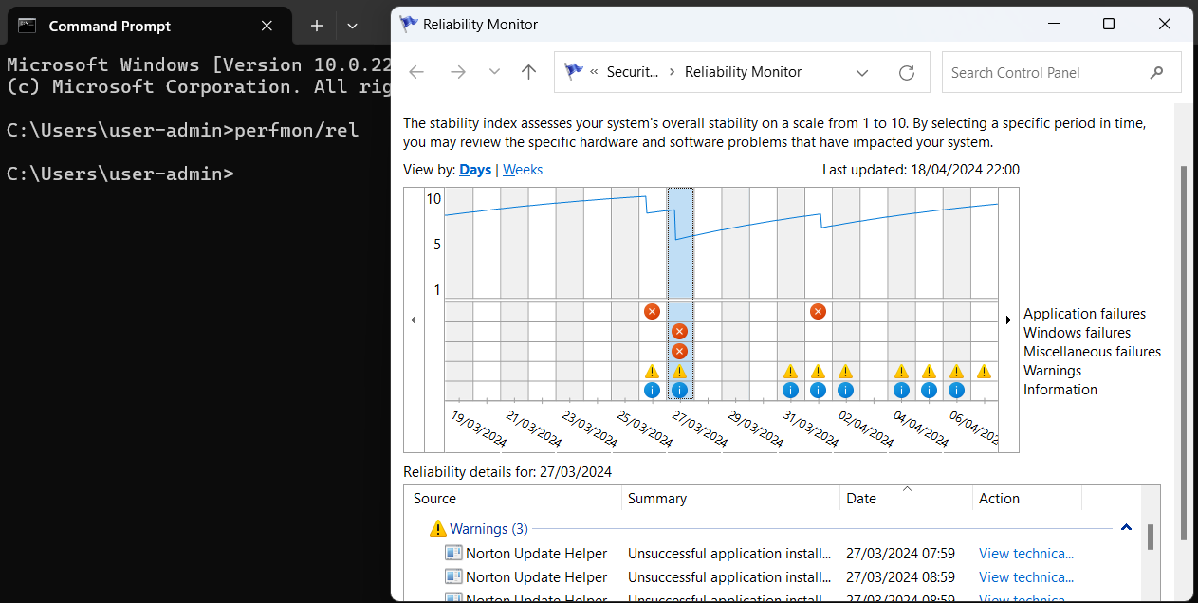
Figure 33: ‘perfmon/rel’ - Opening Reliability monitor, viewing report and identifying sources of reliability issues.

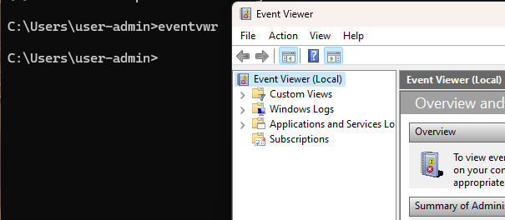
Figure 34: ‘eventvwr’ - Opening Windows OS Event Viewer.

Monitoring and analysis with diagnostic data: ‘Powercfg /batteryreport’

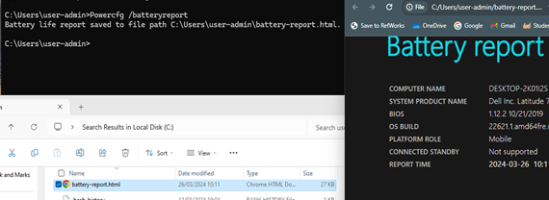
Figure 35: ‘Powercfg /batteryreport’ – Saved HTML file output. File can then be accessed via GUI or by navigating to file location in the CLI.

File navigation and management: ‘cd’, ‘tree’, ‘dir | find’, ‘sort’, ‘>’

Navigation Commands such as ‘cd..’ (move up one directory), ‘cd’ (move to the root folder), and ‘move’ are used to navigate and manipulate directory and file structures.

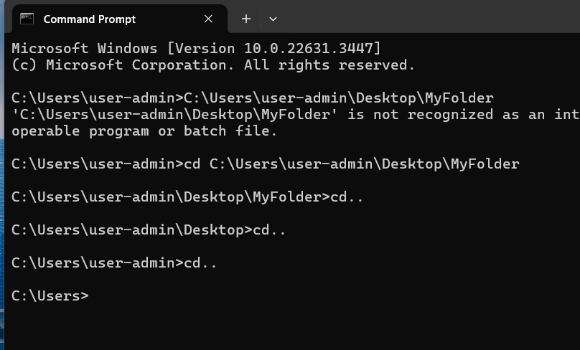
Figure 36: ‘cd’ and practice error. Command required before using file path. ‘cd..’ used to move back through the directory structure.

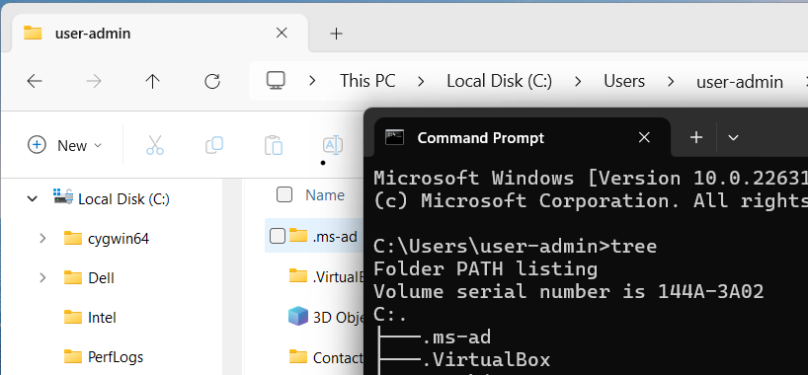
Figure 37: command ‘tree’ showing the branched structure in command line and in the GUI based File Explorer for comparison.

Commands such as ‘copy,’ ‘del’ (delete), ‘sort’, and ‘type’ (prints contents to view) assist users to manage files further.

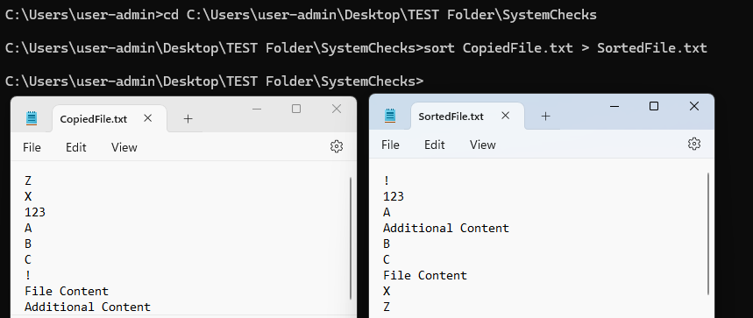
Figure 38: ‘sort’ used with ‘>’ to copy, sort and save a file in one line of command. Adding ‘>>’ will apend to files giving extra flexibility directly from the CLI.

Commands such as "cd.." (move up one directory), "cd" (move to the root folder), and "move" are used to navigate and manipulate file structures.

Using a wider range of commands builds detail, "Assoc" (file types), "Attrib" (file attributes e.g. read-only), “Comp” (compare file sizes).
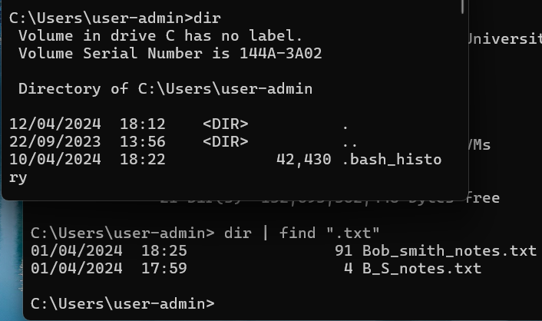
Figure 39: ‘dir’ - contents from the current directory. CLI indicates user and path of directory with the details. Adding a ‘|’ (pipe) allows use with further commands, used here to select by file type .txt. using ‘dir | find’.

Commands can be directory specific or also used with files. Commands like ‘Path’ set the specific location, giving more efficient command execution without step-by-step direction.

Network management: ‘route print’, ‘netstat’, ‘ping -t’, ‘ipconfg’

Variations or combinations control elements such as repetitions, types, or levels of detail, improving live feedback and diagnosis.

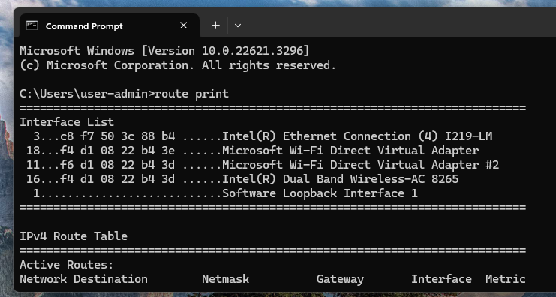
Figure 40: Viewing IP routing via ‘route print’. Assists with diagnosing connectivity issues.

For example, ‘ping -t’ will continue to ping but ‘ping – n’ can be used to limit this. Including ‘-w’ could also control how long the user is waiting if something times out.

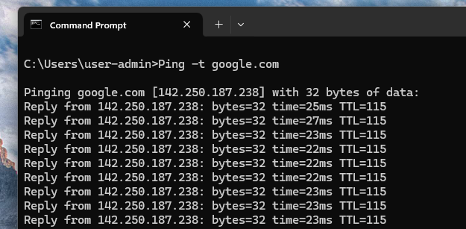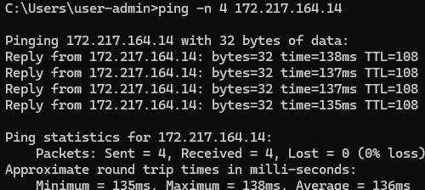
Figure 41: ‘Ping -t’ and google.com’ (class materials) and ‘ping -n’. Useful to check if a connection issue is local or internet level. Ping refers to time taken for packets to be sent and received. [24]

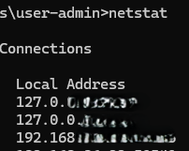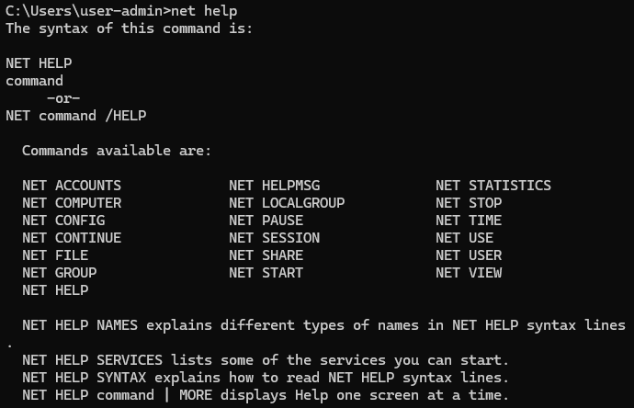
Figure 42: Using ‘netstat’ to look for network-related issues. Current state established confirms working correctly. ‘net’ can be combined to assist with managing, starting and stopping various network services as seen when used with help to view options.

Figure 43: ‘Ping -t’ and google.com’ (class materials) and ‘ping -n’. Useful to check if a connection issue is local or internet level. Ping refers to time taken for packets to be sent and received. [24]

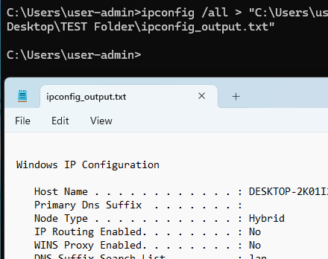
Figure 44: IP configuration detail saved to text file. Increased analysis through logging, collating, and viewing historical data using ‘ipconfg’ with the file path, name and type.

Adding to commands can allow data to be saved to html or text files. Information output in this way from commands gives a helpful reference source for further investigation and analysis. For example, output.txt [25]

Additional Administration Commands: ‘chkdsk’, ‘sfc’

Administrators have greater access (fixing errors on disk with ‘chkdsk’). or ‘sfc’ to check/ repair integrity of system files, keeping functionality and security as intended.

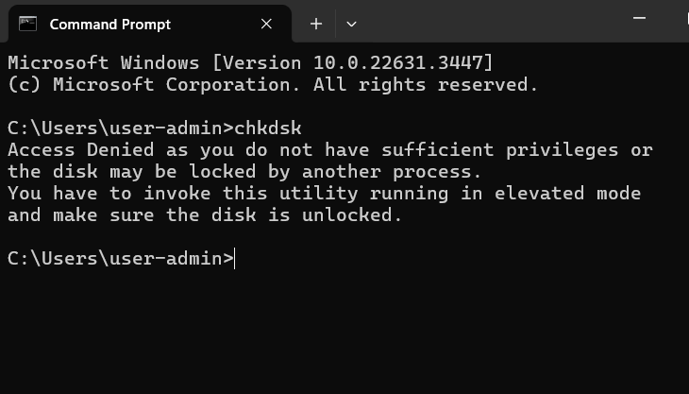
Figure 45: ‘chkdsk’ - Some commands require elevated administrator privileges to run. Additional functionality and access to core systems and therefore greater risks.

“As a system administrator, having a strong command over the Command Prompt (CMD) is essential for effectively managing and troubleshooting Windows systems. By utilizing a range of CMD commands, you can quickly handle various tasks, monitor system performance, and resolve issues efficiently.” [26]
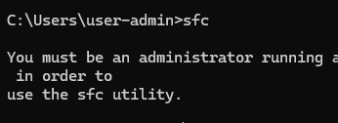
Figure 46: Administrators privileges must be enabled, to fully utilise the power of CLI commands like ‘sfc’ which allow interaction with critical system files.

Use of Linux OS CLI commands

Although Linux can be used with GUI based distributions, there are the same advantages to using direct commands. It offers greater functionality (and risk) due to its monolithic kernel

“The core Linux operating system is very lightweight and makes efficient use of any system’s resources.” [27]

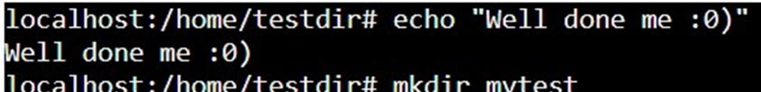
Figure 47: Practicing following tutorial. "Echo" to print text out to the command line.

Linux and the CLI

Linux via a web browser has been used to demonstrate most of the following commands. Further functionality is possible with a full Linux installation and with administrator rights.

General resources used for commands included ss64.com [28] , and LinkedIn course “Learning Linux Command Line.” [29]
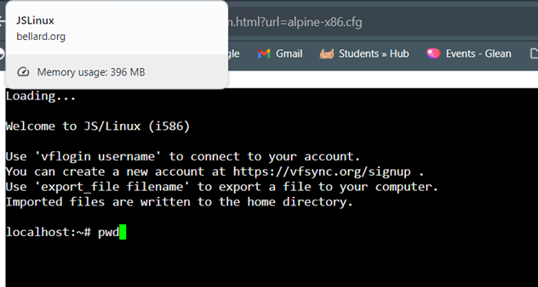
Figure 48: Using Linux Cli commands via Bellard.org. [30]

System Information in Linux: ‘lscpu -p’, ‘lscpu -J’

Bash also provides direct commands which can be enhanced to tailor outputs and can be ‘piped’ together using ‘|’ for more efficient system management and administration tasks.

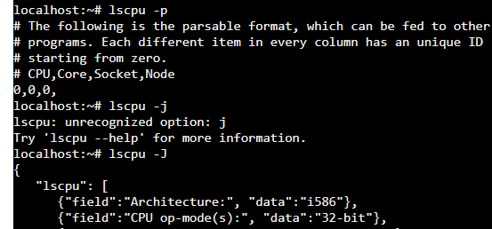
Figure 49: use of ‘lscpu’ with ‘-p’ and ‘-J’ and errors that remind that help with commands is also built in. Here easily resolved. By use of lower instead of uppercase.

“You can also use lscpu with the -p option to print specific fields only or -J for JSON output. Both of these options are great to parse with other programs or scripts.” [31]

Performance & Resource Monitoring: ‘ps aux’, ‘top’

Using commands such as ‘ps’, ‘top’(‘htop’), and ‘kill’, users can view process information, prioritise resource allocation, pause or terminate processes, and manage system performance effectively. [32]
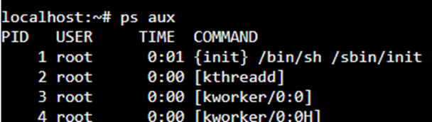
Figure 50: Extending commands allows more precision e.g. ‘ps aux’ for a more detailed overview of running processes.

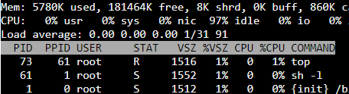
Figure 51: Output after running ‘top’ command via Bellard.org.

File Navigation and Management: ‘pwd’, ‘cd /’, ‘ls’

Commands can assist in navigating or viewing directories and file structures. Especially important for as “system administrators deal with lots of data that exists outside of their own home directory.” [33]

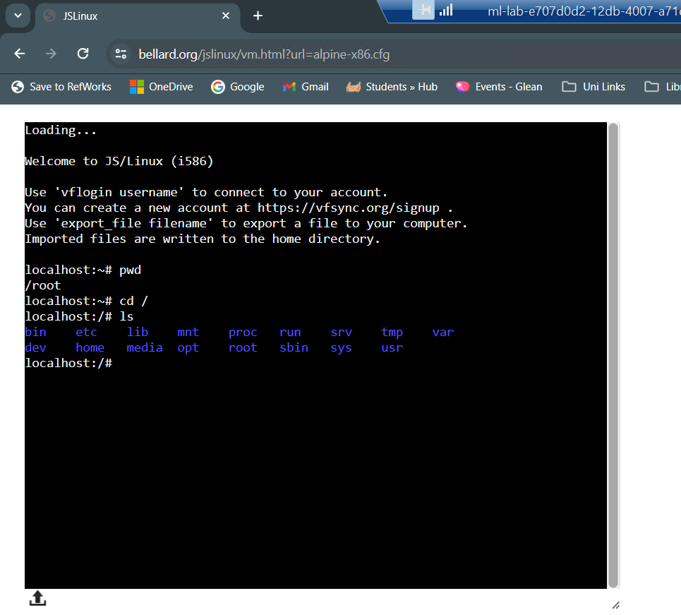
Figure 52: ‘pwd’ showing displaying the current directory (user root), ‘CD /’ to change directory and ‘ls’ to list its contents.

Linux directories are arranged in tiers. Key directories include ‘/root’ (the home directory for the superuser/administrator), ‘/srv’ (for server data), ‘/var’ (housing logs), and ‘/dev’ (containing device files). Directory types matter. Modifying files within directories like ‘/boot’ (related to system startup) or ‘/lib’ (housing drivers for devices like Wi-Fi or sound cards) could result in critical failures and data loss. [34]

Using ‘mkdir’, ‘rm- R’, ‘history’, ‘cp’, ‘chmod’ and ‘cat’

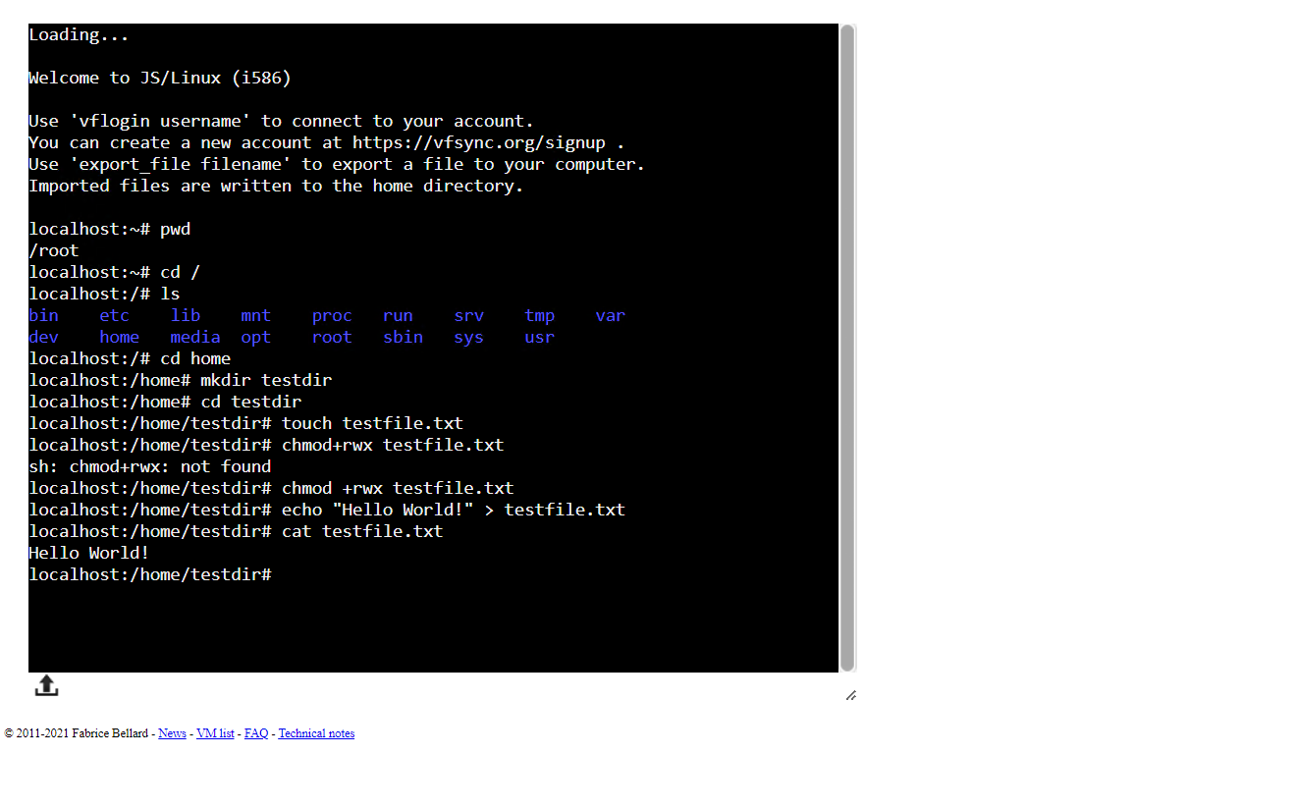
Figure 53: File manipulation, ‘mkdir’ to make a directory, ‘touch’ creates empty files, ‘Chmod’ to set permissions ‘cat’ to concatenate and display contents.

The CLI simplifies file management. “..complicated tasks can be easier with the command line programs. For example, how would you copy all the HTML files from one directory to another, but only copy files that did not exist in the destination directory or were newer than the versions in the destination directory? Pretty hard with a file manager. Pretty easy with the command line.” [35]

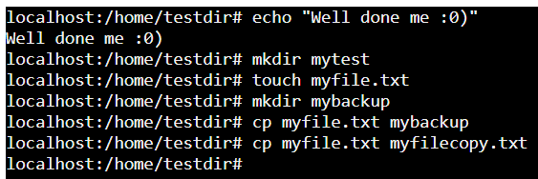
Figure 54: File management with ‘cp’ to copy file to another location or file (new if no match for filename).

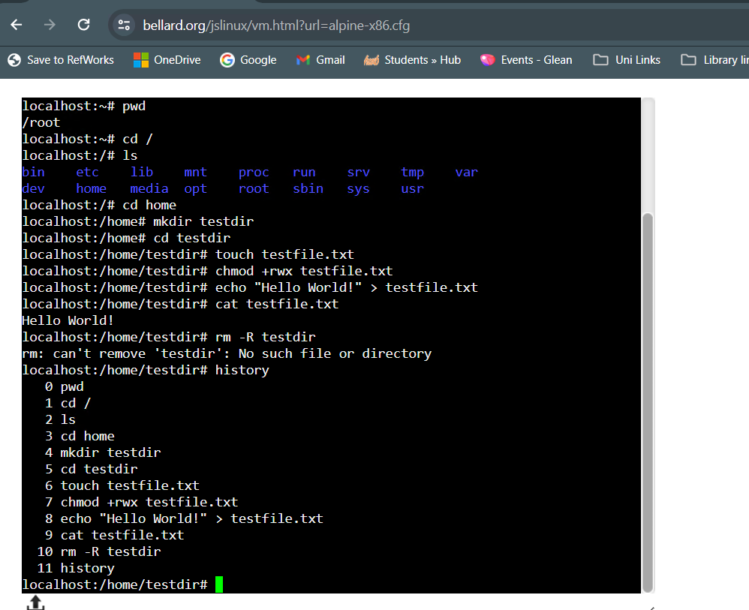
Figure 55: ‘rm -R’ remove, recursive (all contents). Directing to correct location and permissions before executing. The command ‘history’ used here to review steps by listing recent commands.

Network Management: ‘netstat’, ‘ping – c’

Commands such as ‘ip’ (useful with XDP protocols), ‘ping’, ‘traceroute’, ‘netstat’, ‘iptables’, and ‘nc’ allow users to configure network interfaces, diagnose connectivity issues, monitor network activity, and manage firewall rules.
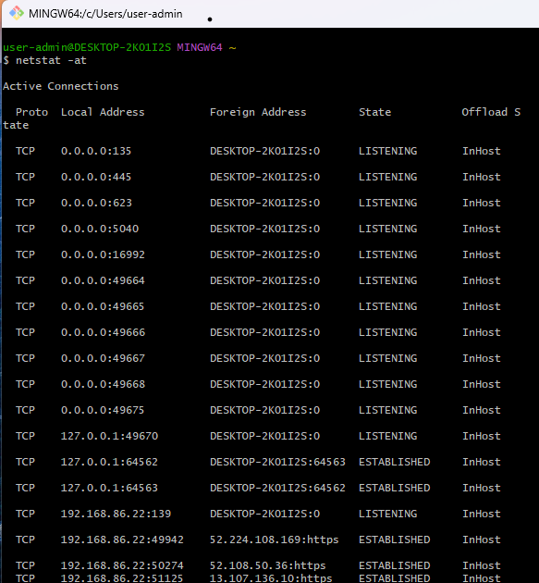
Figure 56: ‘Netstat’ extended with ‘-at’ to show TCP connections and listening ports. Command used in GitHub. [36]

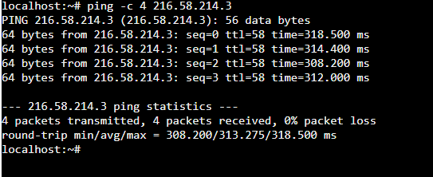
Figure 57: ‘Ping’. This command can be more resource intensive. Limited here to 4 pings for testing and managing available resources. [37]

User and Permission Management: ‘useradd’, ‘chmod’ (octal), ‘sudo’

User/permission management improves system and data security. Commands like ‘useradd’, ‘userdel’, ‘passwd’, ‘chown’, ‘chmod’, and ‘sudo’ are used to create, modify, and delete user accounts, assign ownership and permissions to files and directories, including elevated permissions for administrators.

Permissions are indicated by ‘r’ (read), ‘w’ (write) and ‘x’ (execute). Using the octal method gives more precise settings for levels of users. While it may look more complex than ‘r/w/x’, administrators can simultaneously set permissions for many users. [38]
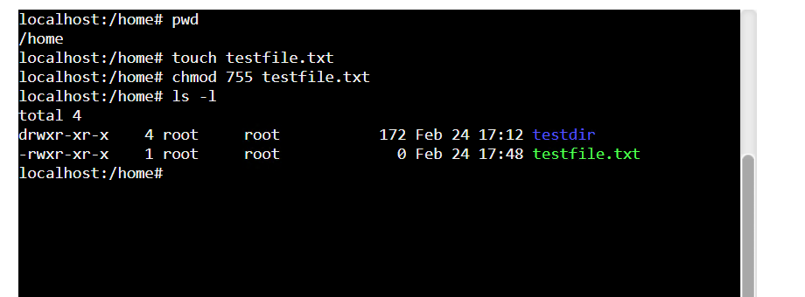
Figure 58: Expanding and combining commands for more precision eg ‘Chmod 755’ to set permissions and ‘ls -1’ to view further detail. Output starting with a ‘d’ and ‘a’ – indicates a directory and file respectively.

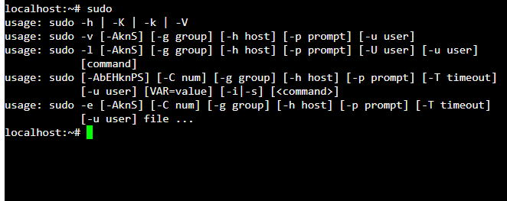
Figure 59: Experimenting with ‘sudo’ for limiting elevated permissions e.g. for a task/ time. Useful for balancing task activity and security. [39]

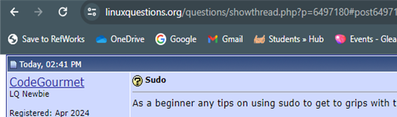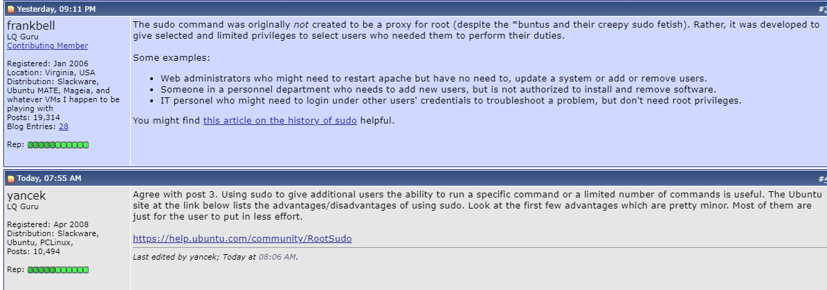
Figure 60: Using Linux Community forums as part of research for use of a command. [40]

The CLI can also be used for tasks such as patching, software upgrades and managing software on the system. With further experience this functionality could be explored more.

Use of Windows OS scripts

Scripting in Batch or PowerShell facilitates decision making, automation, enhances user interaction with scalable, repeatable code. Scripts handle complex file, user, performance, and network management, providing consistency, time savings, and efficiency.

“Scripting offers network professionals a powerful and flexible toolset to craft custom solutions that cater to specific network needs. Whether it's deploying configurations across various devices, monitoring network health, or automating security protocols, scripting serves as an essential component in a network administrator's toolkit.” [41]

Following code practice in tutorials, experimentation and research (syntax tutorialspoint.com), examples have been created and saved as Batch files (.bat).

Basic Syntax and Commands: ‘@Echo off’, ‘exit’, ‘exit /b’

Batch scripts echo commands to the console unless started with '@echo off'.

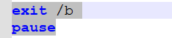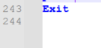
Figure 61: Starting with '@echo off', ‘exit /b’. (exit section) finishing with ‘exit’ (actions/ script complete. Unexpected exits before this, would indicate an error. [42]

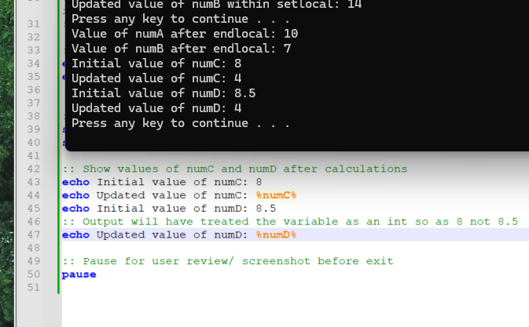
Figure 62: Demonstrating Batch treating floats number values as an Integer (sum ignores the decimal when dividing). Coding community boards suggest workarounds but warn these cause further issues. [43]. setlocaltest.bat.

Comments

Comments aid checks, track steps and clarify desired outcomes.

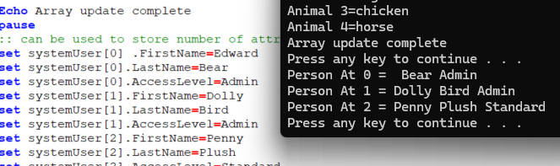
Figure 63: Creating comments using a double colon ‘(::)’ during class exercises and practice provided benefits when remembering and checking intended purpose of code against outputs. ‘Rem’ also works. Demofile.bat.

Variables: ‘set’, ‘%’, ‘~’

Variables store data in a script using ‘set’.

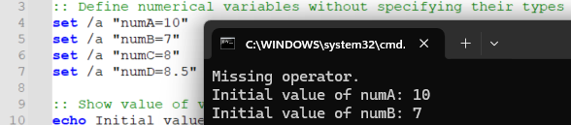
Figure 64: There is no need to specify types of data (e.g., str, int) as might be required in coding languages such as Python. setlocaltest.bat.

Variables have two types “One is for parameters which can be passed when the batch file is called and the other is done via the set command.” [44]

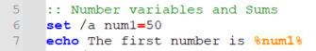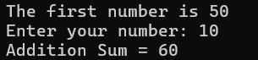
Figure 65: Variables can be stored as here as integers using '/a' or as strings. The ‘%’ symbol references the variable when called. Demofile.bat.

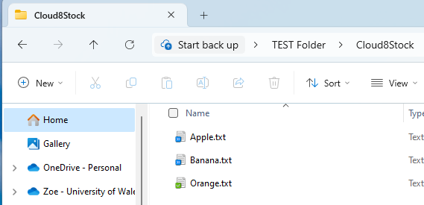
Figure 66: Variables can store dynamic or hardcoded information including file paths. Resulting location showing the stored file outputs in Windows File Explorer. Cloud 8.bat.

Variables holding values (or results of calculations), can be called and output as needed.
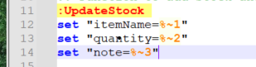
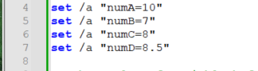
Figure 67: Variables using ‘set’ with ‘%’ and ‘~’ symbols (expansion) to return (feed into script) the values . (Cloud 8.bat). Using ‘set’ with ‘/a’ for numbers in setlocaltest.bat.

Set local environment

Sections of code can have local settings, applying only to parts of the script (local environment). This can ringfence processing and errors.

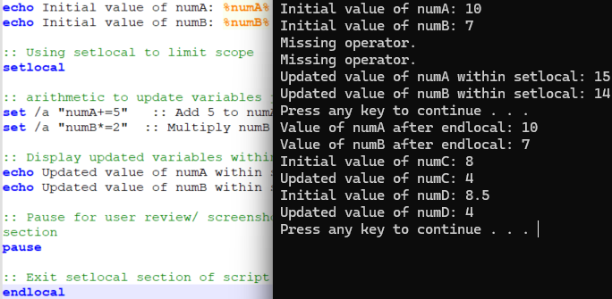
Figure 68: Using ‘setlocal’. After ‘endlocal’ the variables do not need resetting. Useful in nested elements and with ‘enabledelayedexpansion’. setlocaltest.bat. [45]

Input and Outputs

Inputs are controlled through tasks by incorporating menus, user input, and code execution. Outputs can be to the prompt or external files.

User Input: ‘/p’

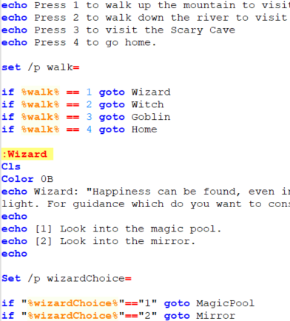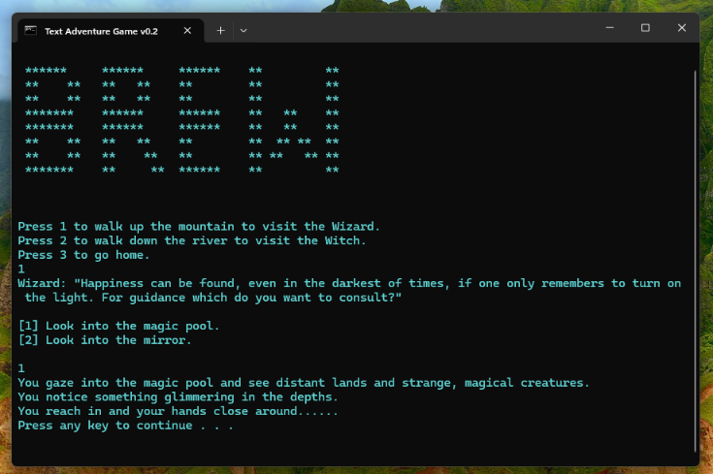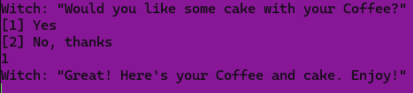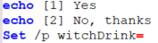
Figure 69: Developing Menus to aid and refine the capture and processing of user decisions. Text Adventure Gamev0.2.bat.

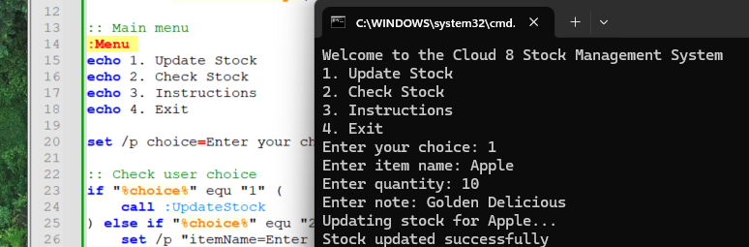
Figure 70: Menu Output to console with 'echo', input using set with '/p' prompting for user input and holding the input in a variable. Cloud 8.bat.

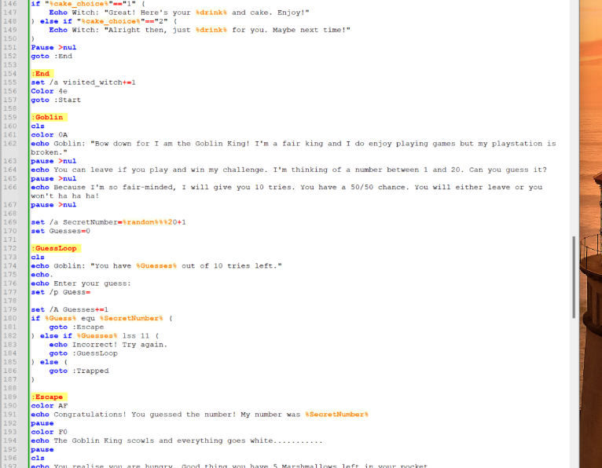
Figure 71: 'goto’ section which runs when the decision is selected via user input. Text Adventure Gamev0.2.bat

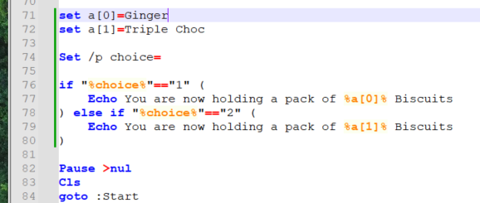
Figure 72: Selecting from an array from user input. Text Adventure Gamev0.2.bat

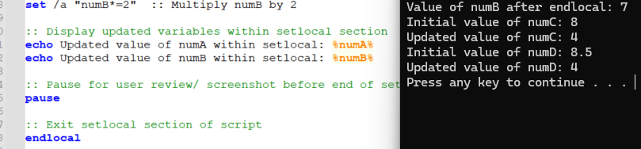
Figure 73: ‘Echo Out to prompt and instruct. Help commands are available to developers. Developers can provide help information for users with ‘echo’. setlocaltest.bat.

Output Formatting and Effects: ASCII, colour & ‘cls’

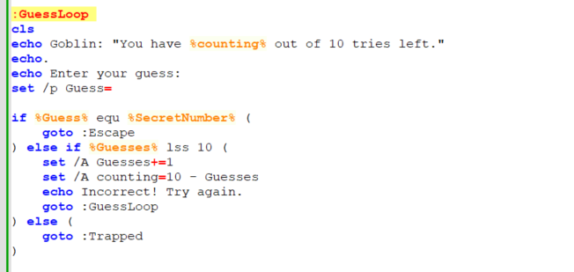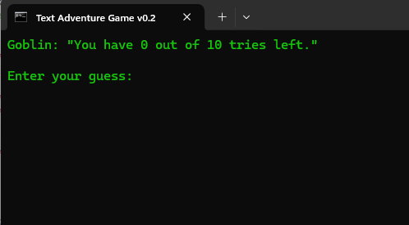
Figure 74: Echo using text and combination of predetermined text and variables that can be hard coded, from user input or a result. Text Adventure Gamev0.2.bat.

Batch text-based output lacks resource intensive audio and graphics, but creativity is possible. Visual interest can be added via changes to text, background colour and ASCII Art

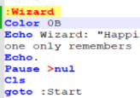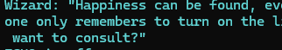
Figure 75: Colour code and ‘cls’ to clear screen of previous output, added as first step. Clearing the screen helped differentiate between activities and improved UX. Text Adventure Gamev0.2.bat. [46]

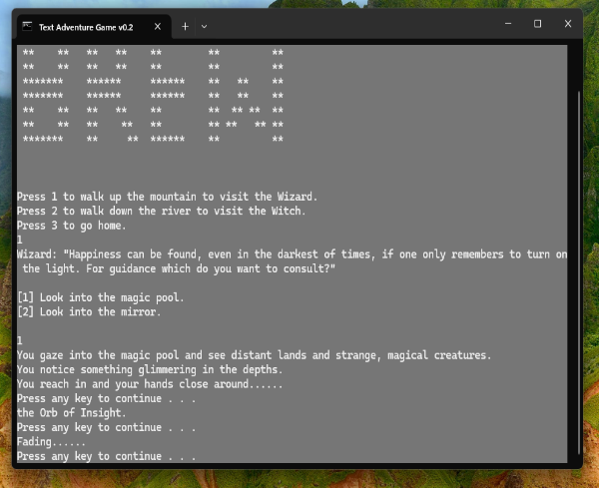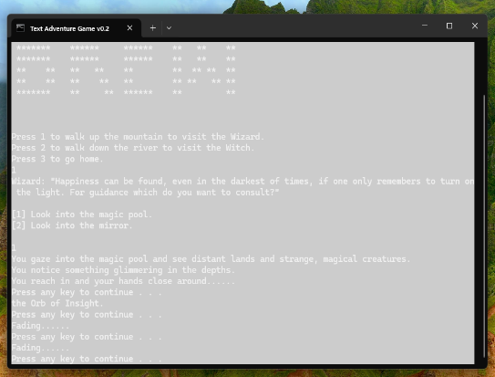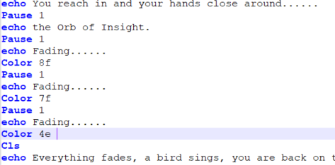
Figure 76: Using a change of colour to highlight different sections and create more dynamic experience. Could be used further, e.g. highlight incorrect input, or type of activity. Text Adventure Gamev0.2.bat.

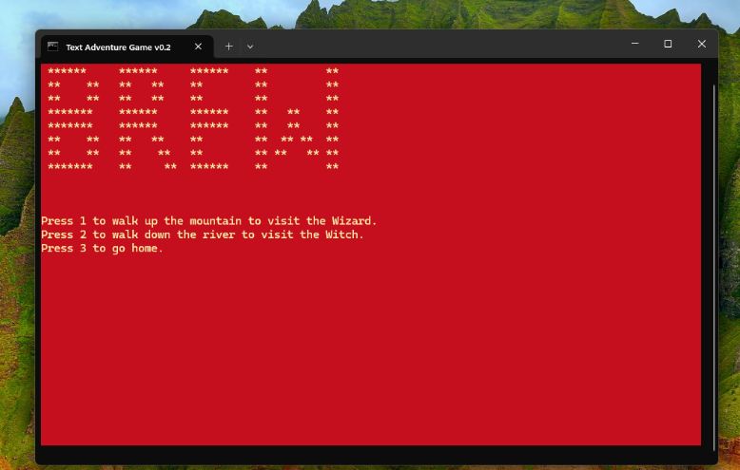
Figure 77: Adding a simple ASCII graphics effect to help game title stand out. Text Adventure Gamev0.2.bat.

Using Outputs for File, Performance, and Network Management

Scripts handle complex file, user, performance, and network management, providing consistency, time savings, and efficiency.

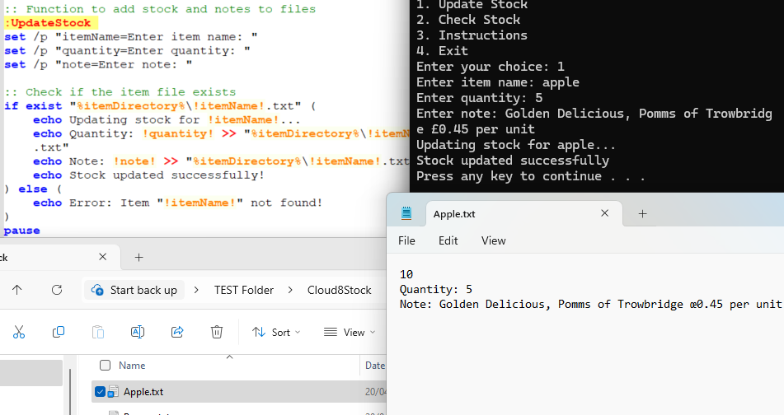
Figure 78: Data generated by the script and inputs can be output to console or stored in a file. Cloud 8.bat.

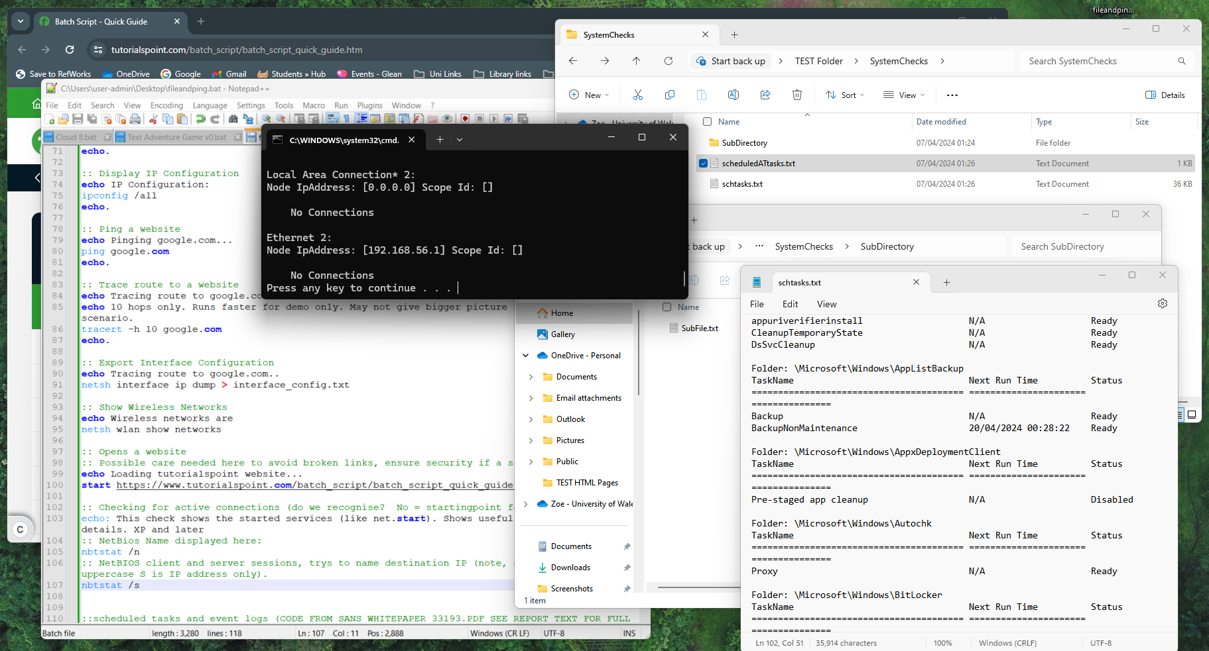
Figure 79: Automated and efficient task processing can be achieved with scripts. Details saved to files, with folder structures controlled .The above needs further work outside time constraints, around permissions and settings and using ‘ |’ for joining commands efficiently. Fileandping.bat. [47]

Control Structures

Commands can flow line by line, jump to other sections or run through iterations in loops.

‘Pause’

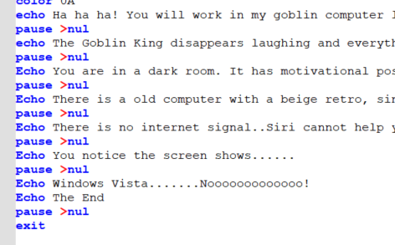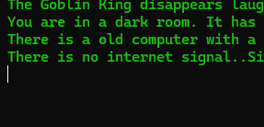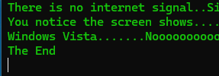
Figure 80: Using 'pause' to change pace and allow user greater control of the pace of the steps. Can be left out if just allowing script to run (automate). Text Adventure Gamev0.2.bat. [48]

Array

Arrays in Batch are simulated using variables and loops. They contain and group information which can also be interacted with as the script runs. “Another way to implement arrays is to define a list of values and iterate through the list of values.” [49]

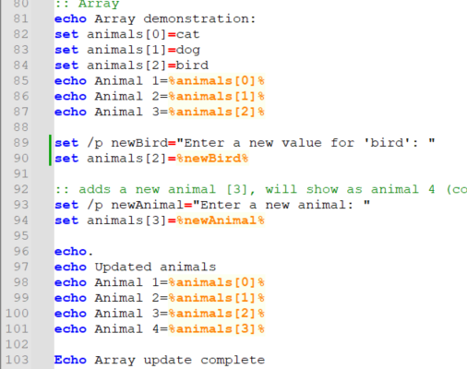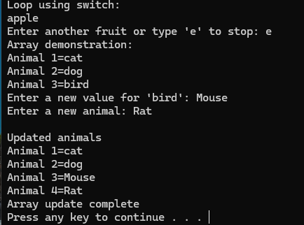
Figure 81: Variables used for an indexed Array started at position ‘[0]’ containing elements/ values of animals (‘cat’). The user input (‘-p’) allows modification. Arrays give potential to automate for changing elements e.g. filenames, performance thresholds or network configurations. Demo file.bat.

“If start# is less than end# the command executes. When the iterative variable exceeds end#, the command shell exits the loop. You can also use a negative step# to step through a range in decreasing values. For example, (1,1,5) generates the sequence 1 2 3 4 5 and (5,-1,1) generates the sequence 5 4 3 2 1.” [50]

The ‘/L’ switch allows iteration through the array without having to output indexed items individually.

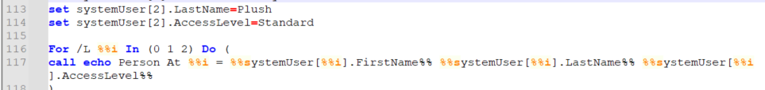
Figure 82: Using an Array with '/L' switch to run through iterations. Here checking user access information by iterating through a for loop. Demo file.bat

Decision-Making

“Decision-making structures require that the programmer specify one or more conditions to be evaluated or tested by the program, along with a statement or statements to be executed if the condition is determined to be true, and optionally, other statements to be executed if the condition is determined to be false.” [51]
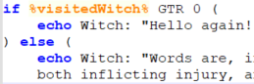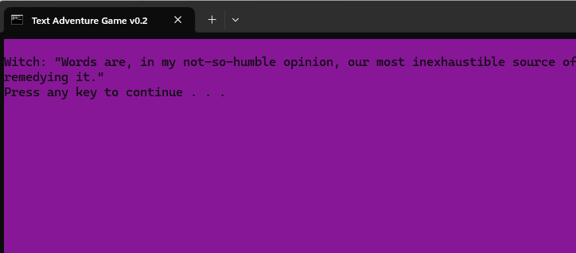
Figure 83: Decision creating 2 outcomes using a counter and without further user intervention. Increased complexity behind the scenes, increased functionality for user. Text Adventure Gamev0.2.bat.

If Statement: ‘if’, ‘else’

Batch “Has control structures such as for, if, while, switch for better automating and scripting.” [52]

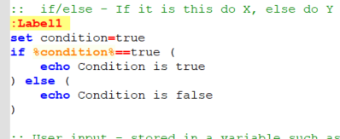
Figure 84: Use of 'if' and 'else' statements to determine if the condition is true or false and take different actions for each. These can be used together and/ or nested. Demofile.bat. [53]

Automation and Repeatable Code

Functions

Functions are built in, added from external libraries, or customised. They improve scalability, by creating reusable command blocks.

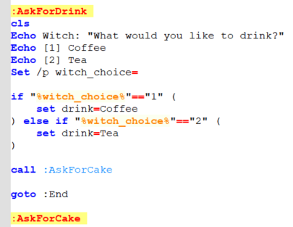
Figure 85: Function with self-describing label "AskForDrink" extending branches of story and can be reused and re-run from the first menu. Text Adventure Gamev0.2.bat

“Every function has a function name, which describes the task that the function performs. To use a function, you "call" that function with its name and pass its input values (known as arguments) that matches the types of the function's parameters.” [54]

‘Goto’

Steps can be linear, from user input or process outcomes. Organising scripts gives clarity, preventing issues, particularly in complex scripts. Scripts can run automatically, reducing repetition and user interventions/errors.

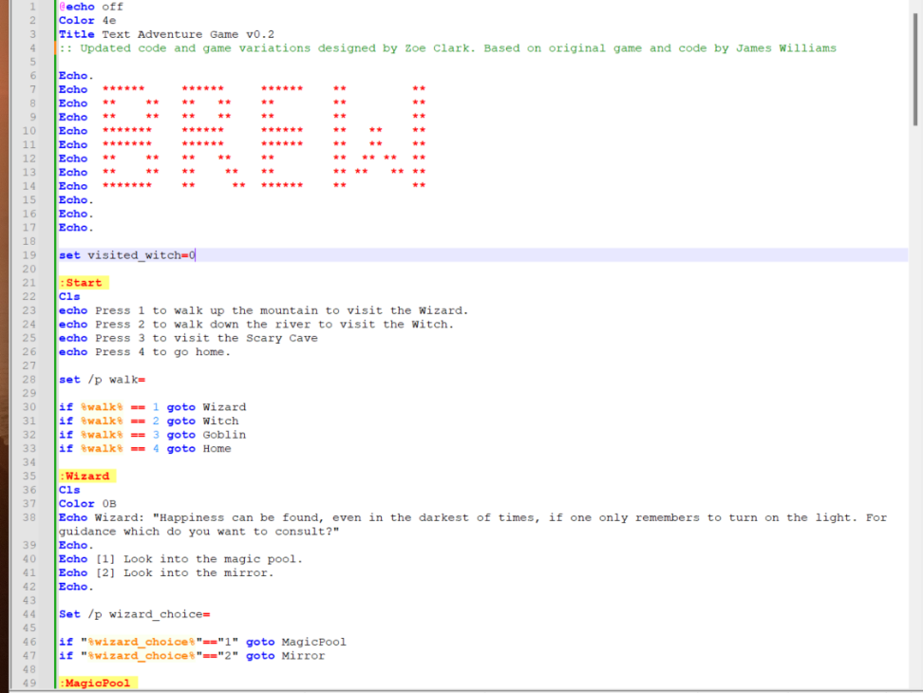
Figure 86: Here ‘if’ used with 'goto’, setting decision ranges and automatically directs the script to the next part of processing. Improves flow and avoids repeating code. Text Adventure Gamev0.2.bat

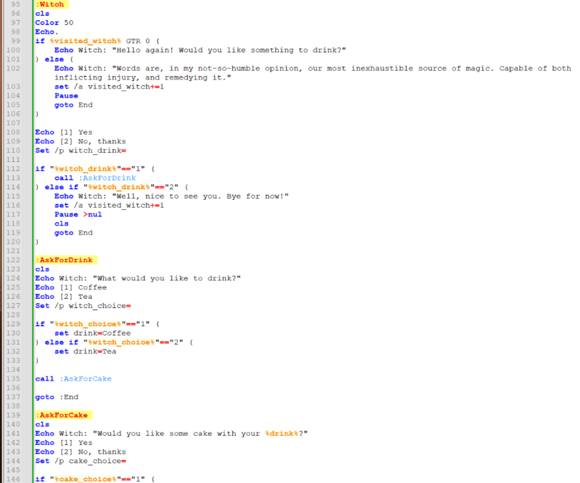
Figure 87: Code added to automate a decision of how the code is processed, following a user decision depending on number of times since the script has run. Text Adventure Gamev0.2.bat.

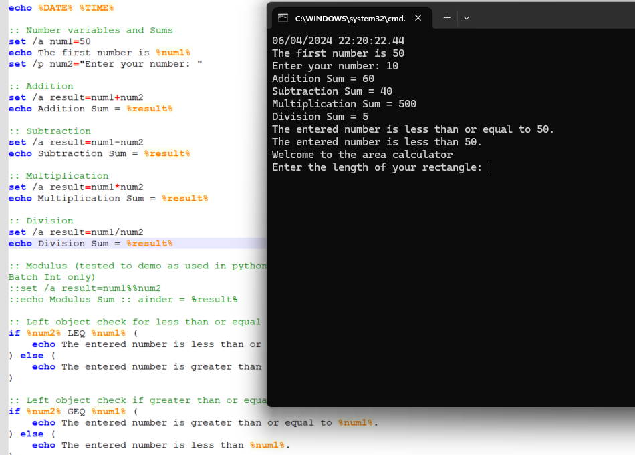
Figure 88: Script running automatically before pausing for user input. Additional scripts could also be linked and run automatically. Helpful when automating system tasks, managing files, configuring networks etc. Demofile.bat.

‘For’ Loop

Loops automate tasks. Iterating until conditions are met. Planning and testing are essential to avoid infinite loops and ensure accurate outputs. Especially with user input.

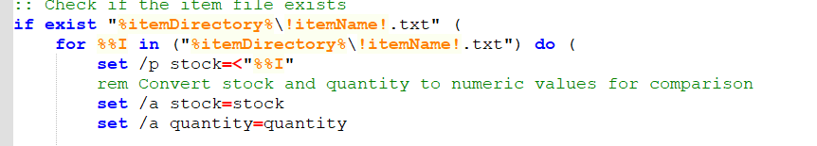
Figure 89: 'for’ Loop – Processes a set of sub actions (indicated by the indent) for stated iterations or in this case until the condition of file checks within the named directory is met. Cloud 8.bat.

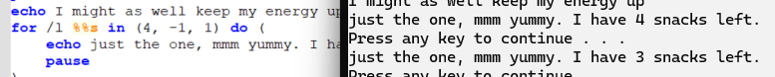
Figure 90: For loop which iterates by -1 each time to process and output a decreasing number with the looping echo. Text Adventure Gamev0.2.bat

“There is no direct while statement available in Batch Script but we can do an implementation of this loop very easily by using the if statement and labels” [55].

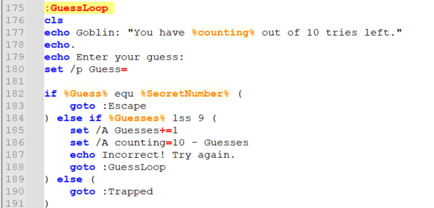
Figure 91: Combining a loop with 'goto' and functions to enhance functionality while reducing lines of code. Text Adventure Gamev0.2.bat

Error Handling and Debugging -
“Debugging is important because it allows to discover and to fix errors in a program before releasing it to the public.” [56]
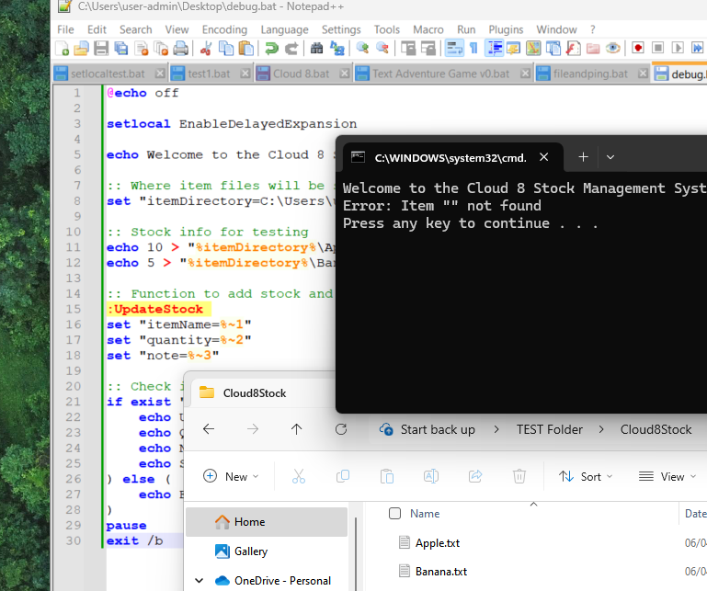
Figure 92: Testing outputs is important. Following checks that logic sound and syntax correct syntax user input added unexpected results. Adding an option to print out an error message or option to try again improves the scripts functionality. While ‘Echo’, ‘pause’ and ‘ErrorLevel’ pinpoint issues Cloud 8.bat.

Correct syntax is crucial. E.g. in arrays, a rogue ‘whitespace’ means an attribute doesn’t output. [57] Reviewing code and incremental testing helps identify errors, ensuring scripts run as intended.
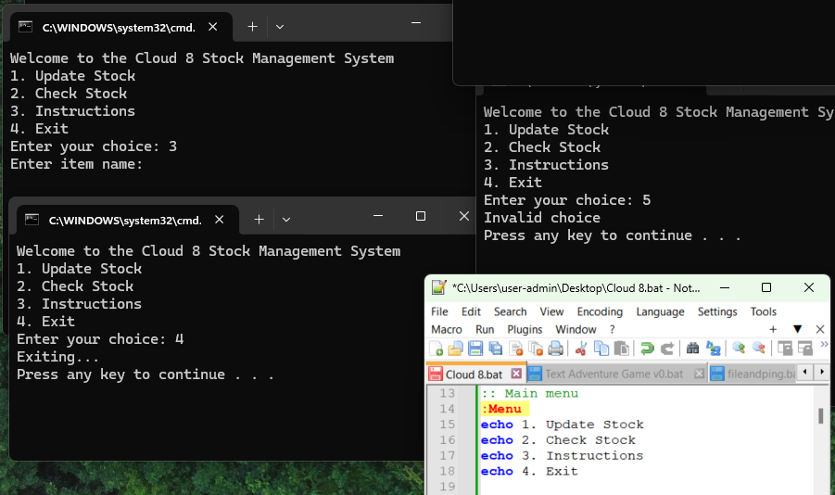
Figure 93: testing boundaries of conditions and options. Cloud 8.bat.

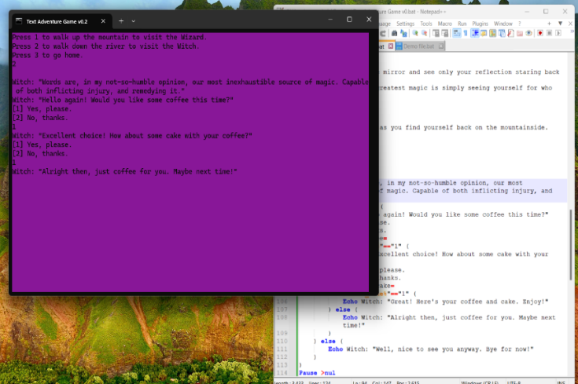
Figure 94: Identifying an issue with logic as well as syntax to ensure desired outcomes. Especially important with decision branches and nesting. Simplicity in design helps avoid errors. Text Adventure Gamev0.2.bat.

While Windows scripts are a powerful option, Linux scripts offer different advantages.

Use of Linux OS scripts

Linux integrates further with “your hardware architecture with much less interfacing than Windows. As a result, the execution of programs and scripts is made much more fluid. In terms of security too, everything is much clearer than on other operating systems. Indeed, here, there are no more resource-intensive cumulative updates” [58]

Basic Syntax and Commands

Git Bash used to demonstrate the following Bash scripts.

“Developers use shell commands for many tasks, such as file system management, network control, and process management. Bash is one of the most commonly used shells and plays an important role in Linux system development and maintenance” [59]

Common commands include ‘echo’ for displaying text, ‘mkdir’ for creating directories, and ‘cp’ for copying files. Commands can function differently to similarly named ones in Batch.

Shebang: ‘#!/bin/bash’
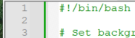
Figure 95: Sha Bang command used at the start to run Bash interpreter for the script. [60]

‘Echo’ and ‘$’
To print out data and return values, ‘echo’ is used.
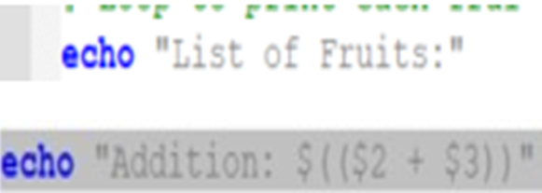
Figure 96: 'echo' for string and ‘$’ to use the value held or calculated in the variable. loopArrayCase.bash.
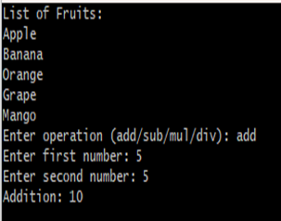
Figure 97: Instructions and returned values displayed using 'echo'. loopArrayCase.bash.

Comments: ‘#’
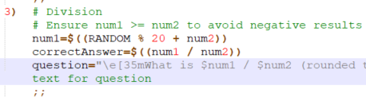
Figure 98: Comments created to clarify purpose of code using '#'. MathQuiz.Bash.

Variables

Variables store data, having an assigned label. (self-describing for clarity). Single quotes used with a variable will return string. Some variables are built in, such as ‘$SECONDS’. [61]

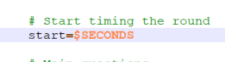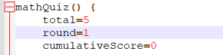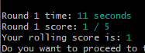
Figure 99: Built in variable '$SECONDS' and variables created using a label followed by '='. [62] MathQuiz.Bash.

Input and Output Handling: ‘read’, ‘-e’

Managing inputs and outputs is essential for interactions and processing. Controlled from the CLI directly, user input from prompts ( ‘- p’) or external files (as in section 4.2). Validation and formatting improve a scripts usability and reliability.

User input: ‘-p’

User input is gathered using ‘-p’. It can be captured or processed anytime during scripts, combining with other activities for processing and storage of data.

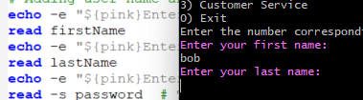
Figure 100: Experimentation with separate line input/ outputs ( ‘echo’ then ‘read’ on next line, ‘-p’ used with output text prompts). More work to differentiate all user input by colour could enhance readability and flow further. MathQuiz.bash and BashUserDetails.bash. [63]

Outputs: ‘printf’, ‘-s’ and colour

The command ‘printf’, offers increased formatting options over echo. This includes printing out floats (not processing, only formatting as string). [64]

Using options like ‘-e’ allow instructions starting with a backslash (e.g. ‘\n’)to be processed and not read as string or echoed out as part of the text.
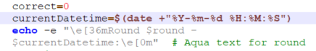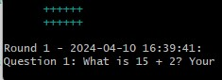
Figure 101: Using customised dynamic data e.g. date and time in script. This data will update each time the script is run. MathQuiz.bash. [65]

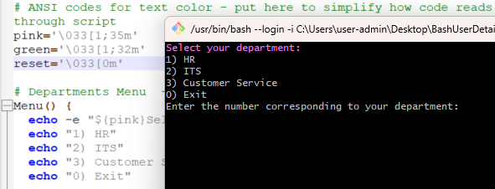
Figure 102: Adding settings to variables and adding user menus to improve flow and readability. BashUserDetails.bash.
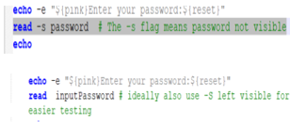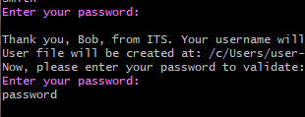
Figure 103: Using '-s' to hide a password for improved security. BashUserDetails.bash.

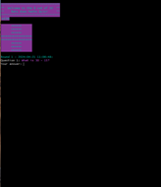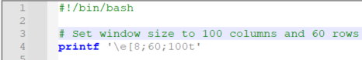
Figure 104: Resizing window when script runs. Adds another way to improve UX. In this case saves the user resizing during the game. MathQuiz.bash. [66]

Control Structures and Decision-Making: Array, ‘if’ statements, operators, ‘case’
​
Control structures, including conditional statements and loops, assist decision-making and iterative tasks in Linux scripts.

Arrays hold multiple data elements and accessed by index position or all at once.

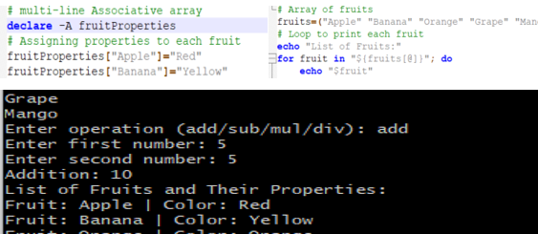
Figure 105: Array syntax in bash script with "@" symbol to print out whole array. Caution required if dealing with larger lists of data to avoid tying up resources. Used also for sets of data. loopArrayCase.bash

Statements ‘if’, ‘elif’, and ‘else’, run branches based on conditions.
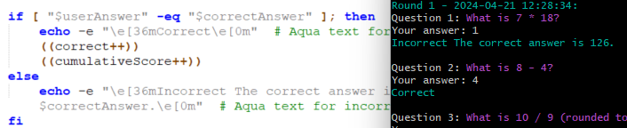
Figure 106: 'if' and 'else' used to output string or results combined with string depending on conditions being met. With Bash these statements are closed with the type of statement written in reverse e.g. ‘fi’. MathQuiz.bash.

Operators allow further processing, [67] data comparisons and file checks e.g. ‘+’ to add values, ‘-eq’ to compare (equal numbers). [68]

“A case statement in bash scripts is used when a decision has to be made against multiple choices. In other words, it is useful when an expression has the possibility to have multiple values.”

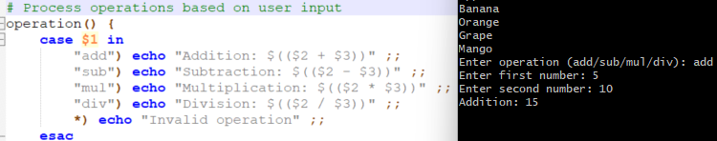
Figure 107: Bash does not have ‘goto’, instead using ‘case’. Starts with ‘case’ and ends with ‘esac’. More concise than stating options via number of ‘if’ statements. loopArrayCase.bash. [69]

Automation and Repeatable Code

Even with the stability of Linux, scripts are an efficient way to maintain and check systems and performance.

Functions and reusable code

Code blocks are created with labels and ‘called’ when needed.
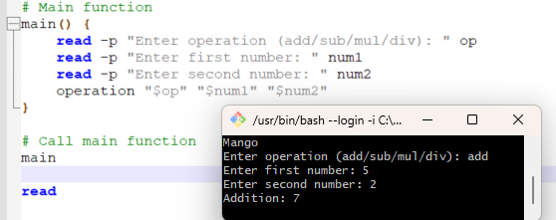
Figure 108: Code blocks echo out and/ or process data, here ‘called’ using the label ‘main’. Passing values to functions in this way has wide usage including user ID’s. loopArrayCase.bash.

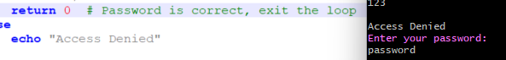
Figure 109 ‘return’ will return a value back from a function ($ to pass values to a function). BashUserDetails.bash.

Loops: ‘while’, ‘for’ and using ‘break’

Loops automate repeating condition checks.
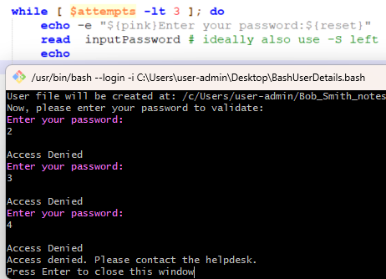
Figure 110: Shows a nested 'while' loop limiting incorrect password attempts to 3. Stops after reaching the limit to prevent infinite attempts or script halting. BashUserDetails.bash.
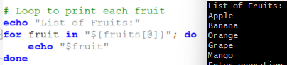
Figure 111: A ‘for’ loop used to print out automatically from an array. loopArrayCase.bash.

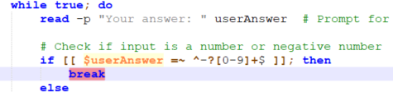
Figure 112: Using 'break' to exit a loop. MathQuiz.bash.

Error Handling and Debugging

Error handling and debugging are done via error checking, logging, and tools like '-v', '-n', and '-x’ to view before, as and after commands are executed. [70]

Reducing errors involves user prompts, limiting selections, and validating against required values.
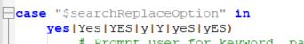
Figure 113: Using “|” to set out variations of acceptable inputs. A beep could be integrated to invalid input messages to further prompt users. MathQuiz.bash.

Mechanisms to handle unexpected inputs and errors. validating boundaries, testing options, maximum/ minimum values are key to script reliability.
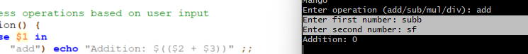
Figure 114: Testing showing further validation need to check for numerical input only. loopArrayCase.bash.

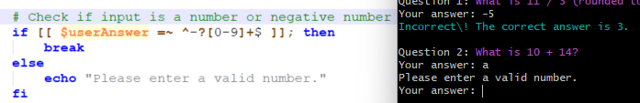
Figure 115: Validation using operators to check input, nesting within the while loop allows for validation, error handling and a return to the user prompt/ script continuation. MathQuiz.bash. [71]

File, Performance, and Network Management

Scripts handle many file, system, and network tasks.
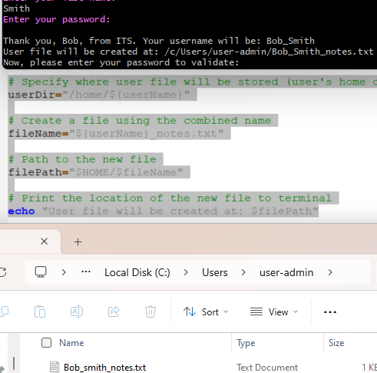
Figure 116: Creating a file for a user to store data based on previous input while controlling location to protect directories and systems. BashUserDetails.bash.

Text processing in Linux: ‘grep’

Options like ‘grep’, sed’ assist in handling files and their contents.

Figure 117: Use of 'grep' and ‘–l’ to list files containing a name provided by user input. BashUserDetails.bash.

‘Nano’

”..nano is an easy-to-use command line text editor for Unix and Linux operating systems. It includes all the basic functionality you’d expect from a regular text editor, like syntax highlighting, multiple buffers, search and replace with regular expression support, spellchecking, UTF-8 encoding, and more.” [72]

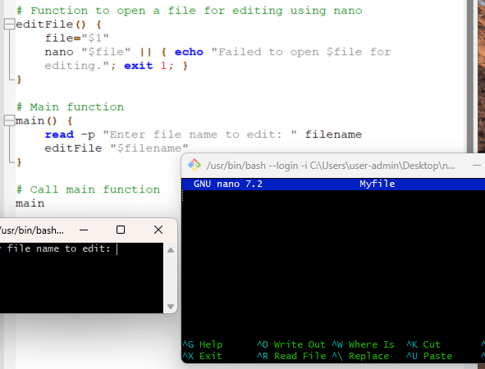
Figure 118: Launching ‘Nano’ via a script for interactive editing of file specified by user input. nanoUse.bash

Combining these features enables powerful interactions with the Linux OS at all levels.

Conclusion

Operating Systems manage complex interactions, enhancing UX but needing regular review for maximum efficiency and security. Across different OS environments, Effective scripting is key in achieving this.

Administrators need diverse skills that share key concepts to deal with the diverse OS used for varying needs.

Ingenuity of human computers like Jackson, Johnson, and Vaughn at NASA offer a reminder. While modern computing offers possibilities, humans are key in exploring and realising the potential.

References

[1] D, Hemmendinger, “Operating System, Computing,” britannica.com, (Nov 9, 2023) [Online] Available: https://www.britannica.com/technology/operating-system [Accessed Jan, 29, 2024]

[2] Codecademy Team, “What Is a Kernel?”, codecademy.com, (May 10, 2023) [Online] Available: https://www.codecademy.com/resources/blog/kernel/ [Accessed Mar, 3, 2024]

[3] S. Miller, ”What is an Operating System” codecademy.com, (Feb 24, 2023) [Online] Available: https://www.codecademy.com/resources/blog/operating-system/ [Accessed Jan, 29, 2024]

[4] I. Englander, The architecture of computer hardware and systems software & networking : an information technology approach, 5th edition. Hoboken, New Jersey: John Wiley & Sons, 2014. P477

[5] Fatima. “How To Choose An Operating System Ideal for Your Needs”, redswitches.com, (Feb, 5, 2024) [Online] Available: https://www.redswitches.com/blog/operating-system-selection/ [Accessed April, 7, 2024]

[6] R Babbush et al. “Quantum simulation of exact electron dynamics can be more efficient than classical mean-field methods” Nature communications, vol. 14, no. 1, pp. 4058–4058, Jul. 2023

[7] T. Mickle and K. Weise, “Microsoft Tops Apple to Become Most Valuable Public Company” nytimes.com, (Jan, 12, 2024 [Online] Available: https://www.nytimes.com/2024/01/12/technology/microsoft-apple-most-valuable-company.html [Accessed Mar, 10, 2024]

[8] Lenovo, “What is Microsoft Windows?” lenovo.com, [Online] Available: https://www.lenovo.com/gb/en/glossary/what-is-microsoft-windows/?orgRef=https%253A%252F%252Fwww.google.com%252F/ [Accessed Feb 24 2024]

[9] A. Rathbone, Windows 10 For Dummies, 4th edition. New Jersey: John Wiley & Sons, Inc., 2020. ch.1, p9.

[10] LogicMonitor, “9 reasons Linux is a popular choice for servers” logicmonitor.com, (Feb, 28, 2023) [Online] Available: https://www.logicmonitor.com/blog/9-reasons-linux-is-a-popular-choice-for-servers/ [Accessed Feb, 24, 2024]

[11] Apple, “Mac: If you can dream it, Mac can do it.” apple.com, [Online] Available: https://www.apple.com/uk/mac/ [Accessed Mar, 20, 2024]

[12] Science Museum Group, “'Baby' and the Birth of Modern Computing,” scienceandindustrymuseum.org.uk, (Jun 12, 2018) [Online] Available: https://www.scienceandindustrymuseum.org.uk/objects-and-stories/baby-and-modern-computing [Accessed Feb 3 2024].

[13] Centre for Computing History, ”Ferranti Mark 1 delivered to Manchester University,”computinghistory.org.uk, [Online] Available: https://www.computinghistory.org.uk/det/6044/Ferranti-Mark-1-delivered-to-Manchester-University/# [Accessed Feb, 3, 2024]. Image accredited to Manchester University.

[14] Apple, “Organise your files in the Finder on Mac.” apple.com, [Online] Available: https://support.apple.com/en-gb/guide/mac-help/mchlp2605/mac [Accessed Mar, 16, 2024]

[15] D. Soham, ‘I/O scheduling in Operating Systems’ geeksforgeeks.org, (Jun 28, 2023) [Online] Available: https://www.geeksforgeeks.org/i-o-scheduling-in-operating-systems/ [Accessed Feb, 11, 2024]

[16] Cisco, “What Is Network Management?” cisco.com, [Online] Available: https://www.cisco.com/c/en/us/solutions/enterprise-networks/what-is-network-management.html [Accessed Feb, 5, 2024]

[17] A. Clemm, M. F. Zhani, and R. Boutaba, “Network Management 2030: Operations and Control of Network 2030 Services,” Journal of network and systems management, vol. 28, no. 4, pp. 721–750, Mar. 2020

[18] Amazon, “What is a CLI?” aws.amazon.com, [Online] Available: https://aws.amazon.com/what-is/cli/ [Accessed Feb, 14, 2024]

[19] R. Harwood et al, “Windows Commands” learn.microsoft.com, (Apr, 26, 2023) [Online] Available: https://learn.microsoft.com/en-us/windows-server/administration/windows-commands/windows-commands [Accessed Feb, 16, 2024]

[20] Tutorials Point, “Batch Script – Commands” tutorialspoint.com, [Online] Available: https://www.tutorialspoint.com/batch_script/batch_script_commands.htm [Accessed Mar, 2, 2024]

[21] W3Schools, “What is Command Line Interface (CLI)?” w3schools.com, [Online] Available https://www.w3schools.com/whatis/whatis_cli.asp [Accessed Feb, 29, 2024]

[22] A. Bamania, “8 Dangerous PowerShell Commands That Will Break A Computer” levelup.gitconnected.com, (Apr 23, 2023) [Online] Available: https://levelup.gitconnected.com/8-dangerous-powershell-commands-that-will-break-a-computer-5f252dfa7777 - Apr 23, 2023 [Accessed Mar, 22, 2024]

[23] J. Gerend et al, “time”, learn.microsoft.com, (Mar 2, 2023) [Online] Available: https://learn.microsoft.com/en-us/windows-server/administration/windows-commands/time [Accessed Mar, 9, 2024]

[24] B. Gavin, “How to Use the Ping Command to Test Your Network” howtogeek.com, (Aug 21, 2023) [Online] Available: https://www.howtogeek.com/355664/how-to-use-ping-to-test-your-network/ [Accessed Mar, 3, 2024]

[25] Tutorials Point, “Batch Script – Input/ Output”, tutorialspoint.com, [Online] Available: https://www.tutorialspoint.com/batch_script/batch_script_input_output.htm [Accessed Mar, 15, 2024]

[26] V. Pathmanathan, “Mastering Windows Troubleshooting: Essential CMD Commands for System Admins”, linkedin.com, (Oct, 28, 2023) [Online] Available: https://www.linkedin.com/pulse/mastering-windows-troubleshooting-10-essential-cmd-pathmanathan-dqxjc published [Accessed Mar, 2, 2024]

[27] Udemy Team, “The Top 20 Reasons Why You Should Use Linux”, udemy.com, (Oct, 2021) [Online] Available: https://blog.udemy.com/why-use-linux/ [Accessed Mar, 2, 2024]

[28] S. Sheppard, “An A-Z Index of the Linux command line: bash + utilities.” ss64.com [Online] Available: https://ss64.com/bash/ [Accessed Mar, 2, 2024]

[29] Linkedin, “Learning Linux command line”, linkedin.com, (Feb, 22, 2023) [Online] Available: https://www.linkedin.com/learning/learning-linux-command-line-14447912/learning-linux-command-line?u=77966930 [Accessed Mar 3 2024]

[30] F. Bellard, “JSLinux”, bellard.org, [Online] Available: https://bellard.org/jslinux/ [Accessed Feb, 22, 2024]

[31] R. Gerardi, “7 Linux commands to gather information about your system”, redhat.com, (Oct, 27, 2022) [Online] Available: https://www.redhat.com/sysadmin/linux-system-info-commands. [Accessed Mar, 2, 2024]

[32] A. Garnett, “How To Use ps, kill, and nice to Manage Processes in Linux”, digitalocean.com, (Mar, 17, 2022) [Online] Available: https://www.digitalocean.com/community/tutorials/how-to-use-ps-kill-and-nice-to-manage-processes-in-linux [Accessed Mar, 10, 2024]
[33] S. Kenlon, “Navigating your filesystem in the Linux terminal” redhat.com, (Jun, 11, 2019) [Online] Available: https://www.redhat.com/sysadmin/navigating-filesystem-linux-terminal [Accessed Mar, 3, 2024]

[34] P. Brown,” Classic SysAdmin: The Linux Filesystem Explained”, linuxfoundation.org, (Feb, 27, 2022) [Online] Available: https://www.linuxfoundation.org/blog/blog/classic-sysadmin-the-linux-filesystem-explained [Accessed Mar, 3, 2024]

[35] W. E. Shotts, “Manipulating Files”, linuxcommand.org, [Online] Available: https://linuxcommand.org/lc3_lts0050.php [Accessed Mar, 3, 2024]

[36] E. Siever, S. Figgins, R. Love, A. Robbins, Linux in a nutshell, 6th ed. Sebastopol: O’Reilly, 2009. ch.3, pp. 306-307.

[37] E. Siever, S. Figgins, R. Love, A. Robbins, Linux in a nutshell, 6th ed. Sebastopol: O’Reilly, 2009. ch.3, pp. P327-328.

[38] D. Garn, “How to manage Linux permissions for users, groups, and others”, redhat.com, (Nov, 26, 2020) [Online] Available: https://www.redhat.com/sysadmin/manage-permissions [Accessed Mar, 9, 2024]

[39] M. Aleksic, “How to Use the sudo Command in Linux”, phoenixnap.com, (Aug, 18, 2020) [Online] Available: https://phoenixnap.com/kb/linux-sudo-command [Accessed Mar, 11, 2024]

[40] - LinuxQuestions.org, “LinuxQuestions.org - where Linux users come for help”, linuxquestions.org, [Online] Available: https://www.linuxquestions.org/ [Accessed Apr, 15, 2024]

[41] A. Chen, “The Power of Scripting in Network Administration”, linkedin.com, (Nov, 11, 2023) [Online] Available: https://www.linkedin.com/pulse/power-scripting-network-management-kai-chen-qp30c [Accessed Mar, 17, 2024]

[42] Urban Dictionary, “@echo off”, urbandictionary.com (Jan, 25, 2020) [Online] Available: https://www.urbandictionary.com/define.php?term=%40echo%20off [Accessed Mar, 17, 2024]

[43] Stack Overflow, “Floating point division in a batch file”, (Feb, 2022) [Online] Available: https://stackoverflow.com/questions/1503888/floating-point-division-in-a-batch-file [Accessed Mar, 1, 2024]

[44] Tutorials Point, “Batch Script - Variables”, tutorialspoint.com, [Online] Available: https://www.tutorialspoint.com/batch_script/batch_script_variables.htm [Accessed Mar, 1, 2024]

[45] J. Gerend et al, “setlocal”, learn.microsoft.com, (Mar 2, 2023) [Online] Available: https://learn.microsoft.com/en-us/windows-server/administration/windows-commands/setlocal [Accessed Mar 10]

[46] S. Sheppard, “COLOR” ss64.com Available: https://ss64.com/nt/color.html [Accessed Feb 29 2024]

[47] R. Harwood et al, “Windows Commands”, learn.microsoft.com, (Apr 26, 2023) [Online] Available: https://learn.microsoft.com/en-us/windows-server/administration/windows-commands/windows-commands [Accessed Feb 27, 2024]

[48] C. Hoffman, “How to Write a Batch Script on Windows”, howtogeek.com, (Sep 6, 2023) [Online] Available: https://www.howtogeek.com/263177/how-to-write-a-batch-script-on-windows/ [Accessed Feb 27, 2024]

[49] Tutorials Point, “Batch Script - Arrays”, tutorialspoint.com, [Online] Available: https://www.tutorialspoint.com/batch_script/batch_script_arrays.htm [Accessed Mar, 1, 2024]

[50] R. Harwood et al, “for”, learn.microsoft.com, (Apr 26, 2023) [Online] Available: https://learn.microsoft.com/en-us/windows-server/administration/windows-commands/for [Accessed Feb 27, 2024]

[51] Tutorials Point, “Batch Script - Decision Making”, tutorialspoint.com, [Online] Available:
https://www.tutorialspoint.com/batch_script/batch_script_decision_making.htm
[Accessed Mar, 1, 2024]

[52] Tutorials Point, “Batch Script - Overview”, tutorialspoint.com, [Online] Available: https://www.tutorialspoint.com/batch_script/batch_script_overview.htm[Accessed Mar, 1, 2024]

[53] S. Sheppard, “IF” ss64.com, [Online] Available: https://ss64.com/nt/if.html [Accessed Mar, 1, 2024]
[54] Tutorials Point, “Batch Script - Functions”, tutorialspoint.com, [Online] Available: https://www.tutorialspoint.com/batch_script/batch_script_functions.htm [Accessed Mar, 5, 2024]
[55] Tutorials Point, “Batch Script - While Statement Implementation”, tutorialspoint.com, [Online] Available: https://www.tutorialspoint.com/batch_script/batch_script_while_statement_implementation.htm [Accessed Mar, 2, 2024]
[56] Tutorials Point, “Batch Script - Debugging”, tutorialspoint.com, [Online] Available: https://www.tutorialspoint.com/batch_script/batch_script_debugging.htm [Accessed Mar, 30, 2024]
[57] S. Janson, “Windows Batch Scripting: Variables”, steve-jansen.github.io, (Mar, 1, 2013) [Online] Available: https://steve-jansen.github.io/guides/windows-batch-scripting/part-2-variables.html [Accessed Mar, 2, 2024]
[58] Datascientest, “Linux: Why is it the most liked OS for developers?”, datascientest.com, (Feb, 27, 2023) [Online] Available: https://datascientest.com/en/linux-the-preferred-os-for-developers#:~:text=Speed%20and%20fluidity%20of%20execution,is%20made%20much%20more%20fluid [Accessed Mar, 17, 2024]

[59] C. Yu, G. Yang, X. Chen, K. Liu, and Y. Zhou, “BashExplainer: Retrieval-Augmented Bash Code Comment Generation based on Fine-tuned CodeBERT,” in 2022 IEEE International Conference on Software Maintenance and Evolution (ICSME), 2022, pp. 82–93. doi: 10.1109/ICSME55016.2022.00016. [Online] Available: https://ieeexplore-ieee-org.ezproxy.uwtsd.ac.uk/document/9978203 [Accessed Mar, 12, 2024]

[60] K. Pykes, “How to Write a Bash Script: A Simple Bash Scripting Tutorial”, datacamp.com, (Nov, 2022) [Online] Available: https://www.datacamp.com/tutorial/how-to-write-bash-script-tutorial [Accessed Mar, 16, 2024]

[61]D. Mckay, “How to Work with Variables in Bash”, howtogeek.com, (Aug, 12, 2023) [Online] Available: https://www.howtogeek.com/442332/how-to-work-with-variables-in-bash/ [Accessed Mar, 17, 2024]

[62] Stack Exchange, “How to use a timer in bash?”, stackexchange.com, (Feb,2020) [Online] Available: https://unix.stackexchange.com/questions/53841/how-to-use-a-timer-in-bash [Accessed Mar, 3, 2024]

[63] techStop, “Colors In Bash Scripts”, techstop.github.io, (Oct, 3, 2019) [Online] Available: https://techstop.github.io/bash-script-colors/ [Accessed Mar, 22, 2024]

[64] Tutorials Point, “Bash Printf - How to Print a Variable in Bash”, tutorialspoint.com, [Online] Available: https://www.tutorialspoint.com/bash-printf-how-to-print-a-variable-in-bash [Accessed Mar, 17, 2024]

[65] D. Mckay, “How to Display the Date and Time in the Linux Terminal (and Use It In Bash Scripts)”, howtogeek.com, (Aug, 12, 2023) [Online] Available: https://www.howtogeek.com/410442/how-to-display-the-date-and-time-in-the-linux-terminal-and-use-it-in-bash-scripts/ [Accessed Mar, 24, 2024]

[66] Stack Overflow, “Bash command to change size of bash window”, stackoverflow.com, (Jan 2022) [Online] Available: https://stackoverflow.com/questions/5243445/bash-command-to-change-size-of-bash-window [Accessed Mar, 24, 2024]

[67] GeeksforGeeks, “Basic Operators in Shell Scripting”, geeksforgeeks.org, (Apr, 17, 2024), [Online] Available: https://www.geeksforgeeks.org/basic-operators-in-shell-scripting/ [Accessed Apr, 17, 2024]

[68] G. Ranuglia, “Compare Numbers in Bash | Scripting Command Guide”, ioflood.com, (Nov, 28, 2023), [Online] Available: https://ioflood.com/blog/bash-compare-numbers/#:~:text=In%20Bash%2C%20you%20can%20compare,the%20relationship%20between%20two%20numbers.&text=In%20this%20example%2C%20we're,gt%20(greater%20than)%20operator. [Accessed Mar, 15, 2024]

[69] GeeksforGeeks, “Basic Operators in Shell Scripting”, geeksforgeeks.org, (Sept, 15, 2024), [Online] Available: https://www.geeksforgeeks.org/bash-scripting-case-statement/ [Accessed Mar, 12, 2024]

[70] K. Shubhneesh, “Debugging a Bash Script”, baeldung.com, (Mar, 18, 2024), [Online] Available: https://www.baeldung.com/linux/debug-bash-script [Accessed Mar, 22, 2024]
[71] Stack Exchange, “Bash test: what does "=~" do?, stackexchange.com, (Mar,2023) [Online] Available: https://unix.stackexchange.com/questions/340440/bash-test-what-does-do [Accessed Mar, 17, 2024]
[72] Linuxize,” How to Use Nano, the Linux Command Line Text Editor”, linuxize.com, (Dec, 12, 2023) [Online] Available: https://linuxize.com/post/how-to-use-nano-text-editor/ - [Accessed Apr, 10, 2024]

Further Reading

Google, “Our quantum computing journey”, quantumai.google, [Online] Available: https://quantumai.google/learn/map [Accessed Feb, 4, 2024].

T. Proffitt, Simple Windows Batch Scripting for Intrusion Discovery, SANS, 33193. 2009 [Online] Available: https://www.sans.org/white-papers/33193/ [Accessed Mar, 25, 2024].

E. Siever, S. Figgins, R. Love, A. Robbins, Linux in a nutshell, 6th ed. Sebastopol: O’Reilly, 2009.

Image Citations
Figure 1: Windows Interface shows - Task manager, File Explorer and Word Software in GUI view. Also shown (in black) is the text-based Command Line Prompt (CLI). 6
Figure 2: OS Types ranging from small scale Embedded OS, as used in individual devices to large scale Network OS linking LAN’s (local area networks) and internet etc. [5] 6
Figure 3: Microsoft increasing market value over Apple, observed around a period of development in generative A.I. [7] 7
Figure 4: Linked functionality through wireless connections, provides the ability to work across mobile and other types of OS e.g. Apple Mobile iOS, linkable to macOS. [11] 8
Figure 5: Windows Task Manager, easily filtered. Shown is CPU, Memory (RAM), disc (storage) and Network activity. Options include current, historical and startup activity. 9
Figure 6: Creating a Dump File from Task Manager via menu selection. This gives a snapshot of memory including high utilisation for analysis of performance or errors. 9
Figure 7: Performance Management in Windows Task Manager, visualising real time performance. The OS manages performance to prevent deadlock, this tool allows user interaction to enhance performance management. 9
Figure 8: Task Scheduler – Users can set tasks to automatically run processes. 9
Figure 9: Startup Tab - Improving startup time through managing what can run automatically when device is booted up. 10
Figure 10: Process Explorer showing linked processes and threads. Useful for narrowing down root causes of issues and spotting suspicious processes or behavior of processes. 10
Figure 11: Details live monitoring activity via Resource Manager. Live monitoring activity gives dynamic insights also important in cloud-based OS. 10
Figure 12: An OS manages error handling and system errors. The reliability monitor displays events including these that impact system reliability. 11
Figure 13: Windows Resource Monitor. Insights and monitoring of system memory resources. 11
Figure 14: Figure 14: Ferranti’s ‘Baby.’ Key development in memory storage and software execution.[12]. Modern memory includes RAM, VRAM or fast access, and SSDs for long-term storage. 12
Figure 15: Designers and Turing overlooking Ferranti ‘Mark 1’ Console - First commercially available, general-purpose computer, with program storage (delivered Feb 1951). [13] Essential for running systems and software in an OS. 12
Figure 16: Windows File Explorer showing Quick Access navigation feature and a saved file within a folder and C disc Properties showing file system type and disc storage. 12
Figure 17: Windows Device Manager and pop-up screen opened by double clicking on one of the devices listed. Shows device details and the peripherals e.g. keyboards and mice. 13
Figure 18: Managing Security through User Management, via Windows control panel. 13
Figure 19: User Management provides insights into user authentication processes, including password management and user account settings used to protect systems and data. 13
Figure 20: Managing Security Features such as Firewalls, preventing unauthorized access via the network. It can also link to 3rd Party software such as Norton to confirm protection status. 14
Figure 21: Windows Defender advanced options such as managing firewall rules (Windows 10). 14
Figure 22: Managing BitLocker encryption settings to protect OS and user data. Encryption is used to protect storage including directories and files stored. 14
Figure 23: Managing Security by checking and installing updates which include improvements, bug fixes and security patches. 14
Figure 24: Protecting data by saving to external drives or the cloud. Allows restoration or recovery. 15
Figure 25: Network Management on Windows. An OS manages network protocols e.g. HTTP, TCP, and IP addressing to identify networked devices. Both at the Local (LAN) and wider (WAN) access levels. 15
Figure 26: Accessing System and Security or Network and Internet settings via the Windows Control Panel. Control of user accounts can protect file. 15
Figure 27: Displays OS version and key system information using 'ver' and 'systeminfo' commands in the Command Line Shell interface. 16
Figure 28: Use of ‘time’ to display (can also set) OS time. [23] 17
Figure 29: ‘Taskmgr’ used to open Windows Task Manager directly from the command interface. One instruction with no navigation involved. 17
Figure 30: ‘Tasklist’ - Lists current running processes including memory usage. 17
Figure 31: ‘resmon’ - Opening the resource monitor from the CLI. 17
Figure 32: ‘perfmon’. Viewing Information in Performance Monitor with a single command. 18
Figure 33: ‘perfmon/rel’ - Opening Reliability monitor, viewing report and identifying sources of reliability issues. 18
Figure 34: ‘eventvwr’ - Opening Windows OS Event Viewer. 18
Figure 35: ‘Powercfg /batteryreport’ – Saved HTML file output. File can then be accessed via GUI or by navigating to file location in the CLI. 18
Figure 36: ‘cd’ and practice error. Command required before using file path. ‘cd..’ used to move back through the directory structure. 19
Figure 37: command ‘tree’ showing the branched structure in command line and in the GUI based File Explorer for comparison. 19
Figure 38: ‘sort’ used with ‘>’ to copy, sort and save a file in one line of command. Adding ‘>>’ will apend to files giving extra flexibility directly from the CLI. 19
Figure 39: ‘dir’ - contents from the current directory. CLI indicates user and path of directory with the details. Adding a ‘|’ (pipe) allows use with further commands, used here to select by file type .txt. using ‘dir | find’. 20
Figure 40: Viewing IP routing via ‘route print’. Assists with diagnosing connectivity issues. 20
Figure 41: ‘Ping -t’ and google.com’ (class materials) and ‘ping -n’. Useful to check if a connection issue is local or internet level. Ping refers to time taken for packets to be sent and received. [24] 20
Figure 42: Using ‘netstat’ to look for network-related issues. Current state established confirms working correctly. ‘net’ can be combined to assist with managing, starting and stopping various network services as seen when used with help to view options. 21
Figure 43: ‘Ping -t’ and google.com’ (class materials) and ‘ping -n’. Useful to check if a connection issue is local or internet level. Ping refers to time taken for packets to be sent and received. [24] 21
Figure 44: IP configuration detail saved to text file. Increased analysis through logging, collating, and viewing historical data using ‘ipconfg’ with the file path, name and type. 21
Figure 45: ‘chkdsk’ - Some commands require elevated administrator privileges to run. Additional functionality and access to core systems and therefore greater risks. 22
Figure 46: Administrators privileges must be enabled, to fully utilise the power of CLI commands like ‘sfc’ which allow interaction with critical system files. 22
Figure 47: Practicing following tutorial. "Echo" to print text out to the command line. 22
Figure 48: Using Linux Cli commands via Bellard.org. [30] 23
Figure 49: use of ‘lscpu’ with ‘-p’ and ‘-J’ and errors that remind that help with commands is also built in. Here easily resolved. By use of lower instead of uppercase. 23
Figure 50: Extending commands allows more precision e.g. ‘ps aux’ for a more detailed overview of running processes. 24
Figure 51: Output after running ‘top’ command via Bellard.org. 24
Figure 52: ‘pwd’ showing displaying the current directory (user root), ‘CD /’ to change directory and ‘ls’ to list its contents. 24
Figure 53: File manipulation, ‘mkdir’ to make a directory, ‘touch’ creates empty files, ‘Chmod’ to set permissions ‘cat’ to concatenate and display contents. 25
Figure 54: File management with ‘cp’ to copy file to another location or file (new if no match for filename). 25
Figure 55: ‘rm -R’ remove, recursive (all contents). Directing to correct location and permissions before executing. The command ‘history’ used here to review steps by listing recent commands. 26
Figure 56: ‘Netstat’ extended with ‘-at’ to show TCP connections and listening ports. Command used in GitHub. [36] 26
Figure 57: ‘Ping’. This command can be more resource intensive. Limited here to 4 pings for testing and managing available resources. [37] 26
Figure 58: Expanding and combining commands for more precision eg ‘Chmod 755’ to set permissions and ‘ls -1’ to view further detail. Output starting with a ‘d’ and ‘a’ – indicates a directory and file respectively. 27
Figure 59: Experimenting with ‘sudo’ for limiting elevated permissions e.g. for a task/ time. Useful for balancing task activity and security. [39] 27
Figure 60: Using Linux Community forums as part of research for use of a command. [40] 27
Figure 61: Starting with '@echo off', ‘exit /b’. (exit section) finishing with ‘exit’ (actions/ script complete. Unexpected exits before this, would indicate an error. [42] 28
Figure 62: Demonstrating Batch treating floats number values as an Integer (sum ignores the decimal when dividing). Coding community boards suggest workarounds but warn these cause further issues. [43]. setlocaltest.bat. 29
Figure 63: Creating comments using a double colon ‘(::)’ during class exercises and practice provided benefits when remembering and checking intended purpose of code against outputs. ‘Rem’ also works. Demofile.bat. 29
Figure 64: There is no need to specify types of data (e.g., str, int) as might be required in coding languages such as Python. setlocaltest.bat. 29
Figure 65: Variables can be stored as here as integers using '/a' or as strings. The ‘%’ symbol references the variable when called. Demofile.bat. 30
Figure 66: Variables can store dynamic or hardcoded information including file paths. Resulting location showing the stored file outputs in Windows File Explorer. Cloud 8.bat. 30
Figure 67: Variables using ‘set’ with ‘%’ and ‘~’ symbols (expansion) to return (feed into script) the values . (Cloud 8.bat). Using ‘set’ with ‘/a’ for numbers in setlocaltest.bat. 30
Figure 68: Using ‘setlocal’. After ‘endlocal’ the variables do not need resetting. Useful in nested elements and with ‘enabledelayedexpansion’. setlocaltest.bat. [45] 31
Figure 69: Developing Menus to aid and refine the capture and processing of user decisions. Text Adventure Gamev0.2.bat. 31
Figure 70: Menu Output to console with 'echo', input using set with '/p' prompting for user input and holding the input in a variable. Cloud 8.bat. 32
Figure 71: 'goto’ section which runs when the decision is selected via user input. Text Adventure Gamev0.2.bat 32
Figure 72: Selecting from an array from user input. Text Adventure Gamev0.2.bat 32
Figure 73: ‘Echo Out to prompt and instruct. Help commands are available to developers. Developers can provide help information for users with ‘echo’. setlocaltest.bat. 32
Figure 74: Echo using text and combination of predetermined text and variables that can be hard coded, from user input or a result. Text Adventure Gamev0.2.bat. 33
Figure 75: Colour code and ‘cls’ to clear screen of previous output, added as first step. Clearing the screen helped differentiate between activities and improved UX. Text Adventure Gamev0.2.bat. [46] 33
Figure 76: Using a change of colour to highlight different sections and create more dynamic experience. Could be used further, e.g. highlight incorrect input, or type of activity. Text Adventure Gamev0.2.bat. 33
Figure 77: Adding a simple ASCII graphics effect to help game title stand out. Text Adventure Gamev0.2.bat. 33
Figure 78: Data generated by the script and inputs can be output to console or stored in a file. Cloud 8.bat. 34
Figure 79: Automated and efficient task processing can be achieved with scripts. Details saved to files, with folder structures controlled .The above needs further work outside time constraints, around permissions and settings and using ‘ |’ for joining commands efficiently. Fileandping.bat. [47] 34
Figure 80: Using 'pause' to change pace and allow user greater control of the pace of the steps. Can be left out if just allowing script to run (automate). Text Adventure Gamev0.2.bat. [48] 35
Figure 81: Variables used for an indexed Array started at position ‘[0]’ containing elements/ values of animals (‘cat’). The user input (‘-p’) allows modification. Arrays give potential to automate for changing elements e.g. filenames, performance thresholds or network configurations. Demo file.bat. 35
Figure 82: Using an Array with '/L' switch to run through iterations. Here checking user access information by iterating through a for loop. Demo file.bat 36
Figure 83: Decision creating 2 outcomes using a counter and without further user intervention. Increased complexity behind the scenes, increased functionality for user. Text Adventure Gamev0.2.bat. 36
Figure 84: Use of 'if' and 'else' statements to determine if the condition is true or false and take different actions for each. These can be used together and/ or nested. Demofile.bat. [53] 36
Figure 85: Function with self-describing label "AskForDrink" extending branches of story and can be reused and re-run from the first menu. Text Adventure Gamev0.2.bat 37
Figure 86: Here ‘if’ used with 'goto’, setting decision ranges and automatically directs the script to the next part of processing. Improves flow and avoids repeating code. Text Adventure Gamev0.2.bat 37
Figure 87: Code added to automate a decision of how the code is processed, following a user decision depending on number of times since the script has run. Text Adventure Gamev0.2.bat. 38
Figure 88: Script running automatically before pausing for user input. Additional scripts could also be linked and run automatically. Helpful when automating system tasks, managing files, configuring networks etc. Demofile.bat. 38
Figure 89: 'for’ Loop – Processes a set of sub actions (indicated by the indent) for stated iterations or in this case until the condition of file checks within the named directory is met. Cloud 8.bat. 38
Figure 90: For loop which iterates by -1 each time to process and output a decreasing number with the looping echo. Text Adventure Gamev0.2.bat 38
Figure 91: Combining a loop with 'goto' and functions to enhance functionality while reducing lines of code. Text Adventure Gamev0.2.bat 39
Figure 92: Testing outputs is important. Following checks that logic sound and syntax correct syntax user input added unexpected results. Adding an option to print out an error message or option to try again improves the scripts functionality. While ‘Echo’, ‘pause’ and ‘ErrorLevel’ pinpoint issues Cloud 8.bat. 39
Figure 93: testing boundaries of conditions and options. Cloud 8.bat. 40
Figure 94: Identifying an issue with logic as well as syntax to ensure desired outcomes. Especially important with decision branches and nesting. Simplicity in design helps avoid errors. Text Adventure Gamev0.2.bat. 40
Figure 95: Sha Bang command used at the start to run Bash interpreter for the script. [60] 41
Figure 96: 'echo' for string and ‘$’ to use the value held or calculated in the variable. loopArrayCase.bash. 41
Figure 97: Instructions and returned values displayed using 'echo'. loopArrayCase.bash. 42
Figure 98: Comments created to clarify purpose of code using '#'. MathQuiz.Bash. 42
Figure 99: Built in variable '$SECONDS' and variables created using a label followed by '='. [62] MathQuiz.Bash. 42
Figure 100: Experimentation with separate line input/ outputs ( ‘echo’ then ‘read’ on next line, ‘-p’ used with output text prompts). More work to differentiate all user input by colour could enhance readability and flow further. MathQuiz.bash and BashUserDetails.bash. [63] 43
Figure 101: Using customised dynamic data e.g. date and time in script. This data will update each time the script is run. MathQuiz.bash. [65] 43
Figure 102: Adding settings to variables and adding user menus to improve flow and readability. BashUserDetails.bash. 43
Figure 103: Using '-s' to hide a password for improved security. BashUserDetails.bash. 44
Figure 104: Resizing window when script runs. Adds another way to improve UX. In this case saves the user resizing during the game. MathQuiz.bash. [66] 44
Figure 105: Array syntax in bash script with "@" symbol to print out whole array. Caution required if dealing with larger lists of data to avoid tying up resources. Used also for sets of data. loopArrayCase.bash 44
Figure 106: 'if' and 'else' used to output string or results combined with string depending on conditions being met. With Bash these statements are closed with the type of statement written in reverse e.g. ‘fi’. MathQuiz.bash. 45
Figure 107: Bash does not have ‘goto’, instead using ‘case’. Starts with ‘case’ and ends with ‘esac’. More concise than stating options via number of ‘if’ statements. loopArrayCase.bash. [69] 45
Figure 108: Code blocks echo out and/ or process data, here ‘called’ using the label ‘main’. Passing values to functions in this way has wide usage including user ID’s. loopArrayCase.bash. 46
Figure 109 ‘return’ will return a value back from a function ($ to pass values to a function). BashUserDetails.bash. 46
Figure 110: Shows a nested 'while' loop limiting incorrect password attempts to 3. Stops after reaching the limit to prevent infinite attempts or script halting. BashUserDetails.bash. 46
Figure 111: A ‘for’ loop used to print out automatically from an array. loopArrayCase.bash. 46
Figure 112: Using 'break' to exit a loop. MathQuiz.bash. 47
Figure 113: Using “|” to set out variations of acceptable inputs. A beep could be integrated to invalid input messages to further prompt users. MathQuiz.bash. 47
Figure 114: Testing showing further validation need to check for numerical input only. loopArrayCase.bash. 47
Figure 115: Validation using operators to check input, nesting within the while loop allows for validation, error handling and a return to the user prompt/ script continuation. MathQuiz.bash. [71] 48
Figure 116: Creating a file for a user to store data based on previous input while controlling location to protect directories and systems. BashUserDetails.bash. 48
Figure 117: Use of 'grep' and ‘–l’ to list files containing a name provided by user input. BashUserDetails.bash. 48
Figure 118: Launching ‘Nano’ via a script for interactive editing of file specified by user input. nanoUse.bash 49
Figure 119: PowerShell Course. Starting out and getting used to syntax. 63
Figure 120: Working through sections and checking understanding with quizzes 63
Figure 121: Exam - checking what I have retained, further revision and success. 64

Appendix

Appendix 1: Tutorial Research/ draft Notes
29.1.24

Q 1 & 2 – tutorial research

  - Rough notes as captured in tutorial.

Library research – limited relevant hits *(Do further research here!)
What is an OS
“manages a computer’s resources, especially the allocation of those resources among other programs. Typical resources include the central processing unit (CPU), computer memory, file storage, input/output (I/O) devices, and network connections.”
https://www.britannica.com/technology/operating-system (web)
What does an operating system do?
“Windows is an operating system, meaning it controls the way you work with your computer.”
A. Rathbone, Windows 10 For Dummies, 4th edition. New Jersey: John Wiley & Sons, Inc., 2020.

https://www.codecademy.com/resources/blog/operating-system/
What does an operating system do?

“Most operating systems are quite complex and handle a lot of jobs. Here are the most common things an operating system does:”
Processor management
Memory management
Device management
File management
Security
https://www.codecademy.com/resources/blog/operating-system/

Types of Operating System

- General Purpose
- Mobile
- Network
- Internetwork OS
General purpose OS cover systems intended to…………. Linux is…Windows is one of the most recognised with Mac following closely behind used on Personal or business personal computers. While the versions have changed the look of these over the years the core functionality remains the same. ………

Mobile systems are well known as most connectivity outside of business use happens on a mobile devices. Android and IoS are the most popular ones with Android being used across a number of devices and iOS like Mac used exclusively for Apple. Again there are many cosmetic differences but purpose and core functionality share ….(same types of things ((REWORK WORDING!! )…….

Network …..control of devices, printing - This is where an Active Directory may be observed important for security in setting levels and types of access.
Internetwork is seen in larger organisations such as my own where it can be used to…………

Network services

“Here are examples of types of network services:
Internet and cloud connectivity
Branch office and campus connectivity
Private data center services
Secure cloud-connectivity services
Virtual network services”
“Trends affecting network services”
“Remote and hybrid work models” - leading to increased uptake of SASE -
“NaaS surpasses traditional network infrastructure in its ability to make scaling resources up or down easier, speed service deployment, and support elimination of some hardware costs. “
https://www.cisco.com/c/en/us/solutions/enterprise-networks/what-are-network-services.html#:~:text=Network%20services%20are%20applications%20at,Secure%20services%20connectivity

Networks are “applications at the network application layer that connect users working in offices, branches, or remote locations to applications and data in a network. These services typically run on servers.”
https://www.cisco.com/c/en/us/solutions/enterprise-networks/what-is-network-management.html

“The Internet of Things (IoT) is exploding, transitioning our environment in cities, offices, and living spaces from static islands that are filled with passive objects into smart environments where everything becomes smart and interconnected. Artificial Intelligence and Machine Learning are finding real-world applications in the networking domain, promising not only greater operational efficiencies but improving networking services, for example, making communications more secure by automatically identifying and isolating threats”
A. Clemm, M. F. Zhani, and R. Boutaba, “Network Management 2030: Operations and Control of Network 2030 Services,” Journal of network and systems management, vol. 28, no. 4, pp. 721–750, 2020, doi: 10.1007/s10922-020-09517-0.

“Network software is the enabling technology that makes IT systems work together”
https://www.computerweekly.com/resources/Network-software

  - Follow on research
Accessed 08.2

“Network software is defined as a wide range of software that streamlines the operations, design, monitoring, and implementation of computer networks. This article explains the concept of network software in detail and shares useful best practices for network software management in 2022.”
Accessed 08.2

AND THE BELOW

- User management allows administrators to add or remove users from the network. This is particularly useful when hiring or relieving
- File management lets administrators decide the location of data storage and control user access to that data.
- Access enables users to enjoy uninterrupted access to network resources.
- Network security systems assist administrators in looking after security and preventing data breaches
https://www.spiceworks.com/tech/networking/articles/what-is-network-software/
Relating to an OS
– built in software – streamline processes
Comms/ resource sharing
facilitate: comms/ resource sharing
- control – devices
Active directory (security procedures/ access control links here!!)
Internetworking – large org use
Cloud/ internet – (my org – secure cloud)
Connectivity of location
Data Centre?
SASE – scalable, faster, reduced costings
IoT

Appendix 2: Online Course Engagement – Learning PowerShell

Online course engaged with: Learning PowerShell
Available: https://www.linkedin.com/learning/learning-powershell/welcome-2?u=77966930
Instructor Matt Hester.

Screenshots
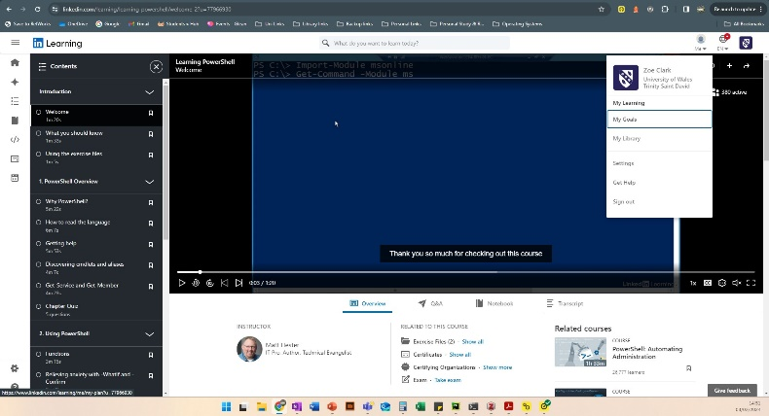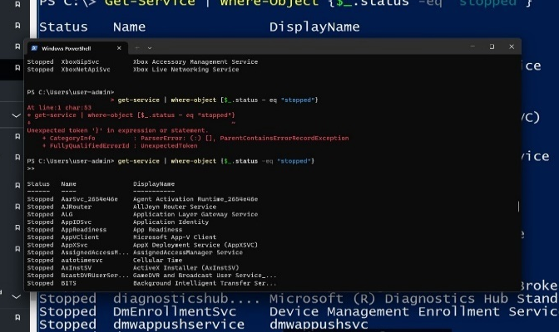
Figure 119: PowerShell Course. Starting out and getting used to syntax.
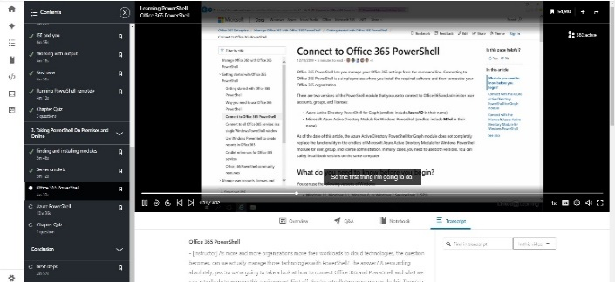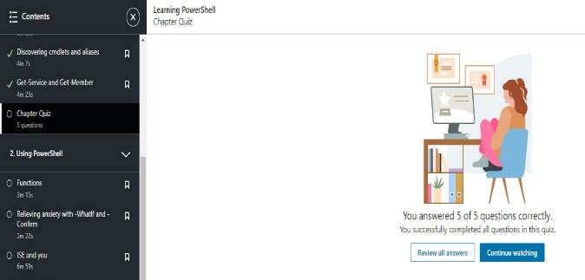
Figure 120: Working through sections and checking understanding with quizzes

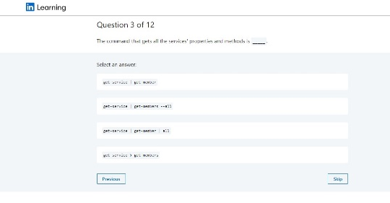
Figure 121: Exam - checking what I have retained, further revision and success.

Appendix 3: Batch Scripts
Please note spacing between lines has been removed from scripts to reduce space in this document but can be observed in screenshots in sections 4 and 5.

  - Demofile.bat script
@echo off
echo %DATE% %TIME%
:: Number variables and Sums
set /a num1=50
echo The first number is %num1%
set /p num2="Enter your number: "
:: Addition
set /a result=num1+num2
echo Addition Sum = %result%
:: Subtraction
set /a result=num1-num2
echo Subtraction Sum = %result%
:: Multiplication
set /a result=num1*num2
echo Multiplication Sum = %result%
:: Division
set /a result=num1/num2
echo Division Sum = %result%
:: Modulus (tested to demo as used in python & on tutorialspoint.com - is technically correct but will not round correctly as Batch Int only)
::set /a result=num1%%num2
::echo Modulus Sum :: ainder = %result%
:: Left object check for less than or equal than right
if %num2% LEQ %num1% (
echo The entered number is less than or equal to %num1%.
) else (
echo The entered number is greater than %num1%.
)
:: Left object check if greater than or equal than right
if %num2% GEQ %num1% (
echo The entered number is greater than or equal to %num1%.
) else (
echo The entered number is less than %num1%.
)
Echo Welcome to the area calculator
set /p length="Enter the length of your rectangle: "
set /p width="Enter the width of your rectangle: "
set /a area=length * width
Echo The area of your rectangle is %area%
:: Goto
echo.
echo Demonstration of Goto:
goto :Label1
:: if/else - If it is this do X, else do Y – ::https://www.tutorialspoint.com/batch_script/batch_script_if_else_statement.htm
:Label1
set condition=true
if %condition%==true (
echo Condition is true
) else (
echo Condition is false
)
:: User input - stored in a variable such as 'input'. Once stored can be used. Referred to by variable name inside 2 % eg this could be used to expand game by storing name of user to be echo'd in the output text at different points in the , how many times a named user has played/ or how much scored
echo.
set /p input="Enter your name: "
echo Hello, %input%!
:: Loop L/ with an exit option
echo.
echo Loop using switch:
set fruit=apple
:loop
echo %fruit%
set /p fruit="Enter another fruit or type 'e' to stop: "
if "%fruit%"=="e" goto :end
goto :loop
:end

:: Array
echo Array demonstration:
set animals[0]=cat
set animals[1]=dog
set animals[2]=bird
echo Animal 1=%animals[0]%
echo Animal 2=%animals[1]%
echo Animal 3=%animals[2]%
set /p newBird="Enter a new value for 'bird': "
set animals[2]=%newBird%
:: adds a new animal [3], will show as animal 4 (counting starts as 0 not 1)
set /p newAnimal="Enter a new animal: "
set animals[3]=%newAnimal%
echo.
echo Updated animals
echo Animal 1=%animals[0]%
echo Animal 2=%animals[1]%
echo Animal 3=%animals[2]%
echo Animal 4=%animals[3]%
Echo Array update complete
pause
:: can be used to store number of attributes and useful for user data eg names/ passwords
set systemUser[0].FirstName=Edward
set systemUser[0].LastName=Bear
set systemUser[0].AccessLevel=Admin
set systemUser[1].FirstName=Dolly
set systemUser[1].LastName=Bird
set systemUser[1].AccessLevel=Admin
set systemUser[2].FirstName=Penny
set systemUser[2].LastName=Plush
set systemUser[2].AccessLevel=Standard
For /L %%i In (0 1 2) Do (
call echo Person At %%i = %%systemUser[%%i].FirstName%% %%systemUser[%%i].LastName%% %%systemUser[%%i].AccessLevel%%
)
pause
:: issue with the method above could be you need to know the number in the list and adjust manually. Could add an increment counter to work around like the one in the adventure story script (witch visit) perhaps. Limited but simpler for it.
::below is function label
:myFunction
::below if function body
echo This is my function.
set /a functionResult=%1+10
echo Result after adding 10: %functionResult%
:: exit function using /b
exit /b
pause
:: Calls the function before it closes
call :myFunction 5
pause
exit /b

  - Text Adventure Game v0.2.bat script
@echo off
Color 4e
Title Text Adventure Game v0.2
:: Updated code and game variations designed by Zoe Clark. Based on original game and code provided by James Williams
:: echo to output
Echo
::ASCII
echo ****** ****** ****** ** **
echo ** ** ** ** ** ** **
echo ** ** ** ** ** ** **
echo ******* ****** ****** ** ** **
echo ******* ****** ****** ** ** **
echo ** ** ** ** ** ** ** ** **
echo ** ** ** ** ** ** ** ** **
echo ******* ** ** ****** ** **
echo
echo
echo
set visitedWitch=0
:Start
Cls
echo
echo Press 1 to walk up the mountain to visit the Wizard.
echo Press 2 to walk down the river to visit the Witch.
echo Press 3 to visit the Scary Cave
echo Press 4 to go home.
:: request user input and store as variable
set /p walk=
::if used here for set of options
if %walk% == 1 goto Wizard
:: &variable% format to use/ declare value being stored in variable %walk% = user input
if %walk% == 2 goto Witch
if %walk% == 3 goto Goblin
if %walk% == 4 goto Home
:: label for Wizard block of code
:Wizard
:: clear screen for themed character colours
Cls
:: hexadecimal colour for background and text (0-F)
Color 0B
echo Wizard: "Happiness can be found, even in the darkest of times, if one only remembers to turn on the light. For guidance which do you want to consult?"
echo
::Menu options (string )
echo [1] Look into the magic pool.
echo [2] Look into the mirror.
echo
Set /p wizardChoice=
:: goto jumps the code to the section with that label
if "%wizardChoice%"=="1" goto MagicPool
if "%wizardChoice%"=="2" goto Mirror
:MagicPool
echo You gaze into the magic pool and see distant lands and magical creatures.
echo In the heart of the pool, something glimmers in the depths.
echo You reach in and your hands close around......
::pauses added – needs user to move forward, adds some control of pace
Pause 1
echo the Orb of Insight.
Pause 1
echo Fading......
Color 8f
Pause 1
echo Fading......
Color 7f
Pause 1
echo Fading......
Color 4e
Cls
echo Everything fades, a bird sings, you are back on the mountainside. You realize the Orb of Insight is glowing like a star......
echo Choose carefully traveller...lest your hopes crumble.......
echo Press 1 for something to POWER UP!
echo Press 2 to convert the Orb of Insight into the thing you most desire in the world!
:: ARRAY index 1 & 2 syntax can also be : set /A Array[1] if was using numbers not str
set a[0]=Ginger
set a[1]=Triple Choc
:: user input requested which will relate to index position (unknown by player)
set /p choice=
:: == is equal on both sides of two things compared
if "%choice%"=="1" (
echo You are now holding a pack of %a[0]% Biscuits
) else if "%choice%"=="2" (
echo You are now holding a pack of %a[1]% Biscuits
)
Pause >nul
Cls
goto :Start
:Mirror
echo You look into the mirror and see only your reflection staring back at you.
echo "Sometimes, the greatest magic is simply seeing yourself for who you are."
Pause >nul
Cls
Color 4e
echo Everything fades as you find yourself back on the mountainside.
Cls
goto :Start
:: More work needed on combination of colour and text here
:Witch
cls
Color 50
Echo
:: check if counter is greater than 0 e.g. 1 then triggers different character interaction (branch)
:: first visit is greeting, afterwards food and drink interactions
if %visitedWitch% GTR 0 (
echo Witch: "Hello again! Would you like something to drink?"
) else (
echo Witch: "Words are, in my not-so-humble opinion, our most inexhaustible source of magic. Capable of both inflicting injury, and remedying it."
set /a visitedWitch+=1
Pause
goto End
)
echo [1] Yes
echo [2] No, thanks
Set /p witchDrink=
if "%witchDrink%"=="1" (
call :AskForDrink
) else if "%witchDrink%"=="2" (
echo Witch: "Well, nice to see you. Bye for now!"
set /a visitedWitch+=1
Pause >nul
cls
goto End
)
:AskForDrink
cls
echo Witch: "What would you like to drink?"
echo [1] Coffee
echo [2] Tea
Set /p witchChoice=
if "%witchChoice%"=="1" (
set drink=Coffee
) else if "%witchChoice%"=="2" (
set drink=Tea
)
call :AskForCake
goto :End
:AskForCake
cls
echo Witch: "Would you like some cake with your %drink%?"
echo [1] Yes
echo [2] No, thanks
Set /p cakechoice=
if "%cakechoice%"=="1" (
echo Witch: "Great! Here's your %drink% and cake. Enjoy!"
) else if "%cakechoice%"=="2" (
echo Witch: "Alright then, just %drink% for you. Maybe next time!"
)
Pause >nul
goto :End
:: Further code could be added here if user selects something invalid (not 1 or 2) to jump to a section to echo not valid and then return to section - Ask for drink or cake as appropriate.
:End
set /a visitedWitch+=1
Color 4e
goto :Start
:Goblin
cls
color 0A
echo Goblin: "Bow down for I am the Goblin King! I'm a fair king and I do enjoy playing games but my playstation is broken."
pause >nul
echo You can leave if you play and win my challenge. I'm thinking of a number between 1 and 20. Can you guess it?
pause >nul
echo Because I'm so fair-minded, I will give you 10 tries. You have a 50/50 chance. You will either leave or you won't ha ha ha!
pause >nul
set /a SecretNumber=%random%%%20+1
set Guesses=0
:GuessLoop
cls
echo Goblin: "You have %counting% out of 10 tries left."
echo
echo Enter your guess:
set /p Guess=
if %Guess% equ %SecretNumber% (
goto :Escape
) else if %Guesses% lss 9 (
set /A Guesses+=1
set /A counting=10 - Guesses
echo Incorrect! Try again.
goto :GuessLoop
) else (
goto :Trapped
)
:: Further work needed here - possibly additional loops to resolve the blank 10
:Escape
:: no clear screen here, left so user can see how many tries before escape
color AF
echo Congratulations! You guessed the number! My number was %SecretNumber%
pause
color F0
echo The Goblin King scowls and everything goes white...........
pause
cls
echo You realise you are hungry. Good thing you have 5 Marshmallows left in your pocket.
pause
echo I might as well keep my energy up
:: loop for a set number of tries. Starts at 4, iterates (decreases - 1) each time, stops at 1 then back into script
for /l %%s in (4, -1, 1) do (
echo just the one, mmm yummy. I have %%s snacks left.
pause
)
echo Oh no, how did I manage to eat all those so quickly!.....
echo The mist starts to clear...
pause
color 4e
goto :Start
:Trapped
cls
:: added in to get rid of 1 out of 10 tries left and move narrative on
color 0A
echo Ha ha ha! You will work in my goblin computer lab forever! My number was %SecretNumber%
pause >nul
echo The Goblin King disappears laughing and everything goes dark, until your eyes adjust to the gloom.......
pause >nul
echo You are in a dark room. It has motivational posters such as cats hanging from branches.....
pause >nul
echo There is a old computer with a beige retro, single monitor...its low res.....
pause >nul
echo There is no internet signal..Siri cannot help you here.......
pause >nul
echo You notice the screen shows......
pause >nul
echo Windows Vista.......Nooooooooooooo!
echo The End
pause >nul
exit
:Home
Cls
Color 4e
echo That was fun. Time to go home for Tea and biscuits
pause >nul
Exit

  - Cloud 8.bat script
@echo off
setlocal EnableDelayedExpansion
echo Welcome to the Cloud 8 Stock Management System!
:: directory where item files will be stored
set "itemDirectory=C:\Users\user-admin\Desktop\TEST Folder\Cloud8Stock"
:: Stock info for testing
:: Information added at the start just for testing 7 > send value 10 to the file
echo 10 > "%itemDirectory%\Apple.txt"
echo 5 > "%itemDirectory%\Banana.txt"
:: Main menu
:Menu
echo 1. Update Stock
echo 2. Check Stock
echo 3. Instructions
echo 4. Exit
set /p choice=Enter your choice:
:: Check user choice call block of code for each option
if "%choice%" equ "1" (
call :UpdateStock
) else if "%choice%" equ "2" (
set /p "itemName=Enter item name: "
call :CheckStock "!itemName!"
) else if "%choice%" equ "3" (
set /p "itemName=Enter item name: "
set /p "quantity=Enter quantity: "
call :Instructions "!itemName!" "!quantity!"
) else if "%choice%" equ "4" (
echo Exiting...
pause
exit /b
) else (
echo Invalid choice!
pause
)
exit /b
:: Function to add stock and notes to files
:UpdateStock
set /p "itemName=Enter item name: "
set /p "quantity=Enter quantity: "
set /p "note=Enter note: "
:: Check if the item file exists
if exist "%itemDirectory%\!itemName!.txt" (
echo Updating stock for !itemName!...
echo Quantity: !quantity! >> "%itemDirectory%\!itemName!.txt"
echo Note: !note! >> "%itemDirectory%\!itemName!.txt"
echo Stock updated successfully!
) else (
echo Error: Item "!itemName!" not found!
)
pause
exit /b
:: Function to check if stock is running low
:CheckStock
set "itemName=%~1"
:: Check if the item file exists
if exist "%itemDirectory%\!itemName!.txt" (
echo Checking stock for !itemName!...
for %%I in ("%itemDirectory%\!itemName!.txt") do (
set /p stock=<"%%I"
echo Stock available for !itemName!: !stock!
)
) else (
echo Error: Item "!itemName!" not found!
)
pause
exit /b
:: Function to provide instructions for reordering
:Instructions
:: using % & ~ to return values from function
set "itemName=%~1"
set "quantity=%~2"
:: Check if the item file exists
if exist "%itemDirectory%\!itemName!.txt" (
for %%I in ("%itemDirectory%\!itemName!.txt") do (
set /p stock=<"%%I"
rem Convert stock and quantity to numeric values for comparison
set /a stock=stock
set /a quantity=quantity
if !quantity! lss !stock! (
echo You have !quantity!, which is less than the stock level of !stock!. You need to reorder.
) else (
echo You have !quantity!, which is greater than or equal to the stock level of !stock!. You don't need to reorder at this time.
)
)
) else (
echo Error: Item "!itemName!" not found!
)
pause
exit /b

  - Fileandping.bat script
@echo off
setlocal enabledelayedexpansion
:: Start in current working directory
:: Set up a new directory
mkdir "C:\Users\user-admin\Desktop\TEST Folder\SystemChecks"
:: Change directory (like moving between folder structure in Windows)
cd "C:\Users\user-admin\Desktop\TEST Folder\SystemChecks"
:: Create a file
echo File content > MyFile.txt
:: Create subdirectory
mkdir SubDirectory
:: Create file inside a subdirectory - giving the path for navigation rather than having to navigate to the directory before creating
echo Subfile content > SubDirectory\SubFile.txt
:: Puts text in a file
echo Additional information >> MyFile.txt
:: Copy a file to another directory (..\ this tells it to go up a directory)
copy MyFile.txt ..\CopiedFile.txt
:: Copy file and the subfile
copy /s MyFile.txt ..\CopiedFiles
:: Delete a file
del MyFile.txt
:: Change directory (up one)
cd ..
:: Sort the content in the file - alphanumeric sorting - additional parameters can be used to change sort orders and specify file/directory
sort CopiedFile.txt > SortedFile.txt
:: Show attributes of files
echo File attributes of SortedFile.txt:
attrib SortedFile.txt
:: Display basic system info
::echo.
::echo System Information:
::hostname
::systeminfo
:: Shows running processes
::echo Running Processes:
::tasklist
::echo.
:: Display running tasks 1 page at a time (more manageable/ easier viewing)
::tasklist | more /P
:: Kill a process
echo.
echo Killing notepad.exe process...
taskkill /f /im notepad.exe
:: Display file types
echo File Types:
assoc
echo.
:: Show system config
echo System Configuration:
systeminfo
echo.
:: Display IP Configuration
echo IP Configuration:
ipconfig /all
echo.
:: Ping a website
echo Pinging google.com...
ping google.com
echo.
:: Trace route to a website
echo Tracing route to google.com...
echo 10 hops only. Runs faster for demo only. May not give bigger picture if used in 'live' scenario.
tracert -h 10 google.com
echo.
:: Export Interface Configuration
echo Interface IP config file being saved..
netsh interface ip dump > interface_config.txt
:: Show Wireless Networks
echo Wireless networks are
netsh wlan show networks
:: Opens a website
:: Possible care needed here to avoid broken links, ensure security if a site compromised etc.
echo Loading tutorialspoint website...
start https://www.tutorialspoint.com/batch_script/batch_script_quick_guide.htm
:: Checking for active connections (do we recognise? No = startingpoint for investigations).
echo: This check shows the started services (like net.start). Shows useful descriptions and details. XP and later
:: NetBios Name displayed here:
nbtstat /n
:: NetBIOS client and server sessions, trys to name destination IP (note, check syntax: uppercase S is IP address only).
nbtstat /s
::scheduled tasks and event logs (CODE FROM SANS WHITEPAPER 33193.PDF SEE FURTHER READING
AT > "C:\Users\user-admin\Desktop\TEST Folder\SystemChecks\scheduledATtasks.txt"
Schtasks > "C:\Users\user-admin\Desktop\TEST Folder\SystemChecks\schtasks.txt"
:: dumpel -f "C:\Users\user-admin\Desktop\TEST Folder\SystemChecks\securitylog.txt" -l security
pause
endlocal

  - setlocaltest.bat script
@echo off
:: Define numerical variables without specifying types
set /a "numA=10"
set /a "numB=7"
set /a "numC=8"
set /a "numD=8.5"
:: Show value of variable before setlocal section
echo Initial value of numA: %numA%
echo Initial value of numB: %numB%
:: Using setlocal to limit scope
setlocal
:: arithmetic to update variables just in setlocal section
set /a "numA+=5" :: Add 5 to numA
set /a "numB*=2" :: Multiply numB by 2
:: Display updated variables within setlocal section
echo Updated value of numA within setlocal: %numA%
echo Updated value of numB within setlocal: %numB%
:: Pause for user review/ screenshot before end of setlocal section
pause
:: Exit setlocal section of script
endlocal
:: Pause for user review/ screenshot after end of setlocal section - removed after tests as not needed. Just created extra interaction without adding anything useful.
:: pause
:: Show value of variable following endlocal (after setlocal section)
echo Value of numA after endlocal: %numA%
echo Value of numB after endlocal: %numB%
:: Perform calculations on numC and numD
set /a "numC/=2"
set /a "numD/=2"
:: Show values of numC and numD after calculations
echo Initial value of numC: 8
echo Updated value of numC: %numC%
echo Initial value of numD: 8.5
:: Output will have treated the variable as an int so as 8 not 8.5
echo Updated value of numD: %numD%
:: Pause for user review/ screenshot before exit
Pause

Appendix 4: Bash Scripts
  - MathQuiz.bash script

#!/bin/bash
# # used for comments and at start of Sha-bang. <<COMMENTS and COMMENTS. Used for multi-line
# Set window size to 100 columns and 60 rows
printf '\e[8;60;100t'
# Banner Function
displayBanner() {
echo -e "\e[45m\e[36m" # Sets background to white with aqua text
echo "**********************************"
echo "** Welcome to the 8 out of 10 **"
echo '** Rats does Maths Quiz! **' # Amended to single quotes instead of escape character after tests
echo "**********************************"
echo "\e[0m" # Resets default colours
}
# ASCII art - plus sign made of plus signs
displayASCII() {
echo -e "\e[36m" # Set text color to aqua
echo " ++++++ "
echo " ++++++ "
echo " ++++++ "
echo "++++++++++++++++++"
echo "++++++++++++++++++"
echo " ++++++ "
echo " ++++++ "
echo " ++++++ "
echo -e "\e[0m" # Reset text color to default
}
# Function to generate random numbers and ask math questions
mathQuiz() {
# variable assigned value with operator = , string need “”, don’t need to declare type
total=5
round=1
cumulativeScore=0
while true; do
correct=0
currentDatetime=$(date +"%Y-%m-%d %H:%M:%S")
echo -e "\e[36mRound $round - $currentDatetime:\e[0m" # Aqua text for round and time
# Start timing the round
start=$SECONDS
# Main questions
for ((i=1; i<=total; i++)); do
num1=$((RANDOM % 20 + 1))
num2=$((RANDOM % 20 + 1))
operation=$((RANDOM % 4))
case $operation in
0) # Addition
correctAnswer=$((num1 + num2))
question="\e[35mWhat is $num1 + $num2?\e[0m" # Pink text for question
;;
1) # Subtraction
# Ensure num1 >= num2 to avoid negative results
num1=$((RANDOM % 20 + num2))
correctAnswer=$((num1 - num2))
question="\e[35mWhat is $num1 - $num2?\e[0m" # Pink text for question
;;
2) # Multiplication
correctAnswer=$((num1 * num2))
question="\e[35mWhat is $num1 * $num2?\e[0m" # Pink text for question
;;
3) # Division
# Ensure num1 >= num2 to avoid negative results
num1=$((RANDOM % 20 + num2))
correctAnswer=$((num1 / num2))
question="\e[35mWhat is $num1 / $num2 (rounded to nearest integer)?\e[0m" # Pink text for question
;;
esac
echo -e "Question $i: $question" # Display question
while true; do
read -p "Your answer: " userAnswer # Prompt for user input
# Check if input is a number or negative number
if [[ $userAnswer =~ ^-?[0-9]+$ ]]; then
break
else
echo "Please enter a valid number."
fi
done
if [ "$userAnswer" -eq "$correctAnswer" ]; then
echo -e "\e[36mCorrect\e[0m" # Aqua text for correct answer
((correct++))
((cumulativeScore++))
else
echo -e "\e[36mIncorrect. The correct answer is $correctAnswer.\e[0m" # Aqua text for incorrect answer
fi
echo
done
# Accessed variables above with $ then variable name which can be used to output the value held in it
# Calculate and display the time taken for the round
duration=$(( SECONDS - start ))
echo -e "Round $round time: \e[36m$duration seconds\e[0m" # Aqua text for time
echo -e "Round $round score: \e[36m$correct / $total\e[0m" # Aqua text for score
echo -e "Your rolling score is: \e[36m$cumulativeScore\e[0m" # Aqua text for cumulative score
# Ask if the user wants to proceed to the next round
while true; do
read -p "Do you want to proceed to the next round? (yes/no): " nextRound
case "${nextRound,,}" in
yes|y) # Proceed to the next round
break ;;
no|n) # End the game
echo "Thank you for playing\!"
read -n 1 -s -r -p "Press any key to exit..." # Pause before exiting – Linux in a Nutshell p639
exit ;;
*) # Invalid input
echo "Please enter a valid response (yes/no).";;
esac
done
((round++))
done
}
# Main function
main() {
displayBanner
displayASCII
mathQuiz
}
# Call main function
Main
  - BashUserDetails script
#!/bin/bash
# ANSI codes for text color - put here to simplify how code reads through script
pink='\033[1;35m'
green='\033[1;32m'
reset='\033[0m'
# Departments Menu - wrong input option added
Menu() {
echo -e "${pink}Select your department:${reset}"
echo "1) HR"
echo "2) ITS"
echo "3) Customer Service"
echo "0) Exit"
read -p "Enter the number corresponding to your department: " departmentChoice
case $departmentChoice in
1) department="HR" ;;
2) department="ITS" ;;
3) department="Customer Service" ;;
0) exit ;;
*) echo "Invalid choice. Please select a valid option." ;;
esac
}
# Call menu function
Menu
# Adding user name and a password
echo -e "${pink}Enter your first name:${reset}"
read firstName
echo -e "${pink}Enter your last name:${reset}"
read lastName
echo -e "${pink}Enter your password:${reset}"
read -s password # The -s flag means password not visible
echo
# Concatenate (combine) names to create a username.
userName="${firstName}_${lastName}"
echo "Thank you, $firstName, from $department. Your username will be: $userName"
# Store password as a variable
storedPassword="$password"

# Specify where user file will be stored (user's home directory)
userDir="/home/${userName}"
# Create a file using the combined name
fileName="${userName}_notes.txt"
# Path to the new file
filePath="$HOME/$fileName"
# Print the location of the new file to terminal
echo "User file will be created at: $filePath"
# Ask for password validation before text input to file
echo "Now, please enter your password to validate:"
# Check Password using a While Loop
validatePassword() {
attempts=0
while [ $attempts -lt 3 ]; do # while attempts are less than 3 (a standard password attempt limit)
echo -e "${pink}Enter your password:${reset}"
read inputPassword # ideally also use -s left visible for easier testing
echo
# Check if the entered password matches the saved one
if [ "$inputPassword" = "$storedPassword" ]; then
echo -e "${green}Password validated.${reset}"
# User input to place in a file - Placed here nested in loop so can only add if password correct.
echo -e "${green}Enter your notes (press Ctrl+D to save and exit):${reset}"
echo "User: $userName" >> "$filePath"
echo "Department: $department" >> "$filePath"
cat >> "$filePath"
return 0 # Password is correct, exit the loop. Value 0 returned from function
else
echo "Access Denied"
fi
attempts=$((attempts + 1)) # Increment attempts counter added when code nested
done

# If password wrong 3 times
echo "Access denied. Please contact the helpdesk."
read -p "Press Enter to close this window"
exit 1 # - password wrong 3 times exit here
}
# Call functionBashUserDetails script
validatePassword
# Opens the text document
nano "$filePath"
# Directory to search in
directory="C:/Users/user-admin"
# Ask the user for the filename to search for
read -p "Enter the filename to search for: " filename
# Search for the file using grep
grep -l "$filename" "$directory"/*.txt
read -p "Press Enter to close this window"

  - nanoUse.bash script
#!/bin/bash
# Function to open a file for editing using nano to work with text
editFile() {
file="$1"
nano "$file" || { echo "Failed to open $file for editing."; exit 1; }
}
# Main function
main() {
read -p "Enter file name to edit: " filename
editFile "$filename"
}
# Call main function
Main

  - loopArrayCase.bash script
#!/bin/bash
# Array of fruits
fruits=("Apple" "Banana" "Orange" "Grape" "Mango")
# Loop to print each fruit
echo "List of Fruits:"
for fruit in "${fruits[@]}"; do
echo "$fruit"
done
# Process operations based on user input
operation() {
case $1 in
"add") echo "Addition: $(($2 + $3))" ;;
"sub") echo "Subtraction: $(($2 - $3))" ;;
"mul") echo "Multiplication: $(($2 * $3))" ;;
"div") echo "Division: $(($2 / $3))" ;;
*) echo "Invalid operation" ;;
esac
}
# Main function
main() {
read -p "Enter operation (add/sub/mul/div): " op
read -p "Enter first number: " num1
read -p "Enter second number: " num2
operation "$op" "$num1" "$num2"
}
# Call main function
main
# Multi-dimensional associative array demonstration
declare -A fruitProperties
# Assigning properties to each fruit
fruitProperties["Apple"]="Red"
fruitProperties["Banana"]="Yellow"
fruitProperties["Orange"]="Orange"
fruitProperties["Grape"]="Purple"
fruitProperties["Mango"]="Yellow"
# Loop to print each fruit and its properties
echo "List of Fruits and Their Properties:"
for fruit in "${fruits[@]}"; do
echo "Fruit: $fruit | Color: ${fruitProperties[$fruit]}"
done
read

Appendix 5: Further research and reading

Machine Learning and Quantum computing

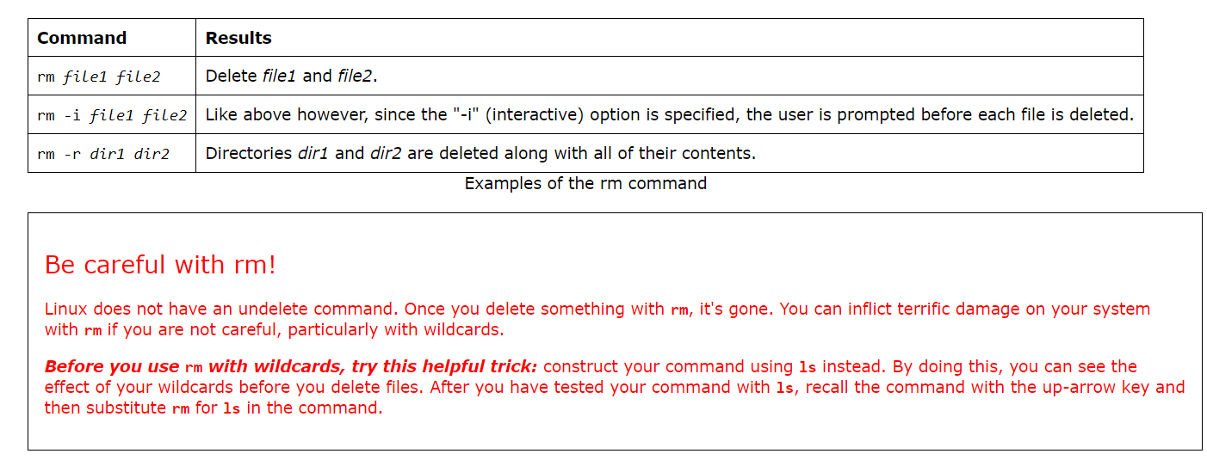
Web research, searching for hints and tips on using CLI commands safely. [35]

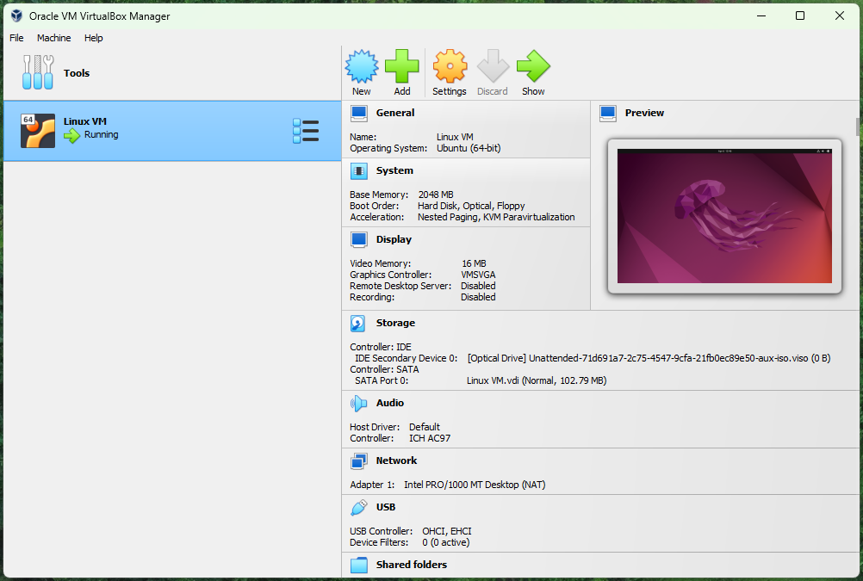
Experimenting with VM and Ubuntu. Will explore further as VM useful for Sandboxing Cyber Security tasks e.g. checking file content.

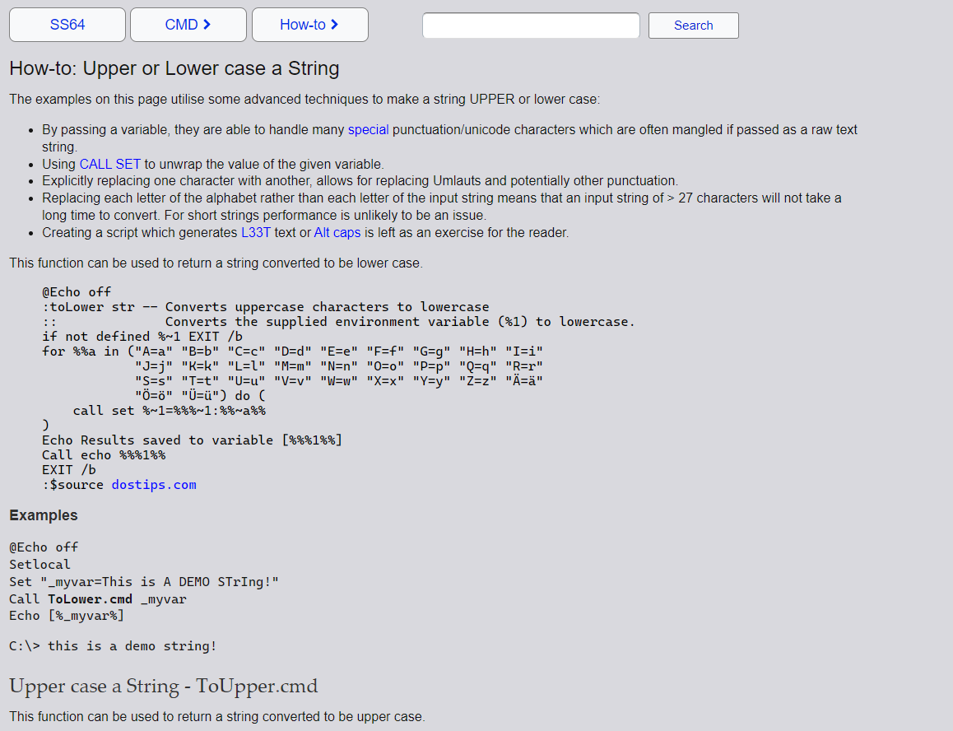
Research ongoing into lowercase/ uppercase resolutions via https://ss64.com/nt/syntax-tolower.html

Research ongoing: Operators e.g. let for incremental scoring/ countdowns & awk to print the result of arithmetic using { ‘statement here’}

