

How can Cities Leverage the Benefits of Digitalization to Relieve Stress on Overstretched Services and Resources?

by
Andrew John Edward Cooper

Lecturer: Prof John Rees

December 2019

Abstract
The population of the world requires the expansion and maturity of urban areas to facilitate people. Exponential growth has also caused services and resources to become overstretched causing pollution and ineffective waste management systems.
The use of IoT in urban areas allow for decreased waste of services and resources and constant analysis of pollutants in the air, which can be used to demand change for both industrial areas and how waste is managed in city structures.

Contents
Abstract i
Table of Figures and Tables iii
1 Introduction 1
1.1 Internet of Things 1
1.1.1 Wireless Sensor Networks (WSN) 1
1.1.2 Protocols 2
1.1.2.1 Zigbee 2
1.1.2.2 WIFI 2
1.1.3 Which Protocol is Best Suited for the Project? 2
1.2 Security 2
1.3 AI in IoT 3
2 Review of Literature 3
3 Problem Statement and Solution 4
Load Sensor 6
Phaesun 10W Photovoltaic Solar Panel 6
900-00008 - 6
SERVO- CONTINUOUS ROTATION-S3 SERVO 11X5879 6
4 Design & Implementation 7
5 Conclusion 8
5.1 Future Work 8
References 9

Table of Figures and Tables
Table 1: Advantages & Disadvantages of Wireless Sensor Networks 1
Table 2: Threat Type by Type of Person and Likeliness 2
Table 3: Components Available for Air Pollution Monitoring 4

Figure 1: Potential Solutions For Smart Bins 6
Figure 2: An Image of the Developed System Top Level 7
Figure 3: An Image of the Proposed Town Cluster 7

Introduction
Smart cities are pinnacle to tackling the world’s carbon footprint and helping reduce the effects already made by global warming. Cities such as Barcelona, Amsterdam, and London are just a small number of cities already relishing the benefits of digitalisation. They have achieved this implementing smart features such as smart street lamps, solar powered waste bins as well as a barrage of other smart technologies [1].
Using smart technologies around urban areas allow governments to systematically analyse nearly every aspect of the city it has been implemented. This new sense of connectivity allows governments to review and act appropriately to changes in the environment whilst saving money in the long term.

Internet of Things
In its simplest form the internet of things (IoT) are sensors and actuators that connect to microcontroller, then a server used to collect data with the use of the internet. Since the term “Internet of Things” was coined in 1999 by Kevin Ashton [2], who some sees as the “father” of IoT. The area of study has been greatly researched and advancements means even people without a good knowledge of networking or computing are able to harness this technology with ease [3].
Although the term was created in 1999, in the 1980s a trio of graduate students modified a Coca Cola vending machine to send data concerning its contents over the network [4]; this become the first known implementation of “IoT”. However, until recently the field of IoT has been slow to develop due to technology not being able to support the implementations.
Now the technology is modern enough to facilitate IoT, it can be used domestically and on a large scale. Therefore, it is only rational that IoT should be implemented into a city structure, as this will help identify issues such as pollution and waste management.

Wireless Sensor Networks (WSN)
Wireless sensor networks (WSNs) are interconnected sensors and actuators used to obtain information of its surrounding area which then sends data to a data gatherer (microcontroller/ nodes) which can send data to external systems, such as a server, used to store and manage the data.
WSNs are important for IoT projects, like smart cities because it allows constant data gathering and will produce highly accurate results.

Advantages | Disadvantage
Easily extendable with new sensors and nodes. | Highly susceptible to attacks, both physical and virtual.
Excels in environments that wired networks would not be able to handle. | Vulnerable to noise from various sources (other WSNs and radio frequencies).
Reduced cost in wiring. | More complex implementation than wired solutions.
Wider area coverage.
Table 1: Advantages & Disadvantages of Wireless Sensor Networks

Protocols
Protocols are used to give a standardization method of communication between networked devices; an important concept in networked infrastructures as this could cause a very inefficient/ non-functioning networks.
There are two main competitors are Zigbee and WIFI due to ease of use and cost being lower than other forms of communication.

Zigbee
Zigbee is very common in industrial settings due to its extendibility of features and robustness. Also, the low energy consumption means that money can be saved on regular replacements for batteries. Another benefit is the reduced reliant on a central hub; due to its mesh standard, data can travel across the network by hopping from one node to another.

WIFI
Unlike Zigbee, WIFI comes with the benefit of increased bandwidth but is also much costlier in terms of power consumption. This is a crucial factor considering the final implemented piece will be required for daily urban living. However, key elements of WIFI include; better throughput, ease of use and the pure ubiquity of WIFI including access points.

Which Protocol is Best Suited for the Project?
Due to the nature of the proposed system, the devices would not be classed as “high priority”, therefore, the amount of times data will have to be sent can be greatly reduced. Also, the sensors will be running constantly, so to ensure that the system can maintain a maximum up-time, the sensors will have low energy consumption. However, as this will be implemented in a large city structure, data will have to be able to travel large distances.
Considering the points made above, the best solution would be to use WIFI as this allows for easy extendibility, cheaper in compatible devices and allow for large area coverage. As for the issue with battery life, using solar panels will allow for battery recharging.

Security
However, with any digitalized project there are concerns of security of the system from potential threats and active attacks, to ensure the system is fit for purpose these will have to be addressed and appropriate precautions put in place. The FBI has also warned of the potential dangers of unmanaged IoT devices with regards to digitalised fraud [5].
Security is important when collecting data, especially when dealing with sensitive information as this could potentially cost the governments millions in lawsuits, should the data become compromised.
Furthermore, physical threats such as theft and vandalism become an important issue, as it could become very costly to replace components regularly.
Big companies with high pollution rates are examples of companies that would not like to be monitored as this could potentially make them alter the way they operate; which would cost time and money. Therefore, they could be inclined to launch attacks to make the system unusable.
Hacktivists are people to gain unauthorised access into computer networks with insights to collect data or cause disruption, usually as a political or environmental stand point.

Attack From | Attack Type | Threat Level
Large Organisations | Virtual/ Physical Threat | High
Vandals | Physical | Medium/ High
Hacktivists | Virtual | Low
Table 2: Threat Type by Type of Person and Likeliness

AI in IoT
AI is very quickly becoming a buzz word in the world of computing because it allows for constant monitoring, effective pattern recognition and reliable future predicting. Using AI as a means to monitor urban areas is a very achievable goal with machine learning algorithms and architectures constantly being developed and abilities increased. However, although a city being monitored closely by AI greatly reduces the probability of human error, one must consider the general and ethical issues that come with replacing humans with machines, such as:
- Job losses – If a machine can perform the same job a human can with no payment, then companies will be eager to reduce cost of labour very quickly.
- Machine malfunction – There’s no denying that technology, like humans, come with a shelf life. Having a machine malfunction could come with a great cost.
- Data manipulation – A company could easily manipulate what data they produce, which could fool the AI as this may potentially evade trends that has been previously found by the AI. [6]
- People – People do not want to be monitored daily and may wish to disrupt functionality.

Review of Literature
In this section, a series of articles, journals, papers and other relevant sources will be reviewed to gain a better understanding of what research has already been completed.
Smart gadgets and IoT are an emerging trend in computing due to implementation being easier and cheaper than ever before meaning this technology is accessible to more people with the ability to solve larger problems and daily tasks.
The need for smart cities stems from the population growth in urban areas [7] [8] [9] [10], this is a claim that has been strengthened by various sources, such as “Evaluation of the concept of the smart city through local regulation and the importance of local initiative” [11]. Their paper aims to find regulations implemented in Morocco concerning smart cities and they discuss how people will play a pivotal role in the success of transition [11], a statement backed up by Paolo Neirotti et al [12].
Secondly, Founoun and Hayar discuss the lack of regulation in the implementation of smart cities [11]; this is a trend that has been seen by others, such as Yalew K. Tolcha et al [13]. This becomes a problem when attempting to implement a project, such as this, as without regulations and standardizations expandability and communication between implementations becomes much more of a chore, which could result in much slower development of the smart city.
Waste and pollution management is an important aspect of daily life as this closely effects peoples’ wellbeing [14] [15]. However, regardless of the health implications concerned with pollution, the UK fail to comply with the “Air Quality Directive” [16] [17], causing court cases, which in turn wastes more money.
A case study, written by Andre Castro Lundin, Ali Gurcan Ozkil and Jakob Schuldt-Jensen [18] suggests that smart waste solutions are likely to reduce costs to public services. Also, data collected from smart bins means waste collection routes can be optimized to reduce c0² emissions from vehicles [19]. Lundin’s paper also suggests a number of approaches of IoT waste management, such as: RIFD which estimates the weight of the bin and a pay-as-you-throw scheme:
- RFID to estimate the weight of the bin – this is a good possible solution as parts and labour can be bought at a reasonable price.
- Pay-as-you-throw (PAYT) – Although this would make people really consider what they throw away, this impacts greatly on the “price of freedom”.
However, a solution that has had great success in cities that have implemented it, is the solar smart bins, developed by companies such as BigBelly Smart Solution for Cities. Although this method will have a greater cost than using the RFID approach initially, it’s believed that money will be saved in the long run due to parts needing to be changed a lot less frequently.

Problem Statement and Solution
This paper, coupled with the packet tracer simulation, aims to provide a solution to the waste and pollution problem in Swansea.
“Swansea has 13 micrograms per cubic metre and Chepstow 12 - the same level as cities nearly 40 times its size”, Anna Lewis, Wales Online [20].
This reference comes from a news article talking about PM2. 5, a measurement of reading which aims to shed light on the air quality around Wales.
Although this report strengthens the suggestion that there needs to be a drastic improvement of pollution management in Swansea, it is also important to note that news reporters have got a tendency to twist words, therefore this quote should be taken lightly. However. with this information, it is clear that the quality of air around Swansea needs to be monitored as this could become a very big health concern.

Secondly, Swansea could benefit from implementing smart waste management; a method adopted by Amsterdam and many other European countries; which has seen a massive decrease in the need for collection, approximately 85% [21]. This would have a massive impact for Swansea, not only fuel consumption and air pollution from vehicles, but would have a positive effect on the bigger picture such as:
- Traffic congestion.
- Budget for waste management.
- Aesthetic appeal in urban areas.
The following table shows a list of components that may be implemented in a smart bin that may assist with waste management.
Component | Cost | Effectiveness | Benefits | Disadvantages
FBlue ESP8266 Serial Port Wifi Module NodeMcu Lua WIFI V3 Internet development board CH-340 | £3.79 | This is a small computer that can be used to obtain information for sensors and send instructions to actuators. | Small enough to implement in many places.  Cost Effective.  Energy efficient.  Purpose can be changed. | Fragile.  Have to have a basic level of programming.
Xiton HC-SR04 Ultrasonic Distance Rangefinder/Obstacle Detection Module | £1.92 | This sensor sends and receives information based on its ahead environment by sending out high frequency waves and wait for the echo signal to return, giving an approximation to free distance. | Can be used to see how high bin levels are.  Cheap. | Struggles with certain types of materials.  Data can be skewed by influxes in temperature.
Load Sensor | £6.57 | This sensor will be used accompanied with another sensors to | Usually quite accurate. | Expensive on power consumption.
Phaesun 10W Photovoltaic Solar Panel | £33.92 | This will be used to power the devices, saving time and money on batteries and labour. | Reduces toxic materials coming from batteries.  Harness natural resources. | Weather dependant (no charging during evenings).
900-00008 -  SERVO- CONTINUOUS ROTATION-S3 SERVO 11X5879 | £16.82 | This could be used to act as a lock to prevent usage of bins which have been read as full. | Efficient. | Has a sense of instability.  Can be easily broken.
Figure 1: Potential Solutions For Smart Bins

Please note, although these are the type of sensors that could be useful in a prototype build of the project, they would struggle in a harsher real-world environment. Therefore, industrial components will needed to be used to increase life time and effectiveness of device.

Design & Implementation
The suggested system aims to help reduce the impact of global warming, therefore, the simulation should reflect that by using modules that harness natural energy, such as solar panels.
Secondly, the proposed topology would resemble a tree structure, where elements of the tree branch off. Below is an image of how the network may look.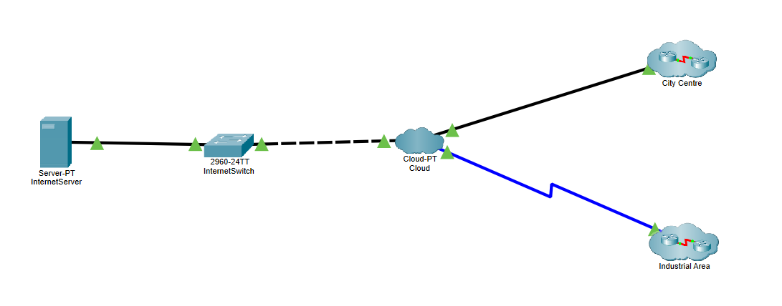
Figure 2: An Image of the Developed System Top Level
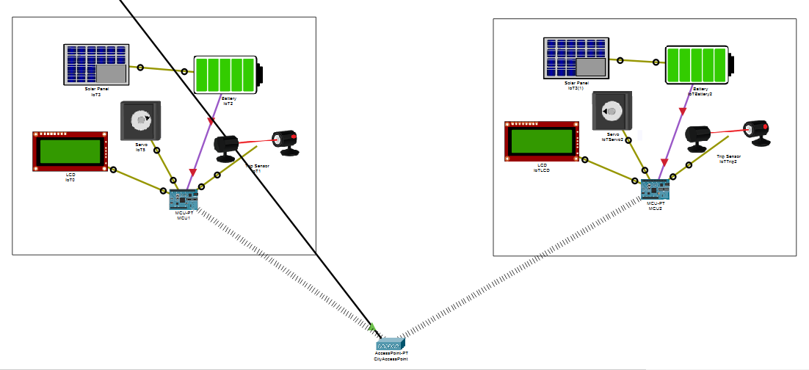
Figure 3: An Image of the Proposed Town Cluster
Figure 2 displays the network at the device level, this image shows the MCU is connected wirelessly to the access point, which in a smart city is commonly found.

Conclusion
This text has aimed to suggest reasons why urban areas, such as Swansea, need to consider making changes to their waste and pollution management systems by adopting a “smart” approach. Without appropriate measures implemented, it is believed cities with large industrial presences will see its residents suffer from ill health and potentially death.
Relevant literature has been reviewed to gain a better understanding of how a project of this scale could be implemented and the overall benefits cities who have adopted this approach have seen.
Thirdly, using packet tracer, the project has been simulated using various sensors and nodes, connected to a web server to display how data could be sent and received across the network.

Future Work
Due to a lack of time, funds and authority, tests and real-world implementations have been left for future readers to extend upon this paper in their own research projects.
However, it would be beneficial for the simulation to be implemented in a working environment, as this will allow for raw data to be collected, analysed and interrogated to make a more well-informed decision on the status & requirement of smart waste and pollution management systems.

References

[1] | “Are university campuses turning into mini smart cities? | Education | The Guardian,” [Online]. Available: https://www.theguardian.com/education/2019/feb/22/are-university-campuses-turning-into-mini-smart-cities.
[2] | O. Alhazmi, “A Survivable Internet of Things Scheme,” Journal of Advanced Research in, no. 1, p. 19, 2018.
[3] | D. C. K. e. al, “Home Automation - Fast - Expanding Market,” Thunderbird International Business Review, vol. 59, no. 1, pp. 80 - 90, 2017.
[4] | J. Teicher, “The little-known story of the first IoT device,” IBM Industries, 07 Feb 2018. [Online]. Available: https://www.ibm.com/blogs/industries/little-known-story-first-iot-device/. [Accessed 28 Nov 2019].
[5] | B. A. Steele, “Tech Tuesday: Internet of Things (IoT),” FBI Portland, 03 Dec 2019. [Online]. Available: https://www.fbi.gov/contact-us/field-offices/portland/news/press-releases/tech-tuesday-internet-of-things-iot. [Accessed 11 Dec 2019].
[6] | N. B. a. E. Yudkowsky, “THE ETHICS OF ARTIFICIAL INTELLIGENCE,” Cambridge University Press, Cambridge, 2011.
[7] | J. Colistra, “The Evolving Architecture of Smart Cities,” in 2018 IEEE International Smart Cities Conference (ISC2), Kansas, 2018.
[8] | M. K. e. al, “Smart Cities in India: Features, Policies, Current Status, and Challenges,” in 2018 IEEE International Conference on Technologies for Smart-City Energy Security and Power (ICSESP-2018), Bhubaneswar, 2018.
[9] | A. Shahat, “A novel big data analytics framework for smart cities. Future Generation Computer Systems,” in International Conference on Connected Smart Cities 2017, Lisbon, 2017.
[10] | W. Y. e. al, “GS1-based Smart City Service Intercommunity,” South Korea, 2019.
[11] | A. H. Adnane FOUNOUN, “Evaluation of the concept of the smart city through local regulation and the importance of local initiative,” in IEEE Annual International Smart Cities Conference, Kansas City, 2018.
[12] | P. N. e. al, “Current Trends in Smart City Initivates: Some Stylised Facts,” Cties, vol. 38, pp. 25 - 36, 2014.
[13] | Y. K. T. e. al, “Oliot-OpenCity: Open Standard Interoperable Smart City Platform,” in 2018 IEEE International Smart Cities Conference (ISC2), Kansas City, 2018.
[14] | W. H. Organisation, “Air Pollution,” [Online]. Available: https://www.who.int/health-topics/air-pollution#tab=tab_1. [Accessed 09 12 2019].
[15] | A. Milne, “Air pollution killing more people than smoking, say scientists,” Thomson Reuters Foundation Trust, London, 2019.
[16] | E. P. UK, “AIR POLLUTION LAWS,” Environmental Protection UK, [Online]. Available: https://www.environmental-protection.org.uk/policy-areas/air-quality/air-pollution-law-and-policy/air-pollution-laws/. [Accessed 09 12 2019].
[17] | D. f. E. F. &. R. Affairs, “UK and EU Air Quality Policy Context,” Department for Environment Food & Rural Affairs, [Online]. Available: https://uk-air.defra.gov.uk/air-pollution/uk-eu-policy-context. [Accessed 09 12 2019].
[18] | A. G. O. J. S.-J. Andre Castro Lundin, “Smart cities: A case study in waste monitoring and management,” in Proceedings of the 50th Hawaii International Conference on System Sciences , 2017.
[19] | e. a. Dhaval Patel, “Smart Dustbins for Smart Cities,” International Journal of Trend in Scientific Research and Development (IJTSRD), vol. 3, no. 3, p. 1830, 2019.
[20] | A. Lewis, “The Welsh towns and cities among the most polluted in Britain,” Wales Online, 02 May 2018. [Online]. Available: https://www.walesonline.co.uk/news/wales-news/welsh-towns-cities-among-most-14604526. [Accessed 08 12 2019].
[21] | M. Dimitrova, “Smart bins reduce waste collection by up to 85%,” The Mayor EU, 17 December 2018. [Online]. Available: https://www.themayor.eu/en/smart-bins-reduce-waste-collection-by-up-to-85. [Accessed 08 Dec 2019].

