Name:Biniyam Memberu

Student Number:2405357

WORKSHEET 4 – TESTING (Dice Duel)

- Original code:
import random
userScore=0
compScore=0
rounds=[]
letsPlay=input("are you ready to roll your dice? y/n")
while letsPlay.lower()=="y" :
print("you rolled...")
userOne=random.randint(1,6)
userTwo=random.randint(1,6)
userThree=random.randint(1,6)
print(userOne,userTwo,userThree)
print()
print("Now the computer will roll.....")
compOne=random.randint(1,6)
compTwo=random.randint(1,6)
compThree=random.randint(1,6)
print(compOne,compTwo,compThree)
userTotal=userOne+userTwo+userThree
compTotal=compOne+compTwo+compThree
print()
print("you rolled",userTotal,"and the computer rolled",compTotal)
if userTotal > compTotal:
print("You Won ")
userScore+=1
elif userTotal<compTotal:
print("Computer Won")
compScore+=1
else:
print("Draw, no points")
print()
print("current score are: you score;",userScore,"computer score",compScore)
print("Round stats:")
letsPlay=input("Go Again y/n")
print("Ok GOOD BYE")

- Code Testing
For each test below (i – ix), run your code and show the results of the scenarios below. Present a screenshot of what happened when the programme ran. Did the programme behave correctly or did it do something unexpected, and if so, why?

Part a)
- Computer wins round
- User wins round
- Draw
- “Go again” – enter y
- “Go again” – enter n
- “Go again” – enter Y
- “Go again” – enter b

Part b)
- Show score/score tracking (depending on how you have implemented your program)
- Show an overall win (however this is achieved eg first to 5, best of 12 etc)

Part c)
x. Analyse your code and write a short paragraph commenting on the efficiency of the original code. Could efficiency be improved and if so comment on what is currently inefficient?

Template for tests:
Test: Computer wins round

Screenshot(s) of output:
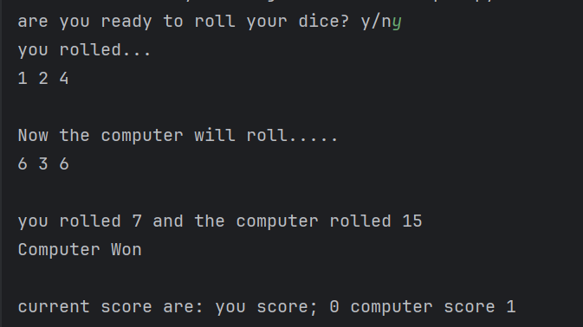
Yes, the program works as expected, logically and syntactically it is correct. The computer rolled a higher total than the user, so the program correctly printed” Computer Won” and increased the computer score by 1.

Test: User wins round
Screenshot(s) of output:
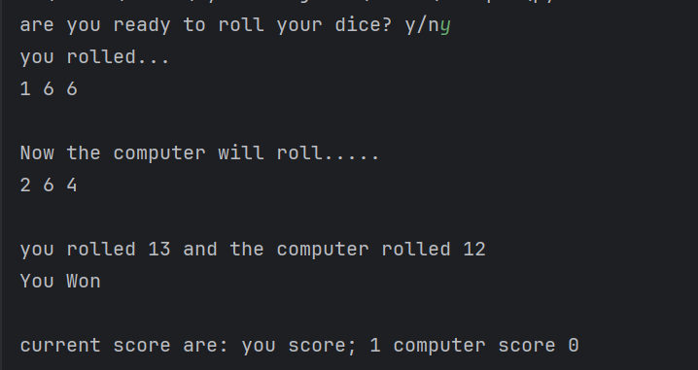
Yes, the program works as expected, logically and syntactically it is correct. The user rolled a higher total than the computer, so the program correctly printed “You Won” and increased the user's score by 1.

Test: Draw

Screenshot(s) of output:

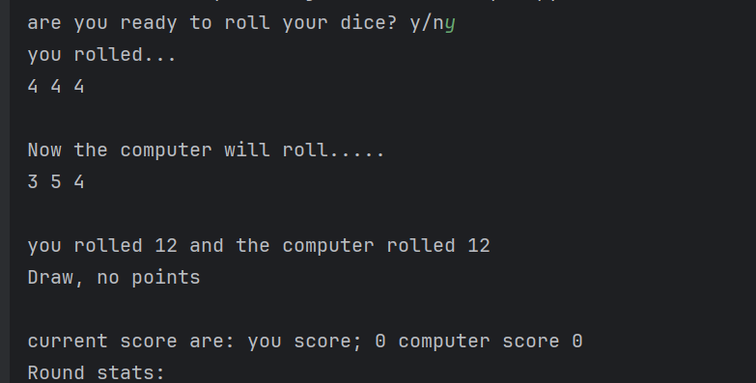
Yes, the program works as expected, logically and syntactically it is correct. Both totals were the same, so the program correctly printed “Draw, no points” and did not change either score.

Test: “Go again” – enter y
Screenshot(s) of output:
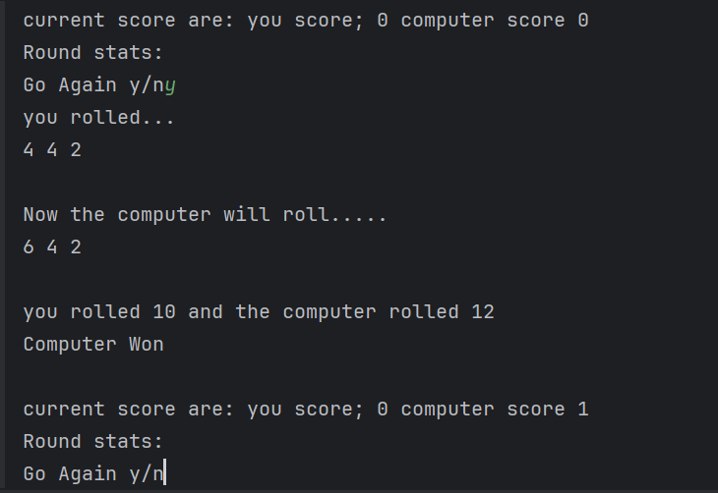
Yes, the program works as expected, logically and syntactically it is correct. Entering y correctly restarted the loop and played another round.

Test: “Go again” – enter n

Screenshot(s) of output:
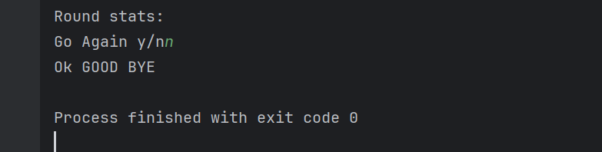
Yes, the program works as expected, logically and syntactically it is correct. Entering n correctly stopped the loop and printed “Ok Good Bye”

Test: “Go again” – enter Y

Screenshot(s) of output:
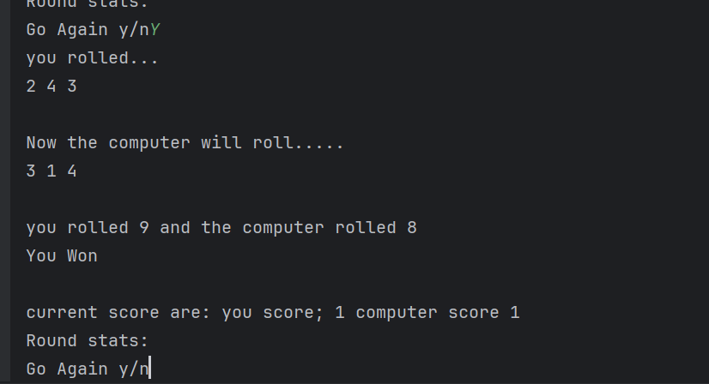
Yes, the program works as expected, logically and syntactically it is correct. The program used lowercase; the program treats Y the same as y, so it correctly continued to the next round.

Test: “Go again” – enter b

Screenshot(s) of output:
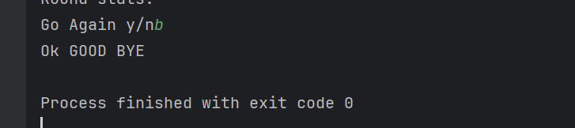

No, the program does not behave as expected. If the user enters b, the program immediately ends, even though the user didn’t mean to quit. It needs improvement to warn the user to ask again, so adding validation improves the program.

Test: Show score/score tracking (depending on how you have implemented your program)

Screenshot(s) of output:
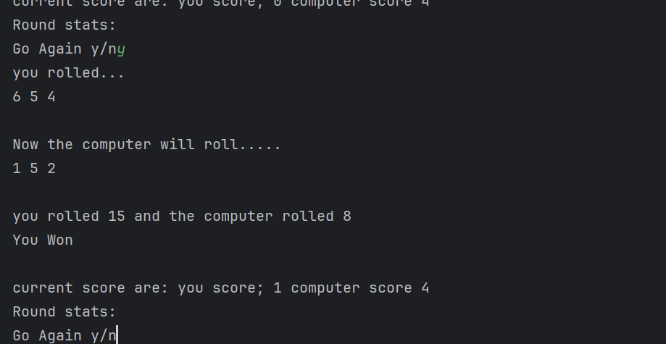
Yes, the program works as expected, logically and syntactically it is correct. Each time a round finished, the program correctly updated the score. The score was displayed after every round, so the tracking worked.

Test: Show an overall win (however this is achieved eg first to 5, best of 12 etc)

Screenshot(s) of output:
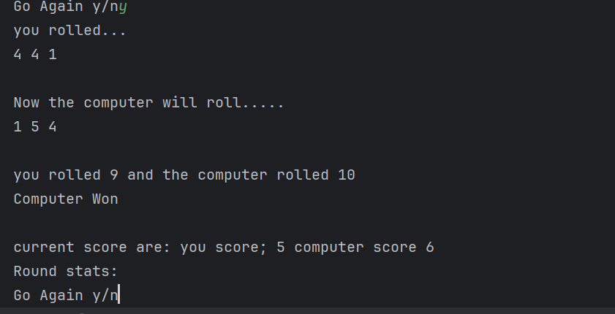
No, the program doesn’t behave as expected. The original program did not include a win condition; it kept playing rounds until the user typed n, so the duel never ended automatically and was incomplete. How to improve: add a condition to stop the game when someone reaches the target score using a loop.

Test: Analyse your code and write a short paragraph commenting on the efficiency of the original code. Could efficiency be improved, and if so, comment on what is currently inefficient?

The original code works correctly, but it is inefficient because it lacks a win condition, so it keeps running until the user manually stops it. Efficiency could be improved by using loops or functions, removing unused variables and a clear stopping rule, such as “first to 5 wins”. Another inefficiency is that the program also stops immediately if the user enters anything other than “y”. This means the program ends even if the user makes a typing mistake, which is not user-friendly. Adding input validation would make the program more robust. These changes would make the program shorter, easier to read and easier to maintain. The full revised code may resolve these conditions and fix the problem

- Consider the results of the above tests and your analysis of program efficiency and revisit your original code in order to address any tests that failed and/or improve code efficiency.

import random
userScore=0
compScore=0
rounds=[]
roundNumber=0
letsPlay=input("Are you ready to roll your dice? y/n")
while letsPlay.lower() not in["y","n"]:
print("Invalid input. Please enter y or n")
letsPlay = input("Are you ready to roll your dice? y/n")
while letsPlay.lower()=="y" and userScore <5 and compScore <5:
roundNumber+=1
print("you rolled...")
userOne=random.randint(1,6)
userTwo=random.randint(1,6)
userThree=random.randint(1,6)
print(userOne,userTwo,userThree)
print()
print("Now the computer will roll.....")
compOne=random.randint(1,6)
compTwo=random.randint(1,6)
compThree=random.randint(1,6)
print(compOne,compTwo,compThree)
userTotal=userOne+userTwo+userThree
compTotal=compOne+compTwo+compThree
print()
print("you rolled",userTotal,"and the computer rolled",compTotal)
if userTotal > compTotal:
print("You Won ")
userScore+=1
rounds.append("Round"+ str(roundNumber)+"you won")
elif userTotal<compTotal:
print("Computer Won")
compScore+=1
rounds.append("Round" + str(roundNumber) + "computer won")
else:
print("Draw, no points")
rounds.append("Round" + str(roundNumber) + "Draw")
print()
print("current score are: you score;",userScore,"computer score",compScore)
if userScore < 5 and compScore < 5:
letsPlay=input("Go Again y/n")
print("Round stats:")
if userScore==5:
print("You win the Duel!!")
elif compScore==5:
print("The Computer wins the duel!!")
for i in rounds:
print(i)
print("Ok GOOD BYE")

