Turbocharger Analysis

By Harrison Liddell
1700953
Contents;

Introduction – Page 3

Turbo strip down / rebuild - Page 4 – 5

Air flow through a turbocharger – Page 6

Turbo calculations – Page 7- 9

Turbo selection – Page 10 – 12

Installation considerations – Page 13

References – Page 14

Introduction;
The aims of this report are to discuss the effects of turbocharging a naturally aspirated petrol engine. A description of how exhaust gasses flow through turbocharger to atmosphere from beginning to end. Along with this a detailed documentation of a full strip down and re-build of a turbocharger including steps to be taken. An important feature to implement during a turbo charger conversion is an intercooler, this report will also outline the effects of adding an intercooler. As part of a task given to decide which turbo charger would be best suited for a V8 spark ignition engine, compressor maps will be analysed and from calculations made, a suitable compressor will be selected to optimise air flow to meet a certain specification. The basic principles of turbo charging a naturally aspirated engine will also be discussed, including what considerations must be made during the conversion.

Turbo Strip Down and Rebuild;
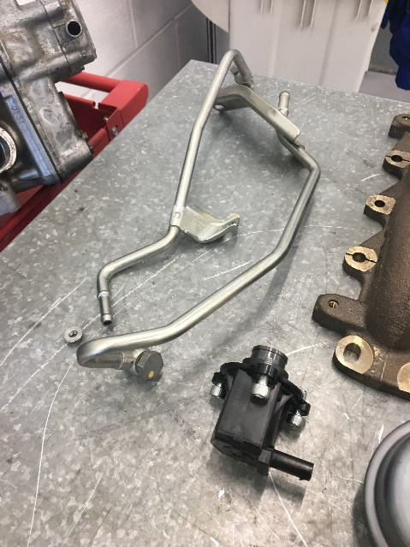
The turbo strip down process was conducted on a failed turbo, with the aim of discovering the cause of failure. To begin, the water feed lines and other connecting pipes are removed and stored safely, it is important to note the angle these lines were removed at as they must be replaced exactly the same. With the lines removed the next step is to remove the exhaust manifold, taking care to ensure the bolts connecting the turbo and manifold are kept together.
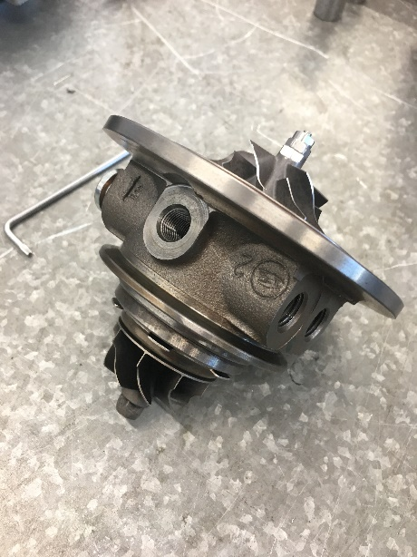
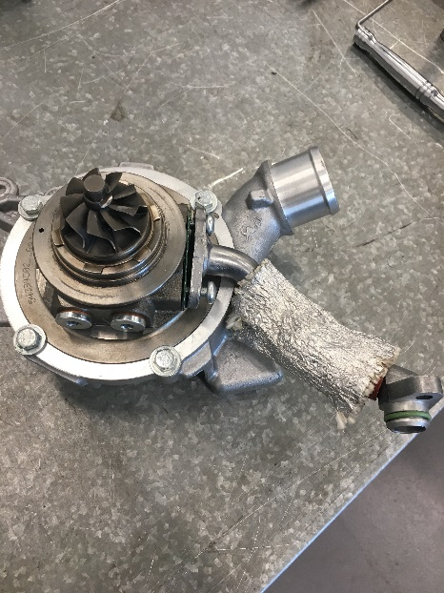
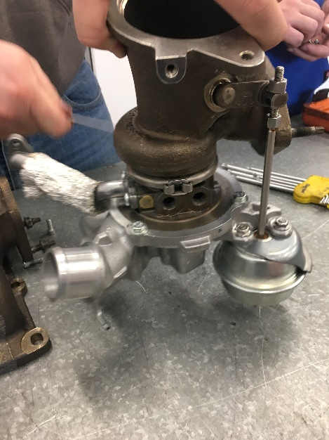
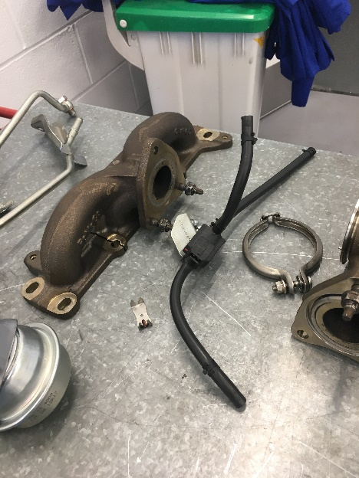
With the manifold removed, the wastegate is removed to allow the two casings to be split from each other, note how far on the thread both nuts are as they will need to be replaced in the same way. The next step is to remove the bolts holding the inlet and exhaust casing together, an alignment mark must be made on the inlet casing and the turbine casing. These two must re align during the rebuild process to ensure the wastegate is aligned. The bolts securing the turbine housing to the inlet casing must be removed to expose the turbine for further inspection. To remove the turbine shaft and gain access to the inner bearing, one side of the turbine must be locked whilst the nuts on the opposite side are removed, with these removed the shaft can be tapped out using a small punch and hammer.

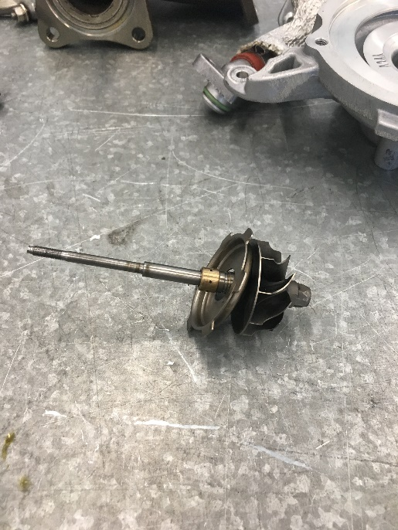
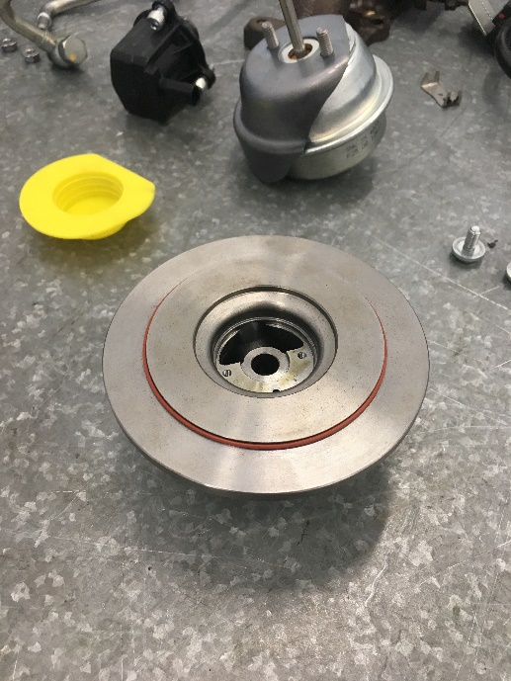
With the inner shaft and turbines removed, the rubber o ring that sits on the inlet side must be inspected. If there are any signs of wear or damage it is essential that it is changed to avoid failure after rebuilding. With the inner shaft removed, the journal bearings can be examined, if there is any sign of wear or damage they must be replaced, if a failure were to occur it could potentially destroy the turbine.
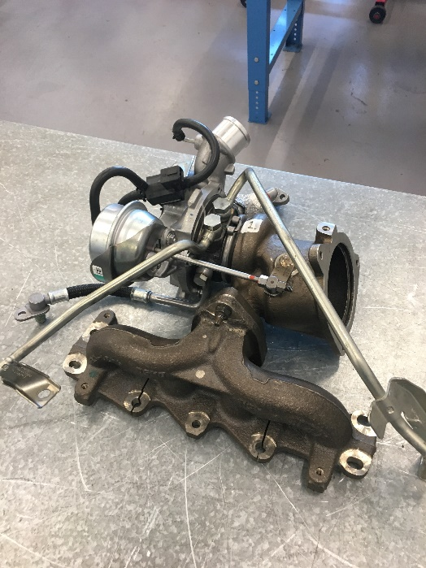
With the strip down and examination completed, with any necessary repairs carried out, the rebuild process can begin. The core is reinserted into the housing with the turbines bolted on each side, the bolts must not be overtightened as they can add extra stress upon the bearings causing them to prematurely fail, as well as adding increased resistance onto the turbine. Both housings are reattached by using the alignment mark made during disassembly. Oil feeds are also reconnected and the wastegate re-attached. The turbo assembly can be bolted back onto the manifold and water lines can be connected. The photo below can be used as a reference for how the assembly should appear.

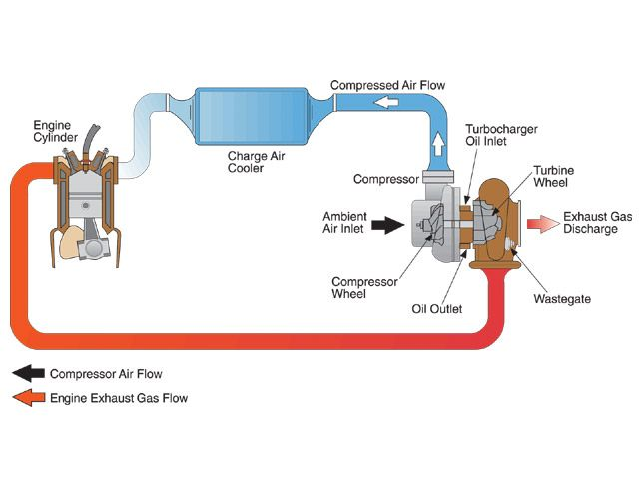
Air flow through a turbo charger;

(Phung, 2009)
The above diagram depicts the flow of air through a turbo. Air drawn in from atmosphere is pulled through the induction system into the inlet side of the turbo. Here it is compressed by the turbine and sent via the intercooler to the cylinder via the inlet port. The intercooler is required to cool the air as when it is compressed it heats up immensely. Cooler air creates a better burn during combustion and therefore is more efficient. Once in the inlet port the air mixes with fuel to create combustion. One combustion is complete the exhaust gas is expelled through the exhaust port and re-circulated to the turbo. The exhaust gas is used to spin the turbine which compresses the air on the inlet side to draw air in and the cycle begins again. Once the exhaust gas has been used to spin the turbine it is then vented to atmosphere through a exhaust pipe, here it will be filtered through a catalytic converter.

Turbo Calculations;
The task given was to select an adequate turbo for a naturally aspirated, spark ignition V8 engine. The engine has a bore of 95mm and a stroke of 80mm, rev limit of 9500rpm, volumetric efficiency of 85% (naturally aspirated form) and the desired running pressure from a turbo is 12 psi. Based on these figures it is possible to calculate the volumetric flow rate of the engine prior to a turbine being fitted. The following calculation is used;

$$V=\frac{v×η×N}{2×60}$$
V = Volumetric Flow Rate v = Volume η = Volumetric Efficiency N = RPM
To Calculate the volume of the cylinder the following simple equation is used as it is currently an unknown in the previous formula;
$$v=A×L$$
A = Area of the cylinder L = Stroke length
To gain the area of the cylinder (as it is currently an unknown) the following formula is used;
$$A=\frac{πd^{2}}{4}=\frac{π×(95×{10}^{-3})^{2}}{4}={7.088×10}^{-3}m^{2}$$
With the area now calculated, it is now possible to discover the volume of the cylinders;
$$v=7.088×{10}^{-3}×80×{10}^{-3}=5.67×{10}^{-4}m^{3}$$
The above calculation shows the volume in one cylinder, as this is a V8 engine it must be multiplied by 8 to gain the volume across all cylinders;
$$v_{t}=5.67×{10}^{-4}×8=4.536{×10}^{-3}m^{3}$$
Now referring to the first formula mentioned, with all necessary values found, the volumetric flow rate can now be obtained.
$$V=\frac{4.536×{10}^{-3}×0.85×9500}{2×60}=0.305\frac{m^{3}}{s}$$

Now the pressure ratio (PR) of the turbine being implemented must be calculated, to do so the following formula is used;
$$PR=\frac{14.7+boost}{14.7}=\frac{14.7+12}{14.7}=1.82 BAR$$
By using the desired boost pressure and adding it to the atmospheric pressure, assumed to be at normal sea level of 14.7, and dividing it by the atmospheric pressure, the ratio of 1.82 BAR is found.
By using the same formula as earlier to discover the volumetric flow rate without the turbine, through slightly adjusting it, the Volumetric flow rate of the turbine can be gained ($V_{t})$;
$$V_{t}=PR×\frac{v×η×N}{2×60}=1.82×\frac{4.536×{10}^{-3}×0.85×9500}{2×60}=0.556 m^{3}/s$$
With this, the flow rate may be calculated (FR) through multiplying the total displacement of the engine 2119, then multiplying by 0.07;
$$FR=V_{t}×2119×0.07=0.556×2119×0.07=82.47 lb/min$$

With these figures now calculated, the temperature difference caused by adding a compressor to the system can be calculated, assuming the temperature at the inlet ($T_{in}$) is $27℃$ (ambient temperature) which equals 300 Kelvin. By multiplying the PR^0.28 by the ambient temperature and deducting the ambient temperature whilst dividing by the compressor efficiency, the outlet temperature is calculated. Using this information, the following formula can be used;
$$T_{in}=27℃=300°K$$
$$T_{out}=PR^{0.28}×T_{in}$$
$$Actual Temp Rise=\frac{\left({PR}^{0.28}×T_{in}\right)-T_{in}}{η_{c}}=\frac{\left({1.82}^{0.28}×300\right)-300}{0.6}=91.28°K$$
$$T_{out}=391.28°K=98.28℃$$

Given there is a 71.28 degree change in temperature by adding a compressor (98.28 – 27) there is a definite need to add an intercooler to improve efficiency. If a 60% efficient intercooler is used in the system, it is possible to calculate the change in temperature that would be seen by using the following method;
$$η_{i}=\frac{T_{co}-T_{io}}{T_{co}-T_{a}}$$
$$T_{co}-T_{io}=η_{i}(T_{co}-T_{a})$$
$$-T_{io}=η_{i}\left(T_{co}-T_{a}\right)-T_{co}$$
$$T_{io}=T_{co}{- η}_{i}\left(T_{co}-T_{a}\right)=391.28-0.6×\left(391.28-300\right)=336.512°K=63.512℃$$
$T_{co}$ – Temperature compressor outlet $T_{co}$ – Temperature compressor inlet
$T_{io}$ – Temperature intercooler outlet $T_{a}$ – Ambient pressure $η_{i}$ – Intercooler efficiency
This proves that adding an intercooler to the system greatly reduces the air temperature, by 34.7 degrees before reaching the combustion chamber. This will improve the combustion and create more power.

Turbo selection;
Given that in the previous section it was discovered that the pressure ratio was 1.82 BAR and the air flow was 82.47lb/min whilst at 12 psi. By using that information, it is possible to select a suitable compressor to maximise efficiency. The following compressors have been put forward for selection and a final choice must be made. By looking at each one individually and evaluating the PR to AF, a suitable turbo can be chosen.
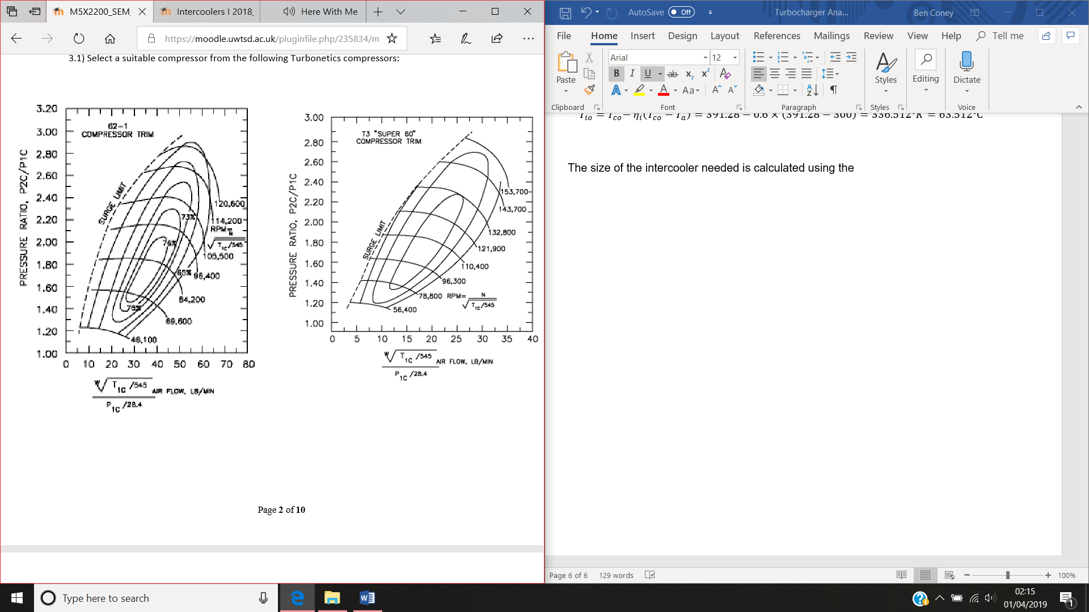

The first compressor map shown above shows that this turbo would not be suitable for the application needed as it cannot withstand an air flow high enough. Even if it were to theoretically run at half of the required air flow, it would be very near the surge limit. The surge line needs to be avoided as it can cause a terminal compressor failure if crossed.

Similar to the first compressor, this one also cannot withstand the amount of pressure or air flow, therefore being inefficient and incapable of running the amount of boost pressure needed without crossing the surge limit. Given the maximum efficient flow rate of this turbo is 25lb/min, it shows that it is far too small for the application required.
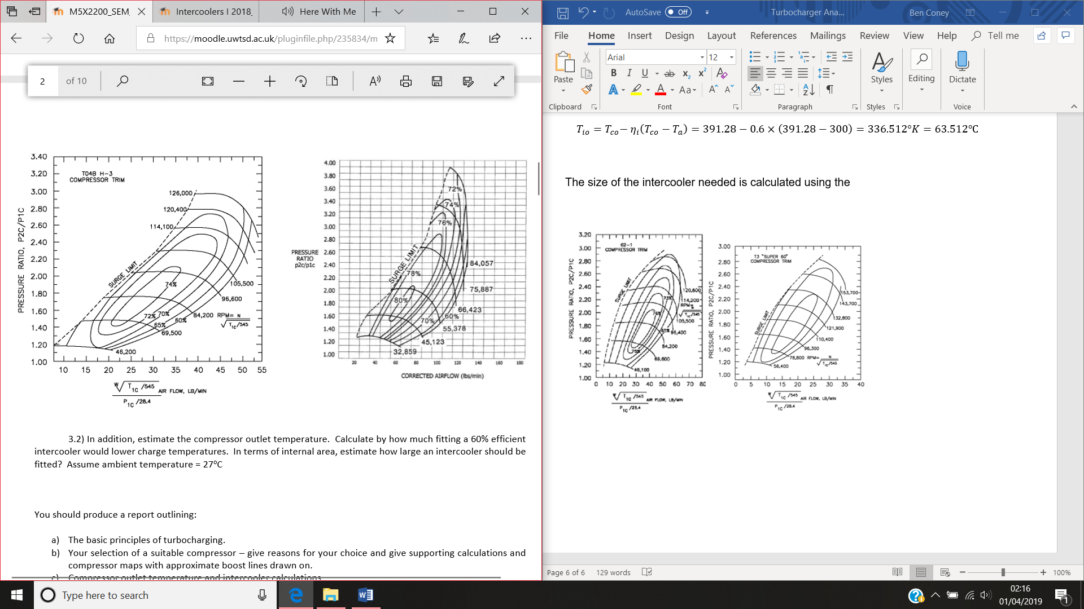

Again, with this compressor, the air flow capacity is too low for the application needed and would not handle the load. As this turbo is too small it would only be efficient if the flow rate was half that is required then the compressor would be 70% which is not enough.

The final compressor would be perfect for the application as it has a high enough air flow to meet the requirement and stays within the surge limit given the pressure ratio. Given it is the only compressor capable of withstanding the pressure and air flow required, it is the turbo that would be used for this application. At 9500 rpm the turbo would be at 78% efficiency, meaning that even when at high rpm it will still perform adequately.

Installation considerations;
The basic premise of turbocharging an engine is to increase the air density the air density and force more air into the combustion changer (Bosch, 2007). Taking this into account, there are accompanying measure that must be implemented to a naturally aspirated engine. With regards to cooling. An intercooler is an essential part of the induction system as it cools the air that has been heated up by the compressor. If an incorrect intercooler was fitted and was not efficient enough, side-affects would include, power loss, engine overheating and poor running, which could lead to a potential engine failure. As well as the addition of the intercooler the engine cooling system would need to be upgraded. A common upgrade to a standard radiator is to opt for an alloy alternative as they can provide over 30% better cooling and are considerably lighter than copper or brass radiators (allisport, n.d.). Oil feeds would have to be implemented and a new external oil pump fitted to take oil from the existing oil reservoir and deliver it to the turbine bearings. If the turbine bearing were not to receive lubrication it would overheat and seize causing terminal failure. The fuelling system would need overhauling as standard fuel pumps and fuel injectors would not cope with the increased amount of air being delivered into the cylinder. If they were not upgraded the mixture could possibly be too lean and therefore cause the engine to run poorly, overheat and prematurely fail. Along with the fuel system upgrade, the engine management would also need upgrading. Given the standard management is only mapped to a naturally aspirated form, a controller for the turbine to limit boost would need to be implemented, as well as controlling the fuel mixture. To accommodate for the turbocharger a new exhaust manifold would have to be designed as well as a new downpipe. Other engine bay modifications may also be necessary in order to accommodate a turbocharger, such as relocating the battery to allocate more space for a turbo charger, or vents cut into the bonnet to allow hot air to escape and keep engine bay temperatures low.

References;

Bibliography
allisport. (n.d.). allisport . Retrieved from allisport : https://www.allisport.com/product-info/alloy-radiators/
Bosch. (2007). Automotive handbook. In Bosch. Wiley.
Phung, P. (2009, 9 1). Retrieved from super street online: http://www.superstreetonline.com/how-to/engine/130-0909-turbocharge-understanding-guide/#photo-02

