DS 1 Template

My Screenshots/Photos
- Please add 4–6 screenshots or photos of your digital life.
- You can use your phone or laptop.
- For each screenshot, write one or two sentences explaining what it shows.

Screenshot/Photo 1

A computer is a big part of our everyday life. We use it to do schoolwork, search for information, watch movies, and talk to friends and family. It helps us finish our work faster and makes learning easier. Many people also use computers for their jobs and to do things like shopping online. We can use a computer for fun, but we should also be careful about what we do on the internet. Overall, computers make our daily lives easier and help us stay connected with the world.

Screenshot/Photo 2

A phone is an important part of our daily life. We use it to call and message our friends and family. It helps us search for information, take pictures, watch videos, and use social media. We can also use our phones for schoolwork and to learn new things. Phones make it easy to stay in touch with people, even when they are far away. Overall, a phone makes our lives easier and helps us stay connected with others.

Screenshot/Photo 3

A digital camera is useful in our everyday life because it helps us take pictures and record special moments. We can use it to take photos of our family, friends, holidays, and important events. It allows us to see our pictures straight away and choose which ones we want to keep. We can also transfer the pictures to a computer or phone and share them with others. Digital cameras help us save memories that we can look at in the future. Overall, a digital camera makes it easy to capture and keep special moments in our lives.

Screenshot/Photo 4
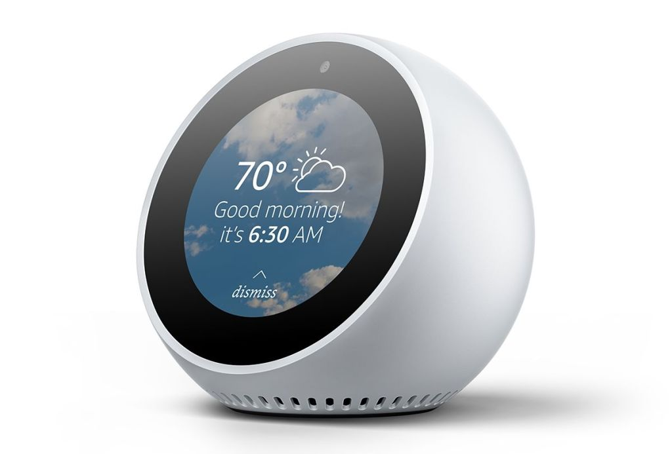
Alexa is a smart assistant that helps us with everyday tasks. We can ask Alexa questions, play music, check the weather, or set alarms. It listens to our voice and responds to what we ask. We can also use it to control smart devices, such as lights, in our homes. Alexa makes life easier because we can do many things without using our hands. Overall, Alexa is a helpful device that makes our daily lives more convenient.

Screenshot/Photo 5

The Xbox One is a games console that people use to play video games at home. It allows us to play different games on our own or with friends. We can also connect to the internet to play with other people around the world. The Xbox One can be used to watch films and videos as well. It is a fun way to relax and enjoy free time after school or work. Overall, the Xbox One is a popular part of digital life because it provides entertainment and helps people connect through gaming.

Screenshot/Photo 6
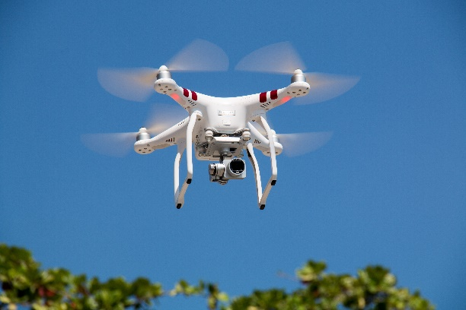
A drone is a flying device that can be controlled using a remote control or a phone. People use drones to take pictures and videos from high above the ground. They are also used to deliver items, check buildings, and help in search and rescue missions. Drones can reach places that are difficult for people to get to. They are useful for work and fun, but we should always use them safely. Overall, drones are a helpful part of digital life because they make some jobs easier and allow us to see things from a different view.

My Short Reflection
- Write 5–8 simple sentences about your digital life.
- You can use the sentence starters below if helpful.

My Short Reflection
I use digital tools to help me with schoolwork and everyday tasks. I feel confident when I use my phone to search for information and talk to people. I want to improve my computer skills and learn how to use new technology. I often use these tools: my phone, computer, Xbox One, digital camera, Alexa, and drone. I sometimes feel nervous about using things I do not understand. I hope this module will help me learn more about digital devices and how to use them properly. Digital skills are important for me because they help me in school, at home, and in the future.

Sentence starters
- I use digital tools to …
- I feel confident when I …
- I want to improve …
- I often use these tools: …
- I sometimes feel nervous about …
- I hope this module will help me …
- Digital skills are important for me because …
You can write more if you want.

Submission Checklist
Before you submit, please check:
​​​ ☐ I added 4–6 screenshots
☐ I wrote short sentences for each screenshot
☐ I wrote my short reflection
☐ My work is my own
☐ My file opens correctly
​​☐ My file opens correctly

References
Statista Research Department (2026) ‘Number of Instagram users in the United Kingdom (UK) from September 2018 to September 2026’. Available at: https://www.statista.com/statistics/1018494/instagram-users-united-kingdom/ (Accessed: 25 October 2026).

