Academic and Employability Skills

09/08/2020

MY OWN REPORT WRITING

Pamela Santos Cepeda 1916655
Silvia Hoffman (ACE)

Table Of Content
Academic and Employability Skills 1
09/08/2020 1
1
Section 1: Introduction 3
• Section 4: Summarizing 3
• Section 5: Paraphrasing 3
Section 2: TERM 1. 3
Section 3: Term 2. 4
• The topics that most impressed from Term 2. 4
• ¿What is CV (Curriculum Vitae)? 4
• ¿What is a Cover Letter? 5
• Reflecting Writing 6
• Reflective Reports 7
• Why reflect? 7
• Section 6: The Activity That Most Caught Me Attention During The week 9. 8
Conclusion 8
References 8

Section 1: Introduction

When I arrived in London my dream was to study at the university, to acquire new knowledge and improvement. I came with the very high prospect, that I would enter any University from day one and could graduate quickly and done, to my surprise I have to say, very disappointing, It wasn’t I expected to be, started my English was much lower than realized and I did not have the tools, the people, or the necessary information to apply to it. At the beginning of this report writing I was very stagnant, overwhelmed and I did not know how to start or what to add in each part of this report, but I have to say that I think I found a way to start something and create a real statement about how I came here. At the same time was kind of difficult to understand the way here, London, they work. For me who has come from another country was like, asking this type of questions, where are the books? Where are parts and tests? But by the time I could understand whole the process. In this second term I must add that from the first moment I have noticed the professionalism and enthusiasm of my teacher. For me the best topic was '' Writing a CV '' and '' Reflection Report '', the CV helped me realise how important it is and the most important thing to know what I had to add and what not, also the letter was from A great help I never thought I would be so bad at doing this task and the '' Reflection Report '' helped me realise that I did not know how to summarise or get the most important thing out of any topic. Regarding the change, I do not think that our teacher needs a change since she has all the points well thought out.

Section 4: Summarizing

Summarizing is a very important skill in which academic writing allows us to extract the most important points from a text and rewrite them in your own words, in an abbreviated form. These skills are invaluable when taking notes and doing research for work, daily life, and more. It also helps us to be able to reflect what someone said to me in a few words and to do it in an appropriate way, with the necessary words to make the other person understand what we wanted to say, and expose our main ideas

Section 5: Paraphrasing

Paraphrasing is rewriting what you have read in your own words without distorting the meaning. When paraphrasing, it is important that the reader feels that they have understood the topic and that they are doing it well. Paraphrasing is much more than simply rewriting the text by changing a few words. What matters is understanding someone else's ideas and sentences and retelling them. And is just something in which we can rewrite a text by changing some words, without being able to distort the meaning and convey the theme correctly. You must avoid plagiarizing the content and that’s going to make your work successfully.

Section 2: TERM 1.

At first seem very chaotic for me, since the teacher started to come into the class and explained something different, in a different way and everything was very confusing. Where I come from its different but think there is the challenge and you can learn another ways and forms to improve yourself. In conclusion I think for all us was difficult, even for the lecture, new course, different people, coming from different countries, was a challenge.

Section 3: Term 2.

After life changed us all from one day to the next, something unexpected and unusual happened in the world, which was Covis-19, this disease made everyone stop, and here we came to teach online classes through Microsoft team, all this was new, new teachers and a new term, but thanks to the professionalism and new progressors and the members of the university we were able to learn everything perfectly.Talking about our subject with Silvia Hoffman, our perspective of studying and learning through Microsoft Team changed, to understand that not being behind a screen was less important or less professional.

The topics that most impressed from Term 2.
In this section I am going to talk about some topics that were the most important, at the same time those that helped me to grow and have more knowledge and at the same time be able to make my assessments in a better way and be able to have a better brand and most importantly do them properly:

¿What is CV (Curriculum Vitae)?

I do really have learned to do a CV (Curriculum Vitae) here in this term, I said that because I used do a lot of them but I never realized that the fact them were wrong and I didn’t make a interested CV to send to the companies. They never took me from my CV and was wondering why, when I have learned to do it in this term I realized why. A curriculum vitae or CV for its abbreviation of a document that is used as a tool to present an express and clear relationship of the data to convincing an employer that who you are, your qualifications, skills and work experiences of a person, with the intention to move forward in a formal selection process. To have clear what you need to write down in your CV, you must write down those 4 important things:
- Knowledge
- Attributes
- Skills
- Other things
Developing and writing a CV, must be simply, illustrative and should be a guide.

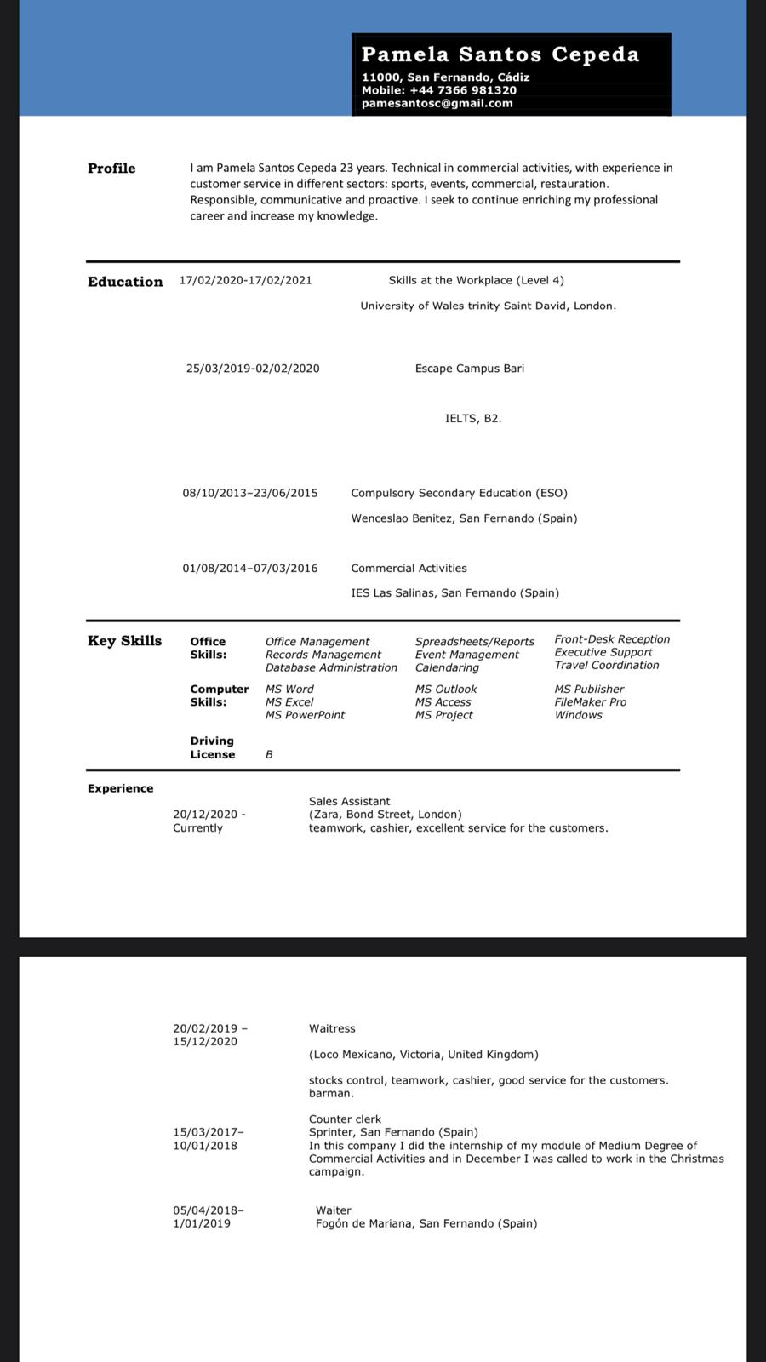

¿What is a Cover Letter?

For me write down a cover letter It was not something that was made easy for me, since I thought it was done in a different way and with different characteristics. When the lecture asked us, how many of us have got a cover letter even half of do not know what it is. When they teach us, was a such a discover, to know better how to write down I learn all those steps. An application letter, also known as a cover letter, it is a document that is sent together with the resume to give additional information about your skills and experiences to the new employer. The cover letter is intended to give detailed information on what is a qualified candidate for the required position.
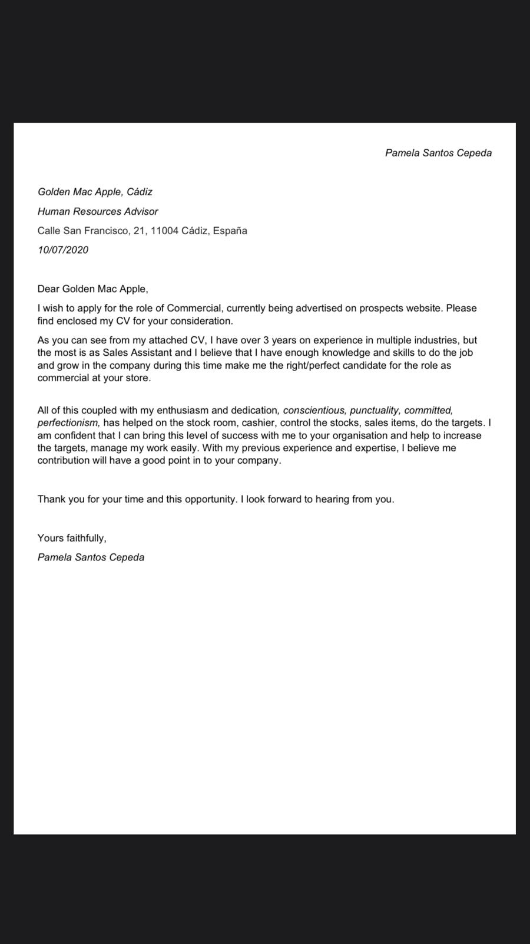

Reflecting Writing

This topic was the more difficult to me, because for me expressing myself has always been difficult, and even the definition of this one seemed strange to me the first time I heard it, with the explanations in class and some activities, I was able to start it up and learn from it.Reflections are deep analyses that an individual makes about a specific topic, be it an imaginary scene, an event, interaction, your passions, and thoughts to reach a conclusion. In any case, all this will lead us to guide us until we arrive. an exact conclusion of what we want to express.In a more technical concept, it is the way to process an experience-based practice to produce learning.Here are some tools that helped me develop this reflective writing much better.
Keys: D Describe what happened
I Interpret the events
E Evaluate the effectiveness
P Plan for the future
Then in class we saw a video that was given to us by our teacher in which she helped us a lot and was very good and usable to learn about this new topic and this will serve to make my assessments in another way and at another level:
https://www.youtube.com/watch?v=SntBj0FIApw
(Melbourne, 2 jun. 2017)

Reflective Reports

About this report when our teacher spoke about it, these were some of the most basic and powerful concepts that I could acquire: It is a piece of writing that summarizes the exploration of a topic using thoughts and personal experience. The goal of the reflective essay is, in the long run, to weave reflections in a way that conveys a new thought to the reader. This gives us an opportunity to gain more insight from work with a deep reflection on your experience, and a better consideration to see the perspectives of others and their theories. Whilst to your reflective writing will be based on personal sources. It will also need to draw on other sources and types of evidence and then you can get better understand your experience. The best aspects of these is that I had no idea how to make it more formal and more academic and these tools helped me a lot:
Possible sources of evidence for reflective writing:
- Other things I know
- Personal aspirations
- Work-based issues
- Applications to other modules/learning
- Academic theory

Why reflect?

To me this was the most important since I could understand what it was about, since for me I had never done something similar or innovative like this and I truly believe that we should all learn to use this tool as it is very important and significant for us to make a successfully carry out our assessments. The best aspects of these is that I had no idea how to make it more formal and more academic and these tools helped me a lot: Initiate a process of personal knowledge, the one for which we referred before. Reflecting helps us to know, identifies us as restless beings, capable of learning,reflection also helps us to clarify those aspects of our life that may seem confusing, and can help to clarify contradictions or internal conflicts that anguish and us cause anxiety or fear.
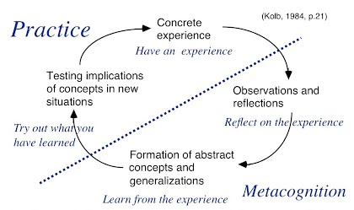

Section 6: The Activity That Most Caught Me Attention During The week 9.

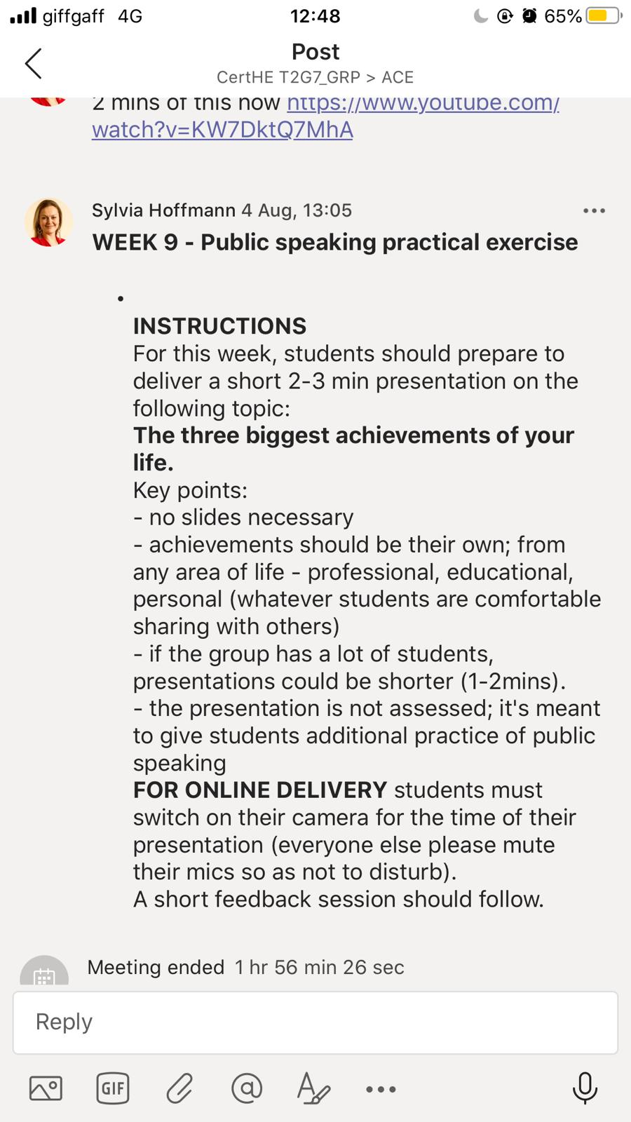
For me it was one of the most important tasks because it made us students get to know each other better and at the same time improved our ways of speaking, expressing ourselves, and improving our English. For me, the most impressive thing about this was when my colleagues began to speak and I felt how much they fight and how willing they are to leave many things and leave their homes to be able to come to a country that offers better professional and educational opportunities, as they struggle. every day to not go back or return to their countries without being able to finish their studies. This is not as easy as it is said or painted.

Conclusion

The conclusion to this term 2 is the most interesting and the one I least expected from it. This I can say because of the great level of English, everything he has learned in class, how important it was to see again topics such as summarising, phrasing, references, in which I can say that I cannot do any work without adding all these topics to be successful. I want to continue learning and be able to graduate having learned much more than I expected. ‘’Learning is the processes by which knowledge is created the transformation of experience’’. (Kolb, 1981, pág. P38)

References
Kolb, D. (1981). Learning styles and disciplinary differences. A.W.
Melbourne, T. U. (2 jun. 2017). Reflective writing. Youtube. Australia: Academic Skills.

