

BA Business Management

International Business Communications

LCBB6001
Component 2: Presentation

Student name: Cristina Caraman (2125666)
Lecturer: Dr Charles Nwaogwugwu
Submission date: 05/04/24

Table of Contents

Introduction 3
Cultural similarities between the UK and Germany 5
Cultural similarities between the UK and Germany (Cont’d) 6
Cultural Sensitivity 7
Hofstede’s Power Index (Country Comparison) 8
Hofstede’s Power Index (Country Comparison Cont'd) 9
Cultural variations between the UK and Germany (Language) 10
Cultural variations between the UK and Germany (Ethnic makeup of the people) 11
Cultural variations between the UK and Germany (Ethnic makeup of the people) Contd. 12
Cultural variations between the UK and Germany (Social structures) 13
Cultural variations between the UK and Germany (Religious values) 14
Cultural variations between the UK and Germany (business- and work-related attitudes) 15
Recommendations 16
Conclusion 17

Introduction

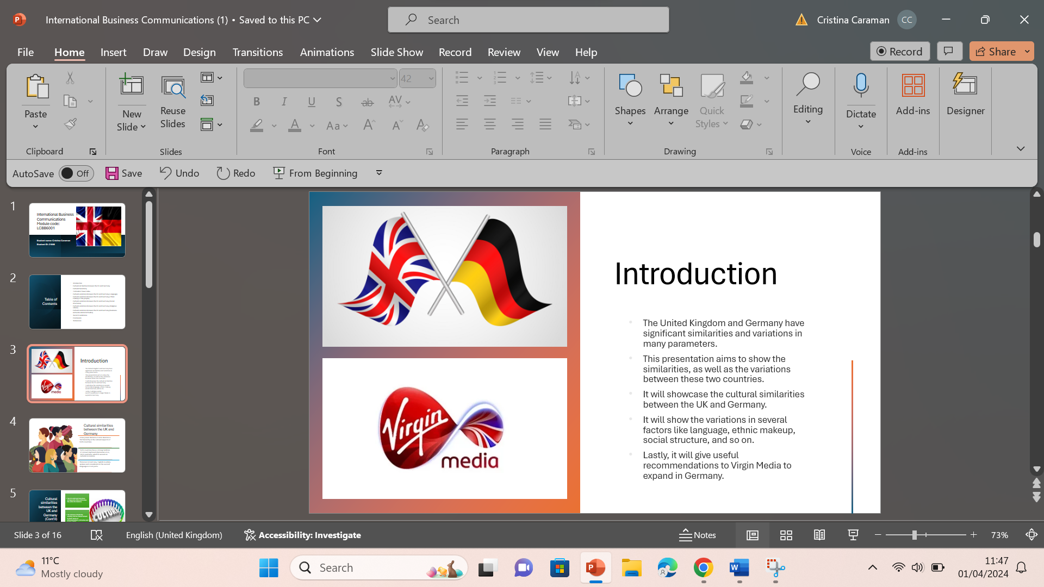

Virgin Media O2 launched on June 1, 2021. They combined the biggest and most trustworthy mobile network in the UK with a broadband network that offers the fastest internet speeds you can get.
Virgin Media O2 cares a lot about its customers and for this reason they put together different ways for people to connect to the internet in one place. Their main goal is to make the internet better in the UK.
Virgin Media O2 is a big part of a partnership between two companies called Liberty Global and Telefónica SA. Together, they're one of the biggest companies in the UK.
They have a lot of people using their services in the UK—around 46.4 million connections for broadband, mobile phones, TV, and home phones. Their own internet network reaches about 16.7 million homes, and their mobile network covers almost everyone in the country with fast 4G internet. They also offer 5G in more than 3200 towns and cities.
Virgin Media O2 invests a lot of money in the UK. They have about 16,000 employees and 384 stores. They plan to spend at least £10 billion over the next five years to make things better.

The United Kingdom and Germany have significant similarities in several aspects. On the contrary, both countries also showcase several variations and differences in many parameters. The following presentation aims to show the similarities, as well as the variations between these two countries in several factors. The aim of this presentation is to provide useful recommendations to Virgin Media which wishes to expand its business to Germany. It will showcase the cultural similarities between the UK and Germany. Next, the presentation will delve into the variations between these two countries in terms of language, ethnic makeup, social structure, religious values, business, and work-related attitudes. Lastly, it will give useful recommendations to Virgin Media to establish a business in Germany by considering these parameters.

Cultural similarities between the UK and Germany

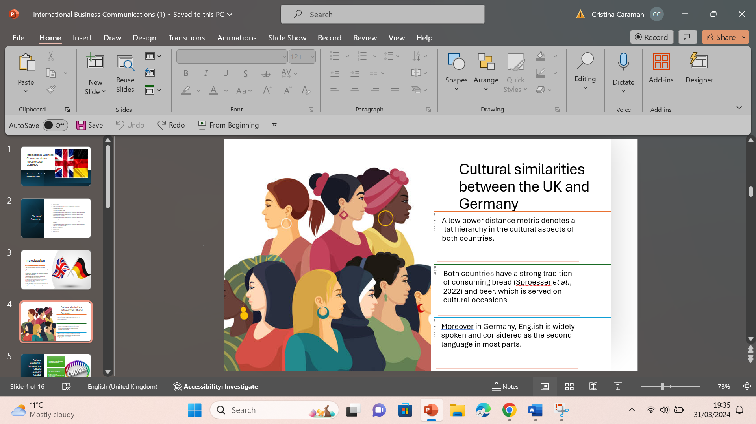

Hofstede’s Cultural Dimension Theory provides useful insights into understanding the cultural differences and similarities between the UK and Germany. To assess the expansion of Virgin Media to Germany, several cultural similarities can be found. The power distance metrics for both countries are relatively low. A low power distance metric denotes that both countries follow a flat hierarchy rather than a chain of command in cultural aspects. Another cultural similarity between these two countries is in their food habit. Both countries have a strong tradition of consuming bread (Sproesser et al., 2022). Moreover, both countries also have a strong tradition of consuming beer, and it is served on cultural occasions. Moreover, in Germany, English is widely spoken and considered as the second language in most parts. Therefore, this can also help Virgin Media in establishing a business there effectively.

Cultural similarities between the UK and Germany (Cont’d)

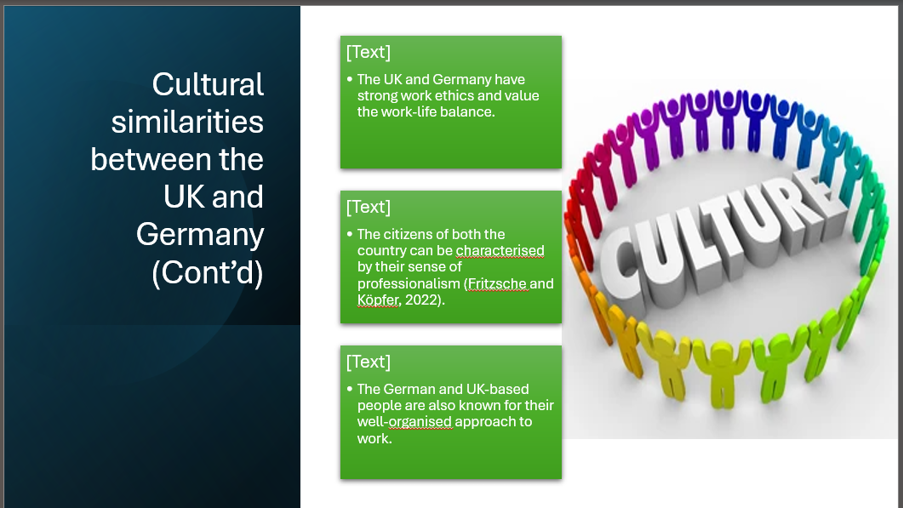

Both the UK and Germany have strong work ethics and value the work-life balance rather than just focusing on career goals. Hofstede’s theory shows that both German and UK-based people are family-oriented. A high metric of Individualism in both countries denotes that the people focus on the parent-children relationship. Moreover, the citizens of both the country can be characterised by their sense of professionalism, as well as their commitment to meeting deadlines (Fritzsche and Köpfer, 2022). The German and UK-based people are also known for their well-organised approach to work. At the same time, both countries are also known for offering handsome employee benefits to the employees at the workplace. These cultural parameters are important for Virgin Media to consider before expanding.

Cultural Sensitivity

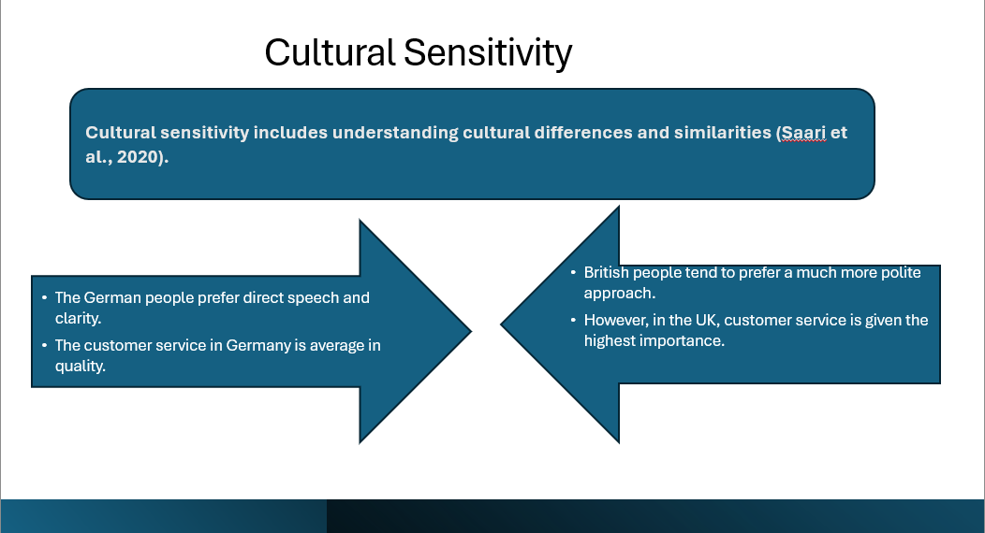

Cultural sensitivity can be defined as a set of skills and knowledge that helps people understand and learn about different cultural backgrounds. It includes being aware of the cultural differences and similarities (Saari et al., 2020). As for the cultural differences between British and German people, the Germans prefer direct speech and value clarity, whereas the British people tend to prefer a polite approach. The Germans do not tend to entertain the pleasantries. However, in the UK, this is considered to be a part of quality conversation. On the other hand, customer service in Germany is average in terms of quality, whereas, for the British people this parameter is of extreme importance.

Hofstede’s Power Index (Country Comparison)

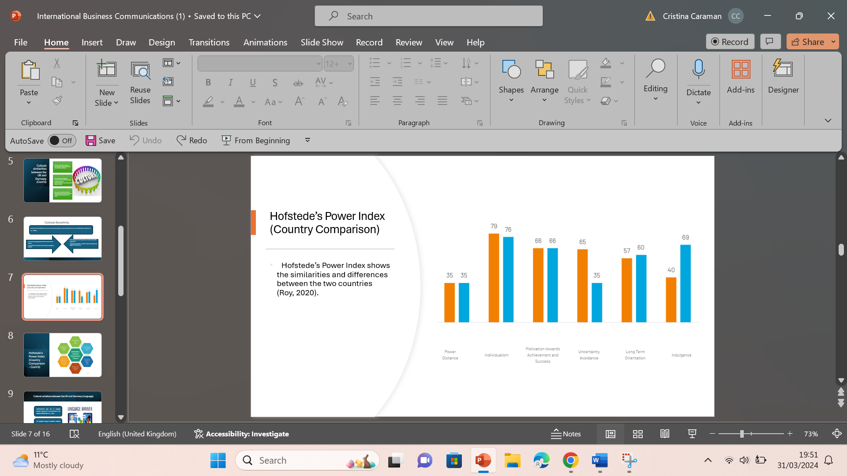

Hofstede’s Power Index defines the degree of existing similarity and dissimilarity between two nations (Roy, 2020). The power distance of both countries with a 35 score denotes the presence of decentralised power in both countries, therefore minimising the overall social inequality. Next, the individualism scores of 79 and 76 of Germany and the UK respectively suggest the individual mindset of people of both countries, where people tend to prefer living with a small family. The score of individualism in both the countries also aligns with the score of Motivation towards success being 66 and 68 for Germany and the UK respectively. A high motivation score suggests that citizens of both countries are driven by competition and focus on attaining individual success.

Hofstede’s Power Index (Country Comparison Cont'd)

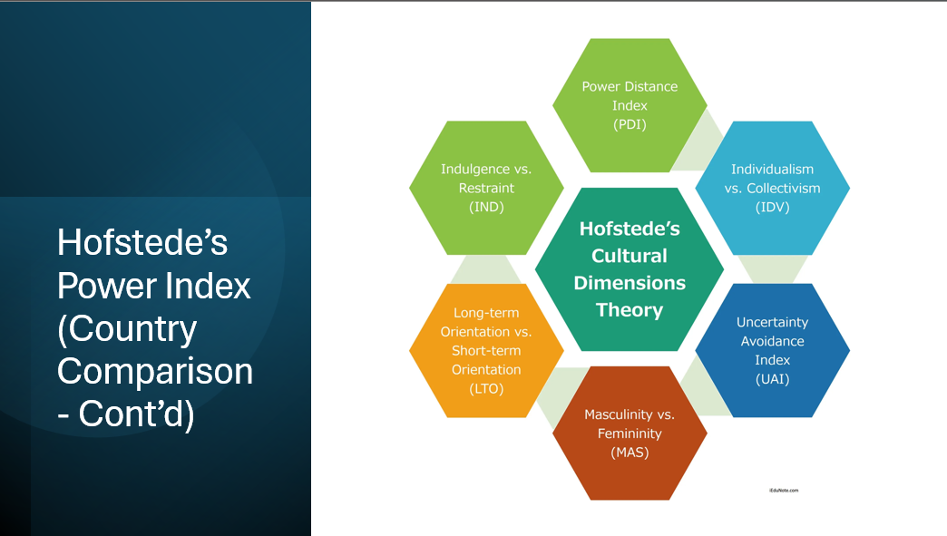

Uncertainty and avoidance are other aspects of Hofstede’s model of cultural dimensions. It refers to the level of comfort of individuals in different cultures regarding uncertainty and the unknown (MasterClass, 2020). This index is higher in Germany (65) as compared to the UK (35). This means that German individuals are more risk-avert as compared to UK individuals. Another crucial factor is “Long term orientation”. In simple terms, it refers to a focus on the future. The UK stands higher on this scale at 60 as compared to Germany (57). It implies that UK individuals put more emphasis on long-term objectives and make sure that their short-term objectives are in alignment with the long-term goals. Lastly Indulgence, Germany stands at 57 and the UK slightly higher at 60. This means the UK is more of a pragmatic society that believes that truth depends very much on situation, context, and time (Hofstede-insights.com, 2020).

Cultural variations between the UK and Germany (Language)

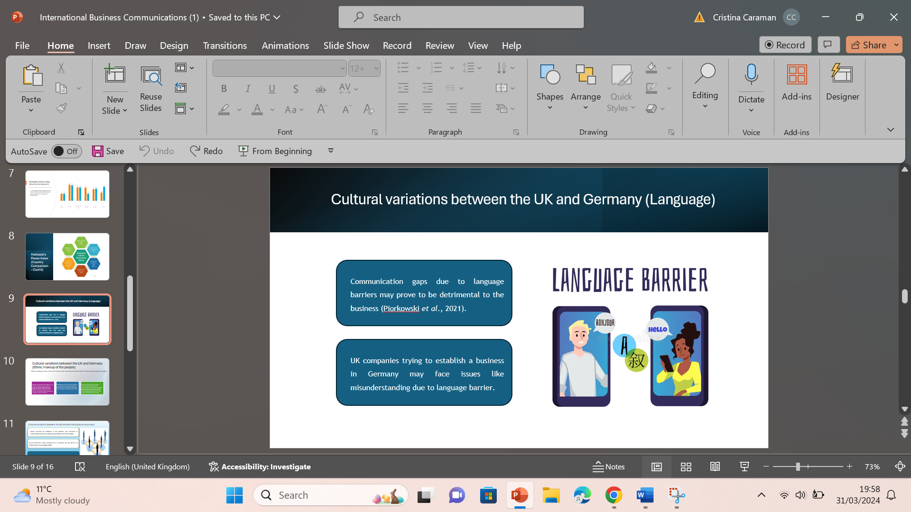

Although English is a major language in Germany and German citizens can speak English fluently, this can also be challenging for businesses like Virgin Media, when establishing its business there. Despite speaking English fluently, German citizens prefer to stick to their own language in their home country. Therefore, businesses like Virgin Media may face issues in several business activities. Moreover, a language barrier can also establish a communication gap within the business which in turn may prove to be detrimental for the business operations (Piorkowski et al., 2021). At the same time, people from the United Kingdom, when trying to establish a business in Germany, may face issues like misunderstanding due to this language barrier. In order to establish a business in Germany, Virgin Media may need to provide training and development support to the employees to learn the German language, which will incur additional costs for the expanding business.

Cultural variations between the UK and Germany (Ethnic makeup of the people)

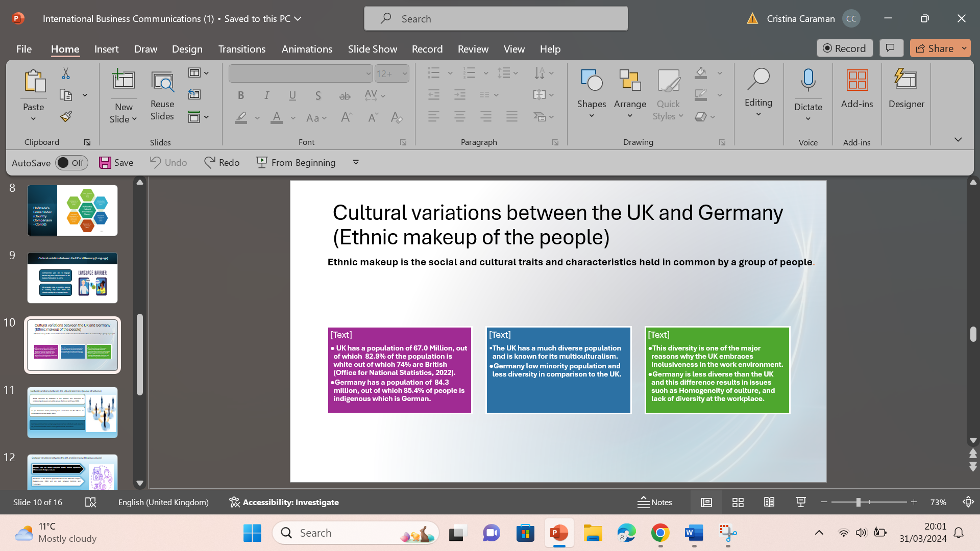

The Ethnic makeup of people simply refers to different ethnicities living in a country. Ethnicity refers to the social and cultural backgrounds, traits, characteristics, or experiences that are held in common by a group of people. The United Kingdom has an estimated population of 67.0 million. The majority of the population that is 82.9% is white. Out of the 82.9%, 74.4% of Individuals are of British/Irish origin. Other minor ethnic groups in the UK include Asian British: (6.3%), Black British: (3.0%), British Mixed: (2.0%), and Other: (0.9%) (Office for National Statistics, 2022). The UK has a more diverse population in comparison to Germany. This is one of the reasons why London, UK is famous for its multiculturalism.

Cultural variations between the UK and Germany (Social structures)

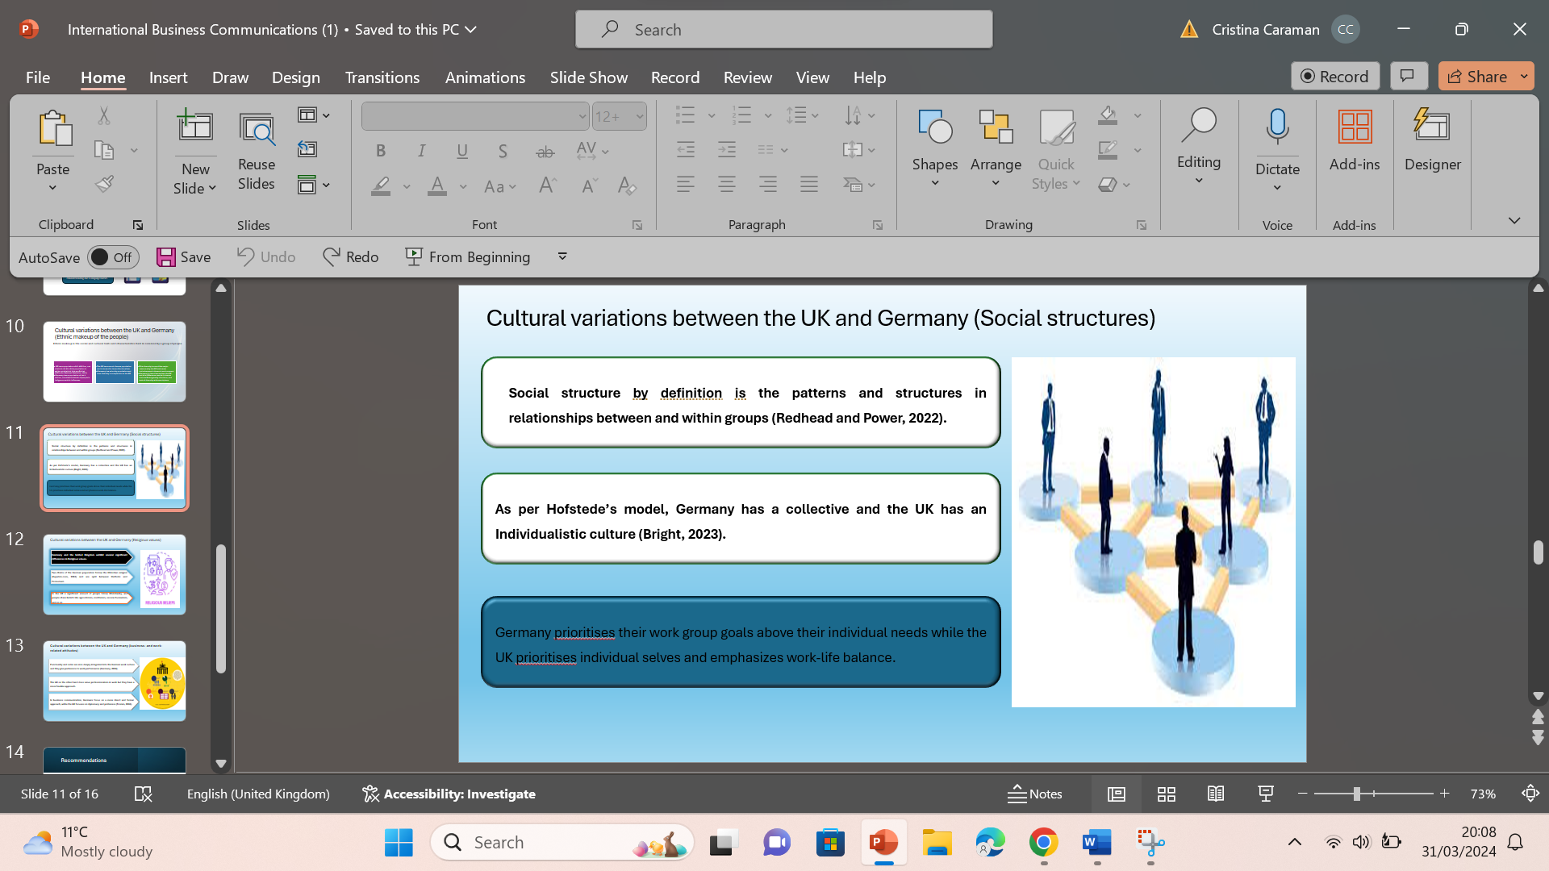

Social structures in the context of a nation can be understood as the patterns and structures in relationships between and within groups (Redhead and Power, 2022). UK and Germany have very vast cultures and beliefs which is a contributing factor to their different approaches to social structures. If we compare these aspects as per Hofstede’s model Germany follows more of a collective culture as compared to the UK which takes more of an individualistic approach (Bright, 2023). Countries such as Germany that follow a collective culture prioritise their work group goals above their individual needs and desires. Whereas the UK follows an individualistic culture, where people prioritise individual selves over the group. In terms of hierarchy and formality Germany due to its collective culture has a more hierarchical structure than the UK.

Cultural variations between the UK and Germany (Religious values)

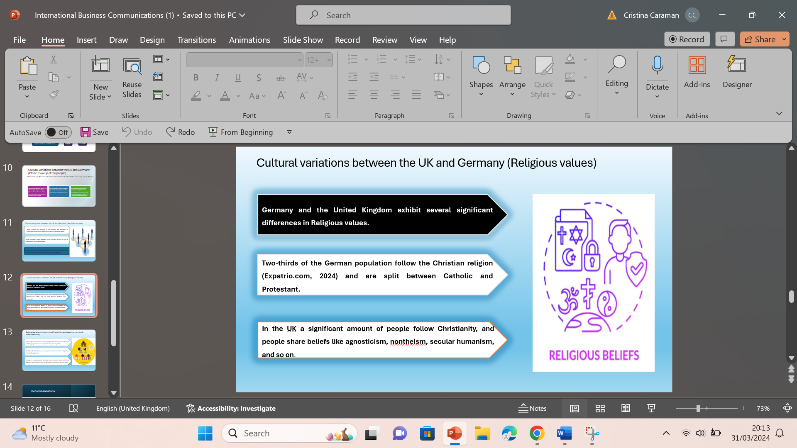
Despite being part of the continent of Europe, both the countries Germany and the United Kingdom exhibit several significant differences in Religious values. As for Germany, most of the countrymen are predominantly Christian, with around two-thirds of the population showcasing themselves to be Christian (Expatrio.com, 2024). However, the German Christians are split between two separate branches namely Catholic and Protestant. Moreover, there is also a minor presence of people following Islamic religious beliefs. On the other hand, in the United Kingdom, the citizens usually exhibit secularism. Though a significant amount of people follows Christianity, people share beliefs like agnosticism, nontheism, secular humanism, and so on. The major factor contributing to the different religious values in Germany is the country’s history of religious conflict. On the other hand, the UK has a long history of religious tolerance. This indicates showing respect for all cultural values, beliefs, as well as ethics. Businesses like Virgin Media need to consider these cultural variations and establish their business accordingly to show respect for the cultural values of German people.

Cultural variations between the UK and Germany (business- and work-related attitudes)

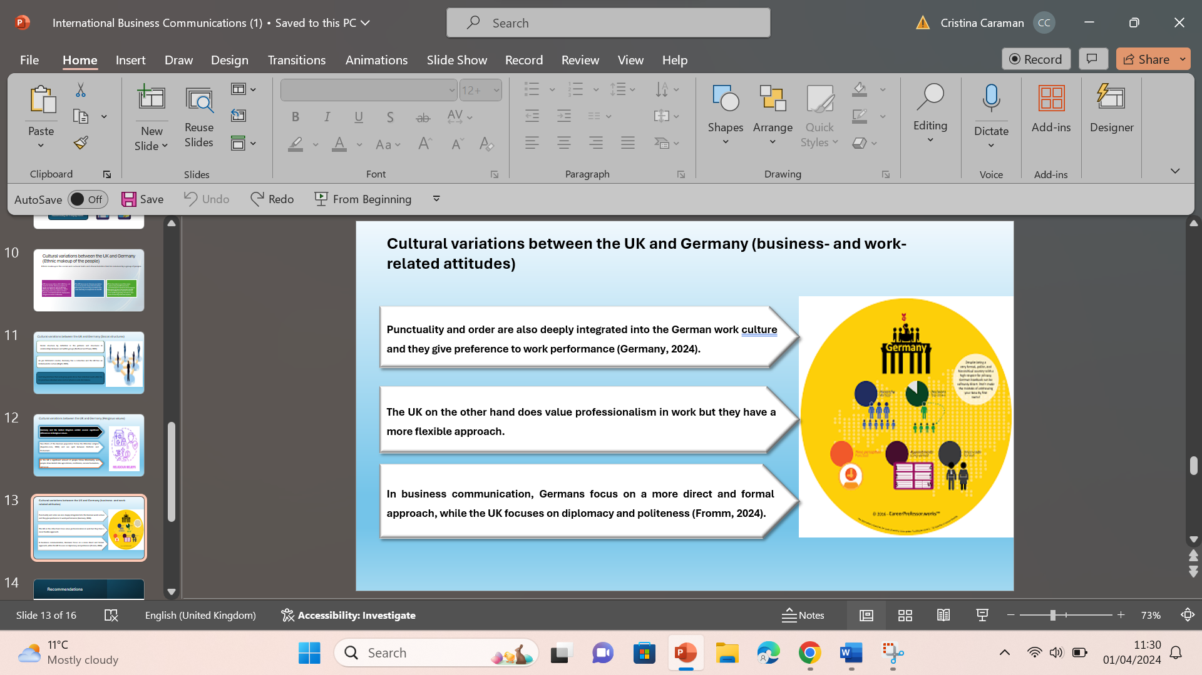

There are several points of difference between the UK and Germany as far as Business and work-related attitudes are concerned. In the case of Germany, Germans are often known for their excellent work ethics. Germans emphasise hard work and dedication in whatever they do. Punctuality and order are also deeply integrated into the German work culture (Germany, 2024). UK on the other hand does value professionalism in work but they have a more flexible approach as compared to Germans. This flexibility can be seen in short working hours with a greater emphasis on work-life balance. As far as Business communication is concerned Germans lay more emphasis on direct communication along with the proper explanation of details (Fromm, 2024). This usually includes a direct approach with formal language. Business communication in the UK is more indirect and emphasises more on being polite and diplomatic and their approach. Work-oriented German culture allows Virgin Media to improve the scope of efficiency and effectiveness in their business operations.

Recommendations
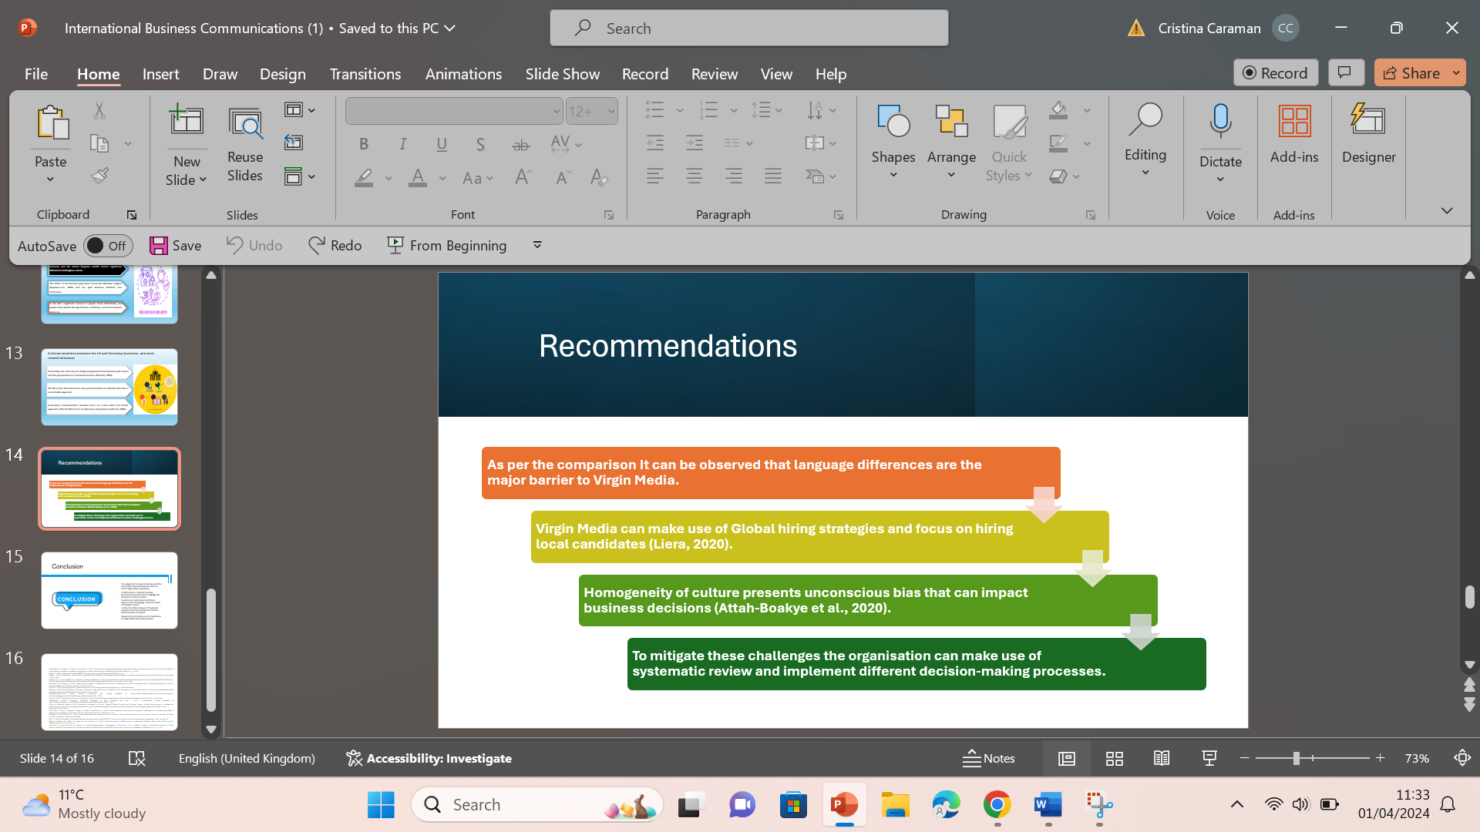

As per the above analysis, it can be observed that language differences are the major barrier that Virgin Media will have to face while operating in Germany. To mitigate these barriers, the organisation can plan and integrate Global hiring strategies hiring local candidates at lower and middle levels (Liera, 2020). Further, the organisation can also leverage the use of technology to facilitate communication with candidates. Since the major population of Germany is indigenous, Virgin Media will face problems regarding the Homogeneity of culture. Adapting to this homogeneity of culture will be key for Virgin Media to formulate successful management styles and HRM policies. Further, the homogeneity of culture can affect the decision-making of the company due to unconscious biases (Attah-Boakye et al., 2020).To avoid such unconscious biases the organisation can make use of different decision-making processes to minimise bias in decision-making.

Conclusion

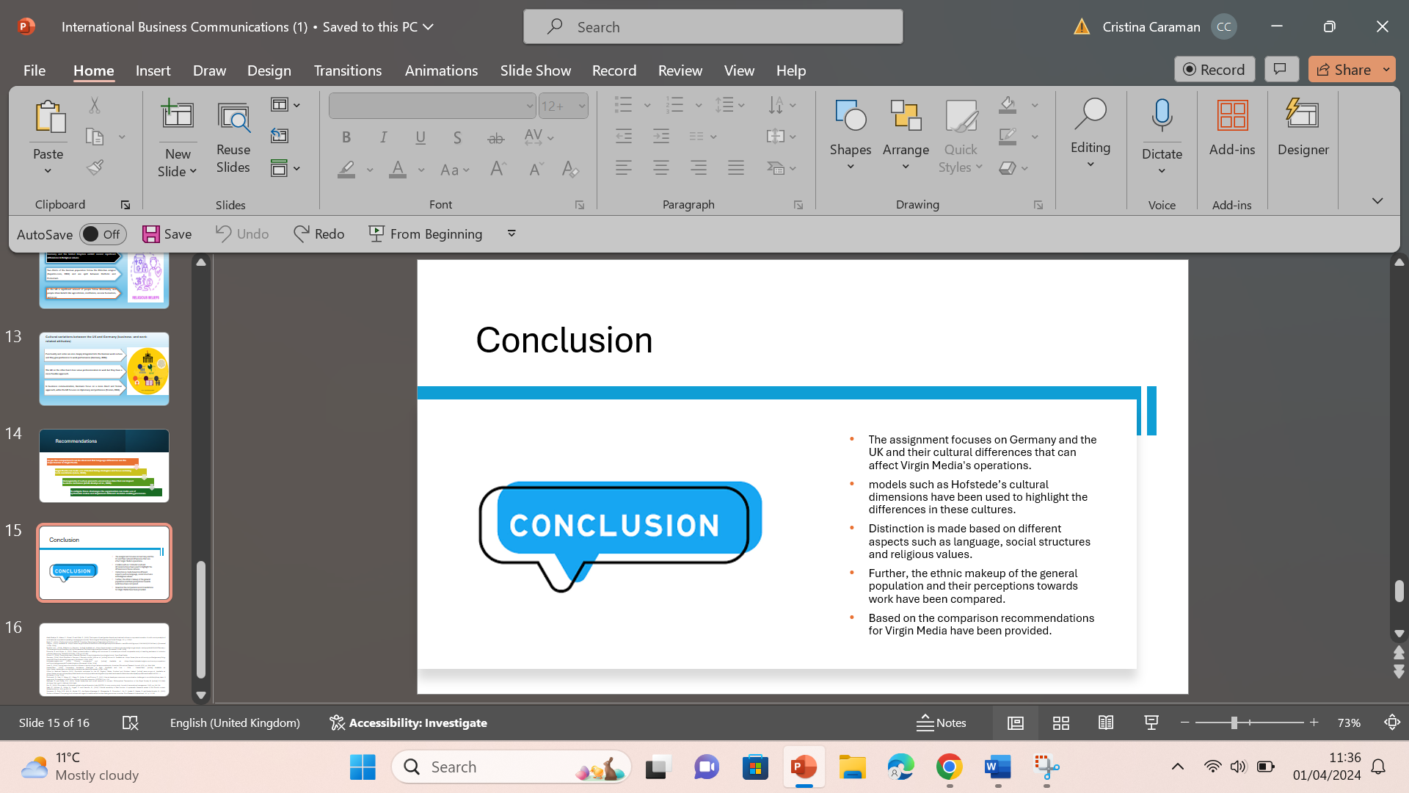
The main focus of this assignment has been on the cultural similarities and variations between Germany and the UK. The assignment has made use of models such as Hofstede’s cultural dimensions have been used to highlight the differences in these cultures. A further distinction is made based on different aspects such as language, social structures and religious values. Further, the ethnic makeup of people in both countries has also been focused on. Further, work-related attitudes such as work ethics and work culture have also been discussed. Lastly, effective recommendations for Virgin Media have been provided, which can improve the scope of their operations.

References
Attah-Boakye, R., Adams, K., Kimani, D. and Ullah, S., (2020). The impact of board gender diversity and national culture on corporate innovation: A multi-country analysis of multinational corporations operating in emerging economies. Technological Forecasting and Social Change, 161, p.120247.
‌Bright, T., (2023). 3 Politics and culture. EBOOK: Coaching, Mentoring and Organisational Politics, p.41.
Cia.gov., (2023). Available at: <https://www.cia.gov/the-world-factbook/countries/germany/summaries/#:~:text=Ethnic%20groups,8.3%25%20(2022%20est.)> [Accessed 12 Mar. 2024].
Virginmedia.com., (2024). Virgin Media. [online] Available at: https://www.virginmedia.com/corporate>. [Accessed 01.Apr.2024]

Expatrio.com., (2024). Religions in Germany. [online] Available at: <https://www.expatrio.com/about-germany/religions-germany#:~:text=popular%20in%20Germany.-,Christianity%20in%20Germany,%2C%20however%2C%20is%20significantly%20lower>. [Accessed 12 Mar. 2024].
Fritzsche, B. and Köpfer, A., (2022). (Para-) professionalism in dealing with structures of uncertainty–a cultural comparative study of teaching assistants in inclusion-oriented classrooms. Disability & Society, 37(6), pp.972-992.
‌Fromm, E., (2024). The working class in Weimar Germany: A psychological and sociological study. Open Road Media.
Germany, (2024). Work Etiquette in Germany | Germany profile | jobs.ac.uk. [online] Jobs.ac.uk. Available at: <https://www.jobs.ac.uk/country-profiles/germany/living-in/article/23/work-etiquette-in-germany> [Accessed 13 Mar. 2024].
Hofstede-insights.com. (2020). Country comparison tool. [online] Available at: <https://www.hofstede-insights.com/country-comparison-tool?countries=germany%2Cunited+kingdom> [Accessed 19 Mar. 2024].
Liera, R., (2020). Moving beyond a culture of niceness in faculty hiring to advance racial equity. American Educational Research Journal, 57(5), pp.1954-1994.
MasterClass., (2020). Uncertainty Avoidance: Examples of High, Moderate and Low - 2024 - MasterClass. [online] Available at: https://www.masterclass.com/articles/uncertainty-avoidance [Accessed 19 Mar. 2024].
Office for National Statistics (2022). Population estimates for the UK, England, Wales, Scotland and Northern Ireland. [online] www.ons.gov.uk. Available at: <https://www.ons.gov.uk/peoplepopulationandcommunity/populationandmigration/populationestimates/bulletins/annualmidyearpopulationestimates/mid2021..> [Accessed 12 Mar. 2024].
Piorkowski, D., Park, S., Wang, A.Y., Wang, D., Muller, M. and Portnoy, F., (2021). How ai developers overcome communication challenges in a multidisciplinary team: A case study. Proceedings of the ACM on Human-Computer Interaction, 5(CSCW1), pp.1-25.
Redhead, D. and Power, E.A., (2022). Social hierarchies and social networks in humans. Philosophical Transactions of the Royal Society B, [online] 377(1845). doi:https://doi.org/10.1098/rstb.2020.0440.
Roy, D., (2020). Formulation of Hofstede’s global cultural dimension index (HGCDI): A cross-country study. Journal of transnational management, 25(3), pp.195-224.
Saari, R., Höckert, E., Lüthje, M., Kugapi, O. and Mazzullo, N., (2020). Cultural sensitivity in Sámi tourism: A systematic literature review in the Finnish context. Matkailututkimus, 16(1), pp.93-110.
Sproesser, G., Ruby, M.B., Arbit, N., Akotia, C.S., dos Santos Alvarenga, M., Bhangaokar, R., Furumitsu, I., Hu, X., Imada, S., Kaptan, G. and Kaufer-Horwitz, M., (2022). Similar or different? Comparing food cultures with regard to traditional and modern eating across ten countries. Food Research International, 157, p.111106.

