

Postgraduate/Distance Learning
Assignment coversheet & feedback form

THIS SHEET MUST BE THE FIRST PAGE OF THE ASSIGNMENT YOU ARE SUBMITTING (DO NOT SEND AS A SEPARATE FILE)

For completion by the student:
Student Name: Beth Scannell

Student University Email: 2409308@student.uwtsd.ac.uk
Module code: HPCA7015  Module title: Foundations of Cultural Astronomy and Astrology | Student ID number:  2409308 |  |  | Educational support needs:  Yes/No
Assignment title: Essay based on a Sky Journal – Sunrise over Lake Ontario

Assignment due date: November 28, 2024
This assignment is for the 1st X 2nd 3rd 4th 5th 6th module of the degree
I confirm that this is my original work and that I have adhered to the University policy on plagiarism.
Signed ……Beth Scannell………………………………………………………
Email submission: if you are submitting this form via email, please tick this box X
(as a substitute for your signature) to confirm that you agree to the above declaration.
Assignment Mark
1st Marker’s Provisional mark
2nd Marker’s/Moderator’s provisional mark
External Examiner’s mark (if relevant)
Final Mark

NB. All marks are provisional until confirmed by the Final Examination Board.

For completion by Marker 1 :
Comments:

Marker’s signature: |  |  | Date:
For completion by Marker 2/Moderator:

Comments:

Marker’s Signature: |  | Date:
External Examiner’s comments (if relevant)

External Examiner’s Signature: |  | Date:

Beth Scannell – HPSC7015 – Essay 2 November 28, 2024
Essay Based on a Sky Journal: Twilight and Sunrise Over Lake Ontario
Introduction
This essay examined my recorded observations of twilights and sunrises from October 17 through November 15, 2024. I live near Lake Ontario in Toronto, Canada, close to a park with unobstructed sunrise views, so I took advantage of this by visiting, viewing, and taking photographs each day from the same spot. I began and ended my observations on the mornings of two consecutive Full Moons, a complete lunar cycle, so I could witness the changing twilight sky as the Moon changed phases, along with the evolving light and colors of the sunrise. The entries in this journal are explored within the context of Alexandra Harris’s Weatherland: Writers and Artists under English Skies, where her considerations on clouds led her to state, ‘to think is to walk among clouds’. Indeed, although my primary purpose was to study the phenomenon of sunrise, I discovered how much the clouds were an integral part of what I experienced. During my journaling, three main themes emerged: the effects of weather on the Skyscape and Landscape, Participation and Inspiration, and the feelings of Enchantment and Awe that experiencing the sunrise evoked.

Effects of Weather
Harris noted that artist John Constable monitored weather forecasts to track the movement and position of clouds. Like Constable, I looked at forecasts daily and tracked the times for twilight and sunrise. For the first week of my observations, the sky was clear and the Moon bright, as shown in Figures 1 and 2. I could see Jupiter, Mars, Sirius, and the constellation Orion, along with the Moon. However, I noted that the bright light from the Moon may have prevented me from seeing other celestial bodies and that this would change with the lunar phases. Indeed, after the New Moon of November 1, the twilight sky was darker, and I could see Gemini, Aldebaran, and, on one especially clear morning, even Uranus.
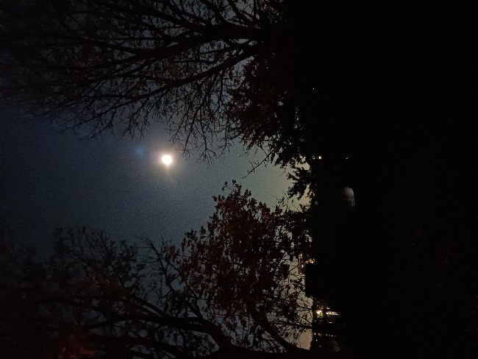
Figure 1 – Full Moon October 17, 2024. Photo: Beth Scannell
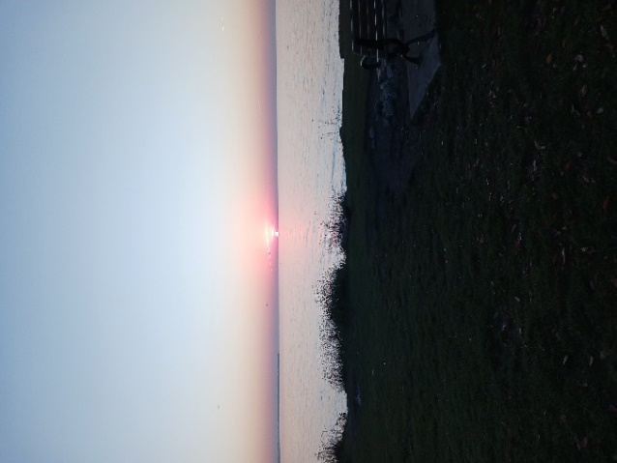
Figure 2 - Sunrise, October 22, 2024. Photo: Beth Scannell
One day that stood out was October 23. The forecast was for clouds with scattered rain, and I wrote in my journal that I was looking forward to it because the sky would appear different from the clear sights I’d been getting, as gorgeous as they were. I knew that the scientific reason behind the red sky was humidity in the atmosphere and that the more humidity there was, the redder the sky would become. As I rarely had the opportunity to see a red morning sky, I was eager to view this phenomenon. However, I was unprepared to be swept away by its beauty as the sky turned to crimson and the lake along with it (Figure 3). That morning, I wrote, ‘It’s as if the sky and the lake are one’!
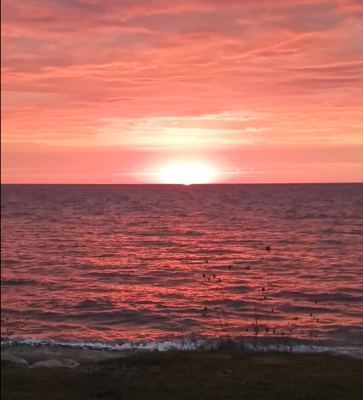
Figure 3 – Red Sky in the Morning, October 23. Photo: Beth Scannell
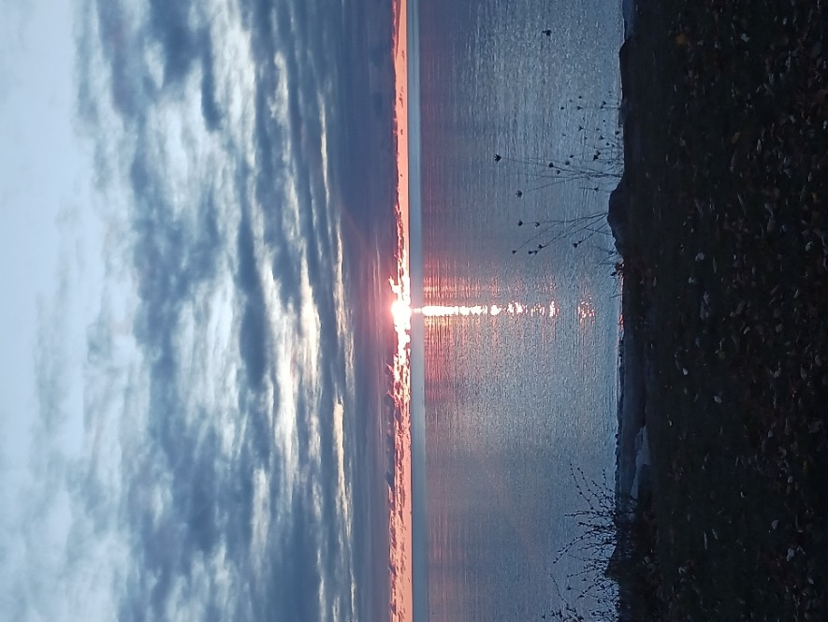
Figure 4 – Blue Sunrise, October 24. Photo: Beth Scannell
Tim Ingold discussed the effects of the atmosphere on light and the way we perceive it, noting, 'as we move, the perspective structure undergoes continuous modulation’. I was always aware of the constantly changing view as the Sun approached the horizon. The following morning brought a different type of clouds and another spectacular comingling of sky and lake (Figure 4). I began to look at the sky, as Constable did, as an ‘organ of sentiment’, and ‘the tonic chord, setting the key for the music of the whole scene’. My appreciation of clouds grew, and I wrote toward the end of my observations,
Clouds give each sunrise its character. With none, the view is lovely but lacks color. With too many, the Sun is blocked out. But the right amount provides interest and color. Clouds are the "spice."
My daily viewing led me to ponder the clouds and to value their role in creating these inspiring skyscapes.

Participation and Inspiration
As I reviewed my notes and photos, I considered them in the context of Participation Mystique, as defined by Lucien Lévy-Bruhl. As I followed the routine of getting up in darkness, driving to the lake, and experiencing the twilight and sunrise, it began to feel like a ritual where I was an integral part of the events while simultaneously observing them objectively. As Lévy-Bruhl stated, ‘it is this duality-unity which is - not thought - but felt first, and it is then, if he reflects, that he recognizes a participation’. This was not something I could put into words, but that I felt viscerally. Lévy-Bruhl continued:
Participation has reality only in so far as it is felt by an individual. It is thus an event which occurs hic et nunc, localized in space and time, or better said which has its own space and time.
This feeling of Participation was absent when I was conversing with others, distracted by my phone, eating breakfast, or otherwise engaged. It was a solitary phenomenon that required mindfulness. I later wrote that even after I had discontinued my daily observations, I still felt a physical and emotional pull to be again at the lake experiencing the sunrise.
The sunrise has often inspired artists. A 2023 study of social media patterns acknowledged sunrise as an inspiration for ceremonies, storytelling, and art in many cultures. My artist friend Kenneth joined me a few times. He is an avid stargazer and painter and I enjoyed sharing observations with him, commenting on the sudden appearance of a golden beam, a changing color, or a cloudbank that appeared to overwhelm the city (Figure 5). I noted in my journal that I enjoyed watching the sunrise with Kenneth, as he had an artist's eye for things and interesting names for the colors. We agreed that watching the sunrise was like watching a painting that continued to evolve. This reminded me of Harris's writings on Wordsworth and his walks with his sister, in which they noted transformations like when 'the Sun suddenly strikes through cloud, or when a figure is glimpsed through a fog'. Kenneth also took photos during our visits and felt inspired to start a series of paintings based on them.
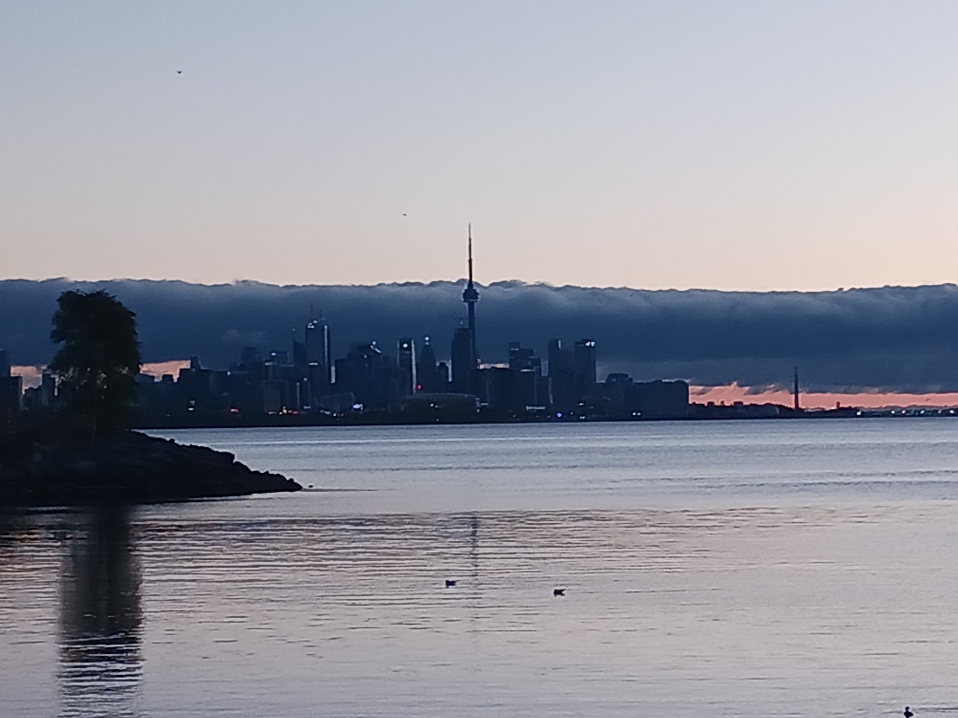
Figure 5 – Cloud bank over Toronto, November 7. Photo: Beth Scannell
Another example is indigenous fiber artist DY Begay, whose exhibit, Sublime Light: Tapestry Art of DY Begay, is showing at the National Museum of the American Indian in Washington, DC. In her exhibit film, Begay described her deep engagement with the land where her ancestors have lived for generations.. Begay takes inspiration from the colors of nature, landscapes, and skyscapes to create dyes for the yarns she uses and designs she weaves into her tapestries. Begay spoke about sunrise as inspiration:
I know I’m going to get a beautiful presentation … when the Sun is rising. I just prepare myself to see what is presented that day. I can’t predict, it all depends on nature.
Although Begay expressed intimate involvement in sunrise as an inspiring phenomenon, I could not be certain that she felt Lévy-Bruhl’s definition of Participation unless I were to interview her directly.

Enchantment and Awe
As mentioned previously, I tracked the weather and sky daily. I had applications on my phone that gave me weather forecasts and others that informed me of sunrise and sunset times and which planets, stars, and constellations would be visible. I also understood the atmospheric phenomena that caused colors to appear before and after sunrise. Nicholas Campion described Max Weber’s argument that science and technology could automatically cause disenchantment. Given all the science and technology I used, if Weber were correct, I would find it difficult to feel enchanted by sunrise. Campion also related various definitions of "enchantment," including Tolkien’s (‘oneness with a living, wonderful world’) and Weber’s (wonder). I found that knowledge of the science behind it took nothing away from my wonder at the red morning sky (Figure 3) or delight when I saw the tip of the Sun peeking over the horizon (Figure 6). Nor did it diminish my sense of Participation, as mentioned earlier, when I was alone with the changing sky, which matched Tolkien’s definition of enchantment.
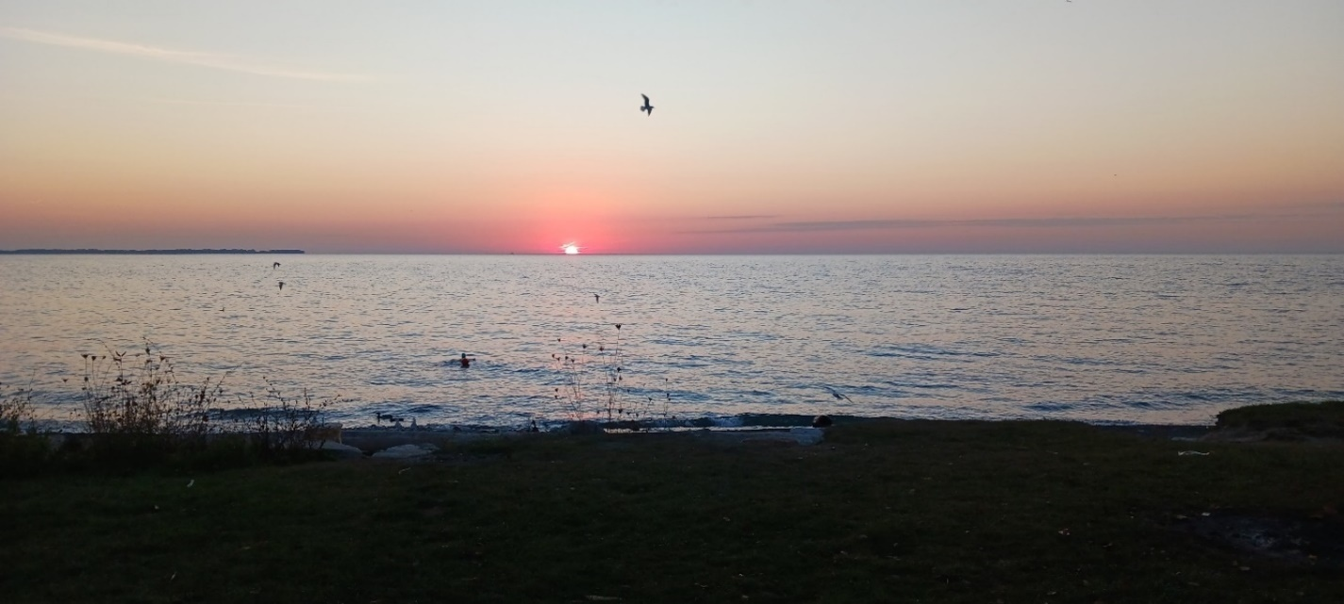
Figure 6 – Swimming into the Sunrise, October 21. Photo: Beth Scannell
Sunrise can also symbolize hope. One example from literature is John Steinbeck’s The Grapes of Wrath, in which dawn coincides with the main characters’ arrival at a beautiful destination and the promise of better things to come. On November 5, the morning of the United States presidential election, I expressed this view of sunrise and my feelings of hope for the future of my country of birth:
Sunrise = hope and renewal. Partners take photos before a sunrise, hoping for a new start. Birds circle because they hope they can find food now that there is enough light. And I hope for good results tonight!
When I woke the following morning, the news was not what I had hoped to hear. As usual, I drove to the park. I thought that at least I could see another beautiful sunrise. What greeted me was something altogether different. For the first time since I started my observations, there was no color in the sky, no break between the clouds for the Sun to shine through (Figure 7).
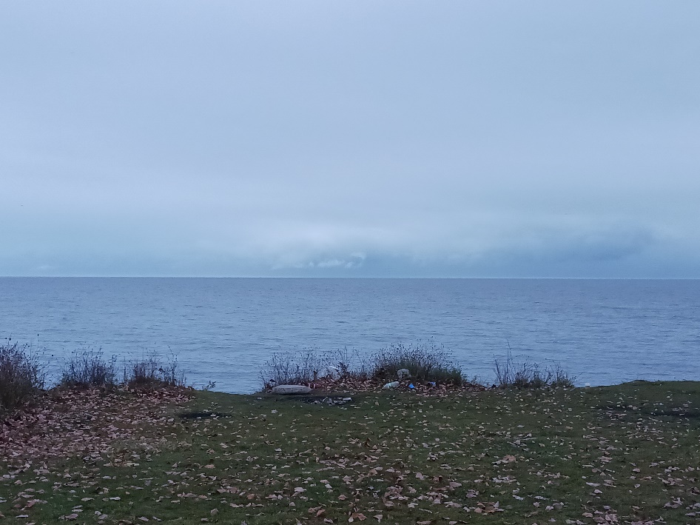
Figure 7 – Sunless Horizon, November 6. Photo: Beth Scannell
The seagulls were also behaving strangely. They had consistently arrived ten minutes before sunrise, flocking to the lake's edge to look for food (Figure 8). A 2017 study on the behavior of migrating birds around the Great Lakes region confirmed that the birds gathered at the lakeshore at dawn, pausing their nighttime migrations and settling in for the day. However, this morning, they flew over land, around the parking area, and swarmed around my car (Figure 9) to the extent that I took refuge in it. I wrote, ‘This morning is gray, cloudy and rainy. No sunrise, no hope, no renewal. The birds are acting crazy! Matches my mood well. How did the sky know?’ It was hard to believe this was a coincidence. I felt that the sky and the birds knew what happened and how I felt. It seemed intentional; I approached a state of awe, defined by Keltner and Haidt as ‘perceived vastness and need for accommodation.’ Although I knew that the same election had occurred nationwide and that not everyone had the same weather or mood as I did, the event felt as vast as the lake and the sky. I could not conceive how the gray weather and the birds’ odd behavior could be so in sync with the moment.

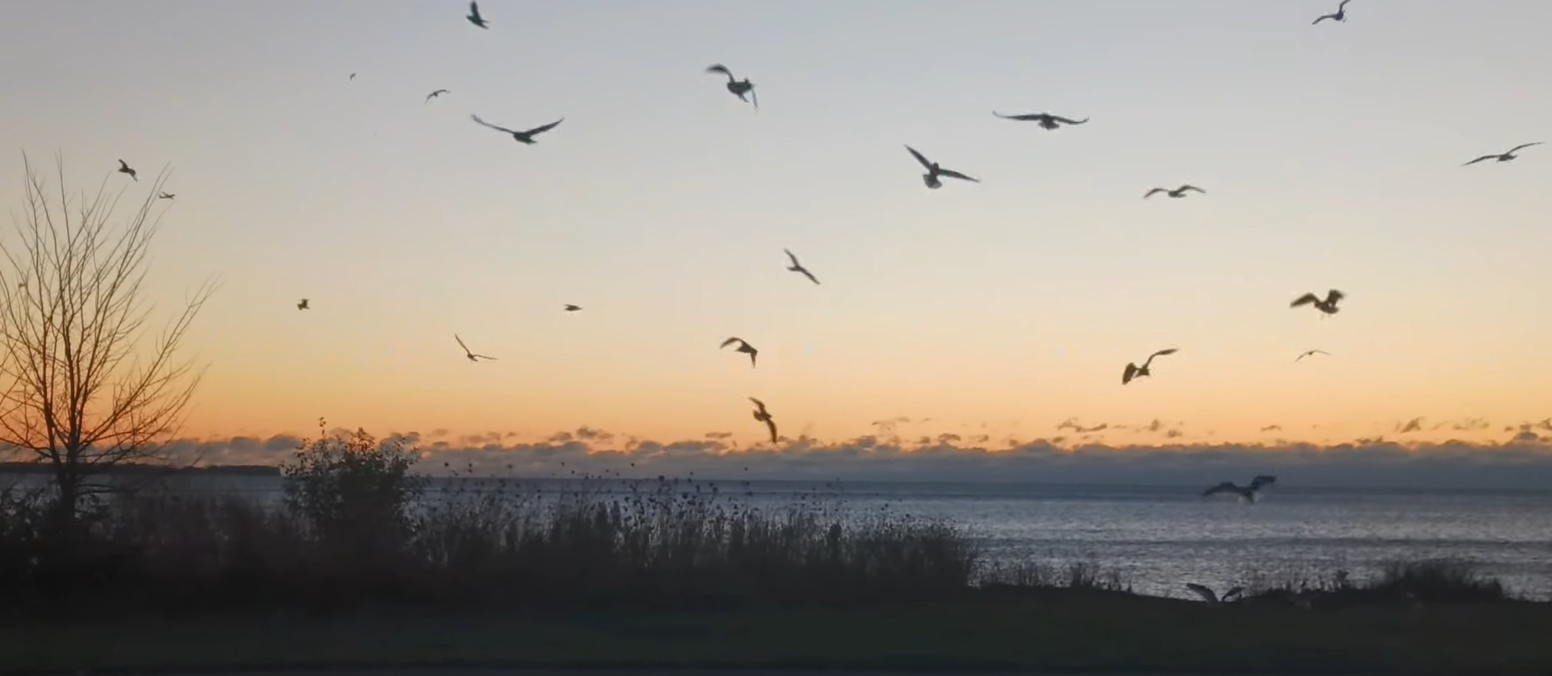
Figure 8 – Birds at Dawn, November 12. Photo: Beth Scannell
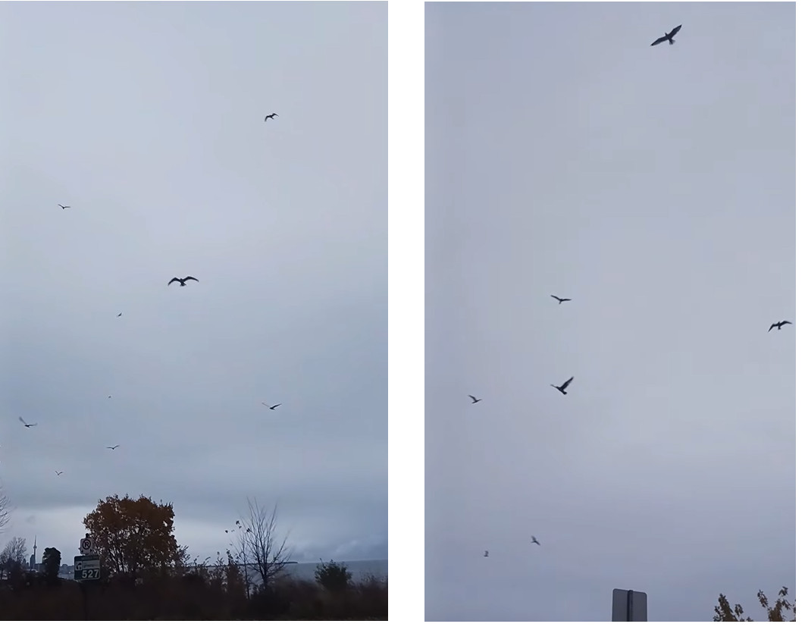
Figure 8 – Birds on November 6. Photo: Beth Scannell
Harris addressed the relationship between clouds and human emotions when describing John Keats’ experience with clouds on Ben Nevis. She stated that Keats ‘made the clouds around him a projection of his own mind’, and ‘he responds by claiming these clouds as his vast mental space.’ These clouds may have been a projection of my own mind, or conversely, my mood may have been affected by the clouds. This connectedness with the sky was something I felt deeply, as demonstrated in my journal entries; my thoughts were indeed mingled with the clouds above.

Conclusion
This essay examined my experience of observing and documenting twilight and sunrise over Lake Ontario for a month between two consecutive Full Moons. Three main themes emerging from my Sky Journal have been explored: the impact of weather on the skyscape and landscape and reactions to them, the inspirational aspects of conducting sunrise observations, including artists finding inspiration in the colors of the sunrise and the experience of participation mystique through the ritual of daily viewing, and the feelings of enchantment and awe evoked by the beauty of the sunrise, as well as through internalizing unexpected events while contemplating sunrise as a symbol of hope. These themes and reflections have been supported by references to academic works on perception, Participation, enchantment, and awe to ground them in the context of Alexandra Harris' quote.

BIBLIOGRAPHY
PRIMARY SOURCES
Begay, DY. 2024. "Sublime Light: Tapestry Art of DY Begay ." YouTube. 09 20. Accessed 11 21, 2024. https://www.youtube.com/watch?v=5TcGvbg2ThE.
Scannell, Beth. 2024. "Sky Journal, October 17 - November 15." Toronto, ON.
Steinbeck, John. 1939. The Grapes of Wrath. New York,, NY: Viking Press.
Washington DC, National Museum of the American Indian. 2024. Exhibitions. Accessed 11 21, 2024. https://americanindian.si.edu/explore/exhibitions/item?id=1006.

SECONDARY SOURCES
Alexander Dunkel, Maximilian C. Hartmann, Eva Hauthal, Dirk Burghardt, Ross S. Purves. 2023. "From sunrise to sunset: Exploring landscape preference through global reactions to ephemeral events captured in georeferenced social media." PLoS ONE 18(2):e0280423 https://doi.org/10.1371/journal.pone.0280423 Accessed November 22,2024.
Campion, Nicholas. 2011. "Enchantment and the Awe of the Heavens." The Inspiration of Astronomical Phenomena VI, Astronomical Society of the Pacific Conference Series Vol. 441 Enrico Maria Corsini (ed.), 415-422.
Harris, Alexandra. 2015. Weatherland: Writers & Artists under English Skies. London: Thames & Hudson.
Ingold, Tim. 2016. "Reach for the Stars - Light, Vision, and the Atmosphere." In The Imagined Sky : Cultural Perspectives, by Darrelyn Gunzburg, 215-233. Equinox Online Library [Accessed November 23, 2024].
Keltner, Dacher & Jonathan Haidt. 2003. "Approaching Awe, a Moral, Spiritual, and Aesthetic Emotion." Cognition and Emotion, 17:2 297-314.
Kevin M. Archibald, Jeffrey J. Buler, Jaclyn A. Smolinsky, and Robert J. Smith. 2017. "Migrating birds reorient toward land at dawn over the Great Lakes, USA." The Auk: Ornithological Advances 134 193–201.
Lévy-Bruhl, Lucie. 1975. The Notebooks on Primitive Mentality. Translated by Peter Riviere. Oxford: Basil Blackwell & Mott Ltd.
Rohmah, Nihayatur. 2016. "The Effect of atmospheric humidity level to the determination of Islamic Fajr/morning prayer time and twilight appearance." Journal of Physics: Conference Series, 1-3.

Harris, Alexandra. 2015. Weatherland: Writers & Artists under English Skies. London: Thames & Hudson
Harris, Weatherland, p. 280.
Harris, Weatherland, p. 273-278.
Scannell, Beth. 2024. Sky Journal, October 17 - November 15. Toronto, ON. October 21, 2024.
Scannell, Sky Journal. November 3, 2024.
Rohmah, Nihayatur. 2016. "The Effect of atmospheric humidity level to the determination of Islamic Fajr/morning prayer time and twilight appearance." Journal of Physics: Conference Series, 1-3, p. 1.
Scannell, Sky Journal. October 23, 2024.
Ingold, Tim. 2016. "Reach for the Stars - Light, Vision, and the Atmosphere." In The Imagined Sky: Cultural Perspectives, by Darrelyn Gunzburg, 215-233. Equinox Online Library [Accessed November 23, 2024], p. 217.
Harris, Weatherland, p. 277.
Scannell, Sky Journal. November 12, 2024.
Lévy-Bruhl, Lucien. 1975. The Notebooks on Primitive Mentality. Oxford: Blackwell.
Lévy-Bruhl, The Notebooks, p. 59.
ibid.
Scannell, Sky Journal. November 18, 2024
Alexander Dunkel, Maximilian C. Hartmann, Eva Hauthal, Dirk Burghardt, Ross S. Purves. 2023. "From sunrise to sunset: Exploring landscape preference through global reactions to ephemeral events captured in georeferenced social media." PLoS ONE 18(2):e0280423, p. 2. https://doi.org/10.1371/journal.pone.0280423 [Accessed November 22, 2024].
Scannell, Sky Journal. November 3, 2024
Harris, Weatherland, p. 265.
Washington DC, National Museum of the American Indian. 2024. Exhibitions. [Accessed 11 21, 2024]. https://americanindian.si.edu/explore/exhibitions/item?id=1006.
Begay, DY. 2024. "Sublime Light: Tapestry Art of DY Begay ." YouTube. 09 20. [Accessed 11 21, 2024]. https://www.youtube.com/watch?v=5TcGvbg2ThE.
Begay, Sublime Light, 7:50.
Campion, Nicholas. 2011. "Enchantment and the Awe of the Heavens." The Inspiration of Astronomical Phenomena VI, Astronomical Society of the Pacific Conference Series Vol. 441 Enrico Maria Corsini (ed.), p. 417.
Campion, Enchantment, 419.
ibid.
ibid.
Steinbeck, John. 1939. The Grapes of Wrath. New York, NY: Viking Press, p. 252.
Scannell, Sky Journal. November 5, 2024
Kevin M. Archibald, Jeffrey J. Buler, Jaclyn A. Smolinsky, and Robert J. Smith. 2017. "Migrating birds reorient toward land at dawn over the Great Lakes, USA." The Auk: Ornithological Advances 134 193–201.
Scannell, Sky Journal. November 6, 2024
Keltner, Dacher & Jonathan Haidt. 2003. "Approaching Awe, a Moral, Spiritual, and Aesthetic Emotion." Cognition and Emotion, 17:2 p. 297.
Harris, Weatherland, p. 279.
Harris, Weatherland, p. 280.

