

University of Wales Trinity Saint David

Certificate of high education – skills for the workplace

Effective team working and communication
(BMSW4002-CARD)

Advise on possible team structures and enable effective channels of communication

Lecturer: Melanie Squair
Student: Mohamed Babeker Osman Ahmed
Student ID: 2112126
March 2022

Contents
1.0 Executive summary: - 2
2.0 Term of reference: - 2
3.0 Procedure: - 2
4.0 Introduction: - 3
5.0 Finding: - 3
5.1 Case study 3
5.2 Meredith Belbin 4
5.3 Bruce Tuckman 4
5.4 Analysing 5
5.5 Verbal and non-verbal Communications: - 6
5.6 Shannon-Weaver Model: - 8
5.7 Berlo’s model of communication: - 8
5.8 Schramm’s model of communication: - 9
6.0 Conclusion: - 9
7.0 Reference list 10
8.0 Appendance 11
Instructions 12
Section 2 13
Section 3 14
Section 4 15
Section 5 16
Section 6 17
Section 7 18
“When I am part of a team which is working on a problem..” 18

Executive summary: -

This report is for Lady’s Fashion to advise on possible team structures to facilitate and enable effective channels of communication regarding the case study in hands, The suggestion is to provide a good academics forms and roles to ensure that business is growing successfully to achieve its goals and designing flexible system of communication to reduce the problems in future.

Term of reference: -

It has been asked by Melanie Squair (lecturer of effective team working and communication) on behalf of University of Wales trinity Saint David. To write final report on the module regarding a case study provided. I have been requested to summit this report on 18th March 2022.

Procedure: -

This report based on the information found from a wide range of resources online and the university’s library, which are books, journals, and google search. And the main resource was from the effective team working and communication’s lecture.

Introduction: -

This report is for Lady’s Fashion to advise on possible team structures to facilitate and enable effective channels of communication. However, regarding the owner of the store seeking for advice, the report would examine two parts toward the case study provided to set a formal effective teamwork and giving the best format in order to systemise suitable communication methods to put the team on the right track. The report will discuss the important elements behaviour and attitude of the employees in the workplace, then how to develop the teams and the work environment accordingly to reduce the potential conflicts may cause regarding the lake of the communications. In the second part of this report will review verbal and non-verbal communication with addressing three different models of communication and how to identify the barriers in the communication process to avoid them in particular to the case study.

Finding: -

Case study
According to the case study reviewed and studied regards Janet Williams about advising on a business consultant toward her lady’s fashion store can identify many strengths that made the store running smoothly and expanding which is the good sings to continue growing. Therefore, there are some questions need to be answered to have a best understanding of what the business is about.
- What are the current strengths and weakness of the team regarding capabilities?
- Would it worth to boost the team capabilities? If so, what will you focus on? By Training or changing the team member behaviours by upgrading the communication channels?
- Is it task-related or teamwork-related capabilities?
According to (Tannenbaum, 2021, P37) Task-related means that individual must be able to perform the work, while teamwork-related mean people need to work and collaborate effectively with one another. However, understanding these differences can be very helpful to achieve management expectations. The expectation of any leader on his team member is to work collaboratively with trust on each other. To achieve this, business management should apply the nine Belbin team roles as follows: -

Meredith Belbin
Team Role are nine elements of behavioural attitude identified by (Belbin, 2010) to help leaders to have a best knowledge about their team individually skills, regarding the emotional and physical capabilities as being effective to facilitate team progress. ‘’This doesn't mean that every team requires nine people. People can have two or more Belbin Team Roles that they will be comfortable with, and this can change over the time when practicing certain skills’’. Each Belbin Team Role has strengths and weaknesses, and each role is equally important to the team's success. To identify the characterise of each member of any team specially in the case study, administration should firstly, know what the best characters their employees are! with taking Belbin questionnaire form which can help to know who can do what in the best manner. And you will find link for the questionnaire in the Appendance. These nine ‘Team Role’ are:
- Resource Investigator 2- Team worker 3- Co-ordinator 4- Planet 5- Monitor evaluator 6- Specialist 7- Shaper 8- Implementer 9- Completer Finisher.
Each of these characteristics has strengths and weaknesses so, must be careful when delegating and sharing the duties to avoid any potential conflicts. The conflicts comes when the team member have been identified and the progress has already stated toward achieving the goals, in the next paragraph you will know how to avoid the potential conflicts with Bruce Tuckman’s stages of team development (Tuckman 1965).

Bruce Tuckman
The idea of Tuckman’s stages of team development (Tuckman and harper 2012) is, the different of stages that a team go through in its development. Therefore, these stages are defining and clarifying the difference between groups and teams. According to the case study we will only focus on the teamwork development and how may Tuckman stages could help the business to grow and prevent itself from the conflicts.
The first stage is the Forming; in this stage the leader or manager should concentrate on the introduction because relationship have not yet formed, and team member are wonder what is expected of them and how they behave. However, this stage is for only employees who are come to work together for the first time. So, for the Lady’s Fashion would be very beneficial to apply this stage when the two new employees arrived.
The second stage is the Storming; in this stage team leaders are expected to understand the emotional of the team members, as mentioned above when any team identified they will straight start vying positions and the conflict may occurs specially with those who are very sensitive in working in teams! Like specialist according to Belbin’s Team Role. Furthermore, it’s important to introduce the rules with opening the communication method in this stage to share the responsibilities after setting the goal or targets of the team.
The third stage is the Norming; when a team reach this stage, that mean work is progressing well and team members will show their capabilities because co-operative developed, and conflicts has settled according to the trust they build in regard of communication have been made.
The fourth stage is the Performing; when the teamwork has solved the conflicts that have faced in the previous stages now the teamwork is achieved and rules are flexible with fully support so, leadership will minimize to self-manages, duties and responsibilities can be clear.

Analysing

According to (Baird and Baard, 2021, P527). Given, the significance of the organisational team to ensure business can fully adapt to dynamic environmental change. The use of controls focuses on the monitoring of the team performance, which could be very useful for the case study. Moreover, Teams with more informal social exchanges and socio-emotional support, usually outperform others. Some studies argue that (Chiu, Chad et al. 2022, P502) factors such as friendship and shared values, a team leader can be able to encourage positive interactions among team members because of their commitment toward an agreed goal. And yet to achieve the goal you should be capable to progress effectively and open good channels of communication.

Verbal and non-verbal Communications: -

Communication is the transactional use of symbols, influenced, guided, and understood in the context of relationships” (Duck, and McMahan, 2015, p.5). By referring to this definition you can realise the importance of the communication in our lives in the formal and informal way. But this advice will be focus only on verbal and non-verbal communication regarding the case study. However, the most important questions to discuss and argue around are.
- how can we manage the communication and its categories?
- What kind of skill needed to outcome the effective teamwork in relation to communication?
- What tools, forms and modules are there we must understand to have a good communication?
Any leadership or a team with committed goals will think carefully about the communication system and style of the workplace environment to reduce the barriers and avoid the conflicts may occurs during the process of communications. In order to provide answers, we should understand the human communication process better (Fuchs, 2021, P37). The communication management requires leaders to be able to develop effective skills which will introduce their own criteria to evaluate them to help collect and analyse the feedback, along with being prepared when delivering a massage whether its vocal, visual or verbal, this important elements has difference percentages in the impact of communications which are; words 7%, voice or tone 38%, and the body language is 55% so, that why managing a good communication is recommends face-to-face meeting regularly to have high level of impact and get the feedback clearly.
Communication skills are the tools that we use to remove the barriers to make an effective communication (MTD Training and Venture, 2012, P11). As a leader you may face on of these barriers or you might face them all at the time of progressing. However, to deliver your massage to employees you must recognise the barriers exist and then apply proper tools to remove these barriers preventing your massage to go through. Instantly, the employee in the other side of these barriers will try to send you a massage back, and they may not have the ability to send their massage in effective communication skills which could leave the success of the communication to the chance. Instead, you can also use your own skills as a manager to make sure you have clearly received their messages as well.
To be successful at communication, tis important that to recognise what tools and terms of communication you are using to send or receive any massages alongside with these barriers to communicate, barriers can occur at any stage of the communication process. Because the communication is tow-way traffic, you may experience in the ‘’communication process’’ these stages are like a circle, you are sending for others and perhaps, wating for the feedback which more often take the same way through to come back to you! And these stages of the communication process as flows are sample diagram showing stages of models to help in the explanation. But there are many different opinions for the exact stages to make an effective communication. However, we shall examine only three different models in the next paragraphs.
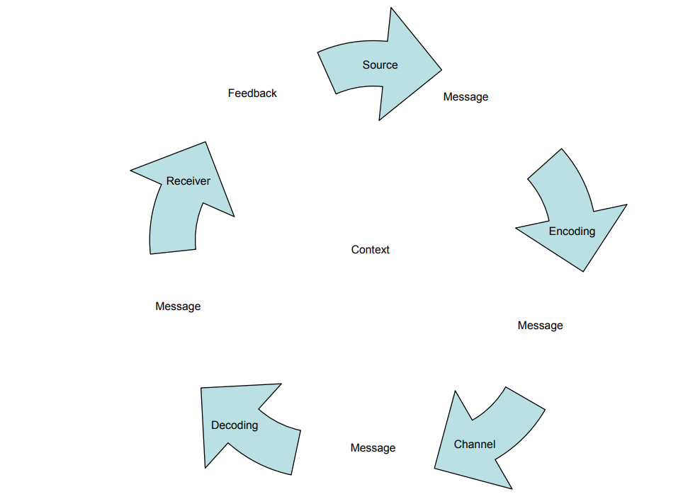
the diagram below showing the communication circle stage

the three different Model we will review makes this diagram collectively to help us understand them severally.

Shannon-Weaver Model: -

Effective communication needed for developing trust in the workplace to have significant impact on the employee’s engagement to improve their capabilities, workplace culture and the productivity. Referring to the diagram above and according to (Shannon-Weaver, 1949) they identified Mathematical Model to introduce the tow-way of communication process includes: -
source which means the information that sender/leader wants to deliver and should know why the massage is necessary and what is the result needed.
Encoder, transferring a massage into proper format, it requires knowing who you are sending it to and make sure it includes all the information they need.
Channel, the methods that you use to communicate with others such as telephone or Email. In this stage you must think twice of the barriers might occurs.
Decoder, process of receiving your massage and it’s your duty to ensure that the receivers are valuate the information that you are sending.
Destination, you may have expectations for respond from receiver/worker, you can increase the chance of getting result by addressing reword and recognition as part of your massage.
This model has mentioned both signals for employer and the employees so, when you come to choose method to communicate with your employees you must make sure to use your communication skills and tools recommended depends on the matter.

Berlo’s model of communication: -

Berlo’s model of communication has same format as Shannon-weaver model however, the only difference was in the channel. Shannon-weaver identified it as a methods and technology, while Berlo mentioned in his model as the body language instead. Passed over to human emotions which have the most impact on effective communication. In regard of high percentage in face-to-face communication to include the five senses of the human body

Schramm’s model of communication: -

Schramm suggested that the communication should be two-way. This means receiver must communicate in return to the massage have received. And that proven the argument of the diagram circle above which have included all the three models in one to help understand the important of effective communication.

Conclusion: -

To conclude, according to Melanie squire, the lecturer of the effective team working and communication, requested to write a report of 2000 words about what I have studied and understand from module. This report is reflecting the skills and knowledge on the module and apply them in case study.

Reference list

Baird, K. and Baard, V. (2021) ‘Management controls and team effectiveness: the mediating role of team structural empowerment’, Journal of management control, 32(4), pp. 517–558. doi:10.1007/s00187-021-00327-2.
Belbin, R.M. (2010) Team roles at Work. Butterworth-Heinemann Title; 2 edition Magin, M. (2004) Making teams Work: 24 Lessons for working together successfully. McGraw-Hill Pub.
Berlo’s SMCR Model of Communication," in Businesstopia, January 6, 2018, https://www.businesstopia.net/communication/berlo-model-communication.
Chiu, C.-Y. (Chad) et al. (2022) ‘Shaping positive and negative ties to improve team effectiveness: The roles of leader humility and team helping norms’, Human relations (New York), 75(3), pp. 502–531. doi:10.1177/0018726720968135.
Effective communication skills (2012). MTD Training & Ventus Publishing Aps.
Fuchs, C. (2021) Marxist humanism and communication theory : communication and society P 37-55. Abingdon, Oxon, England ;: Routledge.
https://www.managementstudyguide.com/schramm-model-of-communication.htm
Shannon and Weaver Model Of Communication," in Businesstopia, January 6, 2018, https://www.businesstopia.net/communication/shannon-and-weaver-model-communication.
Suresh, A.T. et al. (2016) ‘Distributed Mean Estimation with Limited Communication’. Article.
Tannenbaum, S.I. and Salas, E. (2021) Teams that work : the seven drivers of team effectiveness. New York, NY: Oxford University Press,
Tuckman, B.W. (1965) ‘Developmental sequence in small groups’, Psychological bulletin, 63(6), pp. 384–399. doi:10.1037/h0022100.
Tuckman, B.W. and Harper, B.E. (2012) Conducting educational research. 6th edn. United States: Rowman & Littlefield Publishers.

Appendance
https://moodle.uwtsd.ac.uk/mod/resource/view.php?id=202377

