

Managing Enterprise in the 21st Century

Business Plan

Submission Date: 22/07/2026
Lecturer: Andry Rakotovololona

Table of Contents
Group Information 2
Executive Summary 4
Business Concept 5
Business Description 5
Product Description 5
Business Objectives (SMART Objectives) 5
Short-Term Objectives (less than a year) 5
Long-Term Objectives (less than a year) 5
Market Analysis and Marketing Plan 6
Market Analysis (Competitors, Customers, Target Groups) 6
PESTEL Analysis 6
SWOT Analysis 6
Marketing Mix (4Ps) 6
Management Team 6
Management Team and Their Background 7
Organisational Chart 7
Key Milestones 7
Financial Plan (One Year) 7
Sources of Finance 7
Cash Flow Forecast 7
Sales Forecast 7
Cost of Production Forecast 7
Break Even Analysis 7
Operations and Management Plan 7
Production of Good and Service 7
Technology Plan 7
Human Resource Plan 7
Expansion Plan 8
Reference List 8
Appendices: 9

Group Information
Business Name: Enovate London
Module Name: Enterprise and Entrepreneurship
Student Name: Rajakumari Manickam
Student ID: 2430805
Lecture Name: Andry Rakotovolona
Submission Date: 22/07/2026

Executive Summary

ENOVATE is kind of a new fashion design and clothing manufacturing venture, sort of for men and women both. The goal is to deliver modern, comfortable, and affordable clothing, that lets customers show, not just wear, their own personal style. In the start phase, the product lineup will feature casual wear, smart-casual pieces and a handful of selected seasonal collections, nothing too massive at first. The main target group is style aware customers aged 18–40 in the UK, people who want solid quality clothing but also a reasonable price. ENOVATE will lean on small-batch production, so we can check demand faster, cut down on things that won’t sell, and also adjust quickly when fashion trends shift. Sales channels will include an online store, social media platforms, pop-up events and a few chosen retail partnerships. NOVATE will try to stand out by mixing original designs, inclusive sizing, dependable quality, and a more responsible method of production. For promotion, the plan leans on digital marketing, influencer collaborations and customer loyalty offer, all aimed at building awareness and encouraging repeat purchases. The business will start with a tighter, more focused collection, then grow step by step based on customer feedback and sales results. Even if the fashion market is super competitive, ENOVATE still has a real chance to do well, if it offers distinctive designs, keeps costs under control, and builds long-term relationships with customers. This business plan looks at the whole idea and spells out the marketing, operational and financial approaches needed to develop ENOVATE into a sustainable fashion brand.

Business Concept

ENOVATE is a fashion design and clothing manufacturing business for men and women. The idea is to provide stylish, comfortable and good-quality clothing at an affordable price. The brand will focus on customers who want modern fashion but also value comfort, individuality and responsible production. ENOVATE will design its own collections and use small-batch manufacturing to reduce waste and avoid holding too much unsold stock. Products will mainly be sold through the company’s website, social media and pop-up events.

Business Description

- ENOVATE will work as a kind of modern fashion brand, but still customer-focused, know, not just for show. Basically, the company will handle the whole thing from beginning to end, including fashion research, clothing design, picking materials, manufacturing, quality checks, branding and then online sales.
- The main target people are men and women aged 18–40 in the UK. They often keep an eye on trends, and they use online platforms to find, compare and buy clothing. ENOVATE will stand out by delivering original designs, offering inclusive sizes, keeping quality dependable, and providing responsive customer service that feels helpful.
- Fashion is a competitive space. Still, ENOVATE can enter with lower risk by starting with a more focused collection, making clothing in smaller runs, and using customer feedback before going bigger. With this approach the business can control costs more easily, and learn which styles people like , you know, before scaling up.

Product Description

ENOVATE will offer clothing designed for different lifestyles and occasions. Its main product categories will include:

- Men’s and women’s casual wear, such as T-shirts, shirts, tops, jeans and trousers.
- Smart-casual clothing, including dresses, blazers, co-ord sets and tailored shirts.
- Seasonal collections, such as summer wear, winter clothing and occasion wear.
- Limited-edition designs for customers who want distinctive fashion.
- Selected personalised products, allowing customers to choose certain colours, fabrics or design details.
The products will combine style, comfort and practicality. ENOVATE will use suitable materials, clear sizing information and quality checks to improve customer satisfaction. Customer reviews and sales data will guide future designs and product improvements.

Business Objectives

ENOVATE’s objectives are specific, measurable, achievable, relevant and time bound. They will help the business measure its progress and make better decisions.

Short-Term Objectives

SMART objective | Target and deadline
Launch the business | Launch the ENOVATE website and first collection of at least 20 designs within six months.
Generate initial sales | Achieve at least 500 customer orders during the first 12 months.
Build brand awareness | Gain 5,000 relevant social media followers and maintain an average engagement rate of at least 3% within one year.
Improve customer satisfaction | Achieve an average customer satisfaction score of at least 80% by the end of the first year.
Control stock and waste | Keep unsold stock below 15% of total production during the first year through small-batch manufacturing.

Long-Term Objectives

SMART objective | Target and deadline
Increase business revenue | Achieve annual sales revenue of £250,000 by the end of the third year.
Develop customer loyalty | Achieve a repeat-purchase rate of at least 25% by the end of year three.
Expand the product range | Introduce at least two new collections each year from the second year onwards.
Improve responsible production | Use responsibly sourced or lower-impact materials in at least 60% of products by the end of year three.
Expand market access | Secure at least three retail partnerships or regular pop-up locations within the UK by the end of year three.

These objectives give ENOVATE a clear direction, they also let the business keep track of sales, customer satisfaction, marketing performance, stock control and future growth. In other words, it’s sort of measurable all the way through, not just guessing.

Market Analysis and Marketing Plan

Market Analysis

Market Analysis: Competitors, Customers and Target Groups
The UK fashion market is large but highly competitive. Customers can choose between high-street stores, online retailers and independent fashion brands. Online selling creates a good opportunity for ENOVATE because 27.4% of total UK retail sales were completed online in 2025 (Office for National Statistics, 2026).
ENOVATE’s main competitors will include:
Competitor | Main strength | Opportunity for ENOVATE
Zara | Quickly introduces new fashion trends | Offer more original designs and smaller collections
H&M | Affordable prices and a wide product range | Provide better quality and more personal service
ASOS | Strong online presence and convenience | Build a closer relationship with customers
Independent brands | Unique products and loyal customers | Compete through inclusive sizing and fair prices

The main target group will be men and women aged 18–40 in the UK, especially students, young professionals, and digital-active customers. They are into fashionable, comfy, and reasonably priced clothing. The secondary target group will involve people who want limited edition pieces, personalised patterns or even thoughtful gifts.
The whole concept has a real chance, because ENOVATE can put affordable prices next to original designs and responsible small batch manufacturing. Still, it has to earn customer trust and keep production costs under control, otherwise it won’t be able to compete properly.

PESTEL Analysis

Factor | Effect on ENOVATE
Political | Changes in trade rules and import duties may increase the cost of fabrics. ENOVATE should use more than one supplier.
Economic | Inflation and lower customer spending may reduce demand. Competitive prices and flexible product ranges will be important.
Social | Customers increasingly value individuality, inclusive sizing and responsible fashion. ENOVATE can include these values in its designs.
Technological | E-commerce, social media and customer data can support sales and product decisions. A secure, mobile-friendly website will be required.
Environmental | Clothing waste and packaging are important concerns. ENOVATE will use small-batch production and recyclable packaging. UK packaging rules may also require eligible businesses to report packaging data and pay related fees (GOV.UK, 2026a).
Legal | ENOVATE must follow consumer, employment, data protection and advertising laws. Online customers normally have 14 days to cancel after delivery (GOV.UK, 2026b).

SWOT Analysis

Strengths | Weaknesses
Original designs for men and women | New brand with limited recognition
Small-batch production reduces excess stock | Limited starting finance
Inclusive sizing and customer-focused service | Higher unit costs than large competitors
Online-first business model | Dependence on external suppliers

Opportunities | Threats
Growth of online shopping | Strong high-street and online competitors
Demand for personalised clothing | Rapid changes in fashion trends
Influencer and social media marketing | Rising fabric, production and delivery costs
Interest in responsible fashion | Copying of designs and negative online reviews

Marketing Mix (4Ps)

Element | ENOVATE’s approach
Product | Modern men’s and women’s casual wear, smart-casual clothing, seasonal collections and limited personalised designs. Products will focus on comfort, quality and inclusive sizing.
Price | ENOVATE will use competitive mid-range pricing. Introductory discounts, product bundles and loyalty rewards will encourage first-time and repeat purchases. Prices must cover production costs while remaining affordable.
Place | Products will mainly be sold through the ENOVATE website and social media shops. Pop-up events and selected retail partnerships will allow customers to experience the products in person.
Promotion | ENOVATE will use Instagram, TikTok, email marketing, fashion content and carefully selected micro-influencers. Customer reviews, styling videos and behind-the-scenes design content will help build trust. All promotions will be honest because UK rules prohibit misleading advertising and fake reviews (Competition and Markets Authority, 2025).

This marketing plan supports ENOVATE’s objective of entering the market with a focused collection, reaching the correct customers and developing a strong but affordable fashion brand.

Management Team

ENOVATE will begin with a small, and flexible management crew. This setup will help the business keep a tight grip on costs, while also making sure that design, production, marketing and finance are looked after properly. In the first year, a few specialist tasks, like accounting and website upkeep, will be handed over to partners. Then, later, more permanent employees will be brought in once sales start to grow.
The Founder and Managing Director will be the ones taking the key business decisions and tracking the SMART targets. Each person in the team will have their own clear duties, yet the group will still collaborate when building new collections, and also when handling customer feedback.

Management Team and Their Background

Role | Background and responsibilities
Founder and Managing Director | The founder has a strong interest in fashion, customer needs and entrepreneurship. They will manage the business strategy, budget, suppliers, partnerships and overall performance.
Fashion Designer and Product Manager | This person will have knowledge of fashion design, fabrics, sizing and current trends. They will create collections, prepare product specifications and make sure the designs match customer needs.
Production and Quality Coordinator | This person will have experience in clothing production, supplier communication and quality control. They will monitor manufacturing, stock levels, delivery times and product quality.
Digital Marketing and E-commerce Coordinator | This person will have skills in social media, online selling, content creation and customer communication. They will manage the website, advertising campaigns and online customer journey.
Finance and Administration Support | A part-time bookkeeper or external accountant will manage financial records, cash flow, tax and payroll. This approach will give ENOVATE professional financial support without the cost of a full-time employee.

Organisational Chart

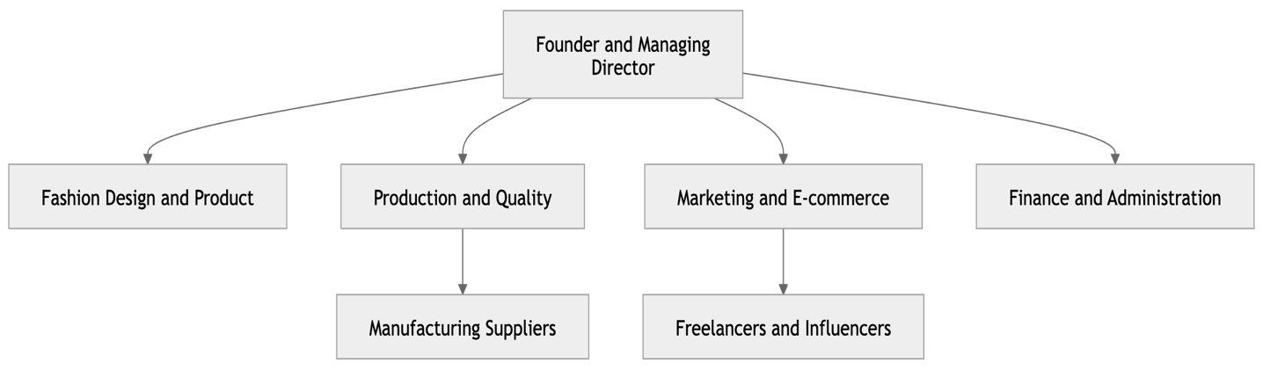

This flat structure will support quick communication and faster decision-making. It is suitable for a start-up because the Founder can monitor all main business activities while each specialist manages a clear area.

Key Milestones

A timeline-style bar graph is more suitable than a pie chart because it clearly shows when each business activity will begin and finish.
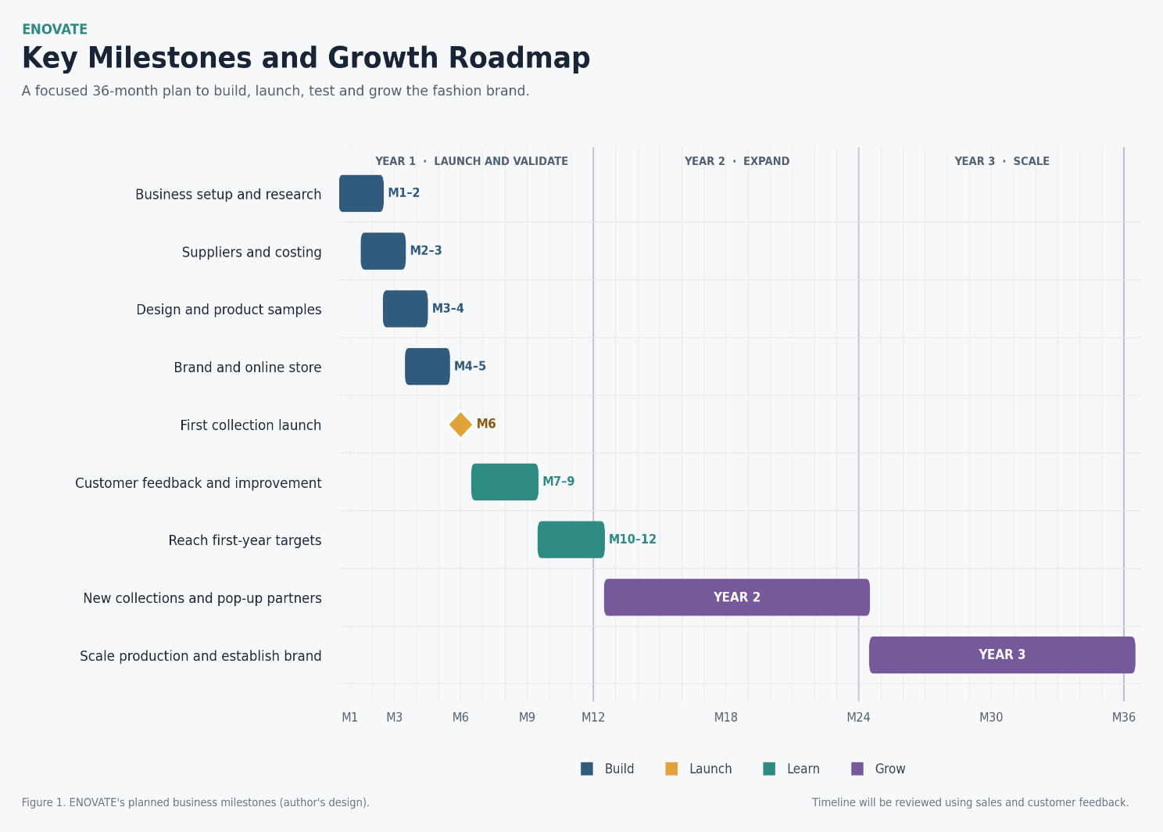

Financial Plan (One Year)

The financial forecast covers ENOVATE’s first 12 months of trading after the first collection and online store are launched. The figures are realistic planning estimates and should later be confirmed through supplier quotations and test sales.
Financial result | Year-one forecast
Sales revenue | £142,000
Production costs | £56,800
Gross profit | £85,200
Fixed operating expenses | £52,200
Operating profit before tax | £33,000
One-time start-up costs | £16,000
Closing cash balance | £42,000

Sources of Finance

ENOVATE will require £25,000 to support its launch, initial production and working capital.
Source | Amount | Share
Founder’s savings | £12,000 | 48%
Start-up loan | £10,000 | 40%
Family or friends’ investment | £3,000 | 12%
Total finance | £25,000 | 100%

The founder’s contribution demonstrates commitment and reduces dependence on borrowing. The start-up loan will provide working capital, while the smaller family or friends’ investment will reduce the amount of debt required. Loan interest and repayments will be added when the final lending terms are confirmed.

Cash Flow Forecast

The cash flow forecast starts with a zero balance and includes the £25,000 funding during Month 1.
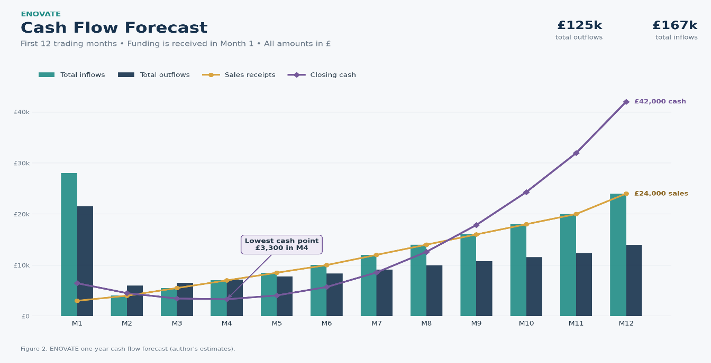

Sales Forecast

The sales forecast assumes an average selling price of £50 per item.
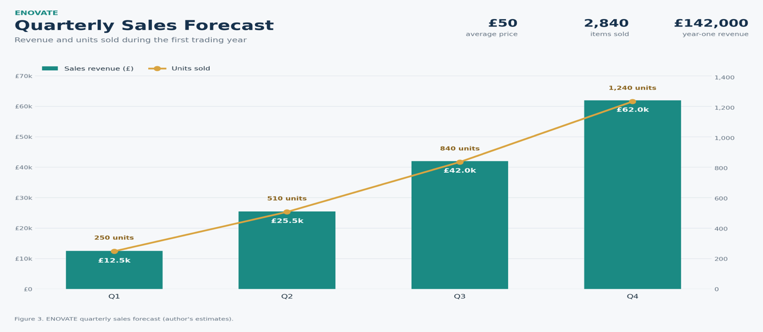

Cost of Production Forecast

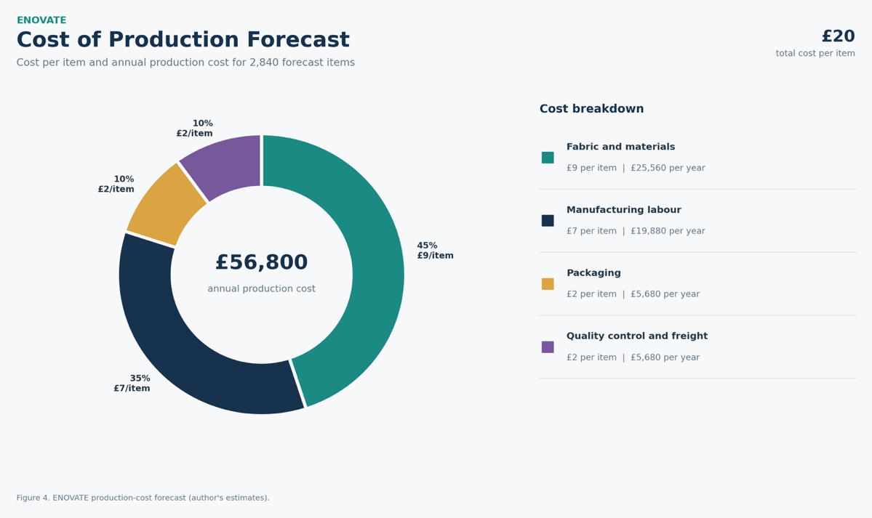

Break Even Analysis

The contribution earned from each item is:
- £50 selling price − £20 variable cost = £30 contribution per item
- Annual fixed operating expenses are estimated at £52,200.
- Break-even units = £52,200 ÷ £30 = 1,740 items
- Break-even revenue = 1,740 × £50 = £87,000

ENOVATE expects to sell 2,840 items, which is 1,100 items above the operating break-even point. This creates a margin of safety of approximately 38.7%. Operating break-even should be reached during Month 10.
When the £16,000 one-time start-up costs are also included, full first-year cost recovery requires approximately 2,274 items or £113,700 in sales. This more cautious calculation shows that the business idea is financially possible, but sales performance and cost control will be important.
The workbook includes linked formulas, monthly cash flow, a financial dashboard, production costs, break-even calculations and model checks.
ENOVATE | Year-One Financial Plan
Investor-style base case • First 12 trading months after launch • Prepared 20 July 2026
YEAR 1 SALES (£) |  |  | GROSS PROFIT (£) |  |  | OPERATING PROFIT (£) |  |  | CLOSING CASH (£)
£142,000 |  |  | £85,200 |  |  | £33,000 |  |  | £42,000
Key financial results |  |  |  |  | Month | Sales (£) | Closing cash (£)
Measure | Result |  |  |  | M1 | £3,000 | £6,450
Total funding (£) | £25,000 |  |  |  | M2 | £4,000 | £4,500
Expected units sold | 2,840 |  |  |  | M3 | £5,500 | £3,450
Break-even units | 1,740 |  |  |  | M4 | £7,000 | £3,300
Break-even revenue (£) | £87,000 |  |  |  | M5 | £8,500 | £4,050
Expected break-even month | Month 10 |  |  |  | M6 | £10,000 | £5,700
 |  |  |  |  | M7 | £12,000 | £8,550
 |  |  |  |  | M8 | £14,000 | £12,600
Funding mix |  |  |  |  | M9 | £16,000 | £17,850
Source | Amount (£) | % |  |  | M10 | £18,000 | £24,300
Founder savings | £12,000 | 48.0% |  |  | M11 | £20,000 | £31,950
Start-up loan | £10,000 | 40.0% |  |  | M12 | £24,000 | £42,000
Family/friends equity | £3,000 | 12.0%
Financial judgement
The base case suggests that ENOVATE can become operationally profitable during its first trading year. However, the result depends on reaching the sales forecast, keeping production cost close to £20 per item and controlling monthly fixed costs. Supplier quotations and test sales should be completed before external finance is accepted.

Operations and Management Plan
ENOVATE will use a simple and flexible operating structure. The Founder and Managing Director will supervise the business and make the main decisions. The Fashion Designer will manage product development, while the Production and Quality Coordinator will control manufacturing, stock and product quality. Digital marketing, e-commerce and customer service will be managed by a Marketing Coordinator. Accounting and specialist technology support will initially be outsourced to control costs.

The business will monitor five important areas: product quality, production cost, delivery time, customer satisfaction and stock levels. Weekly operational meetings will help the team identify problems and respond quickly.

Production of Good and Service

ENOVATE will manage clothing design and manufacturing through a small production studio and approved manufacturing partners. Small-batch production will reduce waste, protect cash flow and allow the business to test customer demand before producing larger quantities.
The production process will follow these stages:
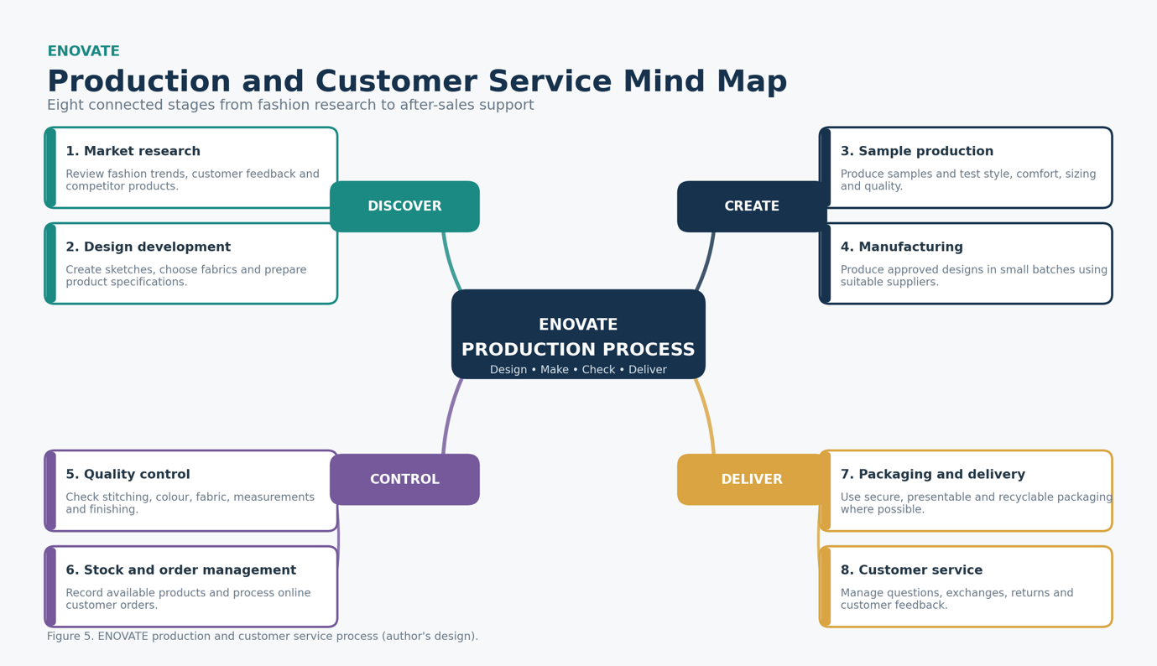

This process will help ENOVATE maintain consistent quality. Products that fail the quality check will not be sold. Customer reviews and sales information will guide improvements to future collections.

Technology Plan
Technology will support ENOVATE’s design, production, sales and customer service activities
Technology | Business purpose
Fashion design software | Create digital designs, patterns and product specifications.
E-commerce website | Display products, accept secure payments and process orders.
Inventory system | Monitor stock and avoid overproduction or unavailable products.
Accounting software | Record sales, expenses, tax information and cash flow.
Customer database | Manage customer enquiries, preferences and loyalty communication.
Social media analytics | Measure engagement, advertising results and customer interests.

The website will be mobile-friendly because many target customers shop through smartphones. ENOVATE will use secure passwords, access controls, regular backups and trusted payment systems to protect customer and business information. Customer information will only be collected when necessary and managed responsibly.

Human Resource Plan

ENOVATE will begin with a small team to keep employment costs manageable.
Role | Initial arrangement | Main responsibility
Founder and Managing Director | Full-time leadership role | Strategy, finance and supplier management
Fashion Designer | Full-time or freelance | Product design and collection development
Production and Quality Coordinator | Part-time initially | Manufacturing and quality control
Marketing and E-commerce Coordinator | Part-time or freelance | Website, promotion and online sales
Accountant or Bookkeeper | Outsourced | Financial records, payroll and tax support

Expansion Plan

ENOVATE will expand gradually to avoid taking unnecessary financial risks.

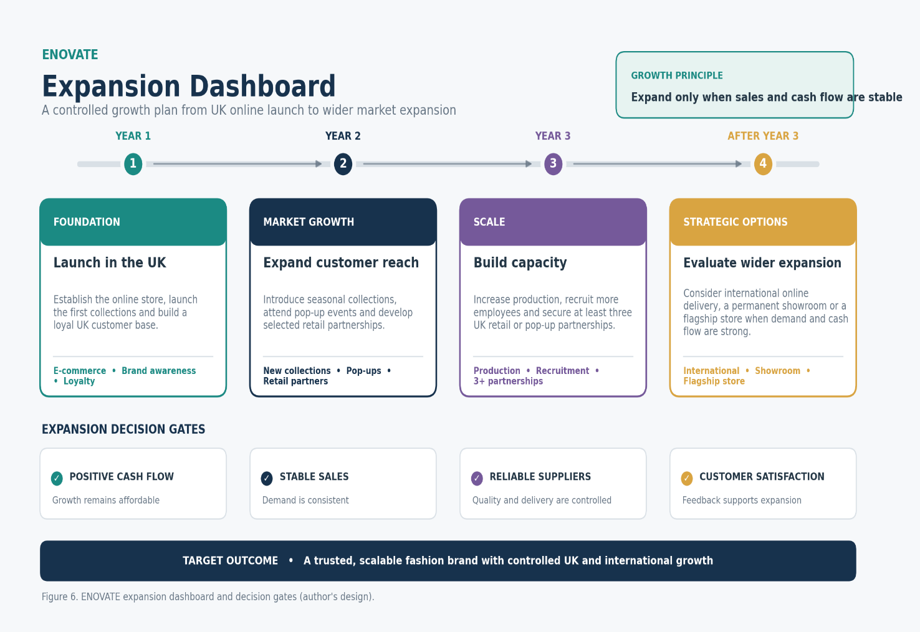

Expansion will only take place when ENOVATE has stable sales, positive cash flow, reliable suppliers and strong customer satisfaction. This cautious approach will allow the business to grow while protecting product quality and financial stability.

Reference List

- Department for Environment, Food & Rural Affairs (2023) Maximising resources, minimising waste: The waste prevention programme for England. Available at: GOV.UK
- Ellen MacArthur Foundation (2021) Circular business models: Redefining growth for a thriving fashion industry. Available at: Ellen MacArthur Foundation
- Office for National Statistics (2026) Internet sales as a percentage of total retail sales (ratio) (%). Available at: ONS
- United Nations Environment Programme (2023) Sustainability and circularity in the textile value chain: A global roadmap. Available at: UNEP
- WRAP (2024) Textiles market situation report 2024. Available at: WRAP

Appendices:

../enovate-financial-plan.xlsx

