Portfolio

Module: Operating Hotel Facilities
Programme: BA Hospitality and Hotel Management
Lecturer: Lisa Bassler, Daniel Payne

Student: Silvia Badea - 2130240

Part 1: Reflective Writing Using Gibbs’ Model (1,500 words)
Introduction
Morgans Hotel in Swansea is a well-known boutique hotel located in the city centre, offering a high standard of service and comfort for its customers. The hotel focuses on providing a welcoming and hygiene environment, which plays a crucial role in the overall guest experience. One of the key departments that supports this is housekeeping, as it ensures that all rooms and public areas are maintained to a high level of cleanliness and presentation. The hotel is recognised for its attention to detail, including well-prepared rooms, quality amenities, and consistent daily cleaning services. This makes tidiness operations a central part of the hotel’s operations.
During my placement at Morgans Hotel in Swansea, I worked within the housekeeping department as part of the Operating Hotel Facilities module. My role involved practical duties such as cleaning client’s rooms, changing bed linen, vacuuming, working in the launderette, and checking rooms before guest check-in. I also refreshed rooms for overstay customers and ensured that all areas met the hotel’s high standards of cleanliness and presentation.
This Department is a fundamental department in hotel operations because it directly influences guest satisfaction, comfort, and the overall perception of the hotel. Cleanliness is one of the most important factors that people consider when evaluating a hotel experience (Vallen and Vallen, 2014). Therefore, maintaining high expectations in this sector is essential for operational success.
This reflection uses Gibbs’ Reflective Cycle (Gibbs, 1988) to analyse my learning. It includes a description of what happened, my feelings, an analysis linked to management and organisational behaviour, a conclusion, and an action plan for future improvement.
Description
During my placement, I was involved in a variety of hotel maintenance services tasks. One of my main responsibilities was cleaning guest rooms. I followed a clear and structured process, which included airing the room, making the bed, vacuuming the floor, and cleaning the bathroom thoroughly. I also ensured that all surfaces were clean and that the room was presented neatly and professionally.
I worked in the launderette, where I helped manage and prepare clean linen such as bed sheets and towels. This task was relevant because the hotel needed a constant supply of clean linen for rooms. Laundry management is a key part of housekeeping operations and supports the smooth running of hotel services (Raghubalan and Raghubalan, 2023).
Another relevant responsibility was preparing rooms for overstay guests. These rooms needed to be refreshed rather than fully cleaned, meaning that I had to replace towels, tidy the room, and ensure it remained well-maintained and comfortable without completely resetting the space. I also checked rooms before check-in to ensure they met the required standards before clients arrived.
The housekeeping department operated with clear organisation. Duties were assigned to staff members, and although I did not receive responsibilities through the WhatsApp system used by staff, I worked closely under supervision. My supervisor guided me and checked my work to ensure that it met the expected requirements.
I also observed maintenance-related issues, such as a broken lamp in one of the rooms, which was reported and replaced. Additionally, I saw guest requests, such as asking for a fridge, as the hotel only offers breakfast. These situations showed how this sector interacts with other departments to meet their needs and maintain service quality.
Feelings
At the beginning of my placement, I felt slightly nervous because I was working in a real hotel environment for the first time. I was unsure about whether I would complete tasks correctly and meet the required standards. However, as I obtained more experience, I became more confident and comfortable in my role.
I felt supported by my supervisor, which helped me learn more quickly and feel less stressed. Their guidance made it easier to understand what was expected of me and how to improve my performance.
I also felt a sense of responsibility because my work had a direct impact on customers. Clean and well-presented rooms contribute to a positive guest experience, which motivated me to complete activities carefully.
In some situations, I also felt the importance of adapting quickly to different tasks, especially when switching between cleaning rooms, checking them before arrival, and working in the launderette. This helped me understand that flexibility is essential in this role.
At times, I became more aware of how physically demanding the job can be, particularly when working for longer periods or completing multiple rooms in a row. This made me appreciate the effort required to maintain high operational standards throughout the day.
I also noticed that communication with staff played a key responsibility in how comfortable I felt in the workplace, as clear instructions from supervisors reduced uncertainty and helped me complete operational duties more effectively.
Overall, my feelings became more positive as I progressed through my placement. I felt satisfied when completing responsibilities successfully and seeing the results of my work.
Evaluation
There were many positive aspects of my experience. One of the main strengths was the structured approach to facility cleaning services tasks. Having a clear routine helped me stay organised and complete my work efficiently.
Another positive aspect was the supportive management style. According to Tesone (2010), this encourages employee development and improves performance. My supervisor provided guidance and feedback, which helped me improve my skills and confidence.
Teamwork and communication were also strong elements. Although I often worked independently, there was information sharing between housekeeping and other departments. For example, when a guest requested a fridge, the request was communicated to reception and handled accordingly. This demonstrates effective collaboration between departments.
However, housekeeping work is physically demanding and requires constant attention to detail. Repeating similar duties throughout the day can be tiring, and maintaining high standards consistently can be challenging. Despite this, I did not feel under pressure, as each room was allocated around 30 minutes to complete. This time allocation helped maintain a balance between efficiency and quality.
Analysis
The management style at Morgans Hotel can be described as supportive and structured. A supportive leadership style focuses on guiding employees and encouraging their development rather than strictly controlling them (Tesone, 2010). This was evident during my placement, as my supervisor provided instructions and allowed me to complete tasks independently while offering support when needed.
Organisational behaviour played a significant role in this department. Clear procedures ensured that all staff followed the same process when cleaning rooms. This consistency is important in hospitality, as it ensures that visitors receive the same level of service each time (Szende et al., 2021).
Communication was essential in maintaining smooth operations. Effective interaction between housekeeping, reception, and maintenance ensured that guest needs were met quickly. For example, when a broken lamp was identified, it was reported and replaced promptly. This reflects good organisational coordination and teamwork.
Attention to detail is a key skill in room operations. Even small issues, such as missing items or unclean areas, can affect people satisfaction. According to Ford and Sturman (2025), attention to detail is critical in maintaining high service standards in hospitality.
Time management was also essential. Each room was given approximately 30 minutes, which required careful planning and efficiency. This aligns with service operations where time and resources must be used effectively (Johnston et al., 2021).
Conclusion
This placement helped me develop relevant skills such as teamwork, and attention to detail. I learned how housekeeping contributes to overall hotel operations.
I also achieved a better understanding of how structured procedures and supportive leadership can improve performance and efficiency in a workplace. Overall, this experience was valuable in preparing me for future roles in the hospitality industry.

Action Plan
In the future, I aim to further improve my organisational and time management abilities by working more efficiently under different levels of workload and prioritising activities effectively in a busy hotel environment. I will also focus on maintaining consistently high standards in all tasks I complete, ensuring that attention to detail is applied to every room and operational duty.
I plan to develop my communication skills further, particularly when working with different departments such as reception and maintenance, to ensure smooth coordination and efficient handling of guest requests. This will help me to respond more effectively in situations where quick action is required and improve overall service delivery.
Additionally, I want to gain more knowledge about facilities management systems, hotel operations, and industry procedures to prepare more effectively for my Level 6 placement. Understanding how different departments interact within the hotel will help me become more confident in a professional working environment.
I will also aim to become more adaptable when dealing with unexpected situations, such as urgent maintenance issues or last-minute customers’ requirements, as flexibility is a vital skill in hospitality operations.
Furthermore, I will continue to learn from feedback provided by supervisors and colleagues, using it to reflect on my performance and identify areas for improvement. Through continued practice and real work experience, I aim to build greater confidence and efficiency in my role within the hospitality industry.

Part 2: Hotel Mentor Feedback (250 words equivalent)
Cleanliness and/or attention to detail: Did the student follow cleaning protocols and/or maintain high attention to detail standards?
Silvia always looked for jobs to do. Regularly cleaning and keeping on top of EHO and in house standards.
Time management and efficiency: Was the student able to complete Housekeeping, Maintenance, Events or Leisure Club tasks within the allocated time?
Silvia worked across F&B, Reception and Housekeeping. Reception includes reporting to maintenance and working with events.
Interaction with guests and handling special requests: Did the student show professionalism when dealing with guest requests or complaints?
Silvia spent time on reception dealing with many daily requests and observing and assisting with dealing with issues.
Overall Feedback: Please provide specific feedback on the student’s performance in the Housekeeping, Maintenance, Meeting/Events or Leisure club departments as relevant.
Silvia is a pleasure to have in the workplace. She is always smiling and has a professional attitude to internal and external customers. Silvia will always look for things to do in quiet times and has received very good feedback from the team.

Part 3: Placement Tutor Feedback (250 words equivalent)
Time Management
Silvia has demonstrated a very strong understanding of the importance of time management throughout her placement. She attended all scheduled shifts consistently as agreed, demonstrating reliability, punctuality, and a professional approach to her responsibilities. No absences were recorded, reflecting her commitment and dependability.
Silvia also consistently attended all one-to-one meetings with her tutor, as well as group sessions such as the assignment workshop, arriving on time and further demonstrating her dedication to personal development and engagement with the learning process.
There is an opportunity for growth in terms of overall availability and exposure to a broader range of operational hours. Silvia’s placement schedule was limited to Mondays and Tuesdays, which are typically quieter periods in a hotel environment. While personal commitments are understandable, increasing flexibility in availability would have provided valuable insight into busier operational periods and enhanced her overall learning experience.
In future professional settings, particularly within the hospitality industry, it will be important for Silvia to balance personal commitments with workplace demands. Being adaptable and available during peak times is essential in such dynamic environments.
A more proactive approach to managing her schedule, such as seeking additional shifts or requesting exposure to different operational periods, would enable Silvia to maximise the benefits of similar experiences in the future.
Communication
Communication has been one of Silvia’s key strengths throughout the placement. She consistently demonstrated professionalism and basic confidence when interacting with hotel staff, peers and her tutor.
During meetings and day-to-day interactions, Silvia’s verbal communication was generally clear and well-structured. She asked insightful and relevant questions related to her assignments, showing a proactive approach, and contributed meaningful updates about her placement. Her ability to engage in constructive dialogue added value to all meetings.
Silvia’s professional communication style was particularly effective in a hospitality setting, where clear interaction with both colleagues and guests is essential. She demonstrated an ability to adapt her communication style to suit different audiences, supporting positive working relationships and effective teamwork. Her professional manner has been recognised by both the hotel team and her tutor.
During her one-to-one meeting, she has also provided clear examples of guest interaction at reception, including responding to guest emails under the supervision of reception staff.
Silvia responds to emails in a timely and appropriate manner. There is some minor scope for improvement in email etiquette, particularly in structure, tone and attention to detail, which will further strengthen her written communication.
While Silvia communicates effectively overall, there is scope to further develop her confidence when expressing ideas. At times, she would benefit from articulating her thoughts more clearly and assertively, particularly when contributing to discussions or sharing her perspectives. With continued practice, this will enhance both clarity and impact.
Overall, Silvia’s communication skills are of a high standard. She demonstrates strong listening skills, respect for others, and the basic ability to convey information effectively. With continued refinement, particularly in confidence and clarity, this strength will continue to support her success in future professional environments.
Behaviour
Throughout the placement, Silvia consistently demonstrated exemplary behaviour. She maintained a positive attitude and approached all aspects of her role with enthusiasm and a genuine willingness to learn. She has successfully gained valuable experience across Food & Beverage, Front Office and Housekeeping, showing both adaptability and a willingness to learn in different operational areas.
She worked collaboratively with both hotel staff and peers, contributing to a supportive and professional working environment. Silvia was respectful, reliable and consistently completed tasks efficiently and to a high standard.
Her professionalism and ability to work effectively as part of a team were recognised and praised by the hotel staff. She showed maturity in her approach to responsibilities and always maintained a constructive and cooperative attitude.
Silvia’s commitment to teamwork, combined with her positive outlook, made her a valued and trusted member of the team.
Problem-Solving
Silvia demonstrated a developing ability to handle challenges during her placement, showing a good foundational understanding of how to approach workplace situations. When faced with difficulties, she was receptive to feedback and guidance, using this support effectively to navigate challenges.
She made clear efforts to address problems when prompted, demonstrating a willingness to learn and improve. Her openness to advice and reflective approach are strong indicators of her potential to grow in this area.
To further develop her problem-solving skills, Silvia would benefit from adopting a more independent and proactive approach. For example, taking greater initiative in managing her departmental rotation and ensuring exposure to all relevant areas of the hotel would strengthen her practical understanding of operations.
With continued experience and confidence, Silvia is well-positioned to become more self-sufficient in identifying issues, proposing solutions and taking initiative in the workplace. Her strong foundation and positive attitude towards learning will support her continued development in this area.

Part 4: Reflection on Hotel and Placement Tutor Feedback (1,000 words)
Introduction
This section reflects on the evaluation received from both my Hotel Mentor and Placement Tutor during my placement at Morgans Hotel in Swansea. The comments relate to my performance across several operational areas, including housekeeping, reception, maintenance, Food & Beverage, and exposure to events-related tasks.
Feedback plays a crucial role in professional development, as it helps identify strengths, areas for improvement, and opportunities for future growth. In hospitality operations, particularly within accommodation maintenance and facilities management, observations are essential for improving service quality, efficiency, and guest satisfaction. According to Ford and Sturman (2025), continuous feedback in hospitality environments supports employee learning and enhances operational performance. This reflection will analyse the comments received, evaluate its impact on my improvement, and outline action steps for future improvement in professional settings, particularly in preparation for Level 6 placement.
1. Understanding the Feedback
The feedback from my Hotel Mentor highlighted several key strengths in my performance. One of the main strengths identified was my proactive attitude, as I consistently looked for tasks to complete, especially during quieter periods. This included maintaining cleanliness expectations and ensuring compliance with both internal procedures and Environmental Health Officer (EHO) requirements. This shows strong initiative and awareness of operational standards within this department and general hotel operations.
Another strength identified was my professionalism and attitude towards both internal staff and visitors. My mentor described me as always smiling, approachable, and maintaining a positive working attitude. In addition, I was recognised for my ability to work across different departments, including Food & Beverage, Reception, and Housekeeping. At Reception, I assisted with client’s requests and observed interactions with maintenance and events-related operational duties.
Time management and efficiency were also positively highlighted. Although I worked across multiple departments, I was able to adapt to different responsibilities and responsibilities. My mentor noted that I contributed effectively to guest service operations, particularly in handling daily requests and supporting front office activities. Overall, I received strong evaluation regarding my adaptability, teamwork, and willingness to engage in operational tasks.
The Placement Tutor feedback further reinforced several of these strengths. My punctuality and reliability were strongly highlighted, as I attended all shifts, meetings, and workshops consistently without absence. This proves strong time management and commitment to my placement responsibilities.
Communication was another key strength identified. I was able to interact effectively with staff, peers, and tutors, asking relevant questions and contributing to discussions. My tutor also noted my ability to communicate professionally in hospitality settings, including responding to guest emails under supervision.
However, areas for improvement were also identified. My Hotel Mentor suggested further development in problem-solving and independent initiative, particularly in managing operational duties across departments. Similarly, my Placement Tutor highlighted the need for greater flexibility in availability to experience busier operational periods, as my placement schedule was limited to quieter days (Mondays and Tuesdays). Additionally, improvements were suggested in email etiquette, verbal confidence, and developing more structured written communication.
A common theme across both responses sources is the importance of increasing independence, confidence, and exposure to varied operational environments.
2. Impact of the Feedback
The feedback has significantly improved my understanding of my strengths and areas for progress within hotel operations. One of the key insights I gained is the importance of being proactive in a facilities environment. My mentor’s observations about always looking for tasks helped me recognise that initiative is highly valued in operational roles, particularly in maintaining standards and supporting overall hotel efficiency.
This also helped me understand the importance of adaptability. My experience working across housekeeping, reception, and Food & Beverage demonstrated that flexibility is essential in hospitality operations. This links to service operations theory, which emphasises the need for employees to adapt to changing demands in dynamic environments (Johnston et al., 2021).
Another significant impact was my improved understanding of communication in a professional setting. My Placement Tutor’s comments highlighted my ability to engage effectively in discussions and communicate clearly with staff and guests. However, it also showed that there is room for improvement and confidence when expressing ideas.
The evaluation also made me more aware of the importance of time management and attendance. My consistent punctuality and attendance demonstrated reliability, which is essential in hospitality operations where service continuity is essential. According to Szende et al. (2021), operational consistency in hospitality depends heavily on staff reliability and structured scheduling.
Furthermore, observations regarding problem-solving highlighted that while I am responsive to guidance, I need to develop more independent decision-making skills. This has reshaped my understanding of professional growth, showing that progression in hospitality requires not only following instructions but also taking initiative in resolving issues.
Overall, the feedback has helped me understand that my performance is strong in areas such as teamwork, interaction, and attitude, but I need to develop greater independence, confidence, and operational exposure.
3. Action Steps for Growth
Based on the responses received, I have identified several key action steps for my future development. Firstly, I aim to improve my problem-solving and independent working skills by taking more initiative in identifying and resolving operational issues without relying heavily on supervision. This will be particularly important in future placements at Level 6, where higher responsibility is expected.
Secondly, I will focus on improving my communication capabilities, especially in written formats such as email correspondence. I will work on improving structure, tone, and attention to detail to ensure professional requirements are consistently met. I also aim to increase my confidence when expressing ideas in meetings and discussions.
Thirdly, I will seek to increase my exposure to different operational environments, including busier periods within hotels. This will help me develop better time management and adaptability competencies in high-pressure situations.
Additionally, I will continue to build my knowledge of housekeeping standards, maintenance processes, and overall hotel operations. This includes understanding how departments work together to ensure smooth service delivery.
Finally, I will actively seek evaluation during future placements and use reflective practice to continuously improve my performance. Reflection is a key tool in professional growth, as it allows individuals to learn from experience and apply improvements in future situations (Gibbs, 1988).
These actions will directly support my professional development as a hospitality professional and improve my ability to work effectively in operational roles.
Conclusion
In conclusion, the analysis from both my Hotel Mentor and Placement Tutor has provided valuable insight into my performance during my placement at Morgans Hotel. Key strengths identified include professionalism, teamwork, reliability, and a proactive attitude.
However, areas for progress such as independent problem-solving, communication confidence, and exposure to varied operational environments have also been highlighted. This reflection has helped me understand the importance of continuous improvement in hospitality operations and the position of observations in professional development.
Moving forward, I am committed to applying these lessons in future placements and professional settings. By developing my skills further and gaining more operational experience, I aim to improve my performance and contribute effectively to hotel operations in a more independent and confident manner.

Part 5: Presentation on Placement Experience (1,000 words equivalent)
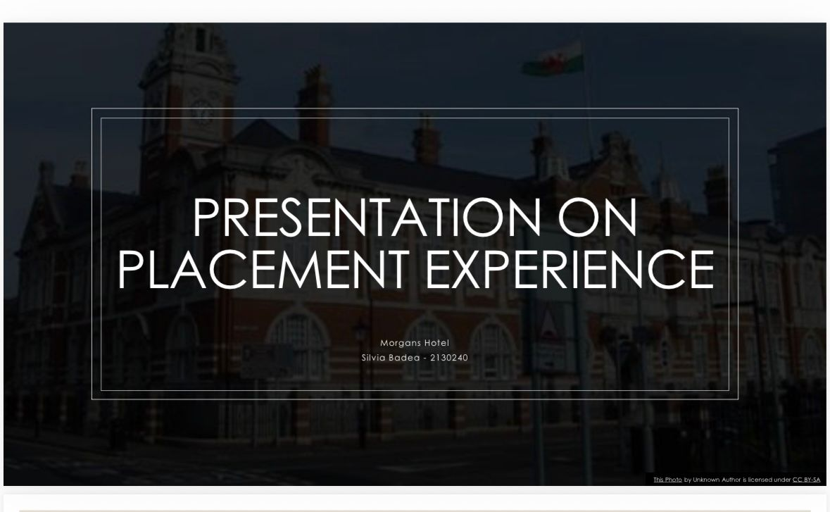
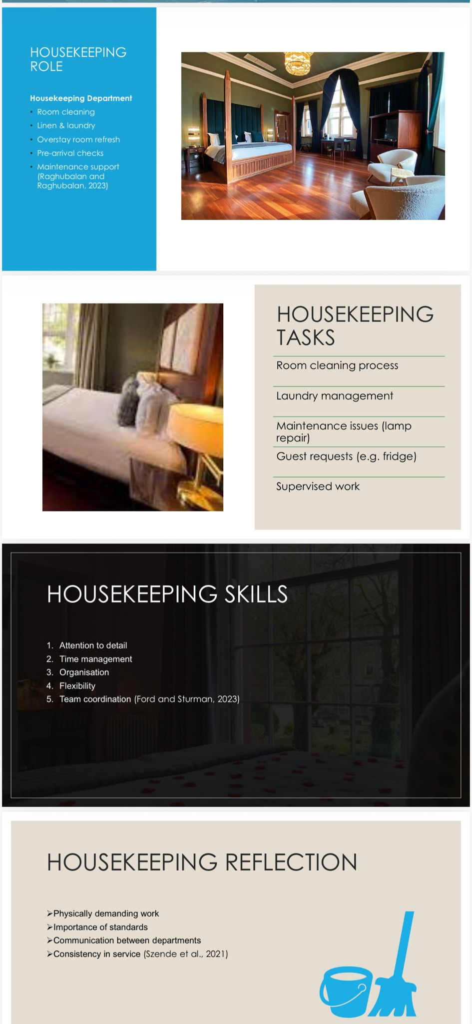
Part 6: Questions and Answers Based on the Presentation

References
- Ford, R.C. and Sturman, M.C. (2023) Managing Hospitality Organizations: Achieving Excellence in the Guest Experience. 3rd ed. Sage.
- Gibbs, G. (1988) Learning by Doing: A Guide to Teaching and Learning Methods. Oxford: Oxford Polytechnic.
- Johnston, R., Shulver, M., Slack, N. and Clark, G. (2020) Service Operations Management: Improving Service Delivery. 5th ed. Pearson.
- Raghubalan, G. and Raghubalan, S. (2023) Hotel Housekeeping: Operations and Management. 4th ed. Oxford University Press.
- Szende, P., Dalton, A.N. and Yoo, M. (2021) Operations Management in the Hospitality Industry. Emerald Publishing.
- Tesone, D.V. (2010) Principles of Management for the Hospitality Industry. Butterworth-Heinemann.
- Vallen, G.K. and Vallen, J.J. (2012) Check-in Check-out: Managing Hotel Operations. 9th ed. Pearson.

