
\

Student name: Joice Rumila Dos Reis Gomes Pina
Student ID: 2312503

Module name: Changemakers: Building your Personal Brand for Sustainable Employment
Module code: BMHP5015
Lecturer name: Brian Mashumba

Assignment Guidance Template
Introduction | The “Changemakers: Building Your Brand for Sustainable Employment” module has equipped me with vital knowledge across four key units: personal branding, boundaryless careers, networking strategies, and emotional intelligence (Capela, 2021). Each unit contributed to a deeper understanding of how to navigate the evolving health and social care landscape. Personal branding helped me articulate my values and strengths, while the concept of boundaryless careers encouraged adaptability and lifelong learning. Networking strategies enhanced my confidence in building professional relationships, and emotional intelligence sharpened my self-awareness and empathy-critical for person-centred care. Collectively, these units have shaped my professional identity and broadened my perspective on global employment trends. They’ve also prompted reflection on wellbeing and resilience, both personally and within care environments. This introduction sets the foundation for exploring how these insights have influenced my development and how I intend to apply them in future health and social care roles.
Reflection on Unit 1: Brand You | The topics I will be covering in Unit 1 are ambition is critical, what drives you, boundaryless careers and boundaryless skills.  I realised that everyone has a different meaning of ambition to them and how important is to be setting a goal for yourself and achieving them. I learned that autonomy, mastery and purpose they are connected may being ambition person. And I learned to understand that you need self-determination to become success and it helps you have ambition and to be true to yourself (authenticity) as well.  Linking Self-Awareness to Johari’s Window  Self-awareness is central to my personal and professional development, particularly in health communication and advocacy. The Johari’s Window model (Luft and Ingham, 1955) provides a structured lens for reflection, categorising self-knowledge into four quadrants: open, blind, hidden, and unknown.  The open area represents aspects recognised by both me and others. My analytical skills and structured writing are acknowledged strengths, and expanding this quadrant through feedback and disclosure resonates with Rogers’ (1961) emphasis on authenticity in relationships.  The blind area highlights traits visible to others but unnoticed by me. Feedback has revealed my tendency to use overly technical language, limiting accessibility. This aligns with Argyris and Schon’s (1987) double-loop learning, where challenging assumptions enhance clarity and adaptability.  The hidden area contains motivations I have not always disclosed, such as mu commitment to maternal health advocacy. Sharing these values reduces the hidden quadrant and fosters psychological safety, consistent with Edmondson’s (1999) framework on team learning.  The unknown area encompasses latent potential, such as public speaking skills that may emerge through blogging. This exploration reflects Kolb’s (1984) experiential learning cycle, where new experiences uncover capabilities.  Overall, Johari’s Window illustrates that self-awareness evolves through feedback, disclosure, and exploration, strengthening authenticity and effectiveness.  Week 1  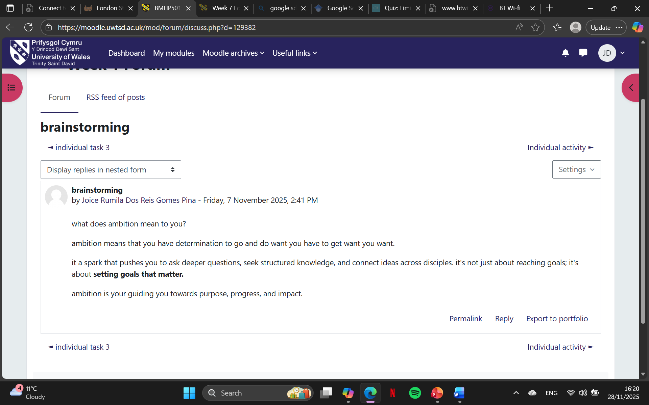  I wrote this to the meaning of ambition to me means that you have the mindset to determination to progress on what I set my mind.  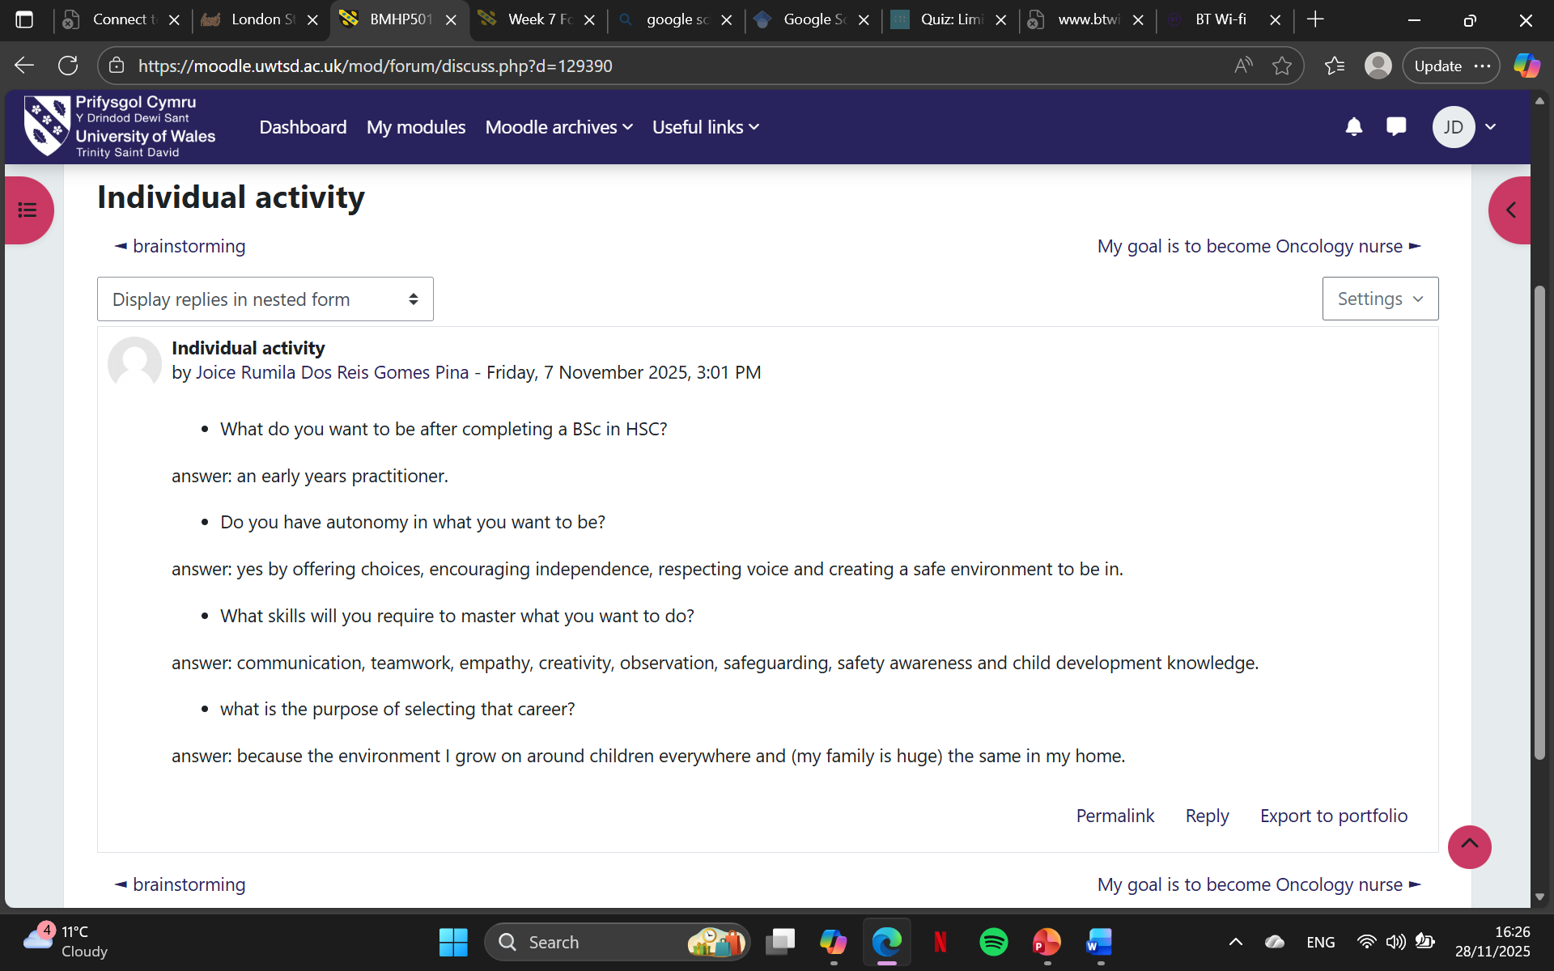  I have the ambition to complete and work on the goal career that I have on mind and the determination to finished it. I wrote what I understand about autonomy, purpose in life and mastery.  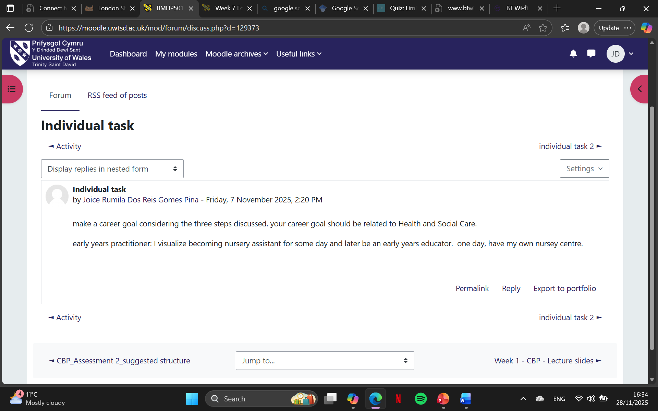This is my career goal and the steps I need to take to get there and the motivation I need to have the mindset to complete it.  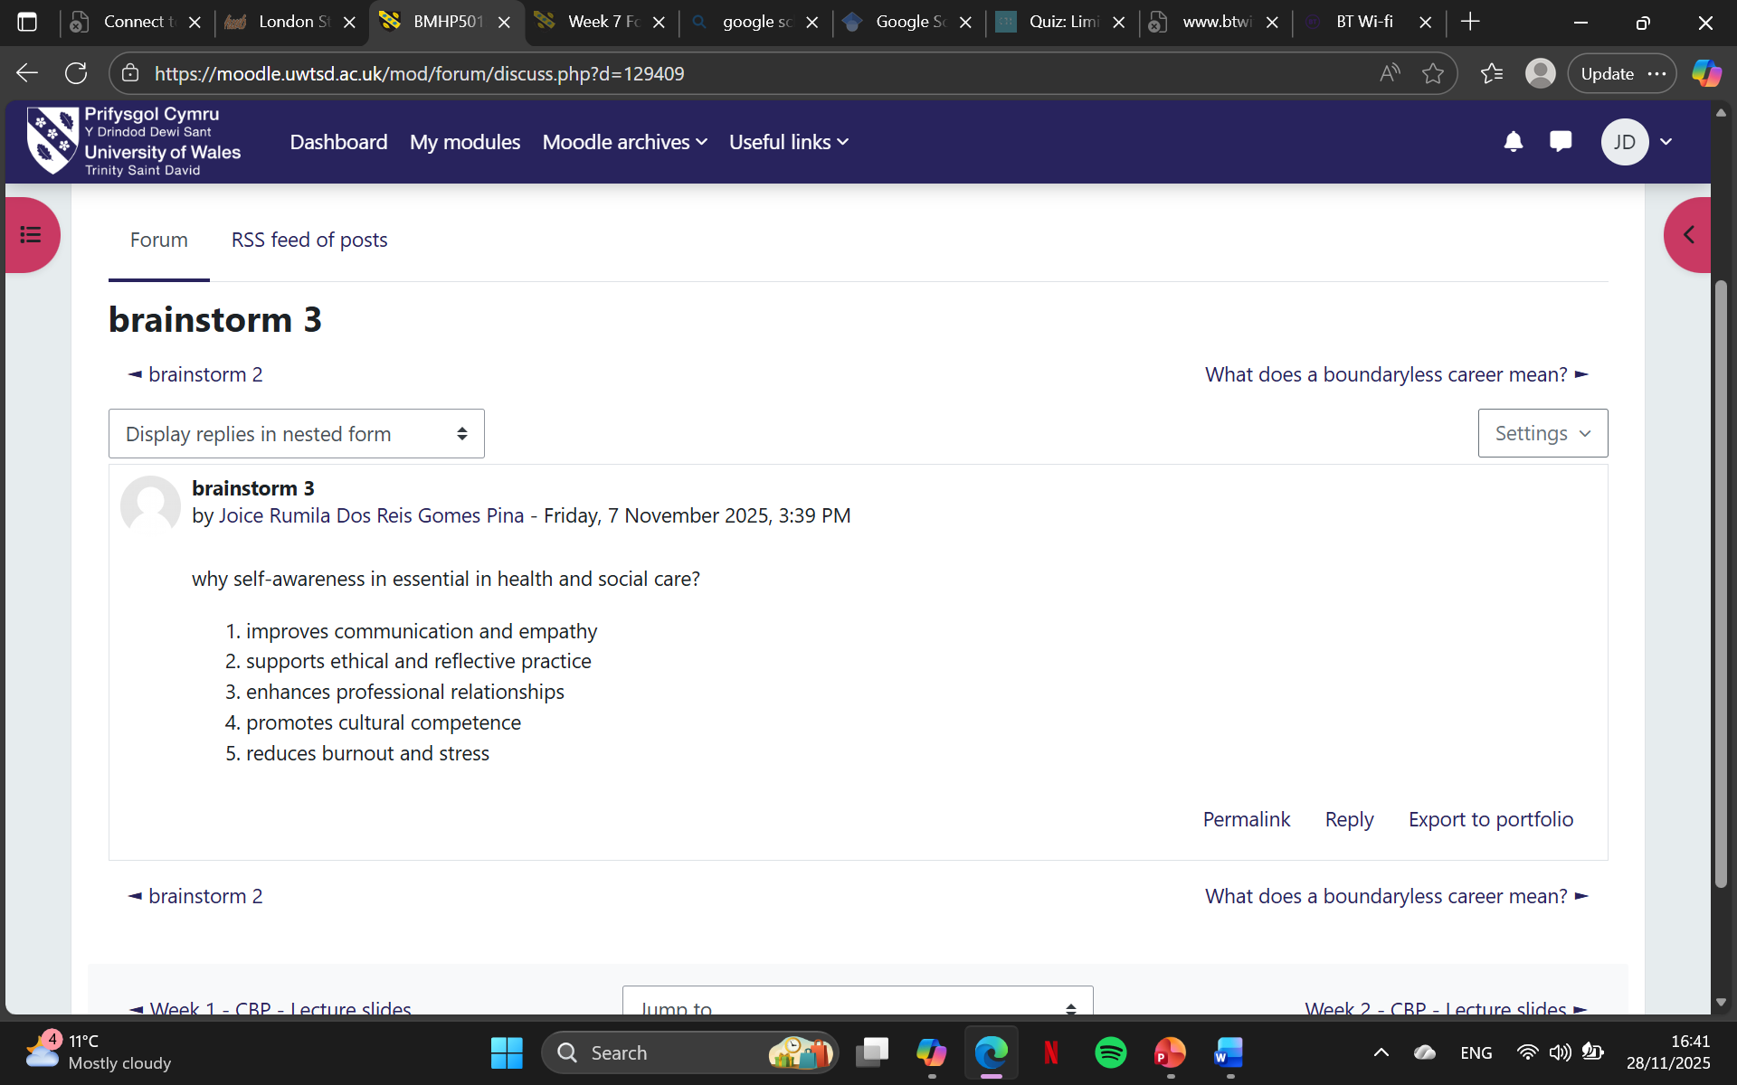Self-awareness is essential in life because it helps improve empathy, supports and reflective practice, and reduces burnout and stress. Self-awareness is when I can enhance professional relationships.
Reflection on Unit 2: It’s a Small World | The topics I covered in class are it is a small world, Variety is the spice of life, Network society, and Making connections.  I learned that networking is to connect with people that have the same experience or interest and the same field as you and that I can meet people in weird places like a café, library, restaurant, in your neighbourhood. I must go out of my comfort zone, and I understood different types of evaluation for example goal-based evaluations, process- based evaluations and outcomes-based evaluations  In reflecting on my cultural awareness, Hofstede’s Cultural Dimensions (Hofstede, 1980; Hofstede, Hofstede and Minkov, 2010) provide a useful framework for interrogating my assumptions and practices in health communication and advocacy. My tendency towards low power distance often leads me to assume that patients and professionals should engage as equals. While this aligns with Western ideals of autonomy, I have encountered contexts where hierarchical structures are more accepted, requiring me to adapt communication strategies to respect authority while still promoting patient-centred care.  Equally, my individualist orientation privileges autonomy in maternal decision-making. However, engaging with collectivist communities has highlighted the importance of family consensus, reminding me that advocacy must be culturally responsive rather than prescriptive. This recognition connects to Johari’s Window (Luft and Ingham, 1961), as what I perceived as an ‘open self’ value was, in fact, a blind spot when applied across cultures. Feedback from diverse groups gas expanded my awareness, reducing blind spots and strengthening authenticity in my studies.  Kolb’s Experiential Learning Cycle (1984) further frames this growth. Concrete experiences of cross-cultural dialogue prompted reflective observation of differing values, which I then linked to Hofstede’s framework as abstract conceptualization. Active experimentation followed, as I adjusted mu communication strategies to align with cultural expectations while maintaining advocacy goals.  Through this process , I have come to view cultural awareness not as static knowledge but as an evolving practice. Hofstede’s model, combined with self-awareness tools, enables me to bridge theory and lived experience, ensuring that my advocacy in health communication remains both evidence-based and culturally attuned.  Week 3  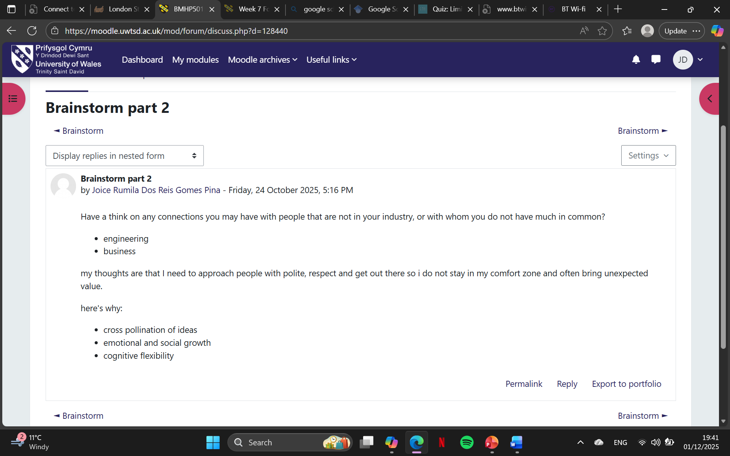  This screenshot is about how I can connect with people by networking and with connections I can bring by helping them and receiving help as well.  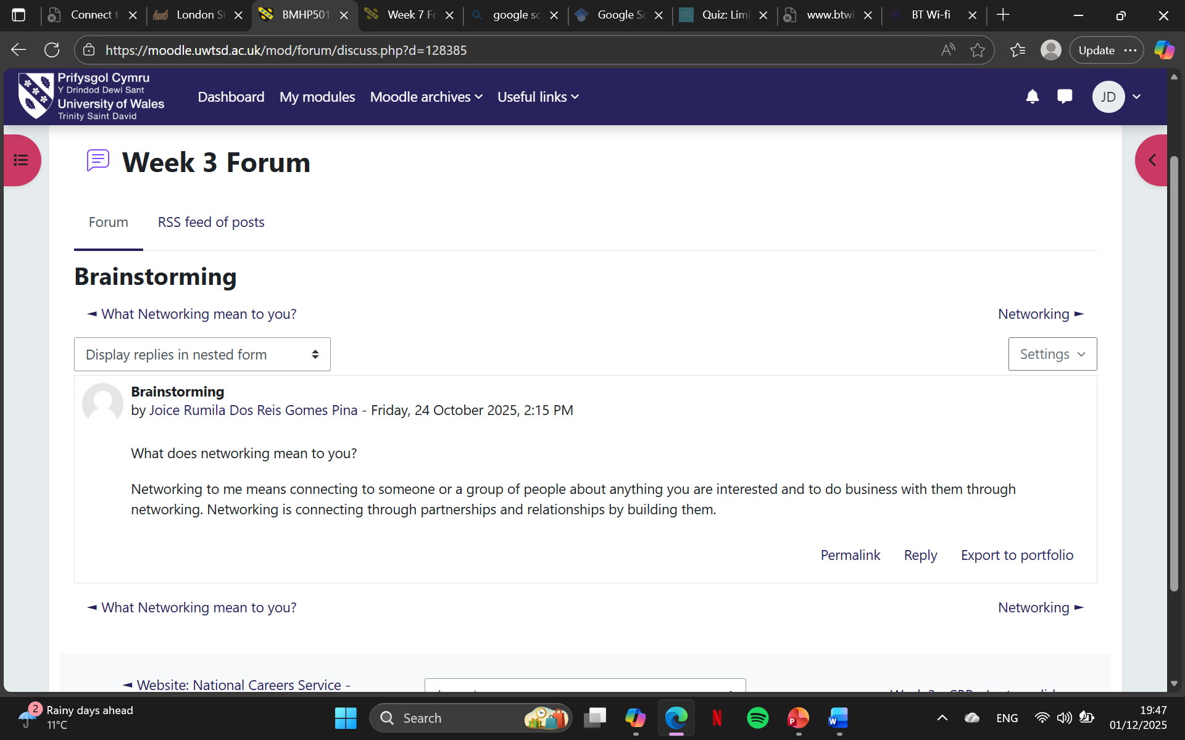  This screenshot is about what networking means to me and what networking does to society, and the importance of networking to get a job right after finishing school.  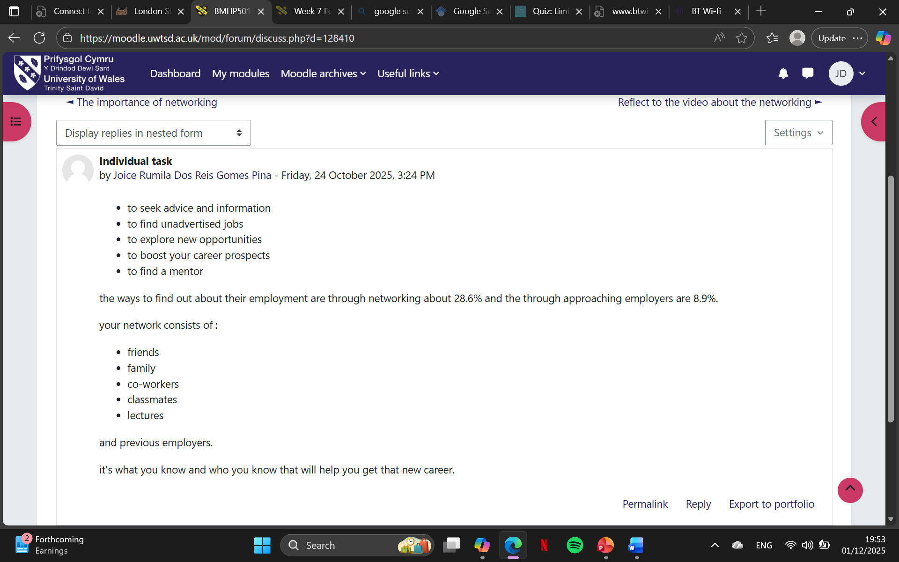  This screenshot is about what is the importance of networking and connecting to people who have the same interest as you. The people who I can started by networking is the closest do me for example family, friends, colleagues, classmates, lectures and previous employers.
Reflection on Unit 3: Opportunity Knocks | The topics I am covering is creating your own luck, identifying career opportunities, open doors and Me.com.  I found that success and finding luck in health and social care profession, considering key points in achieving, and to understand the serendipity mindset, I learned what is traditional and modern recruitment is and what is your or mine work values. I found out that stretch goals are objectives that are purposely challenging to achieve, and that go beyond what is considered normal or expected of me, I found out that I have to sell mine skills to an employer in health and social care, considering the steps I need to take are identify mine unique skills, create a strong cv and cover letter, network, gain relevant experience, prepare for interviews and to have a professional development. I learned that reflection helps me identify and use opportunities that come along the way.  Description and Feelings  In preparing for my advocacy work, I recognised the importance of structured planning. Initially, I felt confident about my approach, but also aware of the uncertainty that comes with anticipating systemic barriers.  Evaluation  The planning was useful in clarifying priorities, yet I noticed gaps in how I accounted for external factors such as business resistance. This highlighted both strengths (organisation, clarity) and weaknesses (limited contingency planning).  Analysis  Gibbs’ Reflective Cycle (1988) emphasises moving from evaluation into deeper analysis. Here Kolb’s (1984) experiential learning theory is relevant: planning represents the abstract conceptualisation stage, but effective action requires active experimentation. Schon’s (1983) notion of the reflective practitioner also resonates, as reflection-on-action enables me to refine strategies for the future advocacy. Argyris and Schon’s (1978) double-loop learning further suggest that effective planning involves questioning underlying assumptions, not just tactical adjustments.  Conclusion  I concluded that while my planning was structured , it lacked flexibility. Reflection revealed the need to embed adaptive strategies and feedback mechanisms into future.  Action plan  Moving forward, I will integrate reflective checkpoints into my planning process, ensuring that action is responsive rather than rigid. This aligns with Gibbs’ final stage and with implementation science literature (Fixsen et al., 2005) which stresses that reflection must lead to actionable, evidence-based strategies for sustainable change.  Week 5  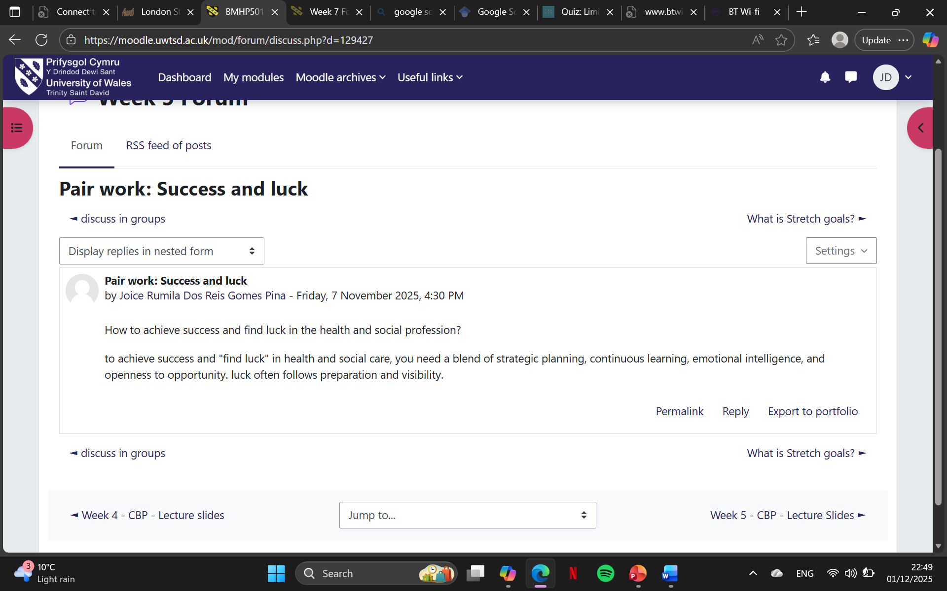  This screenshot is about how important is achieving success or finding luck in a health and social care profession.  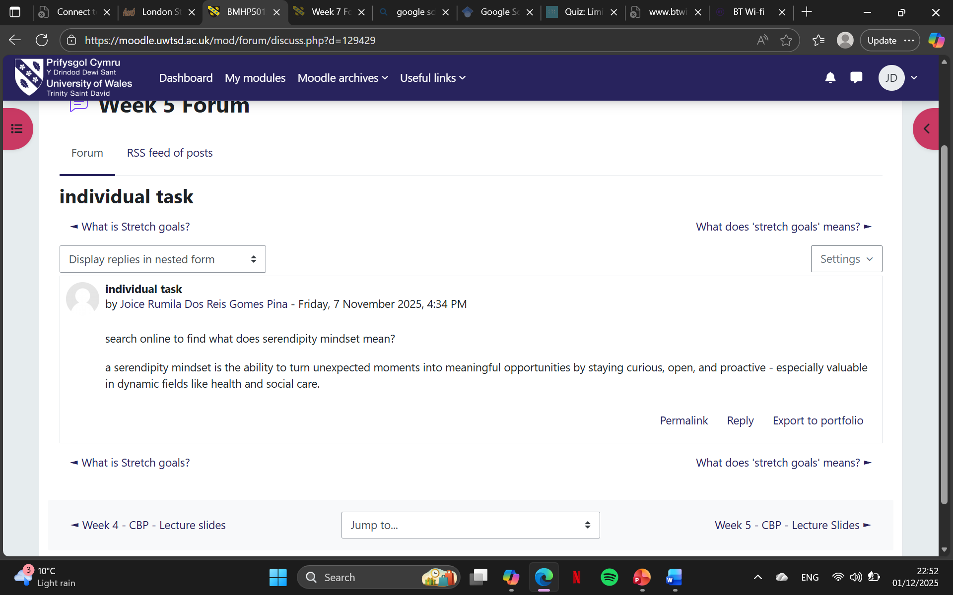  This screenshot shows that for me to have a serendipity mindset I need to have a curious, openness, active and the ability to see things differently.  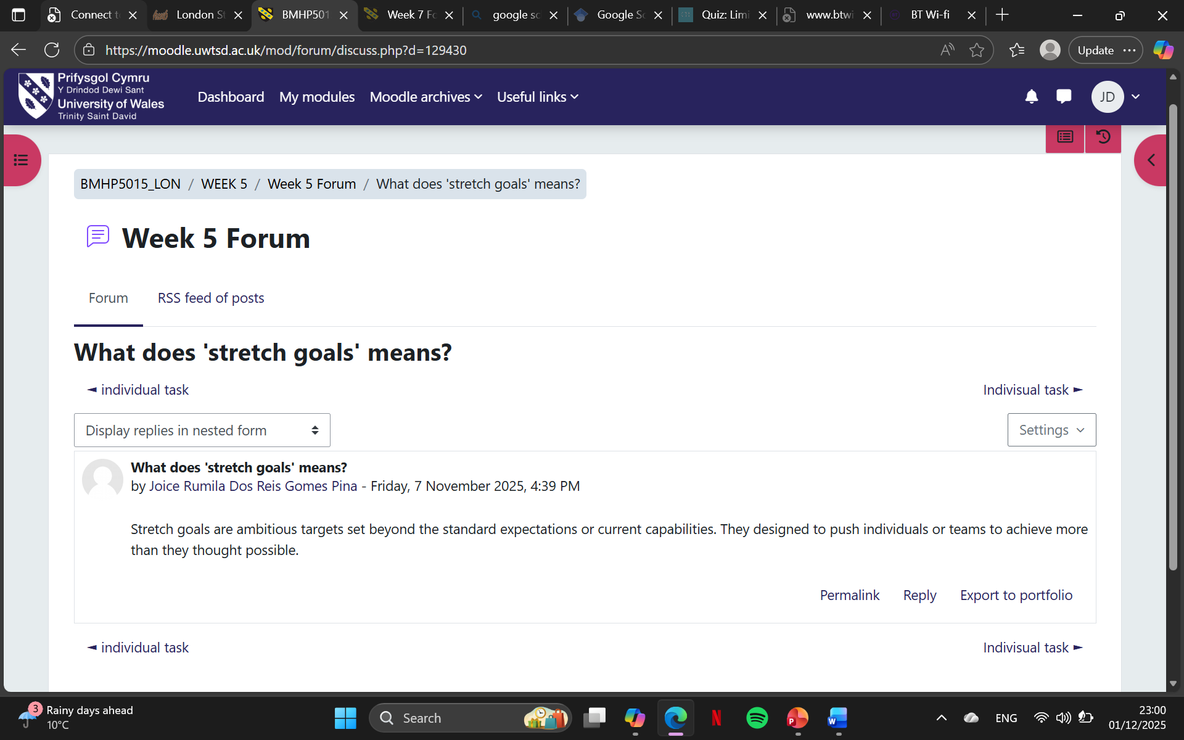  This screenshot shows that I can stretch my goals to match my profession because of the skills and qualities I have learned to have ambition mindset.
Reflection on Unit 4: The Pursuit of Happiness | The topics I covered were future me, passion and perseverance, plan, prepare, perform and career role models include wellbeing, resilience, work-life balance.  Future Me  - Personal development: thinking about “Future Me” encouraged long-term self-awareness. It helps me articulate the kind of person I want to become, aligning values with daily choices. This vision reduced blind spots by making me more intentional about feedback and growth.  - Professional development: it provided a roadmap for career progression. By visualizing my future self as a thought leader in health communication, I could identify the skills, networks, and experiences I need to cultivate now.  Passion and Perseverance  - Personal development: passion gave me energy and purpose, while perseverance taught me resilience. Together, they helped me push through challenges, whatever in academic writing or advocacy work, without losing sight of why the work matters.  - Professional development: these qualities translated into credibility and consistency. Passion made my communication authentic, and perseverance ensured I delivered results even under pressure - key traits for leadership and advocacy roles.  Plan, Prepare, Perform  - Personal development: this framework instilled discipline. Planning clarified goals, preparation-built confidence, and performing strengthened self-efficacy. It shifted me from reactive to proactive living.  - Professional development: in practice, it became a cycle for project management and public engagement. For example, in drafting blog post or presentations, I plan structure, prepare evidence, and perform delivery – ensuring both rigor and accessibility.  Career Role Models  - Personal development: role models provided inspiration and psychological safety. Observing their authenticity and resilience helped me internalize values like empathy and courage.  - Professional development: they offered practical guidance – how to navigate systemic barriers, advocate effectively, and balance personal narrative with professional credibility. Role models became benchmarks for the kind of communicator and leader I aspire to be.  Integrative Impact  They don’t work in isolation – they form a development ecosystem. For instance, role models often embody passion and perseverance, while the “Future Me” vision is realized through planning, preparation, and performance.  Linking Reflection to the PERMA Model  Positive Emotion  - Theory: Seligman (2011) identifies positive emotions as foundational to wellbeing, broadening though – action repertoires (Fredrickson’s broaden-and-build theory, 2001).  - Reflection link: my energized state and sense of purpose in advocacy align with cultivation joy, hope, and gratitude – emotions that sustain resilience in health communication.  - Academic source: Fredrickson, B. L. (2001). The role of positive emotions in positive psychology: the broaden-and-build-theory of positive emotions. American Psychologist, 563, 218-226.  Engagement  - Theory: flow theory (Csikszentmihalyi,1990) underpins engagement – deep absorption in meaningful tasks.  - Reflection Link: my interdisciplinary writing and synthesis of theory with practice demonstrate flow-like engagement, where challenge and skills are balanced.  - Academic source: Csikszentmihalyi, M. (1990). Flow: The psychology of optimal experience. Harper and Row.  Relationships  - Theory: social connectedness and psychological safety (Edmondson,1989) are critical for wellbeing and learning.  - Reflection Link: my emphasis on feedback, authenticity, and reducing blind spots through Johari’s Window reflects investment in trust-based relationships that enhance wellbeing.  - Academic source: Edmondson, A. (1999). Psychological safety and learning behaviour in work teams. Administrative Science Quarterly, 442, 350-383.  Meaning  - Theory: meaning is tied to self-transcendence and purpose (Frankl, 1963; Seligman, 2011).  - Reflection Link: my maternal advocacy and drive to challenge stigma embody meaning making, situating personal narrative within broader social impact.  - Academic source: Frankl, V. E. (1963). Man’s search for meaning. Beacon Press.  Accomplishment  - Theory: achievement contributes to wellbeing when aligned with intrinsic goals (Deci and Ryan’s Self-Determination Theory, 1985).  - Reflection Link: my short-term goal of launching a blog and long-term aim of thought leadership represent accomplishment, reinforcing competence and autonomy.  - Academic source: Deci, E. L., and Ryan, R.M. (1985). Intrinsic motivation and self-determination in human behaviour. Springer.  Week 7  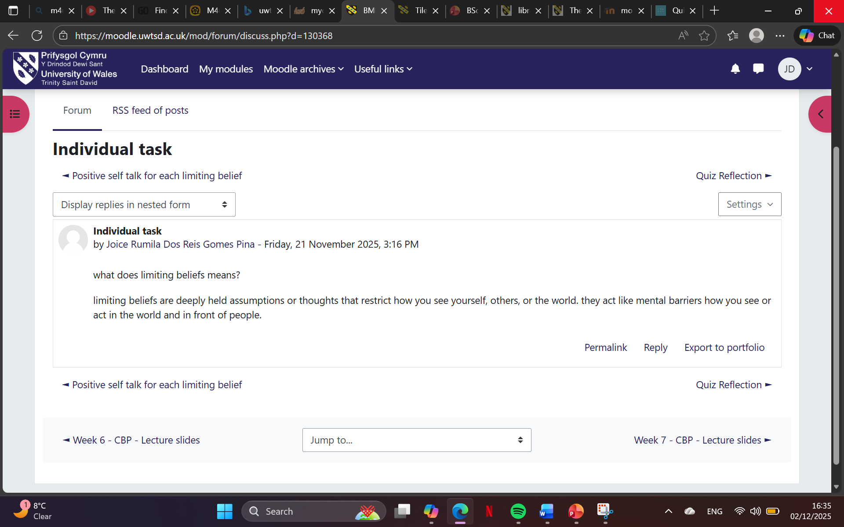  This screenshot shows that I can have a mindset that is limited beliefs, and I see myself from others point of views and that is where I have limited my beliefs and thoughts that are restricted to show.  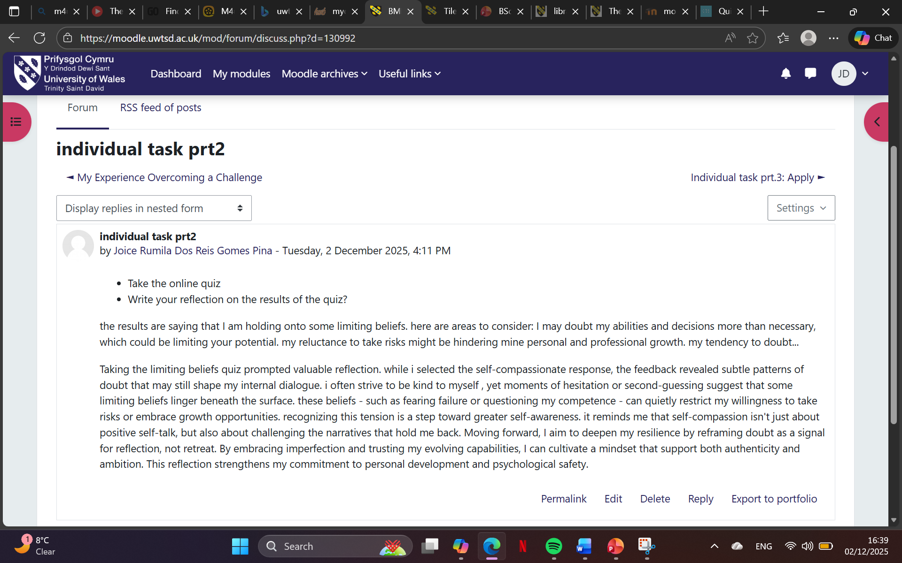  This screenshot is showing that I have a limiting belief and the most important one that I take is doubting my ability and decisions which may not limiting to see my potential.  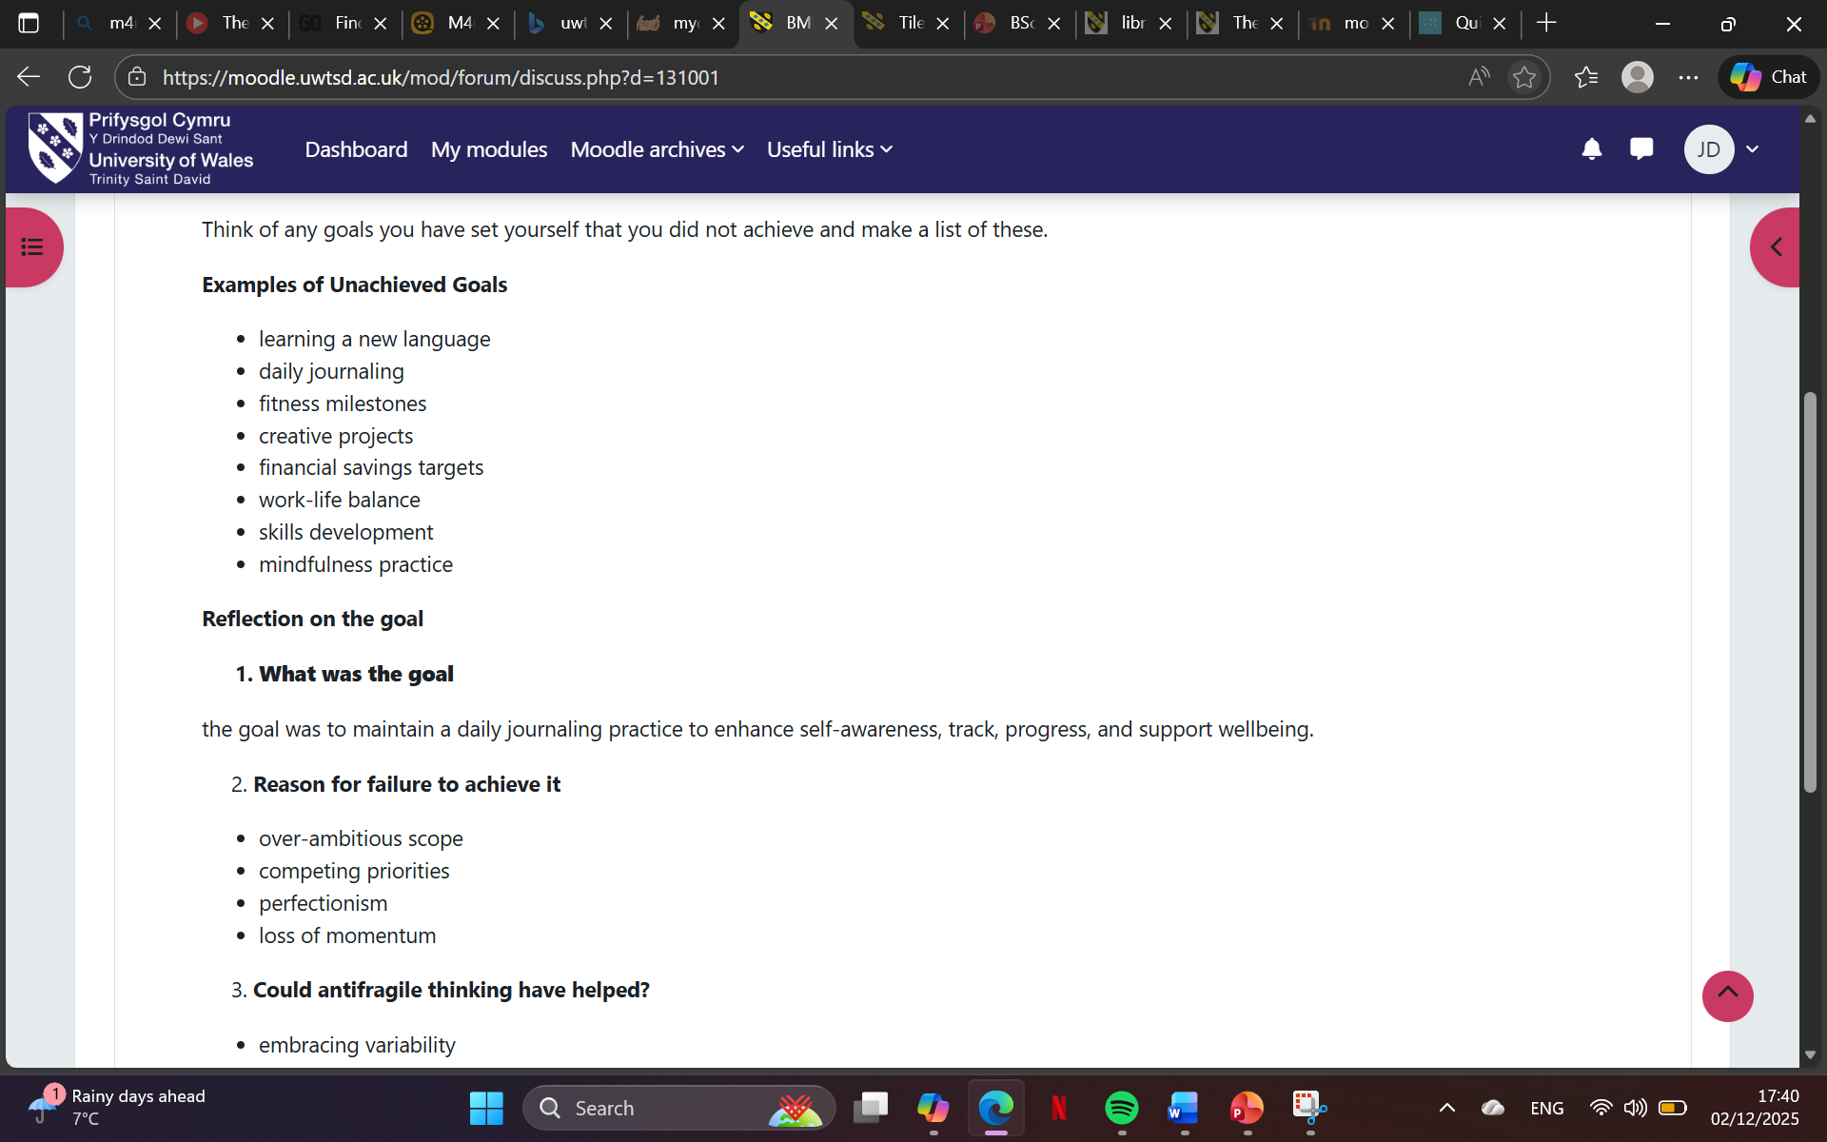  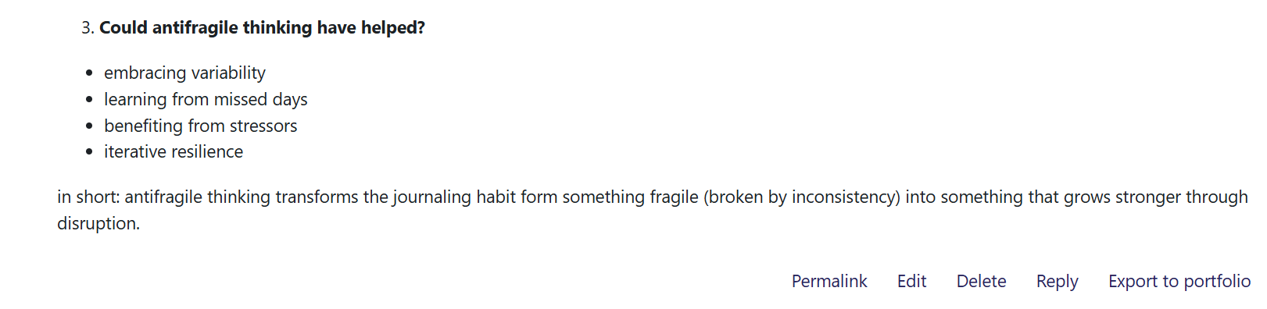  This screenshot shows that when I set a goal they are things that don’t make me achieve it but if I learn how to think antifragile it might help me achieve the goal a set for myself.
Conclusion | In reflecting on my experiences and learning throughout this component, I have gained deeper insight into the importance of self-awareness, communication, and resilience within health and social care settings. Applying models such as Gibbs’ Reflective Cycle and Johari’s Window has enabled me to critically evaluate my strengths and areas for development, particularly in relation to empathy, active listening, and professional boundaries. I now better understand how personal values and emotional intelligence shape interactions with service users and colleagues, and how feedback can be a powerful tool for growth.  This reflection has reinforced the significance of psychological safety and authentic communication in building trust and delivering person-centred care. I have also recognised the value of interdisciplinary thinking , drawing connections between theory and practice to enhance my approach. Moving forward, I will apply these insights to improve my responsiveness, adaptability, and collaborative skills in real-world care environments. By continuing to engage in reflective practice, I aim to foster a culture of learning and compassion in the future role. Overall, this process has strengthened my commitment to ethical, empathetic care and has equipped me with practical strategies to support both service users and my own professional development.
References | Hofstede, G. (1980). Culture’s Consequences: International Differences in Work-Related Values. Sage. (Accessed: 27 November 2025)  Hofstede, G., Hofstede, G. J., and Minkov, M. (2010). Cultures and Organizations: Software of the Mind. McGraw-Hill. (Accessed: 27 November 2025).  Hall, E. T. (1976). Beyond Culture. Anchor Books. (Accessed: 27 November 2025).  Luft, J., and Ingham, H. (1961). Johari’s Window: A Graphic Model of Awareness in Interpersonal Relations. (Accessed: 27 November 2025).  Kolb, D. A. (1984). Experiential Learning: Experience as the Source of Learning and Development. Prentice Hall. (Accessed: 27 November 2025).  Argyris, C. and Schron, D. (1978). Organizational Learning: A Theory of Action Perspective. Reading , MA: Addison-Wesley. (Accessed: 1st December 2025).  Fixsen, D.L., Naoom, S.F., Blasé, K.A., Friedman, R.M. and Wallace, F. (2005). Implementation Research: A synthesis of the Literature. Tampa, FL: University of South Florida. (Accessed: 1st December 2025).  Gibbs, G. (1988). Learning by Doing: A Guide to Teaching and Learning Methods. Oxford: Oxford Polytechnic. (Accessed: 1st December 2025).  Kolb, D.A. (1984). Experiential Learning: Experience as the Source of Learning and Development. Englewood Cliffs, NJ: Prentice Hall. (Accessed: 1st December 2025).  Schon, D.A. (1983). The Reflective Practitioner: How Professionals Think in Action. New York: Basic Books. (Accessed: 1st December 2025).  Arthur, M.B. and Rousseau, D.M., (1996). The Boundaryless Career: A New Employment Principles for a New Organizational Era. Oxford: Oxford University Press. (2nd December 2025).  Capela, J., (2021). Changemakers: Building Your Brand for Sustainable Employment. London: FutureLearn. (Accessed: 2nd December 2025).  Goleman, D., (1995). Emotional Intelligence: Why It Can Matter More Than IQ. New York: Bantam Books. (Accessed: 2nd December 2025).  Peters, T., (1997). The brand called you. Fast Company, Available at: https://www.fastcompany.com (Accessed: 2nd December 2025).  Care Learning (2025). Health and Social Care Qualifications/ Level 3 Award, Certificate and Extended Diploma in Health and Social Care/ HSC DMO14: Technology in health and social care/ 1.1.explain technology application in health and social care. Available at: https://carelearning.org.uk (Accessed: 2nd December 2025).  Celestine (2024). The Roles of Technology in Transforming Health and Social Care Services. Available at: https://blog.lspm.org.uk (Accessed: 2nd December 2025).  Department of Health and Social Care and The Rt Hon Wes Streeting MP (2025). Health and social care/ National Health Service/ Health workforce/ Health and social care training/ Cutting-edge tech introduced in social care. Available at: https://www.gov.uk (Accessed: 2nd December 2025).  Skills for Care (2025). Support for leaders and management/ Managing a service/ Digital technology in social care. Available at: https://www.skillsforcare.org.uk (Accessed: 2nd December 2025).  Health and Social Care Committee (2023). Digital transformation in the NHS. Available at: https://publication.parliament.uk (Accessed: 2nd December 2025).

