Managing Enterprise in the 21st Century
Module code: BMSW4011

Task 1 & Task 2
28/06/2024

Student ID:2244011

Student Name: Mariana-Adela Sugar

Table of Contents
Task 1 – Business Plan 1
Product Description and Proposition 1
Business Name 1
Mission, Aim and Objective of the Business 1
Business Location 2
Human Resource of Elegant Nails & Beauty 2
Marketing Activities 2
Market Research 3
Financial Resources 4
Biggest Threat for Elegant Nails & Beauty and Way to Overcome 6
Task 2 - Reflection 7
Reference 9

Table of Figures
Figure 1. Free Delivery Promotion. 2
Figure 2. Product Promotion of Elegant Nails & Beauty. 3
Figure 3. Sales Promotional Advertisement. 3
Figure 4. Revenue Forecast of Beauty and Nail Products in the Market of the UK. 3

Task 1 – Business Plan

Product Description and Proposition
In the present age, the demand for beauty products for skin care and nail products for nail care is very high. And so, the business is going to focus on different types of beauty products and nail care products, such as face masks, facial creams and skin care products, along with nail kits for nail care (Business Wales, 2021). The products will be luxurious but affordable. The product proposition will be, ‘Your Beauty, Your Way’. The organisation will focus on quick-application nail polish, multi-functional beauty items, and easy-to-use tools that simplify beauty routines.

Business Name
The name of the business is going to be “Elegant Nails & Beauty”.
According to Blythe (2019), the business is going to be focused on beauty products and nail products for skin and nails. The business is going to be a sole proprietorship. A sole trader business, also known as a sole proprietorship, is the simplest and most common form of business ownership. It is relatively easy and inexpensive to start and run a sole trader business. In many jurisdictions, it requires minimal legal formalities and paperwork.

Mission, Aim and Objective of the Business
Mission: ‘To enhance the natural beauty and confidence of our clients by providing exceptional nail care and beauty services, complemented by our premium line of beauty products.’
Aim: To become the go-to destination for premium nail and beauty services and products in the local community, renowned for our commitment to excellence, innovation, and customer satisfaction (Careers Wales, 2021).
Objective:
- To develop a new product line in the market and increase market share by 10% with the help of the top management.
- To create customer satisfaction and increase satisfaction by 10% every year with the help of research and analysis.
- To develop at least 1 new product line every year with the help of the marketing management of the organisation.

Business Location
Morgan (2016) mentioned that for the business, the organisation Elegant Nails & Beauty is primarily going to develop its showrooms and sales in the location of New Port, UK. The organisation will need technological tools for the development of the products and testing them to understand their effectiveness. Also, for the promotion and sales of the organisation, it will need communication tools as well (Kotler et al., 2019).

Human Resource of Elegant Nails & Beauty
The organisation is going to start the business with 25 to 30 employees among whom there will be marketing employees, production employees and research & development employees. There will be 4 specialists for nail and skin care products to understand the production (Zimmerer and Scarborough, 2017).
The people of the organisation will manage and operate the business and they will be recruited with the help of job advertisements and networking so that perfect people can be appointed to the organisation (Wolanin, 2022).

Marketing Activities
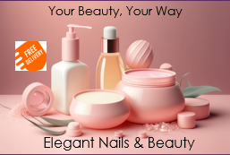
Figure 1. Free Delivery Promotion.
Liu (2022) explained that the marketing activities will be focused in a way so that the costs regarding the promotional activities remain low as the brand is trying to give people a quality product at a value-based price. For promotion, the organisation will maintain social media and for public relations, the organisation will develop events so that Elegant Nails & Beauty can directly become connected to people (Ajayi and Laseinde, 2023).


Figure 2. Product Promotion of Elegant Nails & Beauty.
The organisation will focus on sales promotion activity as well, where customers will get products with a 20% discount for their first order. There will also be an option for free delivery for the first order. The loyalty programme will develop the public relationship with the customers as well (Kroon and Paauwe, 2022).
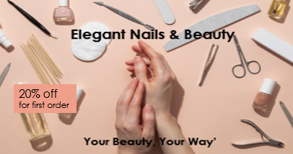
Figure 3. Sales Promotional Advertisement.

Market Research
The beauty and personal care market in the UK is robust and diverse, with significant growth in the nail and beauty sectors. The market is driven by increasing consumer demand for high-quality, innovative, and natural beauty products (Van Laar et al., 2022).
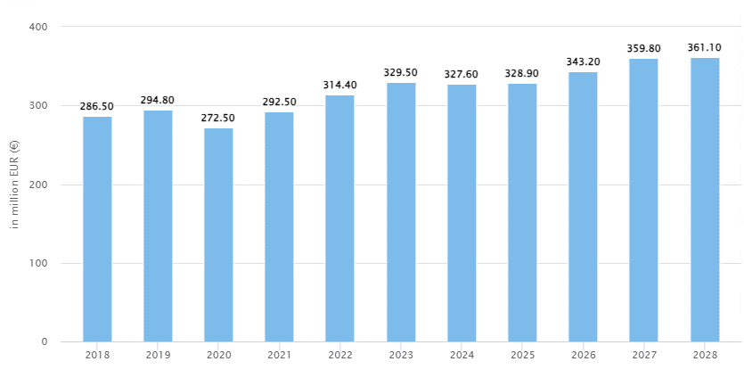
Figure 4. Revenue Forecast of Beauty and Nail Products in the UK Market.
Source: Popescu and Kyriakopoulos (2022).
The forecast shows that the demand for Beauty and nail products is developing and increasing day by day so it is very clear that the demand will be developed very well so the product will get a high positive response.

Financial Resources
Elegant Nails & Beauty requires a careful financial planning strategy to ensure sufficient funds for start-up and smooth operation. By combining personal savings, loans, and possibly investments, the business can secure the necessary financial resources (Min and Kim, 2022).
Cost Required
Terms | 2024 | 2025 | 2026
Business Registration | £500 | - | -
Research and Analysis | £3000 | £1000 | £1000
Premises Deposit and Rent | £5000 | £5000 | £5000
Equipment and Supplies | £6000 | £7000 | £8000
Product Inventory | £7000 | £7000 | £8000
Technology and Software | £5000 | £5000 | £5000
Marketing and Promotion | £3000 | £2000 | £4000
Insurance | £1000 | £1000 | £1000
Total Cost | £30500 | £28000 | £32000

Source of Fund
Source | Amount
Savings | £18000
Bank Loan | £3000
Partner | £10000
Total | £31000

Cash Flow
Terms | 2024
Business Registration | £500
Research and Analysis | £3000
Premises Deposit and Rent | £5000
Equipment and Supplies | £6000
Product Inventory | £7000
Technology and Software | £5000
Marketing and Promotion | £3000
Insurance | £1000
Total Cost | £30500
Cash Flow
Product Sales |  | 32000
Net Income |  | 1500

Every year the cash flow will increase so that the net income can be higher than the previous year. Such as in 2nd year product sales will be $50000 so then net income will be ($50000-$28000) = $22000. In 3rd year the sales will be $80000 so the net income will be ($80000-$32000) = $48000.
Year | Cost Required | Sales Income (Cash Flow) | Net Income
1st | £30500 | £32000 | £1500
2nd | £28000 | £50000 | £22000
3rd | £32000 | £80000 | £48000

Biggest Threat for Elegant Nails & Beauty and Way to Overcome
The biggest threat to Elegant Nails & Beauty is intense competition within the beauty and nail care industry. The UK market is saturated with numerous established brands and emerging businesses offering similar services and products (Popescu and Kyriakopoulos, 2022).
By focusing on the strategies of unique value proposition, customer satisfaction, innovation and trend, and quality assurance, Elegant Nails & Beauty can effectively navigate the competitive landscape, attract and retain customers, and establish a strong, differentiated presence in the market.

Task 2 - Reflection
The study has been focused on a business plan developed for the business related to beauty and nail. Coming up with the business proposition for Elegant Nails & Beauty has been a multifaceted and enriching experience. I have learned to develop a business idea and finding out the business efficiency on that business product (Bassot, 2024). In the study I have developed the business idea regarding the business of nail and beauty products. Here I have focused on the market research and mission, aim, objectives, business location, marketing activity, financial strategy etc. all the terms have enriched my knowledge regarding the business enterprise.
I have developed the business proposition ‘Your Beauty, Your Way’. This has been developed according to the concept of product customisation. The organisation is going to offer customers the customised products so that customer disliking some of the ingredients can develop according to their choice. In the term of nail polish customers can customise the colours of the nail polish or fake nail. Also, in the term of face mask customers can include the flavor they want for the use. I have proposed for natural products so that sustainability can be balanced for the organisation. So the use of recyclable, biodegradable, or refillable packaging to minimize environmental impact has been focused on.
I have found that for developing a business proposal there are some of the skills are needed for a person to develop the organisation and business in the market. It's important to have the ability to view the broad picture, establish the company's vision, and create strategic plans to meet long-term objectives. It is also crucial for creating a cohesive team, assigning work well, and encouraging teamwork in the workplace. A person needs to be a leader to manage a business in the market. So that he or she can develop a team which will help that person to be successful in the market (López-Pellisa et al., 2021).
The path of an entrepreneur is full with obstacles and disappointments. The capacity for resilience, learning from mistakes, and flexibility in the face of change are traits that distinguish successful businesspeople from others. This resilience is combined with a growth mentality, which holds that both individual and corporate progress depend on ongoing learning and development (Cottrell, 2023). Communication skills are also important for the person to develop a way to create networking in the market so that people find the organisation trust worthy and the promotion about the products and organisation can be very high with the help of the mouth-to-mouth promotional activities.
I have decided to find my ability so that when I would like to develop my business can apply these capabilities to develop my business i8n the market. I have attended different seminars regarding the skills required for being an entrepreneur and developing the business of sole trader.

Reference
Ajayi, M.O. and Laseinde, O.T., 2023. A review of supply chain 4IR management strategy for appraising the manufacturing industry's potentials and shortfalls in the 21st century. Procedia Computer Science, 217, pp.513-525.
Bassot, B., 2024. The reflective journal. Bloomsbury Publishing.
Blythe, J. (2019). Essentials of marketing communications. 7th edn. Harlow: Financial Times/ Prentice Hall.
Business Wales (2021), Business Advice in Wales, [online] available at: http://businesswales.gov.wales/ [Accessed 8th June, 2024]
Careers Wales. (2021), Careers advice in Wales, [online] available at: http://www.careerswales.com [Accessed 8th June, 2024]
Cottrell, S., 2023. Critical thinking skills: Effective analysis, argument and reflection. Bloomsbury Publishing.
Kotler, P., Armstrong, G., Harris, Lloyd C, He Hongwei (2019) Principles of marketing Harlow, U, K, Pearson Education.
Kroon, B. and Paauwe, J., 2022. HRM in 21st century small organizations: a midrange typology to describe, contrast and contextualize the phenomenon. The International Journal of Human Resource Management, 33(16), pp.3224-3251.
Liu, X., 2022. Research on the application of humanistic management thought in modern enterprise management. Accounting and Corporate Management, 4(3), pp.87-94.
López-Pellisa, T., Rotger, N. and Rodríguez-Gallego, F., 2021. Collaborative writing at work: Peer feedback in a blended learning environment. Education and Information Technologies, 26(1), pp.1293-1310.
Min, S. and Kim, J., 2022. Effect of opportunity seizing capability on new market development and small and medium-sized enterprise performance: Role of environmental uncertainty in the IT industry. Asia Pacific Management Review, 27(2), pp.69-79.
Morgan, P. (2016). The Business Student’s Guide to Study and Employability. Sage Publications.
Popescu, C.R.G. and Kyriakopoulos, G.L., 2022. Strategic Human Resource Management in the 21st-Century Organizational Landscape: Human and Intellectual Capital as Drivers for Performance Management. COVID-19 Pandemic Impact on New Economy Development and Societal Change, pp.296-323.
Van Laar, E., van Deursen, A.J. and van Dijk, J.A., 2022. Developing policy aimed at 21st-century digital skills for the creative industries: an interview study with founders and managing directors. Journal of Education and Work, 35(2), pp.195-209.
Wolanin, M., 2022. Competencies of top management, and the needs of 21st century enterprises in a VUCA world. VUZF Review, 7(2), p.170.
Zimmerer, T.W. & Scarborough, N.M. (2017) Essentials of Entrepreneurship 6th edition Prentice Hall New Jersey

