E-portfolio report
Learning in the Digital Era – BMPL4007/BMPS4009
Ana Maria Acsinte
Student ID:2232423
Table of Contents

Task 1 – Written summary 2
Task 2 – Mind map 4
Task 3 – Presentation 6
Task 4 – Reflection 10
Reference list 12

Task 1 – Written summary

Higher education encompasses rich culture along with scientific asset which has the capacity to enhance personal development and promotes economic and social changes. On the other hand, higher education can promote the exchange of knowledge, and enhance research skills, which can create the students' education system more innovative. In terms of preparing students for higher education, the student can start planning with a college (Jena, 2020). After completing high school Classes, College is another opportunity where students can start their preparation for higher education. However, in the context of formal education the higher education system is oriented with four stages and those stages are “elementary or primary level of education”, "Secondary Education '', "graduate and postgraduate or research level of education”. On a contradictory note, to prepare for a higher education apart from the education and level students also need to be involved with some extracurricular activities which can help out to establish a good relationship with mentors.

Figure 1: College for preparation of Higher education
(Source: (JAMİR, 2020)
That good relationship will be responsible for enhancing their knowledge (JAMİR, 2020). Apart from these, creating an organisation system is also responsible for preparing higher education. Preparing for higher education means that students want to enhance their knowledge system on any kind of particular subject. In this respect, by choosing a graduate or postgraduate degree students will benefit in multiple ways (Wadhwa et al., 2020). Graduation is a move forward in planning for higher education and the help of this clan student to easily achieve their goals. In contrast, there is guidance which is important for preparing for higher education (Subramanian, 2019). Those would be the guidance of a counsellor, knowing the requirements of the college, establishing a good relationship for accumulating references, and trying to do research on different options for financial aid. The reason behind choosing financial aid is that many other students are there who are facing issues regarding financial assistance. That is why knowing financial aid is considered to be another important part of the preparation for higher education.

Task 2 – Mind map
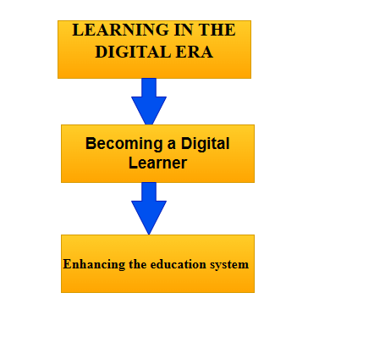
Figure 2: Concept to become a digital learner
(Source: Self-created)
The modern generation education system has upgraded with digitalisation and that is why students need to become digital learners which would be fruitful for their future. The concept of becoming a digital learner is oriented to the topic of learning in the digital era. While students will start learning in the digital Era and then gradually become digital learners (Anthonysamy et al., 2020). In this respect, while students will learn in the digital Era then it will easily enhance their knowledge and that knowledge will empower the student’s minds along with their capacity and which would be fruitful for their future success.
The main principle of this report is learning in the digital era and in this respect while students will habituate themselves in the digitalisation education system then they can easily enhance their knowledge (Williamson, 2021). That knowledge would enhance the educational system. In this respect to enhance the educational system, students will motivate themselves to prepare for higher education. In the stage of higher education with the capacity of digitalisation education, they can easily research online and be able to accumulate the required data. Those accumulated data will conduct impactful research where students can enhance their research capacity and upgrade their bucket of knowledge. Following this way, the main topic is interlinked with becoming a digital learner.

Task 3 – Presentation

Please follow this like to my presentation. Please open it with Google Presentations: https://docs.google.com/presentation/d/1ciX9rbP6tjmDx3nHjaZF5zOat5ORUGxi/edit#slide=id.p1
Personal identity
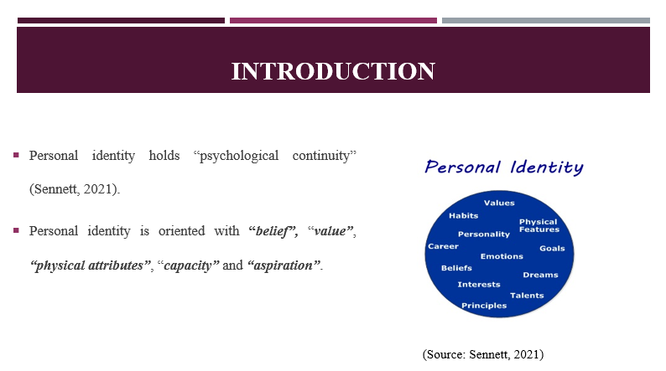
The term “personal identity” is used for a person's self-image along with their belief that they are different from others. In the context of philosophy, personal identity is considered a philosophical question regarding individuals and it is also briefing individuals' characteristics and others. This particular term is considered to be a solid “sense of self” and it has the capacity to “fuel up the recognition of worth”.
How personal identity can shape value and belief
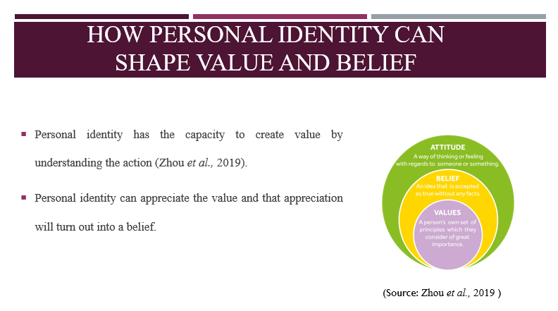
Humans believe it is about the world along with their actual experience and following this way personal identity has the capacity to provide shape to their value and that value will turn from human beings' identity (Zhou et al., 2019). On the other hand, the belief is that the context of what individuals believes and experiencing that experience will turn out into their belief. Following this way, personal identity has created value along with the belief of individuals.
Explaining how personal identity can make a good team player
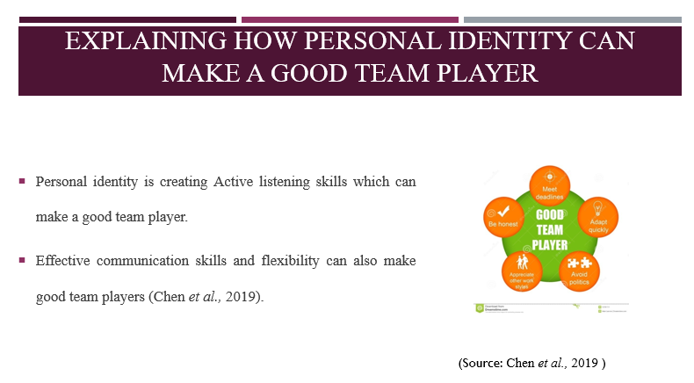
“Personal Identity” is considered to be a Hallmark of being a good team player with the help of an effective personal Identity individual can germinate flexibility and that flexibility would be fruitful for collaboration in an impactful way. In being a good team player, flexibility is the most important thing which can improve performance (Chen et al., 2019). On the other hand, Personal identities also represent the skill of active listening and that skill evokes feelings and assures perception or opinion. On the other hand, personal identity is also creating problems solving skills and effective communication skills. These skills would be helping out to make a good team player.
Conclusion
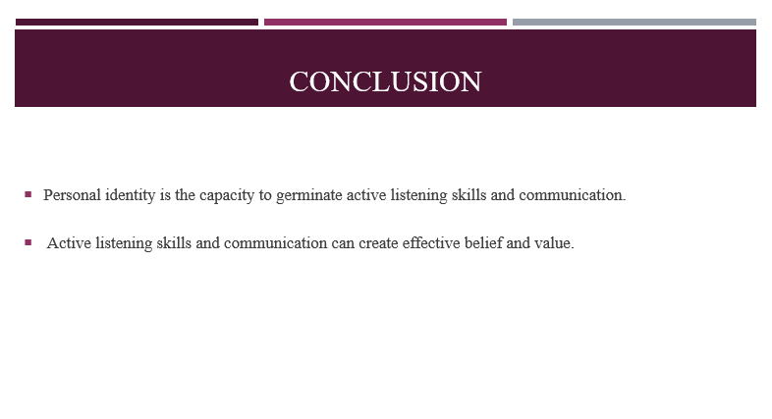
In a nutshell, Personal identities are something that individuals can easily understand others and depending on the understanding they can adopt the next step. Personal identity has the capacity to create a good team player and, in this respect, active listening skills, effective communication, positive attitude will create enthusiasm which can make the personal identity more effective.

Task 4 – Reflection
Borton’s Model OF reflection
Borton’s Model tool is considered to be a Framework for reflection which has been developed by Terry Borton. I believe this tool is the most straightforward model which is very best in any kind of situation and in my perception, it is also allowed for all the uses and structures also. Framework is oriented with three questions which are "what”, "so what”, and “now what”. In the framework of what will be defined the online learning resources and the process of a Writing assignment (Ingham-Broomfield, 2021). The online resources are referring to the website which is useful for every student free to start writing that first assignment. With the help of online resources, I have seen that students can easily accumulate all the required data which places them at the Pinnacle of success and have a good positive experience.
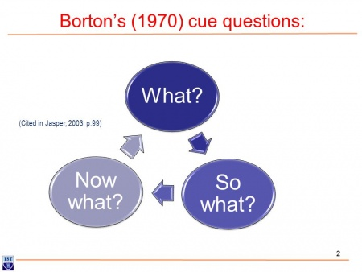
Figure 3: Borton’s Model OF reflection
(Source: Grimmer, 2022)
The stage, “so what” it will explain the impact of online resources and by using online resources students will easily enhance their knowledge skills. With the help of that knowledge skill, we can make their first assignment more effective (Grimmer, 2022). While I am using online resources in my writing assignment, I see that the process of education is going to be simple and I am feeling much more confident regarding the topic. On the other hand, I also noticed that by using online resources in the assignment the learning situation changed and I easily get the answer. However, the third stage is reflecting the stage of “now what” and in this stage, I notice that I enhance my capacity to create better interaction and that interaction will allow all the professors and students to make communication more effective. Moreover, in my opinion, using Borton’s Model educational system has changed and I am improving my understanding of the subject

Reference list
Anthonysamy, L., Koo, A.C. and Hew, S.H., (2020). Self-regulated learning strategies in higher education: Fostering digital literacy for sustainable lifelong learning. Education and Information Technologies, 25, pp.2393-2414.
Chang, C.Y. and Hwang, G.J., (2019). Trends in digital game-based learning in the mobile era: A systematic review of journal publications from 2007 to 2016. International Journal of Mobile Learning and Organisation, 13(1), pp.68-90.
Chen, S.C. and Lin, C.P., (2019). Understanding the effect of social media marketing activities: The mediation of social identification, perceived value, and satisfaction. Technological Forecasting and Social Change, 140, pp.22-32.
Grimmer, A., (2022). The cloverleaf model of cognitive behaviour therapy as experiential learning: implications for case formulation, therapeutic practice and practitioner development. the Cognitive Behaviour Therapist, 15, p.e11.
Ingham-Broomfield, B., (2021). A nurses' guide to using models of reflection. The Australian Journal of Advanced Nursing, 38(4), pp.62-67.
JAMİR, C., (2020). Education and poverty level: a gender analysis of Kohima and Longleng districts of Nagaland, India/Education and Poverty Level: A Gender Analysis of Kohima and Longleng Districts of Nagaland, India. Uluslararası Ekonomi İşletme ve Politika Dergisi, 4(1), pp.221-236.
Jena, P.K., (2020). Impact of Covid-19 on higher education in India. International Journal of Advanced Education and Research (IJAER), 5.
Sennett, R., (2021). The uses of disorder: Personal identity and city life. Verso Books.
Subramanian, A., (2019). The caste of merit: Engineering education in India. Harvard University Press.
Wadhwa, N. and Khatak, S., (2020). Online versus offline mode of education–is India ready to meet the challenges of online education in lockdown? Journal of the Social Sciences, 48(3), pp.404-413.
Williamson, B., (2021). Making markets through digital platforms: Pearson, edu-business, and the (e) valuation of higher education. Critical Studies in Education, 62(1), pp.50-66.
Zhou, B. and Yan, D., (2019). Hydrogen‐Bonded Two‐Component Ionic Crystals Showing Enhanced Long‐Lived Room‐Temperature Phosphorescence via TADF‐Assisted Förster Resonance Energy Transfer. Advanced Functional Materials, 29(4), p.1807599.

