This assignment outlines current academic and legislative guidance and thinking relating to learner engagement and behaviour management in the post-16 education sector. It then reflects on two observations carried out in post-16 settings and a personal reflection from two lessons I taught myself (using the same lesson plan) at post-16 level using Kolb’s (1984) ‘experiential learning cycle’ (Duckworth 2014, p. 117). These observations and reflections will outline what I have learnt with regards to learner engagement and behaviour management. Following this, an action plan, found in the appendices of this document, outlines the aims I have set myself for improving my professional teaching practice linked to these observations and reflections.

Background:

After 30 years since their first publication of ‘Discipline with Dignity’, Mendler, Curwin and Mendler (2018) find that the number one, most important thing when it comes to managing behaviour in the classroom, ‘is that relationships between teachers and students matter more than rules and consequences for changing behaviour’ (Mendler and Curwin 2018, p. 3). They believe that punishing students through traditional methods such as humiliation, detention or even suspension only creates more anger in students and consequently, less compliance. Instead, they advocate for a more preventative approach to managing behaviour by building positive relationships between students and teachers where students are treated with dignity, where students trust their teachers, and where students are involved in the processes which affect them e.g. creating, with students, classroom rules and subsequent consequences (Mendler, Curwin and Mendler 2018).

Similarly, last year the Welsh Government put into force the 2020 Act to end physical punishment of any form in all Welsh education settings (Welsh Government 2022). They stated, as of 21/03/22, “no one in Wales can use the ‘defence of reasonable punishment’ as a defence to common assault” (Welsh Gov 2022). These beliefs are also reflected in the United Nations Convention on the Rights of the Child legislation for the whole of the United Kingdom. Article 19 explains that governments must protect children from violence and abuse (Unicef 2022). As, in the UK, you are a child until the age of 18, this is relevant for the post-16 education sector. The Welsh Government’s latest professional standards for further education instead sets teaching standards to demonstrate respect and courteous behaviour towards students and to build collaborative and positive relationships with them (Welsh Gov 2017). Research found that students in further education settings said that they valued being treated like adults in comparison to their school environment (Welsh Gov 2015).

Building positive relationships between teachers and students, however, has been described, over the years, as just one way in which a positive learning environment can be created. It is this positive classroom environment which has been argued, both by academics (Smith, Fisher and Frey 2015; Vizard 2012; Bender 2017) and legislation (Welsh Gov 2010), along with the implementation of effective teaching and engagement, that has strong impacts on student behaviour. Specifically, Smith, Fisher and Frey (2015), identify that when students are placed in an environment where they have established strong and trusting relationships with both their peers and their teachers, and are provided with lessons which are relevant, engaging, and interesting, then it is much harder for these students to misbehave (Smith, Fisher and Frey 2015).

Student Engagement and motivation:

Bender (2017) defines engagement as a ‘cognitive investment in, active participation with, and emotional commitment to learning particular content’ (Bender 2017, p. 2). He suggests a variety of ways of engaging students using different teaching techniques including flipped classrooms, differentiated instruction, augmenting reality using digital technology, using storyboards and collaborative blogging for example (Bender 2017). However, it can be said that, in order to be engaged, a learner first needs to be both physically and mentally ready (Lebor 2017), and they also need to be motivated (Barkley and Major 2020; Wallace 2007a).

Maslow (1987), for example described a hierarchy of both psychological and physical needs that he argues need to be first met before students can effectively engage in learning. He therefore argued that an understanding of this, and the right support for students, is crucial for any civilised educational environment (Lebor 2017). These ideas can be said to be reflected in the Welsh Government’s Resilience Plan as it places importance on students’ wellbeing needs in order for students to engage in learning after being affected by the Covid-19 pandemic (Welsh Gov 2023). This consideration can also be seen in the Welsh Government’s professional standards for further education; encouraging further education lecturers to ‘Demonstrate commitment to learners, their learning, safety and well-being … working with others to ensure learners are fully supported’ (Welsh Government 2017, p. 10).

Furthermore, engagement is said to emerge from motivation. Motivation can arise either extrinsically, or intrinsically. Extrinsic motivation, being the motivation to achieve good grades, graduating and having good paying jobs, and intrinsic motivation, arising from personal satisfaction, enjoyment or interest in something (Barkley and Major 2020).

Wallace (2007a) explains that there is a common assumption that ‘many learners in FE are keen, well-motivated, hard-working and a pleasure to teach’ (Wallace 2007a, p. 8), she explains, however, that many are not (Wallace 2007a). In fact, there might be a number of reasons why an individual returns to learning. They may have been encouraged to return by an employer to improve specific qualifications/skills or, for example, they may feel they need to improve their own employability due to the unfortunate high levels in unemployment. These reasons mean that many learners can therefore be reluctant (Vizard 2012). Clearly, in this case, extrinsic motivation is not enough. When this is the case, Wallace (2007b) explains that teachers ‘can try to develop in the learners an intrinsic motivation – an enjoyment of, and satisfaction in what they are doing for its own sake’ (Wallace 2007b).

Restorative Practice:

If, and, as Smith, Fisher and Frey (2015) point out, when, students do misbehave, they believe that all students should be offered the chance to restore any relationships damaged in the process, and learn from the mistakes they have made; this process is known as being a ‘restorative approach to discipline’ (Smith, Fisher and Frey 2015, p. 3). This approach is also supported by other academics (Sackville-Ford and Baggaley 2022; Newton and Robinson 2019), and the Welsh Government. In 2010, the Welsh Government released a handbook for secondary schools concerned with providing practical approaches for behaviour management. Although this is directed at secondary schools, links can be made to post-16 as they do not currently have a specific handbook for post-16. Within this document, the explain that policies, procedures and school ethos need developing to support restorative practices as they help to offer ‘fairness’ when dealing with issues (Welsh Gov 2010).

Conclusion:

To conclude, this essay has discussed the relationship between behaviour management and engagement; specifically, it has been argued that the key to managing behaviour is student engagement in a positive classroom environment. This essay subsequently provided both academic and legislative guidance/thinking for managing behaviour and engagement in the post-16 education sector; indicating a need to build positive relationships, cater to individual psychological and physical needs and student motivation for engagement to take place, and finally, the need for restorative practice to restore student’s motivation for learning, and therefore, their engagement.

Observation:

The first observation was carried out with access students. I have given the lecturer the pseudonym ‘Nancy’. The second observation was carried out with AS level learners. I have given the lecturer the pseudonym ‘Kelly’. Finally, my reflections are based on two A2 level groups using the same lesson plan.

First Observation:

The first observation that I will reflect on for Nancy’s lesson was her positive presence upon coming into the classroom and during the lesson. As Nancy walked in through the door to the classroom, she brought with her high-energy, an air of confidence, a big smile, and, most importantly humour. Vizard (2012) explains that when teachers enter a room, students will instantly read their body language and their vocal tone. He therefore suggests that it is important to get this interaction right (Vizard 2012). Duckworth (2014) advises teachers to turn up to their lessons firstly, being themselves, and secondly, with a ‘sense of humour’ (Duckworth 2014, p. 65) as it not only draws the students in, raises the class dynamics, and motivates them, but it also gives them respites from interacting with challenging subjects (Duckworth 2014). This, I observed was executed well by Nancy. The students responded instantly to her positive presence upon entering the room and were engaged instantly. In addition, she had the class, and myself, laughing at multiple times throughout the lesson as she appealed to the students’ interests e.g. through making relevant topical connections to TikTok and having the ability to make fun of herself in the process. This, I could see also helped to build positive and also collaborative relationships between herself and her students; demonstrating her commitment to the Welsh Governments professional standards (Welsh Gov 2017).

Secondly, I had noticed during Nancy’s lesson, that students had their phones out on the tables. When speaking to Nancy about this at the end of the lesson she explained that she was mindful that, at post-16 level, students might have children who depend on them, and they therefore might need to take a call during the lesson if there were ever any issues. She explained that if they were on their phones during class, then she would make it clear, initially through eye contact and non-verbal communication to put it away, and then more through physical presence by walking up to the student while still conducting the lesson and tap on the students’ desk to indicate to put it away. This consideration for her students is reflective of Maslow’s hierarchy of needs. This theory, as discussed earlier in this assignment, emphasises the need to first meet a student’s underlying physical/psychological needs, before effective learning can take place. Lebor (2017) describes the example of a poor student who could not concentrate in class due to the physical distraction of being hungry (Lebor 2017). In this case, Nancy had considered her students’ psychological need; allowing phones to be visible in the case of an emergency, to allow the full focus of her students; and thus, their engagement.

Second Observation:

The first observation I will reflect on for Kelly’s lesson was her personal engagement with the students on a 1-1 basis during activities. Kelly used the space of the classroom after setting activities to approach different students. She would kneel down and speak to them or, on two occasions, she pulled up a chair to get down to their level. One of the times that she pulled up a chair, she sat right next to the student at the desk as if she was talking to her like a peer. Vizard (2012) explains that when a teacher stands over a learner who is seated, it can put teachers at an advantage psychologically, however, he encourages teachers to avoid doing this as students can find it very intimidating. Instead, he explains that ‘Sitting at the same level, or even better crouching at a slightly lower level, can lead to more effective communication and reduce the likelihood of increasing conflict’ (Vizard 2012, p. 62). This very simple and cleaver approach to get students engaged in the activities worked very effectively. Each student Kelly approached engaged with her effectively. In addition, Kelly was also able to give instant formative feedback to students when engaging in these 1-1 interactions, demonstrating her commitment to the professional standards (Welsh Gov 2017). In addition, Smith, Fisher and Frey (2015) explain that ‘Formative assessment can prevent students from becoming frustrated and acting out’ (Smith, Fisher and Frey 2015, p. 33).

A second observation I made was with regards to Kelly’s positive, respectful and supportive environment that she had created for her learners. She knew her students’ names, which, Smith, Fisher and Frey (2012) identify as communicating both importance and value (Smith, Fisher and Frey 2012) and it demonstrated her commitment to inclusion as a professional practice (Welsh Gov 2017). She would great her students as they came in, and additionally, answer any questions they had. She had, as outlined by the Welsh Government, acted ‘as a role model for fair, courteous and respectful behaviours’ (Welsh Gov 2017, p. 10). As mentioned earlier in this assignment, Mendler, Curwin and Mendler (2018) explain the importance of treating students with dignity. This therefore meant that Kelly had created a warm, positive environment for learners to engage in learning.

My Reflection:

The two lessons I carried out unfolded very differently. The majority of the students in the first lesson were more concerned with talking, sometimes across the room, than with listening to me speaking, doing work, or even listening to other students who were answering questions. The majority of the students in the second class, on the other hand, really engaged in the lesson, answering questions, doing their work and facing forward - listening while I spoke. This suggests there was little issue with the lesson I had prepared, but my behaviour management during the lesson.

My approach, during the first lesson to try and tackle the talking, was to ask one of the students what was said by another student as I knew she had not been listening. After confessing that she did not know, I explained that this was why it was important to listen in class. However, after my research on behaviour management, I now feel as though this was a mistake. By me asking a student a question I knew she did not know the answer to, this could have been humiliating for her. As discussed earlier in this essay, Mendler, Curwin and Mendler (2020) state that traditional methods such as humiliation do not work for behaviour management (Mendler, Curwin and Mendler 2020). Instead, they state to adopt a more preventative approach for behaviour management by building positive relationships with students based on respect and trust. One of the suggestions they make is to make a set of rules with the students and their consequences so that they are a part of the decisions that affect them.

In addition, my approach to a specific student who had refused to do as I had asked, may have also been a mistake. Using transactional analysis, which is a theory ‘based on the study of specific ego states’ (Lapworth and Sills 2011, p. 1). I can see that my approach began from an adult perspective, asking the student a question to see if she could understand the importance of why I had asked her to do the task, but I had ended up in a controlling parent state. This meant that she, in the end still did not do what I had asked. Lapworth and Sills therefore explain that when we recognise and become aware of the current ego state we hold, ‘we can become more aware of our options in any given situation’ (Lapworth and Sills 2011, p. 51).
References:

Barkley, E F. and Major, C H. (2020) Student Engagement Techniques (second edition), Hoboken: Jossey-Bass.

Bender, W N. (2017) 20 Strategies for Increasing Student Engagement, West Palm Beach: Learning Sciences International.

Duckworth, V. (2014) How to be a Brilliant FE Teacher: A practical guide to being effective and innovative, Oxon: Routledge.

Lapworth, P. and Sills, C. (2011) An Introduction to Transactional Analysis, London: SAGE.

Lebor, M. (2017) Classroom Behaviour Management in the Post-School Sector: Student and Teacher Perspectives on the Battle against being Educated, Leeds: Palgrave MacMillan.

Mendler, A N., Curwin, R L. and Mendler, B D. (2018) Discipline with Dignity: How to Build Responsibility, Relationships, and Respect in Your Classroom (fourth edition) ASCD.

Newton, E. and Robinson D. (2019) ‘Reflective Practice, Restorative Practice and Trust in Behaviour Management’ in Robinson, D. Classroom Behaviour Management in Further, Adult and Vocational Education, London: Bloomsbury Publishing Plc.

Sackville-Ford, M. and Baggaley, S. (2020) ‘Being human: Compassionate education rather than behaviour management’ in Overland, E., Barber, J. and Sackville-Ford, S. Behaviour Management: An Essential Guide for Student and Newly Qualified Teachers, Oxon: Routledge, pp. 129-146.

Smith, D., Fisher, D. and Frey, N. (2015) Better than Carrots or Sticks: Restorative Practice for Positive Classroom Management, ASCD.

Unicef (2023) A Summary of The UN Convention on the Rights of the Child, available at: https://www.unicef.org.uk/wp-content/uploads/2019/10/UNCRC_summary-1_1.pdf, accessed 19th Feb 2023.

Wallace, S. (2007a) Getting the Buggers Motivated in FE, London: Continuum International Publishing Group.

Wallace, S. (2007b) Managing Behaviour in the Lifelong Learning Sector (second edition), Kent: Bell & Bain Ltd.

Welsh Gov (2010) Practical Approaches to Behaviour Management in the Classroom: A handbook for classroom teachers in secondary schools, available at: https://www.gov.wales/sites/default/files/publications/2018-12/practical-approaches-to-behaviour-management-in-the-classroom-a-handbook-for-classroom-teachers-in-secondary-schools.pdf, accessed 18th Feb 2023.
Welsh Gov (2015) Research briefing 02: Managing Behaviour, available at: https://www.gov.wales/sites/default/files/publications/2018-11/learner-voice-wales-research-briefing-02-managing-challenging-behaviour.pdf, accessed 18th Feb 2023.

Welsh Gov (2017) Professional standards for further education teachers and work-based learning practitioners in Wales, available at: https://hwb.gov.wales/api/storage/460a740a-7bf1-4c7b-b4ae-348ae380879b/professional-standards-further-education-teachers-work-based-learning-practitioners-wales.pdf, accessed 19th Feb 2023.

Welsh Gov (2022) Ending Physical Punishment in Wales, available at: https://www.gov.wales/sites/default/files/publications/2022-08/education-sector-factsheet.pdf, accessed 18th Feb 2023.

Welsh Gov (2023) Covid-19 Resilience Plan for the Post-16 Sector, available at: https://www.gov.wales/sites/default/files/publications/2020-05/covid-19-resilience-plan-post-16-sector.pdf, accessed 19th Feb 2023.

Visard, D. (2012) How to Manage Behaviour in Further Education (second edition), London: SAGE.

Appendices 1:

Observation forms:

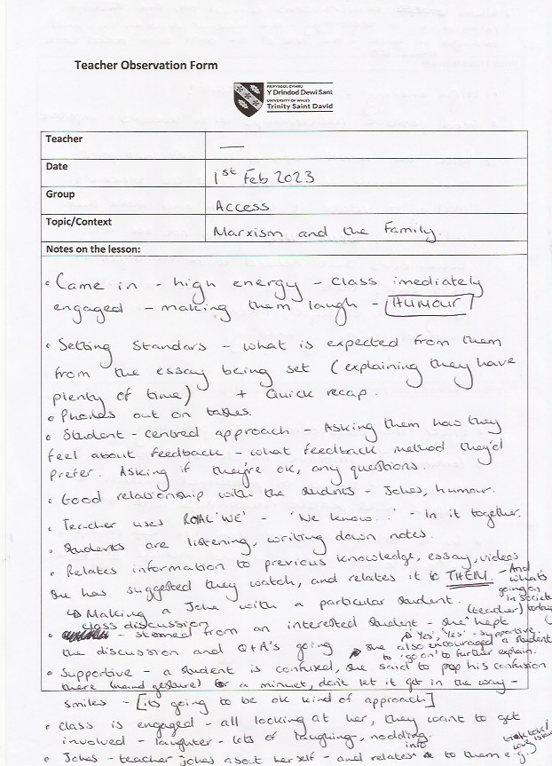
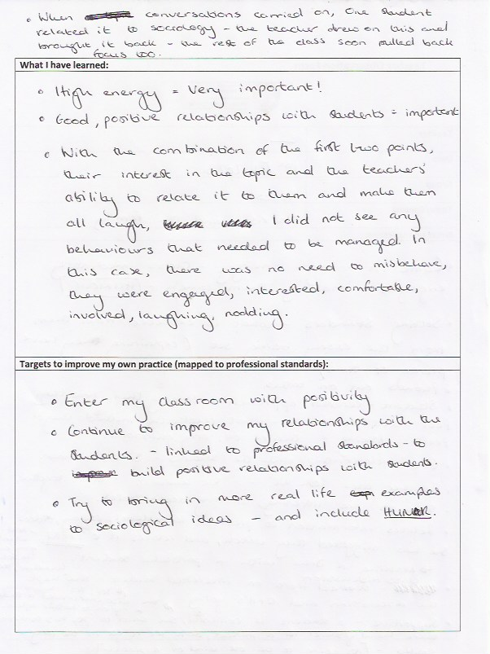
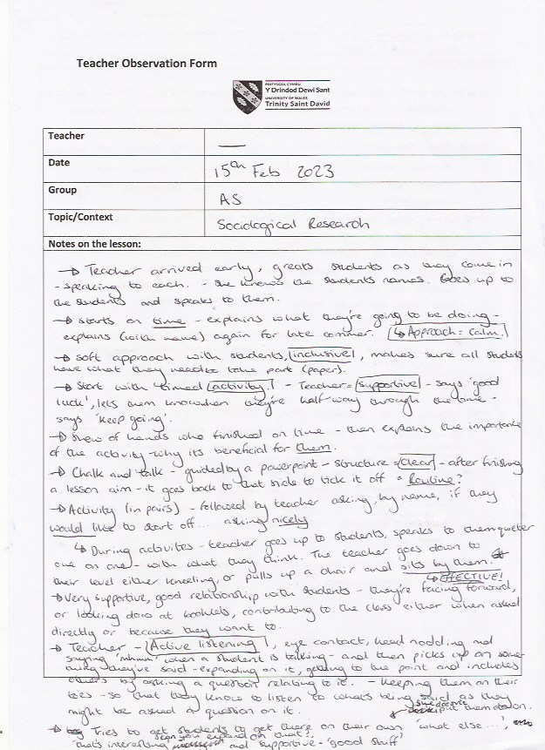

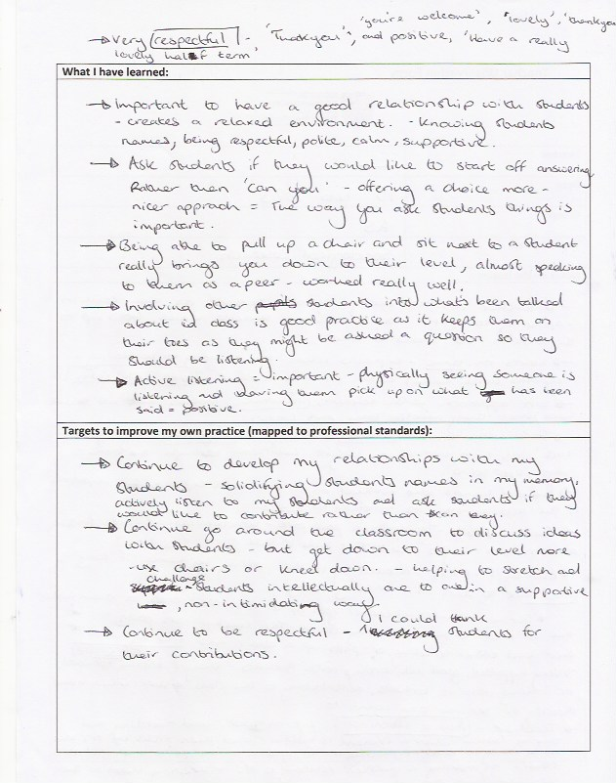
Appendices 2:

Lesson Plan:



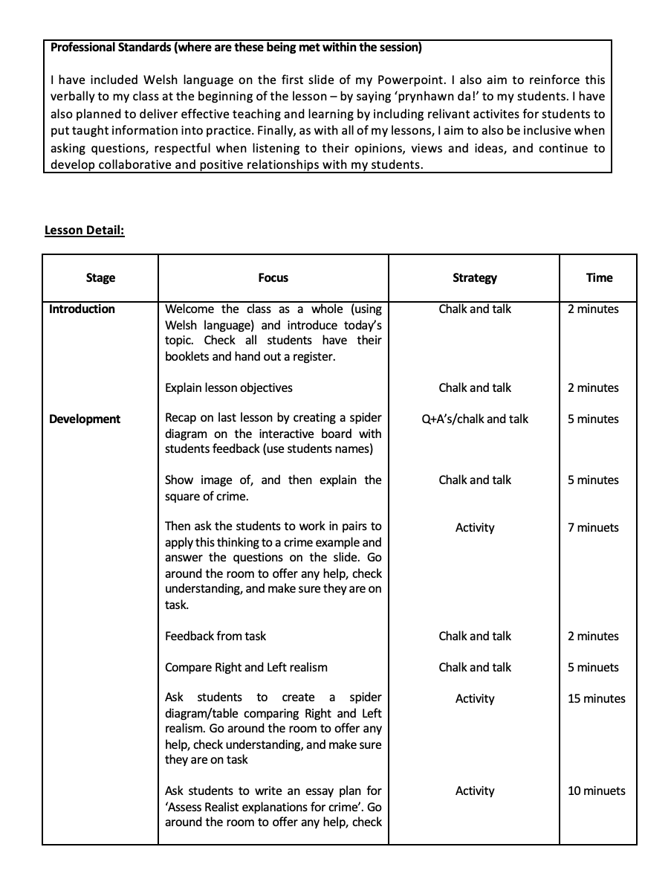

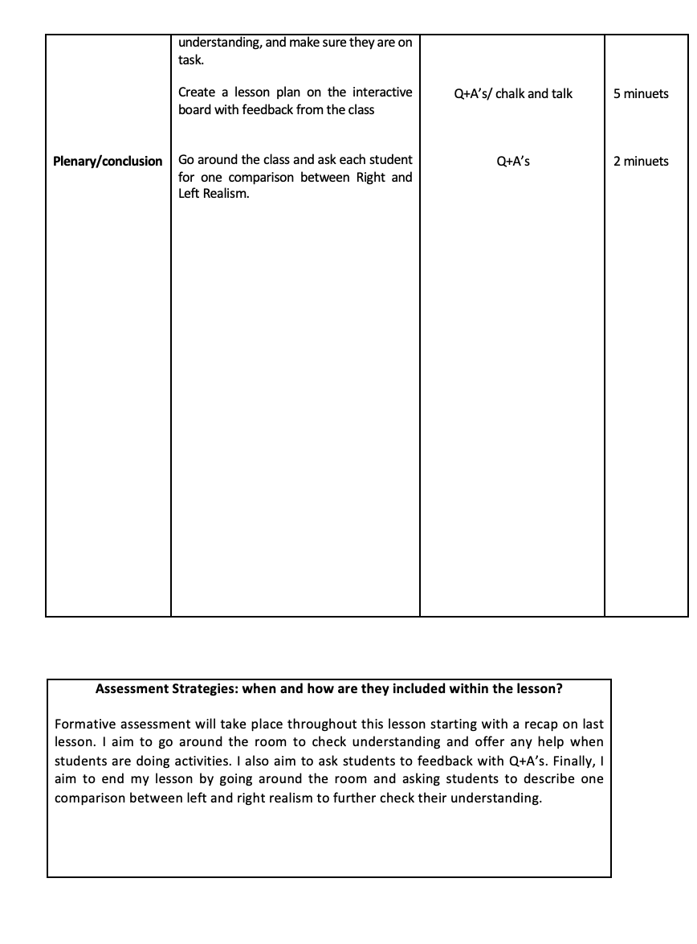

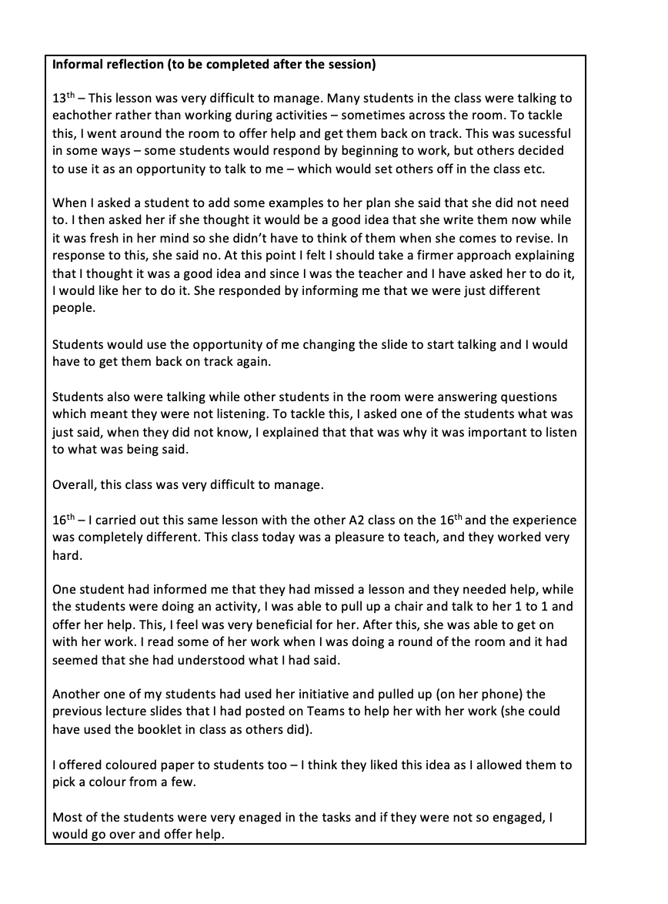
Appendices 3.

Action Plan:

Based on my observations and my reflections on my own teaching practice, I aim to work on the following areas for enhancing my teaching practice and professional standards with regards to student engagement and behaviour management:

- I aim to continue to turn up to each of my classes early, and greet students as they enter. By observing the effects of this during my observations, it solidified for me, the importance of doing this to create a calming and organised atmosphere. I will carry this out indefinitely for my teaching practice.
- Be considerate of students’ psychological and physical needs. I aim to be mindful of this each time I conduct a lesson, and where possible provide support or signposting support for my students so that they can fully engage in my lessons.
- I aim to put in place more practical measures for establishing clear rules with my students for when I return to my Monday A2 class after half term. This will involve asking my students what they think should be acceptable classroom behaviours and the consequences they feel might be appropriate. After this I aim to ask each student if they agree to comply with these rules. Additionally, when I have my own set of students when I become a fully qualified lecturer, I aim to set out clear rules and consequences with the input of my students on the first lesson I have with them.
- I also aim to set clear instructions ahead of time for my students when setting any assignments in the future. This therefore acts as a preventative approach for managing acceptable behaviour.
- I aim to, when I can, use my physicality in a way to make myself level with students. I will do this by kneeling down to talk to students and make use of available chairs where appropriate. I aim to do this consistently throughout my teaching practice. This will also help to build the positive relationships I have with my students, as encouraged by the Welsh governments’ professional standards (Welsh Gov 2017).
- I aim to be more aware of my ego state in my classrooms, aiming to always approach and respond to my students from an adult perspective. I aim to do this by conducting further research into transactional analysis techniques.

