Introduction Page
Programme: BSc Health and Social Care
Module: Changemakers: Creativity and Value Creation
Module code: BMHP5014_BIRM
Lecturer: Dr Azora Hurd
Assignment Title: E-Portfolio Evidence of Learning
Task1 and Task 2

Kerris Adina Smith 1915100

Mind Map
Supporting the community that suffer with Mental Health.
Task1
My creative innovation illustrated in a mind map, shows how the National Health Service can help the community that suffer with mental health in the COVID–19 pandemic.
1.Mental Health in the UK

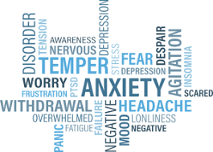
Perera, K (2021)
It is estimated that 75% of people in the UK cannot have access to treatment to help with their mental illness (Mental Health Foundation, 2021). This is a concerning matter that needs to be addressed to improve community-based care during the pandemic.

2.How Covid 19 has affected Mental heath
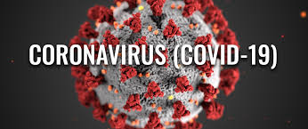
EU Science Hub 2021) The Thornton Practice (2021)
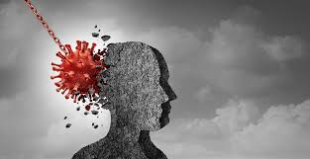
Gold, J. (2021).
Studies have shown that 43% of psychiatrists have witness since the COVID-19 lockdown an increase in emergency and urgent cases of mental health. It is also worrying to know that 45% of psychiatrists have seen that there has been a drop in routine appointments due to the pandemic which lets them know that there may be a lot of mental illness after the pandemic (Mental Health Foundation, 2021).

3.The Impact COVID-19 has had on the community
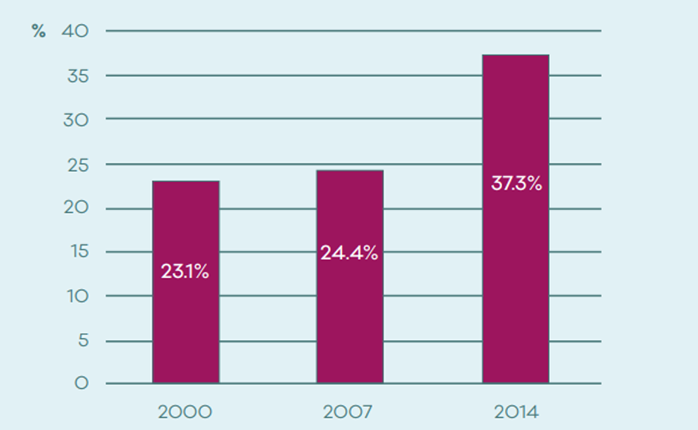
(Mental Health Foundation, 2021).
The above graph shows the amount of people in the UK with common mental illnesses that were getting treatment before COVID-19, as you can see it has dropped since the pandemic.

4.What needs to happen to help people in the community.

Lane, C. (2021) Hutchinson Health (2021)
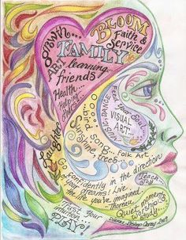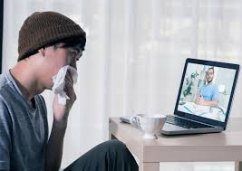
Pinterest (2021) Lifesize.com (2021)

My creative innovation suggests people that suffer with a mental illness should have access to an app. Within the app it will have many different techniques that can have a positive impact on the mind i.e., random acts of kindness which adds values to their life's, plan their day better, prompted them to do daily exercise and phycological art activities. The app can also enable video calls with healthcare professions. Also, videos advising on how to keep their mental state good.

My Blog
Task2
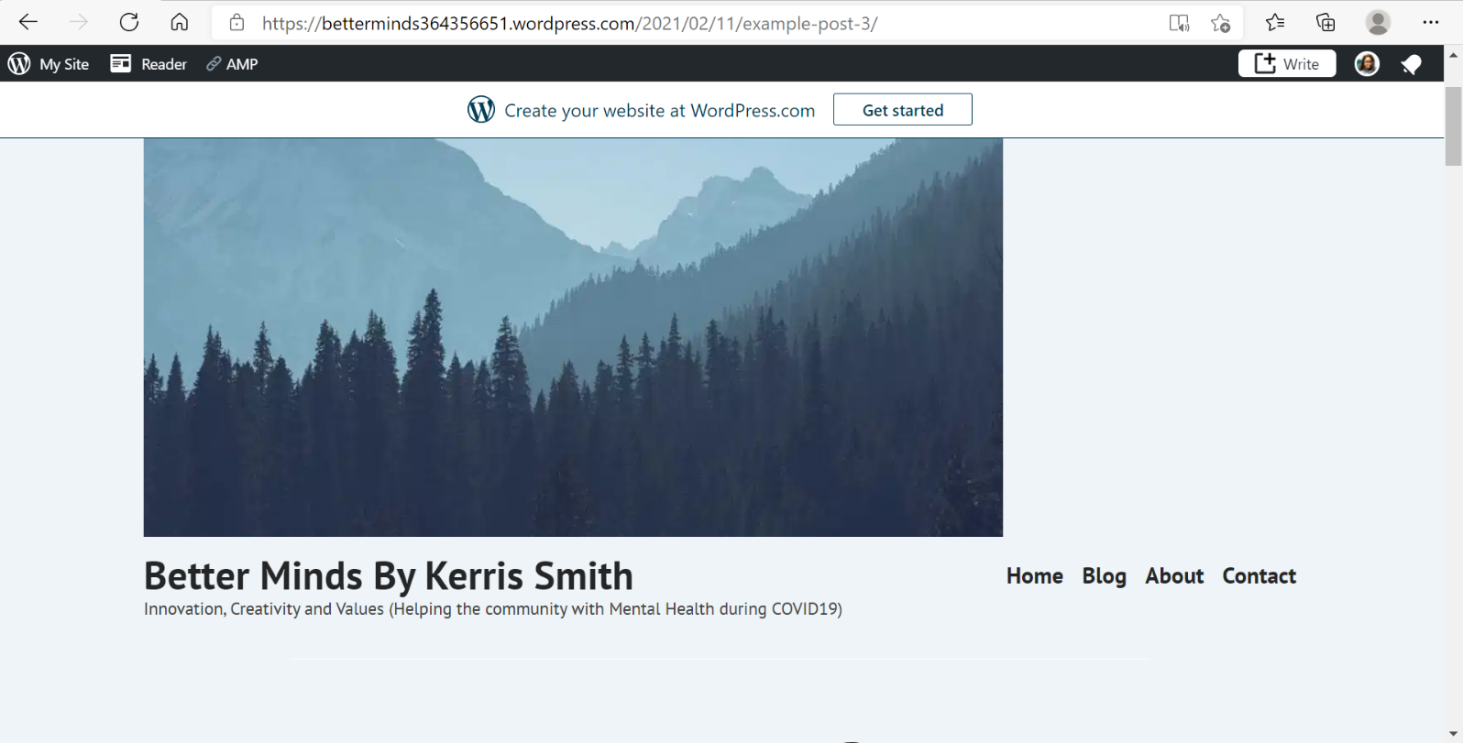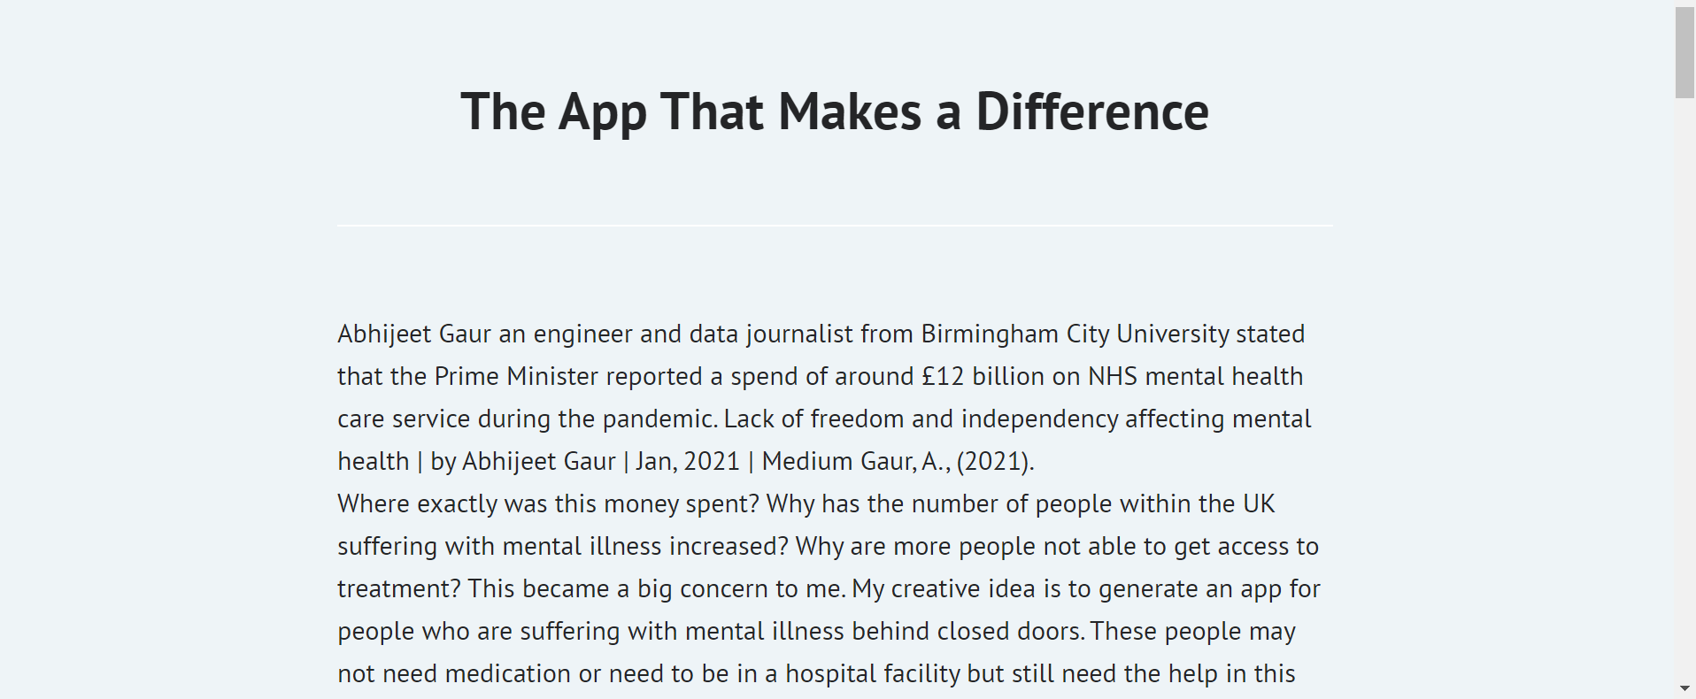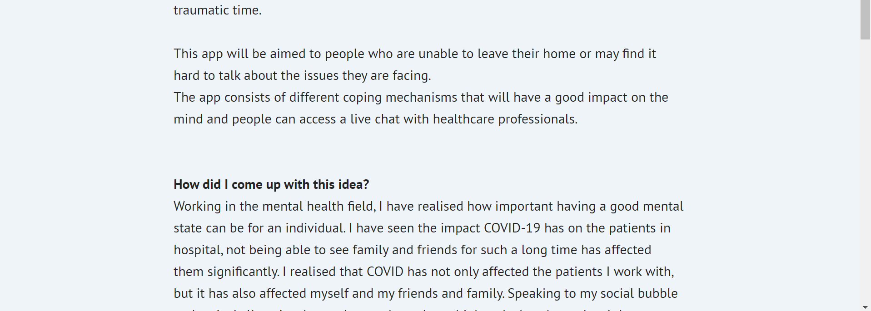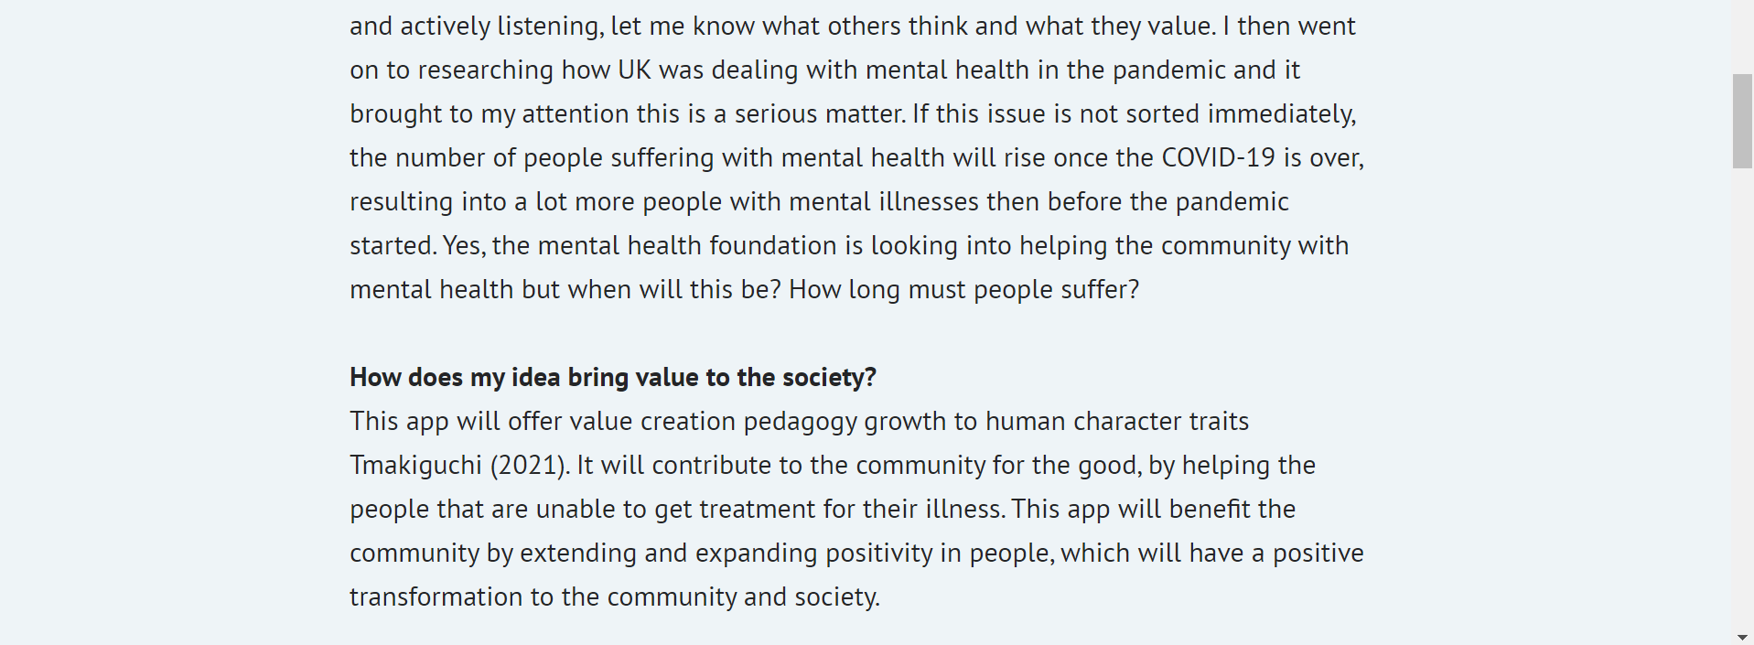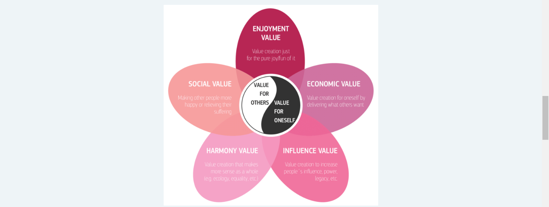
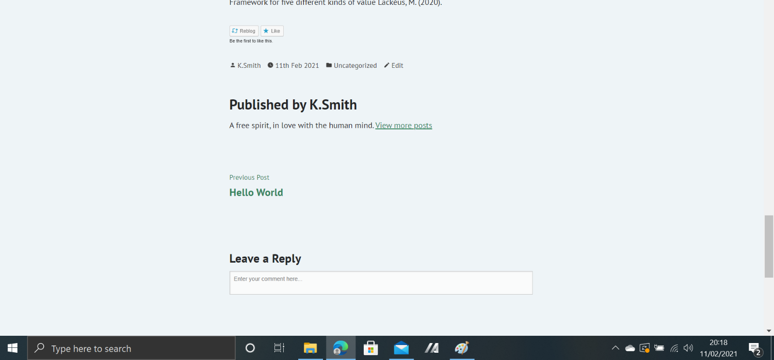

Reference

- EU Science Hub - European Commission (2021). COVID-19 and counter-measures both detrimental to mental health - EU Science Hub - European Commission. Available at: <https://ec.europa.eu/jrc/en/news/covid-19-and-counter-measures-both-detrimental-mental-health> (Accessed: 7 February 2021).
- Gaur, A., (2021). Covid affecting life — lack of freedom and independency felt in Britain. Medium. Available at: <https://abhijeetgaur8.medium.com/covid-affecting-life-lack-of-freedom-and-independency-felt-in-britain-3c143837399e> (Accessed:11 February 2021).
- Gold, J. (2021). Covid-19 Might Lead To A ‘Mental Health Pandemic’. Forbes. Available at: <https://www.forbes.com/sites/jessicagold/2020/08/06/covid-19-might-lead-to-a-mental-health-pandemic/?sh=4a3919d4706f> (Accessed: 7 February 2021).
- Hutchinson Health (2021). Random Acts of Kindness - Hutchinson Health Health & Well-Being. Available at: <https://hutchhealth.com/health-well-being/random-acts-kindness/> (Accessed: 7 February 2021).
- Lackéus, M., (2020). Comparing the impact of three different experiential approaches to entrepreneurship in education. International Journal of Entrepreneurial Behavior & Research, [online] 26(5), pp.937-971. Available at: <https://www.emerald.com/insight/content/doi/10.1108/IJEBR-04-2018-0236/full/pdf?title=comparing-the-impact-of-three-different-experiential-approaches-to-entrepreneurship-in-education> [Accessed 11 February 2021.
- Lane, C. (2021). Digital Health and the Rise of Mental Health Apps. Psychology Today. Available at: <https://www.psychologytoday.com/gb/blog/side-effects/201808/digital-health-and-the-rise-mental-health-apps> (Accessed: 7 February 2021).
- Lifesize.com (2021). Video Conferencing for Healthcare & Telehealth Lifesize. Available at: <https://www.lifesize.com/en/solutions/industry/healthcare> (Accessed: 7 February 2021).
- Mental Health First Aid (2021). Mental health statistics. Available at: <https://mhfaengland.org/mhfa-centre/research-and-evaluation/mental-health-statistics/> (Accessed: 7 February 2021).
- Mental Health Foundation (2021) Mental health statistics: people seeking help. Available at: <https://www.mentalhealth.org.uk/statistics/mental-health-statistics-people-seeking-help> (Accessed: 6 February 2021).
- NHS England and NHS Improvement (2020) Adult and older adult mental health. 2020. Available at: https://www.england.nhs.uk/mental-health/adults/ (Accessed: 6 February 2021).
- Pinterest (2021). 50+ Art & Psychology ideas | art psychology, therapy, art therapy. Available at: <https://www.pinterest.co.uk/tanglevermont/art-psychology/> (Accessed: 7 February 2021).
- The Thornton Practice (2021). COVID-19 FAQs - The Thornton Practice. Available at: <https://www.thedoctors.co.uk/2509-2/> (Accessed: 7 February 2021).
- Tmakiguchi.org (2021). Value-Creating Pedagogy Tsunesaburo Makiguchi Website. Available at: <https://www.tmakiguchi.org/educator/educationalreformer/valuecreatingpedagogy.html> (Accessed: 11 February 2021).

