DS 1 Template

My Screenshots/Photos
- Please add 4–6 screenshots or photos of your digital life.
- You can use your phone or laptop.
- For each screenshot, write one or two sentences explaining what it shows.

Screenshot/Photo 1
Google \Maps
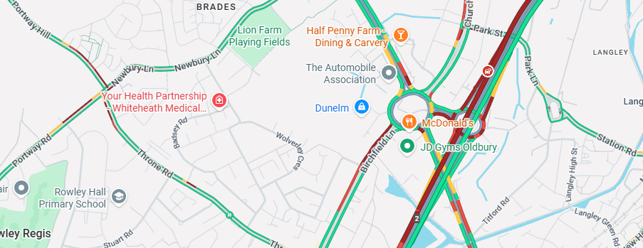
[Google Maps is a digital tool used to help you navigate ]

Screenshot/Photo 2
[Uber Eats ]

[Uber eats is a digital food ordering company]

Screenshot/Photo 3
[Tiktok]

[Tiktok is a popular social media platform for creating sharing and discovering video]

Screenshot/Photo 4
[Facebook]

[Facebook is a massive social networking service that lets you connect with family and friends free ]

Screenshot/Photo 5
[Insert Photo/Screenshot below]

[Write what this shows of your digital life]

Screenshot/Photo 6
[Insert Photo/Screenshot below]
[Write what this shows of your digital life]

My Short Reflection
- Write 5–8 simple sentences about your digital life.
- You can use the sentence starters below if helpful.
I use digital tools in my everyday routine to help me navigate order things online and to keep in contact with my family
I want to improve my digital skills as it will help me grow my online shop and research
I sometimes feel nervous about not knowing how to use online tools

Sentence starters
- I use digital tools to …
- I feel confident when I …
- I want to improve …
- I often use these tools: …
- I sometimes feel nervous about …
- I hope this module will help me …
- Digital skills are important for me because …
You can write more if you want.

Submission Checklist
Before you submit, please check:
​​​ ☒ I added 4–6 screenshots
☒ I wrote short sentences for each screenshot
☒ I wrote my short reflection
☒ My work is my own
☒ My file opens correctly
​​☒ My file opens correctly

