

WRITTEN RESEARCH REPORT
on Topic:"Exploring the factors that influence eating behaviour among postgraduate students in a public university : A Focus group discussion"

Student Name: Anagha Shyamala Vinod
Student ID: 2215804
Lecturer's Name: Dr Aishat T. Bakre
Module Code: LCHS7001.

Table of Contents

Introduction (Literature-based background of the study) 3
Rationale & Research questions/Aims/ Hypothesis 4
Research Questions 5
Research Methodology 5
Recruitment, sampling & study participants 6
Materials/ data collection methods/ procedure 7
Data analysis techniques 8
Ethical considerations 8
Results 9
Discussions 10
Conclusions 11
References 13
Appendix 15

Introduction (Literature-based background of the study)
Particularly for the student population, maintaining excellent eating habits is crucial for health and well-being. Postgraduate students in particular are known to experience significant levels of stress due to the demands of their academic work, which may negatively affect their eating habits (Burns, Dagnall, and Holt, 2020). This report aims to examine the conditions influencing the eating behavior of postgraduate students at a public university. Also, this report will start by providing a broad overview of the need to encourage children to adopt healthy eating habits and the drawbacks of making poor food choices. The factors that influence postgraduate students' eating behaviors will then be examined, including stress, social and cultural concerns, and the availability of healthy food options.
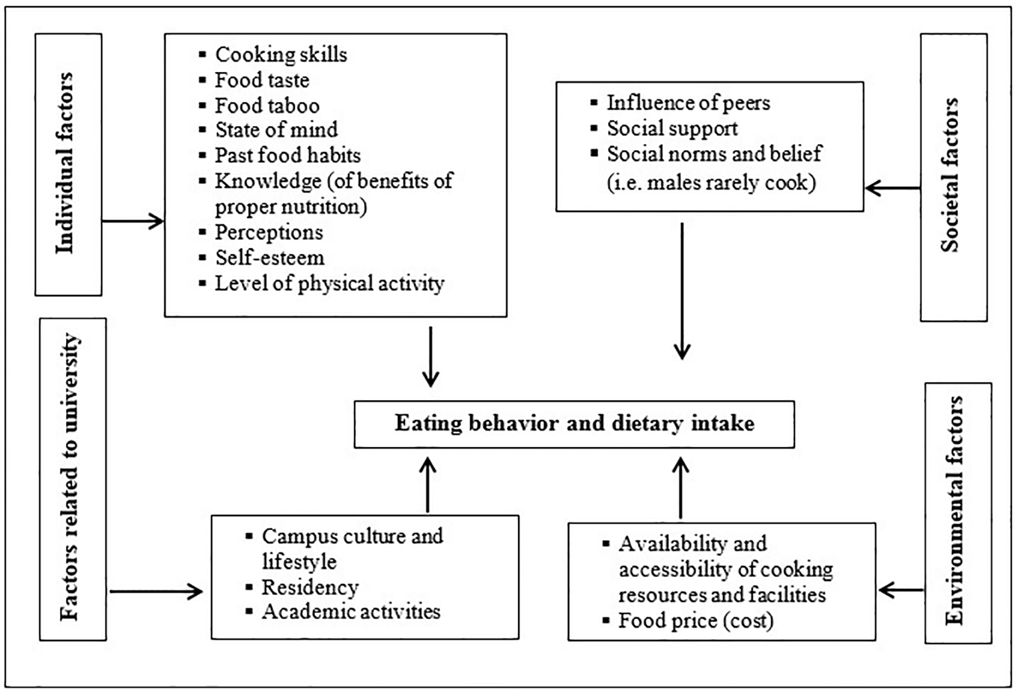
Figure 1: Factors influencing healthy eating behaviors among university students
Source: Kristo et al. (2020)
From the above theoretical framework, it can be seen four key aspects that have a substantial impact on students' eating patterns. These are the factors related to the university, as well as individual, societal, and environmental issues. Subfactors are further broken down into each of the factors.
Kristo et al. (2020) used the finding that university students skip breakfast due to academic obligations to illustrate how students' healthy eating habits change as they progress through higher education. According to Kabir, Miah, and Islam (2018), students often skip meals, especially breakfast, as a result of stress from andies. According to the findings of this study, eating breakfast each day is essential to avoiding exhaustion brought on by a busy class schedule and other health problems.

Rationale & Research questions/Aims/ Hypothesis
Research Aims
This report seeks to investigate what factors influence eating behavior among postgraduate students at a public college. The main objective of this report is to pinpoint the elements that influence the eating behaviors of postgraduate students and to provide suggestions for enhancing their general health and well-being.

The rationale of the research
Understanding the factors that affect postgraduate students' eating behavior is crucial given the potential harm that bad dietary choices could do to their health and well-being. By identifying these positive health indicators, universities, and health experts can develop targeted initiatives to promote healthy eating among this demographic. This report's goal was to investigate the elements that affect postgraduate students' eating habits at a public university.
Consequently, this study is crucial to understanding the conditions influencing the eating behaviors of postgraduate students in public universities. Even while past studies have looked at the eating patterns of university students, McGee, Griffith, and Houston (2019) argue that additional study expressly concentrating on postgraduate students is still required. In contrast to undergraduate students, this population is distinct, faces different personal and academic pressures, and may face different barriers to eating healthily. The ultimate goal of this research is to enhance the health and well-being of postgraduate students at a public institution while lowering the risk of chronic diseases associated with bad dietary choices.

Research Questions
- What individual characteristics influence the healthy eating behavior of postgraduate students in public universities?
- What social and environmental characteristics affect the healthy eating habits of postgraduate trainees in public universities?
- What methods could foster healthy eating routines among postgraduate students in public universities?
Research Hypothesis
This report’s main hypothesis is that a variety of factors affect postgraduate students’ eating behavior when they attend a public university. Particularly, access to healthy food options, social and cultural factors, and stress all have a big impact on how postgraduate students choose to maintain their dietary choices. Knowing these factors will help us better understand the challenges and barriers faced by postgraduate students in maintaining healthy eating habits and inform the development of targeted interventions to promote healthy dietary choices among this population. In the end, this report intends to contribute to improving the overall health and well-being of postgraduate students and reducing the risk of chronic diseases associated with poor dietary choices.

Research Methodology
The ways a researcher might collect the data, whether it be through surveys or interviews, are known as research methods. These methods will determine what type of study the researcher does and if it is qualitative or quantitative. Qualitative research is a method of inquiry that involves collecting and analyzing textual data to understand social phenomena (Castleberry and Nolen, 2018). The aim of qualitative research is to help the researcher to provide a rich and detailed understanding of a particular social phenomenon, rather than to generalize findings to a larger population. The qualitative research method typically involves collecting data through methods such as interviews, observation, and document analysis. The current research was conducted using a qualitative research method. The data collected by the researcher using qualitative data methods was preferred as it is often rich in detail and context highlighting the reasons and solutions to changing eating behavior of postgraduate students of UWTSD University. Moreover, the qualitative research method has helped the researcher collect more accurate data and make better conclusions about the findings of eating behavior of 6 students of UWTSD university
The most important disadvantage in the selected methodology is the small sample chosen for the collection of information in the present qualitative study. The present study is an exploratory analysis which should have included a large number of respondents instead of only 6 university students.

Research design
Research design is a blueprint of research activity that highlights the overall strategy that the researcher has undertaken in the smooth conduction of research activity. It is mentioned in the study of Binet et al. (2019) that research design outlines the analysis technique used by the researcher based on the nature and specificity of the research objective. The authors further expanded their study by outlining four divisions of research design which are descriptive, experimental, diagnostic and correlational research design. It can be inferred from the study of Binet et al. (2019) that descriptive research design is recommended to present research activity in a way that proper explanation about the happenings of research problems with their solutions is required. The researcher has chosen a descriptive research design based on focus group discussion which assisted the researcher to present the research activity in an explanatory manner on the basis of data and information collected through questionnaire. Furthermore, it is due to the selection of focus group discussion that the research activity highlights each and every point related to eating behavior of postgraduate students of UWTSD university. Focus group discussion has also proved productive in making research more relevant as it allowed to include data related to factors and solution for changing eating behavior by explaining its various factors including hectic schedules and academic pressure.

Recruitment, sampling & study participants
Research recruitment, sampling and participants are the core elements of the research activity that ensures relevency of research activity affected by knowledge and skills of the recruited sample. It is explained in the study of Villarosa et al. (2021) that research recruitment and research sampling define the effectiveness of research participants contributing their effort by providing information and sets of data regarding research problems or objectives that can be used to complete the research activity. The authors further stated in their study that research sampling is also a crucial element for the success of research activity as research sampling is representative of research respondents. It is mandatory to select a proper method to select research respondents to get the most relevant data regarding the subject matter of the research activity. The researcher has used the application of purposive sampling where Msc students of UWTSD university have been selected on the basis of characteristics they possess matching to the requirements of the researcher. This research methodology also involves Focus Group Discussion for the research design. Focus group discussion (FGD) is a qualitative research design that involves a group of people discussing a particular topic or issue under the guidance of a researcher. The group typically consists of 6-10 participants who are selected based on certain criteria, such as their demographic characteristics or their experiences related to the topic of interest. A combination of qualitative data analysis and primary data application ensures high relevancy, accuracy and reliability of the research activity aiming at analyzing the eating behavior of 6 (3 males and 3 females) postgraduate students of Msc public health and social welfare at UWTSD university. The researcher has further focused on the group discussion methods of data collections and analysis wherein selected PG students were asked to discuss the problem of equating behavior they face. Group discussion methods usually help researchers to get more authentic sets of information related to the research problem. FGDs provide an opportunity to explore participants' attitudes, beliefs, and experiences related to the topic of interest in a group setting. This has helped the researcher gain a richer understanding of the topic than they might have through individual interviews.
The current research study has selected 6 (3boys and 3 girls) students of MSC public health and social welfare aged between 24 and 34. The researcher has selected 3 north indian students and 3 south indian students as the respondents for this research.

Materials/ data collection methods/ procedure
It is mentioned in the study of Quintero and Chon, (2020) Data collection is a process of following sets of rules and regulations keeping in mind the fundamental requirements of research activity that affect the collected data. The authors further expanded their study by stating that the data collection methods affect the achievement of research objectives as different methods of data collection (questionnaire, interviews, secondary methods and virtual interviews) affect the nature of final data that has been used to create solutions to research problems. Questionnaires have been used as a method of data collection to get the raw data regarding the eating behavior amongst the students of PG in the university. Collecting data via questionnaire has helped the researcher to know the real problems affecting the healthy eating behavior of postgraduate students and the need that postgraduate students want to be fulfilled to follow a healthy eating behavior followed by a healthy lifestyle. The researcher has formulated core questions that has been effective enough to analyze the eating behavior among students. The researcher has done focus group discussion,questions were asked to 6 postgraduate students of Msc public health and social care studying in UWTSD Birmingham and has been supposed to reply with answers by using their intellect and experience. Researcher was also inclined in the conduction of group discussion of selected postgraduate students of UWTSD university in order to bring more authenticity in the data collection.`

Data analysis techniques
It is mentioned in the study of Quintero and Chon, (2020) that data analysis is concerned with the identification, introduction, classification, summarizing, interpretation and deriving conclusions from the data. Data analysis should be done keeping in mind the core problems and objectives of the research activity. The study of Quintero and Chon, (2020) further explained that there are four methods of data analysis techniques including the thematic approach, structural approach, functional approach and performance that can be used to analyze data in a way so that research objectives can be achieved effectively. It can be inferred from the study of Ragnoli, Blasiis, and Benedetto, (2018) that thematic data analysis is assistive in nature to focus on more specific data by creating themes. The researcher has used a thematic approach to data analysis that has helped him to focus on different aspects of changing eating behavior via creation of different themes that highlights different factors including research problems and solutions of eating behavior of postgraduate students in the university. Application of the thematic approach of data analysis based on qualitative data analysis is the effective combination that ensures reliability factor in research activity by extracting the most specific data and information for respondents and analyzing extracted data based on different factors at different intervals of time. Researcher has created themes related to eating behavior of PG students by following steps that includes familiarization with data, themes generation, searching more appropriate themes, themes review, naming themes and presenting the themes.

Ethical considerations
Ethical consideration is one of the most important factors that must be considered to keep research activity free from bias and controversies. It is mentioned in the study of Brendel et al. (2021) that ethical consideration is a set of guidelines, principles, rules and regulations that must be followed to follow healthy practices that have not hurted the beliefs and rights of interested parties in research activity including respondents and researcher himself. It is mentioned in the study of Nitschke et al. (2021) that ethical considerations are of different types including informed consent, anonymity, free from personal bias, voluntary participation, result communication and potential for harm. The researcher has followed ethical considerations of voluntary participation, informed consent, and free from bias. The researcher considered the consent of research respondents for filling out a questionnaire to keep the research free from any kind of forceful act. Further. The researcher has ensured that the respondents have taken part in the research process of his or their own and not under influence of someone else including the researcher himself. Researcher has also ensured the following steps to complete the research activity keeping in mind to keep the research free from his personal bias to sustain the reliability and relevance of the research activity.

Results
It is mentioned in the study of Scaglioni et al. (2018) that eating behavior is practices accepted by individuals related to meal time, meal quality, meal preference and selection influenced by social factors, genetic factors, psychological factors and physiological factors. It is also found in the study by the same authors that the time factor is a highly influential factor that affects the maintenance of healthy eating behavior. A hectic schedule is a primary reason behind the unhealthy or ineffective eating behavior of postgraduate students. They need more time from their hectic schedule to meet the requirements of healthy eating behavior.
It has been found from the response of Questionnaire sent to six students of UTSWD university that the first respondent believes in elimination of unhealthy food which are fat concentrated and suggested eating healthy food with effective nutritional value. Respondent 2 believes that eating behavior is practices accepted by individuals related to meal time, meal quality, meal preference and selection influenced by social factors, genetic factors, psychological factors and physiological factors. Respondent 1 also mentioned that people using vegetables and salads in their diet have a strong immune system. According to respondent 1, “... a healthy person does not make not too much consumption of junk food and fat”. Respondent 6 also found that a hectic schedule was another important reason behind the unhealthy or ineffective eating behavior of postgraduate students as stated by the majority of the respondents of the questionnaire. According to respondent 4, “ But due to the university timetable right now I take only two times in the past and in the afternoon I take generally junk foods.”All the respondents want their class to be limited to few minutes. Response of other respondents found that they got very minimal time from their hectic schedule to meet the requirements of healthy eating behavior. According to respondent 3, “So we take our sleep like 6 hours sleep minimum, and by that time we’re done. We won’t have time to prepare our food. So we’ll be in a rush. We’ll be running late everyday. So I believe time is the most important and critical barrier”. Maintenance of healthy eating behavior requires effective time in selecting healthy meals that need to be taken in an effective time interval under fixed quantity backed by effective quality. It has been also deduced from the response of questionnaire that postgraduate students found it difficult to pay so much attention to fixing and selecting meals according to their physical requirements and were often found accepting eating behavior that is not up to the mark. According to Respondent 4, “ I lose my weight around 2 to 4 kg”. Another factor that affected the eating behavior of postgraduate students in the university was psychological factors like stress, anxiety and depression as believed by one of the six respondents.
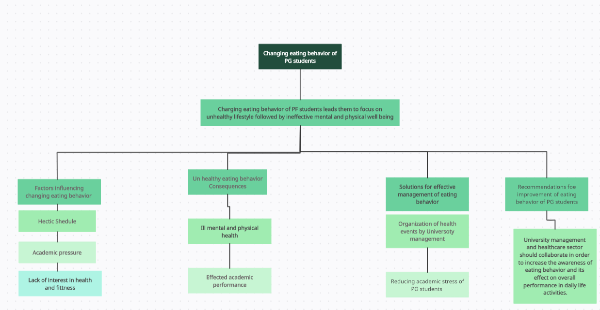
Figure 2: Thematic Map
Source: Self-designed

Discussions
Eating behavior plays a great role in the maintenance of effective psychological health that needs to be accomplished to keep the overall focus of UWTSD students on their primary objective to achieve effective milestones in their academics so that they achieve their dream of pursuing an effective career. Respondents want a separate gym by UWTSD management. Gramaglia et al. (2019), found that background demographics including gender, year level, study session, and personality all had an impact on effect behaviors of UWTSD students.. Moreover, Lewis et al. (2020), agreed in their Net of Science and Informit search breakdown that young individuals skipped regular meals, consumed fewer fruits and vegetables, and preferred energy-dense snacks. Furthermore, the author did a qualitative study using focus group talks in Europe to examine the factors that influence eating routines among UWTSD students. The study found that because of their irregular sleeping patterns and unstructured lifestyles, students frequently consumed sweet snacks. In difference, a qualitative analysis by Briggs et al. (2019), found that students skipped breakfast because they didn’t have enough time to make healthy meals, thus they opted for convenient food to save time. The study further clarified that students' healthy eating habits are impacted by how simple and convenient it is to prepare food, and nutritional behaviors and perceived barriers found that the absence of time was a deterrent to selecting to eat healthily among public UWTSD students. University students' healthy eating habits were frequently impacted by the eating behaviors and preferences of tertiary students, who frequently chose meals based on flavor. In line with the current study used focus group discussions to discover the effects on UWTSD students collecting eating manners. Healthy eating behavior for UWTSD students can be ensured with the help of the limited lecture period of few minutes, availability of gym inside campus and availability of a kitchen with updated amenities.. University management needs to conduct events and competitions that promote the acceptance of healthy eating behavior to maintain effective physiological and physical health. As it is found that the primary reason for the unhealthy or ineffective eating behavior of postgraduate students is related to hectic schedules and increasing pressure on them to give the best performance in their academics, management should focus on an alternative that can be used to minimize the burden of postgraduate students in the college environment.

Conclusions
It can be deduced from the current study on the eating behavior of postgraduate students that the burden and hectic schedule of students made them unable to focus on meeting effective eating behavior. Eating behavior ensures well-being of mental and physical health that is required for students to complete their academies without suffering issues like anxiety, depression and stress. The significance of healthy eating behavior can be ascertained by its linkage with healthy mental health and physical well-being. UWTSD University management is liable to manage the problems that students face to maintain an affecting eating behavior. Management of the university should focus on tactics that would minimize the burden on students regarding academics by decreasing the number of assignments and increasing the deadline that help students to make sufficient time out of their busy schedule and focus on building healthy eating behavior by selecting effective meal quality and quality on healthy intervals all around the day. Students also benefit from the events that are supposed to be organized by university management to create awareness related to a healthy diet and proper maintenance of mental and physical well-being.

References

Binet, A., Gavin, V., Carroll, L. and Arcaya, M., 2019. Designing and facilitating collaborative research design and data analysis workshops: lessons learned in the healthy neighborhoods study. International journal of environmental research and public health, 16(3), p.324. https://doi.org/10.3390/ijerph16030324
Brendel, A.B., Mirbabaie, M., Lembcke, T.B. and Hofeditz, L., 2021. Ethical management of artificial intelligence. Sustainability, 13(4), p.1974. https://doi.org/10.3390/su13041974
Briggs, A.M., Houlding, E., Hinman, R.S., Desmond, L.A., Bennell, K.L., Darlow, B., Pizzari, T., Leech, M., MacKay, C., Larmer, P.J. and Bendrups, A., 2019. Health professionals and students encounter multi-level barriers to implementing high-value osteoarthritis care: a multi-national study. Osteoarthritis and Cartilage, 27(5), pp.788-804. https://doi.org/10.3389/ijph.2021.1604149
Burns, D., Dagnall, N. and Holt, M., 2020. Assessing the impact of the COVID-19 pandemic on student wellbeing at universities in the United Kingdom: A conceptual analysis. In Frontiers in Education (Vol. 5, p. 582882). Frontiers Media SA. https://doi.org/10.3389/feduc.2020.582882
Castleberry, A. and Nolen, A., 2018. Thematic analysis of qualitative research data: Is it as easy as it sounds? Currents in pharmacy teaching and learning, 10(6), pp.807-815. https://doi.org/10.1016/j.cptl.2018.03.019
Gramaglia, C., Gambaro, E., Delicato, C., Marchetti, M., Sarchiapone, M., Ferrante, D., Roncero, M., Perpiñá, C., Brytek-Matera, A., Wojtyna, E. and Zeppegno, P., 2019. Orthorexia Nervosa, eating patterns and personality traits: a cross-cultural comparison of Italian, Polish and Spanish university students. BMC Psychiatry, 19(1), pp.1-11. https://doi.org/10.1186/s12888-019-2208-2
Kabir, A., Miah, S. and Islam, A., 2018. Factors influencing eating behavior and dietary intake among resident students in a public university in Bangladesh: A qualitative study. PloS one, 13(6), p.e0198801. https://doi.org/10.1371/journal.pone.0198801
Kristo, A.S., Gültekin, B., Öztağ, M. and Sikalidis, A.K., 2020. The effect of eating habits’ quality on scholastic performance in Turkish adolescents. Behavioral sciences, 10(1), p.31. https://doi.org/10.3390/bs10010031
Lewis, M., McNaughton, S.A., Rychetnik, L. and Lee, A.J., 2020. A systematic scoping review of the habitual dietary costs in low socioeconomic groups compared to high socioeconomic groups in Australia. Nutrition journal, 19, pp.1-12. https://doi.org/10.1186/s12937-020-00654-5
McGee, E.O., Griffith, D.M. and Houston, S.L., 2019. “I know I have to work twice as hard and hope that makes me good enough”: Exploring the stress and strain of Black doctoral students in engineering and computing. Teachers College Record, 121(4), pp.1-38. https://doi.org/10.1177/016146811912100407
Nitschke, I., Hahnel, S. and Jockusch, J., 2021. Health-related social and ethical considerations towards the utilization of dental medical services by seniors: influencing and protective factors, vulnerability, resilience and sense of coherence. International journal of environmental research and public health, 18(4), p.2048. https://doi.org/10.3390/ijerph18042048
Posada-Quintero, H.F. and Chon, K.H., 2020. Innovations in electrodermal activity data collection and signal processing: A systematic review. Sensors, 20(2), p.479. https://doi.org/10.3390/s20020479
Ragnoli, A., De Blasiis, M.R. and Di Benedetto, A., 2018. Pavement distress detection methods: A review. Infrastructures, 3(4), p.58. https://doi.org/10.3390/infrastructures3040058
Roose, G. and Mulier, L., 2020. Healthy advertising coming to its senses: The effectiveness of sensory appeals in healthy food advertising. Foods, 9(1), p.51. https://doi.org/10.3390/foods9010051
Scaglioni, S., De Cosmi, V., Ciappolino, V., Parazzini, F., Brambilla, P. and Agostoni, C., 2018. Factors influencing children's eating behaviors. Nutrients, 10(6), p.706. https://doi.org/10.3390/nu10060706
Villarosa, A.R., Ramjan, L.M., Maneze, D. and George, A., 2021. Conducting population health research during the COVID-19 pandemic: impacts and recommendations. Sustainability, 13(6), p.3320. https://doi.org/10.3390/su13063320

Appendix
QUESTION: Where are you from, and what is your name?
QUESTION: Describe a healthy person?
QUESTION: What comes to your mind when you think of the 'health of the university students' ?
QUESTION: Since you became a university student has your body weight and/or body composition changed?
QUESTION: Since you entered university has your eating behaviour changed?
QUESTION: What factors do you think are influencing your healthy eating habits at the university,What barriers and enablers of healthy eating behaviour can you identify?
QUESTION: Which of the previously mentioned factors have had the greatest influence on your healthy eating behaviour?
QUESTION: Do you have any suggestions, additions?
QUESTION: Can you give us some advice on how to promote healthy eating behaviours in students?
QUESTION: What can university do to promote healthy eating habits among students?

