
Strategic Management
Does Pfizer have the correct strategy management for today environment?
Bettina Silsby - 1905229 | 25th of June 2022 | University of Wales Trinity Saint David

Executive Summary

This report has been written up on the request to investigate Pfizer Strategic Management Process. To implement success strategy plan on the cooperate level the organisation must work out plan that is working towards to the mission statement. Pfizer acquisition strategy failed to deliver innovative medication to treat and cure today life illnesses. Therefore, the organisation has worked out a six-year strategy plan builds on the strongest business unit the Innovation Medication, to create a 25 new drug by 2025 using innovation and technology. To create this plan the organisation has been analysing internal and external factors that is have effect on the organisation and tom help allocate resources for the new strategy plan the report have been identified the organisation mission statement is to sort and it is not change since 1849. Five force analysis have showed the suppliers have great power through the organisation and dictate the price of raw material, hence the materials are very rear and is not many options to change suppliers. Stakeholders are mainly driven by profit and acting true to the Mission statement. The main influence on the strategy is the CEO, the supplier chain and the constantly changing market. The CEO of the organisation has created the new complex strategy plan using top-down approach and is indication the well implemented Positioning thinking school process. Overall, the organisation yearly financial report is showing major turn over for the Innovation Business unit and this unit has developed thirteen new drugs so far out of twenty-five. The plan was to complete this by the end of 2025 financial year, and all the research and analysis are showing the organisation will be likely to achieve a positive outcome.

Table of content

Table of Contents
1.0 Introduction 3
1.1 Terms of References ……………………………………………………………………………………………………….3
1.2. History of the organisation……….. ………………………………………………………………………………….3
1.3 Mission/Vision Statement……………………………………………………………………………………………….4
1.4. Pfizer ownership…………………………….………………………………………………………………………………4
1.5. Market revenues ……………………………………………………………………………………………………………5
1.6 Overview the passed five years……………………………………………………………………………………….6
2.0 Main Body 7
2.1. 1. Analysis of the current strategy of Innovation Business Unit …………………………………….7
2.1.2. SWOT………………………………………….………………………………7
2.1.3. PESTLE & 5 Force Analysis…………………………………………………..8
2.1.5. Generic Analysis……………………………………………………………….8
2.1.6. Stakeholder Analysis…………………………………………………………..9
2.1.7. BCG Matrix …………………………………………………………………..10
2.1.8. Overview of the analysis outcomes…………………………………………..10
2.2. Advantage and disadvantage of the strategy plan ………………………………………10
2.2.1. Strategy plan and Mission statement ………………………………………….10
2.2.2. Strategy management …………………………………………………………11
2.2.3. Analysing the strategy plan…………………………………………………….12
2.2.4. Outcome of Strategy plan …………………………………………………….13
3.0. Conclusion …………………………………………………………………………………………………………………………14
4.0. Reference list……………………………………………………………………………………………………………………..15
5.0. Appendices…………………………………………………………………………………………………………………………..18

- Introduction

  - Term of References
This report has been put together upon the request to analyse Pfizer strategy plan through looking at SWOT, PESTLE, 5 – Force analysis, Generic Analysis, Stakeholders Analysis and BCG Matrix. This report has been requested by Maria Heffernan CEO of Pfizer on 25th of April 2022 and it has been completed by Bettina Silsby the Strategy Manager Director of Pfizer on the 24th of June 2022.
The purpose of this report is to help understand the last five years challenges due to internal and external impact on the organisation and analysing the strategy plan that the organisation has put in place to help in profit margin and stay on the top of the market. The constantly changing market and competition are become more stronger, has pushed Pfizer to change the acquisition strategy something more effective strategy plan. To able the deliver a successful strategy plan process the organisation must constantly analyse market positions and the need of the new products. To able to target the right market and price well the new drugs the organisation must use strategic management tools and choose a strategy thinking process. Creating a good strategic plan can push the organisation forward and would shape the organisation to adapt any new challenges. This report will be critically looking at the mission statement of the organisation and will analysing the strategy planning direction. The report will draw out a conclusion based on the evidence research and discuss outlining which areas of the organisation strategy is the most successful in today environment.
To create this report and have critical view on the all-organisation primary and secondary sources have been analysed, for example Articles, Journals, websites, and Books.

1.2 History of the organisation
According to Pfizer United States Securities and Exchange Document (2021) Pfizer Inc. is a research-based, global biopharmaceutical company. The organisation applies science and global resources to bring therapies to people that extend and significantly improve their lives through the discovery, development, manufacture, marketing, sale, and distribution of biopharmaceutical products worldwide. Pfizer work across developed and emerging markets to advance wellness, prevention, treatments, and cure and challenge the most feared diseases of our time. The organisation collaborates with healthcare providers, governments and local communities to support and expand access to reliable, affordable healthcare around the world. The company was established in 1849 in New York by two German immigrants, Charles Pfizer (1824–1906) and his cousin Charles F. Erhart (1821–1891). In 2018 Pfizer divided into three distinct business units: Innovation Medication, Establish Product and Consumer Health. (LaMotta, 2018) Each of those business units are responsible for managing unique manufacturing, marketing and regulatory units, allowing those units to operate with more autonomy. This report will investigate the Establish Product business unit of Pfizer.
1.3. Vision/Mission Statement
Pfizer mission statement is to become the world most valued company to all the people. (pfizer, 2022) Pfizer key Values is Breakthroughs that can change patients’ lives. (Pfizer, 2019) According to BIO IT World (2021) online article The CEO Albert Bourla defined Pfizer’s mission as driving breakthroughs that change patients’ life. As part of that mission the organisation is undertaking a business transformation to become a leaner, more science-driven and patient-focused organisation. Digital plays a part in almost every aspect of how the organisation going to achieve that transformation. The organisation ultimate plan is to deliver 25 drug breakthroughs by 2025. Pfizer's vision statement is: Innovate to bring therapies to patients that significantly improve their lives, that is in line with the new strategy plan. Pfizer’s core values are customer focus, leadership, quality innovation, collaboration, respect for people, integrity, and performance. (Sorbello, 2022) Pfizer’s commitment to respect its customers and collaborate with partners ensures that its products can reach everyone that needs it. So, its core values are right in line with the mission statement and the vision statement of the company as well as its general practices.

1.4. Pfizer ownership
The top shareholders of Pfizer are Frank A. D'amelio, John Douglas Young, Mikael Dolsten, Vanguard Group Inc., BlackRock Inc, and State Street Corp. (Johnston, 2021) Albert Bourla is the chairman and CEO of Pfizer as whole organisation, however each business unit has different leaders. (Pfizer, 2022) The innovation Medication business unit is the largest unit of Pfizer. John Young and Angela Hwang will lead the innovative medicines business. Young will be responsible for the internal medicine, oncology (including biosimilars), and rare disease business units. Hwang will be responsible for the inflammation and immunology (including biosimilars), vaccines, and hospital medicines business units. (Keown, 2018) However Pfizer CEO and Pfizer executive leadership team are still responsible for leadership and decision-making and focusing on financial, strategic and operation management for the entire company. (Pfizer, 2022)

1.5. Market Revenues
According to Keown (2022) Innovation Medication Business unit includes all the current innovative health business units, as well as the new hospital medicines unit. This unit is commercialising Pfizer’s portfolio of sterile injectable and anti-infective medicines, and it included biosimilar portfolio in its oncology and inflammation and immunology business units.
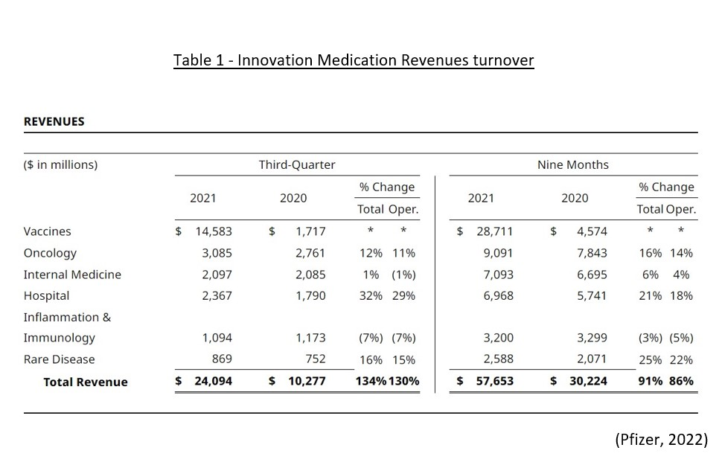
As Table 1 shows the business unit made major profit in the past two years, developing vaccination mainly for Covid-19. During the first nine months of 2021, Pfizer paid $6.5 billion of cash dividends, or $1.17 per share of common stock, which represents an increase in dividends per share of 3% compared to the same period last year. (Pfizer, 2021) The top shareholders of Pfizer are Frank A. D'amelio, John Douglas Young, Mikael Dolsten, Vanguard Group Inc., BlackRock Inc., and State Street Corp. there were not any new shareholders added in 2021. (Johnston, 2021)

1.6. Overview of the past five years
Pfizer’s acquisition strategy in the early 2000s was to acquire companies with patented drugs. Pfizer’s purchases of Warner-Lambert, and then of Pharmacia, are two examples. But as healthcare costs continued to soar, the market for cheaper generic drugs showed strong potential for growth. (JOHNSTON, 2021) Pfizer failed takeover Astra Zeneca and remained a strong competition with cheaper price ranged medication. (Trefis, 2014) Therefore, Pfizer reorganised the organisation into three different business unit, that is including Innovation Medication unit which covers the hospital focused segment for anti-infectives and sterile injectables. (Keown, 2018) This change has become the beginning of 2019 financial year. Not long after Covid-19 pandemic started. Covid pandemic has bought many challenges to all other business units and for the innovation medication unit for example delays in supply chain and labour shortages, delays in clinical trials. (Pfizer, 2021) The organisation has used a major resource to assist in responding to the pandemic; costs associated with the COVID-19 pandemic, including practices intended to reduce the risk of transmission, increased supply chain costs and additional Research & Development (R&D) costs incurred in our efforts to develop a vaccine to help prevent COVID-19 and an oral COVID-19 treatment. Although many challenges the unit remained strong focus to developing Covid-19 vaccination as soon as possible. 17th of March 2020 the IM unit has started to admit the first does of vaccinations and since this the organisation has admitted 1.4 billion doses of vaccine. (Silver, 2022) Pfizer made nearly $37bn (£27bn) in sales from its Covid-19 vaccine last year – making it one of the most lucrative products in history. (Kollewe, 2022) In 2021 Pfizer has developed a Covid-19 pill Paxlovid to treat and cut the risk of hospitalisation or death by 89% in vulnerable adults. (Reed, 2021)
The Business unit made a net profit of nearly $22bn in 2021, up from $9.1bn in 2020. It increased its 2022 estimate for Comirnaty sales to $32bn and expects Paxlovid to contribute $22bn in revenues. (Kollewe, 2022) Not only developing covid vaccination the unit have focused on developing new drugs for many other disease

2.0. Findings

2.1. 1. Analysis of the current strategy of Innovation Business Unit
In 2018 the organisation has announced a new strategy plan based on the Innovation Medication Business Unit. The organisation strategy plan main objective is to deliver 25 drug breakthroughs by 2025. (Gloss, 2021) The organisation set out three main step to achieve that: applying digital technologies to help speed up discovery and development of medicines and vaccines, enhance the patient and customer experience, and through that enhancement the organisation can improve outcomes to make the development faster and easier through the application of automation. The organisations largest and most profitable unit is the Innovation Medication. This strategy plan is driven by the original mission statement and the capability of developing new medication. (Gloss, 2021) To help achieve this plan Pfizer must look at internal and external factors, carry out market analysis and use strategic management tools.
Please see all the tables in the in appendices.
2.1.2. SWOT
The main purpose of a SWOT analysis is to identify the strategies that the organisation can utilise external opportunities or threats, and build on and protect the organisation strengths, eradicating weaknesses. The result of covid-19 pandemic is many other illnesses and diseases have been out of focus and have been put on the side due to emergent developing Covid- 19 Vaccination and pill, therefore there is an emergent need on the market to create new drugs to cure and treat serious illnesses. According to the SWOT analysis (Table 2) Innovation Business unit shows very good market position with high turnover, that makes available funds to spend new developments and trials of the medications. Therefore, Pfizer have seen the opportunity to use the business unit as a main driver for the strategy and import opportunity to strengths. Pfizer already have a successful brand image that helps in the market strategy for the new medications. Many opportunities through approval many new drugs for example covid-19 pill and the rheumatoid arthritis blockbuster drug. However, the weakness is showing the organisation had supplier chain issues and problems with testing, that could have bad effect on the strategy and causing delays in the process. Unfavourable patient laws can damage the brand name and is drifting away from the mission of the organisation to become the most valued company.

2.1.3. PESTLE & 5 Force Analysis
The application of PESTEL (Table-3) has identified political, economic and social forces that can shape the strategy and change the market growth. Under the political factors is indication of the USA government changing funding for medical treatments, that will have effect on the pricing strategy. Economical factor is the growing labour costs, which could increase the product price. Social behaviour is changing people choosing a healthier lifestyle, people are more conscious of how the product is tested. Those factors could lead to decline of the market for the product and have bad effect on the prize that Pfizer will be able to sell the new product. However, the 5-force analysis (Table-4) have showing Pfizer making the largest profit from the new inventive medication that treat rare diseases. For the new medication there are no alternative solution that is forcing the patient to buy medication that have been manufactured by Pfizer. The social factor from Pestle has no major as developing new illness or disease not only can cause lifestyle in many causes is genetic could develop in anyone and does not depend on lifestyle choses. This has encouraged Pfizer strategy to put more asset and use the innovation unit for the main driver for the strategy. The 5-force analysis shows the supply chain have major power over the organisation. The innovative medication component is very rare and require a high level of quality control the suppliers can price sky high and Pfizer have no power to negotiate that. Also, delays in the supplier chain can cause delays in delivering the strategy plan. USA government changing funding for medical treatment, means can narrow down the market as patients could not afford to pay for the treatments. However, the health is the most important in every person, therefore people will try to find a way to purchase the drugs.
2.1.5. Generic Analysis
Generic Analysis (Table 5) can help understand what is the market that the strategy targeting and how to price the new product. Pfizer have several different market lines and all the new developed drugs are different and unique. The table is showing Pfizer uses differentiation in combination with the cost leadership strategy to achieve growth objectives. Through differentiation generic strategy, Pfizer positions its product offerings in a way to stand out and be different from the available alternatives or being unique. The customer trusts the strong brand name, so the company uses differentiation as a tool to reduce the pressure from other brands. Therefore, Pfizer is treating competition seriously as the Generic analysis (Table-5) showing the brand name must stay strong and the product must be unique to able meet with the strategy objectives. Previous strategy of Pfizer was the acquisition of small pharmaceutical companies to make sure the small companies will not be a competitor also it was indication the seriousness market strategy. (Johnston, 2021) To be able to achieve differentiation Pfizer regularly analyse the market to able to keep the organisation on the top of the market. Those factors are strong indications of The Positioning School. The strategy plan is strongly working towards to the mission statement and the organisation constantly try to take the leading position of the market, through different strategies. However, the Generic and 5 force analysis show indication of influence Power and Culture Schools on Corporate Strategy. The main indicators are the organisation have used internal factors for the base of the strategy plan and the scientist have big influence on the outcome. If the scientist is unable to put through a successful trial of drug the plan would not work or could be delays in the strategy.
The undertaken those analysis is leading to the fact that the organisation corporate strategy follows the mission statement and implementing in the business unit strategy. The market always has need for new drugs to able to fight with new illnesses and develop more successful treatments for diseases. Therefore, the strategic plan is demonstrating outlooking strategy. The organisation must analysis the market frequently to be able to identify needs for new drugs and able to meet with all those needs. However, the main drivers for the strategy are the resources of the business unit and the capability of developing new product. Therefore, this strategy is well planned and a deliberate strategy.

2.1.6. Stakeholder Analysis
The Stakeholder analysis (Table-6) have identified the main stakeholders are driven from profit and by acting true to the organisation Mission and Vision statement. The main influence on the strategy is the CEO, the chair board, suppliers, and scientists at the organisation. Where the health care provider will describe the product as do not have other alternative and the patient will pay for the medication as there is no other choice, therefore stakeholders do not have much influence on the plan. The Strategy plan based on market condition more than like stakeholder influence. The market needs new drugs to able to fight with different illnesses and the organisation must develop new drugs to able to stay on the top of the market.

2.1.7. BCG Matrix
BCG matrix offers a simple way to assess Innovation Business Unit market share compared to the market growth. Innovation business is star stage at the moment. However, the Covid-19 Vaccination development made major profit for the organisation, the unit still stayed in the star stage due to still developing many more new treatments for rare diseases.
2.1.8. Overview of the analysis outcomes
This strategy is Complex and strongly focussed on the Mission and Vision Statement, having the right system and technology in place as the SWOT analysis shows the strength section. Pfizer must look at issues from PESTLE that can influence on the outcome of the strategy for example changing regulations, high health and safety requirement and strong quality control. The scope of the strategy based on the Innovation Medication Business Unit, as the SWOT analysis shows this unit is the strongest unit of the organisation with the right technology to carry out the strategy plan. The organisation has had annual strategy thinking, budgeting and planning with execution of six years. The period strategic followed by design and planning and reanalysing on 6-month period, therefore the organisation following a Deliberate strategy plan.

2.2. Advantage and disadvantage of the strategy plan

2.2.1. Strategy plan and Mission statement
Pfizer original mission statement is To become the world’s most valued company to all of these people. (pfizer, 2022) It was created in 1849, since then no change has been carried out on the statement. (pfizer, 2022) Seker (2005) has stated the mission statement should clarify what values and behaviours are critical for the organisation and help carry out corporate strategy. Therefore, the mission statement is key and this is the reason of the existence of the organisation. To look at the mission statement is always a top priority when it comes to planning strategy on corporate level. Organisations can change values and behaviour as years pass by due to micro and macro environment changes, those changes have an effect on the organisation. However, organisations must update the mission statement to make sure it is the true mirror for the organisation purpose. Pfizer mission statement showing the organisation desires to be big, powerful, and consequently of the highest value. The only way a pharmaceutical company can achieve that is to stay unique by create new and effective drugs and number down competitors. Which is evident from the company’s heavy investment in acquiring patents as well investing in Innovation Business unit. Therefore, building a strategy plan around innovation medication unit was convenience and helping to achieve the mission of the organisation. The acquisition of several smaller pharmaceutical companies has number down the competition but was not as effective as the organisation was hoping. To old strategy plan was based on acquisition and before 2018 Biopharmaceuticals group consisted of seven commercial business unit. (Pfizer, 2022) According to LaMotta (2018) together these businesses strived to deliver transformational medicines that can address major global health priorities in cancer, rare diseases, inflammation and immunology or vaccination. Therefore, Pfizer reorganised the business and set out new strategy that is based on innovation Medications. However, this mission statement is very short and does not show how important for the organisation being ethical or staying sustainable and does not indicate to the employees how to behave to achieve the goal. Archer (1998) argued that a well-conceived mission statement provides a control mechanism over the behaviour of employees, assists the organisation in creating a balance between the competing interests of various stakeholders and contributes to a more focused resource allocation to achieving a working strategy plan. The mission statement does not show any indication of behaviour and only gives view of goal.
2.2.2. Strategy management
Strategic management process can help organisations to achieve goals within a dynamic and competitive environment. According to Kennedy (2020) Strategic management is a comprehensive process designed for firms to best use organisation resources and capabilities to provide superior firm performance. Analysis of the external, competitive, and internal environments help shape the strategies that a firm pursues to be successful. Strategies are broad goals that, as accomplished, help the organisation move forward toward its vision. Therefore, all organisations need to set out a long- or short-term strategy through carrying out market research and looking at internal and external factors that effect the company.
Strategy plan can be corporate or business level strategy. Corporate Level strategy is referring to the top management approach for administering and directing the entire concern and based on the organisation environment and internal capabilities. (BusinessJargons, 2022) The report have identified in Task 2, Pfizer strategy plan that was coming from the CEO of the organisation and will be monitored and coordinated from the top management, therefore the strategy plan is a Corporate Level of strategy. Also, the strategy plan working towards
the mission statement and implementing the use of Positioning School strategy thinking.

2.2.3. Analysing the strategy plan
Strategy in general and realised strategy, will be defined as a pattern in a stream of decisions. When a sequence of decisions in some area exhibits a consistency over time, a strategy will be considered to have formed. (Mintzberg, 2009) Pfizer following a positioning school. According to Mintzberg et al, (2009) Positioning strategy refers to a company's success in a particular area that they choose to focus on. Positioning strategy usually chooses one or two important areas of the organisation to build the strategy. Pfizer have chosen to concentrate the strategy plan on the Innovation Medication Business unit. An effective positioning strategy considers the strengths and weaknesses of the organisation, the needs of the customers and market and the position of competitors. The purpose of a positioning strategy is that it allows an organisation to spotlight specific areas where the organisation can outshine and beat competition. (Study.com, 2022) To able to use position strategy the organisation must constantly assess how the market changes through market research and use Generic analysis to be able to use price positioning for the new medication. However, when is come to pricing a new product must look at other factors from PESTLE and from 5 Force analysis. The 5-force analysis has shown suppliers have big power over the organisation and can increase raw material cost rapidly. The new medication is unique therefore can push Pfizer to the destination to price to new product very costly. (Generic Analysis) If the medication price is too high and is not available to many patients due to the price it will go against the mission statement. The organisation will not be the most valued for all the people.

2.2.4. Outcome of Strategy plan
The year of 2020 will go down in history as the year when global macro and micro economical environments were affected the most since the second world war. The pharmaceutical industry has despite this glum picture managed positive returns for stakeholders. COVID-19 pandemic had affected Pfizer operations and financial condition and results have been and may continue to be impacted by the COVID-19 pandemic to varying degrees. The pandemic has presented a number of risks and challenges on the business, including, among others: impacts due to travel limitations and mobility restrictions; manufacturing disruptions and delays; supply chain disruptions and shortages, including challenges related to reliance on third-party suppliers resulting in reduced availability of materials or components used in the development, manufacturing, distribution or administration of products; disruptions to pipeline development and clinical trials, including difficulties or delays in enrolling certain clinical trials, retaining clinical trial participants, accessing needed supplies, and accruing a sufficient number of cases in certain clinical trials; decreased product demand, due to reduced numbers of in-person meetings with prescribers, patient visits with physicians, vaccinations and elective surgeries, resulting in fewer new prescriptions or refills of existing prescriptions and reduced demand for products used in procedures; reduced product demand as a result of unemployment or increased focus on COVID-19 vaccination. (Pfizer, 2021)
During 2021, Pfizer have further enhanced the commitment to Environmental, Social, and Governance (ESG) principles. Pfizer’s ESG strategy is focused on six areas where we see opportunities to create a meaningful and measurable impact over the next decade: product innovation; equitable access and pricing; product quality and safety; diversity, equity, and inclusion; climate change; and business ethics. (Pfizer, 2021) Pfizer have reached an estimated 1.4 billion patients with our medicines and vaccines. (Pfizer 2021) Pfizer have initiated 13 pivotal clinical studies out of the 25 new drugs. (Pfizer 2021) According to Pfizer the organisation has increased the investments in Research & Development (R&D) from $8.9 billion in 2020 to $10.5 billion in 2021. The Annual report of the organisation shows that Innovation business unit grew revenues to $81.3 billion (reflecting 92% operational growth). (Pfizer).
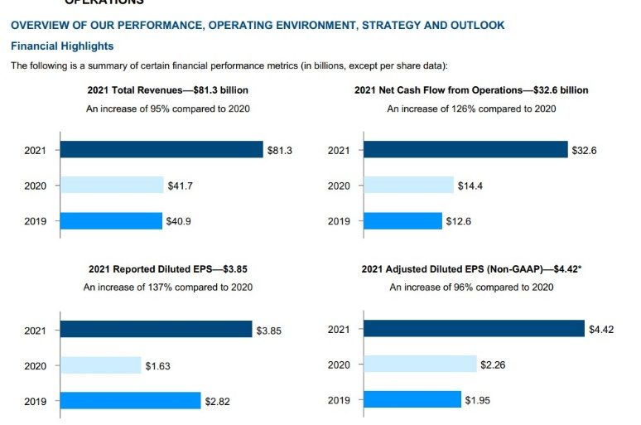
Pfizer transformed into a more focused, global leader in science-based innovative medicines and vaccines and beginning of 2020 operated as a single operating segment engaged in the discovery, development, manufacturing, marketing, sale and distribution of biopharmaceutical products worldwide. (Pfizer, 2021)

3.0. Conclusion

The growth fundamentals for the Innovative Medicines business are strong with an aging population that is leading to increasing demand for new innovative medicines and quickly advancing biological science that is delivering breakthrough solutions. With a robust portfolio of growing in-market products, the organisation well delivering the strategy plan.
The report has analysed Pfizer Innovation Medication Business unit through several strategic management tools and identified many strength, opportunities to develop a successful strategy plan, also few disadvantage that need to be addressed. Pfizer have understood the acquisition strategy was not working and it has failed to deliver up to expectation to find cure and treatment for cancer and many other illnesses. The organisation had to change strategy, therefore Pfizer have chosen to divide the organisation to three main business units. The organisation has assets many opportunities and in 2019 the new strategy plan was made, and the plan was based on the organisation biggest and successful unit to the Innovation Medication Business. The plan is to produce 25 new medications by 2025 using innovation and new technology developments. The organisation strategy plan is strong and long-term plan with a deliberate approach working towards to the mission statement. However, the mission statement feels too short and does not give indication to the right behaviour for employees or not indicate any values that is important for the organisation to achieve goals. Mission statement can help encourage the workforce and show the direction of the way that must be followed to achieve goals in an ethical and sustainable way. However, Pfizer have not included any values, ethics or sustainability in the mission statement, and the organisation have not carried out any change on the mission statement since 1849. The main decision making is down to the organisation CEO regarding any strategy movement. The organisation using top-down approach and the management must deal with many issues, starting with supplier issues, meeting with new regulation, therefore mangers have to try reducing uncertainty with firm and have full control on this complex strategy plan. The organisation is analysing the market frequently to be able to stay on the top of the market and keep the uniqueness of the new product. Planning ahead and forward-looking strategy planning are indication the deliberateness strategy planning. The organisation using Positioning School strategy thinking, therefore Pfizer is very aware of competitors and of any change of market. The 5-Force analysis shows the power of suppliers is very strong over the organization, due to the low number of suppliers that are available in comparison with the number of players in the industry. In the case of the pharmaceutical industry, the number of major players is more than the suppliers in this industry and hence the suppliers enjoy a lot of bargaining power as the raw materials in this case are quite rare in many cases. Stake holders’ analysis have showed the stake holders are driven by the profit and the Strategy plan based on market condition more than like stakeholder influence. The Covid- 19 pandemic had affected the organisation and made the organisation adapt; however Pfizer was one of the first pharmaceutical company to develop vaccination for the virus and this helped achieve high turnover.
Overall, the organisation yearly financial report is showing major turn over for the Innovation Business unit and this unit has developed thirteen new drugs so far out of twenty-five. The plan was to complete this by the end of 2025 financial year, and all the research and analysis are showing the organisation will be likely to achieve a positive outcome.

4.0. References

References
BusinessJargons, (2022). Corporate-Level Strategy. [Online]
Available at: https://businessjargons.com/corporate-level-strategy.html
[Accessed 15 06 2022].
Curry, R., (2020). Who Owns Pfizer and BioNTech?. [Online]
Available at: https://marketrealist.com/p/who-owns-pfizer-biontech/
[Accessed 01 May 2022].
Gloss, S., (2021). Pfizer’s Digital Strategy and Transformation. [Online]
Available at: https://www.bio-itworld.com/news/2021/07/20/pfizer-s-digital-strategy-and-transformation
[Accessed 03 06 2022].
Henry Mintzberg, B. A. e. a., Harlow. (2018) Strategy Safari: The complete guide through the wilds of strategic management. 2nd ed. New York: Financial Times Prentice Hall..
Jim Reed, Philippa Roxby, (2021). Covid: Pfizer says antiviral pill 89% effective in high-risk cases. BBC News.
Johnston, M., (2021). 7 Companies Owned by Pfizer. [Online]
Available at: https://www.investopedia.com/companies-owned-by-pfizer-5211303
[Accessed 01 May 2022].
JOHNSTON, M., (2021). 7 Companies Owned by Pfizer. [Online]
Available at: https://www.investopedia.com/companies-owned-by-pfizer-5211303#:~:text=Pfizer%E2%80%99s%20acquisition%20strategy%20in%20the%20early%202000s%20was,cheaper%20generic%20drugs%20showed%20strong%20potential%20for%20growth.
[Accessed 21 06 2022].
Johnston, M., (2021). Top Pfizer Shareholders. [Online]
Available at: https://www.investopedia.com/articles/company-insights/082316/top-10-shareholders-pfizer-pfe.asp
[Accessed 01 May 2022].
Keown, A., (2018). Pfizer to Reorganize into Three Business Units. [Online]
Available at: https://www.biospace.com/article/pfizer-to-reorganize-into-three-business-units/#:~:text=The%20innovative%20medicines%20business%20will%20be%20the%20largest,Pfizer%E2%80%99s%20portfolio%20of%20sterile%20injectable%20and%20anti-infective%20medicines.
[Accessed 03 06 2022].
Kollewe, J., (2022). Pfizer accused of pandemic profiteering as profits double. The Guardian .Available at: Pfizer accused of pandemic profiteering as profits double | Pfizer | The Guardian (accessed: 3/6/2022)
LaMotta, L., (2018). Pfizer rejiggers business units. [Online]
Available at: https://www.biopharmadive.com/news/pfizer-rejiggers-business-units/527547/#:~:text=Pfizer%20announced%20Wednesday%20it%20will%20reorganize%20the%20sprawling,its%20biosimilars%20and%20a%20new%20Hospital%20Medicines%20unit.
[Accessed 01 May 2022).
Mintzberg, H., Ahlstrand, B.W. and Lampel, J. (2009) Strategy safari: the complete guide through the wilds of strategic management. 2nd ed. Harlow: Financial Times Prentice Hall.
Norman P. Archer, Fereidoun Ghasemzadeh and Christopher K. Bart, (1998). A comparison of mission statements and their rationales in innovative and non-innovative firms. International Journal of Technology Management, Volume 16, pp. 64-77.
Pfizer, (2019). Living Our Purpose. [Online]
Available at: https://www.pfizer.com/sites/default/files/investors/financial_reports/annual_reports/2019/our-purpose/living-our-purpose/index.html
[Accessed 6 6 2022].
Pfizer, (2021). Annual Review. [Online]
Available at: https://www.pfizer.com/sites/default/files/investors/financial_reports/annual_reports/2021/files/Pfizer_Annual_Review.pdf
[Accessed 17 6 2022].
Pfizer, (2021). PFIZER REPORTS THIRD-QUARTER 2021 RESULTS. [Online]
Available at: https://www.pfizer.com/news/press-release/press-release-detail/pfizer-reports-third-quarter-2021-results
[Accessed 03 06 2022].
Pfizer, (2021). United States Securities and Exchange Document. [Online]
Available at: https://s28.q4cdn.com/781576035/files/doc_financials/2021/ar/PFE-2021-Form-10K-FINAL.pdf
[Accessed 01 May 2022].
pfizer, (2022). Company Timeline: a Legacy of Innovation. [Online]
Available at: https://www.pfizer.com/about/history
[Accessed 15 06 2022].
Pfizer, (2022). Pfizer managet board. [Online]
Available at: https://www.pfizer.com/about/people/executives
[Accessed 01 May 2022].
pfizer, (2022). Pfizer Mission and Vision Statment. [Online]
Available at: https://mission-statement.com/pfizer/
[Accessed 12 06 2022].
Reed Kennedy, and etall, (2020.) Strategy Management. Virginia: Virginia Tech.
Seker, Y., (2005). The role of mission and its position withwin the srategic management process. Norderstedt Germany: Green Verlag.
Silver, K., (2022). Shot of a Lifetime: How Pfizer and BioNTech Developed and Manufactured a COVID-19 Vaccine in Record Time. [Online]
Available at: https://www.pfizer.com/news/articles/shot_of_a_lifetime_how_pfizer_and_biontech_developed_and_manufactured_a_covid_19_vaccine_in_record_time
[Accessed 03 06 2022].
Sorbello, A., (2022). Pfizer Mission Statement Analysis and Vision. [Online]
Available at: https://www.astrogrowth.com/blog/pfizer/#:~:text=Pfizer%27s%20vision%20statement%20is%3A%20%E2%80%9C%20Innovate%20to%20bring,is%20a%20
[Accessed 03 06 2022].
Study.com, (2022). Positioning Strategy: Definition & Examples. [Online]
Available at: https://study.com/academy/lesson/positioning-strategy-definition-examples.html
[Accessed 12 06 2022].
Trefis, (2014). Pfizer's Acquisition Strategy: Will Pfizer Still Go For A Big Acquisition?. [Online]
Available at: https://www.forbes.com/sites/greatspeculations/2014/12/16/pfizers-acquisition-strategy-will-pfizer-still-go-for-a-big-acquisition-part-1-of-2/?sh=7e92d45628d3
[Accessed 21 06 2022].

5.0. Appendices

Table 2 SWOT
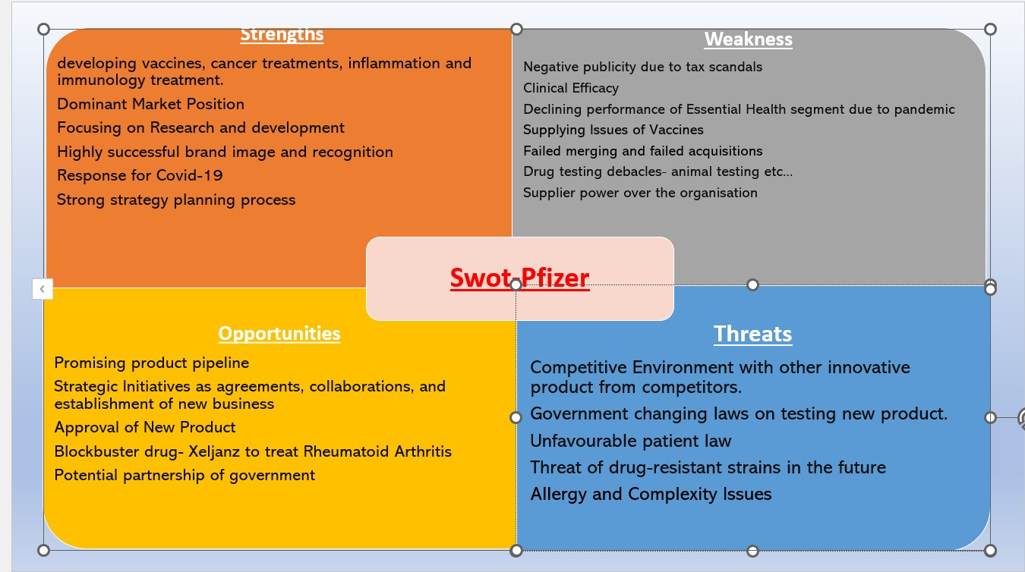

Table 3 PESTLE
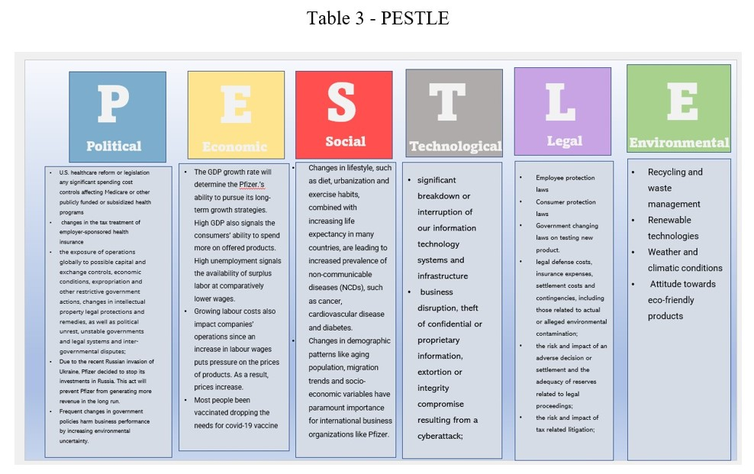

Table 4- 5 Force Analysis
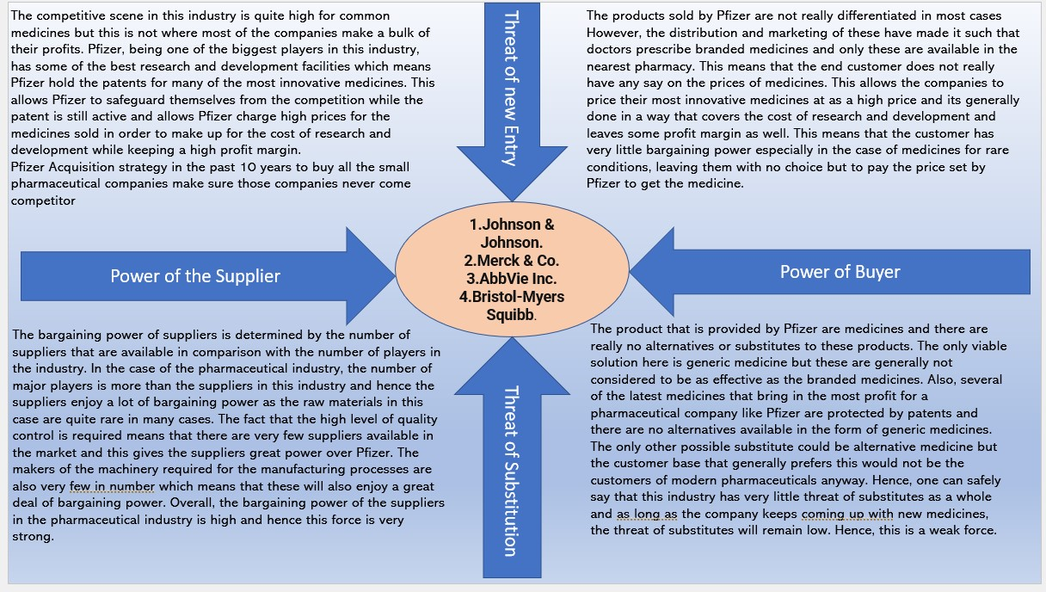

Table 5 – Porter Generic Analysis
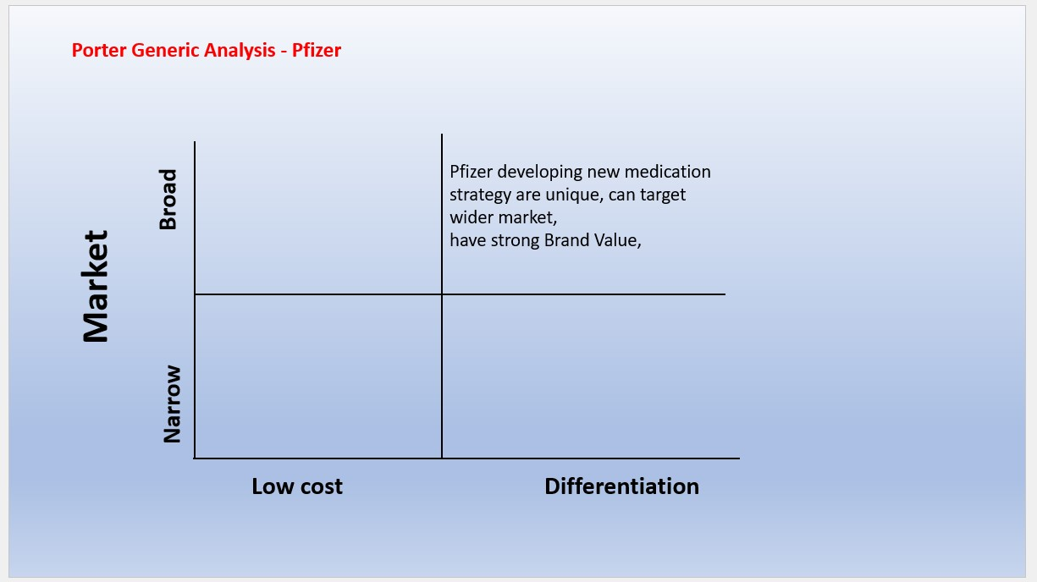

Table 6 - Stakeholder analysis
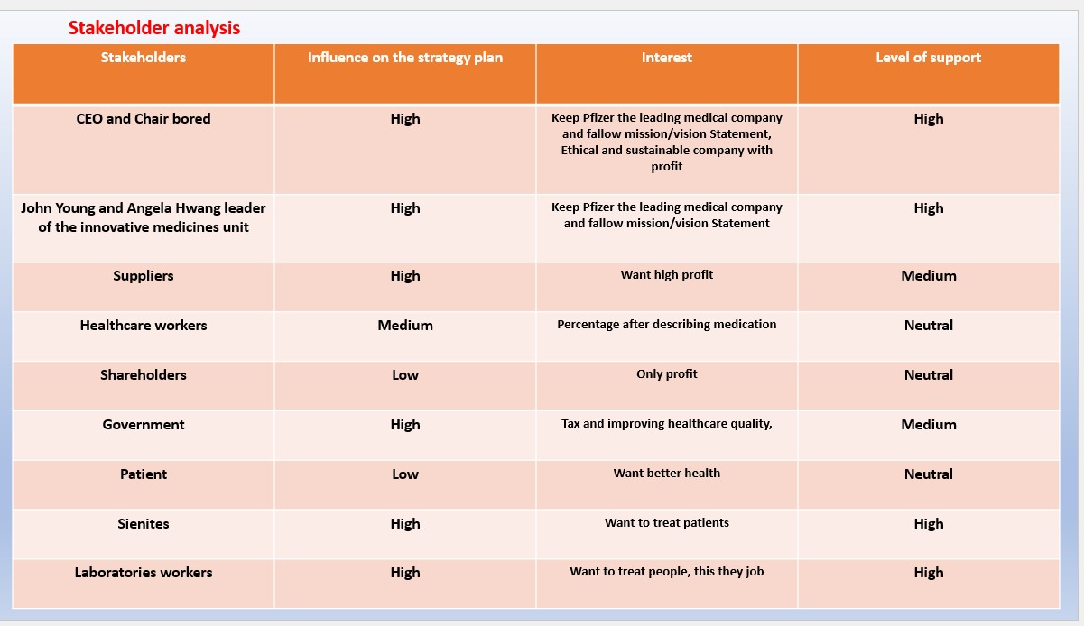
Table 7 – BCG Matrix


