
University of Wales Trinity Saint David
BA Leadership and Management
Module: Managing Projects in the Organisation
Module Tutor: Giulia Chifari
Student Name: Salma Farache
Student ID: 2408621
Assignment: Report
Project Title: Fundraising and Well-being Event
Date:02/07/2026
Word Count: 2191

Table of Contents
Executive Summary ...............................................................................................................................3
- Introduction ..............................................................................................................................4
- Findings ....................................................................................................................................5
2.1 Project Lifecycle and Planning ............................................................................................5
2.2 Critical Assessment of Project Management Tools and Techniques .................................7
Iron Triangle ...........................................................................................................................7
Work Breakdown Structure (WBS) ......................................................................................8
Gantt Chart ..........................................................................................................................9
2.3 Stakeholder Analysis and Communication ..........................................................................9
Stakeholder Analysis………………..........................................................................................10
Communication Planning .....................................................................................................11
2.4 Risk Management ................................................................................................................11
2.5 Monitoring, Evaluation and Project Closure ........................................................................12
- Conclusion ...............................................................................................................................15
- Future Improvements and Recommendations ........................................................................16
- References ...............................................................................................................................17

MANAGING PROJECTS IN THE ORGANISATION
Fundraising and Well-being Event Supporting EYST

Executive Summary
This report critically evaluates a Fundraising and Well-being Event undertaken as part of the Managing Projects in the Organisation module. The project aimed to raise funds for the Ethnic Youth Support Team (EYST) while promoting well-being, inclusion, and community engagement within the university. The project followed the five stages of the project lifecycle: initiation, planning, execution, monitoring and control, and closure.
The report critically assesses the effectiveness of key project management tools and techniques, including the Iron Triangle, Work Breakdown Structure (WBS), Gantt Chart, stakeholder analysis, communication planning, risk management, and project evaluation. Rather than describing these approaches, the report evaluates how they informed project decisions, strengthened stakeholder engagement, reduced risks, and contributed to successful project delivery.
As Team Leader and Coordinator, I was responsible for planning activities, coordinating stakeholders, allocating responsibilities, and monitoring project progress. The project successfully raised £115 for EYST, attracted approximately 40 participants, and received positive feedback through a QR survey.
Overall, the report concludes that successful project management depends not only on applying appropriate tools and techniques but also on effective communication, stakeholder collaboration, proactive risk management, and continuous evaluation. Recommendations are provided to improve the planning and delivery of future fundraising projects.

1. Introduction
Projects are temporary activities undertaken to achieve specific objectives within defined constraints of time, cost, and resources (Clegg et al., 2020). Effective project management enables organisations to achieve objectives while managing risks, stakeholder expectations, and limited resources (APM, 2022). Selecting appropriate project management tools and techniques is therefore essential for improving project performance and increasing the likelihood of success (Burke, 2013).
This report presents a critical analysis of a Fundraising and Well-being Event organised by a student project team in support of the Ethnic Youth Support Team (EYST). The project aimed to raise funds while promoting well-being, inclusion, and community engagement through fundraising activities and a well-being initiative.
The project objectives were to deliver a successful fundraising event, encourage participation, promote well-being, and evaluate project outcomes. As Team Leader and Coordinator, I planned activities, coordinated stakeholders, allocated responsibilities, and monitored progress throughout the project.
The report examines the project lifecycle, project management tools and techniques, stakeholder management, communication, risk management, project outcomes, and recommendations for future improvement.

2. Findings
2.1 Project Lifecycle and Planning
The project followed the five stages of the project lifecycle: initiation, planning, execution, monitoring and control, and closure. According to the Project Management Institute (PMI, 2021), the project lifecycle provides a structured framework for organising activities, managing resources, and achieving project objectives. Similarly, Turner (2014) argues that following a structured lifecycle improves coordination and increases the likelihood of project success.
The initiation stage involved selecting EYST as the charity beneficiary, agreeing the project objectives, and allocating team roles, establishing a clear direction for the project (Westland, 2018). During the planning stage, the team conducted stakeholder analysis, communication planning, risk assessment, scheduling, promotional planning, and obtained approval from the University Operations Team. Effective planning reduced uncertainty, clarified responsibilities, supported resource allocation, and minimised the risk of delays before implementation (Maylor, 2010; Burke, 2013).
The project's principal deliverables included the Fundraising and Well-being Event, promotional materials, the QR feedback survey, and the transfer of the £115 donation to EYST. These deliverables aligned with the project objectives and provided measurable indicators for evaluating project success (Heldman, 2018).
Planning was guided by the Iron Triangle, which balances time, cost, and scope when making project decisions (Maylor, 2010). Within this project, the model supported decisions regarding resource allocation, scheduling, and low-cost promotional activities. However, as the effectiveness of the Iron Triangle is critically evaluated in Section 2.2, only its role within the planning stage is discussed here.
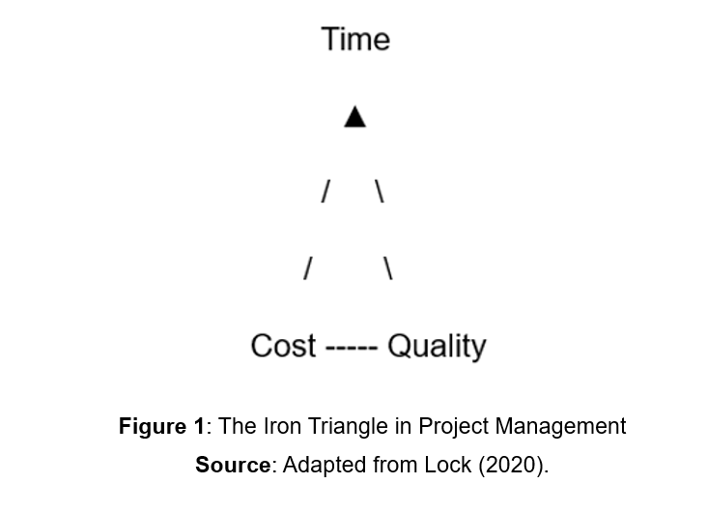

Execution involved delivering the fundraising event, promoting well-being activities, and engaging participants through the well-being corner. Monitoring and control were maintained through regular team meetings, progress updates, and continuous stakeholder communication to ensure that activities remained aligned with project objectives. During the closure stage, project outcomes were evaluated, lessons learned were identified, and the funds raised were transferred to EYST.
Although the project lifecycle is presented as separate stages, communication, monitoring, and stakeholder engagement continued throughout the project. This demonstrates that successful project management requires flexibility alongside structured planning, enabling the team to respond effectively to changing project requirements (Meredith, Mantel and Shafer, 2017).

2.2 Critical Assessment of Project Management Tools and Techniques
Project management tools support planning, scheduling, monitoring, communication, and decision-making throughout the project lifecycle. However, no single tool can effectively manage every aspect of a project. Their effectiveness depends on selecting techniques that reflect the project's objectives, complexity, and constraints (Young, 2016). Within this project, the Iron Triangle, Work Breakdown Structure (WBS), and Gantt Chart were used together to support planning, coordination, and project control.

Iron Triangle
The Iron Triangle identifies time, cost, and scope as the three principal constraints influencing project performance (Maylor, 2010). Balancing these constraints was essential because the project had to deliver fundraising and well-being objectives within a limited budget and fixed timeframe.
The model informed planning decisions by supporting resource allocation and the selection of low-cost promotional methods, including LinkedIn, posters, flyers, and word-of-mouth communication. These decisions enabled the project to remain within budget while attracting approximately 40 participants and raising £115 for EYST, demonstrating the practical value of the model.
However, project success cannot be evaluated solely through time, cost, and scope. Atkinson (1999) argues that stakeholder satisfaction should also be considered, while Cooke-Davies (2002) highlights organisational learning and long-term value as additional measures of success. This project reflected these wider criteria through positive participant feedback, effective stakeholder collaboration, and meaningful well-being outcomes.

Work Breakdown Structure (WBS)
The Work Breakdown Structure (WBS) was a key planning tool used to divide the project into manageable tasks. According to Heagney (2016), the WBS improves organisation, responsibility allocation, and project control.
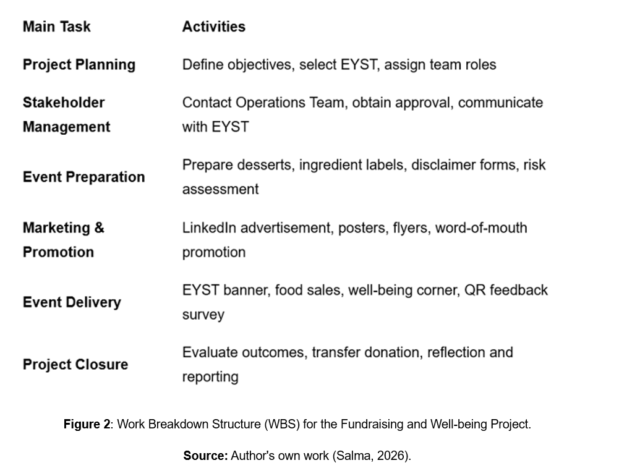
The WBS organised the project into planning, stakeholder communication, marketing, event preparation, event delivery, and evaluation. This clarified responsibilities, improved coordination, and reduced the likelihood of important activities being overlooked. The WBS was particularly suitable because the project required several team members to complete different tasks within a limited timeframe.
However, the WBS identifies project activities without showing their sequence or timing. Consequently, it was most effective when combined with the Gantt Chart, which provided a detailed schedule and supported progress monitoring (Heldman, 2018).

Gantt Chart
The Gantt Chart was used to schedule project activities and monitor progress throughout implementation. Unlike the WBS, which identifies project tasks, the Gantt Chart illustrates activity sequences, durations, and deadlines (Lock, 2020).
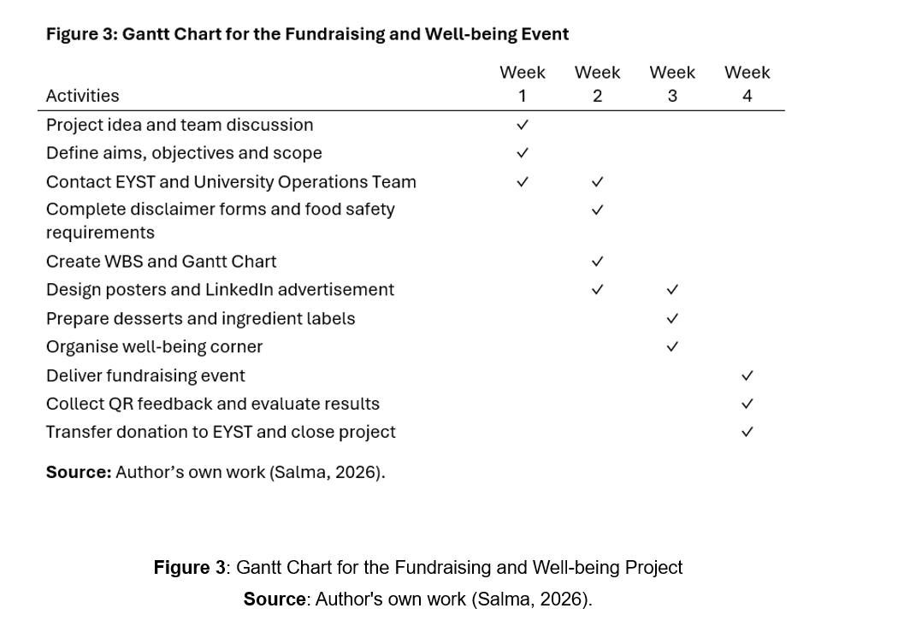
The chart scheduled key activities, including obtaining approval from the University Operations Team, preparing promotional materials, organising resources, delivering the event, and evaluating outcomes. By highlighting task dependencies, it ensured that approval requirements were completed before promotional activities commenced, reducing the likelihood of delays.
The Gantt Chart also improved visibility of project progress by enabling team members to monitor deadlines and coordinate responsibilities effectively. Although it required regular updating as project activities changed, it remained an effective planning and monitoring tool because it supported project control and timely decision-making (Walker, 2015).

Overall, the Iron Triangle, WBS, and Gantt Chart complemented one another throughout the project lifecycle. The Iron Triangle informed planning decisions, the WBS clarified responsibilities, and the Gantt Chart translated activities into a realistic schedule. Together, these tools improved coordination, supported resource allocation, and strengthened project control. However, their effectiveness depended on continuous communication and stakeholder collaboration rather than the tools alone, demonstrating that successful project management requires both appropriate techniques and effective leadership (Pinto, 2019).

2.3 Stakeholder Analysis and Communication
Stakeholder Analysis
Stakeholder analysis was essential because the success of the Fundraising and Well-being Event depended on the support and involvement of different individuals and organisations. According to the Association for Project Management (APM, 2022), stakeholders are individuals or groups who can influence, or be influenced by, a project. Pinto (2019) further argues that understanding stakeholder interests supports effective decision-making and project success.
The principal stakeholders included EYST, the University Operations Team, students, staff, and the project team. EYST had high influence and interest as the project beneficiary, while the University Operations Team played a key role by approving the event. Students and staff influenced participation, and the project team was responsible for planning and delivery.
Stakeholder analysis informed project decisions by identifying which stakeholders required early engagement. Prioritising communication with the University Operations Team enabled approval requirements to be completed before implementation, reducing the likelihood of delays. Similarly, recognising students as the primary participants influenced the choice of promotional methods to maximise attendance. However, stakeholder priorities may change throughout a project, requiring continuous communication and regular review (Meredith, Mantel and Shafer, 2017). Despite this limitation, stakeholder analysis strengthened decision-making and contributed to successful project delivery.

Communication Planning
Effective communication is widely recognised as a critical factor in project success because it supports collaboration and enables information to be shared accurately (Newton, 2016). Turner (2014) further argues that effective communication reduces misunderstandings and improves coordination.
Communication with the University Operations Team was conducted primarily through email to maintain a formal record of approvals and documentation, while the project team used WhatsApp and face-to-face meetings to coordinate activities and resolve issues promptly. LinkedIn, posters, flyers, and word-of-mouth promotion were used to increase awareness and encourage participation.
Selecting communication methods according to stakeholder needs improved coordination and supported informed decision-making throughout the project. Formal communication ensured compliance with university procedures, whereas informal communication enabled rapid responses to emerging issues. Although communication could not overcome the challenge of organising the event near the end of the academic year, it strengthened stakeholder engagement and supported successful project delivery (Pinto, 2019).
2.4 Risk Management
Risk management enabled potential challenges to be identified and addressed before they affected project objectives. According to Kerzner (2022), effective risk management reduces the likelihood and impact of uncertain events, while Young (2016) argues that proactive risk management supports better project outcomes by preventing problems rather than reacting to them.
A key risk was organising the event near the end of the academic year, when student attendance was expected to decline. To reduce this risk, the team promoted the event through LinkedIn, posters, flyers, and word-of-mouth communication. Although attendance may have been higher earlier in the academic year, these actions attracted approximately 40 participants and contributed to raising £115 for EYST, demonstrating the effectiveness of the mitigation strategy.
Another significant risk related to food allergies because the event included homemade desserts containing nuts, dairy products, and gluten. Ingredient labels, disclaimer forms, and food safety documentation enabled participants to make informed choices while ensuring compliance with university requirements.
A further risk involved delays in obtaining approval from the University Operations Team. Early communication and timely submission of documentation ensured that approval was received before implementation, preventing disruption to the project schedule.
Overall, identifying risks at an early stage enabled preventative action, reduced disruption, and supported successful project delivery (Heldman, 2018).
2.5 Monitoring, Evaluation and Project Closure
Monitoring and evaluation are essential throughout the project lifecycle because they enable progress to be assessed, project performance to be reviewed, and lessons to inform future practice (APM, 2022). Meredith, Mantel and Shafer (2017) further argue that continuous monitoring allows project managers to respond to issues before they affect project objectives.
Throughout the project, monitoring was maintained through regular team meetings, WhatsApp communication, progress updates, and ongoing stakeholder engagement. These approaches ensured that responsibilities were reviewed regularly and activities remained aligned with the project schedule and objectives.
Project evaluation used both numerical outcomes and participant feedback to assess the success of the event. The project successfully raised £115 for EYST and attracted approximately 40 participants.

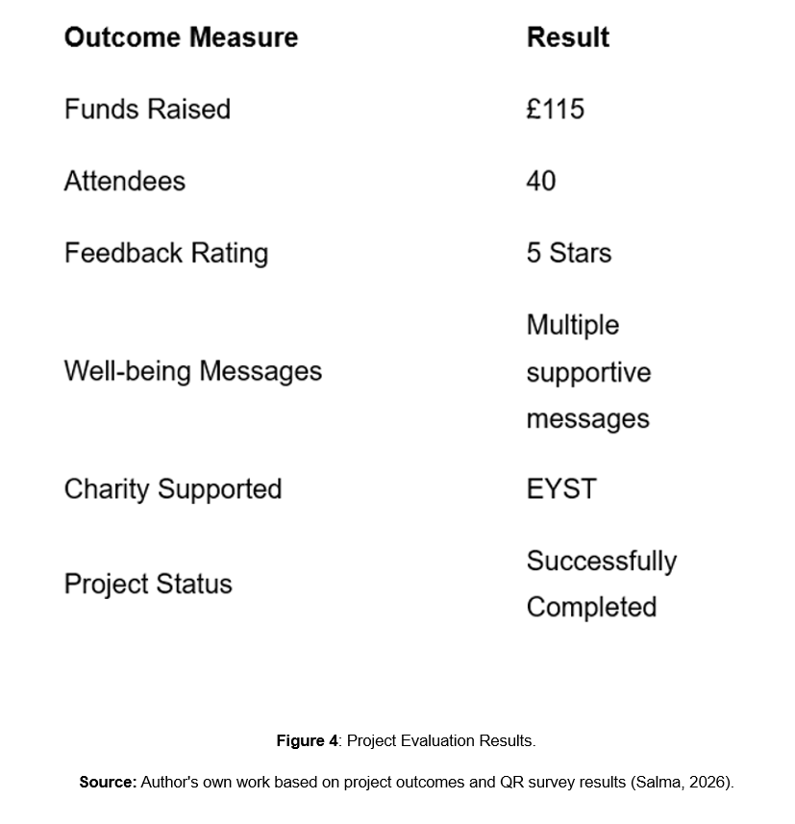

Feedback collected through the QR survey showed high levels of participant satisfaction, with most respondents awarding the event five stars and commenting positively on the organisation, atmosphere, and quality of the food.
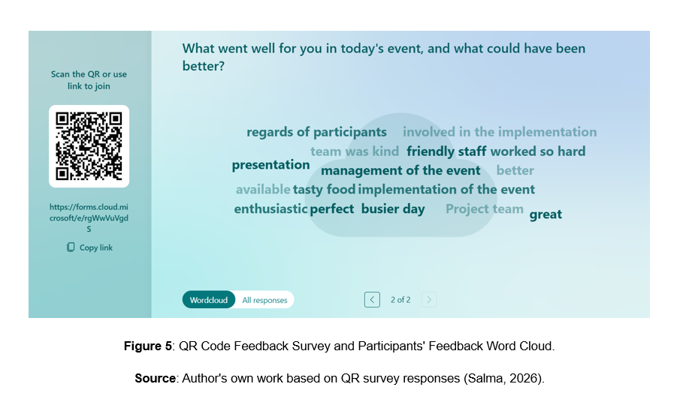
In addition to its financial success, the project promoted well-being through a dedicated well-being corner where participants shared encouraging messages that strengthened inclusion and community engagement. These outcomes demonstrate that project success extended beyond fundraising to achieving broader social objectives.
Project closure involved evaluating outcomes, reflecting on lessons learned, and transferring the funds raised to EYST. As Cooke-Davies (2002) suggests, successful projects should generate organisational learning as well as immediate results. The lessons identified will support the planning and delivery of future fundraising projects.

3. Conclusion
This report critically evaluated the Fundraising and Well-being Event organised in support of the Ethnic Youth Support Team (EYST). The project successfully achieved its objectives by raising £115, attracting approximately 40 participants, and promoting well-being through fundraising activities and a dedicated well-being initiative.
The report critically assessed the project lifecycle together with key project management tools and techniques, including the Iron Triangle, Work Breakdown Structure (WBS), Gantt Chart, stakeholder analysis, communication planning, and risk management. These approaches informed project decisions, strengthened stakeholder engagement, reduced project risks, and contributed to successful project delivery.
As Team Leader and Coordinator, I developed leadership, communication, stakeholder management, organisational, and problem-solving skills. The project demonstrated that successful project management depends not only on appropriate tools and techniques but also on effective communication, collaboration, adaptability, and continuous evaluation throughout the project lifecycle (Müller and Turner, 2010).

4. Future Improvements and Recommendations
Although the project achieved its objectives, several improvements could strengthen future fundraising events.
The main challenge was the timing of the event, which took place near the end of the academic year when student participation was lower than anticipated. Organising similar events earlier in the academic year would likely increase attendance and improve fundraising outcomes.
Future projects could also increase awareness by making greater use of university social media platforms, student societies, and institutional communication channels.
The project demonstrated that combining project management tools was more effective than relying on a single technique. The Iron Triangle supported planning decisions, the WBS clarified responsibilities, the Gantt Chart improved scheduling, stakeholder analysis informed communication priorities, and risk management enabled preventative action before problems occurred. Together, these approaches strengthened planning and supported successful project delivery.
Personally, the project strengthened my leadership, communication, stakeholder management, and organisational skills. It also highlighted the importance of balancing attention to detail with effective delegation. In future projects, I will place greater trust in team members while maintaining appropriate monitoring and communication.
Overall, the lessons learned from this project will support my continuing professional development and improve my future project management practice.

- References
Association for Project Management (APM) (2022) APM Body of Knowledge. 8th edn. Princes Risborough: Association for Project Management.
Atkinson, R. (1999) 'Project management: Cost, time and quality, two best guesses and a phenomenon, it’s time to accept other success criteria', International Journal of Project Management, 17(6), pp. 337–342.
Burke, R. (2013) Project Management: Planning and Control Techniques. 5th edn. Chichester: John Wiley & Sons.
Clegg, S., Kornberger, M., Pitsis, T. and Mount, M. (2020) Managing and Organizations: An Introduction to Theory and Practice. 6th edn. London: Sage Publications.
Cooke-Davies, T. (2002) ‘The “real” success factors on projects’, International Journal of Project Management, 20(3), pp. 185–190.
Heagney, J. (2016) Fundamentals of Project Management. 5th edn. New York: AMACOM.
Heldman, K. (2018) Project Management JumpStart. 4th edn. Indianapolis: John Wiley & Sons.
Kerzner, H. (2022) Project Management: A Systems Approach to Planning, Scheduling, and Controlling. 13th edn. Hoboken, NJ: Wiley.
Lock, D. (2020) Project Management. 11th edn. London: Routledge.
Maylor, H. (2010) Project Management. 4th edn. Harlow: Pearson Education.
Meredith, J.R., Mantel, S.J. and Shafer, S.M. (2017) Project Management: A Managerial Approach. 9th edn. Hoboken, NJ: Wiley.
Müller, R. and Turner, J.R. (2010) ‘Leadership competency profiles of successful project managers’, International Journal of Project Management, 28(5), pp. 437–448.
Newton, R. (2016) The Project Manager: Mastering the Art of Delivery. 3rd edn. Harlow: Pearson.
Pinto, J.K. (2019) Project Management: Achieving Competitive Advantage. 5th edn. Harlow: Pearson.
Project Management Institute (PMI) (2021) A Guide to the Project Management Body of Knowledge (PMBOK® Guide). 7th edn. Newtown Square, PA: Project Management Institute.
Turner, J.R. (2014) Handbook of Project-Based Management. 4th edn. New York: McGraw-Hill Education.
Walker, A. (2015) Project Management in Construction. 6th edn. Chichester: Wiley-Blackwell.
Westland, J. (2018) The Project Management Life Cycle: A Complete Step-by-Step Methodology for Initiating, Planning, Executing and Closing a Project Successfully. London: Kogan Page.
Young, T.L. (2016) Successful Project Management. 6th edn. London: Kogan Page.

