Programme: BA Business Management
Module: Data Handling and Business Intelligence
Module Code: LCBB5000
Assignment Title: Assessment 2 Coursework (written report)
Student Name: Loredana Aurora Padure
Student ID: 2019942

DATA HANDLING AND BUSINESS INTELLIGENCE

Executive summary
The part A of this report helps in reflecting the fact that Excels and the contained advanced functions are essential in order to create data and making its interpretation. The findings of the first part explain that crime rates have positive relationship with the high unemployed employment rate. The second part of this report has helped ion reflecting the fact that the use of the SPSS is essential in terms of explaining large quantities of data. The result from part B highlights that the female candidates are bigger in number and vanilla is the most liked ice cream flavor.

Table of Contents
Part 1 2
(a) Introduction 2
(b) Significance 2
(c) Evaluation of the procedures 3
(d) Findings and analysis 4
(e) Benefits and limitations 6
(f) Conclusion 7
Part 2 8
(a) Introduction 8
(b) Findings and discussion 8
Vanilla flavour liked by students 8
Number of males and females 9
Computation of mean and median 10
(c) Cluster analysis 11
(d) The methods used in text and data mining 12
(e) Benefits and limitations of SPSS and Excel 12
(f) Conclusion 14
References 15

Part 1

(a) Introduction
Data analysis is gaining massive popularity in recent years as the use of large datasets in helping analysts to make sense of the obtained information. Furthermore, it can also be depicted that the interpretation of a large dataset is becoming possible through this process and the use of the different data analysis platforms is also used in this context.

(b) Significance
In terms of explaining the significance of data analysis, it can be stated as an appropriate method of analysing data. The research of Hopke and Jaffe (2020, p.689) explains that the principal components included in the observation can be thoroughly analysed through the application of the data analysis methods. It is identified to be a quantitative information analysis tool and identifies the relationship between the variables. The data analysis includes functions that appropriately explain the average and least squared values. In this context, it has also been identified that the identification of the least squared values is useful to find out as it provides the most suitable way of fitting curves while developing data points at the top of the charts. As opined by Nieminen and Kaur (2019, p.1784), the uprising trend of the statistical intensity is changing since its inception and it is also observable that traditional methods are getting continuously replaced by the newer approaches. Techniques such as multiple variable regression models as well as multilevel modelling of statistics are helping to establish relationships between the variables. Furthermore, it can also be depicted from this evaluation that the use of the data analysis is helping to identify the changes. Furthermore, it has also been identified that the use of the data analysis is enhanced through the graphical presentation as it provides more in-depth as well as critical understanding to the viewers (Caiet al. 2022, p.041407). More specifically, it has also been identified that the evaluation through obtaining algorithms from the data set can be considered useful in order to acquire knowledge from the observation. Therefore, the use of the data set can be considered useful to perform analysis on the large set of evidence of the data set collected. As stated by Zhu (2022, p.57), in the research works the use of the data analysis methods is becoming a popular topic of discussion. The use of the data analysis is helping the readers to understand the data in an easier way and due to such a reason insights from the observation can be easily obtained. It has also been identified that the scope of time reduction in making sense of large data sets is enabled through the application of data analysis technologies. It is stated that to be productive as well as effective in data handling the use of data analysis is crucial. In addition, it can also be depicted that the use of the data analysis methodologies is useful to determine the overall result from the set of observations.

(c) Evaluation of the procedures
The identification of the process included in the estimation has been done through the implication of the different data analysis tools and techniques. On that note, it has also been identified here in the given case study that the crime rates of different locations have been provided based on whichthe charts and graphs are needed to be produced by the analysts. On that note, it can also be depicted that the use of the different techniques of excel can be useful to plot data in a graphical presentation more effectively. For instance, here in order to develop the analysis from the given data set, Microsoft Excel has been used. The functions of Microsoft excel are likely to be considered helpful in terms of producing these results. On that note, the evaluation of the process of developing the relevant data can be done through the inclusion of the tools such as the IF function and Pivot table.
Developing the IF function is an essential aspect in order to develop a logical comparison between the variables. More specifically, it has also been recognised that the process of developing the IF function requires a thorough understanding of the application of the formula. The application of this function may be helpful in producing two types of answers from the dataset, The TRUE results are identified to be the logical reasoning as it reflects the value to be 1 and FALSE can be referred to as the numeric value 0 as per the Boolean logical reasoning. Hence, practising this technique can be useful to compare the relationships. Here in the context of the given case study, it has been identified that the implementation of the IF function has been proposed in order to explain the relationship between crime rates and unemployment rates in the locations. Furthermore, it can also be depicted from this evaluation that judgement or decision can be made on the scenarios.
The evaluation of the pivot tables can also be considered helpful in terms of explaining the datasets. More specifically, it has also been identified that the process of developing a pivot table helps in reflecting the fact that it analyses data in a step by step process. The analysts are needed to have prior experience e\in order to generate meaningful results.The excel that would be used to generate the user data will contain cells and values. The analysis would be required to select the range of values from the cells and then an option called pivot table would be pressed to generate the fact sheet in a new or existing worksheet of excel. The values then will be selected and the rows, as well as columns, are also to be evaluated through this process. The different variables that are identified in the datasheet of the crime rate would be effectively used in order to generate the pivot table.

(d) Findings and analysis
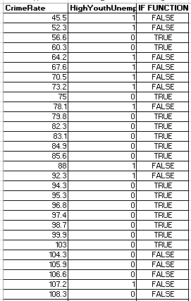
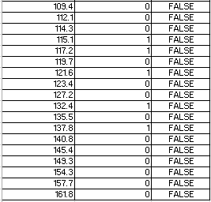
Figure 1: Crime rate and IF function
(Source: Created by the learner)
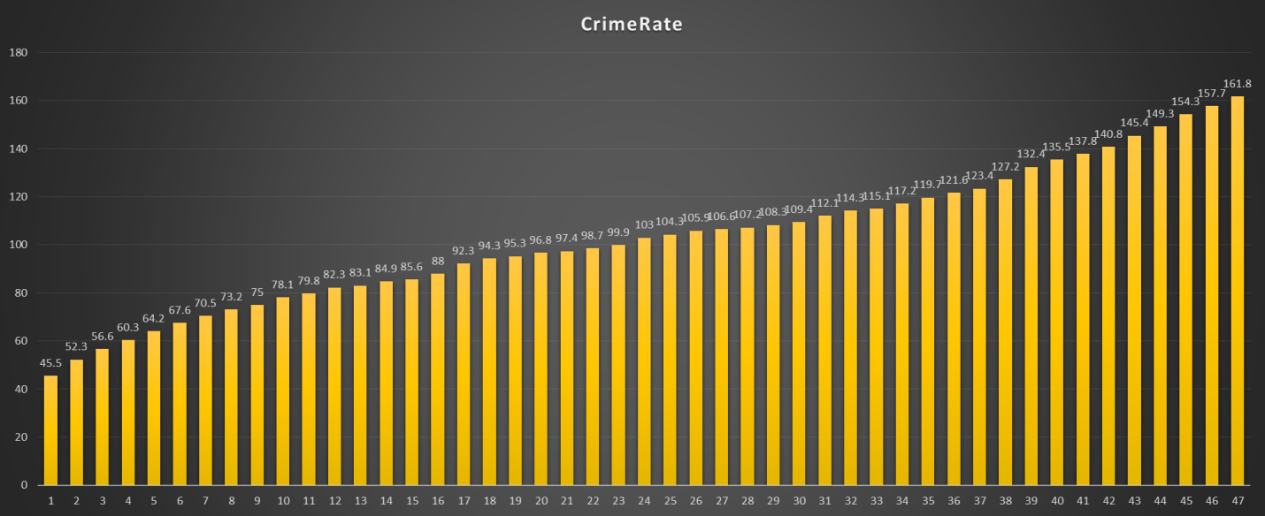
Figure 2: Graphical illustration of crime rates and influence of unemployment
(Source: Created by the learner)
Through making a complete evaluation of the above presentation it has been identified that the application for the IF function has helped to produce the required data. Making a complete analysis of the above-presented dataset it has also been identified that the overall relationship between the crime rates and unemployment is strong. It is because the IF conditional formula reflects that low crime rates have a false relationship with high unemployment. More specifically, it can also be depicted from this evaluation of the data presented in a table or figure 1 hesp in reflection the fact that as the unemployment rate has been increased the rate of crimes has also been increased Therefore, from this evaluation it can also be identified that the unemployment of the youths is causing a significant and negative impact on the crime rates.
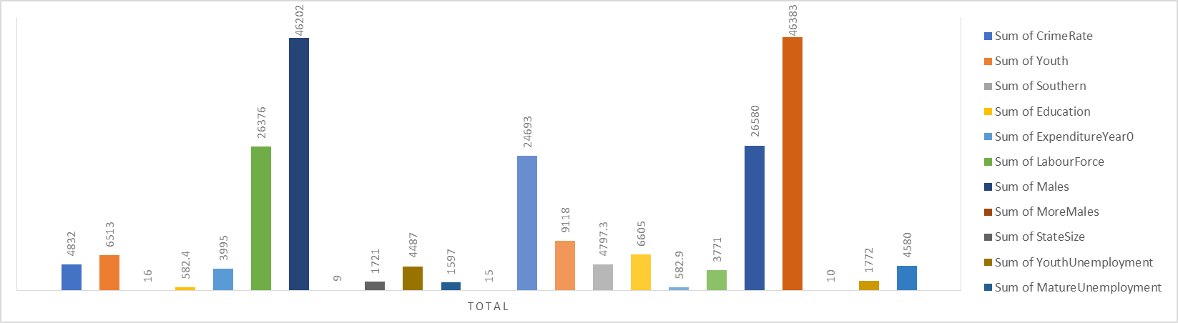
Figure 3: Presentation of crime rates and other relevant variables
(Source: created by the learner)
Through making a complete evaluation of the above-presented graph it can be clearly highlighted that the overall values have been identified through analysis of the values identified from the variables. The pivot table explains that the crime rates, as well as a number of offences, are dependent upon the wage rate, unemployment rates among the youth and variables like under wage, gender and location. Furthermore, it can also be identified that the usefulness of the pivot table has made the result possible as it included the variables in its browns and values. The crime rate has been used as the filter of the pivot table.

(e) Benefits and limitations
One of the major benefits that can be obtained through the development of the pivot table is that the results can be presented in an analytical manner. The importance can be further explained by depicting that a pivot table is considered useful in producing multiple analytical tables through which a huge set of data can be contained in a single workfile. Furthermore, it has also been identified that the benefits of the pivot table also include easy accessibility and friendliness. It is because the Pivot table is very easy to understand and segmenting different variables to produce such an effective chart can be helpful (Darmawan et al. 2019, p.15). It is because through the incorporation of pivot tables the analysts would be able to identify the values as instant formulas are available to create charts and graphs. The major disadvantage of using a Pivot table is that the calculation included in a pivot table can be manual due to which the overall time consumption may be increased. Furthermore, it has also been identified that the collection of data can be done manually affecting the overall time consumption in the process. It has also been identified from this evaluation that expertise is essential to present data in an efficient manner. Therefore, having limited knowledge in the field of data analysis and in the context of using the software can be disadvantageous as practising such techniques would become very difficult (Hüseyniet al. 2017, p.65). Hence, the use of the pivot table can be considered a critical approach, developing an understanding of this aspect is considered essential.
The IF function is identified to be a logical function in Microsoft Excel and therefore through the inclusion of this function the overall comparison of the variables can be presented. Furthermore, it has also been identified from this evaluation that through the implementation of the IF function the criteria-based judgements can be made through which the overall result can be obtained in an efficient manner (Kuo-Ping et al. 2019, p.1658). Furthermore, it can also be stated from this evaluation that through the implementation of this methodology the overall calculation can be made fast-paced. In terms of explaining the disadvantages of the IF function, it can also be stated that the knowledge of the advanced Excel functions is essential to understanding the if function (Lokasree, 2021, p.840). The evaluation further depicts that the demerits of the excel function are that it can be stated that the IF function has a lack of control over the results that are to be produced.

(f) Conclusion
Making a complete evaluation of the above-presented data helps in reflecting the fact that data analysis is an essential concept that is helping data analysts to manage large quantities of data. Through the application of this technique, it can be identified that evaluation of the data and proper interpretation can also be developed. Based on the evaluation of the above explanation of the crime rate it has been observable that functions such as pivot travel as well as IF function reflecting high crime rates are associated with the unemployment of the youths and other important as well as relevant variables.

Part 2

(a) Introduction
The use of the statistical functions can also be done through the implementation of the IBM SPSS technology. on that note, it can also be highlighted in this context that the statistical functions are useful to determine relationships between variables. Here in this context, the SPSS tool would be used to explain the sample population and their ice cream preferences.

(b) Findings and discussion

Vanilla flavour liked by students
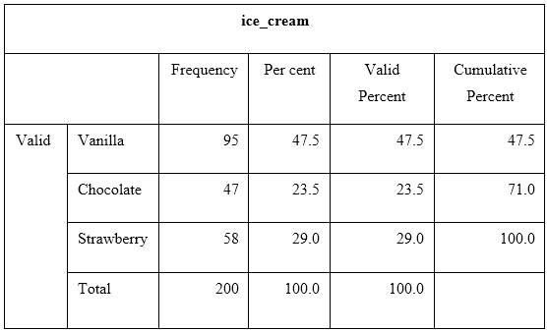
Figure 4: Frequency test of vanilla flavour
(Source: Created by the learner)
Through making a complete evaluation of the above table it has been clearly identified that the statistical test is depicted among the total sample population. 47.5% of students prefer Vanilla flavoured ice cream (Nasutionet al. 2019, p.1255). Furthermore, it has also been identified that among the total population vanilla is mainly liked by the students.

Number of males and females
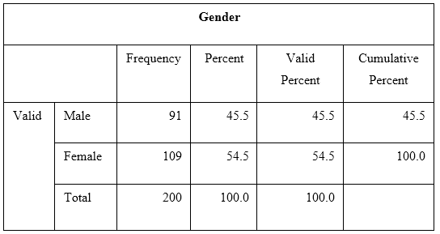
Figure 5: Number of students by gender
(Source: Created by the learner)
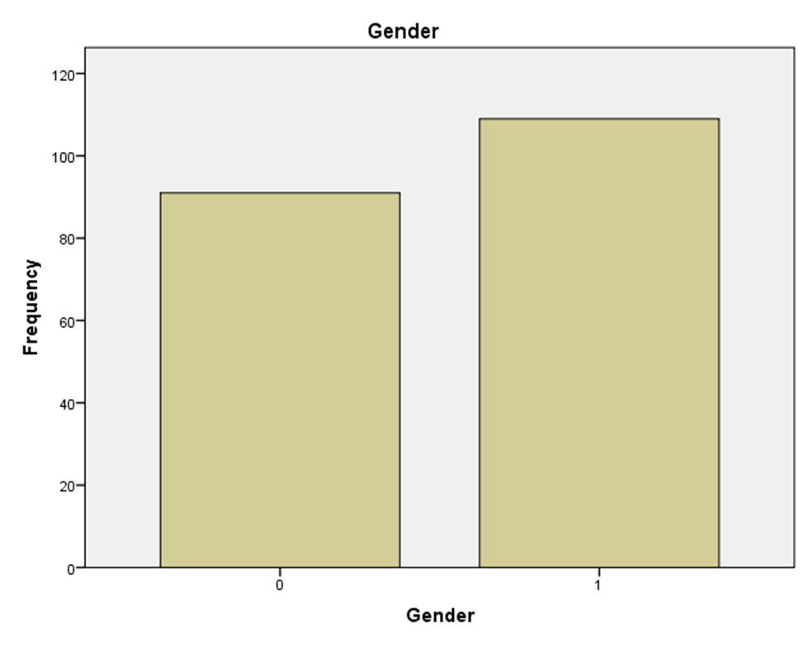
Figure 6: Genders of sample size
(Source: Created by the learner)
Through making a complete evaluation of the above statement it has also been identified that out of the total sample population of students most of them are identified to be female students therefore the percentage is estimated to be 54.5%. Furthermore, it has also been identified that 91 out of the 200 students are males, hence in percentage, it would be 45.5%. Furthermore, in order to evaluate these results the use of the mean calculation frequency test has been considered effectively as it has provided the result in an effective manner showcasing the number population based on gender.

Computation of mean and median
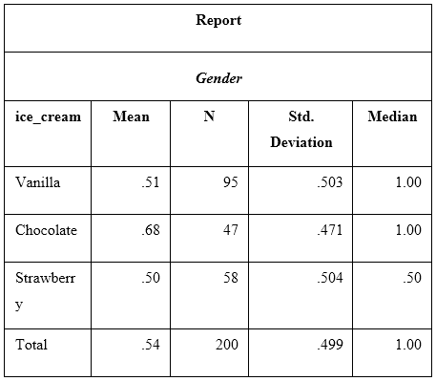
Figure 7: Statistical; analysis of the collected sample
(Source: Created by the learner)
Through making a complete evaluation of the above-presented table it has been identified that three types of flavours' comparative mean are an essential technique of SPSS that makes the analysis relevant. Furthermore, Through conducting the above analysis it can be identified that the inclusion of this technique has effectively identified the average values of the different flavoured ice creams liked by the students. The estimation of the median of the identified variable helps in reflecting the fact that the overall vanilla is the most liked flavour whereas the strawberry and chocolate are the two important flavours as well. The evaluation of the table presented above helps to reflect the fact that only vanilla is the closest to the median value and the rest are estimated to be very low. Therefore a strong relationship between two variables students and vanilla flavoured ice cream is observable in the given case.

(c) Cluster analysis
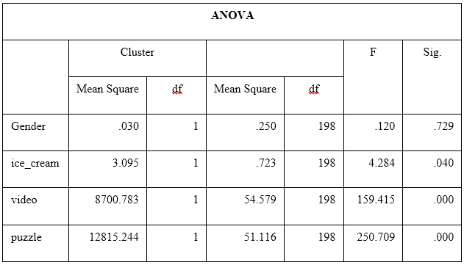
Figure 8: presentation of cluster analysis
(Source: Created by the learner)
Cluster analysis is an essential concept as it provides a method to cluster the data in a group. More specifically, this tool in the SPSS software is used in order to analyse the exploratory data. The evaluation of the above information also helps in reflecting the fact that it provides a general solution through which the various algorithms included in the data can be identified. The evaluation of the cluster analysis also helps in reflecting the fact that businesses are using this tool to analyse the density of the plotted data. From the evaluation of the above information presented in table 4, it can be identified that the analysis of the ANOVA can be used to determine the overall clustered graph. The table explains that the sigma of gender is 0.729 and the influence of video ad puzzles is estimated to be 0 as the significance of these two variables is also 0. The mean square value is essential to analyse because

(d) The methods used in text and data mining
Extraction of information is one of the primary activities that is undertaken in the context of the text and data mining, It has also been identified that the collection of the unstructured data is needed to be presented in an effective manner so that large datasets can be categorised effectively, Categorisation of the information is also essential to sort such large size of data collected from the sources (Rawat and Yadav, 2021, p.15). It can also be deducted from this evaluation that the detection of the important data and removal of the duplicates is also another essential factor for the data and text mining, The process includes identification of the patterns and algorithms of the data provided in a large data set. Based on this aspect the overall data can be presented in a coherent manner. Conversion is another essential technology or method that is used in order to make the data in a structured format (Sakouvogui, 2020, p.1787). The application of text mining tools and software such as MIS is helpful in terms of producing valuable insights from the given data. Furthermore, it can be stated that making an analysis of the pattern of the identified data needs to be stored and analysed. Clustering is another major effective process that is applied in order to generate text from potential customers (Sooktaweeet al. 2020, p.489). The evaluation of this method explains that the process includes a collection of the documents and then the classification of the collected information based on the documents.

(e) Benefits and limitations of SPSS and Excel
Variables | Excel | SPSS
benefits | - Excel shows the several extracts and information as well as knowledge from the data combined with a variety of sources and formats (Taboada and Han, 2020, p.1270).  - Excel provides authentic data regarding the study as well as identifying the reason for how the data are sourced and processed to avoid any insurgency.  - Excel tools include various mathematical tools and statistics such as calculus, algebra and many more (Taboadaet al. 2020, p.4995). | 1. SPSS is a comprehensive system as well as statistical software tools. it enables the various tests such as ANOVA, and interpretations that have been built within the firm.  2. It operates easily and quickly displays the data tables as well as is able to expand within multiple features.  3. It combines or contained multiple features and records regarding the different tests and statistical approaches.
Limitations | - The data that exists within Excel is too high as it might slow down the overall process and program during training.  - Excel is not completely integrated with any other business or system.  - It does not have clear consistency and visibility. However, the usage of Excel is complex in terms of making reports. | - It has been identified that the SPSS tools and expensive for the students.  - It usually involves multiple training and operating features that can be exploited during the time of any academic training (Wang et al. 2019, p.1620).  - The gap features within the SPSS tools are not simple as compared with Microsoft excel.

Table 1: benefits and limitations of SPSS and Excel
(Source: Created by the learner)

(f) Conclusion
Making a complete evaluation of the above analysis also reflects the fact that SPSS is an essential tool in order to explaining the overall concept of statistical information. Based on the evaluation of the above explanation it has been clearly identified that the inclusion of the techniques such as the regression model or the frequency test is helpful in terms of explaining the relationship between the variables. The assessment has explicitly shown that the introduction of the statistical test and K means is essential to explain large data sets accurately. Furthermore, it has also been identified that the use of the SPSS has been helpful as this method is more effective than excel. However, in terms of accessibility Excel is quite easy to understand and therefore applications of these technologies are essential to analyse data to interpret it into meaningful.

References
Cai, Y., Wu, J. and Dai, Q., 2022. Review of data analysis methods for mesoscale neural imaging in vivo. Neurophotonics, 9(4), p.041407.
Darmawan, N., Wahyudi, E.J., Kadir, W.G.A. And Sule, R., 2019. Processing and data analysis of time-lapse microgravity due to groundwater level changing in baseline stage of CO0RW1S34RfeSDcfkexd09rT421RW1S34RfeSDcfkexd09rT4 injection. IOP Conference Series.Earth and Environmental Science, 318(1),.
Hopke, P.K. and Jaffe, D.A., 2020. Ending the use of obsolete data analysis methods. Aerosol and Air Quality Research, 20(4), pp.688-689.
Hüseyni, I., Eren, M. And Çelik, A.K., 2017. Examining the Relationship Among Economic Growth, Exports and Total Productivity for OECD Countries Using Data Envelopment Analysis and Panel Data Analyses. Montenegrin Journal of Economics, 13(3), pp. 63-73.
Kuo-Ping, L., Chun-Min, Y. And Chen, K., 2019. Production data analysis system using novel process capability indices-based circular economy. Industrial Management & Data Systems, 119(8), pp. 1655-1668.
Lokasree, B.S., 2021. Data Analysis And Data Classification In Machine Learning Using Linear Regression and Principal Component Analysis. Turkish Journal of Computer and Mathematics Education, 12(2), pp. 835-844.
Nasution, N.H., Efendi, S. And Tulus, 2019. Sensitivity Analysis In Data Envelopment Analysis for Interval Data. Journal of Physics: Conference Series, 1255(1),.
Nieminen, P. and Kaur, J., 2019. Reporting of data analysis methods in psychiatric journals: Trends from 1996 to 2018. International Journal of Methods in Psychiatric Research, 28(3), p.e1784.
Rawat, R. And Yadav, R., 2021. Big Data: Big Data Analysis, Issues And Challenges And Technologies. IOP Conference Series.Materials Science and Engineering, 1022(1),.
Sakouvogui, K., 2020. A comparative approach of stochastic frontier analysis and data envelopment analysis estimators: evidence from the banking system. Journal of Economic Studies, 47(7), pp. 1787-1810.
Sooktawee, S., Kanchanasuta, S., Boonyapitak, S., Patpai, A. And Piemyai, N., 2020. Distinguish Potential Source Areas of PM0RW1S34RfeSDcfkexd09rT42.51RW1S34RfeSDcfkexd09rT4 and PM0RW1S34RfeSDcfkexd09rT4101RW1S34RfeSDcfkexd09rT4 by Statistical Data Analysis. IOP Conference Series.Earth and Environmental Science, 489(1),.
Taboada, G.L. And Han, L., 2020. Exploratory Data Analysis and Data Envelopment Analysis of Urban Rail Transit. Electronics, 9(8), pp. 1270.
Taboada, G.L., Seruca, I., Sousa, C. and Pereira, Á., 2020. Exploratory Data Analysis and Data Envelopment Analysis of Construction and Demolition Waste Management in the European Economic Area. Sustainability, 12(12), pp. 4995.
Wang, D., Zhong, Z., Bai, K. and He, L., 2019. Spatial and Temporal Variabilities of PM0RW1S34RfeSDcfkexd09rT42.51RW1S34RfeSDcfkexd09rT4 Concentrations in China Using Functional Data Analysis. Sustainability, 11(6), pp. 1620.
Zhu, Z., 2022. The Role and Significance of Statistics in Economic and Social Development. Frontiers in Business, Economics and Management, 3(3), pp.56-58.

